Supporting Information to:

Analysis of fecal sludges reveals common enteric pathogens in urban Maputo, Mozambique

Authors: Drew Capone^{1,2}, David Berendes³, Oliver Cumming⁴, Jackie Knee⁴, Rassul Nala⁵, Benjamin B. Risk⁶, Christine Stauber⁷, Kevin Zhu¹, Joe Brown^{1,2}
- Civil and Environmental Engineering, Georgia Institute of Technology, Atlanta, Georgia, 30332, United States of America
- Department of Environmental Sciences and Engineering, Gillings School of Global Public Health, University of North Carolina at Chapel Hill, Chapel Hill, North Carolina 27599, United States
- Waterborne Disease Prevention Branch, Division of Foodborne, Waterborne, and Environmental Diseases, National Center for Emerging Zoonotic and Infectious Diseases, Centers for Disease Control and Prevention, Atlanta, Georgia, 30329, United States of America
- Department of Disease Control, Faculty of Infectious and Tropical Diseases, London School of Hygiene & Tropical Medicine, WC1E 7HT, London, United Kingdom
- Ministério da Saúde, Instituto Nacional de Saúde Maputo, Maputo, Mozambique
- Department of Biostatistics and Bioinformatics, Emory University, Atlanta, Georgia, 30322 United States of America
- School of Public Health, Georgia State University, Atlanta, Georgia, 30302, United States of America
*Corresponding author: Dr. Joe Brown
Phone: +1 404-385-4579
Email: joe.brown@ce.gatech.edu
Summary: Supporting information contains 3 figure, 6 texts, and 5 tables
Contents
- Figure S1. Photos of latrine samplers
- Text S1. Description of MapSan trial
- Text S2. Methodology for fecal sludge collection
- Text S3. Methodology for total nucleic acid extraction from fecal sludge and stool.
- Text S4. Custom TaqMan Array Card (TAC)
- Table S1. TAC and GPP comparison
- Table S2. Assays used on the custom TAC
- Table S3. Interpretation of gene targets on the TAC
- Text S5. Regression models
- Figure S2. DAGs of stool models
- Figure S3. DAGs of sludge models
- Table S4. Summary of pathogens in stools and sludges
- Table S5. Average Cq values
- Table S6. Associations between variables and the number of detected pathogenic bacteria, viruses, protozoa, or STHs in stools and sludges.
- Table S7. Pathogen detection data disaggregated by sanitation infrastructure (septic tanks and latrines)

Figure S1. Photos of latrine samplers
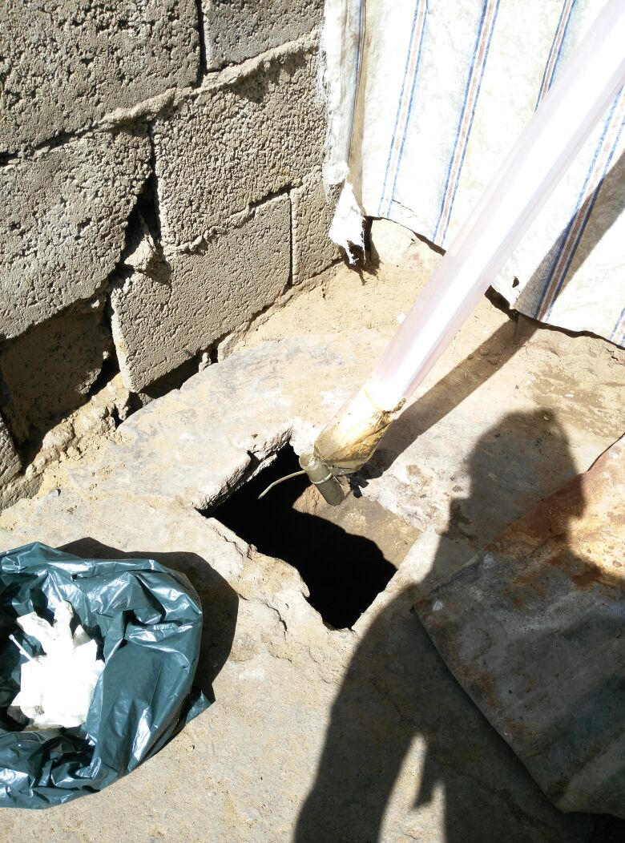
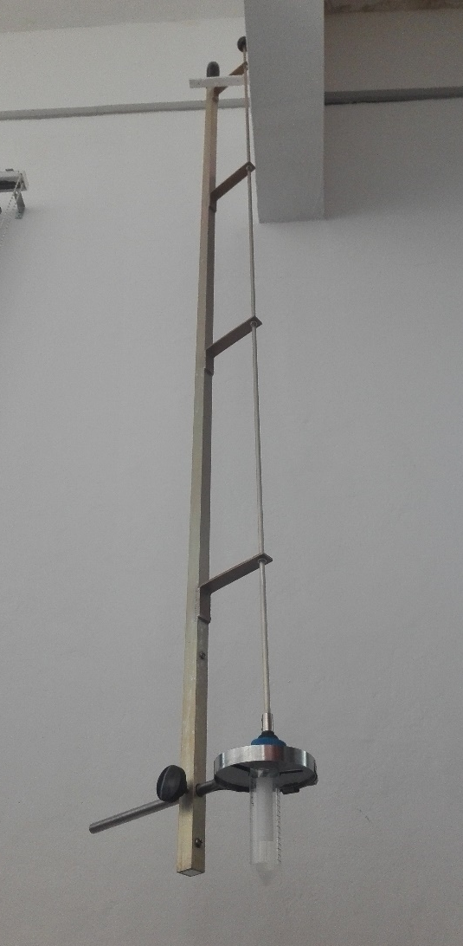
Modified Wheaton sub-surface sampler
Sludge nabber
Text S1. Description of MapSan trial
The organization Water and Sanitation for the Urban Poor (WSUP) built 250 shared latrines and 50 community sanitation blocks at compound in the low-income urban neighborhoods of Maputo, Mozambique with funding from the Japanese Social Development Fund. Compounds with approximately 15-20 people received a shared latrine and generally compounds with ≥21 people received a community sanitation block. Shared latrines became the property of the residents and included a toilet, superstructure, septic tank, and a lined infiltration pit. Community sanitation blocks officially remained the property of the municipality and included the same infrastructure as a shared latrine, but contained multiple toilets (one toilet per twenty people), a new piped water connection with a water storage tank, sink pedestal for handwashing (no running water but the drain was connected to the septic tank), rainwater harvesting tank, cement laundry basin, and community sanitation blocks with ≥60 residents received a urinal on an external wall of the structure which drained to the septic tank. Compound residents that received community sanitation blocks formed sanitation management committees, which were responsible for maintaining the sanitation infrastructure. The septic tanks in the shared latrines and community sanitation blocks were sized according to the number of users and were designed to be emptied every two years (assuming 40 liters accumulation per person per year). All intervention septic tanks contained an access port for hygienic emptying, but the ports were sealed shut.
WSUP selected intervention compounds based on the following criteria: (1) residents shared sanitation in poor condition as determined by an engineer; (2) located in the pre-defined implementation neighborhoods; (3) no fewer than 12 residents; (4) residents were willing to contribute financially to construction costs; (5) sufficient space for construction of the new facility; (6) accessible for transportation of construction materials and tank-emptying activities; (7) access to a legal piped water supply; and (8) groundwater level was deep enough to allow construction of a septic tank. The newly constructed intervention latrines were opened for use between February 2015 and February 2016. The study team used criteria 1, 3, 4, and 7 to select control sites within the 11 intervention neighborhoods and six adjacent but similar neighborhoods.
Data and stool samples were collected at baseline (0 months), 12-months post-intervention and 24-months post-intervention from an open cohort of children. At baseline we received written informed consent from a parent or guardian, and verbal consent from the compound leader, then enrolled children aged 1-48 months from intervention and control compounds. At the 12- and 24-month follow-up visits, children were eligible for enrollment if they were 1-48 months old, or if they had been eligible for enrollment at baseline but were not present during the baseline study visit. Additional details regarding enrollment are described in Knee et al. 2018.
The study protocol was approved by the Comité Nacional de Bioética para a Saúde (CNBS), Ministério da Saúde (333/CNBS/14), the Research Ethics Committee of the London School of Hygiene & Tropical Medicine (reference # 8345), and the Institutional Review Board of the Georgia Institute of Technology (protocol # H15160).
Text S2. Methodology for fecal sludge collection
To modify the sludge nabber, we first covered the sampler with disposable plastic tubing (Amazon.com, https://www.amazon.co.uk/Empire-Packaging%C2%AE-Layflat-Polythene-Tubing/dp/B01B2WT8SE/) (to limit direct contact with feces) and then used zip ties to fasten a 50mL centrifuge tube to the sampler. We inserted the sludge nabber down the drophole below the surface of the fecal sludge in pit latrines at one point (in the middle of the pit latrine). We submerged the sampler tube for 5 seconds and then withdrew it. We then capped and closed the sampler tube, sterilized the outside with bleach and placed it in a cooler. Between pit latrine sampling events, we sprayed the sampler with bleach and allowed 15 minutes of contact time to sterilize it prior to drying it off with a fresh paper towel.
For septic tanks, we used a modified Wheaton sub-surface sampler I system (Fisher Scientific, Waltham, Massachusetts) to fill a 50 mL centrifuge tube. We laser cut extruded acrylic insert disks for the centrifuge tubes to be held in the sampler. We then inserted the centrifuge tube into the disks, clamped it firmly, and attached the suction top of the sampler to the tube, keeping the tube closed. At the septic tank, we opened the side access port (for emptying) and submerged the sampler into the solids layer at the bottom of the septic tank (generally the bottom 1-2 feet of the tank). We then twisted the suction arm to open the sampler for 5 seconds and closed it firmly before lifting the sampler out of the tank. We then removed the tube and sterilized the outside of the sampler and tube with bleach prior to drying it off with a fresh paper towel and placing the tube in a cooler. Samples were stored on ice for transport. To make sample aliquots from both pit latrines and septic tanks we vortexed the 50 mL tubes for 10 seconds and pipetted 2 mL of fecal sludge into a 2 mL cryovial. Within 6 hours of collection samples were stored at -80ºC and remained frozen until analysis.
Standard Operating Procedure: Sludge Sample Collection

Latrine Sludge Sample Collection Protocol
Pit Latrines
Before visiting compound:
- Cut pink plastic into lengths equal to the longest length (extended arm) of the sampling apparatus (“Sludge Nabber”)
- Ensure that you have enough bleach solution (10% bleach)
  - If not, take orange spray bottle and measure out just over 100 mL of bleach into it
  - Fill the bottle the rest of the way with water
  - Close the top of the bottle and swirl in circles to mix
- Ensure that you have enough ethanol solution (75% ethanol) in orange spray bottle
- Supplies for sampling:
  - 2 sampler apparatuses (Sludge Nabbers)
  - 50mL tubes (1 per latrine + 2 extra)
  - gloves
  - pink plastic sheeting
  - paper towels
  - trash bags (4)
  - bleach solution
  - ethanol
  - zip ties
  - rubber bands
  - cooler with ice packs

At compound:
- Put gloves on
- Extend the Sludge Nabber to full length by turning the handle in the direction indicated to loosen, extending the arm, and then turning it back in the opposite direction to lock
- Grab a pre-measured length of plastic and slide it over the Sludge Nabber, starting at the bottom
  - Gather the end of the plastic that is under the bottom of the Sludge Nabber and tie it tightly together with a zip-tie
  - Wrap a rubber band tightly around the outside of the bottom, covered end of the sampler and slide a clean 50mL tube into the end once it’s wrapped
  - Unscrew the top of the tube and place to the side
- Remove the cover of the latrine drophole
- Holding the sampler by the handle, lower it into the latrine until it reaches the top of the feces, trying not to touch the sampler to the side of the drophole
  - Firmly push the end down into the feces until the tube is submerged and hold for 5 seconds
- Raise the sampler out of the latrine and place it directly in an open trash bag
  - Ensure that at least half of the tube is filled before proceeding
  - Grab the cap of the tube and screw it back on tightly using only one hand, keep the other hand away from the contaminated area
  - Spray the entire lower portion of the Sludge Nabber and tube with plenty of bleach using the hand that has not touched the feces
  - Take off gloves and throw into trash bag. Wrap the trash bag up, tying it above the area that has feces on it
  - Allow sampler to have contact with bleach for 15 minutes (bring sampler to next household and begin with sampling next latrine while you wait)
- After 15 minutes, wearing clean gloves, unwrap trash bag from sampler
  - Using left hand, undo the rubber band from the Sludge Nabber and throw in trash bag
  - Using left hand, pick up tube by its top and wipe it off with a paper towel using right hand
  - Spray ethanol on the tube and wipe it off with another paper towel
  - Place tube into tube rack in cooler
  - Holding the Sludge Nabber in your right hand by the plastic tubing along the pole, pull the plastic tubing off the bottom of the sampler using your left hand—into the trash bag
  - Using your right hand, remove the Sludge Nabber from the trashbag and place it to the side
  - Take off your gloves and throw them in the trash bag
- Put on a new set of gloves and write the sample ID on the tube using a Sharpie
  - The sample ID is “[MapSan compound code]-LS-[date]”, so a sample from July 11, 2017 from compound 2323 would be “2323-LS-110717”

At the end of the day (before leaving compound site):
- Wearing gloves, spray down entire Sludge Nabber (while extended) using bleach and leave for 15 minutes
  - Can be placed in trash bag and transported in the meantime
- After 15 minutes, wipe down Sludge Nabber using paper towel, spray entire Sludge Nabber with ethanol, and wipe down again
- Turn and retract Sludge Nabber
- Consolidate trash bags into a single trash bag and take to the lab to be placed with biohazardous waste
- Ensure all samples are labelled correctly and bring them to the lab
- Thoroughly wash your hands
Note: during sampling during the day, sampling apparatus should be left extended

Pour Flush Latrines
Before visiting compound:
- Ensure that you have enough bleach solution (10% bleach)
  - If not, take orange spray bottle and measure out just over 100 mL of bleach into it
  - Fill the bottle the rest of the way with water
  - Close the top of the bottle and swirl in circles to mix
- Ensure that you have enough ethanol solution (75% ethanol) in orange spray bottle
- Supplies for sampling:
  - 2 sampler apparatuses
  - 50mL tubes (1 per latrine + 2 extra)
  - gloves
  - paper towels
  - trash bags (4)
  - bleach solution
  - ethanol
  - cooler with ice packs
  - plastic insert disks (4)
  - metal circle clamp (2)

At compound:
- Put gloves on
- Stack 2 of the insert disks and place them into the metal circle clamp, twisting the metal handle to tighten the clamp around them
- Place an open garbage bag to the side for later
- Place a 50mL tube into the disks and tighten the clamp fully
  - Ensure that the suction cup is directly aligned with the top of the tube
    - If it is not, loosen the plastic handle (on the apparatus itself, not the clamp) to adjust the distance of the clamp accordingly and tighten when in place
- Press the suction cup itself tightly onto the top of the tube
  - Twist the handle at the top of the apparatus to ensure it opens and closes the tube
  - Prior to submerging the tube, loosen the top just a very small amount so it is not as tight as possible, but is still wound in the threads
- Holding the sampler by the handle, submerge the end of sampler, tube first, in the tank at an angle towards the drophole. Move relatively quickly in pushing the sampler all the way to the bottom (or as far down as possible without submerging the handle).
  - If you feel a layer of a different consistency, push through it—this is the sludge layer you want to be sampling from.
  - Once at the bottom, twist the handle connected to the suction cup counterclockwise to undo it and pull it slightly upwards to fill.
  - Wait 5 seconds.
  - Push the handle back down onto the tube, feeling for the threads of the tube. Close firmly.
- Pull the sampler out of the tank.
  - Set it down on the concrete (but not above the opening to the tank), leaning the handle against the latrine.
  - Ensure the cap of the tube is closed firmly.
  - Loosen the metal clamp just enough to remove the tube.
    - Remove the tube and place it in the open garbage bag
  - Place the sampler itself in the open garbage bag.
    - If any visual sediment is on the disks, loosen the clamp and remove them, wiping the disks back in the tank.
  - Remove gloves and throw into garbage bag
  - Spray bleach all over tube and sampler in the garbage bag
    - Allow 15 minutes of contact time of bleach with sampler/tube
    - If necessary, wrap the garbage bag up the sampler, grab another garbage bag and pull it over the top of the sampler, tying the bags at the middle.
      - Take care not to touch the sampler with your bare hands
    - You can bring the sampler to the next compound when it is wrapped up like this, while you wait for it to have contact with bleach for 15 minutes.
  - After 15 minutes, put on a new set of gloves
    - Undo trash bags and wipe down entire sampler and tube with paper towels
    - Using a Sharpie, write the sample ID on the tube and place it in the cooler
      - The sample ID is “[MapSan compound code]-LS-[date]”, so a sample from July 11, 2017 from compound 2323 would be “2323-LS-110717”
    - Spray down the entire sampler with ethanol and wipe off with paper towels
    - Remove gloves and throw into garbage bag

At the end of the day (before leaving compound site):
- Wearing gloves, spray down entire sampler once more using bleach and leave for 15 minutes
  - Can be placed in trash bag and transported back in the meantime
- After 15 minutes, wipe down sampler using paper towel, spray entire sampler with ethanol, and wipe down again
- Consolidate trash bags into a single trash bag and take to the lab to be placed with biohazardous waste
- Ensure all samples are labelled correctly and bring them to the lab
- Thoroughly wash your hands

Text S3. Methodology for total nucleic acid extraction from fecal sludge and stool.
We vortexed fecal sludge samples (in 2 mL cryovials) for 3 seconds, then pipetted 100 μL of watery sludge or 100 mg of thick sludge or stool into a Bertin SK-38 (Bertin Corp, Rockville, MD) bead beating tube with 1 mL of Qiagen Buffer ASL (Qiagen, Hilden, Germany) and phage MS2 as an extraction control. We vortexed bead beating tubes for 5 minutes, incubated at room temperature for 15 minutes and then centrifuged at 14,000 rpm for 2 minutes. We proceeded with extraction following the manufacturer’s protocol for the QIAamp 96 Virus QIAcube HT Kit, which we automated on the QIAcube (Qiagen, Hilden, Germany).
We incubated 100 mg of each fecal sludge sample at 105ºC for 1 hour to determine moisture content, which we included as a potential confounder in GLMs. For compounds where the MapSan trial collected more than one child’s stool prior to the fecal sludge sample, we a priori decided to analyze the oldest child’s stool sample (e.g. one stool per compound) because older children are more likely to have intra-compound exposures and defecate into the latrine compared to younger children.²⁰

Text S4. Custom TaqMan Array Card (TAC)
We purchased custom TACs produced by Thermo Fisher Scientific (Waltham, MA). TAC is a 384-well array card with 8 ports for loading samples and each 1-µL well contains dried-down primers and hydrolysis probes for the detection of defined targets.
For analysis, we mixed 50 μL of total nucleic acid template (0.5 μL template per reaction well) with 50 μL of qScript XLT 1-Step RT-qPCR ToughMix (Quantabio, Beverly, MA), then filled ports 2-7 with the combined 100 μL. In total we tested 6 samples per card, using the first port as a negative control and the last port as a positive control, for which we used individual aliquots of our combined positive control material (gene targets inserted into plasmids) (IDT, Coralville, IA). Combined positive controls were developed using methods from Kodani et al. 2012 (PMID: 22170926). Following the manufacturer’s instructions, we centrifuged each card twice at 1,200 rpm for one minute, sealed the card, trimmed the loading ports, and loaded the card into a QuantStudio 7 (Thermo Fisher Scientific, Waltham, MA). To perform reverse transcriptase real-time PCR we used the following cycling conditions with a 1̊ C/s ramp rate between all steps: 45̊ C for 10 minutes, 94̊ C for 10 minutes, and then 45 cycles of 94̊ C for 30 seconds and 60̊ C for 1 minute. All positive controls amplified as expected (typically ~ Ct = 28-30 depending on the assay) and we detected MS2 in all samples. In addition, the TAC included an internal positive control (TaqMan™ Exogenous Internal Positive Control, Applied Biosystems, Foster City, CA), which we used to monitor for potential inhibition. The internal positive control assay amplified consistently with no indication of inhibition for all stools (average Ct = 24, range =24-26) and sludges (average Ct = 25, range =24-26). We observed positive amplification for all assays using our positive controls (n = 32). We observed no amplification for any assay in any of our extraction controls (n=8) or no template controls (n=24) below a quantification cycle (Cq) of 40.
Using the extraction methods described in Text S2, the 0.5 μL of template in each reaction well on TAC represents a 6,600 fold dilution from the starting gram of stool or sludge.
Equation S1: $dilution factor = \frac{0.5 μL template per well }{60 μL total} ×\frac{200 μL supernatant extracted from }{1,100 μL total in bead beating tube} ×100 mg stool or sludge extracted from×\frac{1 gram}{1000 mg} = \frac{1}{6600}$
To compare our TAC’s performance, we tested a subset of stool and fecal sludge samples using the Luminex Gastrointestinal Pathogen Panel^{25,26} (Luminex, Austin, TX) – a FDA cleared assay – according to manufacturer’s instructions (Table S1).

Table S1. TAC and GPP comparison
We chose to use a custom TAC because the format permitted us to use published and validated TAC assays on known targets. Further, it is customizable and therefore suited to a wide range of pathogens that may vary by setting, and it has the potential to be made quantitative.
Fecal Sludge Comparison (n = 26)
Target | GPP Positive & TAC Positive | GPP Positive & TAC Negative | GPP Negative & TAC Positive | GPP Negative & TAC Negative
Adenovirus 40/41 | 2 | 1 | 11 | 12
Norovirus GI/GII | 4 | 0 | 10 | 12
Rotavirus A | 0 | 0 | 2 | 24
C. difficile toxin A/B | 0 | 2 | 2 | 22
C. jejuni | 1 | 0 | 0 | 25
ETEC LT/ST | 12 | 0 | 4 | 10
STEC stx1/stx2 | 0 | 0 | 4 | 22
Shigella | 17 | 3 | 3 | 3
Vibrio cholerae | 0 | 0 | 0 | 26
Yersinia enterocolitica | 0 | 0 | 0 | 26
Cryptosporidium | 0 | 0 | 8 | 18
Entamoeba histolytica | 1 | 0 | 4 | 21
Giardia | 22 | 0 | 0 | 4
Percentage | 17% | 1.8% | 14% | 67%
Stool comparison (n = 91)
Target | GPP Positive & TAC Positive | GPP Positive & TAC Negative | GPP Negative & TAC Positive | GPP Negative & TAC Negative
Adenovirus 40/41 | 2 | 0 | 2 | 87
Norovirus GI/GII | 5 | 1 | 6 | 79
Rotavirus A | 0 | 0 | 1 | 90
C. difficile toxin A/B | 1 | 1 | 2 | 87
C. jejuni | 3 | 1 | 2 | 85
ETEC LT/ST | 19 | 6 | 13 | 53
STEC stx1/stx2 | 5 | 2 | 1 | 83
Shigella | 42 | 3 | 5 | 41
Vibrio cholerae | 0 | 0 | 0 | 91
Yersinia enterocolitica | 0 | 0 | 0 | 91
Cryptosporidium | 1 | 1 | 8 | 81
Entamoeba histolytica | 1 | 1 | 0 | 89
Giardia | 53 | 1 | 7 | 30
Percentage | 11% | 1.4% | 4.0% | 83%

Table S2. Assays used on the custom TAC.
Target | Assay reference
Bacteria
Campylobacter coli | Cunningham, S. A.; Sloan, L. M.; Nyre, L. M.; Vetter, E. A.; Mandrekar, J.; Patel, R. Three-Hour Molecular Detection of Campylobacter, Salmonella, Yersinia, and Shigella Species in Feces with Accuracy as High as That of Culture Downloaded From. J. Clin. Microbiol. 2010, 48 (8), 2929–2933.
Campylobacter jejuni | Cunningham, S. A.; Sloan, L. M.; Nyre, L. M.; Vetter, E. A.; Mandrekar, J.; Patel, R. Three-Hour Molecular Detection of Campylobacter, Salmonella, Yersinia, and Shigella Species in Feces with Accuracy as High as That of Culture Downloaded From. J. Clin. Microbiol. 2010, 48 (8), 2929–2933.
Clostridium difficile (tcdA) | Houser, B. A.; Hattel, A. L.; Jayarao, B. M. Real-Time Multiplex Polymerase Chain Reaction Assay for Rapid Detection of Clostridium Difficile Toxin-Encoding Strains. Foodborne Pathog. Dis. 2010, 7 (6), 719–726.
Clostridium difficile (tcdB) | Houser, B. A.; Hattel, A. L.; Jayarao, B. M. Real-Time Multiplex Polymerase Chain Reaction Assay for Rapid Detection of Clostridium Difficile Toxin-Encoding Strains. Foodborne Pathog. Dis. 2010, 7 (6), 719–726.
E. coli / Shigella (ipaH gene) | Thiem, V. D.; Sethabutr, O.; Seidlein, L. von; Tung, T. Van; Canh, D. G.; Chien, B. T.; Tho, L. H.; Lee, H.; Houng, H.-S.; Hale, T. L.; et al. Detection of Shigella by a PCR Assay Targeting the IpaH Gene Suggests Increased Prevalence of Shigellosis in Nha Trang, Vietnam. J. Clin. Microbiol. 2004, 42 (5), 2031–2035.
EAEC (aaiC gene) | Liu, J.; Gratz, J.; Amour, C.; Kibiki, G.; Becker, S.; Janaki, L.; Verweij, J. J.; Taniuchi, M.; Sobuz, S. U.; Haque, R.; et al. A Laboratory-Developed Taqman Array Card for Simultaneous Detection of 19 Enteropathogens. J. Clin. Microbiol. 2013, 51 (2), 472–480.
EAEC (aatA gene) | Boisen, N.; Struve, C.; Scheutz, F.; Krogfelt, K. A.; Nataro, J. P. New Adhesin of Enteroaggregative Escherichia Coli Related to the Afa/Dr/AAF Family. Infect. Immun. 2008, 76 (7), 3281–3292.
EPEC (bfpA gene) | Liu, J.; Gratz, J.; Amour, C.; Kibiki, G.; Becker, S.; Janaki, L.; Verweij, J. J.; Taniuchi, M.; Sobuz, S. U.; Haque, R.; et al. A Laboratory-Developed Taqman Array Card for Simultaneous Detection of 19 Enteropathogens. J. Clin. Microbiol. 2013, 51 (2), 472–480.
EPEC (eae gene) | Liu, J.; Gratz, J.; Amour, C.; Kibiki, G.; Becker, S.; Janaki, L.; Verweij, J. J.; Taniuchi, M.; Sobuz, S. U.; Haque, R.; et al. A Laboratory-Developed Taqman Array Card for Simultaneous Detection of 19 Enteropathogens. J. Clin. Microbiol. 2013, 51 (2), 472–480.
ETEC-LT | Hidaka, A.; Hokyo, T.; Arikawa, K.; Fujihara, S.; Ogasawara, J.; Hase, A.; Hara-Kudo, Y.; Nishikawa, Y. Multiplex Real-Time PCR for Exhaustive Detection of Diarrhoeagenic Escherichia Coli. J. Appl. Microbiol. 2009, 106 (2), 410–420.
ETEC-ST | Liu, J.; Gratz, J.; Amour, C.; Kibiki, G.; Becker, S.; Janaki, L.; Verweij, J. J.; Taniuchi, M.; Sobuz, S. U.; Haque, R.; et al. A Laboratory-Developed Taqman Array Card for Simultaneous Detection of 19 Enteropathogens. J. Clin. Microbiol. 2013, 51 (2), 472–480.
Salmonella | Liu, J.; Gratz, J.; Amour, C.; Kibiki, G.; Becker, S.; Janaki, L.; Verweij, J. J.; Taniuchi, M.; Sobuz, S. U.; Haque, R.; et al. A Laboratory-Developed Taqman Array Card for Simultaneous Detection of 19 Enteropathogens. J. Clin. Microbiol. 2013, 51 (2), 472–480.
Shiga-like toxin 1 (stx1) | Liu, J.; Gratz, J.; Amour, C.; Kibiki, G.; Becker, S.; Janaki, L.; Verweij, J. J.; Taniuchi, M.; Sobuz, S. U.; Haque, R.; et al. A Laboratory-Developed Taqman Array Card for Simultaneous Detection of 19 Enteropathogens. J. Clin. Microbiol. 2013, 51 (2), 472–480.
Shiga-like toxin 2 (stx2) | Hidaka, A.; Hokyo, T.; Arikawa, K.; Fujihara, S.; Ogasawara, J.; Hase, A.; Hara-Kudo, Y.; Nishikawa, Y. Multiplex Real-Time PCR for Exhaustive Detection of Diarrhoeagenic Escherichia Coli. J. Appl. Microbiol. 2009, 106 (2), 410–420.
Vibrio cholerae | Liu, J.; Gratz, J.; Amour, C.; Kibiki, G.; Becker, S.; Janaki, L.; Verweij, J. J.; Taniuchi, M.; Sobuz, S. U.; Haque, R.; et al. A Laboratory-Developed Taqman Array Card for Simultaneous Detection of 19 Enteropathogens. J. Clin. Microbiol. 2013, 51 (2), 472–480.
Yersinia spp. | Liu, J.; Gratz, J.; Maro, A.; Kumburu, H.; Kibiki, G.; Taniuchi, M.; Howlader, A. M.; Sobuz, S. U.; Haque, R.; Talukder, K. A.; et al. Simultaneous Detection of Six Diarrhea-Causing Bacterial Pathogens with an In-House PCR-Luminex Assay. J. Clin. Microbiol. 2012, 50 (1), 98–103.
Viruses
Adenovirus 40/41 | Jothikumar, N.; Cromeans, T. L.; Hill, V. R.; Lu, X.; Sobsey, M. D.; Erdman, D. D. Quantitative Real-Time PCR Assays for Detection of Human Adenoviruses and Identification of Serotypes 40 and 41. Appl. Environ. Microbiol. 2005, 71 (6), 3131–3136.
Astrovirus | Liu, J.; Kibiki, G.; Maro, V.; Maro, A.; Kumburu, H.; Swai, N.; Taniuchi, M.; Gratz, J.; Toney, D.; Kang, G.; et al. Multiplex Reverse Transcription PCR Luminex Assay for Detection and Quantitation of Viral Agents of Gastroenteritis. J. Clin. Virol. 2011, 50 (4), 308–313.
Norovirus GI | Jothikumar, N.; Lowther, J. A.; Henshilwood, K.; Lees, D. N.; Hill, V. R.; Vinjé, J. Rapid and Sensitive Detection of Noroviruses by Using TaqMan-Based One-Step Reverse Transcription-PCR Assays and Application to Naturally Contaminated Shellfish Samples. Appl. Environ. Microbiol. 2005, 71 (4), 1870–1875.
Norovirus GII | Kageyama, T.; Kojima, S.; Shinohara, M.; Uchida, K.; Fukushi, S.; Hoshino, F. B.; Takeda, N.; Katayama, K. Broadly Reactive and Highly Sensitive Assay for Norwalk-like Viruses Based on Real-Time Quantitative Reverse Transcription-PCR. J. Clin. Microbiol. 2003, 41 (4), 1548–1557.
Rotavirus A | Jothikumar, N.; Kang, G.; Hill, V. R. Broadly Reactive TaqMan® Assay for Real-Time RT-PCR Detection of Rotavirus in Clinical and Environmental Samples. J. Virol. Methods 2009, 155 (2), 126–131.
Sapovirus I/II/IV | Liu, J.; Gratz, J.; Amour, C.; Kibiki, G.; Becker, S.; Janaki, L.; Verweij, J. J.; Taniuchi, M.; Sobuz, S. U.; Haque, R.; et al. A Laboratory-Developed Taqman Array Card for Simultaneous Detection of 19 Enteropathogens. J. Clin. Microbiol. 2013, 51 (2), 472–480.
Sapovirus V | Liu, J.; Gratz, J.; Amour, C.; Kibiki, G.; Becker, S.; Janaki, L.; Verweij, J. J.; Taniuchi, M.; Sobuz, S. U.; Haque, R.; et al. A Laboratory-Developed Taqman Array Card for Simultaneous Detection of 19 Enteropathogens. J. Clin. Microbiol. 2013, 51 (2), 472–480.
Protozoa
Cryptosporidium parvum | Jothikumar, N.; da Silva, A. J.; Moura, I.; Qvarnstrom, Y.; Hill, V. R. Detection and Differentiation of Cryptosporidium Hominis and Cryptosporidium Parvum by Dual TaqMan Assays. J. Med. Microbiol. 2008, 57 (9), 1099–1105.
Entamoeba histolytica | Verweij, J. J.; Blangé, R. A.; Templeton, K.; Schinkel, J.; Brienen, E. A. T.; van Rooyen, M. A. A.; van Lieshout, L.; Polderman, A. M. Simultaneous Detection of Entamoeba Histolytica, Giardia Lamblia, and Cryptosporidium Parvum in Fecal Samples by Using Multiplex Real-Time PCR. J. Clin. Microbiol. 2004, 42 (3), 1220–1223.
Giardia duodenalis | Verweij, J. J.; Blangé, R. A.; Templeton, K.; Schinkel, J.; Brienen, E. A. T.; van Rooyen, M. A. A.; van Lieshout, L.; Polderman, A. M. Simultaneous Detection of Entamoeba Histolytica, Giardia Lamblia, and Cryptosporidium Parvum in Fecal Samples by Using Multiplex Real-Time PCR. J. Clin. Microbiol. 2004, 42 (3), 1220–1223.
Helminth
Ascaris lumbricoides | Wiria, A. E.; Prasetyani, M. A.; Hamid, F.; Wammes, L. J.; Lell, B.; Ariawan, I.; Uh, H. W.; Wibowo, H.; Djuardi, Y.; Wahyuni, S.; et al. Does Treatment of Intestinal Helminth Infections Influence Malaria? Background and Methodology of a Longitudinal Study of Clinical, Parasitological and Immunological Parameters in Nangapanda, Flores, Indonesia (ImmunoSPIN Study). BMC Infect. Dis. 2010, 10 (1), 77.
Trichuris trichiuria | Pilotte, N.; Papaiakovou, M.; Grant, J. R.; Bierwert, L. A.; Llewellyn, S.; McCarthy, J. S.; Williams, S. A. Improved PCR-Based Detection of Soil Transmitted Helminth Infections Using a Next-Generation Sequencing Approach to Assay Design. PLoS Negl. Trop. Dis. 2016, 10 (3), e0004578.

Table S3. Interpretation of gene targets on the TAC
Target | Gene Targeted | Interpretation
Bacteria
Campylobacter coli | cadF gene | If either was detected, call as Campylobacter coli/jejuni positive
Campylobacter jejuni | cadF gene
Clostridium difficile (tcdA) | tcdA gene | If either was detected, call as Clostridium difficile positive
Clostridium difficile (tcdB) | tcdB gene
EIEC / Shigella (ipaH) | ipaH gene | If detected, call as Shigella/EIEC positive
EAEC (aaiC) | aaiC gene | If either was detected, call as EAEC positive
EAEC (aatA) | aatA gene | If either was detected, call as EAEC positive
EPEC (bfpA) | bfpA gene | If either was detected, call as EPEC positive
EPEC (eae) | eae gene | If either was detected, call as EPEC positive
ETEC-LT | LT gene | If either was detected, call as ETEC positive
ETEC-ST | STh/STp | If either was detected, call as ETEC positive
Salmonella spp. | invA gene | If detected, call as Salmonella spp. positive
Shiga-like toxin 1 (stx1) | stx₁ gene | If either was detected, call as STEC positive
Shiga-like toxin 2 (stx2) | stx₂ gene | If either was detected, call as STEC positive
Vibrio cholerae | toxR gene | If detected, call as Vibrio cholerae positive
Yersinia spp. | lysP gene | If detected, call as Yersinia spp.positive
Viruses
Adenovirus 40/41 | Fiber gene | If detected, call as Adenovirus 40/41 positive
Astrovirus | Capsid gene | If detected, call as Astrovirus positive
Norovirus GI | ORF1-ORF2 gene | If either was detected, call as Norovirus GI/GII positive
Norovirus GII | ORF1-ORF2 gene | If either was detected, call as Norovirus GI/GII positive
Rotavirus A | NSP3 gene | If detected, call as Rotavirus positive
Sapovirus I/II/IV | RdRp gene | If either was detected, call as Sapovirus positive
Sapovirus V | RdRp gene | If either was detected, call as Sapovirus positive
Protozoa
Cryptosporidium parvum | 18S | If detected, call as Cryptosporidium parvum positive
Entamoeba histolytica | 18S | If detected, call as Entamoeba histolytica positive
Giardia duodenalis | 18S | If detected, call as Giardia duodenalis positive
Helminth
Ascaris lumbricoides | 18S | If detected, call as Ascaris lumbricoides positive
Trichuris trichiuria | ITS1 | If detected, call as Trichuris trichuria positive

Text S5. Regression models
We analyzed data in R version 4.0.0 (R Foundation for Statistical Computing, Vienna, Austria). We fit separate models with the number of bacteria, viruses, protozoa, and helminths detected in the two matrices as the response variables. We used the base R function glm() with a Poisson (log) distribution to assess factors that may have impacted pathogen detection in stools and fecal sludges. For model diagnostics, we assessed dispersion using the dispersiontest function from the AER package in R. All models were under-dispersed, so we retained the Poisson distribution. We used the Simple Poverty Scorecard® Poverty-Assessment Tool for Mozambique (Mark Schreiner 2013) and data from the MapSan 24-month follow-up dataset to calculate wealth scores.

Pathogens detected in stools
For pathogens detected in stools, we a priori decided to adjust our models for variables with strong plausibility as risk factors for enteric infection. We included the full model to assess each exposure variable compared to the reference: children’s age versus children 1-23 month’s old, a one-quartile increase in wealth score, a 10-person increase in compound population, and pour flush to septic tank sanitation systems versus pit latrines. We obtained data for all variables from the MapSan 24-month follow-up dataset. To account for the missing data (17/95 child’s ages) we used multiple imputation with chained equations (mice package in R) to create 50 complete datasets (m=50) containing 50 iterations (maxit=50), and predictive mean matching (meth= “pmm”).
We developed directed acyclic graphs to represent our models. We fit models using the sum of the number of pathogenic bacteria (from 0 to 10), viruses (from 0 to 5), protozoa (from 0 to 3), or helminths (from 0 to 2) as the response variables.
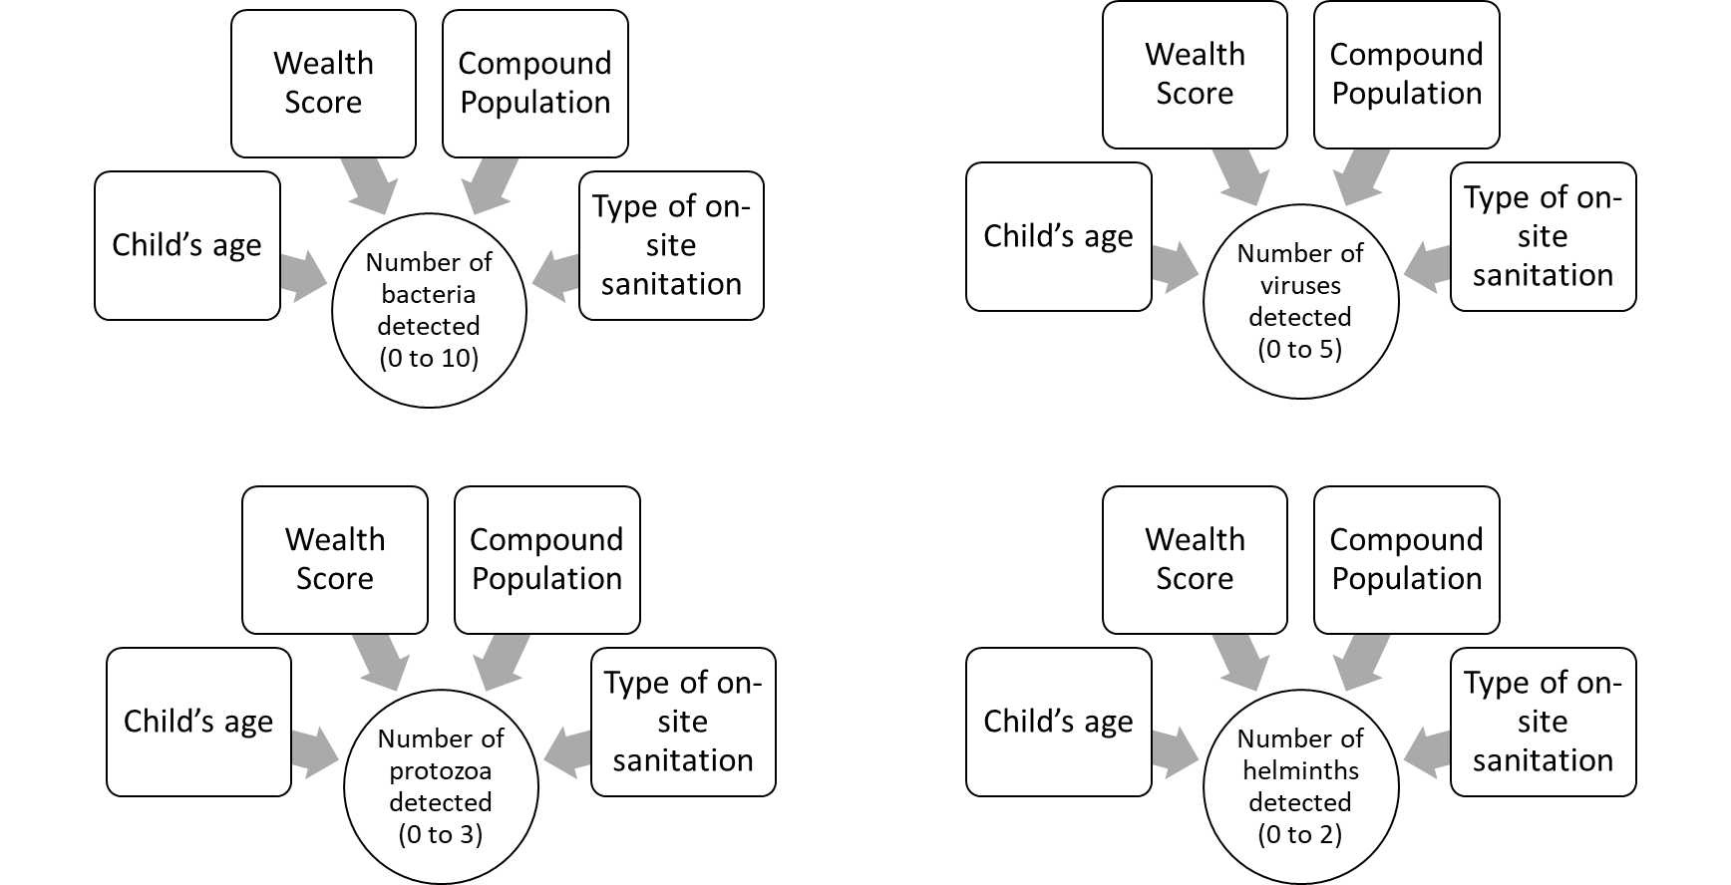
Figure S2. Directed acyclic graphs representing GLMs with the number of pathogenic bacteria, viruses, protozoa, or STHs detected in stools as the response variable

Pathogens detected in fecal sludges
For pathogens detected in fecal sludges, we a priori decided to adjust our models for variables with strong plausibility as risk factors for enteric pathogen detection in fecal sludges. We included the full model to assess each exposure variable compared to the reference: a one-quartile increase in wealth score, a 10-person increase in compound population, and pour flush to septic tank sanitation systems versus pit latrines. Further, we included the log₁₀ transformed fecal sludges solids content of each sample as an additional covariate in adjusted models. We obtained data for variables (type of on-site sanitation system, wealth score, compound population) from the MapSan 24-month follow-up dataset and our experimental data (fecal sludge solids content).
We developed directed acyclic graphs to represent our models. We fit models using the sum of the number of pathogenic bacteria (from 0 to 10), viruses (from 0 to 5), protozoa (from 0 to 3), or helminths (from 0 to 2) as the response variables.

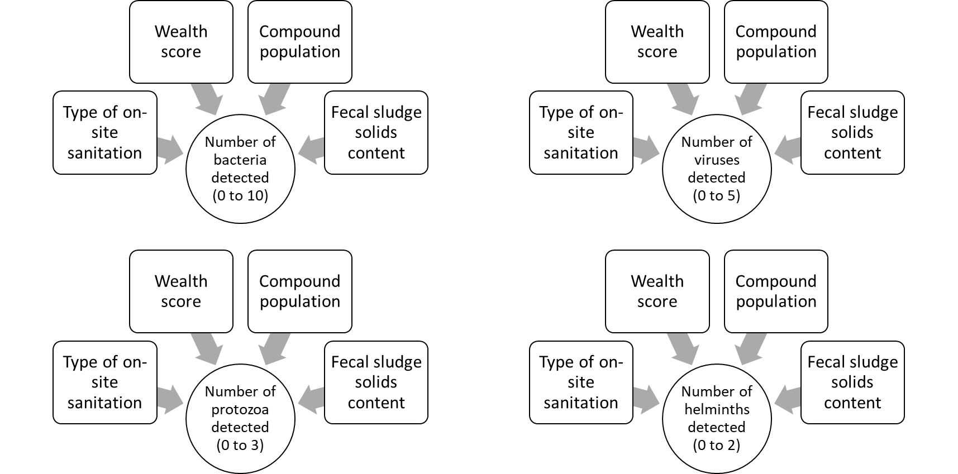
Figure S3. Directed acyclic graphs representing GLMs with the number of pathogenic bacteria, viruses, protozoa, or STHs detected in sludges as the response variable

Table S4. Summary of pathogens in stools and sludges
# of pathogens on TAC |  | Prevalence (95% CI) |  | Mean number detected (95% CI)
 |  | Stool (n=95) | Sludge (n=95) | Stool (n=95) | Sludge (n=95)
10 | Bacteria | 96% (92%, 100%) | 95% (90%, 99%) | 2.1 (1.9, 2.3) | 2.9 (2.6, 3.2)
5 | Viruses | 28% (19%, 38%) | 91% (95%, 96%) | 0.36 (0.23, 0.49) | 2.2 (2.0, 2.5)
3 | Protozoa | 68% (59%, 78%) | 88% (82%, 95%) | 0.77 (0.65, 0.89) | 1.2 (1.1, 1.4)
2 | STHs | 53% (43%, 63%) | 95% (90%, 99%) | 0.74 (0.58, 0.90) | 1.5 (1.4, 1.7)
20 | All | 99% (97%, 100%) | 99% (97%, 100%) | 3.9 (3.6, 4.3) | 7.9 (7.4, 8.4)

Table S5. Average Cq values
Target | Sludge |  | Stool
Bacteria | Average Cq | Standard Deviation | Average Cq | Standard Deviation
Campylobacter coli | 32 | 2.4 | 26 | 9.3
Campylobacter jejuni | 33 | NA | 24 | 4.8
Clostridium difficile (tcdA) | 33 | 1.8 | 33 | 1.2
Clostridium difficile (tcdB) | 33 | 3.3 | 32 | 1.8
EIEC / Shigella (ipaH) | 31 | 2.9 | 25 | 4.4
EAEC (aaiC) | 29 | 4.1 | 25 | 6.5
EAEC (aatA) | 29 | 3.9 | 25 | 6.7
EPEC (bfpA) | 31 | 2.2 | 29 | 4.3
EPEC (eae) | 31 | 4.1 | 30 | 5
ETEC-LT | 36 | 3.3 | 34 | 5.3
ETEC-ST | 32 | 3.6 | 28 | 6.8
Salmonella spp. | 36 | 2.3 | 36 | 2.7
Shiga-like toxin 1 (stx1) | 33 | 3.2 | 34 | 4.7
Shiga-like toxin 2 (stx2) | 29 | 4.1 | 29 | 1.7
Vibrio cholerae | 34 | NA | 36 | 3.4
Yersinia spp. | 34 | 2 | NA | NA
Viruses
Adenovirus 40/41 | 30 | 3.3 | 26 | 8.1
Astrovirus | 30 | 3.4 | 33 | 2.4
Norovirus GI | 33 | 3.3 | 27 | 7.3
Norovirus GII | 32 | 4.1 | 28 | 7.6
Rotavirus A | 32 | 5.3 | 32 | NA
Sapovirus I/II/IV | 30 | 3.5 | 27 | 4.5
Sapovirus V | 33 | 1.9 | 33 | 1.8
Protozoa
Cryptosporidium parvum | 36 | 1.8 | 35 | 3.3
Entamoeba histolytica | 29 | 4 | 25 | NA
Giardia duodenalis | 29 | 3.7 | 24 | 5.9
Helminth
Ascaris lumbricoides | 29 | 4.1 | 25 | 3.1
Trichuris trichiuria | 30 | 2.5 | 26 | 3.1
Note: EAEC: Enteroaggregative E. coli. EIEC: Enteroinvasive E. coli. ETEC: Enterotoxigenic E. coli. EPEC: Enteropathogenic E. coli. Cq: quantification cycle.

Table S6. Associations between variables and the number of detected pathogenic bacteria, viruses, protozoa, or STHs in stools and sludges.
Stool
 |  | Bacteria |  | Viruses |  | Protozoa |  | STHs
Mean number detected (95% CI) |  | 2.1 (1.9, 2.3) |  | 0.36 (0.23, 0.49) |  | 0.77 (0.65, 0.89) |  | 0.74 (0.58, 0.90)
Exposure | Reference | PR (95% CI) | aPR* (95% CI) | PR (95% CI) | aPR* (95% CI) | PR (95% CI) | aPR* (95% CI) | PR (95% CI) | aPR* (95% CI)
Age (24-47 months) | 1-23 months | 1.2 (0.84, 1.8) | 1.2 (0.82, 1.7) | 0.39 (0.16, 0.90) | 0.41 (0.17, 0.97) | 1.8 (0.99, 3.4) | 1.9 (1.0, 3.6) | 3.8 (1.5, 9.4) | 4.2 (1.7, 10)
Age (48-82 months) | 1-23 months | 1.3 (0.87, 1.9) | 1.2 (0.82, 1.7) | 0.17 (0.05, 0.57) | 0.16 (0.05, 0.54) | 1.2 (0.63, 2.4) | 1.3 (0.66, 2.6) | 4.3 (1.8, 11) | 4.3 (1.8, 10)
Wealth score | 1-quartile increase | 0.94 (0.83, 1.1) | 0.95 (0.84, 1.1) | 1.2 (0.89, 1.6) | 1.1 (0.83, 1.5) | 0.98 (0.80, 1.2) | 0.98 (0.79, 1.2) | 0.96 (0.78, 1.2) | 0.98 (0.79, 1.2)
Compound population | 10-person increase | 1.1 (0.95, 1.4) | 1.1 (0.93, 1.4) | 0.83 (0.48, 1.3) | 0.95 (0.53, 1.7) | 1.1 (0.78, 1.5) | 0.99 (0.71, 1.4) | 0.99 (0.70, 1.4) | 0.91 (0.64, 1.3)
Onsite sanitation: pour-flush to septic tank system | Pit latrine | 0.90 (0.68, 1.2) | 0.86 (0.64, 1.2) | 1.2 (0.60, 2.4) | 1.1 (0.51, 2.2) | 1.1 (0.71, 1.8) | 1.1 (0.69, 1.8) | 0.78 (0.49, 1.2) | 0.89 (0.54, 1.4)
Sludge
 |  | Bacteria |  | Viruses |  | Protozoa |  | STHs
Mean number detected (95% CI) |  | 2.9 (2.6, 3.2) |  | 2.2 (2.0, 2.5) |  | 1.2 (1.1, 1.4) |  | 1.5 (1.4, 1.7)
Exposure | Reference | PR (95% CI) | aPR† (95% CI) | PR (95% CI) | aPR† (95% CI) | PR (95% CI) | aPR† (95% CI) | PR (95% CI) | aPR† (95% CI)
Wealth score | 1-quartile increase | 1.0 (0.91, 1.1) | 1.0 (0.91, 1.1) | 0.98 (0.87, 1.1) | 1.0 (0.89, 1.1) | 0.99 (0.85, 1.2) | 1.0 (0.86, 1.2) | 0.95 (0.83, 1.1) | 0.96 (0.83, 1.1)
Compound population | 10-person increase | 1.0 (0.85, 1.2) | 1.1 (0.94, 1.3) | 1.2 (1.0, 1.4) | 1.2 (0.97, 1.4) | 1.1 (0.88, 1.5) | 1.1 (0.85, 1.4) | 0.97 (0.77, 1.2) | 0.95 (0.75, 1.2)
Onsite sanitation: pour- flush to septic tank system | Pit latrine | 0.62 (0.49, 0.78) | 0.66 (0.50, 0.86) | 1.4 (1.1, 1.9) | 1.3 (0.96, 1.8) | 1.2 (0.84, 1.8) | 1.2 (0.78, 1.8) | 1.1 (0.81, 1.6) | 1.2 (0.85, 1.8)
Fecal sludge solids content (mass dry solids / mass wet sludge) | Log₁₀ increase | 1.7 (1.2, 2.4) | 1.4 (0.97, 2.1) | 0.72 (0.49, 1.1) | 0.88 (0.57, 1.3) | 0.87 (0.52, 1.4) | 0.98 (0.55, 1.7) | 1.2 (0.76, 1.9) | 1.3 (0.79, 2.2)
Note: Bold indicates p≤0.05 following false discovery rate correction for multiple comparisons across taxa. PR: prevalence ratio. aPR: adjusted prevalence ratio. STH: soil transmitted helminth. CI: confidence interval
*The full model was run for each taxa, which included children’s age, wealth score, compound population, and sanitation system for a total of 4 stool models
†The full model was run for each taxa, which included wealth score, compound population, sanitation system, and the log₁₀ transformed fecal sludge solids content for a total of 4 sludge models
Table S7. Pathogen detection data disaggregated by sanitation infrastructure (septic tanks and latrines).
 | Septic Tanks |  |  | Pit Latrines (with or without a slab)
 | Stool (n = 52) | Jaccard similarity coefficient (intersection / union) | Sludge (n = 52) | Stool (n=43) | Jaccard similarity coefficient  (intersection / union) | Sludge (n=43)
Bacteria
EAEC | 62% (48%, 75%) | 57% (25/44) | 71% (59%, 84%) | 74% (61%, 88%) | 74% (31/42) | 95% (89%, 100%)
Shigella/EIES | 46% (32%, 60%) | 37% (15/41) | 62% (48%, 75%) | 56% (41%, 71%) | 52% (22/42) | 93% (85%, 100%)
ETEC (ST/LT) | 37% (23%, 50%) | 35% (11/31) | 44% (31%, 58%) | 37% (23%, 52%) | 31% (11/35) | 70% (56%, 84%)
EPEC | 33% (20%, 46%) | 11% (3/27) | 25% (13%, 37%) | 33% (18%, 47%) | 27% (8/30) | 56% (41%, 71%)
Salmonella | 9.6% (1.5%, 18%) | 0% (0/10) | 9.6% (1.5%, 18%) | 2.3% (0%, 6.9%) | 0% (0/4) | 7.0% (0%, 15%)
Campylobacter jejuni/coli | 5.8% (0%, 12%) | 0% (0/5) | 3.8% (0%, 9.1%) | 4.7% (0%, 11%) | 0% (0/4) | 4.7% (0%, 11%)
STEC (stx1/stx2) | 3.8% (0%, 9.1%) | 0% (0/3) | 1.9% (0%, 5.7%) | 9.3% (0.52%, 18%) | 0% (0/17) | 30% (16%, 44%)
C. difficile | 1.9% (0%, 5.7%) | 0% (0/3) | 3.8% (0%, 9.1%) | 4.7% (0%, 11%) | 0% (0/7) | 12% (1.9%, 21%)
Vibrio Cholerae | 0% | 0% (0/1) | 1.9% (0%, 5.7%) | 0% | NA | 0% (0%, 0%)
Yersinia spp. | 0% | 0% (0/2) | 3.8% (0%, 9.1%) | 0% | NA | 0% (0%, 0%)
Viruses
Sapovirus I/II/IV/V | 13% (4.1%, 23%) | 13% (4/30) | 52% (38%, 66%) | 9.3% (0.52%, 18%) | 22% (4/18) | 42% (27%, 57%)
Astrovirus | 9.6% (1.5%, 18%) | 10% (4/40) | 75% (63%, 87%) | 7.0% (0%, 15%) | 9.1% (2/22) | 49% (34%, 64%)
Norovirus GI/GII | 9.6% (1.5%, 18%) | 8.8% (3/34) | 62% (48%, 75%) | 12% (1.9%, 21%) | 7.7% (2/26) | 53% (38%, 69%)
Adenovirus 40/41 | 3.8% (0%, 9.1%) | 6.9% (2/29) | 56% (42%, 69%) | 4.7% (0%, 11%) | 7.1% (1/14) | 30% (16%, 44%)
Rotavirus A | 1.9% (0%, 5.7%) | 17% (1/6) | 12% (2.8%, 20%) | 0% | 0% (0/2) | 4.7% (0%, 11%)
Protozoa
Giardia duodenalis | 65% (52%, 78%) | 62% (31/50) | 89% (82%, 98%) | 63% (48%, 77%) | 63% (24/38) | 81% (70%, 93%)
Cryptosporidium parvum | 13% (4.1%, 23%) | 9.1% (2/22) | 33% (20%, 46%) | 9.3% (0.52%, 18%) | 11% (1/9) | 14% (3.5%, 24%)
Entamoeba histolytica | 1.9% (0%, 5.7%) | 20% (1/5) | 9.6% (1.5%, 18%) | 0% (0%, 0%) | 0% (0/6) | 14% (3.5%, 24%)
Helminths
Trichuris trichuria | 37% (23%, 50%) | 44% (17/39) | 71% (59%, 84%) | 49% (34%, 64%) | 39% (13/33) | 58% (43%, 73%)
Ascaris lumbricoides | 29% (16%, 41%) | 29% (14/48) | 90% (82%, 98%) | 35% (20%, 49%) | 33% (13/39) | 86% (76%, 97%)
Note: Bold indicates same rank order of detection in stools and sludges

