Supplemental Materials
Associations of a Toenail Metal Mixture with Attention and Memory in the Gulf Long-term Follow-up (GuLF) Study
Joyce J.Y. Lin^{1*}, Jordan R. Kuiper², Aisha S. Dickerson³, Jessie P. Buckley⁴, Heather E. Volk⁵, Diane S. Rohlman⁶, Kaitlyn G. Lawrence⁷, W. Braxton Jackson II⁸, Dale P. Sandler⁷, Lawrence S. Engel^{4,7}, Ana M. Rule¹
¹Department of Environmental Health and Engineering, Johns Hopkins Bloomberg School of Public Health, Baltimore, MD, USA. ²Department of Environmental and Occupational Health, The George Washington University Milken Institute School of Public Health, Washington, DC, USA.³ Department of Epidemiology, Johns Hopkins Bloomberg School of Public Health, Baltimore, MD, USA. ⁴ Department of Epidemiology, University of North Carolina Gillings School of Global Public Health, Chapel Hill, NC, USA. ⁵Depmartment of Mental Health, Johns Hopkins Bloomberg School of Public Health, Baltimore, MD, USA. ⁶ Department of Occupational and Environmental Health, University of Iowa College of Public Health, Iowa City, IA, USA. ⁷Epidemiology Branch, National Institute of Environmental Health Sciences, National Institutes of Health, Research Triangle Park, NC, USA. ⁸Social & Scientific Systems, Inc., Durham, NC, USA.

Contents
Supplemental Table 1. Participant characteristics in this study vs overall GuLF cohort
Supplemental Table 2. Limits of detection (LOD) and summary measures for toenail metal concentrations
Supplemental Table 3. Difference in performance for each neurobehavioral test with a difference in log10-transformed concentration of each metal from the 25th to 75th percentile adjusted for covariates
Supplemental Table 4. Summary of effect estimates across sensitivity analyses

Supplemental Figure 1. Conceptual Framework
Supplemental Figure 2. Distribution of results for attention and memory measures by race.
Supplemental Figure 3. Correlation of toenail metal concentrations
Supplemental Figure 4. Stratified results by race and education
Supplemental Figure 5a. Exposure–response functions for each metal at varying levels (25th, 50th, 75th percentile) of another metal, when other co-occurring metals are set at their median for CPT D Prime score
Supplemental Figure 5b. Zoom in exposure-response functions of Cu x Cr, Hg x Cr, and Mn x Cr which exhibit weak suggestive evidence of interaction for CPT D Prime score
Supplemental Figure 5c. Exposure–response functions for each metal at varying levels (25th, 50th, 75th percentile) of another metal, when other co-occurring metals are set at their median for DST Reverse Count
Supplemental Figure 6a. Race-specific results for univariate relationship between toenail metals and CPT D Prime score modelled with Bayesian kernel machine regression
Supplemental Figure 6b. Race-specific results for univariate relationship between toenail metals and DST Reverse Count score modelled with Bayesian kernel machine regression
Supplemental Figure 7. Differences in toenail metal concentrations Black vs White participants
Supplemental Figure 8. Distribution of metal concentrations by race

Supplemental Table 1. Participant characteristics in present study vs overall GuLF cohort
 | This study  (n = 413) | Kidney and Liver Injury study participants (n = 667) | Eligible participants at CE (n = 2,652)
Age (years), n (%)
20 - 39 | 120 (29.1) | 210 (31.5) | 679 (25.6)
40 - 59 | 222 (53.8) | 360 (53.9) | 1382 (52.1)
60 - 69 | 71 (17.2) | 97 (14.5) | 439 (16.6)
70 + | 0 (0) | 0 (0) | 152 (5.7)
Race, n (%)
Black | 191 (46) | 295 (44.2) | 984 (37.1)
White | 190 (46) | 324 (48.6) | 1439 (54.3)
Other | 32 (8) | 48 (7.2) | 223 (8.5)
Smoking History, n (%)
Current | 0 (0) | 236 (35.4) | 879 (33.1)
Former | 139 (33.7) | 142 (21.3) | 626 (23.6)
Never | 274 (66.3) | 286 (42.9) | 1138 (42.9)
Missing | 0 (0) | 3 (0.4) | 9 (0.4)
Educational Attainment, n (%)
< High school | 72 (17.4) | 151 (22.6) | 557 (21.0)
High school | 145 (35.1) | 257 (38.5) | 902 (34.0)
Some college | 132 (32.0) | 182 (27.3) | 793 (29.9)
College or more | 64 (15.5) | 77 (11.5) | 398 (15.0)
Missing | 0 (0) | 0 (0) | 2 (0)
Marital Status, n (%)
Married/living together | 228 (55.2) | 347 (52.0) | 1377 (51.9)
Widowed/separated | 78 (18.9) | 132 (19.8) | 636 (24.0)
Never married | 106 (25.7) | 187 (28.0) | 633 (23.9)
Missing | 1 (0.2) | 1 (0.2) | 6 (0.2)
BMI, n (%)
Underweight | 3 (0.7) | 5 (0.7) | 19 (0.7)
Healthy | 74 (17.9) | 150 (22.5) | 589 (22.2)
Overweight | 137 (33.2) | 293 (43.9) | 836 (31.5)
Obese | 199 (48.2) | 205 (30.7) | 1148 (43.3)
Missing | 0 (0) | 14 (2.1) | 60 (2.3)

Supplemental Table 2. Limits of detection (LOD) and summary measures for toenail metal concentrations
Metal | LODª  (µg/g) | Percent detection | Geometric Mean (GSD) (µg/g) | Median (25th–75th percentile)
Arsenic | 0.0003 | 87 | 0.019 (14) | 0.039 (0.015, 0.078)
Chromium | 0.002 | 93 | 0.11 (7.5) | 0.15 (0.042, 0.37)
Copper | 0.003 | 99 | 3.2 (2.4) | 3.13 (2.46, 4.07)
Lead | 0.0003 | 94 | 0.091 (9.3) | 0.13 (0.045, 0.33)
Manganese | 0.0003 | 98 | 0.30 (6.1) | 0.36 (0.15, 0.79)
Mercury | 0.0006 | 94 | 0.13 (6.3) | 0.18 (0.071, 0.39)
Selenium | 0.0005 | 99 | 0.68 (2.4) | 0.74 (0.65, 0.83)
Zinc | 0.007 | 99 | 89 (3.1) | 98 (82, 116)
ªLOD varied by batch - average LOD across batches is shown

Supplemental Table 3. Difference in performance for each neurobehavioral test with a difference in log10-transformed concentration of each metal from the 25th to 75th percentile adjusted for covariates. Models adjusted for age, BMI, education level, smoking history, and marital status
Metal | Model | CPT D Prime  Estimate (95 % CI) | CPT Hit Fraction †  Estimate (95 % CI) | CPT Correct Response Fraction †  Estimate (95 % CI) | DST Reverse Count  Estimate (95 % CI)
As | Full | 0.01 (-0.06, 0.08) | -0.03 (-0.38, 0.29) | -0.28 (-1.08, 0.32) | -0.01 (-0.12, 0.11)
 | White | 0.01 (-0.08, 0.11) | -0.27 (-2.00, 0.73) | -0.93 (-6.17, 1.26) | -0.03 (-0.23, 0.18)
 | Black | -0.04 (-0.14, 0.06) | -0.29 (-0.89, 0.19) | -0.36 (-1.32, 0.37) | -0.05 (-0.19, 0.09)
Cr | Full | -0.19 (-0.31, -0.07)** | -0.97 (-1.62, -0.38)** | -0.33 (-1.26, 0.49) | -0.07 (-0.26, 0.13)
 | White | -0.09 (-0.24, 0.05) | -0.71 (-2.21, 0.51) | 0.68 (-1.76, 3.52) | -0.09 (-0.40, 0.22)
 | Black | -0.22 (-0.41, -0.04)** | -1.29 (-2.27, -0.43)** | -0.54 (-1.95, 0.58) | -0.02 (-0.28, 0.25)
Cu | Full | 0.093 (-0.01, 0.19)* | 0.01 (-0.33, 0.39) | 1.31 (0.38, 2.50)** | 0.20 (0.03, 0.36)**
 | White | 0.16 (0.03, 0.28)** | 0.90 (-0.05, 2.28) | 0.34 (-0.83, 3.15) | 0.29 (0.02, 0.56)**
 | Black | -0.05 (-0.20, 0.11) | -0.30 (-0.89, 0.23) | 1.21 (0.035, 3.00) | 0.08 (-0.14, 0.31)
Hg | Full | 0.03 (-0.08, 0.13) | -0.05 (-0.47, 0.33) | -0.42 (-1.30, 0.31) | -0.05 (-0.21, 0.12)
 | White | 0.03 (-0.09, 0.15) | -0.43 (-1.53, 0.39) | -2.45 (-8.75, 0.42) | -0.13 (-0.39, 0.12)
 | Black | -0.06 (-0.22, 0.11) | -0.35 (-1.05, 0.19) | -0.42 (-1.37, 0.31) | -0.02 (-0.26, 0.21)
Mn | Full | -0.02 (-0.15, 0.11) | 0.23 (-0.32, 0.75) | -0.83 (-1.87, 0.17) | -0.19 (-0.41, 0.01)*
 | White | 0.001 (-0.18, 0.18) | -0.78 (-2.35, 0.63) | -0.33 (-3.77, 3.30) | -0.30 (-0.69, 0.08)
 | Black | -0.14 (-0.34, 0.06) | 0.12 (-0.81, 0.84) | -1.08 (-2.67, 2.54) | -0.32 (-0.61, -0.04)**
Pb | Full | -0.002 (-0.11, 0.10) | -0.03 (-0.49, 0.38) | -0.64 (-1.73, 0.25) | 0.08 (-0.09, 0.25)
 | White | -0.09 (-0.22, 0.04) | -0.30 (-2.11, 1.00) | 0.022 (-3.74, 2.56) | 0.17 (-0.12, 0.45)
 | Black | 0.06 (-0.10, 0.22) | 0.15 (-0.39, 0.67) | -0.86 (-2.15, 0.16) | 0.11 (-0.11, 0.34)
Se | Full | -0.02 (-0.09, 0.05) | -0.13 (-0.45, 0.17) | -0.33 (-0.84, 0.25) | 0.03 (-0.09, 0.14)
 | White | -0.03 (-0.13, 0.06) | -0.15 (-0.94, 0.84) | -0.13 (-1.59, 1.29) | 0.0001 (-0.20, 0.20)
 | Black | -0.09 (-0.19, 0.02)* | -0.55 (-1.17, -0.02)* | -0.64 (-1.57, 0.14) | 0.05 (-0.09, 0.20)
Zn | Full | 0.02 (-0.07, 0.11) | 0.27 (-0.09, 0.64) | 0.03 (-0.62, 0.62) | -0.07 (-0.21, 0.07)
 | White | 0.01 (-0.14, 0.17) | 0.003 (-1.41, 1.23) | -0.22 (-2.72, 1.59) | 0.23 (-0.10, 0.55)
 | Black | 0.17 (0.04, 0.30)** | 0.90 (0.29, 1.63)** | 0.46 (-0.36, 1.38) | -0.06 (-0.24, 0.13)
†Log odds, dichotomous outcome
Lower scores indicate poorer performance. GLM estimates were calculated by scaling the regression coefficients by interquartile range.
**= p<0.05. *= orange p<0.10.
Supplemental Table 4. Summary of effect estimates across sensitivity analyses 1) removing the 99th percentile of toenail Cr and Mn concentrations, and 2) additionally adjusting for state of
participation.
 |  | Primary analysis | Outliers removed | Adjustment for state
CPT D Prime
Cr | Full | -0.19 (-0.31, -0.07) | -0.21 (-0.34, -0.09) | -0.22 (-0.34, -0.09)
 | White | -0.09 (-0.24, 0.05) | -0.09 (-0.26, 0.06) | -0.11 (-0.27, 0.05)
 | Black | -0.22 (-0.41, -0.04) | -0.24 (-0.43, -0.04) | -0.29 (-0.48, -0.09)
DST Reverse Count
Mn | Full | -0.19 (-0.41, 0.01) | -0.27 (-0.57, 0.01) | -0.27 (-0.56, 0.02)
 | White | -0.30 (-0.69, 0.08) | -0.41 (-0.95, 0.13) | -0.43 (-0.97, 0.11)
 | Black | -0.32 (-0.61, -0.04) | -0.44 (-0.84, -0.05) | -0.42 (-0.82, -0.02)

Effects observed in primary analyses are robust to the exclusion of influential metal concentrations and additional adjustment for state of participation. The magnitude of the effect for Mn and DST Reverse Count is increased after outlier removal and additional adjustment for state.

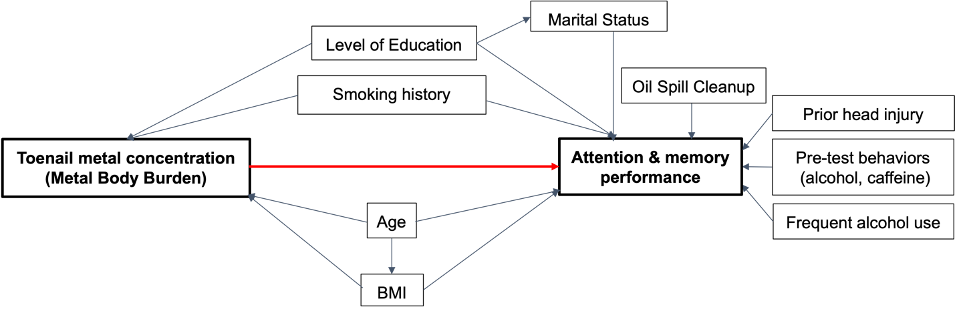
Supplemental Figure 1. Conceptual Framework
Age (continuous). Body mass index (BMI, continuous). Level of education (continuous, years). Smoking history (former, never). Marital status (Single/divorced/widowed, married/living with partner). (Oil Spill Cleanup assessed using total average cumulative total hydrocarbon (THC) exposure as proxy of oil spill cleanup intensity and duration. Prior head injury (self-reported: yes, no). Pre-test alcohol/caffeine use within 2h of neurobehavioral exam (yes, no). Frequent alcohol use defined as >14 drinks per week.

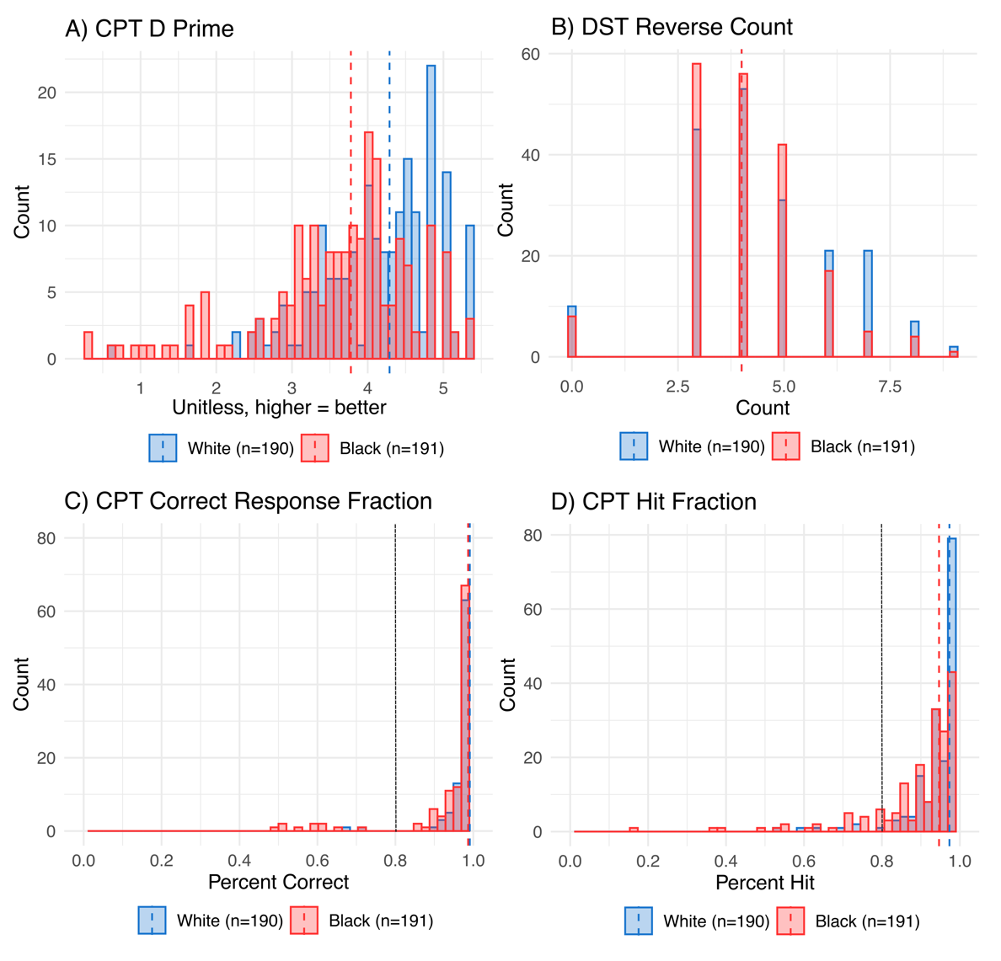
Supplemental Figure 2. Distribution of results for attention and memory measures by race. Red dashed line indicates median score among Black participants. Blue dashed line indicates median score among White participants. Black dashed line at 80% in both indicates cutoff point for dichotomization.

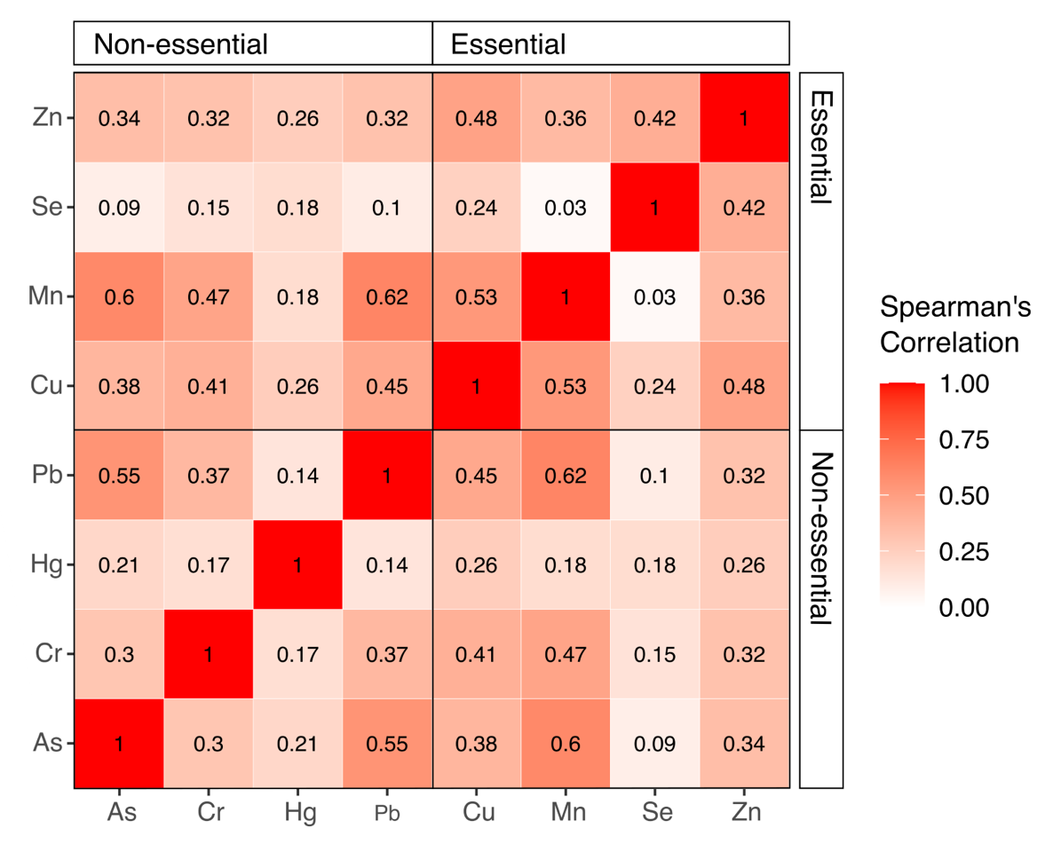
Supplemental Figure 3. Correlation of toenail metal concentrations.

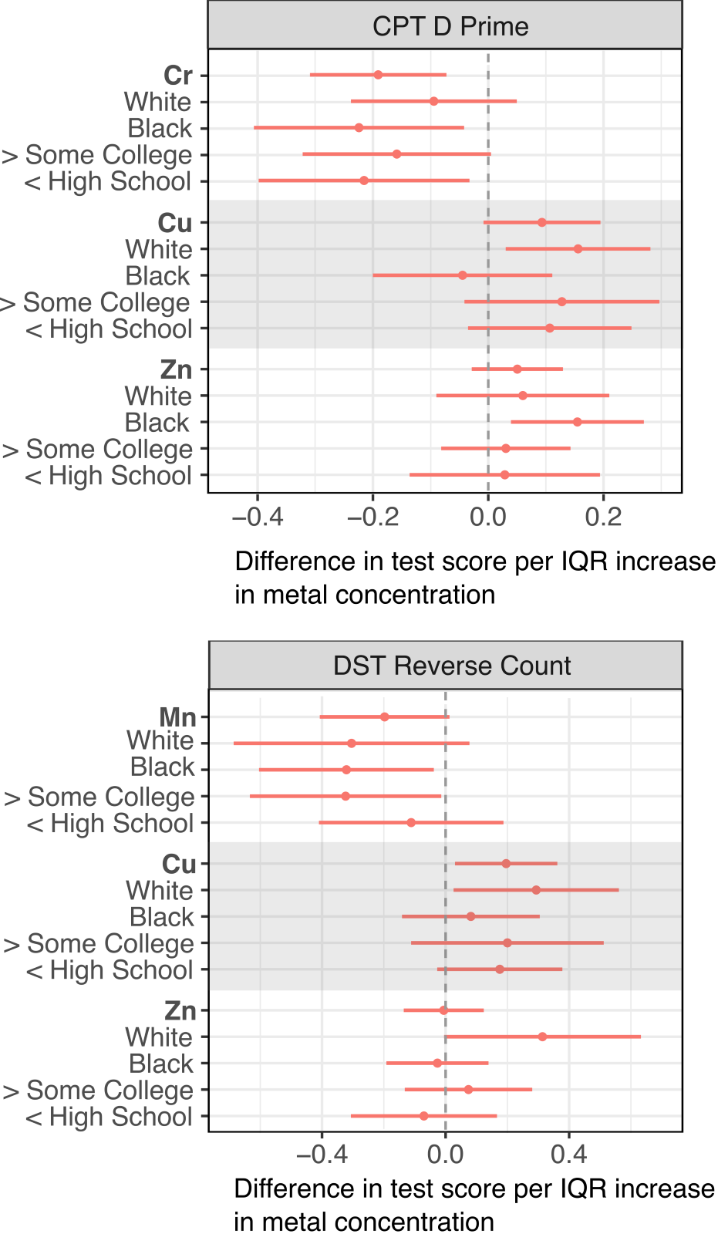
Supplemental Figure 4. Comparisons of education stratified results with race stratified results for Mn, Cu, and Zn for CPT D Prime and DST Reverse Count. Models adjusted for age, BMI, education level, smoking history, and marital status. Total (n = 413), White (n=190), Black (n=191), > Some College (n=196), <High School (n=217).

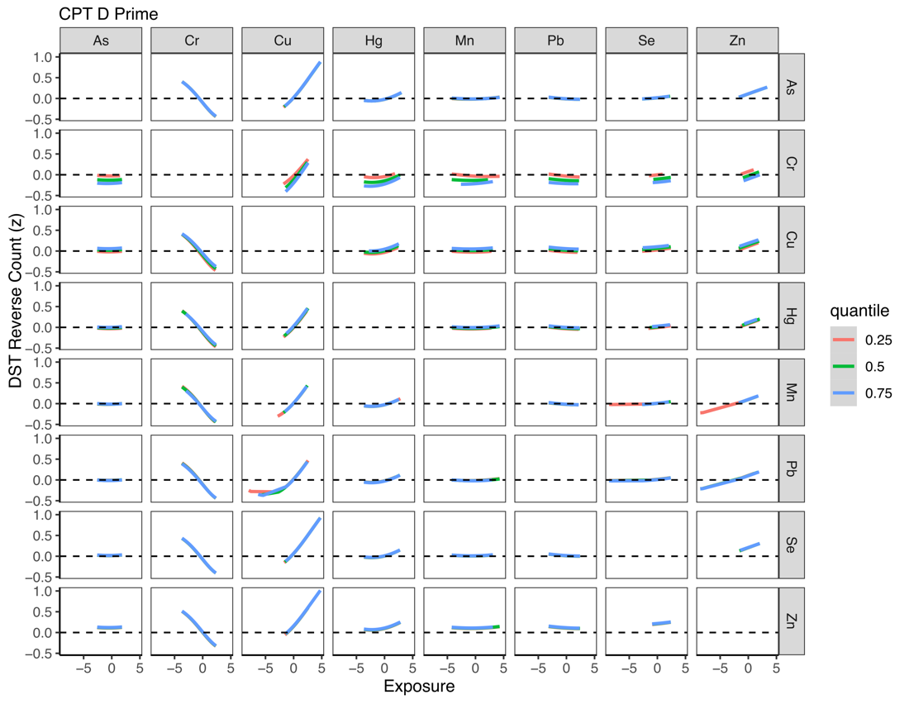
Supplemental Figure 5a. Exposure–response functions for each metal at varying levels (25th, 50th, 75th percentile) of another metal, when other co-occurring metals are set at their median for CPT D Prime score.

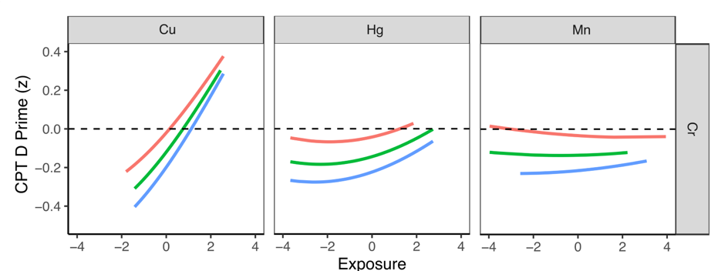
Supplemental Figure 5b. Zoom in exposure-response functions of Cu x Cr, Hg x Cr, and Mn x Cr which exhibit weak suggestive evidence of interaction for CPT D Prime score.

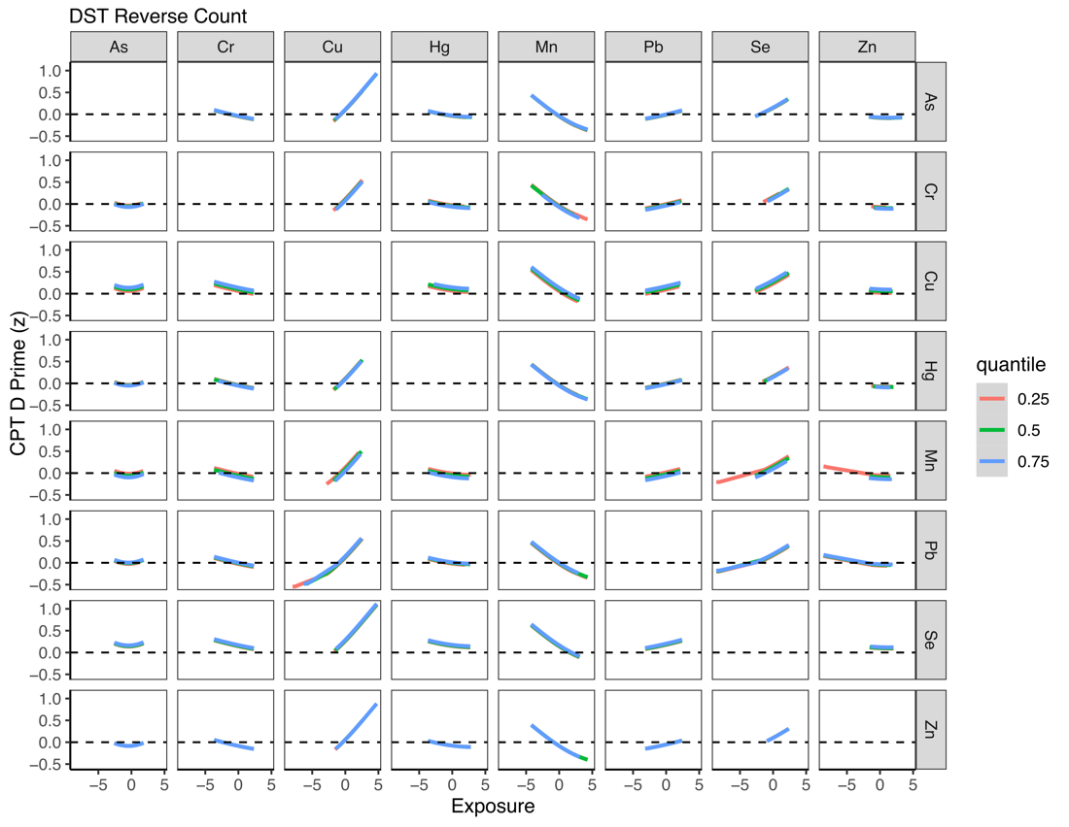
Supplemental Figure 5c. Exposure–response functions for each metal at varying levels (25th, 50th, 75th percentile) of another metal, when other co-occurring metals are set at their median for DST Reverse Count.

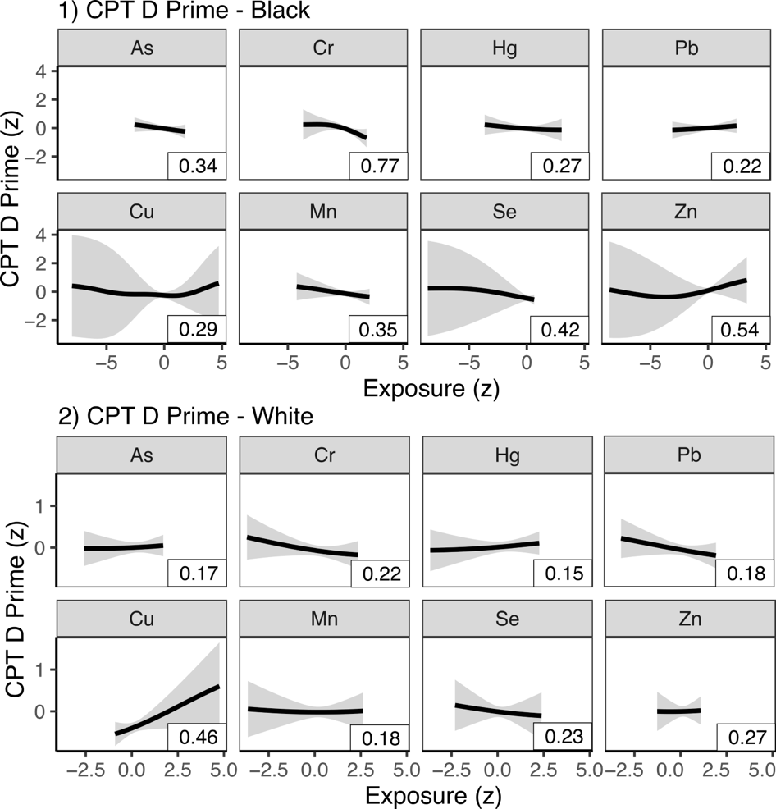
Supplemental Figure 6a. Race-specific results for univariate relationship between toenail metals and CPT D Prime score modelled with Bayesian kernel machine regression (five parallel chains, each with 40,000 iterations and default priors) 1) Black only and 2) White only. Outcomes have been standardized. Exposures have been log10-transformed and standardized. Models included all 8 metals while adjusting for age, BMI, education level, smoking history, and marital status. Posterior inclusion probabilities (PIPs) are denoted in boxes on the bottom right corner of each plot.

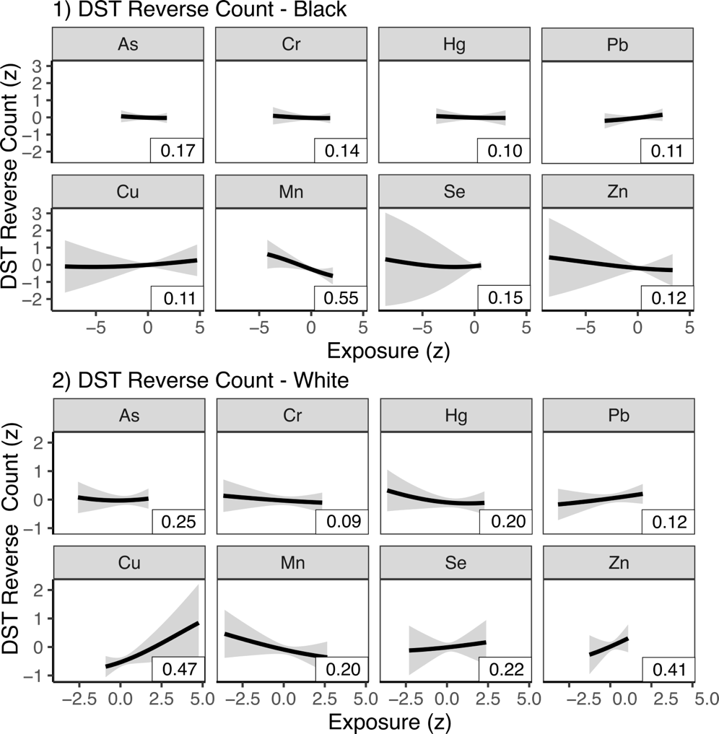
Supplemental Figure 6b. Race-specific results for univariate relationship between toenail metals and DST Reverse Count score modelled with Bayesian kernel machine regression (five parallel chains, each with 40,000 iterations and default priors) 1) Black only and 2) White only. Outcomes have been standardized. Exposures have been log10-transformed and standardized. Models included all 8 metals while adjusting for age, BMI, education level, smoking history, and marital status. Posterior inclusion probabilities (PIPs) are denoted in boxes on the bottom right corner of each plot.

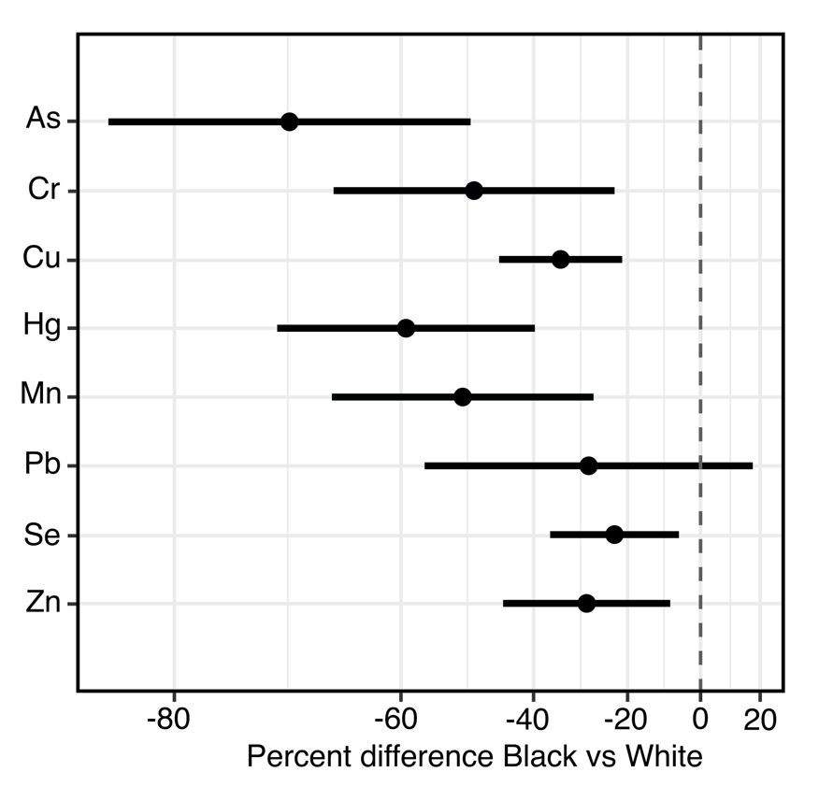
Supplemental Figure 7. Differences in toenail metal concentrations Black participants vs White adjusting for age, BMI, smoking history, passive smoke exposure, state of residence, oil spill cleanup exposure

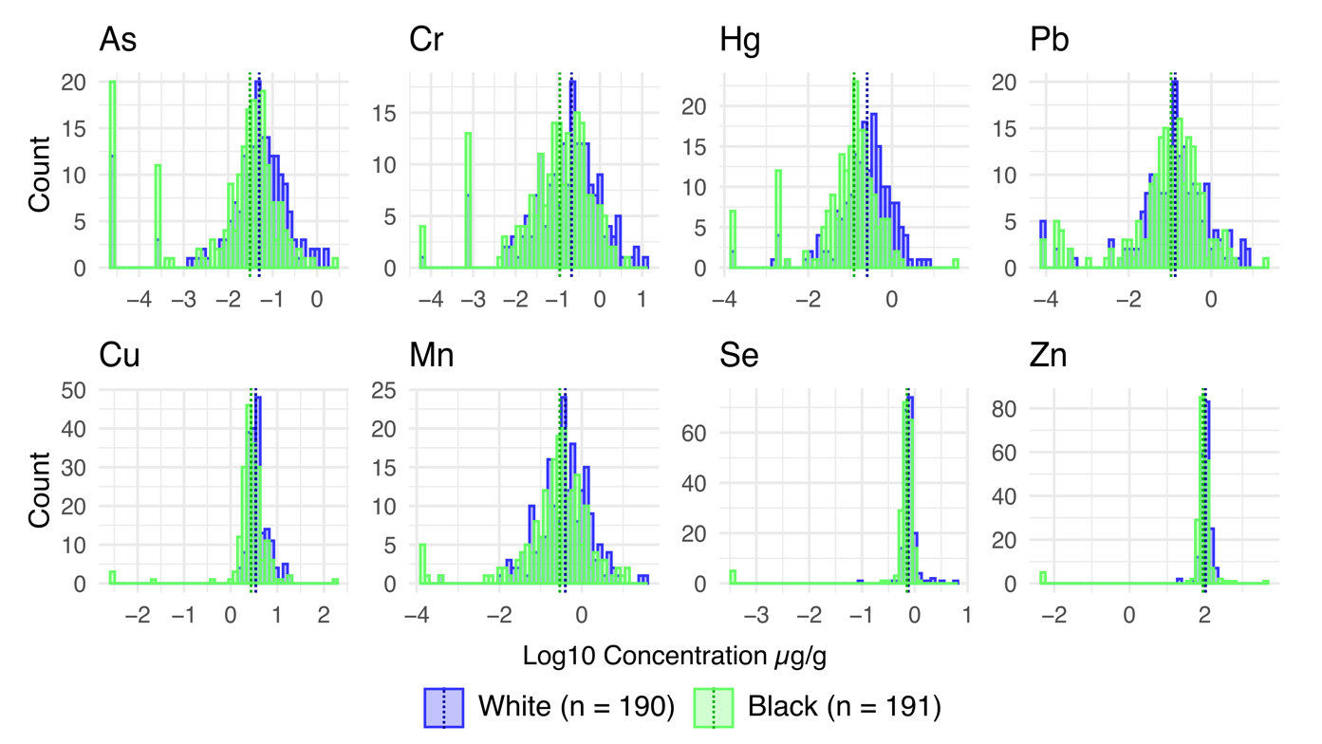
Supplemental Figure 8. Distribution of metal concentrations by race. Dotted lines indicate median concentrations with blue line representing median metal concentration among White participants and green line representing median metal concentration among Black participants.

