Keywords for filtering notes with social determinants of health (SDoH)
'discharge summary', 'social worker', 'social history', 'income', 'employment', 'unemployment', 'financial', 'education', 'house', 'housing', 'crime', 'violence', 'physical activity', 'neighborhood', 'neighbourhood', 'community', 'poverty', 'occupation', 'indigence', 'homeless', 'shelter’, 'socioeconomic', 'lives with', 'living with', 'resideswith', 'worked in', 'work as', 'works as', 'working in', 'working at', 'working as', 'employed as', 'employed in', 'retired', 'accompanied by', 'here with', 'disability', 'disabled', 'food insecurity', 'transportation need', 'physical abuse', 'physical activity', 'sexual abuse', 'well developed'

Table S1. Summary of attributes for social determinants of health concepts.
SDoH concept | Attributes
Tobacco_use | Substance_use_status: e.g., current smoker  Smoking_type: type of tobacco use, e,g., cigarettes  Smoking_freq_ppd: pack per day  Smoking_freq_sy: years of smoking  Smoking_freq_py: pack year  Smoking_freq_qy: years of quit smoking  Smoking_other: other information related with tobacco use
Alcohol use | Substance_use_status: e.g., “yes”, “no”  Alcohol_freq: e.g., “25.0 standard drinks of alcohol per week”  Alcohol_type: e.g., “wine”  Alcohol_other: other information related with alcohol use
Drug use | Substance_use_status: e.g., “yes”, “no”, “severe”  Drug_freq: frequency of drug use  Drug_type: e.g., “cocaine”  Drug_other: other inforamtion related with drug use
Sexual activity | Sdoh_status: e.g., “yes”, “never”, “no”  Partner: “female”, “male”  Protection: protections of sexual activity
Marital status | N/A
Education | N/A
Language | N/A
Employment | Occupation: job position, title, specialty, e.g., “in the meat department”  Employment_status: employment status such as “employed”, “unemployed”, “retired”  Employment_location: location of employment, e.g., “works in a lab”
Gender | N/A
Race | N/A
Ethnicity | N/A
Physical activity | Physical_act: physical activity such as “running”, “exercise”  Sdoh_freq: e.g., “7 days per week”  Sdoh_status: e.g., “yes”, “no”, “currently not exercising”
Living condition | Living_Condition: e.g., “homeless”, “shelter”, “live with mom”
Living supply | Living_supply: food and water resource, and other supplies required for living  Sdoh_status: “yes”, “no”, “never”, indicating whether patients have supply issues
Financial constraint | Financial_constrain: descriptions for financial constrain, e.g., “difficulty paying for basics?”  Sdoh_status: “yes”, “no”, “not hard at all”
Abuse | Abuse: general/physical/mental abuse
Transportation | Transportation: “lack of transportation for medical needs?”  Sdoh_status: e.g., “yes”, “no”
Social cohesion | Social_cohesion: Any social activity including person-person or person-organization interactions, e.g., “talks on phone”, “attend religious service”  Sdoh_status: “yes”, “no”, “never”, “sometimes”  Sdoh_freq: e.g., “twice a week”, “2 to 4 times a year”
SDoH ICD | SDoH_ICD: ICD-10 codes appeared in notes associated with SDH (e.g., ICD-10 Z55-Z65)

Table S2. Detailed results for GatorTron to identify social determinants of health concepts and attributes.
 | Strict |  |  | Lenient
 | Prec. | Rec. | F1 | Prec. | Rec. | F1
Race | 0.9091 | 1 | 0.9524 | 0.9091 | 1 | 0.9524
Abuse | 0.9412 | 0.9091 | 0.9249 | 0.9412 | 0.9091 | 0.9249
Gender | 0.933 | 0.9435 | 0.9382 | 0.933 | 0.9435 | 0.9382
Partner | 0.8824 | 0.8824 | 0.8824 | 1 | 1 | 1
Sex_act | 0.9792 | 0.9895 | 0.9843 | 0.9792 | 0.9895 | 0.9843
Drug_use | 0.9808 | 0.9189 | 0.9488 | 0.9808 | 0.9189 | 0.9488
Language | 1 | 1 | 1 | 1 | 1 | 1
Drug_type | 0.8182 | 0.75 | 0.7826 | 0.9091 | 0.8333 | 0.8696
Sdoh_freq | 0.9773 | 1 | 0.9885 | 0.9773 | 1 | 0.9885
Drug_freq | 1 | 1 | 1 | 1 | 1 | 1
Education | 0.9268 | 0.9344 | 0.9306 | 0.9593 | 0.9672 | 0.9633
Ethnicity | 0.875 | 0.875 | 0.875 | 1 | 1 | 1
Occupation | 0.7604 | 0.7849 | 0.7725 | 0.8617 | 0.871 | 0.8663
Drug_other | 0 | 0 | 0 | 1 | 0.3333 | 0.5
Protection | 0.6667 | 0.5 | 0.5714 | 0.6667 | 0.5 | 0.5714
Alcohol_use | 0.9217 | 0.9138 | 0.9177 | 0.9217 | 0.9138 | 0.9177
Tobacco_use | 0.7 | 0.75 | 0.7241 | 0.7 | 0.75 | 0.7241
Sdoh_status | 0.9573 | 0.9515 | 0.9544 | 0.9634 | 0.9576 | 0.9605
Physical_act | 0.9787 | 0.9583 | 0.9684 | 0.9787 | 0.9583 | 0.9684
Alcohol_freq | 0.8103 | 0.7705 | 0.7899 | 1 | 0.918 | 0.9573
Smoking_type | 0.9931 | 0.9863 | 0.9897 | 0.9931 | 0.9863 | 0.9897
Alcohol_other | 0.55 | 0.6471 | 0.5946 | 0.65 | 0.7647 | 0.7027
Living_supply | 0.9652 | 0.9737 | 0.9694 | 0.9652 | 0.9737 | 0.9694
Gender_status | 0.4 | 0.8 | 0.5333 | 0.625 | 1 | 0.7692
Marital_status | 0.9633 | 0.9292 | 0.9459 | 1 | 0.9646 | 0.982
Transportation | 1 | 0.9744 | 0.987 | 1 | 0.9744 | 0.987
Social_cohesion | 0.9889 | 0.978 | 0.9834 | 1 | 0.989 | 0.9945
Smoking_freq_qy | 0.6923 | 0.7714 | 0.7297 | 0.8462 | 0.9429 | 0.8919
Smoking_freq_py | 0.8667 | 0.9286 | 0.8966 | 0.8667 | 0.9286 | 0.8966
Smoking_freq_sy | 0.9804 | 0.9615 | 0.9709 | 0.9804 | 0.9615 | 0.9709
Smoking_freq_ppd | 0.9714 | 0.9855 | 0.9784 | 0.9857 | 1 | 0.9928
Living_condition | 0.5714 | 0.5714 | 0.5714 | 0.7857 | 0.7857 | 0.7857
Employment_status | 0.2 | 0.0833 | 0.1176 | 0.6 | 0.25 | 0.3529
Smoking_freq_other | 0.5 | 0.5714 | 0.5333 | 0.625 | 0.7143 | 0.6667
Financial_constrain | 0.8095 | 0.8947 | 0.85 | 0.8095 | 0.8947 | 0.85
Overall (micro) | 0.9197 | 0.9146 | 0.9172 | 0.9434 | 0.9359 | 0.9396

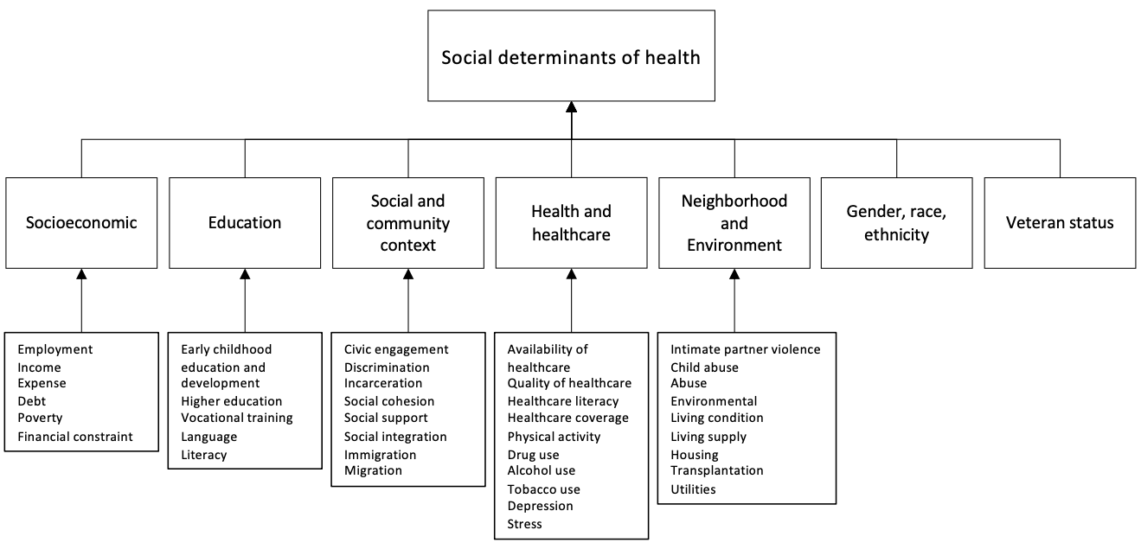

Figure S1. An overview of the 7 social determinants of health classes and 38 subclasses.

