Supplementary Material

Table S1. Distribution of features selected for analysis in SLE and healthy controls, based on matching to chemical names and formulas.

Features | SLE | Controls | P (t-test)
Named-matched features per subject: Mean (Range) | 34 (11-55) | 19 (7-32) | 4.8e-50
Formula matched features per subject: Mean (Range) | 410 (88-563) | 247 (88-379) | 3.9e-42
Unmatched features per subject: Mean (Range) | 657 (63-924) | 348 (78-595) | 2.5e-45
Unadjusted abundances of detected features: Mean (Range) | 32,568 (13,772-62,307) | 22,789 (12,481-35,388) | 7.7e-33

Table S2. Chemical categories of name-matched features between SLE cases and healthy controls. Mean quantification of abundances and detection frequency of features are shown Association analysis with SLE as the outcome, adjusted for sex and age

* Coefficient is the mean difference between cases and controls, adjusted for covariates.

Table S3. Case-control analysis of matched features between SLE participants with a disease duration of 2 years or less and healthy controls

* Coefficient is the mean difference between cases and controls, adjusted for covariates.

Table S4. Features found only in SLE participants and in less than 5% of healthy controls
Matched Feature | Frequency in Cases  (n=285) | Frequency in Controls  (n=106) | Potential toxicity | Previous association with SLE
4-tert-Nonylphenol | 161 | 0 | Alkylphenols and their ethoxylates (APEs): chemicals used mainly as surfactants in commercial detergents and cleaners. Estrogenic endocrine disrupting chemical. ⁴⁹ | No
Perfluorodecyl ethanoic acid | 161 | 0 | Biomarkers of exposure of exposure to perfluorinated carboxylates (PFCAs) which is a per- and polyfuoroalkyl substances (PFAS). A “forever chemical” that persists in the environment and does not break down⁵⁰ | Associated with immune toxicity
Butacarb metabolite | 156 | 0 | Carbamate pesticide | Yes³⁹
Perfluorohexyl ethanoic acid | 136 | 0 | A class of perfluorinated compound, associated with bioaccumulation. Metabolite associated with the short-chain fluorotelomer-based chemistry. Endocrine disruptor, and associated with liver toxicity in animal studies⁴⁷ | Associated with immune toxicity
Perfluorooctadecanoic acid (PFOA) | 121 | 0 | A class of perfluorinated compound, associated with bioaccumulation. Endocrine disruptor, and associated with liver toxicity in animal studies⁵¹ | Associated with immune toxicity
3,5-Di-tert-Butylsalicylic acid | 117 | 0 | Synthetic salicylic acid used as an antioxidant and stabilizer in various industrial applications, including in the production of polymers, plastics, and lubricants | No
Perfluorohexadecanoic acid (PFHxDA) | 106 | 0 | A class of perfluorinated compound, associated with bioaccumulation. Endocrine disruptor, and associated with liver toxicity in animal studies⁵² | Associated with immune toxicity
Perfluorotetradecanoic acid (PFTeDA) | 103 | 0 | A class of perfluorinated compound, associated with bioaccumulation. Endocrine disruptor, and associated with liver toxicity in animal studies⁴⁸ | Associated with immune toxicity
Perfluorooctyl ethanoic acid (PFOEA) | 99 | 0 | A class of perfluorinated compound, associated with bioaccumulation. Endocrine disruptor, and associated with liver toxicity in animal studies⁵³ | Associated with immune toxicity
Methyl eugenol (A) | 119 | 1 | natural organic compound: phenylpropenes. Used as a flavoring agent in the food industry and as a fragrance ingredient in perfumes and cosmetics. | No
Phosalone metabolite | 105 | 1 | Metabolite of organophosphorus insecticide | No
Methyl eugenol (B) | 123 | 2 | natural organic compound: phenylpropenes. Used as a flavoring agent in the food industry and as a fragrance ingredient in perfumes and cosmetics. | No
Monocarboxyisoheptyl phthalate (MCIHP) | 103 | 4 | A class of phthalate, a plasticizer used in several consumer products. Toxicity suspected based on phthalate chemical class being a potential endocrine disruptor²¹ | No

Table S5. Features associated with medication use

Mycophenolate Mofetil | p-value | coeff | Potential chemical match
C11H10O2_174.0682_4.676 | 1.98E-13 | 1.10934 | Menadiol; *other multiple chemicals
C15H14N8O2_338.136_4.045 | 2.07E-08 | 1.275664 | (S)-cis-N-methylstylopine/Columbamine, Jatrorrhizine
C15H14N8O2_338.136_4.045 | 2.07E-08 | -0.83217 | 1-Peroxyferolide, Diethyl [(3,4,5-trimethoxyphenyl)methylidene]propanedioate
C32H46FN5OS_567.3402_4.679 | 9.11E-08 | -1.19599
C24H41N4O3_433.3194_5.402 | 8.34E-07 | -0.75248 | Lithocholic acid glycine conjugate
unknown_609.3509_4.503 | 3.66E-06 | 1.10934 | b-D-Glucopyranosiduronic acid, (3a,5b)-24-[(carboxymethyl)amino]-24-oxocholan-3-yl
Antimalarials | p-value | coeff | Potential chemical match
unknown_511.2091_3.872 | 2.42E-27 | 3.78262
C17H24ClN3_305.1659_3.981 | 4.04E-27 | 2.291966 | Desmethylchloroquine, N~1~-(4-Ethylisoquinolin-5-yl)cyclohexane-1,4-diamine--hydrogen chloride (1/1)
C18H24ClN3O2_349.1562_4.005 | 4.48E-27 | 4.16265 | 1-Propanone, 1-(1,4,5,6-tetrahydro-1-(p-methoxyphenyl)-3-cyclopentapyrazolyl)-3-(dimethylamino)-, monohydrochloride, Serpentine, Oxayohimbanium, 3,4,5,6,16,17-hexadehydro-16-(methoxycarbonyl)-19-methyl-, (19alpha,20alpha)-
unknown_273.9821_4.012 | 1.06E-22 | 1.829719
unknown_714.2873_3.847 | 4.65E-10 | 0.954142 | Urdamycin G
unknown_234.0919_3.911 | 1.44E-07 | 0.963506
unknown_363.1353_3.998 | 3.33E-07 | 0.849513
C25H36O12_528.22_4.174 | 4.42E-07 | 1.160721 | salvinicin A
C21H42F6N6O_508.3283_5.665 | 4.85E-07 | -0.79677
unknown_431.1585_3.961 | 8.84E-07 | 0.847287
C25H38ClN2O12_593.2109_3.817 | 7.34E-06 | 0.745761
Prednisone | p-value | coeff | Potential chemical match
C38H61F7O5S2_794.3845_4.847 | 3.55E-15 | -1.10236
C45H43F3N5OS_758.3138_4.843 | 5.45E-15 | -0.99383
C16H26F2N3S_330.1835_4.798 | 4E-14 | -1.56247 | Gibberellin A15/Carnosol/Gibberellin A15/16-Hydroxy-4-oxoretinoic acid/Dicyclohexyl phthalate/16-Hydroxy-4-oxoretinoic acid/Dicyclohexyl phthalate/Carnosol
unknown_360.1942_4.624 | 5.08E-14 | 0.836923
C35H44F3IO7_760.2074_5.013 | 9.85E-12 | -0.68755
C13H19N4O2S_295.12_3.782 | 7.5E-11 | -0.67934 | 3-Pyrrolidineacetic acid, 5-oxo-4,4-diphenyl- (9CI)/(+)-Mecambroline/Japonine/Pukateine/Mecambrine/Xylopine, Indobufen
C13H19N4O2S_295.12_3.782 | 7.5E-11 | -0.54342 | Desmethylfluoxetine, Norfluoxetine
unknown_1319.213_4.93 | 1.23E-10 | 1.264178
unknown_420.2154_4.777 | 1.53E-10 | -1.01756
unknown_450.2622_5.404 | 5.17E-10 | -1.17061 | Laserpitin, 2-[8-Hydroxy-8a-(hydroxymethyl)-5,6-dimethyloctahydro-2H-spiro[naphthalene-1,2'-oxiran]-5-yl]-1-(5-oxo-2,5-dihydrofuran-3-yl)ethyl 2-methylbutanoate
unknown_450.2622_5.404 | 5.17E-10 | -1.27787 | arginyl-isoleucyl-tyrosine
unknown_368.1664_5.065 | 1.26E-09 | -0.46906 | 3-ÃŸ-hydroxyandrost-5-en-17-one sulfate/Testosterone sulfate/Prasterone sulfate/Testosterone sulfate/Prasterone sulfate/Prasterone sulfate/3-ÃŸ-hydroxyandrost-5-en-17-one sulfate/Testosterone sulfate/3-ÃŸ-hydroxyandrost-5-en-17-one sulfate/Prasterone sulfate/Testosterone sulfate/3-ÃŸ-hydroxyandrost-5-en-17-one sulfate
C16H31FO7S_386.1766_4.19 | 1.18E-08 | 0.639182
C26H50N5O4S4_624.2744_4.052 | 2.06E-08 | -0.91031
unknown_420.2155_4.688 | 2.40E-07 | -0.93353
C22H41FN3O11_542.2726_4.38 | 3.65E-07 | -0.45092 | Cortolone-3-glucuronide/Cortolone-3-glucuronide/Cortolone-3-glucuronide
C8H7F2N6_225.0695_4.134 | 5.97E-07 | -0.55057
C31H27FN2OS2_526.1553_4.862 | 1.59E-06 | -1.14197
unknown_1291.1821_5.033 | 1.63E-06 | -0.71134 | 5a-Dihydrotestosterone sulfate/5a-Dihydrotestosterone sulfate/5a-androstane-3a-ol-17-one sulfate/5a-Dihydrotestosterone sulfate/5a-androstane-3a-ol-17-one sulfate/17ÃŸ-Hydroxy-5a-androstan-3-one sulfate/17ÃŸ-Hydroxy-5a-androstan-3-one sulfate/5a-Dihydrotestosterone sulfate/Androsterone sulfate/17ÃŸ-Hydroxy-5a-androstan-3-one sulfate/17ÃŸ-Hydroxy-5a-androstan-3-one sulfate/5ÃŸ-Androstan-3a-ol-17-one sulfate/5a-androstane-3a-ol-17-one sulfate/5a-androstane-3a-ol-17-one sulfate/5ÃŸ-Androstan-3a-ol-17-one sulfate/17ÃŸ-Hydroxy-5a-androstan-3-one sulfate/5a-Dihydrotestosterone sulfate/5ÃŸ-Androstan-3a-ol-17-one sulfate/Androsterone sulfate/5ÃŸ-Androstan-3a-ol-17-one sulfate/Androsterone sulfate/5ÃŸ-Androstan-3a-ol-17-one sulfate/5a-androstane-3a-ol-17-one sulfate/Androsterone sulfate/Androsterone sulfate
unknown_370.1819_4.651 | 1.86E-06 | -0.86175
C22H39FO10_482.2509_4.32 | 2.12E-06 | -1.15451 | 11-beta-hydroxyandrosterone-3-glucuronide/11-beta-hydroxyandrosterone-3-glucuronide
unknown_526.2775_4.206 | 2.29E-06 | -0.41282
C22H39FN3O11_540.2574_4.182 | 2.64E-06 | -0.758 | Tetrahydroaldosterone-3-glucuronide/17-a, 21-dihydroxy-11,20-dioxo-5-ÃŸ-pregnan-3-a-yl-ÃŸ-d-glucuronide/Tetrahydroaldosterone-3-glucuronide/17-a, 21-dihydroxy-11,20-dioxo-5-ÃŸ-pregnan-3-a-yl-ÃŸ-d-glucuronide, 18,21-Dihydroxy-20-oxo-11,18-epoxypregnan-3-yl hexopyranosiduronic acid
unknown_1335.2077_4.631 | 2.83E-06 | -0.46277
unknown_247.0829_4.024 | 3.74E-06 | -0.45403 | Doranidazole, Asp Asn/Asn Asp/Asp Gly Gly/Gly Asp Gly/Gly Gly Asp
unknown_352.1708_5.772 | 3.85E-06 | -0.55955 | Candidone/Methylhildgardtol B/Methylhildgardtol A/Xuulanin/4'-O-Methylbavachalcone/Pongagallone A/2,2-Dimethyl-3-(4-methoxyphenyl)-4-ethyl-2H-1-benzopyran-7-ol acetate/Ovalichalcone, 1,4-Cyclohexanedimethanol, dibenzoate
unknown_433.3266_5.608 | 3.90E-06 | 0.625399
unknown_424.2458_5.037 | 1.33E-05 | -1.10236
unknown_362.2092_4.584 | 1.68E-05 | -0.99383

Table S6. Features that differ across self-report race and ethnicity in SLE participants and healthy controls.
 |  |  |  | Mean abundances of features, natural log transformed
Chemical Feature | ANOVA p-value | Most significant comparison (Tukey test) | Tukey pair mean abundance difference | Asian- Pacific Islander | Black | Hispanic | White
unknown_267.0255_4.081 | 1.84E-09 | Black-Asian P.I. | -1.485 | 7.560 | 6.075 | 6.593 | 6.720
C30H28F2N4O3_530.213_5.08 | 3.58E-07 | Black-Asian P.I. | 1.186 | 6.417 | 7.602 | 6.874 | 7.160
C26H51F2N3O10_603.3554_6.473 | 9.28E-07 | Black-Asian P.I. | 2.214 | 7.229 | 9.443 | 7.442 | 8.068
C26H34O10_506.2156_4.827 | 1.94E-06 | Black-Asian P.I. | 1.301 | 6.736 | 8.038 | 7.407 | 7.422
C20H20O10S_452.0777_4.863 | 4.75E-06 | Black-Asian P.I. | -1.027 | 7.037 | 6.010 | 6.322 | 6.511
C32H46FN5OS_567.3402_4.679 | 1.24E-05 | Black-Asian P.I. | 0.999 | 7.593 | 8.591 | 7.995 | 8.165
unknown_376.1887_5.7 | 5.44E-09 | White-Asian P.I. | 0.668 | 6.838 | 7.773 | 7.488 | 7.506
unknown_211.9545_4.432 | 3.71E-08 | White-Asian P.I. | 0.775 | 6.399 | 6.053 | 6.339 | 7.175
C8HIN4_279.9234_4.577 | 3.76E-07 | White-Asian P.I. | 0.565 | 7.394 | 7.586 | 7.999 | 7.959
C12H4FN2O2_227.0254_4.191 | 8.77E-07 | White-Asian P.I. | 0.897 | 6.226 | 7.315 | 6.697 | 7.124
C4H5Cl2F2NS_206.9488_4.127 | 1.64E-06 | White-Asian P.I. | -0.675 | 7.330 | 7.020 | 6.837 | 6.655
unknown_334.2149_4.831 | 4.85E-06 | White-Asian P.I. | 1.462 | 6.384 | 7.136 | 7.348 | 7.846
unknown_175.0635_4.479 | 5.26E-06 | White-Asian P.I. | 0.931 | 6.290 | 6.513 | 6.830 | 7.221
C7H4Br2O4_309.8476_4.975 | 8.25E-06 | White-Asian P.I. | 0.662 | 8.422 | 8.795 | 8.414 | 9.084
unknown_356.0566_4.602 | 1.32E-05 | White-Asian P.I. | 1.021 | 6.332 | 6.782 | 7.128 | 7.353
unknown_275.0543_4.207 | 1.63E-05 | White-Asian P.I. | 0.743 | 6.088 | 6.349 | 6.649 | 6.831
Perfluorohexanesulfonic acid | 3.16E-06 | White-Hispanic | 0.970 | 7.232 | 7.799 | 6.829 | 7.812

Mass spectrometry data of compounds detected in samples utilizing commercially available reference standards. Experiments performed at a 2.5 ul dilution of reference standard. Shaded light gray compounds are confirmed based on Category 1 criteria. Shaded dark gray compounds are confirmed based on Category 2 criteria (see Methods Section).

Dataset | Samples  (N) | Count | Compound | # of Hits | Avg Score (Tgt) | Avg RT Diff (Tgt) | Avg Area | Avg Score (Lib) | # of Scores
1 | 33 | 1 | 5-Oxononanoic acid | 24 | 77.06 | 0.097 | 58658
1 | 33 | 2 | Butyl 4-oxopentanoate | 4 | 71.20 | 0.166 | 51743
1 | 33 | 3 | o-Pyrocatechuic acid | 3 | 78.82 | 0.019 | 8647
1 | 33 | 4 | Perfluorohexanesulfonic acid | 3 | 70.97 | 0.156 | 18250
2 | 14 | 1 | 5-Oxononanoic acid | 10 | 76.91 | 0.091 | 39969
2 | 14 | 2 | Butyl 4-oxopentanoate | 1 | 70.87 | -0.159 | 16342
2 | 14 | 3 | Glycerophospho-N-Palmitoyl Ethanolamine | 1 | 75.99 | 0.130 | 22625
2 | 14 | 4 | o-Pyrocatechuic acid | 1 | 87.95 | 0.011 | 7224
3 | 21 | 1 | 5-Oxononanoic acid | 18 | 84.69 | 0.050 | 40260
3 | 21 | 2 | Butyl 4-oxopentanoate | 10 | 87.00 | 0.007 | 13962
3 | 21 | 3 | Methyl 1-(hydroxymethyl)cyclohexane-1-carboxylate | 4 | 88.46 | 0.003 | 10376
3 | 21 | 4 | o-Pyrocatechuic acid | 2 | 79.29 | 0.039 | 8479
4 | 6 | 1 | 5-Oxononanoic acid | 5 | 88.49 | 0.033 | 56237
4 | 6 | 2 | Butyl 4-oxopentanoate | 3 | 90.77 | 0.000 | 11449
4 | 6 | 3 | Methyl 1-(hydroxymethyl)cyclohexane-1-carboxylate | 1 | 89.80 | 0.001 | 26651
6 | 99 | 1 | 5-Oxononanoic acid | 34 | 83.24 | 0.003 | 25929
6 | 99 | 2 | Bilirubin | 8 | 79.87 | 0.040 | 195635 | 92.58 | 6
6 | 99 | 3 | Butyl 4-oxopentanoate | 37 | 86.26 | 0.046 | 45397
6 | 99 | 4 | Glycerophospho-N-Palmitoyl Ethanolamine | 21 | 77.90 | 0.047 | 134337
6 | 99 | 5 | Methyl 1-(hydroxymethyl)cyclohexane-1-carboxylate | 58 | 84.26 | 0.074 | 84490
6 | 99 | 6 | Perfluorohexanesulfonic acid | 7 | 80.42 | 0.055 | 17825 | 100 | 1
7 | 239 | 1 | 4-tert-Nonylphenol | 2 | 73.74 | 0.080 | 6190
7 | 239 | 2 | 5-Oxononanoic acid | 151 | 84.25 | 0.004 | 85829
7 | 239 | 3 | Bilirubin | 5 | 82.57 | 0.036 | 22633
7 | 239 | 4 | Butyl 4-oxopentanoate | 81 | 86.88 | 0.061 | 88769
7 | 239 | 5 | Glycerophospho-N-Palmitoyl Ethanolamine | 220 | 91.02 | 0.023 | 125183
7 | 239 | 6 | Methyl 1-(hydroxymethyl)cyclohexane-1-carboxylate | 98 | 85.26 | 0.070 | 145624
7 | 239 | 7 | N-Palmitoyl Taurine | 17 | 79.44 | 0.038 | 8040 | 89.01 | 4
7 | 239 | 8 | o-Pyrocatechuic acid | 35 | 73.51 | 0.068 | 9463
7 | 239 | 9 | Perfluorohexanesulfonic acid | 141 | 89.94 | 0.018 | 15768 | 100 | 71
8 | 106 | 1 | 5-Oxononanoic acid | 24 | 84.97 | 0.052 | 29613
8 | 106 | 2 | Bilirubin | 15 | 72.37 | 0.135 | 105613 | 95.28 | 14
8 | 106 | 3 | Butyl 4-oxopentanoate | 80 | 84.77 | 0.051 | 40810
8 | 106 | 4 | Glycerophospho-N-Palmitoyl Ethanolamine | 80 | 94.85 | 0.021 | 140584
8 | 106 | 5 | Methyl 1-(hydroxymethyl)cyclohexane-1-carboxylate | 28 | 96.33 | 0.004 | 105632
8 | 106 | 6 | N-Palmitoyl Taurine | 3 | 73.66 | 0.016 | 10857
8 | 106 | 7 | o-Pyrocatechuic acid | 2 | 70.89 | 0.170 | 72763 | 96.23 | 2
8 | 106 | 8 | Perfluorohexanesulfonic acid | 43 | 84.80 | 0.053 | 17536 | 100 | 3

Table S8 Mass spectrometry data of compounds detected in samples utilizing commercially available reference standards. Experiments performed at a 50 ul dilution of reference standard. Shaded light gray compounds are confirmed based on Category 1 criteria. Shaded dark gray compounds are confirmed based on Category 2 criteria (see Methods Section).

Dataset | Samples (N) | Count | Compound | # of Hits | Avg Score (Tgt) | Avg RT Diff (Tgt) | Avg Area | Avg Score (Lib) | # of Scores
1 | 33 | 1 | 5-Oxononanoic acid | 2 | 87.81 | 0.034 | 7872
1 | 33 | 2 | Glycerophospho-N-Palmitoyl Ethanolamine | 33 | 86.89 | 0.074 | 314459
1 | 33 | 3 | N-Palmitoyl Taurine | 1 | 70.29 | 0.018 | 9344
1 | 33 | 4 | o-Pyrocatechuic acid | 3 | 79.16 | 0.013 | 8647
1 | 33 | 5 | Perfluorohexanesulfonic acid | 15 | 85.07 | 0.045 | 10255
2 | 14 | 1 | 5-Oxononanoic acid | 3 | 78.06 | 0.059 | 7014
2 | 14 | 2 | Glycerophospho-N-Palmitoyl Ethanolamine | 14 | 88.01 | 0.063 | 380654
2 | 14 | 3 | N-Palmitoyl Taurine | 1 | 71.91 | 0.003 | 5544
2 | 14 | 4 | o-Pyrocatechuic acid | 1 | 88.17 | 0.005 | 7224
2 | 14 | 5 | Perfluorohexanesulfonic acid | 4 | 85.98 | 0.041 | 14326
3 | 21 | 1 | 5-Oxononanoic acid | 5 | 73.92 | 0.079 | 6436
3 | 21 | 2 | Glycerophospho-N-Palmitoyl Ethanolamine | 17 | 77.92 | 0.122 | 322876
3 | 21 | 3 | o-Pyrocatechuic acid | 2 | 80.04 | 0.033 | 8485
3 | 21 | 4 | Perfluorohexanesulfonic acid | 6 | 79.37 | 0.086 | 8783 | 100 | 4
4 | 6 | 1 | Glycerophospho-N-Palmitoyl Ethanolamine | 4 | 70.89 | 0.161 | 300583
6 | 99 | 1 | 5-Oxononanoic acid | 8 | 80.45 | 0.014 | 26309
6 | 99 | 2 | Bilirubin | 4 | 83.53 | 0.059 | 239972 | 90.98 | 3
6 | 99 | 3 | Glycerophospho-N-Palmitoyl Ethanolamine | 73 | 86.48 | 0.056 | 86138
6 | 99 | 4 | Perfluorohexanesulfonic acid | 3 | 81.70 | 0.081 | 19182
7 | 239 | 1 | 4-tert-Nonylphenol | 2 | 82.85 | 0.025 | 7240
7 | 239 | 2 | 5-Oxononanoic acid | 138 | 83.19 | 0.030 | 120100
7 | 239 | 3 | Bilirubin | 2 | 78.76 | 0.105 | 22294
7 | 239 | 4 | Glycerophospho-N-Palmitoyl Ethanolamine | 168 | 81.32 | 0.096 | 141154
7 | 239 | 5 | N-Palmitoyl Taurine | 3 | 83.55 | 0.049 | 9669
7 | 239 | 6 | o-Pyrocatechuic acid | 23 | 73.77 | 0.069 | 9083
7 | 239 | 7 | Perfluorohexanesulfonic acid | 85 | 80.50 | 0.086 | 17246 | 100 | 46
8 | 106 | 1 | 5-Oxononanoic acid | 61 | 82.85 | 0.060 | 89357
8 | 106 | 2 | Bilirubin | 37 | 81.34 | 0.083 | 98288 | 93.36 | 31
8 | 106 | 3 | Glycerophospho-N-Palmitoyl Ethanolamine | 6 | 70.52 | 0.174 | 203669
8 | 106 | 4 | o-Pyrocatechuic acid | 2 | 71.49 | 0.164 | 72763 | 96.38 | 2
8 | 106 | 5 | Perfluorohexanesulfonic acid | 4 | 71.87 | 0.148 | 22052 | 100 | 1

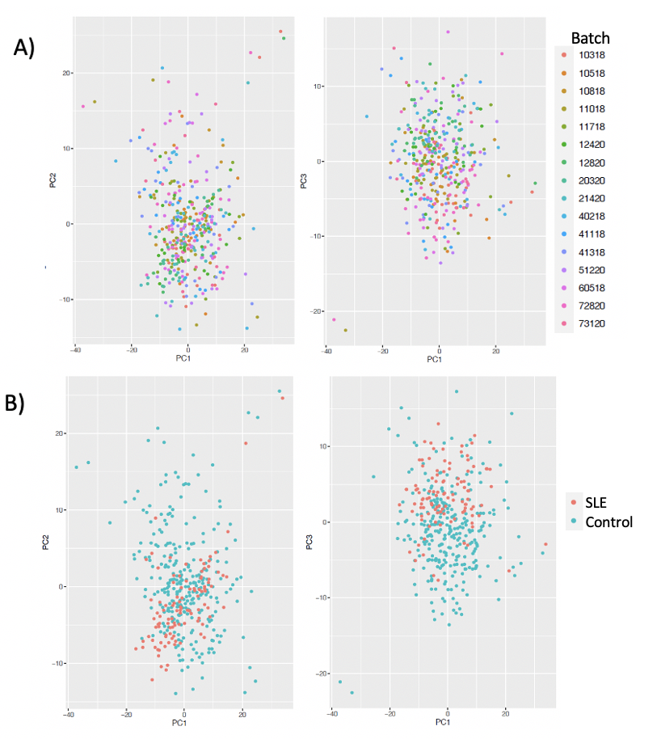

Fig S1. Principal component analysis (PCA) plots of 2,737 features selected for analysis after quality control and batch adjustment. A) PC1 vs PC2, PC1 vs PC3 colored by batch. B) PC1 vs PC2, PC1 vs PC3 colored by case-control status.

Fig S2: Number of features detected by counts of samples.
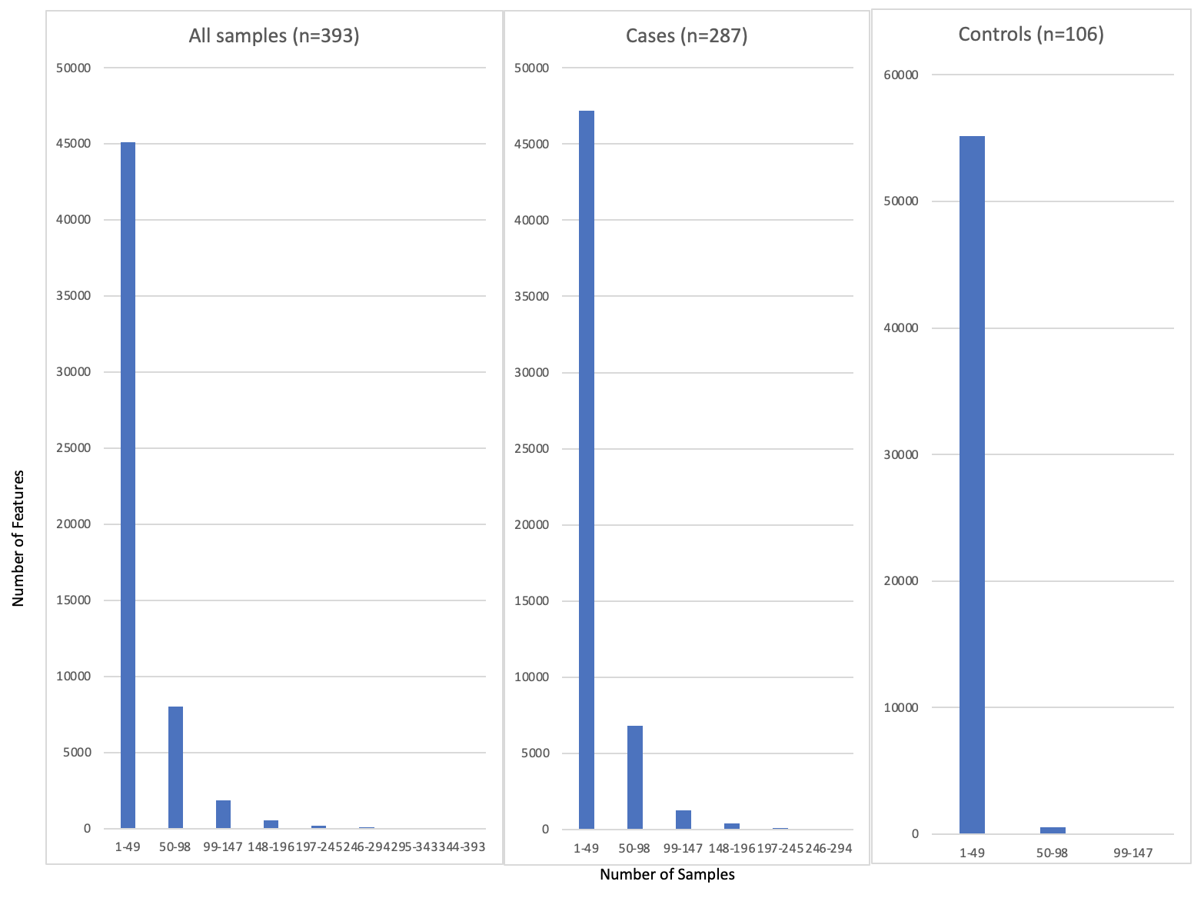

Fig S3. Violin plots of adjusted abundances of representative unmatched features in SLE cases and healthy controls.
