Supplementary Information for “Development of air purifier operation guideline using grey box models for the concentrations of particulate matter in elementary school classrooms”

Sowoo Park^{a,+}, Doosam Song^{a,+}, Young Min Jo^{b,+}, Ju-Hyeong Park^{c,+}, Tae Jeong Lee^{b}, Junemo Koo^{d,+}
ªSchool of Civil, Architectural Eng., and Landscape Architecture, Sungkyunkwan University, Suwon 16419, South Korea; ^{b}Department of Environmental Science and Environmental Engineering, College of Engineering, Kyung Hee University, Yong-In, Gyung-Gi Do, South Korea; ^{c}Respiratory Health Division, National Institute for Occupational Safety and Health, Morgantown, WV, U.S.A; ^{d}Department of Mechanical Engineering, College of Engineering, Kyung Hee University, Yong-In, Gyung-Gi Do, South Korea
⁺ These authors contributed equally.
* CONTACT Junemo Koo jmkoo@khu.ac.kr Department of Mechanical Engineering, College of Engineering, Kyung Hee University, Yong-In, Gyung-Gi Do, South Korea

List of Contents

1. Introduction
Table S1. Summary of published studies of levels of indoor particulate matter in school classrooms
2.2 Measurements
Figure S1. Schematics of sensors installation in a school (a) classroom indoor, and (b) outdoors on a flatform in a school playground
Figure S2 Logarithmic plot of fan pressurization test result for reference classrooms in A-D schools (a-d) and representative photo of test installation (e)
2.3 Model development
Figure S3. Comparison of the actual measurements (red line) and the model fitted values (red dot) for the classes in schools A (plot a), B (b), C (c), and D (d). The time segments where the measured and fitted data are overlapped were the ones that satisfied the reference conditions in Table 1 and that were actually used for model development. The shaded areas represent regular or lunch break.
2.4 Model validation
Figure S4. Ranges of the measured outdoor PM concentrations during the study. The colored boxes represent the interquartile ranges (IQR), and the thick horizontal lines show the medians. The whiskers are the extended minimum and maximum data within 1.5 times of IQR from the first and third quartiles, where the filled black circle represents outliers outside 1.5 times of IQR.

Introduction
Table S1. Summary of published studies of levels of indoor particulate matter in school classrooms
Authors | Study  location | Concentration of studied PM:  µg/m³ (PM type) | Study characteristics and findings
Braniš et al. (Braniš et al. 2005) | A university lecture room in Prague, Czech | Indoor: 42 (PM₁₀); 22 (PM_{2.5}); 14 (PM₁)  Outdoor: 39 (PM₁₀) | - Size of classroom floor: 117 m²; number of students in a classroom: up to 80  - Occupant was an important source of indoor coarse particles (PM_{2.5-10}).  - Indoor PM₁ and PM_{2.5} concentrations were highly and significantly correlated with outdoor concentrations.
Stranger et al. (Stranger et al. 2008) | Classrooms in twenty-seven primary schools in Antwerp, Belgium | Indoor: 61 (PM_{2.5})  Outdoor: 52 (PM_{2.5}) | - Number of students in a classroom: 15-26  - Resuspension of dust by room occupants was the main contributor to I/O ratios  higher than unity. (Average I/O = 1.75)
Weichenthal et al. (Weichenthal et al. 2008) | 37 classrooms from an elementary- and a secondary-school in Ontario, Canada | Number concentrations were used for the study.  Indoor: 5017/cm³ (PM₁) Outdoor: 9448/cm³ (PM₁) | - Average size of classroom floor: 79 m²  - Windows were generally closed.  - Classroom ultrafine particle (UFP) number concentrations may be reasonably estimated from outdoor UFP data.  - The estimates were not accurate in the presence of indoor sources of UFP.  - An increase in classroom UFP concentrations was apparent when school doors were open due to increased infiltration of outdoor air.
Elbayoumi et al. (Elbayoumi et al. 2013, 2014, 2015) | Classrooms of twelve schools in Gaza Strip, Palestine | Indoor: 350 (PM₁₀); 104 (PM_{2.5})  Outdoor: 150 (PM₁₀); 35 (PM_{2.5}) | - Number of students in a classroom: 30-45  - Indoor PM_{2.5} and PM₁₀ were positively correlated with outdoor concentrations.  - Elevated concentrations of indoor PM_{2.5} and PM₁₀ were due to high concentrations of outdoor PMs from dust storm in winter and resuspension from the unpaved playground due to students’ high activities, and resuspension from the classroom floors and chalk dust from the blackboard due to student’s high indoor activities.

Tran et al. (Tran et al. 2014) | Classrooms in three elementary  Schools, North of France | Indoor: 85 (PM₁₀); 12 (PM₂)  Outdoor: 35 (PM₁₀); 7 (PM₂) | - Average size of classroom floor: 73 m²; number of students in a classroom: 24-27  - Children’s activities affected the suspended coarse PM fraction more strongly than the fine PM.  - The fraction of coarse particle increased significantly during the class hours.  - The impact of students’ activity increased with the particle size.  - The concentration of coarse PM exceeded the national guidelines but the concentration of fine PM remained below the guidelines.  - I/O > 1 for PM₂ and PM₁₀ during the class hours and < 1 during the non-class hours.  - Window opening affected indoor PM concentrations.
Chithra and Nagendra (Chithra and Nagendra 2014) | Three classrooms in two schools, Channai, India | Indoor: 136 (PM₁₀); 36 (PM_{2.5}); 20 (PM₁)  Outdoor: 76 (PM₁₀); 33 (PM_{2.5}); 23 (PM₁) | - Average size of classroom floor: 44 m²; number of students in a classroom: 40-43  - A mass balance indoor air quality (IAQ) model was used to predict the indoor PM concentration in the classroom.  - The prediction accuracies (R²) were approximately 0.8 for PM₁ and PM_{2.5}, but poor for PM₁₀ (R² ~ 0.2) due to the unpredictable nature of human activities that strongly affected the coarse particle concentrations.
Yang Razali et al. (Yang Razali et al. 2015) | Three classrooms in three secondary schools, Malaysia | Indoor: 31 (PM₁₀); 18 (PM_{2.5}); 16 (PM₁)  Outdoor: 34 (PM₁₀); 26 (PM_{2.5}); 23 (PM₁) | - Average size of classroom floor: 61.4 m²; number of students in a classroom: 26-31  - Indoor PM concentrations were not influenced by outdoor concentrations.  - Indoor PM concentrations were lower than the national standards of Malaysian, Singapore, and Hong Kong.  - Windows were open during the class hours.  - I/O ratios increased with particle size.  - The higher I/O ratio for PM₁₀ resulted from the generation of coarse particles by students’ activities.
Liu et al. (Liu et al. 2018) | Two unoccupied classrooms of a university in Nanjing, China | Indoor: 15 (PM_{2.5})  Outdoor: 40 (PM_{2.5}) | - Average size of classroom floor: 55 m²  - The study examined the influence of natural ventilation rate on PM_{2.5} deposition.  - The deposition rate was linearly associated with the natural ventilation rate.  - The merits of natural ventilation could be evaluated using the concept of the balance-point outdoor concentrations at which the air exchange rate did not affect the I/O ratio after considering the impact of indoor generation and resuspension.
Othman et al. (Othman et al. 2019) | A classroom in an elementary school in Kuala Lumpur, Malaysia | Indoor: 11.2 (PM_{2.5})  Outdoor: 11.4 (PM_{2.5}) | - Size of the classroom floor: 105 m²; number of students in a classroom: 31  - The source or resuspension due to student activities was the main contributor to indoor PM_{2.5}.  - A maximum I/O ratio of PM_{2.5} was determined when the classroom was unoccupied to demonstrate the importance of outdoor source contribution to indoor PM_{2.5}.
Park et al. (Park et al. 2020) | 102 classrooms from 34 elementary schools located on the mainland peninsula and an island, Korea | Indoor: 44.9 (PM₁₀); 11.5 (PM_{2.5})  Outdoor: 32.4 (PM₁₀); 12.6 (PM_{2.5}) | - Average size of classroom floor: 68 m²; mean number of students in a classroom: 23.4  - Average I/O: 2.0 for PM₁₀ and 1.3 for PM_{2.5}  - Correlation between indoor and outdoor PM_{2.5} was higher than that of PM₁₀.  - School location, classroom occupant density, and ambient PM levels significantly affected classroom PM concentrations.  - Adjusted PM levels in classrooms using air cleaners were significantly lower by 35%.
Zhou et al. (Zhou et al. 2021) | Classrooms in a primary schools, North China | Indoor: 20-100 (PM_{2.5})  Outdoor: 40-95 (PM_{2.5}) | - Average size of classroom floor: 62 m²; number of students: 55  - Quantitative estimation of the impact of student behavior on indoor PM_{2.5} concentration was the main objective of this study.  - Increased student behavior resulted in the spike of the indoor PM_{2.5} concentration.  - Time periods of students’ activities were incorporated into the student source strength model.
Mohammadyan et al. (Mohammadyan et al. 2017) | Six classrooms in six primary schools, Iran | Indoor: 397 (PM₁₀); 47 (PM_{2.5}); 18 (PM₁)  Outdoor: 37 (PM₁) | - Average size of classroom floor: 29.8 m²; number of students in a classroom: 14-37  - The I/O ratios were higher than 1 for PM₁, PM_{2.5}, and PM₁₀.  - Outdoor PM_{2.5} concentration was the most significant predictor of the indoor PM concentrations.

2.2 Measurements

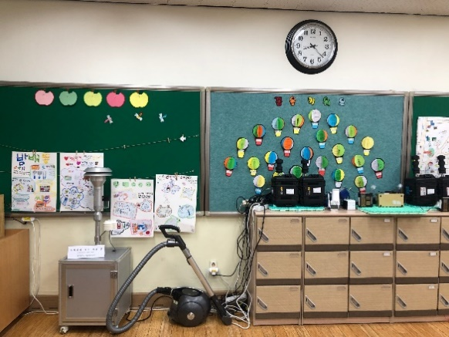  (a) | 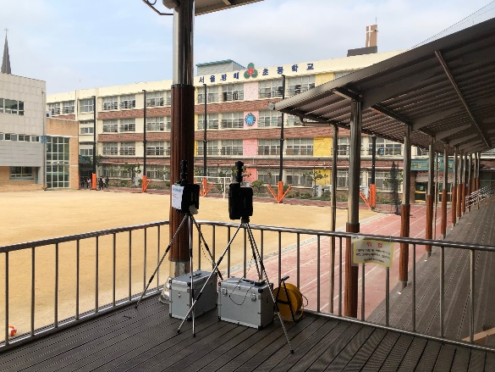  (b)
Figure S1. Schematics of sensors installation in a school (a) classroom indoor, and (b) outdoors on a flatform in a school playground

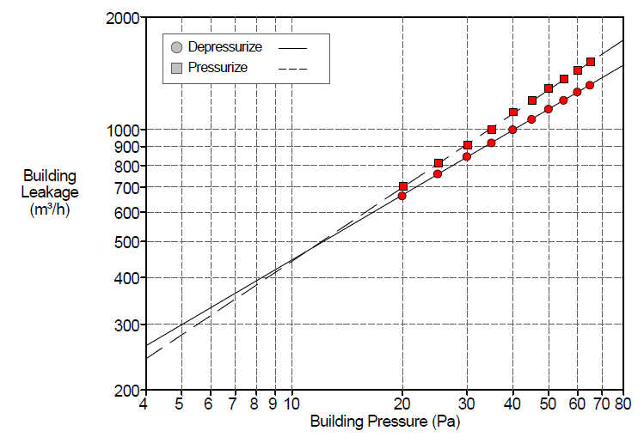 | 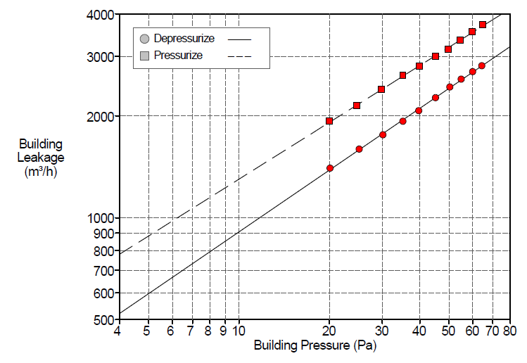
(a) School A | (b) School B
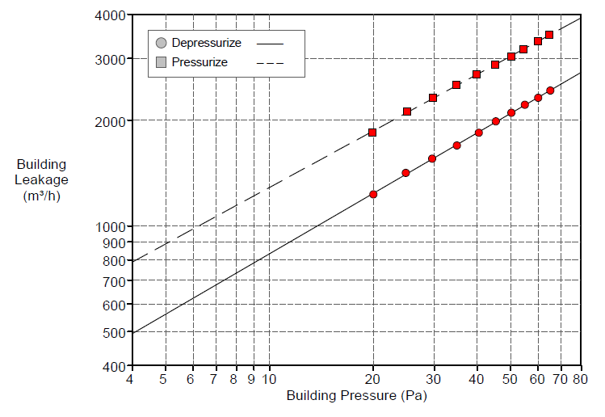 | 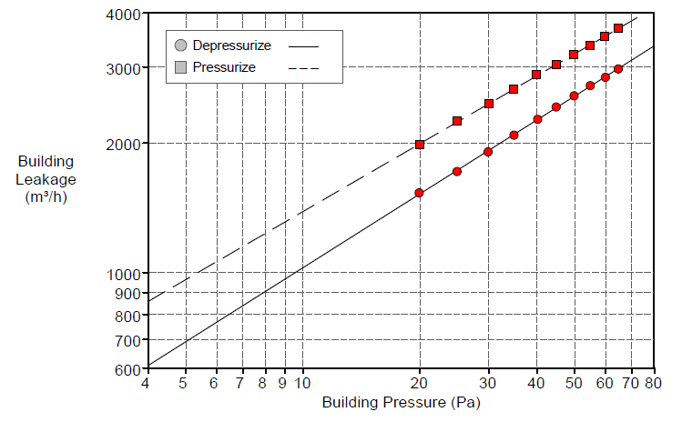
(c) School C | (d) School D
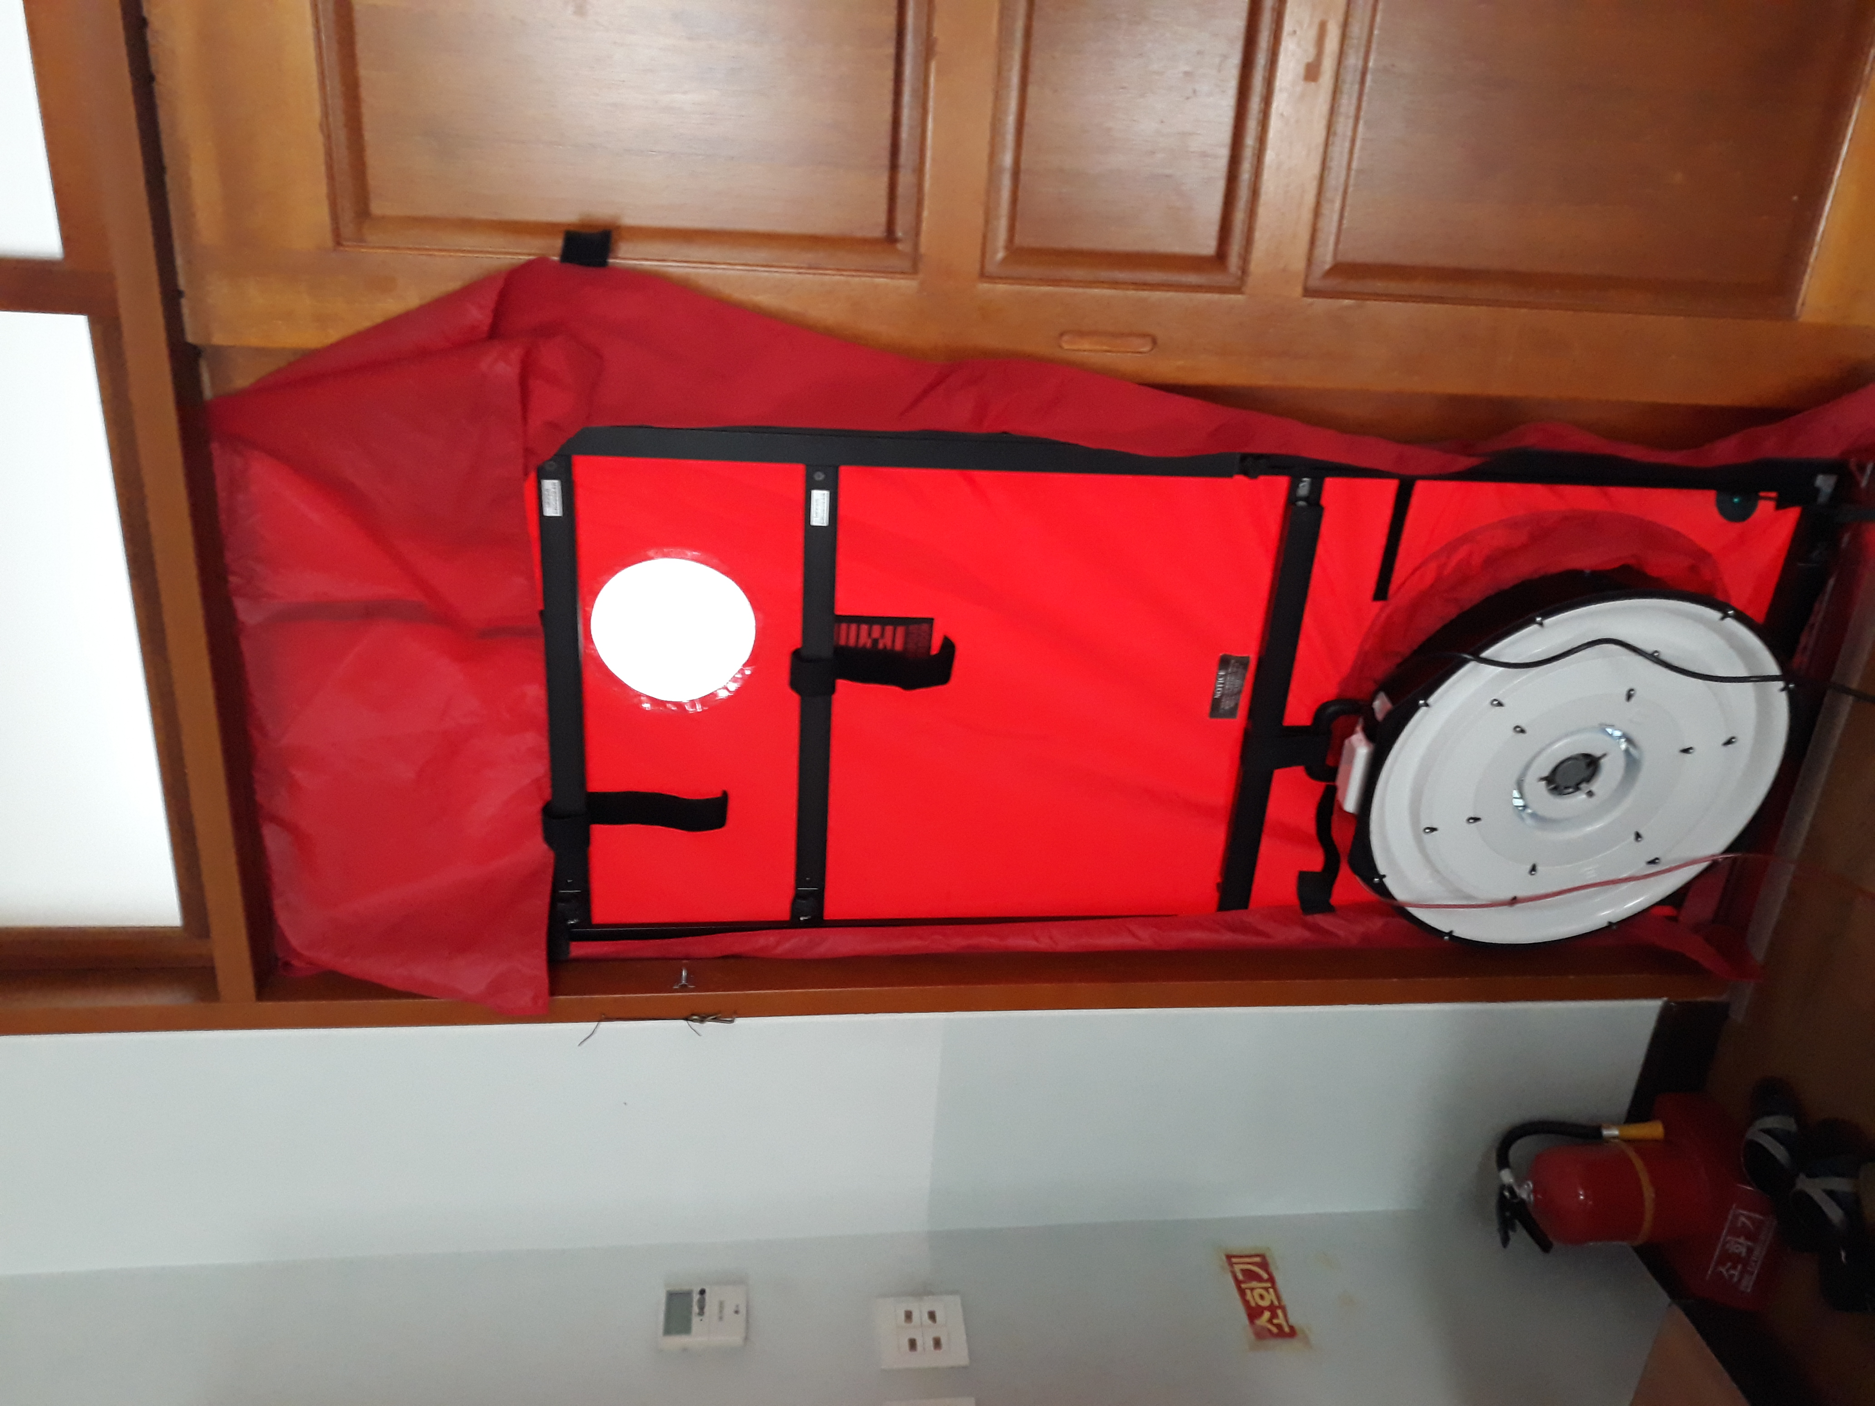
(e)
Figure S2 Logarithmic plot of fan pressurization test result for reference classrooms in A-D schools (a-d) and representative photo of test installation (e)

2.3 Model development
As described in Section 2.2, the classroom operating conditions including the operations of windows, an air purifier, and a heater significantly affected indoor PM levels. Of the whole sampling period in Fig. S2, we selected the time segments for model development that the classroom operating conditions satisfied the baseline operating conditions in Table 1, except for the ones with the extremely high level of students’ indoor activity between 10:50 and 11:30 am in school B. Although the classroom schedules slightly varied among schools, the first class usually began at 9:00 a.m. and each class lasted 40 minutes followed by 10‒20 minutes of break time until 12:10 p.m. Fig. S2 shows that the pattern of changes in the indoor PM concentrations matches with that in student activity levels grouped by class or break time (Zhou et al. 2021; Park et al. 2020; Elbayoumi et al. 2013, 2014, 2015; Tran et al. 2014; Stranger et al. 2008; Braniš et al. 2005). As shown in Table 1, simple scenarios using the baseline operating conditions were assumed to simplify the model development. In the model development, students’ activity was represented with class schedule (class or break time) by which the model parameters were estimated as described earlier. The model assumption in Table 1 that the windows and doors were closed, is a typical condition during the episodes of high outdoor PM concentrations. Using the least squares method with the optimization packages of DEoptim (Ardia et al. 2020) and minpack.lm (Elzhov et al. 2016) for R language (R Core Team and Team 2019), we estimated model parameters ($P^{'}$, $k^{'}$, and $\dot{s})$ that best fit the data for each class and break time with the added condition that the model coefficients during breaks are greater than those during class hours. The determined model parameters are shown in Table 2. The model used PM₁, PM_{1-2.5}, and PM_{2.5-10} data instead of PM₁, PM_{2.5}, and PM₁₀ to ensure that the model fitted PM values satisfied the inequality constraint (PM₁ ≤ PM_{2.5} ≤ PM₁₀) (Park et al. 2022). Then the model-fitted data for PM_{2.5} were reconstructed by simply adding the model-fitted PM₁ to the model-fitted PM_{1-2.5}, and for PM₁₀, adding this PM_{2.5} to the model-fitted PM_{2.5-10}.

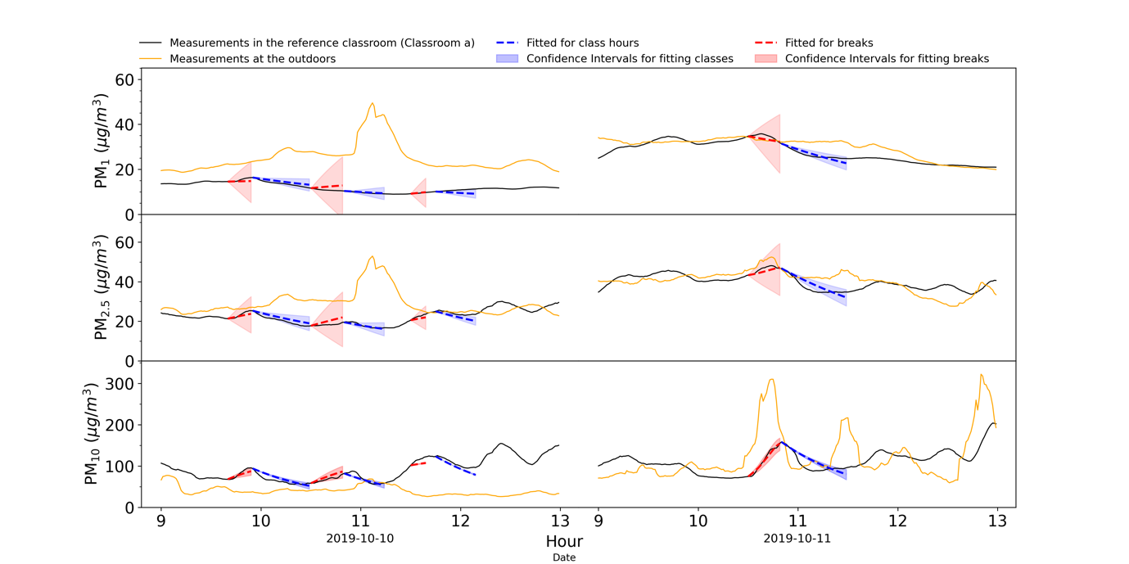
(a)
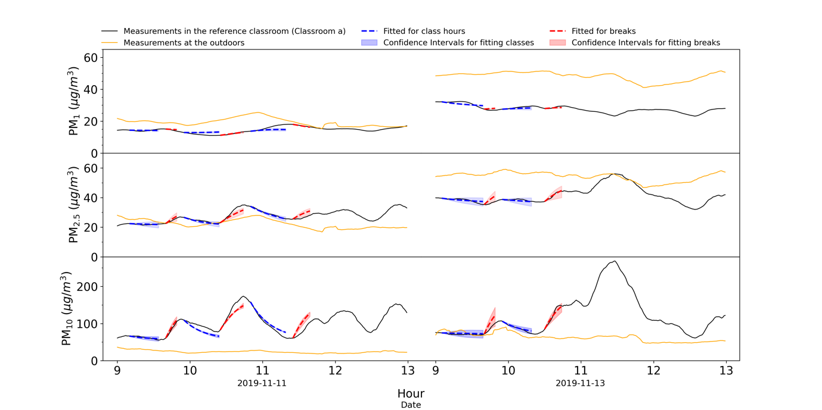
(b)
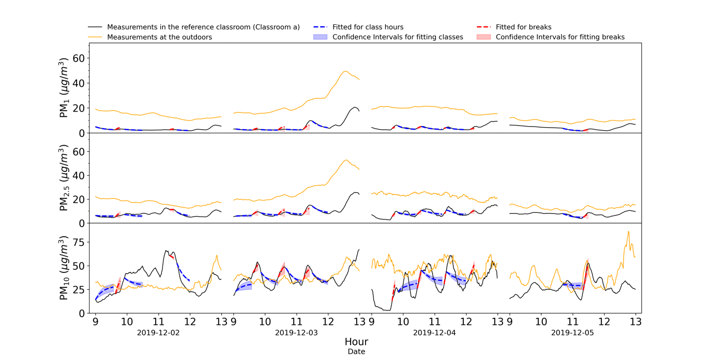
(c)
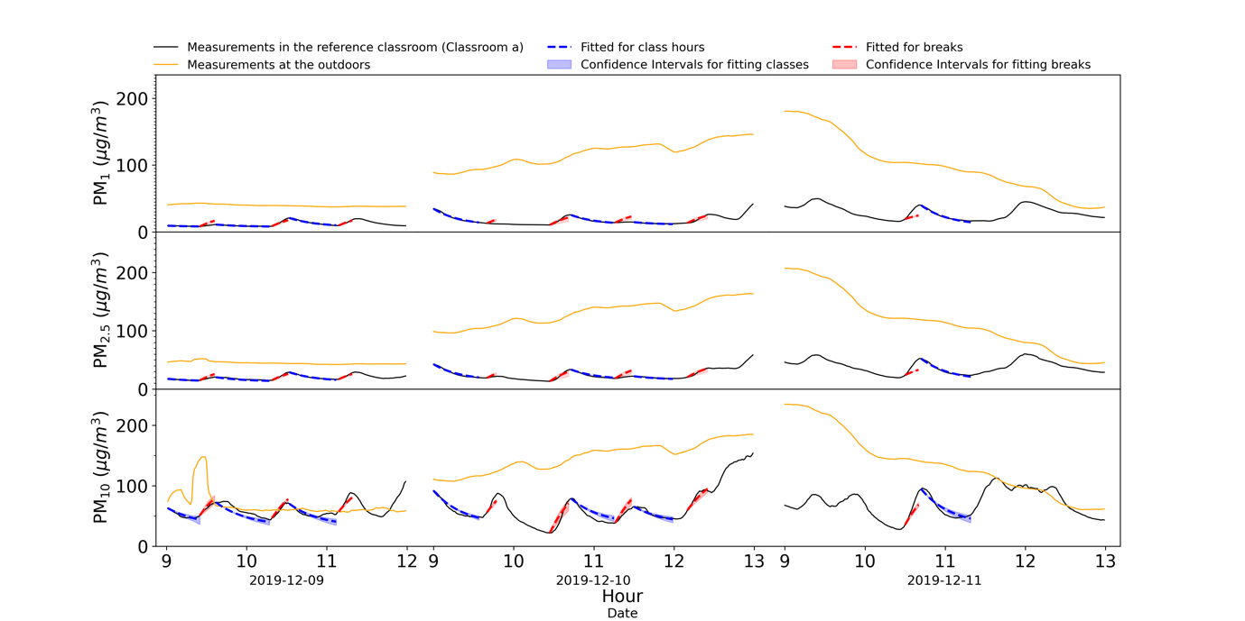
(d)
Figure S3. Comparison of the actual measurements (red line) and the model fitted values (red dot) for the classes in schools A (plot a), B (b), C (c), and D (d). The time segments where the measured and fitted data are overlapped were the ones that satisfied the reference conditions in Table 1 and that were actually used for model development. The shaded areas represent regular or lunch break.

2.4 Model validation
The fitting accuracy of the developed models was evaluated according to the ASTM D5157 standard that provides guidance for statistical evaluation of the IAQ model (Conshohocken 2013). In this study, the model performance (accuracy) metrics were the correlation coefficient ($r$), slope ($b)$, and intercept ($a$) of the linear regression between the observed and model-fitted values, normalized mean squared error ($NMSE$), fractional bias ($FB$), and similar index of bias based on variance ($FS$). They were calculated as shown in Equations SI(1)–(6):
$r=\frac{\sum_{i=1}^{n}{\left[\left(C_{oi}-{\overline{C}}_{o} \right)\left(C_{pi}-{\overline{C}}_{p} \right)\right]}}{\sqrt{\left[\sum_{i=1}^{n}{{\left(C_{oi}-{\overline{C}}_{o}\right)}^{2}}\right]\left[\sum_{i=1}^{n}{{\left(C_{pi}-{\overline{C}}_{p}\right)}^{2}}\right]} }$ SI(1)
$b=\frac{\sum_{i=1}^{n}{\left[\left(C_{oi}-{\overline{C}}_{o} \right)\left(C_{pi}-{\overline{C}}_{p} \right)\right]}}{\sum_{i=1}^{n}{{\left(C_{oi}-{\overline{C}}_{o} \right)}^{2}}}$ SI(2)
$a={\overline{C}}_{p}-b{\overline{C}}_{o}$ SI(3)
$NMSE=\frac{\overline{{\left(C_{p}-C_{o}\right)}^{2}}}{{\overline{C}}_{o}⋅{\overline{C}}_{p}}$ SI(4)
$FB=2⋅\frac{\left({\overline{C}}_{p}-{\overline{C}}_{o}\right)}{\left({\overline{C}}_{p}+{\overline{C}}_{o}\right)}$ SI(5)
$FS=2⋅\frac{\left(σ_{C_{p}}^{2}-σ_{C_{o}}^{2}\right)}{\left(σ_{C_{p}}^{2}+σ_{C_{o}}^{2}\right)}$ SI(6)
where $C_{o}$, $C_{p}$, $i$, $σ^{2}$, and $n$ are the observed data, model predictions, index for individual data point, variance, and number of collected data points, respectively. A bar over the symbol represents the mean value. The acceptable ranges of the model performance metrics for an adequate model were $r≥0.9$, $0.75≤b≤1.25$, $\left|a\right|≤0.25{\overline{C}}_{o}$, $NMSE≤0.25$, $\left|FB\right|≤0.25$, and $\left|FS\right|≤0.5$ (Conshohocken 2013).

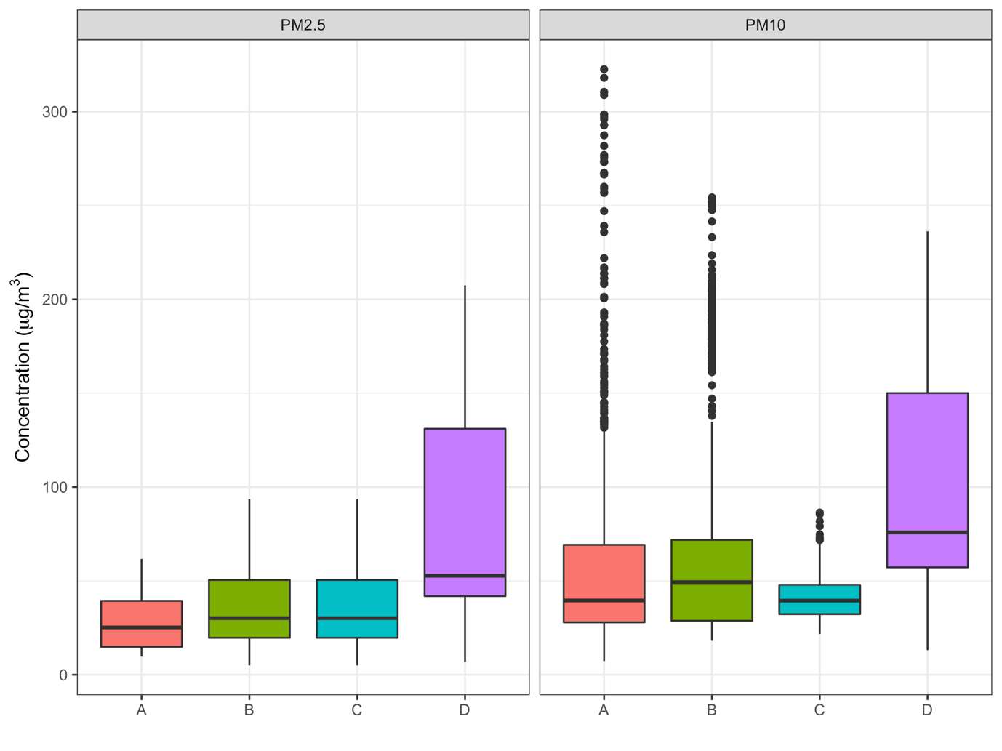
Figure S4. Ranges of the measured outdoor PM concentrations during the study. The colored boxes represent the interquartile ranges (IQR), and the thick horizontal lines show the medians. The whiskers are the extended minimum and maximum data within 1.5 times of IQR from the first and third quartiles, where the filled black circle represents outliers outside 1.5 times of IQR.

References

Ardia, D., Mullen, K.M., Peterson, B.G., and Ulrich, J. (2020). {DEoptim}: Differential Evolution in {R}.
Braniš, M., Řezáčová, P., and Domasová, M. (2005). The effect of outdoor air and indoor human activity on mass concentrations of PM10, PM2.5, and PM1 in a classroom. Environ Res 99 (2):143–149. doi:10.1016/J.ENVRES.2004.12.001.
Chithra, V.S. and Nagendra, S.M.S. (2014). Characterizing and predicting coarse and fine particulates in classrooms located close to an urban roadway. http://dx.doi.org/10.1080/10962247.2014.894483 64 (8):945–956. doi:10.1080/10962247.2014.894483.
Conshohocken, W. (2013). Standard Guide for Statistical Evaluation of Indoor Air Quality Models 1. 97 (Reapproved 2008):3–6.
Elbayoumi, M., Ramli, N.A., and Md Yusof, N.F.F. (2015). Spatial and temporal variations in particulate matter concentrations in twelve schools environment in urban and overpopulated camps landscape. Build Environ 90:157–167. doi:10.1016/J.BUILDENV.2015.03.036.
Elbayoumi, M., Ramli, N.A., Md Yusof, N.F.F., and al Madhoun, W. (2013). Spatial and seasonal variation of particulate matter (PM10 and PM2.5) in Middle Eastern classrooms. Atmos Environ 80:389–397. doi:10.1016/J.ATMOSENV.2013.07.067.
Elbayoumi, M., Ramli, N.A., Md Yusof, N.F.F., Yahaya, A.S. bin, al Madhoun, W., and Ul-Saufie, A.Z. (2014). Multivariate methods for indoor PM10 and PM2.5 modelling in naturally ventilated schools buildings. Atmos Environ 94:11–21.
Elzhov, T. v, Mullen, K.M., Spiess, A.-N., and Bolker, B. (2016). minpack.lm: R Interface to the Levenberg-Marquardt Nonlinear Least-Squares Algorithm Found in MINPACK, Plus Support for Bounds.
Liu, C., Yang, J., Ji, S., Lu, Y., Wu, P., and Chen, C. (2018). Influence of natural ventilation rate on indoor PM2.5 deposition. Build Environ 144:357–364. doi:10.1016/J.BUILDENV.2018.08.039.
Mohammadyan, M., Alizadeh-Larimi, A., Etemadinejad, S., Latif, M.T., Heibati, B., Yetilmezsoy, K., Abdul-Wahab, S.A., and Dadvand, P. (2017). Particulate Air Pollution at Schools: Indoor-Outdoor Relationship and Determinants of Indoor Concentrations. Aerosol Air Qual Res 17 (3):857–864. doi:10.4209/AAQR.2016.03.0128.
Othman, M., Latif, M.T., and Matsumi, Y. (2019). The exposure of children to PM2.5 and dust in indoor and outdoor school classrooms in Kuala Lumpur City Centre. Ecotoxicol Environ Saf 170:739–749. doi:10.1016/J.ECOENV.2018.12.042.
Park, J.H., Lee, T.J., Park, M.J., Oh, H.N., and Jo, Y.M. (2020). Effects of air cleaners and school characteristics on classroom concentrations of particulate matter in 34 elementary schools in Korea. Build Environ 167:106437. doi:10.1016/j.buildenv.2019.106437.
Park, S.B., Park, J.-H., Jo, Y.M., Song, D., Heo, S., Lee, T.J., Park, S., and Koo, J. (2022). Development and validation of a dynamic mass-balance prediction model for indoor particle concentrations in an office room. Build Environ 207:108465. doi:10.1016/J.BUILDENV.2021.108465.
R Core Team and Team, R.C. (2019). R: A Language and Environment for Statistical Computing.
Stranger, M., Potgieter-Vermaak, S.S., and van Grieken, R. (2008). Characterization of indoor air quality in primary schools in Antwerp, Belgium. Indoor Air 18 (6):454–463. doi:10.1111/J.1600-0668.2008.00545.X.
Tran, D.T., Alleman, L.Y., Coddeville, P., and Galloo, J.C. (2014). Indoor–outdoor behavior and sources of size-resolved airborne particles in French classrooms. Build Environ 81:183–191. doi:10.1016/J.BUILDENV.2014.06.023.
Weichenthal, S., Dufresne, A., Infante-Rivard, C., and Joseph, L. (2008). Characterizing and predicting ultrafine particle counts in Canadian classrooms during the winter months: Model development and evaluation. Environ Res 106 (3):349–360. doi:10.1016/J.ENVRES.2007.08.013.
Yang Razali, N.Y., Latif, M.T., Dominick, D., Mohamad, N., Sulaiman, F.R., and Srithawirat, T. (2015). Concentration of particulate matter, CO and CO2 in selected schools in Malaysia. Build Environ 87:108–116. doi:10.1016/J.BUILDENV.2015.01.015.
Zhou, Y., Yang, G., and Li, X. (2021). Indoor PM2.5 concentrations and students’ behavior in primary school classrooms. J Clean Prod 318:128460. doi:10.1016/J.JCLEPRO.2021.128460.

