Supplemental Information
The output from the detector after amplification as measured with a 1 MΩ input impedance oscilloscope can be written as:
$$O_{open beam}= \int_{0}^{∞}{R\left(λ\right)*T_{passband}\left(λ\right)dλ ≅ \int_{λ_{1}}^{λ_{2}}{R\left(λ\right)dλ }}$$
Equation 1

where $R\left(λ\right)$ is the system response including the source, detector, and pre-amp characteristics. With the sample in the beam:
$$O_{sample}= \int_{0}^{∞}{R\left(λ\right)*T_{sample}\left(λ\right)*T_{passband}\left(λ\right)dλ }≅ \int_{λ_{1}}^{λ_{2}}{{R\left(λ\right)*T}_{sample}\left(λ\right)dλ}$$
Equation 2

if we assume the response of the system $R\left(λ\right)$ is constant from λ1 to λ2
$$O_{open beam}= C$$
Equation 3
$$O_{sample}=C\left[\int_{λ_{1}}^{λ_{2}}{T_{sample}\left(λ\right)dλ}\right]$$
Equation 4
For each passband filter, there is a different $λ_{1},$ $λ_{1}$ and $C$, but for clarity we are only considering one passband filter at the moment.
The metric chosen, M, when utilizing the non-dispersive Infrared spectrometer has been the output from the detector with the sample in place divided by the output from the detector without the sample in place.
$$M ≡\frac{O_{sample}}{O_{open beam}}$$
Equation 5
$$M≅\int_{λ_{1}}^{λ_{2}}{T_{sample}\left(λ\right)dλ}$$
Equation 6
This metric is measured for each of the passband filters.
We can approximate $T_{sample}\left(λ\right)$ and $T_{passband}\left(λ\right)$ by measuring them with the FT-IR. In this way, we can arrive at an approximation of M.
$$M ≡\frac{O_{sample}\left[mV\right]}{O_{open beam}\left[mV\right]}≅ \hat{M}= \frac{C \left[\sum_{λ_{o}}^{λ_{f}}{{\hat{T}}_{sample}\left(λ\right)*{\hat{T}}_{passband}\left(λ\right)}\right]}{C \left[\sum_{λ_{o}}^{λ_{f}}{{\hat{T}}_{passband}\left(λ\right)}\right]}$$
Equation 7
To obtain ${\hat{T}}_{passband}\left(λ\right),$ each passband filter was placed in the FT-IR and its transmittance measured; the results are shown in Figure 1. An example of ${\hat{T}}_{sample}\left(λ\right)*{\hat{T}}_{passband}\left(λ\right)$ is illustrated in Figure 2.
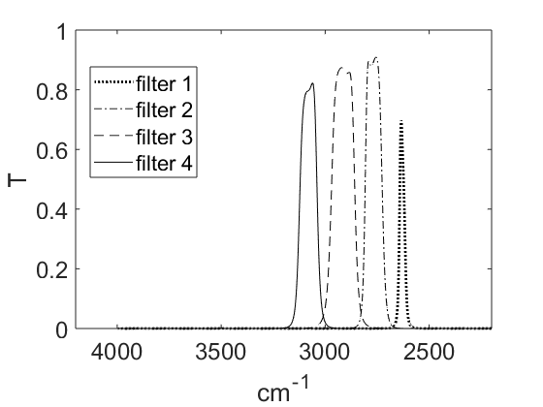
Figure S1: Transmittance of the 5 optical passband filters. Note filter 5 is outside the FT-IR measurement range.

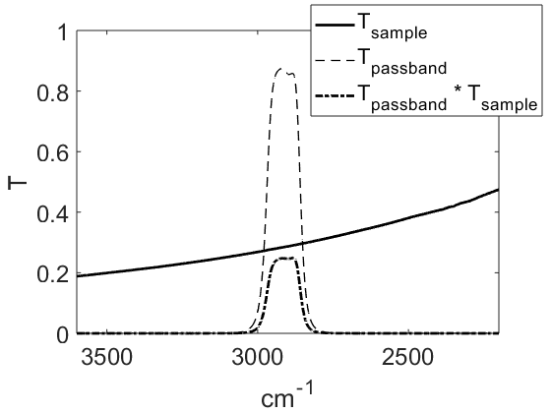
Figure S2: Transmittance of passband filter, a sample (Teflon filter) as measured by FT-IR and their product.

