Supplemental Materials
Biomarkers of Organophosphate and Polybrominated Diphenyl Ether (PBDE) Flame Retardants of American Workers and Associations with Inhalation and Dermal Exposures

Authors: Cheryl Fairfield Estill¹, Alexander C. Mayer*¹, I-Chen Chen¹, Jonathan Slone², Mark J. LaGuardia³, Nayana Jayatilaka⁴, Maria Ospina⁴, Andreas Sjodin⁴ and Antonia M. Calafat⁴
¹National Institute for Occupational Safety and Health (NIOSH), Cincinnati, OH, 45226, USA; ²RCS Corporation, Charlotte, NC, 27277, USA; ³Virginia Institute of Marine Science, College of William & Mary, Gloucester Point, VA,23062, USA; ⁴National Center for Environmental Health, Centers for Disease Control and Prevention, Atlanta, GA, 30341, USA

Supplemental materials pages: 15
Figures: S1-S2
Tables: S1-S10

Correspondence to:
Alexander Mayer, MPH
Division of Field Studies and Engineering
National Institute for Occupational Safety and Health
1090 Tusculum Ave, MS R-14
Cincinnati, OH 45226
(work) 513.458-7180
(fax) 513.841-4486
Nru1@cdc.gov

Methods – Specific Gravity
Specific gravity was measured in the field with a handheld Master refractometer (Atago, Uricon-Ne Product numbers 2722, range 1.000-1.050 UG). Results were normalized for specific gravity (SG) using Equation 1 (Carignan et al. 2016) using an average specific gravity of 1.024 (Boeniger et al. 1993):
Equation 1: C_{sg}= Concentration*[(1.024-1)/(SG-1)].
Methods – Creatinine
Creatinine was measured at CDC using an enzymatic method with a Roche/Hitachi Cobas® c501 chemical analyzer (Roche Diagnostics, Inc., Indianapolis, IN).

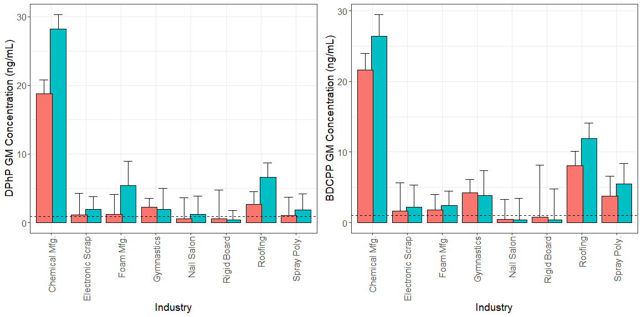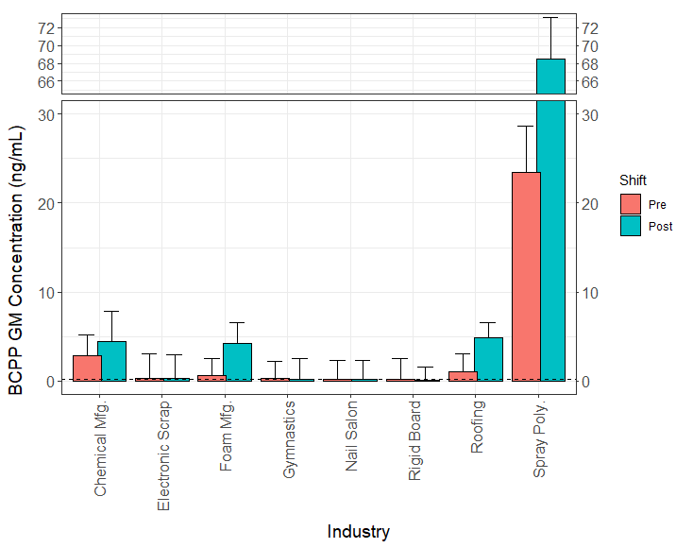
*
*
*
*
*
*
*
*
*
Figure S1. Unadjusted urinary geometric mean (GM) concentrations and corresponding geometric standard deviations (GSDs) of DPhP, BDCPP, and BCPP (ng/mL) by industry. Dashed lines represent GM concentrations in the U.S. general population of 2015-2016 NHANES (0.89, 1.00, and 0.18 ng/mL for DPhP, BDCPP, and BCPP, respectively). Asterisks (*) represent the significant mean differences between pre- and post-shift concentrations by industry and analyte.

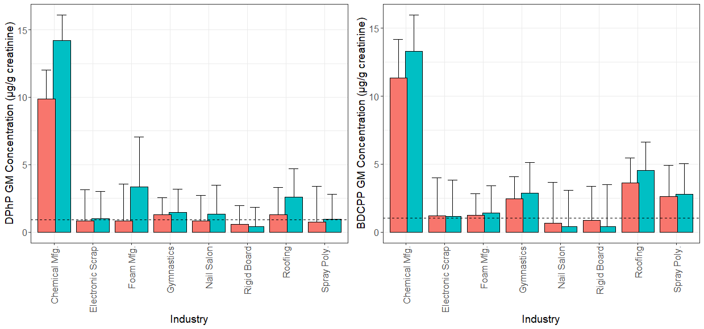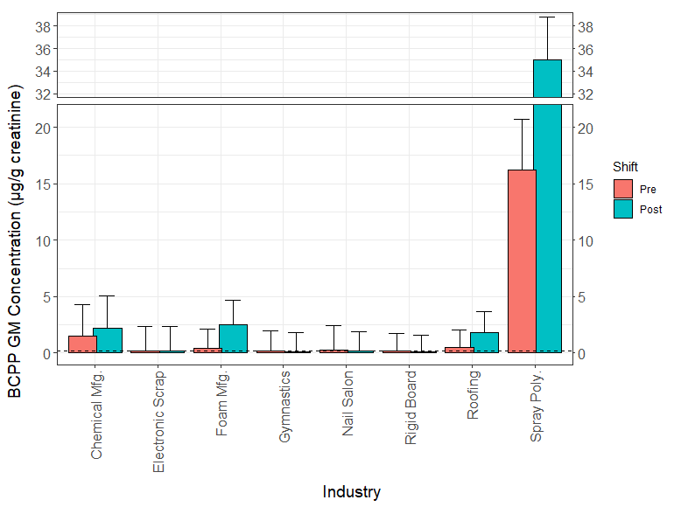
*
*
*
*
*
*
*
*
Figure S2. Creatinine-adjusted urinary geometric mean (GM) concentrations and corresponding GSDs of DPhP, BDCPP, and BCPP (μg/g creatinine) by industry. Dashed lines represent GM concentrations in the U.S. general population of 2015-2016 NHANES (0.91, 1.03, and 0.19 μg/g creatinine for DPhP, BDCPP, and BCPP, respectively). Asterisks (*) represent the significant mean differences between pre- and post-shift concentrations by industry and analyte.

Table S1. OPE urine metabolite unadjusted concentrations (ng/mL) by industry (2015-2017)*.
 |  | Pre-Shift Concentration (ng/mL) |  |  |  |  |  | Post-Shift Concentration (ng/mL)
Analyte | Industry | N | % > LOD† | GM  (GSD) | Multiple Comparisons‡ | P-value§  (vs GP) | N |  | % > LOD† | GM  (GSD) | Multiple Comparisons‡ | P-value§  (vs GP) | P-value‖  (Pre vs Post)
DPhP | Overall | 102 | 93 | 1.52 (3.73) |  |  | 102 |  | 99 | 2.81 (3.59)
 | Chemical Mfg. (C) | 10 | 100 | 18.8 (2.02) |  | <0.001 | 10 |  | 100 | 28.2 (2.15) |  | <0.001 | 0.151
 | Roofing (R) | 9 | 100 | 2.68 (1.80) | C-R | <0.001 | 10 |  | 100 | 6.62 (2.09) | C-R | <0.001 | 0.017
 | Gymnastics (G) | 9 | 100 | 2.23 (1.29) | C-G | <0.001 | 9 |  | 100 | 1.92 (3.12) | C-G | 0.077 | 0.679
 | Foam Mfg. (F) | 11 | 91 | 1.17 (2.95) | C-F | 0.415 | 10 |  | 100 | 5.37 (3.61) | C-F | 0.002 | 0.012
 | Electronic Scrap (E) | 19 | 95 | 1.12 (3.14) | C-E | 0.397 | 19 |  | 100 | 1.95 (1.84) | C-E, R-E | <0.001 | 0.014
 | Spray Poly. (S) | 29 | 97 | 1.08 (2.62) | C-S | 0.299 | 29 |  | 97 | 1.83 (2.34) | C-S, R-S, F-S | <0.001 | 0.012
 | Nail Salon (N) | 12 | 75 | 0.57 (3.07) | C-N, R-N, G-N | 0.205 | 12 |  | 100 | 1.25 (2.64) | C-N, R-N, F-N | 0.248 | 0.011
 | Rigid Board (B) | 3 | 67 | 0.53 (4.22) | C-B | 0.604 | 3 |  | 100 | 0.44 (1.33) | C-B, R-B, F-B | 0.046 | 0.811
 | NHANES# | 1508 | 97 | 0.89 (3.21) |  | Ref. | 1508 |  | 97 | 0.89 (3.21) |  | Ref.
BDCPP | Overall | 103 | 96 | 2.86 (4.29) |  |  | 103 |  | 97 | 3.52 (4.76)
 | Chemical Mfg. | 10 | 100 | 21.6 (2.39) |  | <0.001 | 10 |  | 100 | 26.4 (3.10) |  | <0.001 | 0.455
 | Roofing | 10 | 100 | 8.09 (2.05) |  | <0.001 | 10 |  | 100 | 11.9 (2.23) |  | <0.001 | 0.163
 | Gymnastics | 9 | 100 | 4.23 (1.89) | C-G | <0.001 | 9 |  | 100 | 3.81 (3.57) | C-G | 0.014 | 0.768
 | Spray Poly. | 29 | 100 | 3.75 (2.80) | C-S | <0.001 | 29 |  | 100 | 5.45 (2.94) | C-S | <0.001 | 0.024
 | Foam Mfg. | 11 | 100 | 1.83 (2.15) | C-F, R-F | 0.026 | 11 |  | 100 | 2.42 (2.03) | C-F, R-F | 0.002 | 0.137
 | Electronic Scrap | 19 | 95 | 1.64 (4.00) | C-E, R-E | 0.140 | 19 |  | 100 | 2.22 (3.13) | C-E, R-E | 0.007 | 0.124
 | Rigid Board | 3 | 67 | 0.78 (7.40) | C-B, R-B | 0.847 | 3 |  | 67 | 0.42 (4.40) | C-B, R-B, S-B | 0.421 | 0.184
 | Nail Salon | 12 | 83 | 0.44 (2.89) | C-N, R-N, G-N, S-N, F-N, E-N | 0.020 | 12 |  | 83 | 0.38 (3.10) | C-N, R-N, S-N, G-N, F-N, E-N | 0.014 | 0.631
 | NHANES # | 1508 | 95 | 1.00 (3.56) |  | Ref. | 1508 |  | 95 | 1.00 (3.56) |  | Ref.
BCPP | Overall | 103 | 89 | 1.40 (9.31) |  |  | 103 |  | 91 | 2.79 (13.6)
 | Spray Poly. | 29 | 100 | 23.5 (5.14) |  | <0.001 | 29 |  | 100 | 68.5 (4.65) |  | <0.001 | <0.001
 | Chemical Mfg. | 10 | 100 | 2.87 (2.31) | S-C | <0.001 | 10 |  | 100 | 4.42 (3.44) | S-C | <0.001 | 0.107
 | Roofing | 10 | 100 | 1.06 (2.03) | S-R | <0.001 | 10 |  | 100 | 4.83 (1.71) | S-R | <0.001 | <0.001
 | Foam Mfg. | 11 | 100 | 0.66 (1.89) | S-F | <0.001 | 11 |  | 100 | 4.27 (2.29) | S-F | <0.001 | <0.001
 | Gymnastics | 9 | 100 | 0.29 (1.92) | S-G, C-G | 0.064 | 9 |  | 78 | 0.20 (2.34) | S-G, R-G, C-G, F-G | 0.709 | 0.096
 | Electronic Scrap | 19 | 74 | 0.27 (2.79) | S-E, C-E | 0.103 | 19 |  | 89 | 0.33 (2.60) | S-E, R-E, C-E, F-E | 0.015 | 0.284
 | Nail Salon | 12 | 58 | 0.16 (2.16) | S-N, C-N, R-N | 0.486 | 12 |  | 67 | 0.17 (2.11) | S-N, R-N, C-N, F-N | 0.757 | 0.608
 | Rigid Board | 3 | 67 | 0.16 (2.38) | S-B, C-B | 0.804 | 3 |  | 67 | 0.11 (1.44) | S-B, R-B, C-B, F-B | 0.123 | 0.429
 | NHANES # | 1508 | 54 | 0.18 (2.91) |  | Ref. | 1508 |  | 54 | 0.18 (2.91) |  | Ref.
 |  | Pre-Shift Concentration (ng/mL) |  |  |  |  |  | Post-Shift Concentration (ng/mL)
Analyte | Industry | N | % > LOD† | GM  (GSD) | Multiple Comparisons‡ | P-value§  (vs GP) | N |  | % > LOD† | GM  (GSD) | Multiple Comparisons‡ | P-value§  (vs GP) | P-value‖  (Pre vs Post)
DBuP | Overall | 103 | 88 | 0.26 (4.03) |  |  | 103 |  | 93 | 0.41 (4.89)
 | Chemical Mfg. | 10 | 100 | 2.50 (2.20) |  | <0.001 | 10 |  | 100 | 6.11 (2.47) |  | <0.001 | <0.001
 | Gymnastics | 9 | 100 | 0.37 (2.19) | C-G | <0.001 | 9 |  | 100 | 0.27 (2.17) | C-G | 0.006 | 0.324
 | Roofing | 10 | 100 | 0.33 (1.80) | C-R | <0.001 | 10 |  | 100 | 0.46 (1.41) | C-R | <0.001 | 0.023
 | Foam Mfg. | 11 | 91 | 0.32 (3.05) | C-F | 0.007 | 11 |  | 100 | 0.49 (1.73) | C-F | <0.001 | 0.252
 | Rigid Board | 3 | 100 | 0.27 (2.65) |  | 0.228 | 3 |  | 100 | 0.23 (1.12) | C-B | 0.005 | 0.750
 | Spray Poly. | 29 | 86 | 0.20 (4.73) | C-S | 0.035 | 29 |  | 86 | 0.47 (6.95) | C-S | <0.001 | 0.001
 | Nail Salon | 12 | 75 | 0.12 (2.41) | C-N | 0.676 | 12 |  | 92 | 0.15 (2.21) | C-N | 0.117 | 0.303
 | Electronic Scrap | 19 | 79 | 0.12 (2.74) | C-E | 0.636 | 19 |  | 89 | 0.18 (3.41) | C-E | 0.076 | 0.246
 | NHANES# | 1508 | 40 | 0.10 (1.94) |  | Ref. | 1508 |  | 40 | 0.10 (1.94) |  | Ref.
DpCP! | Overall | 103 | 31 | 0.07 (3.97) |  |  | 103 |  | 27 | 0.07 (4.64)
 | Chemical Mfg. | 10 | 100 | 3.13 (2.75) |  |  | 10 |  | 100 | 4.90 (3.40) |  |  | 0.142
 | Roofing | 10 | 60 | 0.07 (2.36) | C-R |  | 10 |  | 60 | 0.09 (2.88) | C-R |  | 0.145
 | Gymnastics | 9 | 33 | 0.05 (1.55) | C-G |  | 9 |  | 33 | 0.05 (1.63) | C-G |  | 0.603
 | Electronic Scrap | 19 | 16 | 0.04 (1.69) | C-E |  | 19 |  | 11 | 0.04 (1.48) | C-E, R-E |  | 0.458
 | Spray Poly. | 29 | 31 | 0.04 (1.33) | C-S |  | 29 |  | 21 | 0.04 (1.48) | C-S, R-S |  | 0.994
 | Foam Mfg. | 11 | 9 | 0.04 |  |  | 11 |  | 9 | 0.04 |  |  | -
 | Rigid Board | 3 | 0 | - |  |  | 3 |  | 0 | - |  |  | -
 | Nail Salon | 12 | 0 | - |  |  | 12 |  | 0 | - |  |  | -
BCEtP | Overall | 103 | 95 | 0.60 (2.90) |  |  | 103 |  | 96 | 0.69 (3.27)
 | Roofing | 10 | 100 | 1.24 (2.23) |  | 0.002 | 10 |  | 100 | 1.14 (2.23) |  | 0.003 | 0.784
 | Gymnastics | 9 | 100 | 0.89 (1.95) |  | 0.009 | 9 |  | 100 | 0.49 (2.91) |  | 0.623 | 0.083
 | Electronic Scrap | 19 | 95 | 0.64 (2.80) |  | 0.081 | 19 |  | 100 | 1.01 (2.17) |  | <0.001 | 0.027
 | Spray Poly. | 29 | 90 | 0.64 (3.43) |  | 0.066 | 29 |  | 93 | 0.90 (4.01) |  | 0.005 | 0.157
 | Foam Mfg. | 11 | 100 | 0.51 (2.72) |  | 0.492 | 11 |  | 91 | 0.56 (5.21) |  | 0.552 | 0.817
 | Chemical Mfg. | 10 | 100 | 0.48 (2.10) |  | 0.549 | 10 |  | 100 | 0.50 (2.27) |  | 0.492 | 0.840
 | Rigid Board | 3 | 100 | 0.47 (3.20) |  | 0.850 | 3 |  | 100 | 0.28 (3.19) |  | 0.617 | 0.637
 | Nail Salon | 12 | 92 | 0.28 (2.92) | R-N | 0.262 | 12 |  | 92 | 0.34 (2.47) |  | 0.487 | 0.523
 | NHANES # | 1508 | 84 | 0.41 (3.39) |  | Ref. | 1508 |  | 84 | 0.41 (3.39) |  | Ref.
 |  | Pre-Shift Concentration (ng/mL) |  |  |  |  | Post-Shift Concentration (ng/mL)
Analyte | Industry | N | % > LOD† | GM  (GSD) | Multiple Comparisons‡ | P-value§  (vs GP) | N |  | % > LOD† | GM  (GSD) | Multiple Comparisons‡ | P-value§  (vs GP) | P-value‖  (Pre vs Post)
TBBA | Overall | 103 | 10 | 0.04 (1.87) |  |  | 103 |  | 17 | 0.05 (2.31)
 | Spray Poly. | 29 | 24 | 0.06 (2.73) |  | 0.054 | 29 |  | 38 | 0.08 (3.77) |  | 0.004 | 0.009
 | Electronic Scrap | 19 | 5 | 0.04 |  | - | 19 |  | 5 | 0.04 |  | -
 | Gymnastics | 9 | 11 | 0.04 |  | - | 9 |  | 44 | 0.05 (1.68) |  | 0.184
 | Roofing | 10 | 10 | 0.04 |  | - | 10 |  | 10 | 0.04 |  | -
 | Chemical Mfg. | 10 | 0 | - |  | - | 10 |  | 0 | - |  | -
 | Foam Mfg. | 11 | 0 | - |  | - | 11 |  | 9 | 0.04 |  | -
 | Rigid Board | 3 | 0 | - |  | - | 3 |  | 0 | - |  | -
 | Nail Salon | 12 | 0 | - |  | - | 12 |  | 0 | - |  | -
 | NHANES# | 1508 | 7 | 0.04 (1.44) |  | Ref. | 1508 |  | 7 | 0.04 (1.44) |  | Ref.
* DBzP and DoCP not listed because all samples had concentrations below the limit of detection (LOD, DoCP=0.05 ng/mL, DBzP=0.05 ng/mL).
† Limit of detection (LOD) in ng/mL: DPhP=0.16, BDCPP=0.11, BCPP=0.10, DBuP=0.05, DpCP=0.05, BCEtP=0.08.
‡ Only significant differences in means of log-concentrations are listed.
§ A two-sample Welch’s t-test, accounting for heterogeneous variances, was utilized to compare industry’s adjusted pre-shift or post-shift urine data (μg/g creatinine) with the general population (GP) of NHANES
‖ A one-sample Student’s t-test was utilized to examine differences of logarithm urine pre- and post-shift concentrations. Green p-values are significantly lower and red p-values are significantly higher.
# The data from the National Health and Nutrition Examination Survey (NHANES) during 2015/16: https://wwwn.cdc.gov/Nchs/Nhanes/2015-2016/SSFR_I.htm are restricted to participants aged 18 years and older. No 2015-16 NHANES data for DpCP and DoCP. The LOD (ng/mL) in NHANES was 0.10 ng/mL for DPhP, BDCPP, BCPP, DBuP, BCEtP.
The abbreviations in the Multiple Comparisons are: Chemical Manufacturing (C), Electronic Scrap (E), Foam Manufacturing (F), Gymnastics (G), Nail Salon (N), Rigid Board Installation (B), Roofing (R), and Spray Polyurethane (S). If the means of log-concentrations for two industries were significantly different, the comparison of the two industries would be presented in the table. For example, “C-E” means that the mean of log-concentrations for chemical manufacturing was significantly different from electronic scrap.
! Di-p-cresyl phosphate (DpCP) was detected in 100% of urine samples collected from chemical manufacturing workers (LOD 0.05 ng/mL); we were not able to compare this analyte to the general population from 2015-16; but, for 2013-2014 (Ospina et al, 2018), only 11% of adults had detectable concentrations.

Table S2. OPE urine metabolite creatinine-adjusted concentrations (μg/g creatinine) by industry (2015-2017)*.
 |  | Pre-Shift Concentration (μg/g creatinine) |  |  |  |  | Post-Shift Concentration (μg/g creatinine)
Analyte | Industry** | N | % > LOD† | GM  (GSD) | Multiple Comparisons‡ | P-value§  (vs GP) | N | % > LOD† | GM  (GSD) | Multiple Comparisons‡ | P-value§  (vs GP) | P-value‖  (Pre vs Post)
DPhP | Overall | 102 | 93 | 1.10 (2.99) |  |  | 102 | 99 | 1.64 (3.07)
 | Chemical Mfg. (C) | 10 | 100 | 9.88 (2.13) |  | <.001 | 10 | 100 | 14.20 (1.90) |  | <.001 | 0.147
 | Gymnastics (G) | 9 | 100 | 1.30 (1.24) | C-G | <.001 | 9 | 100 | 1.45 (1.73) | C-G | 0.036 | 0.597
 | Roofing (R) | 9 | 100 | 1.29 (2.04) | C-R | 0.186 | 10 | 100 | 2.61 (2.08) | C-R | 0.001 | 0.030
 | Foam Mfg. (F) | 11 | 91 | 0.85 (2.70) | C-F | 0.627 | 10 | 100 | 3.36 (3.68) | C-F | 0.012 | 0.017
 | Nail Salon (N) | 12 | 75 | 0.84 (1.88) | C-N | 0.645 | 12 | 100 | 1.35 (2.12) | C-N | 0.099 | 0.008
 | Electronic Scrap (E) | 19 | 95 | 0.81 (2.34) | C-E | 0.555 | 19 | 100 | 1.01 (2.00) | C-E, F-E, R-E | 0.561 | 0.060
 | Spray Poly. (S) | 29 | 97 | 0.74 (2.66) | C-S | 0.268 | 29 | 97 | 0.94 (1.88) | C-S, F-S, R-S | 0.844 | 0.193
 | Rigid Board (B) | 3 | 67 | 0.59 (1.37) | C-B | 0.135 | 3 | 100 | 0.40 (1.42) | C-B, F-B, R-B | 0.054 | 0.390
 | NHANES# | 1508 | 97 | 0.91 (2.67) |  | Ref. | 1508 | 97 | 0.91 (2.67) |  | Ref.
BDCPP | Overall | 103 | 96 | 2.03 (3.13) |  |  | 103 | 97 | 2.04 (3.56)
 | Chemical Mfg. | 10 | 100 | 11.35 (2.84) |  | <.001 | 10 | 100 | 13.30 (2.67) |  | <.001 | 0.460
 | Roofing | 10 | 100 | 3.61 (1.84) |  | <.001 | 10 | 100 | 4.54 (2.09) |  | <.001 | 0.184
 | Spray Poly. | 29 | 100 | 2.60 (2.33) | C-S | <.001 | 29 | 100 | 2.79 (2.26) | C-S | <.001 | 0.491
 | Gymnastics | 9 | 100 | 2.47 (1.61) | C-G | <.001 | 9 | 100 | 2.88 (2.25) | C-G | 0.005 | 0.505
 | Foam Mfg. | 11 | 100 | 1.23 (1.58) | C-F | 0.235 | 11 | 100 | 1.41 (2.01) | C-F, R-F | 0.165 | 0.281
 | Electronic Scrap | 19 | 95 | 1.19 (2.80) | C-E | 0.547 | 19 | 100 | 1.14 (2.67) | C-E, R-E, S-E | 0.660 | 0.595
 | Rigid Board | 3 | 67 | 0.86 (2.51) | C-B | 0.766 | 3 | 67 | 0.39 (3.09) | C-B, R-B, S-B, G-B | 0.271 | 0.026
 | Nail Salon | 12 | 83 | 0.64 (3.04) | C-N, R-N, S-N, G-N | 0.164 | 12 | 83 | 0.42 (2.66) | C-N, R-N, S-N,  G-N, F-N, E-N | 0.008 | 0.007
 | NHANES# | 1508 | 95 | 1.03 (2.81) |  | Ref. | 1508 | 95 | 1.03 (2.81) |  | Ref.
BCPP | Overall | 103 | 89 | 0.99 (8.17) |  |  | 103 | 91 | 1.62 (11.09)
 | Spray Poly. | 29 | 100 | 16.24 (4.45) |  | <.001 | 29 | 100 | 35.02 (3.81) |  | <.001 | <0.001
 | Chemical Mfg. | 10 | 100 | 1.51 (2.80) | S-C | <.001 | 10 | 100 | 2.23 (2.87) | S-C | <.001 | 0.105
 | Roofing | 10 | 100 | 0.47 (1.61) | S-R | <.001 | 10 | 100 | 1.84 (1.81) | S-R | <.001 | <.001
 | Foam Mfg. | 11 | 100 | 0.45 (1.66) | S-F | <.001 | 11 | 100 | 2.49 (2.18) | S-F | <.001 | <.001
 | Nail Salon | 12 | 58 | 0.23 (2.18) | S-N, C-N | 0.421 | 12 | 67 | 0.18 (1.69) | S-N, C-N, R-N, F-N | 0.898 | 0.327
 | Electronic Scrap | 19 | 74 | 0.20 (2.17) | S-E, C-E | 0.743 | 19 | 89 | 0.17 (2.19) | S-E, C-E, R-E, F-E | 0.573 | 0.250
 | Rigid Board | 3 | 67 | 0.18 (1.53) | S-B, C-B | 0.805 | 3 | 67 | 0.10 (1.45) | S-B, C-B, R-B, F-B | 0.088 | 0.265
 | Gymnastics | 9 | 100 | 0.17 (1.80) | S-G, C-G | 0.623 | 9 | 78 | 0.15 (1.69) | S-G, C-G, R-G, F-G | 0.294 | 0.601
 | NHANES# | 1508 | 54 | 0.19 (2.84) |  | Ref. | 1508 | 54 | 0.19 (2.84) |  | Ref.
 |  | Pre-Shift Concentration (μg/g creatinine) |  |  |  |  | Post-Shift Concentration (μg/g creatinine)
Analyte | Industry** | N | % > LOD† | GM  (GSD) | Multiple Comparisons‡ | P-value§  (vs GP) | N | % > LOD† | GM  (GSD) | Multiple Comparisons‡ | P-value§  (vs GP) | P-value‖  (Pre vs Post)
DBuP | Overall | 103 | 88 | 0.18 (3.61) |  |  | 103 | 93 | 0.24 (4.40)
 | Chemical Mfg. | 10 | 100 | 1.31 (2.46) |  | <.001 | 10 | 100 | 3.08 (2.23) |  | <.001 | <0.001
 | Rigid Board | 3 | 100 | 0.30 (1.59) |  | 0.060 | 3 | 100 | 0.21 (1.50) | C-B | 0.110 | 0.398
 | Foam Mfg. | 11 | 91 | 0.22 (2.72) | C-F | 0.042 | 11 | 100 | 0.29 (1.79) | C-F | <.001 | 0.452
 | Gymnastics | 9 | 100 | 0.22 (2.36) | C-G | 0.041 | 9 | 100 | 0.21 (1.48) | C-G | 0.001 | 0.867
 | Nail Salon | 12 | 75 | 0.17 (2.59) | C-N | 0.123 | 12 | 92 | 0.17 (2.10) | C-N | 0.066 | 0.943
 | Roofing | 10 | 100 | 0.15 (2.19) | C-R | 0.242 | 10 | 100 | 0.18 (1.84) | C-R | 0.030 | 0.268
 | Spray Poly. | 29 | 86 | 0.14 (4.28) | C-S | 0.382 | 29 | 86 | 0.24 (6.16) | C-S | 0.026 | 0.017
 | Electronic Scrap | 19 | 79 | 0.09 (2.54) | C-E | 0.288 | 19 | 89 | 0.09 (3.26) | C-E | 0.555 | 0.832
 | NHANES# | 1508 | 40 | 0.11 (2.14) |  | Ref. | 1508 | 40 | 0.11 (2.14) |  | Ref.
DpCP | Overall | 103 | 31 | 0.05 (4.17) |  |  | 103 | 27 | 0.04 (4.70)
 | Chemical Mfg. | 10 | 100 | 1.64 (3.27) |  |  | 10 | 100 | 2.47 (2.91) |  |  | 0.431
 | Roofing | 10 | 60 | 0.03 (2.27) | C-R |  | 10 | 60 | 0.03 (2.51) | C-R |  | 0.330
 | Electronic Scrap | 19 | 16 | 0.03 (2.74) | C-E |  | 19 | 11 | 0.02 (1.99) | C-E |  | 0.124
 | Spray Poly. | 29 | 31 | 0.03 (1.68) | C-S |  | 29 | 21 | 0.02 (1.94) | C-S |  | 0.060
 | Gymnastics | 9 | 33 | 0.03 (1.41) | C-G |  | 9 | 33 | 0.04 (2.05) | C-G |  | 0.276
 | Foam Mfg. | 11 | 9 | 0.02 |  |  | 11 | 9 | 0.07 |  |  | -
 | Rigid Board | 3 | 0 | - |  |  | 3 | 0 | - |  |  | -
 | Nail Salon | 12 | 0 | - |  |  | 12 | 0 | - |  |  | -
BCEtP | Overall | 103 | 95 | 0.42 (2.36) |  |  | 103 | 96 | 0.40 (2.63)
 | Roofing | 10 | 100 | 0.55 (2.09) |  | 0.286 | 10 | 100 | 0.44 (1.86) |  | 0.880 | 0.269
 | Rigid Board | 3 | 100 | 0.53 (3.74) |  | 0.803 | 3 | 100 | 0.25 (4.62) |  | 0.618 | 0.401
 | Gymnastics | 9 | 100 | 0.52 (1.90) |  | 0.381 | 9 | 100 | 0.37 (1.97) |  | 0.598 | 0.057
 | Electronic Scrap | 19 | 95 | 0.46 (2.22) |  | 0.623 | 19 | 100 | 0.52 (1.87) |  | 0.170 | 0.332
 | Spray Poly. | 29 | 90 | 0.44 (2.77) |  | 0.826 | 29 | 93 | 0.46 (3.14) |  | 0.698 | 0.826
 | Nail Salon | 12 | 92 | 0.42 (2.29) |  | 0.947 | 12 | 92 | 0.37 (1.93) |  | 0.480 | 0.407
 | Foam Mfg. | 11 | 100 | 0.34 (2.33) |  | 0.433 | 11 | 91 | 0.33 (5.28) |  | 0.613 | 0.904
 | Chemical Mfg. | 10 | 100 | 0.25 (1.85) |  | 0.024 | 10 | 100 | 0.25 (1.65) |  | 0.009 | 0.848
 | NHANES# | 1508 | 84 | 0.42 (3.17) |  | Ref. | 1508 | 84 | 0.42 (3.17) |  | Ref.
 |  | Pre-Shift Concentration (μg/g creatinine) |  |  |  |  | Post-Shift Concentration (μg/g creatinine)
Analyte | Industry** | N | % > LOD† | GM  (GSD) | Multiple Comparisons‡ | P-value§  (vs GP) | N | % > LOD† | GM  (GSD) | Multiple Comparisons‡ | P-value§  (vs GP) | P-value‖  (Pre vs Post)
TBBA | Overall | 103 | 10 | 0.03 (2.42) |  |  | 103 | 17 | 0.03 (2.31)
 | Electronic Scrap | 19 | 5 | 0.23 |  | - | 19 | 5 | 0.27 |  | -
 | Gymnastics | 9 | 11 | 0.06 |  | - | 9 | 44 | 0.04 (2.17) |  | 0.834
 | Spray Poly. | 29 | 24 | 0.04 (2.77) |  | 0.903 | 29 | 38 | 0.04 (3.31) |  | 0.733 | 0.557
 | Roofing | 10 | 10 | 0.03 |  | - | 10 | 10 | 0.02 |  | -
 | Chemical Mfg. | 10 | 0 | - |  | - | 10 | 0 | - |  | -
 | Foam Mfg. | 11 | 0 | - |  | - | 11 | 9 | 0.04 |  | -
 | Rigid Board | 3 | 0 | - |  | - | 3 | 0 | - |  | -
 | Nail Salon | 12 | 0 | - |  | - | 12 | 0 | - |  | -
 | NHANES # | 1508 | 7 | 0.04 (2.17) |  | Ref. | 1508 | 7 | 0.04 (2.17) |  | Ref.
* Analyte DBzP and DoCP not listed due to all samples being below limit of detection.
† Limit of detection (LOD) for each analyte in ng/mL: DPHP=0.16, BDCPP=0.11, BCPP=0.10, DBuP=0.05, DpCP=0.05, BCEtP=0.08, TBBA=0.05, DoCP=0.05, DBzP=0.05.
‡ Only significant differences in means of log-concentrations are listed.
§ A two-sample Welch’s t-test, accounting for heterogeneous variances, was utilized to compare industry’s adjusted pre-shift or post-shift urine data (μg/g creatinine) with the general population of NHANES.
‖ A paired t-test was utilized to examine differences of logarithm urine pre- and post-shift concentrations.
# Data from the National Health and Nutrition Examination Survey (NHANES) during 2015/16: https://wwwn.cdc.gov/Nchs/Nhanes/2015-2016/SSFR_I.htm are restricted to participants aged 18 years and older.
** The abbreviations in the Multiple Comparisons are: Chemical Manufacturing (C), Electronic Scrap (E), Foam Manufacturing (F), Gymnastics (G), Nail Salon (N), Rigid Board Installation (B), Roofing (R), and Spray Polyurethane (S). If the means of log-concentrations for two industries were significantly different, the comparison of the two industries would be presented in the table. For example, “C-E” means that the mean of log-concentrations for chemical manufacturing was significantly different from electronic scrap.

Table S3. Univariable analysis results using log-transformed, specific gravity (SG) adjusted OPE urinary pre-shift concentration (ng/mL) as the outcome or dependent variable*. Industry was adjusted for in the analyses.
 | Outcome variable: Urine Pre-Shift
 | DPhP (N=102) |  |  | BDCPP (N=103) |  |  | BCPP (N=103)
Covariate | Estimate (SE) | P-value | Factor * | Estimate (SE) | P-value | Factor * | Estimate (SE) | P-value | Factor *
Last shift worked  Yesterday  2 days ago  3 days ago  4 or more | Ref  -0.42 (0.43)  0.12 (0.24)  -0.24 (0.33) | 0.367  0.638  0.496 | 0.66  1.13  0.79 | Ref  0.56 (0.47)  -0.14 (0.27)  -0.023 (0.36) | 0.280  0.614  0.951 | 1.75  0.87  0.98 | Ref  0.63 (0.50)  -0.75 (0.29)  -1.26 (0.38) | 0.259  0.040  0.016 | 1.87  0.47  0.28
* Exponent of the estimate.

Table S4. Univariable analysis results using log-transformed, unadjusted OPE urinary pre-shift concentration (ng/mL) as the outcome or dependent variable. Industry and creatinine (mg/dL) were adjusted for in the analyses.
 | Outcome variable: Urine Pre-Shift
 | DPhP (N=102) |  |  | BDCPP (N=103) |  |  | BCPP (N=103)
Covariate | Estimate (SE) | P-value | Factor * | Estimate (SE) | P-value | Factor * | Estimate (SE) | P-value | Factor *
Last shift worked  Yesterday  2 days ago  3 days ago  4 or more | Ref  -0.66 (0.50)  0.01 (0.28)  -0.42 (0.38) | 0.228  0.961  0.300 | 0.52  1.01  0.66 | Ref  0.72 (0.49)  -0.26 (0.28)  0.21 (0.37) | 0.188  0.385  0.595 | 2.05  0.77  1.23 | Ref  0.37 (0.55)  -0.94 (0.31)  -1.07 (0.39) | 0.524  0.018  0.030 | 1.45  0.39  0.34
* Exponent of the estimate.

Table S5. Univariable analysis results using log-transformed, specific gravity (SG) adjusted OPE urinary post-shift concentration (ng/mL) as the outcome or dependent variable*. Industry was adjusted for in the analyses.
 | Outcome variable: Urine Post-Shift
 | DPhP (N=102) |  |  |  |  | BDCPP (N=103) |  |  |  |  | BCPP (N=103)
Covariate or Independent Variable | N | Estimate (SE) | P-value | Factor † | N |  | Estimate (SE) | P-value | Factor † | N |  | Estimate (SE) | P-value | Factor †
Time-weighted average (TWA) air, ng/m^{3 *} | 66 | 0.20 (0.11) | 0.151 | 1.22 | 91 |  | 0.40 (0.19) | 0.096 | 1.49 | 91 |  | 0.005 (0.001) | 0.028 | 1.005
Hand wipe post, μg/sample * | 51 | 1.3×10⁻⁴ (4×10⁻⁵) | 0.024 | 1.0001 | 76 |  | 8×10⁻⁶ (3×10⁻⁶) | 0.050 | 1.00001 | 90 |  | 7×10⁻⁶ (2×10⁻⁶) | 0.019 | 1.00001
Age, years | 102 | -0.001 (0.01) | 0.871 | 0.998 | 103 |  | -0.01 (0.01) | 0.255 | 0.99 | 103 |  | -0.02 (0.01) | 0.152 | 0.98
BMI, kg/m² | 102 | -0.002 (0.02) | 0.906 | 0.998 | 103 |  | 0.004 (0.02) | 0.834 | 1.004 | 103 |  | 0.02 (0.02) | 0.310 | 1.02
Length of working time, years | 102 | -0.001 (0.02) | 0.942 | 0.999 | 103 |  | -0.04 (0.02) | 0.091 | 0.96 | 103 |  | -0.02 (0.02) | 0.387 | 0.98
Hands wash  No  Yes | 102  30  72 | Ref  -0.02 (0.23) | 0.938 | 0.98 | 103  30  73 |  | Ref  -0.001 (0.27) | 0.998 | 0.999 | 103  30  73 |  | Ref  0.15 (0.30) | 0.625 | 1.17
* Air and hand wipe environmental measures are for the relevant parent chemical as shown in Table 1. TPhP was compared to DPhP, TDCPP was compared to BDCPP, and TCPP was compared to BCPP.
† Exponent of the estimate.

Table S6. Univariable analysis results using log-transformed, unadjusted OPE urinary post-shift concentration (ng/mL) as the outcome or dependent variable. Industry and creatinine (mg/dL) were adjusted for in the analyses.
 | Outcome variable: Urine Post-Shift
 | DPhP (N=102) |  |  |  |  | BDCPP (N=103) |  |  |  |  | BCPP (N=103)
Covariate or Independent Variable | N | Estimate (SE) | P-value | Factor † | N |  | Estimate (SE) | P-value | Factor † | N |  | Estimate (SE) | P-value | Factor †
Time-weighted average (TWA) air, ng/m^{3 *} | 66 | 0.15 (0.11) | 0.247 | 1.16 | 91 |  | 0.41 (0.18) | 0.059 | 1.51 | 91 |  | .0038 (.0014) | 0.038 | 1.004
Hand wipe post, μg/sample * | 51 | 1.2×10⁻⁴ (4×10⁻⁵) | 0.035 | 1.00012 | 76 |  | 6×10⁻⁶ (4×10⁻⁶) | 0.175 | 1.00001 | 90 |  | 7×10⁻⁶ (2×10⁻⁶) | 0.008 | 1.00001
Age, years | 102 | 0.004 (0.008) | 0.630 | 1.004 | 103 |  | -0.01 (0.01) | 0.439 | 0.99 | 103 |  | -0.01 (0.01) | 0.298 | 0.99
BMI, kg/m² | 102 | 0.01 (0.02) | 0.674 | 1.01 | 103 |  | 0.01 (0.02) | 0.571 | 1.01 | 103 |  | 0.02 (0.02) | 0.288 | 1.02
Length of working time, years | 102 | 0.001 (0.02) | 0.971 | 1.001 | 103 |  | -0.04 (0.02) | 0.068 | 0.96 | 103 |  | -0.03 (0.02) | 0.243 | 0.97
Hands wash  No  Yes | 102  30  72 | Ref  -0.20 (0.22) | 0.381 | 0.82 | 103  30  73 |  | Ref  -0.16 (0.26) | 0.551 | 0.85 | 103  30  73 |  | Ref  0.004 (0.30) | 0.989 | 1.004
* Air and hand wipe environmental measures are for the relevant parent chemical as shown in Table 1. TPhP was compared to DPhP, TDCPP was compared to BDCPP, and TCPP was compared to BCPP.
† Exponent of the estimate.

Table S7. Multivariable analysis results using log-transformed, unadjusted OPE urinary post-shift concentration (ng/mL) as the outcome or dependent variable. Industry and creatinine (mg/dL) were adjusted for in the analyses.
Urinary Outcome (N) | Covariate or Independent Variable | N of Air or Hand Wipe Samples | Estimate (SE) | P-value | Factor †
DPhP  (N=102) | Time-weighted average (TWA) air concentration, ng/m^{3 *} | 66 | 0.07 (0.10) | 0.513 | 1.07
 | Hand wipe post concentration, μg/sample * | 51 | 1.1×10⁻⁴ (4×10⁻⁵) | 0.047 | 1.00011
BDCPP  (N=103) | Time-weighted average (TWA) air concentration, ng/m^{3 *} | 91 | 0.40 (0.17) | 0.058 | 1.49
 | Hand wipe post concentration, μg/sample * | 76 | 3×10⁻⁶ (3×10⁻⁶) | 0.425 | 1.000003
BCPP  (N=103) | Time-weighted average (TWA) air concentration, ng/m^{3 *} | 91 | 0.004 (0.001) | 0.020 | 1.004
 | Hand wipe post concentration, μg/sample * | 90 | 7×10⁻⁶ (2×10⁻⁶) | 0.007 | 1.000007
* Air and hand wipe environmental measures are for the relevant parent chemical as shown in Table 1. TPhP was compared to DPhP, TDCPP was compared to BDCPP, and TCPP was compared to BCPP.
† Exponent of the estimate. E.g., Interpretation of the factor=1.07 is that for every increment that, after adjusting for industry, if TWA air concentration increases by one ng/m3, DPhP increases by 1.07 ng/mL.

Table S8. Spearman correlation coefficients (r) for time-weighted average (TWA) air (ng/m3) and hand wipe post (μg/sample) samples, and unadjusted (ng/mL) and creatinine-adjusted (μg/g creatinine) OPE urinary post-shift concentrations.
Unadjusted | DPhP |  |  |  |  | BDCPP |  |  |  |  | BCPP
 |  | Air TPhP |  | Hand TPhP |  |  | Air TDCPP |  | Hand TDCPP |  |  | Air TCPP |  | Hand TCPP
Industry | N | Coeff. | P-value | Coeff. | P-value | N | Coeff. | P-value | Coeff. | P-value | N | Coeff. | P-value | Coeff. | P-value
Chemical Mfg. | 5 | 0.700 | 0.188 | 0.200 | 0.747 | 10 | 0.491 | 0.150 | 0.818 | 0.004 | 10 | 0.467 | 0.174 | 0.758 | 0.011
Electronic Scrap | 19 | 0.125 | 0.611 | 0.463 | 0.046 | 19 | -0.096 | 0.694 | 0.345 | 0.148 | 19 | 0.079 | 0.748 | 0.342 | 0.152
Foam Mfg. | 0 |  |  |  |  | 11 | -0.564 | 0.071 | 0.219 | 0.517 | 11 | 0.045 | 0.894 | -0.055 | 0.873
Gymnastics | 9 | 0.500 | 0.171 | 0.867 | 0.003 | 9 | -0.033 | 0.932 | 0.717 | 0.030 | 9 | -0.084 | 0.831 | -0.502 | 0.168
Nail Salon | 12* | -0.273 | 0.391 | 0.191 | 0.574 | 0 |  |  |  |  | 0
Roofing | 0 |  |  |  |  | 10 | 0.310 | 0.383 | 0.158 | 0.663 | 10 | 0.442 | 0.200 | 0.600 | 0.067
Spray Poly. | 21† | -0.177 | 0.444 | 0.607 | 0.148 | 29‡ | 0.283 | 0.137 | 0.136 | 0.630 | 29 | 0.220 | 0.252 | 0.318 | 0.093
Overall | 66 | 0.252 | 0.042 | 0.467 | <.001 | 88 | 0.372 | <.001 | 0.634 | <.001 | 88 | 0.887 | <.001 | 0.835 | <.001
Creatinine-Adjusted | DPhP |  |  |  |  | BDCPP |  |  |  |  | BCPP
 |  | Air TPhP |  | Hand TPhP |  |  | Air TDCPP |  | Hand TDCPP |  |  | Air TCPP |  | Hand TCPP
Industry | N | Coeff. | P-value | Coeff. | P-value | N | Coeff. | P-value | Coeff. | P-value | N | Coeff. | P-value | Coeff. | P-value
Chemical Mfg. | 5 | 0.900 | 0.037 | 0.100 | 0.873 | 10 | 0.564 | 0.090 | 0.636 | 0.048 | 10 | 0.721 | 0.019 | 0.552 | 0.098
Electronic Scrap | 19 | 0.289 | 0.229 | 0.326 | 0.173 | 19 | -0.044 | 0.859 | 0.500 | 0.029 | 19 | -0.002 | 0.994 | 0.240 | 0.322
Foam Mfg. | 0 |  |  |  |  | 11 | -0.664 | 0.026 | 0.429 | 0.188 | 11 | 0.155 | 0.650 | 0.400 | 0.223
Gymnastics | 9 | 0.417 | 0.265 | 0.900 | <.001 | 9 | -0.350 | 0.356 | 0.667 | 0.050 | 9 | 0.033 | 0.932 | -0.492 | 0.179
Nail Salon | 12* | -0.266 | 0.404 | 0.327 | 0.326 | 0 |  |  |  |  | 0
Roofing | 0 |  |  |  |  | 10 | 0.055 | 0.881 | 0.321 | 0.366 | 10 | 0.164 | 0.652 | 0.770 | 0.009
Spray Poly. | 21† | -0.357 | 0.112 | 0.214 | 0.645 | 29‡ | 0.250 | 0.191 | 0.279 | 0.315 | 29 | 0.136 | 0.482 | 0.222 | 0.247
Overall | 66 | 0.859 | <.001 | 0.465 | <.001 | 88 | 0.355 | <.001 | 0.685 | <.001 | 88 | 0.895 | <.001 | 0.841 | <.001
* N=12, except for hand wipe post TPhP where N=11.
† N=21, except for hand wipe post TPhP where N = 7.
‡ N=29, except for hand wipe post TDCPP where N=15.

Table S9. PBDEs average of serum sampling concentrations (ng/g lipid) by industry (2015-2017).
Analyte* | Industry | N | % > LOD# | GM  (ng/g lipid) (GSD) | Median (ng/g lipid)
BDE-17 | Overall | 91 | 12.1 | 0.13 (1.58) | 0.12
 | Electronic Scrap (E) | 18 | 38.9 | 0.19 (2.10) | 0.14
 | Foam Mfg. (F) | 9 | 22.2 | 0.13 (1.82) | 0.11
 | Spray Poly. (S) | 24 | 8.3 | 0.13 (1.27) | 0.14
 | Roofing (R) | 10 | 0.0
 | Gymnastics (G) | 9 | 0.0
 | Rigid Board (B) | 3 | 0.0
 | Nail Salon (N) | 8 | 0.0
 | Chemical Mfg. (C) | 10 | 0.0
 | NHANES‡ | 1629 | 3.0 |  | 0.12
BDE-66 | Overall | 91 | 12.1 | 0.14 (1.45) | 0.14
 | Roofing | 10 | 10.0 | 0.20 (1.24) | 0.18
 | Spray Poly. | 24 | 8.3 | 0.16 (1.35) | 0.17
 | Electronic Scrap | 18 | 33.3 | 0.15 (1.67) | 0.14
 | Gymnastics | 9 | 22.2 | 0.14 (1.30) | 0.13
 | Nail Salon | 8 | 0.0
 | Rigid Board | 3 | 0.0
 | Foam Mfg. | 9 | 0.0
 | Chemical Mfg. | 10 | 0.0
 | NHANES‡ | 1637 | 6.7 |  | 0.14
* No univariable analysis was conducted because of low detection rates (both analytes had 12% in overall).
# Maximum limit of detection (LOD) divided by the square root of 2 in ng/g lipid for each analyte in the general population (GP): BDE-17=0.26 and BDE-66=0.30. The maximum LOD divided by the square root of 2 for the serum samples collected: BDE-17=0.30 and BDE-66=0.41.
‡ Data from the National Health and Nutrition Examination Survey (NHANES) during 2015/16: https://wwwn.cdc.gov/Nchs/Nhanes/2015-2016/BFRPOL_I.htm are restricted to participants aged 20 years and older.

Table S10. Multivariable analysis results using log-transformed, averaged PBDE serum concentration (ng/g lipid) as the outcome.
 | BDE-183
 | Electronic Scrap (N = 18)
Covariate | N | Estimate (SE) | P-value | Factor*
Time-weighted average (TWA) air, ng/m³ | 18 | 102.1 (39.8) | 0.022 | 2.2*10⁴⁴
Length of working time, years | 18 | 0.23 (0.10) | 0.032 | 1.26
* Factor represents exp(estimate).

