The supplemental material:
Reference Protein | PMGA | Gene | Mutation | Associated Antibiotic Resistance(s) | References
DNA gyrase subunit A | NEIS1320 | gyrA | T91I | Ciprofloxacin | 1-4
DNA gyrase subunit A | NEIS1320 | gyrA | T173A | Ciprofloxacin; Levofloxacin | 4
DNA gyrase subunit A | NEIS1320 | gyrA | T91F | Ciprofloxacin | 3
DNA gyrase subunit A | NEIS1320 | gyrA | D95A | Ciprofloxacin | 3
DNA gyrase subunit A | NEIS1320 | gyrA | D95N | Ciprofloxacin | 2-3
Penicillin Binding Protein 2 | NEIS1753 | penA | F504L | Penicillin; Ampicillin | 5-6
Penicillin Binding Protein 2 | NEIS1753 | penA | A510V | Penicillin; Ampicillin | 5-6
Penicillin Binding Protein 2 | NEIS1753 | penA | I515V | Penicillin; Ampicillin | 5-6
Penicillin Binding Protein 2 | NEIS1753 | penA | H541N | Penicillin; Ampicillin | 5-6
Penicillin Binding Protein 2 | NEIS1753 | penA | I566V | Penicillin; Ampicillin | 6
Penicillin Binding Protein 2 | NEIS1753 | penA | I312M | Cephalosporins; Penicillins | 7
Penicillin Binding Protein 2 | NEIS1753 | penA | V316T | Cephalosporins; Penicillins | 7
Penicillin Binding Protein 2 | NEIS1753 | penA | N512Y | Cephalosporins; Penicillins | 7
Penicillin Binding Protein 2 | NEIS1753 | penA | G545S | Cephalosporins; Penicillins | 7
Penicillin Binding Protein 2 | NEIS1753 | penA | A501V | Cephalosporins | 7
Penicillin Binding Protein 2 | NEIS1753 | penA | A501P | Cephalosporins | 7
Penicillin Binding Protein 2 | NEIS1753 | penA | A311V | Cephalosporins | 7
Penicillin Binding Protein 2 | NEIS1753 | penA | V316P | Cephalosporins | 7
Penicillin Binding Protein 2 | NEIS1753 | penA | T483S | Cephalosporins | 7
Penicillin Binding Protein 2 | NEIS1753 | penA | G482S | Cephalosporins | 7
Penicillin Binding Protein 2 | NEIS1753 | penA | G542S | Cephalosporins | 7
Penicillin Binding Protein 2 | NEIS1753 | penA | P551S | Cephalosporins | 7
Penicillin Binding Protein 2 | NEIS1753 | penA | P551L | Cephalosporins | 7
Penicillin Binding Protein 1 | NEIS0414 | ponA | L421P | Penicillins | 7
DNA topoisomerase IV subunit A | NEIS1525 | parC | D86N | Ciprofloxacin | 8
DNA topoisomerase IV subunit A | NEIS1525 | parC | S87I | Ciprofloxacin | 8
DNA topoisomerase IV subunit A | NEIS1525 | parC | S87R | Ciprofloxacin | 8
DNA topoisomerase IV subunit A | NEIS1525 | parC | E91G | Ciprofloxacin | 8
RNA Polymerase Beta-subunit | NEIS0123 | rpoB | S548F | Rifampin | 9
RNA Polymerase Beta-subunit | NEIS0123 | rpoB | H552R | Rifampin | 9
RNA Polymerase Beta-subunit | NEIS0123 | rpoB | H552N | Rifampin | 9
RNA Polymerase Beta-subunit | NEIS0123 | rpoB | S557D | Rifampin | 9
RNA Polymerase Beta-subunit | NEIS0123 | rpoB | D542V | Rifampin | 9
RNA Polymerase Beta-subunit | NEIS0123 | rpoB | H552Y | Rifampin | 10
RNA Polymerase Beta-subunit | NEIS0123 | rpoB | G560S | Rifampin | 10
Table S1. List of alleles associated with antibiotic resistance among N. meningitidis strains

References:
- Wu et al. 2009 Emergence of ciprofloxacin-resistant Neisseria meningitidis in North America. N Engl J Med 360:886-892
- Hong et al. 2013 Target gene sequencing to define the susceptibility of Neisseria meningitidis to ciprofloxacin. Antimicrob Agents Chemother 57:1961-1964
- Chen et al. 2015 Shifts in the antibiotic susceptibility, serogroups, and clonal complexes of Neisseria meningitidis in Shanghai, China: A Time Trend Analysis of the Pre-Quinolone and Quinolone Eras. PLoS Medicine 12(6):e1001838
- Castanheira et al. 2012 Evaluation of quinolone resistance–determining region mutations and efflux pump expression in Neisseria meningitidis resistant to fluoroquinolones. Diagn Microbiol Infect Dis. 72:263-266.
- Taha et al. 2007 Target gene sequencing to characterize the penicillin G susceptibility of Neisseria meningitidis., Antimicrob Agents Chemother 51:2784–2792
- Deghmane et al. 2017 Emergence of meningococci with reduced susceptibility to third-generation cephalosporins., J Antimicrob Chemother 72:95-98.
- Zapun et al. 2016 Resistance to β-Lactams in Neisseria ssp due to chromosomally encoded penicillin-binding proteins. Antibiotics (Basel) 5:35. doi: 10.3390/antibiotics5040035.
- Chen et al. 2020 Meningococcal quinolone resistance originated from several commensal Neisseria species. Antimicrob Agents Chemother 64:1494-519.
- Taha et al. 2010 Multicenter study for defining the breakpoint for rifampin resistance in Neisseria meningitidis by rpoB sequencing. Antimicrob Agents Chemother 54:3651-3658
- Taha et al. 2006 Rifampin-resistant Neisseria meningitidis. Emerg Infect Dis 12: 859-860.

Table S2. Clinicals vs. Isolates WGS cost comparison per specimen
Items | Clinical, $ | Isolate, $
 | Enrichment
EquiPhi (Thermo Fisher) | 4.75 | -
Pyrophosphatase (Thermo Fisher) | 1.33 | -
dNTP (Roche) | 0.82 | -
SWGA primers (IDT) | 0.62 | -
Magnetic beads (Beckman) | 1.97 | -
 | Fragmentation
Tubes (Covaris) | 4.65 | 4.65
Caps (Covaris) | 0.47 | 0.47
 | Library Prep
NEBNext Ultra II  Library Preparation Kit (NEB) | 23.39 | 23.39
Magnetic beads (Beckman) | 2.4 | 2.4
 | Whole Genome Sequencing
NovaSeq 6000 SP Reagent Kit v1.5 (500 cycles) | 21ª | 5.46^{b}
NEBNext Indices (NEB) | 5.2 | 5.2
Total | 66.6 | 41.6

ªThe cost is based on multiplexity value of 200 specimens loaded per single cartridge for enriched clinical specimens
^{b}The cost is based on multiplexity value of 768 specimens loaded per single cartridge for isolates

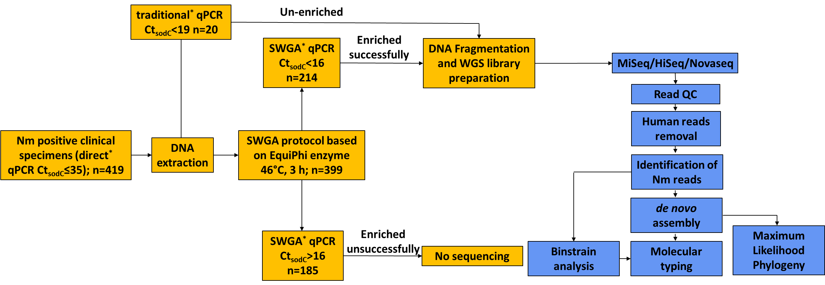

Figure S1. Scheme of the workflow used in the study. Stars designate three types of qPCR: performed on crude specimen (direct); on extracted DNA (traditional); on enriched specimens (SWGA). Orange boxes - bench work; Blue boxes – data analysis.

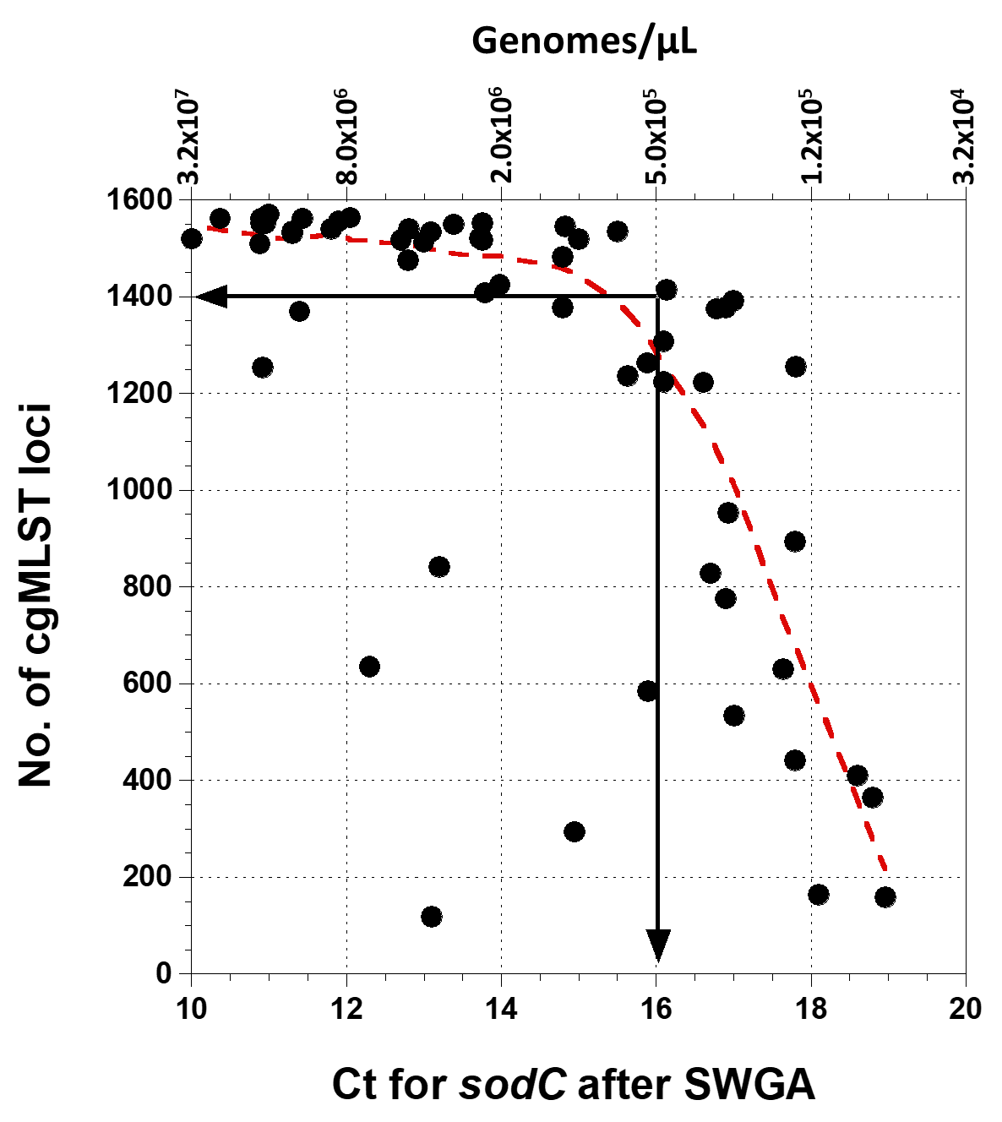

Fig. S2
The number of cgMLST loci present in genome assemblies as a function of Ct sodC value measured after SWGA procedure (bottom axis) or corresponding genome titer (upper axis). Genome assemblies with more than 1,400 cgMLST loci generally had over 95% accuracy at those loci that is required for accurate molecular typing of N. meningitidis (Itsko et al., 2020. Full Molecular Typing of Neisseria meningitidis Directly from Clinical Specimens for Outbreak Investigation. J Clin Microbiol 58, DOI:10.1128/JCM.01780-20). The arrows demonstrate the rational for cut off of Ct sodC 16.
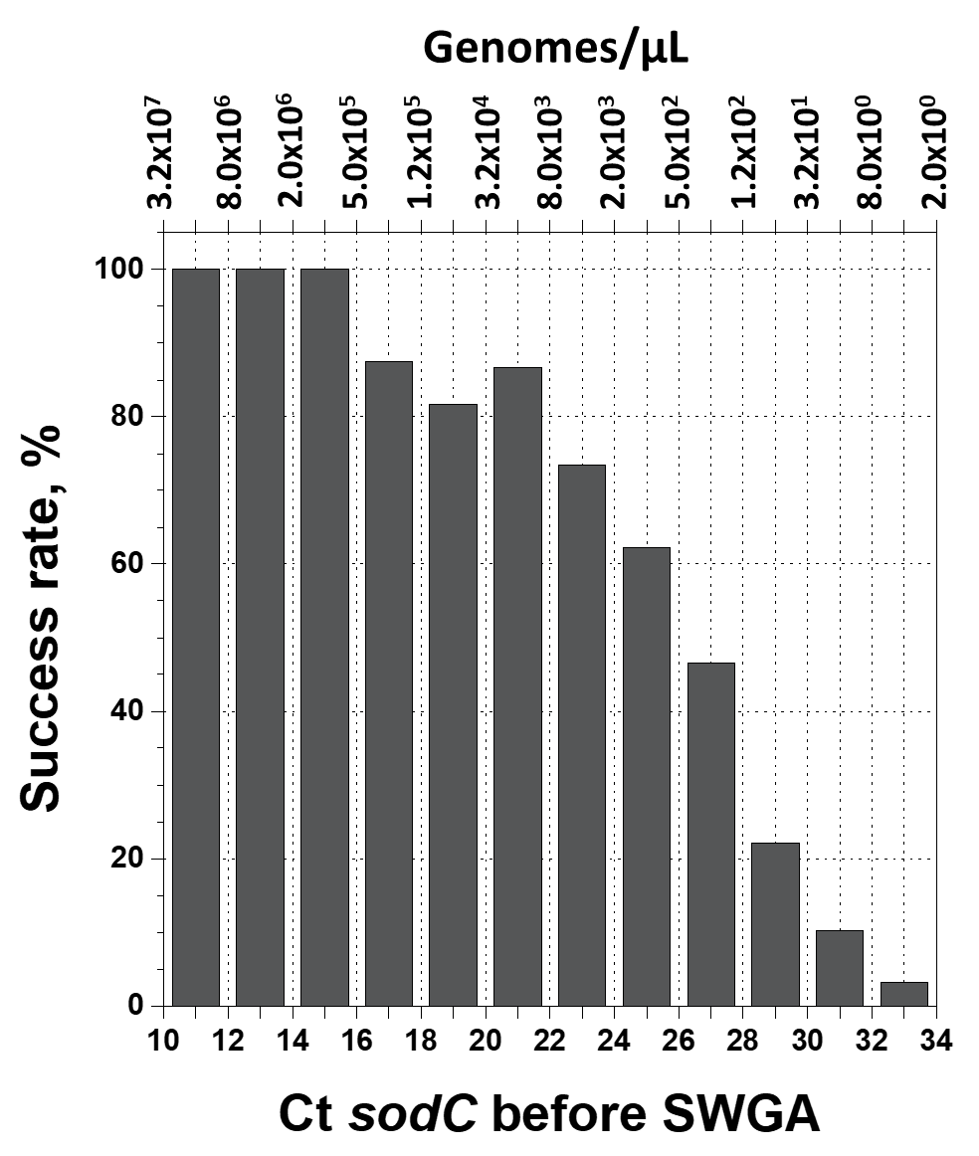

Fig. S3
Success rate of full molecular typing for N. meningitidis present in CSF specimen as a function of Ct sodC value measured before SWGA (bottom axis) or corresponding genome titer (upper axis). Each bin represents 2 Ct units or fourfold difference in titer.

