Supplement

Supplemental Methods

Study enrollment and data collection

Participants were recruited through two ascertainment mechanisms. In sentinel recruitment, persons with positive SARS-CoV-2 test results were identified and recruited from participating medical centers, community testing sites, actively surveilled cohorts, and public health registries. Sentinel recruitment sites were located in Arizona, California, Colorado, New York, North Carolina, Tennessee, and Wisconsin. In remote recruitment, persons with positive SARS-CoV-2 test results were identified through remote testing services or commercial testing platforms throughout the continental US. Index cases were deemed ineligible if >5 days had elapsed since symptom onset (or, if asymptomatic, first positive SARS-CoV-2 test), or if another household member tested positive for SARS-CoV-2 or reported COVID-19-like symptoms in the 7 days prior to enrollment.

Upon enrollment, participants (index and household contacts) completed a questionnaire providing demographics, household location, SARS-CoV-2 vaccination and infection history, and chronic medical conditions. We geocoded household location to the 2020 United States decennial census tract and then mapped to the Social Vulnerability Index (SVI). [1] SVI uses 16 U.S. census variables to indicate the relative vulnerability of every U.S. census tract to a hazardous event with values closer to 1 representing highly vulnerable areas and values closer to 0 representing less vulnerable areas. Elicited chronic medical conditions included asthma, non-asthma chronic lung disease, cancer, diabetes, cardiovascular/heart disease, immunocompromising conditions, immune suppressing medications, kidney disease, liver disease, and other chronic medical conditions. All participants were followed prospectively for 10 days after enrollment completing a daily diary recording symptoms experienced and medications taken for COVID-19 and providing daily specimens for SARS-CoV-2 testing. Elicited symptoms included fever (including feeling feverish/chills), cough, sore throat, runny nose, nasal congestion, fatigue (including feeling run down), wheezing, trouble breathing (including shortness of breath), chest tightness (including chest pain), loss of smell or taste, headache, abdominal pain, diarrhea, vomiting, and body aches (including muscle aches). All chronic medical conditions and symptoms had the response options of “Yes”, “No”, “Don’t know or can’t remember”, or “Prefer not to answer”. For symptoms, if all responses for a single day were either “don’t know or can’t remember”, “prefer not to answer”, or not answered, this day was excluded from all analyses (including rebound, average symptoms, etc.). Elicited COVID-19 medications included molnupiravir, remdesivir, and nirmatrelvir/ritonavir; other medications were reported in a free-response section of the diary.

Inclusion was restricted to participants with sufficient non-missing values for key variables. We excluded participants who did not respond “yes” or “no” to at least one chronic medical condition question or had missing SVI. We excluded individuals whose first symptom diary response was more than 5 days after symptom onset and individuals who did not complete at least two days of symptom diaries after treatment completion to ensure there was enough information to assess symptom trajectories after treatment completion.

Propensity Score Matching

We used propensity score (PS) matching to select similar untreated participants compared to N/R treated participants. PS matching was performed using logistic regression with the outcome of N/R treatment completion (N/R treated) versus no COVID-19 treatment with the following covariates: age at enrollment, sex, race/ethnicity, SVI, prior COVID-19, recruitment method, participant type (index vs. contact), accessed medical care after enrollment, received ≥3 verified COVID-19 vaccine doses, received a verified COVID-19 vaccine dose ≤6 months of index onset, SARS-CoV-2 variant circulating at the time of index onset, number of comorbidities, and whether the participant reported each of asthma or other lung disease, heart disease, diabetes, cancer, liver or kidney disease, immunocompromising condition or taking immunosuppressing medication, or any other chronic health condition. Balance of PS match was assessed using the absolute standardized mean difference using a value <0.1 to represent acceptable balance. We assessed several matching ratios and calipers on PS distance using the nearest method. The ratios we assessed ranged from 1:1 to 1:3 N/R treated to untreated participants and the calipers we assessed ranged from 0.2 to 0.9. Optimal balance and sample size was achieved with a 1:2 ratio of N/R treated to untreated participants using the nearest PS method and a caliper on PS distance of 0.4 (Supplemental Figure S1).

Sample collection, RT-PCR, and Viral Load Testing

Nasal swabs were self-collected and either directly inoculated by the participant or frozen and then inoculated by the central lab into Hologic Direct Load Tubes. These were tested for SARS-CoV-2 via real-time reverse transcriptase polymerase chain reaction (qRT-PCR) on the automated Hologic Panther Fusion assay. Although not intrinsically part of this platform, matrix-specific calibrators were also extracted and included in each qRT-PCR analysis, directly traceable to the International Unit-based standard of the WHO. [2] Viral loads (VL) of positive specimens were calculated via linear regression of the Ct-values of these calibrators. For VL analyses, negative results were set to zero log₁₀IU/mL and results below the limit of quantification (3.0 log₁₀IU/mL), but with a qualitative positive result were set to 1.5 log₁₀IU/mL.

Saliva samples were tested for SARS-CoV-2 using the Sampled/Infinity BiologiX TaqPath SARS-CoV-2 Assay. VL was not available for saliva samples and these samples were excluded from VL analyses.

N/R treated participants were included in VL analysis if they had ≥1 nasal VL result before treatment completion and ≥2 nasal VL results after treatment completion. Similarly, selected untreated participants were included if they had ≥1 nasal VL result before treatment completion proxy and ≥2 nasal VL results after proxy.

Supplemental References
1. Centers for Disease Control and Prevention/Agency for Toxic Substances and Disease Registry/Geospatial Research Analysis and Services Program. CDC/ATSDR Social Vulnerability Index 2020 Database US., 2020.
2. Bentley E, Mee ET, Routley S, et al. Collaborative Study for the Establishment of a WHO International Standard for SARS-CoV-2 RNA. Geneva, 2020.

Supplemental Tables/Figures

Table S1. Nirmatrelvir/ritonavir initiation and completion characteristics among all participants who initiated treatment compared to participants who completed treatment and were included in overall analysis

 | Initiated N/R | Subset who completed N/R
Characteristic | N = 222¹ | N = 133¹
Days from symptom onset to medication start
Median (IQR) | 2.00 (1.00, 3.00) | 2.00 (1.00, 3.00)
Range | 0.00, 5.00 | 0.00, 5.00
Duration of medication based on dates
Median (IQR) | 6.00 (5.00, 6.00) | 6.00 (5.00, 6.00)
Range | 1.00, 9.00 | 5.00, 6.00
Days from symptom onset to medication end
Median (IQR) | 6.00 (6.00, 7.00) | 7.00 (6.00, 7.00)
Range | 1.00, 10.00 | 5.00, 10.00
Completed N/R in 5-6 days² | 145 (65%) | 133 (100%)
Missed a day or more of medication | 22 (9.9%) | 0 (0%)
¹median (IQR), range, or n (%)
²Includes left censored people who reported N/R for 3-4 days

Figure S2. Absolute standardized mean difference of covariates predicting nirmatrelvir/ritonavir treatment completion including all untreated (All) and selected untreated (Matched) participants before and after propensity score matching

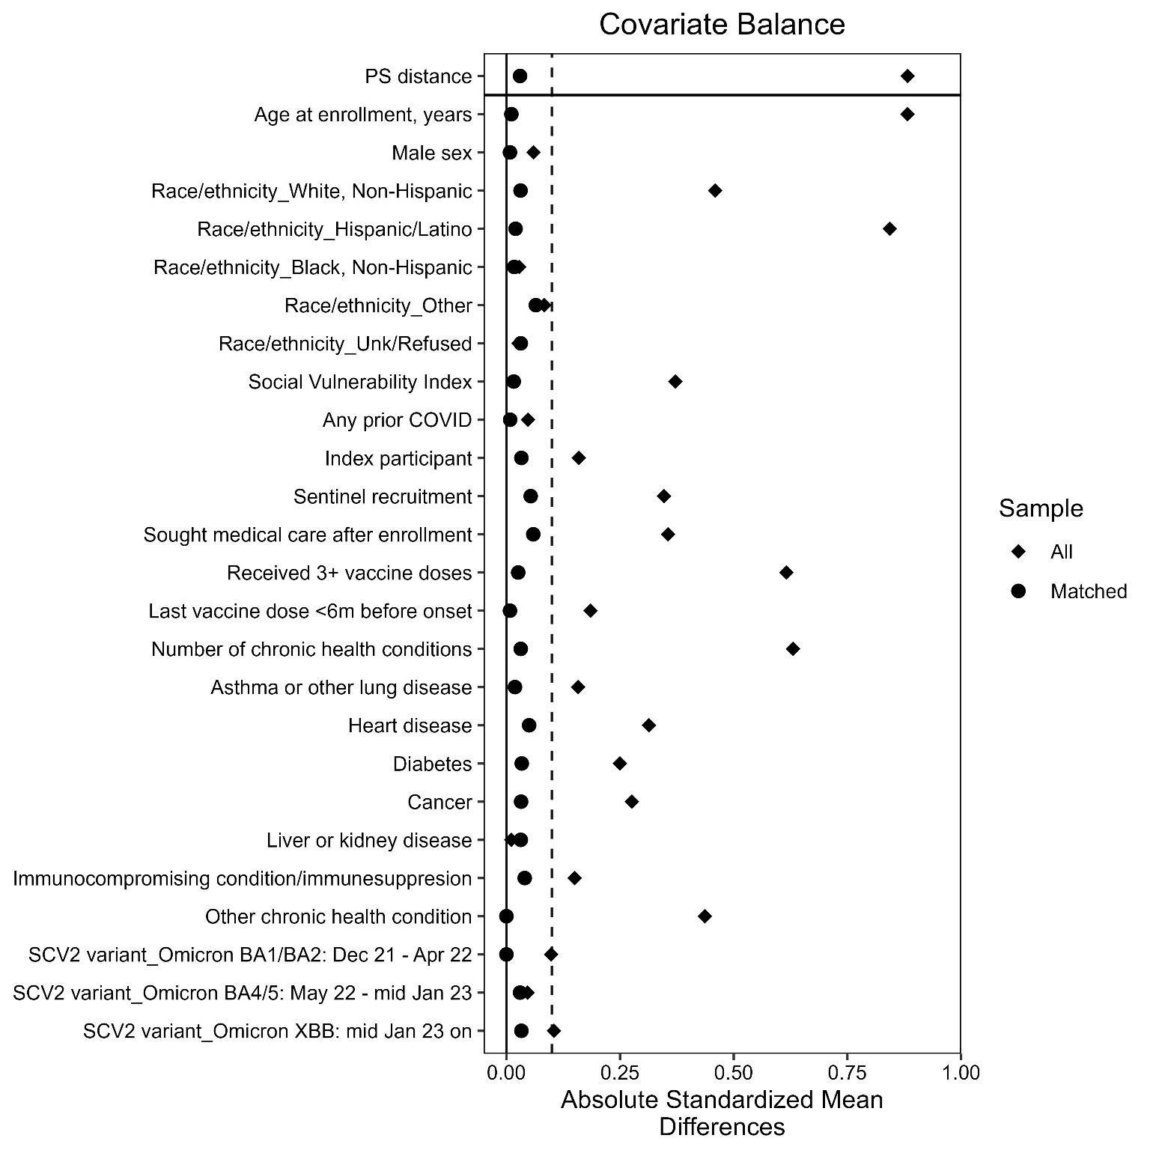
Footnote: Propensity score (PS) of N/R treatment completion (N/R treated) versus no COVID-19 treatment (untreated) was estimated using logistic regression with the following covariates: age at enrollment, sex, race/ethnicity, social vulnerability index, prior COVID-19, recruitment method, participant type (index vs. contact), accessed medical care after enrollment, received ≥3 verified COVID-19 vaccine doses, received a verified COVID-19 vaccine dose ≤6 months of index onset, SARS-CoV-2 variant circulating at the time of index onset, number of comorbidities, and whether the participant reported each of asthma or other lung disease, heart disease, diabetes, cancer, liver or kidney disease, immunocompromising condition or taking immunosuppressing medication, or any other chronic health condition.
Figure S1. Method for determination of symptom and viral load rebound status based on daily symptoms and nasal viral loads among nirmatrelvir/ritonavir treated participants and untreated participants.

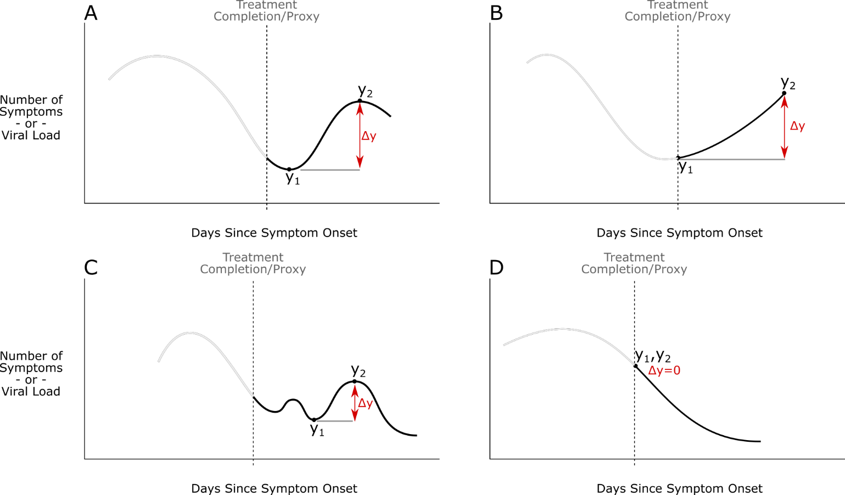
Footnote: Each panel diagrammatically depicts a hypothetical trajectory of a participant’s daily symptom number or viral load. The dotted vertical line in each figure represents the day of treatment completion among those who took nirmatrelvir/ritonavir or day seven since symptom onset among those who did not take treatment, also known as the day of treatment completion proxy. To determine whether a participant met rebound criteria, the following algorithm was used: a local maximum y2 was defined as the highest symptom number/viral load experienced by the participant after treatment completion/proxy; a local minimum y1 was defined as the lowest symptom number/viral load experienced between the day of treatment completion/proxy and y2. A participant is defined as experiencing rebound if the Δy (y2 – y1) is greater than or equal to a predefined value. In the primary analysis, the Δy for symptom rebound was defined as 2 symptoms and the Δy for viral load rebound was defined as 1 log₁₀IU/mL (conditional that y2 ≥ 5.0 log₁₀IU/mL).
Table S2. Sensitivity analysis of symptom rebound definition stratified by nirmatrelvir/ritonavir (N/R) treatment status
 |  | N/R treated, N = 130 |  | untreated, N = 241
Definition difference | N | n | Event rate  (95% CI¹) | n | Event rate  (95% CI¹) | p-value²
Analysis definition³ | 371 | 41 | 32% (24%, 40%) | 47 | 20% (15%, 25%) | 0.009
After 7 days SSO, both groups | 371 | 39 | 30% (22%, 39%) | 47 | 20% (15%, 25%) | 0.022
3+ symptoms | 371 | 19 | 15% (9.3%, 22%) | 22 | 9.1% (5.9%, 14%) | 0.11
4+ symptoms | 371 | 12 | 9.2% (5.1%, 16%) | 7 | 2.9% (1.3%, 6.1%) | 0.008
5+ symptoms | 371 | 9 | 6.9% (3.4%, 13%) | 3 | 1.2% (0.32%, 3.9%) | 0.005
Rebound from asymptomatic | 371 | 11 | 8.5% (4.5%, 15%) | 5 | 2.1% (0.77%, 5.0%) | 0.004
Rebound from asymptomatic; asymptomatic denominator | 79 | 11 | 28% (16%, 45%) | 5 | 13% (4.7%, 28%) | 0.082
¹CI = Confidence Interval
²Pearson's Chi-squared test; Fisher's exact test
³Symptom rebound, as included in the main analysis, was defined as an increase of two or more symptoms after treatment completion among N/R treated or proxy for treatment completion (7 days since symptom onset) among untreated
SSO=since symptom onset

Table S3. Participant demographics and characteristics for nirmatrelvir/ritonavir (N/R) treated and untreated groups, symptoms analysis participants compared to viral load analysis participants
 | Matched |  |  |  | Two or More VL
Characteristic |  | N/R treated  130¹ | Untreated  241¹ | p-value² |  | N/R treated  97¹ | Untreated  179¹ | p-value²
Age at enrollment, years |  | 56 (41, 66) | 53 (43, 65) | 0.5 |  | 54 (41, 65) | 52 (43, 64) | 0.7
Male sex |  | 54 (42%) | 99 (41%) | >0.9 |  | 41 (42%) | 75 (42%) | >0.9
Race/ethnicity |  |  |  | >0.9 |  |  |  | 0.8
White, Non-Hispanic |  | 108 (83%) | 203 (84%) |  |  | 78 (80%) | 150 (84%)
Hispanic/Latino |  | 5 (3.8%) | 11 (4.6%) |  |  | 5 (5.2%) | 7 (3.9%)
Black, Non-Hispanic |  | 7 (5.4%) | 12 (5.0%) |  |  | 6 (6.2%) | 12 (6.7%)
Other |  | 8 (6.2%) | 12 (5.0%) |  |  | 7 (7.2%) | 7 (3.9%)
Unk/Refused |  | 2 (1.5%) | 3 (1.2%) |  |  | 1 (1.0%) | 3 (1.7%)
Social Vulnerability Index |  | 0.28  (0.10, 0.50) | 0.28  (0.11, 0.49) | 0.6 |  | 0.30  (0.10, 0.52) | 0.27  (0.11, 0.49) | 0.9
Prior COVID-19 |  | 41 (32%) | 79 (33%) | 0.8 |  | 30 (31%) | 59 (33%) | 0.7
Enrolled from a sentinel site |  | 97 (75%) | 181 (75%) | >0.9 |  | 97 (100%) | 179 (100%)
Index participant |  | 87 (67%) | 166 (69%) | 0.7 |  | 66 (68%) | 117 (65%) | 0.7
Sought medical care after enrollment |  | 24 (18%) | 33 (14%) | 0.2 |  | 18 (19%) | 30 (17%) | 0.7
Received 3 or more COVID-19 vaccine doses |  | 117 (90%) | 217 (90%) | >0.9 |  | 86 (89%) | 157 (88%) | 0.8
Received COVID-19 vaccine <6 months ago |  | 52 (40%) | 95 (39%) | >0.9 |  | 39 (40%) | 67 (37%) | 0.7
Number of reported chronic medical conditions |  | 1 (1, 2) | 1 (0, 2) | 0.2 |  | 2 (0, 2) | 1 (0, 2) | 0.4
Asthma or other non-asthma chronic lung disease |  | 27 (21%) | 47 (20%) | 0.8 |  | 18 (19%) | 32 (18%) | 0.9
Cardiovascular/heart disease |  | 40 (31%) | 66 (27%) | 0.5 |  | 30 (31%) | 45 (25%) | 0.3
Diabetes |  | 17 (13%) | 27 (11%) | 0.6 |  | 10 (10%) | 21 (12%) | 0.7
Cancer |  | 18 (14%) | 26 (11%) | 0.4 |  | 13 (13%) | 20 (11%) | 0.6
Chronic kidney or liver disease |  | 2 (1.5%) | 4 (1.7%) | >0.9 |  | 2 (2.1%) | 3 (1.7%) | >0.9
Immunocompromising condition or currently takes any immune suppressing medications |  | 12 (9.2%) | 23 (9.5%) | >0.9 |  | 11 (11%) | 17 (9.5%) | 0.6
Any other chronic medical condition |  | 52 (40%) | 93 (39%) | 0.8 |  | 38 (39%) | 71 (40%) | >0.9
Predominant variant at time of enrollment |  |  |  | >0.9 |  |  |  | >0.9
Omicron BA1/BA2: Dec 21 - Apr 22 |  | 5 (3.8%) | 9 (3.7%) |  |  | 5 (5.2%) | 9 (5.0%)
Omicron BA4/5: May 22 - mid Jan 23 |  | 108 (83%) | 202 (84%) |  |  | 75 (77%) | 141 (79%)
Omicron XBB: mid Jan 23 on |  | 17 (13%) | 30 (12%) |  |  | 17 (18%) | 29 (16%)
¹Median (IQR); n (%)
²Wilcoxon rank sum test; Pearson's Chi-squared test; Fisher's exact test

Table S4. Sensitivity analysis of Viral load rebound definition stratified by nirmatrelvir/ritonavir (N/R) treatment status
 |  | N/R treated, N = 97 |  | untreated, N = 179
Definition difference | N | n | Event rate  (95% CI¹) | n | Event rate  (95% CI¹) | p-value²
Analysis definition³ | 276 | 26 | 27% (19%, 37%) | 12 | 6.7% (3.7%, 12%) | <0.001
After 7 days SSO, both groups | 276 | 22 | 23% (15%, 33%) | 12 | 6.7% (3.7%, 12%) | <0.001
0.5+ log increase | 276 | 27 | 28% (19%, 38%) | 21 | 12% (7.6%, 18%) | <0.001
1.5+ log increase | 276 | 25 | 26% (18%, 36%) | 6 | 3.4% (1.4%, 7.5%) | <0.001
2+ log increase | 276 | 23 | 24% (16%, 34%) | 4 | 2.2% (0.72%, 6.0%) | <0.001
3 log rebound threshold | 276 | 36 | 37% (28%, 48%) | 17 | 9.5% (5.8%, 15%) | <0.001
4 log rebound threshold | 276 | 28 | 29% (20%, 39%) | 12 | 6.7% (3.7%, 12%) | <0.001
6 log rebound threshold | 276 | 23 | 24% (16%, 34%) | 9 | 5.0% (2.5%, 9.6%) | <0.001
Rebound from BLQ | 276 | 18 | 19% (12%, 28%) | 0 | 0% (0.0%, 2.6%) | <0.001
Rebound from negative | 276 | 7 | 7.2% (3.2%, 15%) | 0 | 0% (0.0%, 2.6%) | <0.001
Rebound from negative; negative denominator | 61 | 7 | 21% (9.3%, 38%) | 0 | 0% (0.0%, 16%) | 0.014
¹CI = Confidence Interval
² Pearson's Chi-squared test; Fisher's exact test
³Viral load rebound, as included in the main analysis, was defined as an increase of 1 log10UI/mL in viral load (above 5 log10IU/mL threshold) after treatment completion among N/R treated or proxy for treatment completion (7 days since symptom onset) among untreated
SSO=since symptom onset; BLQ=below limit of quantification

Table S5. Symptom and viral load rebound among participants who initiated nirmatrelvir/ritonavirª compared with symptom and viral load rebound among participants who completed nirmatrelvir/ritonavir in 5-6 consecutive days (main analysis population)^{b}.
 | Any N/R treatment durationª |  |  |  | Completed N/R in 5-6 days^{b}
Characteristic | N | N/R treatment initiated¹ | Untreated¹ | p-value² | N | N/R treated¹ | Untreated¹ | p-value²
 |  | 215 | 374 |  |  | 130 | 241
Symptom rebound³ | 588 |  |  | 0.009 | 371 |  |  | 0.009
No rebound |  | 154 (72%) | 302 (81%) |  |  | 89 (68%) | 194 (80%)
Rebound |  | 61 (28%) | 71 (19%) |  |  | 41 (32%) | 47 (20%)
Viral load rebound⁴ | 420 |  |  | <0.001 | 276 |  |  | <0.001
No rebound |  | 114 (74%) | 249 (94%) |  |  | 71 (73%) | 167 (93%)
Rebound |  | 41 (26%) | 16 (6.0%) |  |  | 26 (27%) | 12 (6.7%)
¹n (%)
²Pearson's Chi-squared test
³Symptom rebound was defined as an increase of two or more symptoms after treatment completion among N/R treated or proxy for treatment completion (7 days since symptom onset) among untreated
⁴Viral load rebound was defined as an increase of 1 log₁₀UI/mL in viral load (above 5 log₁₀IU/mL threshold) after treatment completion among N/R treated or proxy for treatment completion (7 days since symptom onset) among untreated
ªParticipants included in the N/R treatment initiated group met same criteria as N/R treated participants except that N/R could be taken for any duration. Propensity score matching to select similar untreated participants was based on the probability of N/R treatment initiation versus no COVID-19 treatment given demographic, SVI, chronic medical conditions, COVID-19 vaccination history, prior infection, and dominant variant characteristics of the N/R treatment initiated participants. Covariate balance was achieved with 2:1 ratio of untreated to treatment initiated participants using the nearest PS and a caliper of 0.4 on PS distance.
^{b}Participants included in N/R treated are described in the manuscript and are a subset of the N/R treatment initiated group. Propensity score matching to select similar untreated participants was based on the probability of completing N/R treatment versus no COVID-19 treatment as described in the manuscript.

Table S6. Symptom and viral load rebound among participants who initiated nirmatrelvir/ritonavir by days of treatment completed
 |  | Less than 5 days  N = 59 |  | 5-6 days  N = 136 |  | Greater than 6 days  N = 20
Outcome | N | n | Event rate  (95% CI¹) | n | Event rate  (95% CI¹) | n | Event rate  (95% CI¹)
Symptom rebound² | 215 | 14 | 24% (14%, 37%) | 43 | 32% (24%, 40%) | 4 | 20% (6.6%, 44%)
Viral load rebound³ | 155 | 8 | 22% (10%, 39%) | 28 | 28% (20%, 38%) | 5 | 29% (11%, 56%)
¹CI = Confidence Interval
² Symptom rebound was defined as an increase of two or more symptoms after treatment completion among N/R treated or proxy for treatment completion (7 days since symptom onset) among untreated
³Viral load rebound was defined as an increase of 1 log10UI/mL in viral load (above 5 log10IU/mL threshold) after treatment completion among N/R treated or proxy for treatment completion (7 days since symptom onset) among untreated

