**Supplemental Table 1.** Histology Classification

|  |  |
| --- | --- |
| **Histology Variable: Categories** | **ICD-O-3 morphology codes** |
| Non-epithelial Histologies | 8000-8004, 8240-8245, 8330-8335, 8340, 8590-8671, 8680-8806, 8810-8921, 9040-9055, 9060-9105, 9120-9373, 9380-9523, 9530-9589 |
| Epithelial Histologies | 8005, 8010-8015, 8020-8046, 8050-8084, 8090-8110, 8120-8131, 8140-8231, 8246-8300, 8310-8325, 8336-8337, 8341-8375, 8380-8441, 8443, 8450, 8452-8454, 8460-8461, 8470-8471, 8480-8482, 8490, 8500-8551, 8560-8562, 8570-8589, 8930-8991, 9000, 9010-9030, 9110 |

**Supplemental Table 2.** Adjusted Odds of Completion of First-line Course of Chemotherapy as Planned (Versus Prematurely Discontinuing Chemotherapy Course) (N=430)

|  |  |  |  |
| --- | --- | --- | --- |
|  | | OR* | 95% CI |
| Age at Diagnosis (Years) | 18-45 | Reference | |
| 46-60 | 1.73 | 0.66-4.53 |
| 61-75 | 0.83 | 0.33-2.09 |
| 76-89 | 0.44 | 0.16-1.21 |
| Census Tract Median Income | $1-39,999 | Reference | |
| $40,000-50,999 | 0.94 | 0.45-1.98 |
| $51,000-65,999 | 0.94 | 0.42-2.07 |
| $66,000+ | 1.44 | 0.61-3.41 |
| Charlson Score at Diagnosis | 0 | Reference | |
| 1 | 1.23 | 0.63-2.42 |
| 2+ | 1.19 | 0.43-3.31 |
| Gynecologic Oncologist Involved in Chemotherapy | No | Reference | |
| Yes | 0.99 | 0.58-1.68 |
| Insurance Status | Insured | Reference | |
| Uninsured | 2.15 | 0.44-10.5 |
| Percentage of Census Tract Residents with Less Than a High School Education | 0-10% | Reference | |
| 11-20% | 1.31 | 0.70-2.44 |
| 21%+ | 0.71 | 0.25-2.02 |
| Race/Ethnicity | Non-Hispanic White | Reference | |
| Non-White | 1.18 | 0.36-3.92 |
| Rurality | Urban | Reference | |
| Rural | 0.93 | 0.54-1.61 |
| Stage | II | Reference | |
| III | 0.53 | 0.21-1.35 |
| IV | **0.28** | **0.10-0.77** |
| Unknown | -- | -- |
| Tumor Sequence | Only Ovarian Primary | Reference | |
| First Ovarian Primary | 2.72 | 0.57-13.0 |
| Visible Residual Tumor After Surgery | >1cm/ Unknown | Reference | |
| ≤1 cm | 1.29 | 0.80-2.08 |

Bolding indicates a significance at 0.05.

*Adjusted for all other exposures in the first column above that have values.

**Supplemental Table 3.** Adjusted Odds of Post-Surgery Tumor Growth

|  |  |  |  |  |  |
| --- | --- | --- | --- | --- | --- |
|  | | Platinum Resistant  (Versus Not)A  N=430 | | Platinum Sensitive  (Versus Not)B  N=310 | |
| OR* | 95% CI | OR* | 95% CI |
| Age at Diagnosis (Years) | 18-45 | Reference | | | |
| 46-60 | 2.34 | 0.66-8.28 | 1.44 | 0.59-3.50 |
| 61-75 | 2.47 | 0.70-8.73 | 1.05 | 0.43-2.57 |
| 76-89 | 2.13 | 0.53-8.62 | 0.60 | 0.20-1.80 |
| Census Tract Median Income | $1-39,999 | Reference | | | |
| $40,000-50,999 |  |  | 2.08 | 0.94-4.59 |
| $51,000-65,999 |  |  | 1.34 | 0.58-3.12 |
| $66,000+ |  |  | 0.96 | 0.40-2.32 |
| Charlson Score at Diagnosis | 0 | Reference | | | |
| 1 | 1.63 | 0.84-3.19 | 1.13 | 0.55-2.30 |
| 2+ | 0.99 | 0.35-2.82 | **4.55** | **1.32-15.7** |
| Grade | Well-Moderately Differentiated | Reference | | | |
| Poorly-Undifferentiated/ Unknown | 1.05 | 0.94-1.18 | 0.97 | 0.84-1.11 |
| Completion of First-line Course of Chemotherapy as Planned | No | Reference | | | |
| Yes |  |  | 1.03 | 0.55-1.93 |
| Gynecologic Oncologist Involved in Chemotherapy | No | Reference | | | |
| Yes | 1.36 | 0.76-2.44 | **2.00** | **1.10-3.61** |
| Insurance Status | Insured | Reference | | | |
| Uninsured |  |  | 0.85 | 0.22-3.36 |
| Percentage of Census Tract Residents with Less Than a High School Education | 0-10% | Reference | | | |
| 11-20% |  |  | **0.47** | **0.24-0.94** |
| 21%+ |  |  | 0.78 | 0.25-2.43 |
| Primary Site | Ovary | Reference | | | |
| Fallopian Tube and Peritoneum | 0.94 | 0.52-1.69 | 1.22 | 0.69-2.17 |
| Race/Ethnicity | Non-Hispanic White | Reference | | | |
| Non-White |  |  | 2.37 | 0.77-7.31 |
| Rurality | Urban | Reference | | | |
| Rural | 0.69 | 0.39-1.23 | 1.43 | 0.80-2.57 |
| Stage | II | Reference | | | |
| III | 2.99 | 0.88-10.2 | 2.13 | 0.95-4.77 |
| IV | **4.79** | **1.33-17.2** | **2.75** | **1.06-7.12** |
| Unknown | 2.92 | 0.22-38.7 | 1.87 | 0.19-18.4 |
| Tumor Sequence | Only Ovarian Primary | Reference | | | |
| First Ovarian Primary | 0.23 | 0.03-1.80 | 1.03 | 0.32-3.32 |
| Visible Residual Tumor After Surgery | >1cm/ Unknown | Reference | | | |
| ≤1 cm |  |  | 1.07 | 0.65-1.77 |

Bolding indicates a significance at 0.05.

*Adjusted for all other exposures in the first column above that have values.

A. The covariates included in the Platinum Resistant multivariable logistic regression model (versus the Platinum Sensitive) were limited to prevent over parameterization due to a small number of events/outcomes.

B. The Platinum Sensitive population is reduced (N= 310 versus 430) because women who had already had platinum resistant tumor growth or were deceased 6 months after chemotherapy were removed and ineligible from this analysis

**Supplemental Image 1**. Covariate Selection Through the Behavioral Model of Health Services Use Theory

*Predisposing*

*Factors*

*Enabling*

*Factors*

*Need*

*Factors*

*Outcomes*

**1. Chemotherapy Initiation**

**2. Gynecologic Oncologist Involved in Chemotherapy**

*Demographic Factors*

- Age

*Social Structure Factors*

- Race/Ethnicity

*Belief Factors*

-

*Family Factors*

- Insurance Status

*Community*

*Factors*

- Rurality of Residence at Diagnosis

- Resources of census tract—proxied by average wealth and education of census tract

**- Type of Surgeon**

*Perceived Factors*

- Overall health—proxied through the Charlson comorbidity score

*Evaluated*

*Factors*

- Stage at diagnosis

- Visible Residual Tumor After Surgery

- Tumor Sequence

This image shows the covariates included in Table 2 placed into the cateories of the Behavioral Model of Health Services Use theoretical framework. Bolding indicates the primary exposure and the outcomes of interest for the models in Table 2.

**Supplemental Image 2.** 5-year All-Cause Survival Probabilities by Tumor Remaining After Surgery

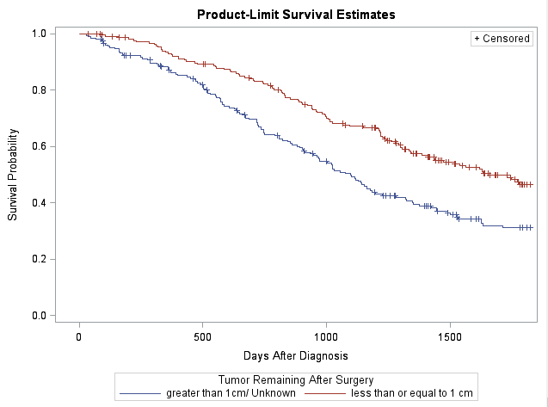

This shows the product-limit survival estimates for Tumor remaining after surgery.

**Supplemental Image 3.** 5-year All-Cause Survival Probabilities by Stage at Diagnosis

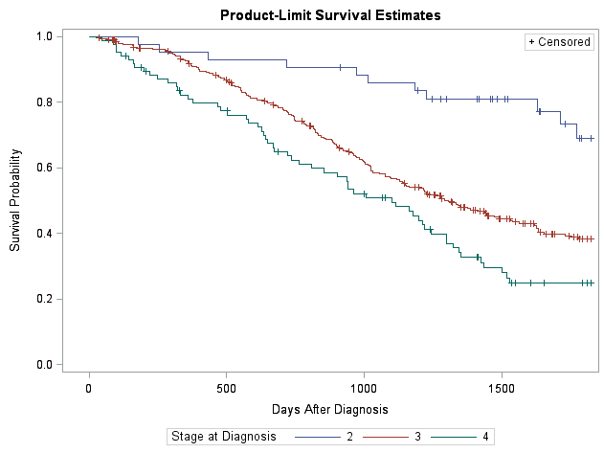

This shows the product-limit survival estimates for stage at diagnosis.