The Role of Stroke Care Infrastructure on the Effectiveness of a Hub-and-Spoke Telestroke Model in South Carolina: Online Appendix

This online appendix presents additional results for the evaluation of the MUSC telestroke model.
- Figure A1: MUSC telestroke network map
- Table A1: Analytic sample of telestroke encounters across spoke hospitals (2015-2022)
- Table A2: Distribution of spoke hospitals by rurality and size (2015-2022)
- Table A3: Distribution of spoke hospitals by stroke coordinators and stroke center certifications (2015-2022)
- Table A4: Distribution of telestroke encounters by stroke coordinators and stroke center certifications (as of 2022)
- Table A5: Adjusted association between DTN time and existence of stroke infrastructure components at spoke hospitals (2015-2022), by hospital types defined by rurality and size

Figure A1: MUSC telestroke network map
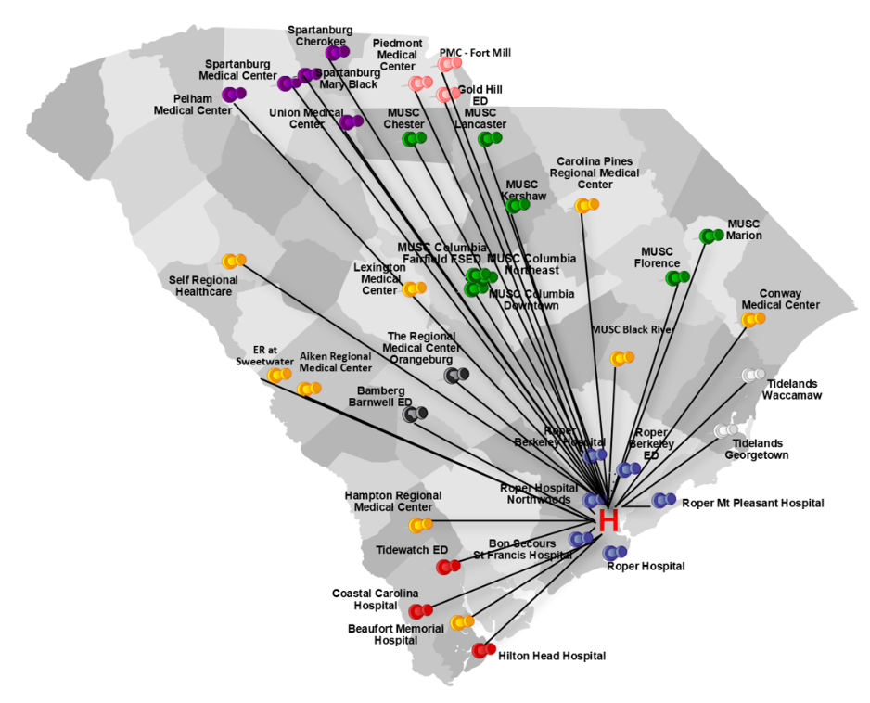
Source: Map provided to the evaluation team by MUSC. The different colored pins represent different hospital systems within the telestroke network. Green represents the regional health network (RHN), purple represents the Spartanburg system, pink represents the Piedmont system, blue represents the Roper system, red represents the coastal system, black represents the Orangeburg system, white are Tidelands system, and yellow represents “other.”

Table A1: Analytic sample of telestroke encounters across spoke hospitals (2015-2022)
Inclusion Criteria | Number of Encounters | Number of Spoke Hospitals Represented by the Encounters
Telestroke encounters/spoke hospitals in registry | 26,651 | 37
Those with a diagnosis of acute ischemic stroke | 12,059 | 37
Those associated with patients aged 18 and above | 12,048 | 37
Those during which tPA was given | 3,041 | 36
Total number of included observations/spoke hospitals with non-missing data on analytic variables of interest | 1,974 | 29*
tPA = tissue plasminogen activator.
*Hospitals were excluded from analysis if they reported having a coordinator but were missing the coordinator start date, or if they reported having certification but were missing the certification effective date.

Table A2: Distribution of included spoke hospitals by rurality and size (2015-2022)
Variable | N | %
Spoke hospital location
Urban area | 18 | 62.1
Rural area | 11 | 37.9
Spoke hospital size
Large | 7 | 24.1
Medium | 12 | 41.4
Small | 10 | 34.5
Spoke hospital rurality was determined by merging hospital zip codes with the Health Resources and Services Administration’s (HRSA) Federal Office of Rural Health Policy data files. Spoke hospital size is based on an MUSC-provided classification of hospitals, according to which small hospitals are those with 1-25,000 emergency department (ED) visits; medium hospitals are those with 25,001-50,000 ED visits; and large hospitals are those with 50,001-90,000 ED visits.

Table A3: Distribution of included spoke hospitals by stroke coordinators and stroke center certification (as of 2022)
Variable | N | %
Stroke infrastructure component
Had both | 18 | 62.1
Had a stroke coordinator only | 2 | 6.9
Had stroke center certification only | 2 | 6.9
No coordinator or certification | 7 | 24.1
Stroke certification type
Acute Stroke Ready | 4 | 13.8
Advanced Primary Stroke Center | 15 | 51.7
Thrombectomy-Capable Stroke Center | 1 | 3.4
No certification | 9 | 31.0

Table A4: Distribution of included telestroke encounters by stroke coordinators and stroke center certifications (2015-2022)
Variable | N | %
Stroke infrastructure component
Had both | 1,197 | 60.6
Had a stroke coordinator only | 395 | 20.0
Had stroke center certification only | 105 | 5.3
No coordinator or certification | 277 | 14.0
Stroke certification type
Acute Stroke Ready | 47 | 2.4
Advanced Primary Stroke Center | 1,252 | 63.4
Thrombectomy-Capable Stroke Center | 3 | 0.2
No certification | 672 | 34.0

Table A5: Adjusted association between DTN time and existence of stroke infrastructure components at spoke hospitals (2015-2022), by hospital types defined by rurality and size
Variable | Mean DTN Time  β (95% CI) | DTN Time ≤60 Min  OR (95% CI) | DTN Time ≤45 Min  OR (95% CI)
Rural Hospitals | −14.93***  (−23.11 - −6.74) | 2.33***  (1.34 - 4.03) | 2.87**  (1.14 - 7.26)
Encounter in spoke hospital with one stroke infrastructure component | −14.93***  (−23.11 - −6.74) | 2.33***  (1.34 - 4.03) | 2.87**  (1.14 - 7.26)
Encounter in spoke hospital with both stroke infrastructure components | −24.78***  (−34.00 - −15.57) | 4.59***  (2.43 - 8.66) | 5.99***  (2.34 - 15.37)
Reference category: Encounter in spoke hospital with neither component | - | - | -
Urban Hospitals | −12.95**  (−24.13 - −1.77) | 2.74**  (1.13 - 6.65) | 4.04***  (2.35 - 6.92)
Encounter in spoke hospital with one stroke infrastructure component | −12.95**  (−24.13 - −1.77) | 2.74**  (1.13 - 6.65) | 4.04***  (2.35 - 6.92)
Encounter in spoke hospital with both stroke infrastructure components | −10.66*  (−21.54 - 0.22) | 2.36**  (1.10 - 5.05) | 3.32***  (2.15 - 5.11)
Reference category: Encounter in spoke hospital with neither component | - | - | -
Small/Medium Hospitals | −16.68***  (−24.12 - −9.23) | 2.99***  (1.78 - 5.03) | 3.81***  (1.94 - 7.50)
Encounter in spoke hospital with one stroke infrastructure component | −16.68***  (−24.12 - −9.23) | 2.99***  (1.78 - 5.03) | 3.81***  (1.94 - 7.50)
Encounter in spoke hospital with both stroke infrastructure components | −20.62***  (−29.55 - −11.70) | 4.18***  (2.31 - 7.59) | 4.42***  (2.46 - 7.95)
Reference category: Encounter in spoke hospital with neither component | - | - | -
Large Hospitals | −16.89***  (−25.37 - −8.42) | 3.08***  (1.45 - 6.57) | 5.49***  (2.56 - 11.80)
Encounter in spoke hospital with one stroke infrastructure component | −16.89***  (−25.37 - −8.42) | 3.08***  (1.45 - 6.57) | 5.49***  (2.56 - 11.80)
Encounter in spoke hospital with both stroke infrastructure components | −14.98***  (−17.90 - −12.06) | 2.76***  (2.07 - 3.67) | 5.07***  (3.93 - 6.54)
Reference category: Encounter in spoke hospital with neither component | - | - | -
*** p <0.01, ** p <0.05, * p <0.1.
All models controlled for age, sex, race, and initial NIHSS score reported during the telestroke encounter. Hospital size-based regressions also controlled for hospital rurality, while the hospital rurality-based regressions also controlled for hospital size.
β = beta coefficient, CI = confidence interval, DTN = door-to-needle, NIHSS = National Institutes of Health Stroke Scale, OR = odds ratio.

