Supplemental Content

Supplemental Figure 1. Participating local health departments
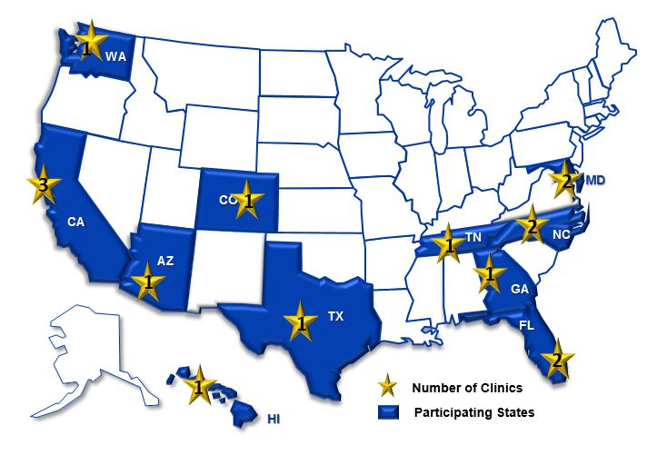

Fifteen local health department TB clinics within 13 cities across 11 US states.

Supplemental Table 1. Site-specific patient and testing characteristics
Study site | N¹ | Non-US–born  n (%) | Female  n (%) | TST (16,689)  n (%)² | QFT (6,993)  n (%)² | T-SPOT (1,934)  n (%)²
Clinic 1 | 9,053 | 3,526 (39) | 5,250 (58) | 9,053 (100) | 127 (1) | 127 (1)
Clinic 2 | 2,636 | 2,307 (89) | 1,373 (52) | 513 (19) | 2,543 (96) | 147 (6)
Clinic 3 | 2,180 | 1,044 (97) | 1,000 (46) | 1,235 (57) | 84 (4) | 884 (41)
Clinic 4 | 2,022 | 369 (19) | 956 (47) | 1,088 (54) | 989 (49) | 0 (0)
Clinic 5 | 1,634 | 1,074 (86) | 790 (48) | 762 (47) | 914 (56) | 0 (0)
Clinic 6 | 1,423 | 274 (20) | 532 (37) | 1,273 (89) | 154 (11) | 0 (0)
Clinic 7 | 1,419 | 306 (22) | 1,056 (74) | 1,408 (99) | 0 (0) | 12 (1)
Clinic 8 | 1,181 | 1,181 (100) | 588 (50) | 424 (36) | 1,180 (100) | 272 (23)
Clinic 9 | 647 | 56 (14) | 400 (62) | 425 (66) | 4 (<1) | 240 (37)
Clinic 10 | 571 | 322 (59) | 311 (55) | 327 (57) | 2 (<1) | 244 (43)
Clinic 11 | 385 | 248 (65) | 163 (42) | 20 (5) | 385 (100) | 5 (1)
Clinic 12 | 362 | 79 (22) | 191 (53) | 75 (21) | 309 (85) | 1 (<1)
Clinic 13 | 275 | 201 (77) | 144 (52) | 60 (22) | 229 (83) | 0 (0)
Clinic 14 | 59 | 48 (81) | 34 (58) | 12 (20) | 47 (80) | 2 (3)
Clinic 15 | 38 | 15 (56) | 15 (39) | 14 (37) | 26 (68) | 0 (0)
TST, tuberculin skin test; QFT, QuantiFERON-TB Gold-in-Tube/Plus test; T-SPOT, T-SPOT.TB test
¹ Patients receiving local health department directed testing (primary analysis). The median number of participants per site was 1,181 (IQR 362-2022)
² In some cases the total number of tests exceeds the total number of unique individuals as some received more than one test

Supplemental Table 2: LTBI Care Cascade for those with health department directed testing
Cascade Step
 |  | Non-US–born |  | US-born |  | Total³ | P⁴
 |  | n | %¹ | n | %¹ | n
Tested |  | 11,050 | -- | 10,962 | -- | 23,885
LTBI test positive |  | 2,498 | 23% | 336 | 3.1% | 2,877 (12%) | <0.01
Diagnosed with LTBI^{2,5} |  | 2,192 | 88% | 291 | 87% | 2,515 (87%) | <0.01
Started LTBI treatment⁶ |  | 950 | 43% | 113 | 39% | 1,073 (43%) | 0.145
 | isoniazid | 130 | 14% | 31 | 27% | 163 | <0.01
 | isoniazid + rifampin/rifabutin | 60 | 6% | 2 | 2% | 62
 | isoniazid + rifapentine | 206 | 22% | 16 | 14% | 226
 | rifampin | 550 | 58% | 62 | 55% | 615
 | unknown/Other | 4 | 0.4% | 2 | 2% | 7
Completed LTBI treatment |  | 740 | 78% | 69 | 61% | 817 (76%) | <0.01
LTBI, Latent tuberculosis infection
¹ Percentages are relative to the prior row. Percentages for medications is relative to those starting therapy.
² Diagnosed individuals based on clinical documentation of an LTBI diagnosis or LTBI treatment initiation, and includes a minority of individuals without available chest x-ray results or laboratory test results. Thirty-three individuals had a diagnosis of LTBI without any documented positive test results. 2,264 (91%) of non-USB and 286 (85%) had documentation of chest x-ray completed.
³ Total includes 1,873 patients for whom birth country was not known, of whom 43 had a positive test result, 32 were diagnosed with LTBI, and 10 started therapy.
⁴ P-values for comparisons between non-US–born and US-born individuals.
⁵The proportion diagnosed with LTBI by race was 25% [973/3875], 23% 575/2509, 14% [14/3201] for Asian, Black, White, respectively, among non-USB individuals. The proportion diagnosed with LTBI differed by reason for testing and were highest among contacts of individuals with TB disease (19.6% [316/1616]), 16% (816/5144) among individuals tested for refugee associated care, 35% (606/1701) among other immigration related care overall [ (50% [335/662] among subgroup of individuals with Class B1 visa), and lower among individuals tested for student evaluation (158/3062, 5%), and employment (363/6688, 5%).
⁶ The proportion of individuals with LTBI starting therapy was highest among individuals evaluated as part of contact investigations (231/316, 73%), of which 70% (162/231) completed therapy. Among 816 refugees diagnosed with LTBI, 494 (61%) started therapy, of which 396 (80%) completed therapy. Among all individuals evaluated for immigration related care (non-refugee) with diagnosis of LTBI 31% (190/606) initiated therapy, of which 154 (81%) completed treatment.

Supplemental Table 3: LTBI Care Cascade inclusive of those with health department directed testing AND those referred into care with a known positive test.¹

Cascade Step
 | Non-US—born |  | US-born |  | Total³
 | n | %² | n | %² | N
LTBI test positive¹ | 3,811 | REF | 565 | REF | 4,563
Diagnosed with LTBI | 3,336 | 88% | 464 | 82% | 3,972(87%)
Started LTBI treatment | 1,474 | 44% | 183 | 39% | 1,670(42%)
Completed LTBI treatment | 1,070 | 73% | 111 | 61% | 1,192(71%)
¹ Some individuals were referred to the health department with a known positive test and excluded in primary analysis which included assessment of percent positivity among individuals being evaluated for LTBI. In this secondary analysis, we present the cascade beginning with individuals with positive tests inclusive of individuals referred with prior positive test results
² Percentages are relative to the prior row.
³ There were 187 individuals without birth country recorded who are included in the total

Supplemental Figure 2: LTBI care cascade by site

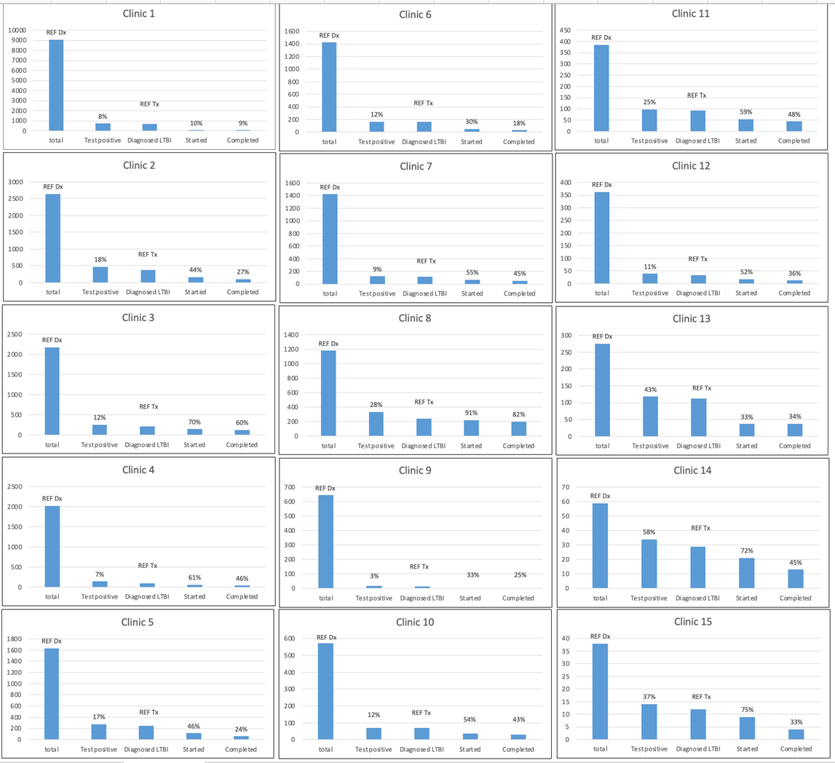
LTBI, latent tuberculosis infection
Percentage of patients who test positive are relative to the total number of patients at each site (REF Dx)
Percentage of patients who start/complete treatment are relative to the number of patients diagnosed with LTBI (REF Tx)

Supplemental Figure 3: Clinic-specific random effects for starting treatment, among those diagnosed with LTBI.

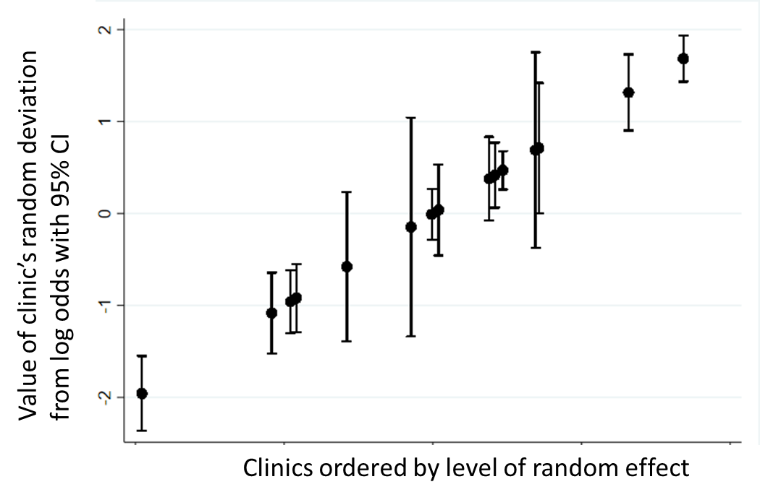
Figure legend: We conducted a generalized linear mixed effect regression with sites as a random effect. There was variation in initiating therapy between sites. Each point represents the individual clinic’s deviation from the average log odds for initiating therapy.

Supplemental Figure 4: Clinic-specific random effects for completing treatment, among those who started LTBI treatment.

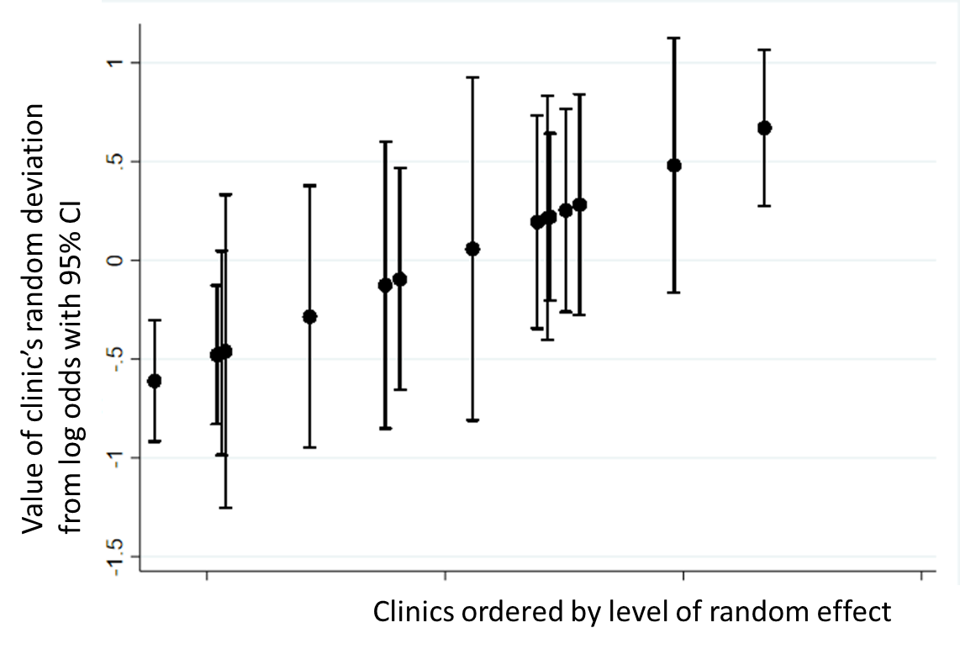
Figure legend: We conducted a generalized linear mixed effect regression with sites as a random effect. Each point represents the individual clinic’s deviation from the average log odds for completing therapy.

