Supplementary Figure 1 (S1): The sequencing library with P5 and P7 flow-cell binding sequences. We used two separate sequencing primers for priming Read 1 and Read 2 on the MiSeq for paired-end sequencing (Table 1). The upper strand (us) sequence (5'- to 3'-end) pairs with its lower strand (ls) in the direction from its 3'- to 5'-end. Arrows point sequencing reaction direction.

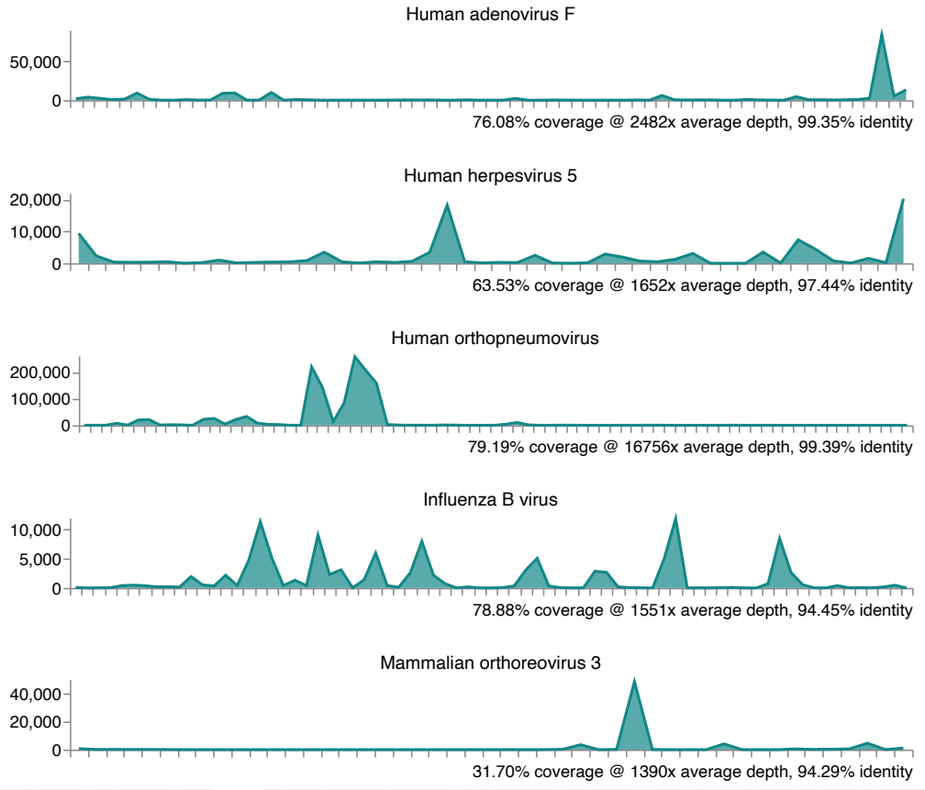
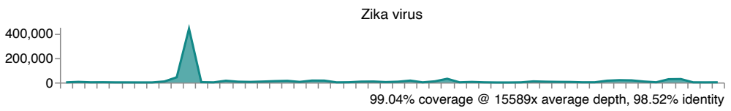

Supplementary Figure: One Codex sequence alignment report. The analysis of sequence alignment of raw sequencing reads (FASTQ) to viral reference genomes was performed. Viruses are reported as "detected" if ≥20% of the genome is observed at ≥ 10x depth. The Y and X axis represent the genome fold coverage (reads/base) and genome position respectively.

Supplementary Figure 2 (S2): Depth of coverage plot generated by One Codex. The performance chart shows the nucleotide coverage read depth (alignment-based coverage using Minimap2) plotted on a log scale in vertical axis (y) and the read length (nucleotide position) on a linear scale in horizontal axis (x). The genome coverage for the virus was established based on the read length and depth. One Codex alignment confirmed the detection of each virus in a given sample if only the breadth of genome coverage (percent of genome sequenced that is aligned with reference genome) is ≥20% and as well as the depth of sequencing (number of sequencing reads at each reference nucleotide base) at ≥ 10×.

