Supplementary Materials
Changes in Opioid Dispensing by Medical Specialties after Release of the 2016 CDC Guideline for Prescribing Opioids for Chronic Pain
Phillip P. Salvatore, PhD, SM^{a,b} Gery P. Guy Jr., PhD, MPH^{b} Christina A. Mikosz, MD, MPH^{b}
ª Epidemic Intelligence Service, Centers for Disease Control and Prevention, Atlanta, GA
^{b} Division of Overdose Prevention, National Center for Injury Prevention and Control, Centers for Disease Control and Prevention

Figure S1. Flow Chart for Dispensed Prescriptions Included for Analysis – United States, 2015-2019.
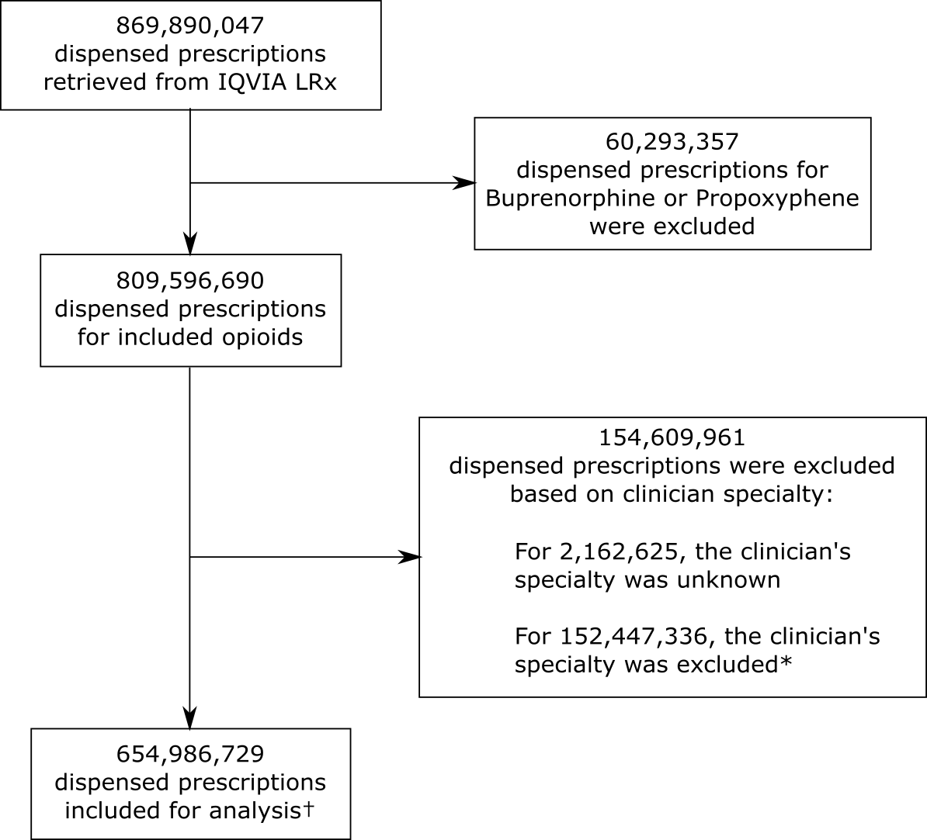
*A full list of clinician specialties which were excluded is included in Supplementary Table SX.
† 654,986,729 dispensed prescriptions met minimum data completeness for inclusion and are analyzed in Table 1. An additional 998,482 dispensed prescriptions (<0.1% of included data) for which dosage, quantity, and/or dispensing date were missing were excluded from the interrupted time-series analysis.
Table S1. Medical Specialty Group Categorization for IQVIA Clinician Specialties.

Clinician Specialty Description | Specialty Group
Addiction Medicine | Addiction Medicine
Addiction Psychiatry | Addiction Medicine
Allergy | Allergy & Immunology
Allergy & Immunology | Allergy & Immunology
Clinical & Laboratory Immunology (Internal Medicine) | Allergy & Immunology
Clinical Laboratory Immunology (Allergy & Immunology) | Allergy & Immunology
Immunology | Allergy & Immunology
Adult Cardiothoracic Anesthesiology | Anesthesiology
Anesthesiology | Anesthesiology
Certified Nurse Anesthetist | Anesthesiology
Internal Medicine/Anesthesiology | Anesthesiology
Obstetric Anesthesiology | Anesthesiology
Pediatric Anesthesiology | Anesthesiology
Pediatrics/Anesthesiology | Anesthesiology
Adult Congenital Heart Disease (Internal Medicine) | Cardiology
Advanced Heart Failure & Transplant Cardiology | Cardiology
Cardiovascular Disease | Cardiology
Clinical Cardiac Electrophysiology | Cardiology
Interventional Cardiology | Cardiology
Dental Hygienist | Dentist
Dentist | Dentist
Dentistry/Anesthesiology | Dentist
Dentistry/Endodontics | Dentist
Dentistry/Orthodontics | Dentist
Dentistry/Pedodontics | Dentist
Dentistry/Periodontics | Dentist
Dentistry/Prosthodontics | Dentist
Clinical Informatics (Emergency Medicine) | Emergency Medicine
Critical Care Medicine (Emergency Medicine) | Emergency Medicine
Emergency Medical Services | Emergency Medicine
Emergency Medical Services | Emergency Medicine
Emergency Medicine | Emergency Medicine
Internal Medicine/Emergency Medicine | Emergency Medicine
Medical Toxicology (Emergency Medicine) | Emergency Medicine
Medical Toxicology (Preventive Medicine) | Emergency Medicine
Pediatric Emergency Medicine | Emergency Medicine
Pediatric Emergency Medicine (Pediatrics) | Emergency Medicine
Pediatrics/Emergency Medicine | Emergency Medicine
Clinician Specialty Description | Specialty Group
Sports Medicine (Emergency Medicine) | Emergency Medicine
Underseas Medicine (Emergency Medicine) | Emergency Medicine
Diabetes | Endocrinology
Endocrinology, Diabetes & Metabolism | Endocrinology
Clinical Informatics (Family Medicine) | Family Medicine
Family Medicine | Family Medicine
General Practice | Family Medicine
Geriatric Medicine (Family Medicine) | Family Medicine
Internal Medicine/Family Medicine | Family Medicine
Sports Medicine (Family Medicine) | Family Medicine
Gastroenterology | Gastroenterology/Hepatology
Hepatology | Gastroenterology/Hepatology
Transplant Hepatology (Internal Medicine) | Gastroenterology/Hepatology
Infectious Disease | Infectious Disease
Clinical Informatics (Internal Medicine) | Internal Medicine
Geriatric Medicine (Internal Medicine) | Internal Medicine
Hospitalist | Internal Medicine
Internal Medicine | Internal Medicine
Internal Medicine/Preventive Medicine | Internal Medicine
Osteopathic Manipulative Medicine | Internal Medicine
Sports Medicine (Internal Medicine) | Internal Medicine
Nephrology | Nephrology
Sleep Medicine | Neurology
Critical Care Medicine (Obstetrics & Gynecology) | OB/GYN
Female Pelvic Medicine & Reconstructive Surgery | OB/GYN
Gynecology | OB/GYN
Maternal & Fetal Medicine | OB/GYN
Obstetrics | OB/GYN
Obstetrics & Gynecology | OB/GYN
Reproductive Endocrinology & Infertility | OB/GYN
Aerospace Medicine | Occupational Medicine
General Preventive Medicine | Occupational Medicine
Occupational Medicine | Occupational Medicine
Public Health & General Preventive Medicine | Occupational Medicine
Underseas Medicine (Preventive Medicine) | Occupational Medicine
Gynecological Oncology | Oncology and/or Hematology
Hematology (Internal Medicine) | Oncology and/or Hematology
Hematology/Oncology | Oncology and/or Hematology
Clinician Specialty Description | Specialty Group
Medical Oncology | Oncology and/or Hematology
Musculoskeletal Oncology | Oncology and/or Hematology
Radiation Oncology | Oncology and/or Hematology
Ophthalmology | Ophthalmology
Retinal Specialist | Ophthalmology
Abdominal Radiology | Other
Acupuncturist | Other
Anatomic Pathology | Other
Anatomic/Clinical Pathology | Other
Behavioral Health & Social Services | Other
Blood Banking/Transfusion Medicine | Other
Cardiothoracic Radiology | Other
Chemical Pathology | Other
Clinical Biochemical Genetics | Other
Clinical Cytogenetics | Other
Clinical Genetics | Other
Clinical Informatics (Pathology) | Other
Clinical Molecular Genetics | Other
Clinical Neurophysiology | Other
Clinical Pathology | Other
Cytopathology | Other
Dermatologic Surgery | Other
Dermatology | Other
Dermatopathology | Other
Diagnostic Radiology | Other
Diagnostic Radiology/Nuclear Medicine | Other
Epilepsy | Other
Forensic Pathology | Other
Hematology (Pathology) | Other
Interventional Radiology-Integrated | Other
Medical Genetics | Other
Molecular Genetic Pathology (Pathology) | Other
Musculoskeletal Radiology | Other
Neurology | Other
Neuromuscular Medicine (Neurology) | Other
Neuropathology | Other
Neuroradiology | Other
Nuclear Cardiology | Other
Nuclear Medicine | Other
Nuclear Radiology | Other
Pediatric Pathology | Other
Pharmaceutical Medicine | Other
Clinician Specialty Description | Specialty Group
Procedural Dermatology | Other
Radiology | Other
Selective Pathology | Other
Therapeutic Radiology | Other
Vascular & Interventional Radiology | Other
Vascular Medicine | Other
Vascular Neurology | Other
Pain Medicine | Pain Medicine
Pain Medicine (Anesthesiology) | Pain Medicine
Pain Medicine (Neurology) | Pain Medicine
Pain Medicine (Physical Medicine & Rehabilitation) | Pain Medicine
Pain Medicine (Psychiatry) | Pain Medicine
Regional Anesthesiology And Acute Pain Medicine (Anesthesia) | Pain Medicine
Hospice & Palliative Medicine | Palliative Care
Hospice & Palliative Medicine (Anesthesiology) | Palliative Care
Hospice & Palliative Medicine (Emergency Medicine) | Palliative Care
Hospice & Palliative Medicine (Family Medicine) | Palliative Care
Hospice & Palliative Medicine (Internal Medicine) | Palliative Care
Hospice & Palliative Medicine (Obstetrics & Gynecology) | Palliative Care
Hospice & Palliative Medicine (Pediatrics) | Palliative Care
Hospice & Palliative Medicine (Physical Medicine & Rehabilitation) | Palliative Care
Hospice & Palliative Medicine (Psychiatry & Neurology) | Palliative Care
Hospice & Palliative Medicine (Radiology) | Palliative Care
Palliative Medicine | Palliative Care
Pediatric Hematology/Oncology | Pediatric Hematology/Oncology
Child & Adolescent Psychiatry | Pediatric Subspecialties (Other)
Child Neurology | Pediatric Subspecialties (Other)
Clinical & Laboratory Immunology (Pediatrics) | Pediatric Subspecialties (Other)
Pediatric Allergy | Pediatric Subspecialties (Other)
Pediatric Cardiology | Pediatric Subspecialties (Other)
Pediatric Cardiothoracic Surgery | Pediatric Subspecialties (Other)
Pediatric Critical Care Medicine | Pediatric Subspecialties (Other)
Pediatric Dermatology | Pediatric Subspecialties (Other)
Pediatric Endocrinology | Pediatric Subspecialties (Other)
Pediatric Gastroenterology | Pediatric Subspecialties (Other)
Pediatric Infectious Disease | Pediatric Subspecialties (Other)
Pediatric Nephrology | Pediatric Subspecialties (Other)
Pediatric Ophthalmology | Pediatric Subspecialties (Other)
Pediatric Orthopedics | Pediatric Subspecialties (Other)
Pediatric Otolaryngology | Pediatric Subspecialties (Other)
Clinician Specialty Description | Specialty Group
Pediatric Pulmonology | Pediatric Subspecialties (Other)
Pediatric Radiology | Pediatric Subspecialties (Other)
Pediatric Rheumatology | Pediatric Subspecialties (Other)
Pediatric Surgery | Pediatric Subspecialties (Other)
Pediatric Surgery (Neurology) | Pediatric Subspecialties (Other)
Pediatric Transplant Hepatology | Pediatric Subspecialties (Other)
Pediatrics/Psychiatry/Child & Adolescent Psychiatry | Pediatric Subspecialties (Other)
Sports Medicine (Pediatrics) | Pediatric Subspecialties (Other)
Adolescent Medicine (Internal Medicine) | Pediatrics
Adolescent Medicine (Pediatrics) | Pediatrics
Child Abuse Pediatrics | Pediatrics
Clinical Informatics (Pediatrics) | Pediatrics
Developmental/Behavioral Pediatrics | Pediatrics
Internal Medicine/Pediatrics | Pediatrics
Neonatal-Perinatal Medicine | Pediatrics
Neurodevelopmental Disabilities (Pediatrics) | Pediatrics
Pediatrics | Pediatrics
Brain Injury Medicine (Physical Medicine & Rehabilitation | Physical Medicine & Rehabilitation
Neuromuscular Medicine (Physical Medicine & Rehabilitation) | Physical Medicine & Rehabilitation
Pediatric Rehabilitation Medicine | Physical Medicine & Rehabilitation
Physical Medicine & Rehabilitation | Physical Medicine & Rehabilitation
Sports Medicine (Physical Medicine & Rehabilitation) | Physical Medicine & Rehabilitation
Podiatrist | Podiatry
Brain Injury Medicine (Psychiatry & Neurology) | Psychiatry
Forensic Psychiatry | Psychiatry
Geriatric Psychiatry | Psychiatry
Internal Medicine/Psychiatry | Psychiatry
Neurodevelopmental Disabilities (Psychiatry & Neurology) | Psychiatry
Psychiatry | Psychiatry
Psychiatry/Family Medicine | Psychiatry
Psychiatry/Neurology | Psychiatry
Anesthesiology Critical Care Medicine (Emergency Medicine | Pulmonary/Critical Care Medicine
Critical Care Medicine (Anesthesiology) | Pulmonary/Critical Care Medicine
Critical Care Medicine (Internal Medicine) | Pulmonary/Critical Care Medicine
Neurocritical Care (Psych & Neuro) | Pulmonary/Critical Care Medicine
Pulmonary Critical Care Medicine | Pulmonary/Critical Care Medicine
Pulmonary Disease | Pulmonary/Critical Care Medicine
Rheumatology | Rheumatology
Abdominal Surgery | Surgery
Clinician Specialty Description | Specialty Group
Adult Reconstructive Orthopedics | Surgery
Cardiothoracic Surgery | Surgery
Cardiovascular Surgery | Surgery
Colon & Rectal Surgery | Surgery
Congenital Cardiac Surgery (Thoracic Surgery) | Surgery
Craniofacial Surgery | Surgery
Critical Care Medicine (Neurological Surgery) | Surgery
Endovascular Surgical Neuroradiology (Neurological Surgery) | Surgery
Endovascular Surgical Neuroradiology (Neurology) | Surgery
Endovascular Surgical Neuroradiology (Radiology) | Surgery
Facial Plastic Surgery | Surgery
Female Pelvic Medicine & Reconstructive Surgery (Urology) | Surgery
Foot & Ankle, Orthopedics | Surgery
General Surgery | Surgery
Hand Surgery | Surgery
Hand Surgery (Orthopedics) | Surgery
Hand Surgery (Plastic Surgery) | Surgery
Hand Surgery (Surgery) | Surgery
Head & Neck Surgery | Surgery
Neurological Surgery | Surgery
Neurotology (Otolaryngology) | Surgery
Oral & Maxillofacial Surgery | Surgery
Orthopedic Surgery | Surgery
Orthopedic Surgery Of The Spine | Surgery
Orthopedic Trauma | Surgery
Otolaryngology | Surgery
Otology | Surgery
Pediatric Urology | Surgery
Plastic Surgery | Surgery
Plastic Surgery Within The Head & Neck | Surgery
Plastic Surgery Within The Head & Neck (Otolaryngology) | Surgery
Proctology | Surgery
Spinal Cord Injury Medicine | Surgery
Sports Medicine (Orthopedic Surgery) | Surgery
Surgical Critical Care (Surgery) | Surgery
Surgical Oncology | Surgery
Thoracic Surgery | Surgery
Transplant Surgery | Surgery
Trauma Surgery | Surgery
Urology | Surgery
Vascular Surgery | Surgery
Clinician Specialty Description | Specialty Group
Advanced Registered Nurse | EXCLUDED
Alternate Therapy | EXCLUDED
Ancillary Services | EXCLUDED
Anesthesia Assistant | EXCLUDED
Audiology | EXCLUDED
Chiropractic | EXCLUDED
Clinical Nurse Specialist | EXCLUDED
Clinical Pharmacology | EXCLUDED
Clinical Social Worker | EXCLUDED
Epidemiology | EXCLUDED
Home Health/Personal Care | EXCLUDED
Legal Medicine | EXCLUDED
Licensed Practical Nurse | EXCLUDED
Licensed Vocational Nurse | EXCLUDED
Massage Therapy | EXCLUDED
Medical Management | EXCLUDED
Medical Microbiology | EXCLUDED
Military Health Care Provider | EXCLUDED
Naturopathic Doctor | EXCLUDED
Not Applicable | EXCLUDED
Nurse Midwife | EXCLUDED
Nurse Practitioner | EXCLUDED
Nutrition | EXCLUDED
Nutritionist | EXCLUDED
Occupational Therapy | EXCLUDED
Occupational Therapy - Assistant | EXCLUDED
Optometrist | EXCLUDED
Orthotics | EXCLUDED
Clinician Specialty Description | Specialty Group
Other Specialty | EXCLUDED
Perfusionist | EXCLUDED
Pharmacist | EXCLUDED
Pharmacist Intern | EXCLUDED
Pharmacy Technician | EXCLUDED
Phlebology | EXCLUDED
Physical Therapy | EXCLUDED
Physical Therapy - Assistant | EXCLUDED
Physician Assistant | EXCLUDED
Podiatrist - Assistant | EXCLUDED
Psychoanalysis | EXCLUDED
Psychology | EXCLUDED
Radiological Physics | EXCLUDED
Registered Dietician | EXCLUDED
Registered Nurse | EXCLUDED
Respiratory Therapist | EXCLUDED
Specialist/Technologist/Technician-Other | EXCLUDED
Student, Health Care | EXCLUDED
Surgical Assistant | EXCLUDED
Technologist - Audiology/Speech/Language | EXCLUDED
Technologist - Dental | EXCLUDED
Technologist - Health Information | EXCLUDED
Technologist - Pathology | EXCLUDED
Technologist - Radiologic | EXCLUDED
Technologist - Vision | EXCLUDED
Transitional Year | EXCLUDED
Unspecified | EXCLUDED
Veterinarian | EXCLUDED

Table S2. Changes in Prescription Dispensing Level After Release of the 2016 CDC Guideline for Prescribing Opioids for Chronic Pain – United States, 2015-2019.
 | Total  Prescriptions |  | High-  Dosage Prescriptions |  | Total  Monthly  MME |  | Average  MME per Prescription |  | Average  Prescription Duration
 | Δβ₀* | p-value | Δβ₀* | p-value | Δβ₀* | p-value | Δβ₀* | p-value | Δβ₀* | p-value
Addiction Medicine | -0.35 | 0.002 | 0.04 | 0.219 | <0.001 | 0.432 | 15.81 | <0.001 | -0.10 | 0.534
Allergy & Immunology | 0.10 | <0.001 | 0.04 | 0.003 | <0.001 | 0.002 | 2.80 | 0.225 | 0.83 | 0.298
Anesthesiology | 8.04 | <0.001 | 3.29 | <0.001 | 0.21 | <0.001 | 1.58 | 0.087 | 0.39 | <0.001
Cardiology | 0.48 | 0.122 | 0.07 | 0.145 | 0.01 | 0.018 | 1.52 | 0.158 | 0.63 | 0.121
Dentist | 34.69 | <0.001 | 0.61 | 0.004 | 0.04 | <0.001 | 1.13 | 0.021 | 0.09 | <0.001
Emergency Medicine | 19.30 | 0.233 | -0.41 | 0.403 | <0.001 | 0.930 | -0.12 | 0.592 | 0.04 | 0.557
Endocrinology | 0.02 | 0.839 | -0.04 | 0.032 | <0.001 | 0.431 | -1.54 | 0.225 | 1.33 | 0.012
Family Medicine | 67.8 | <0.001 | 11.3 | <0.001 | 1.02 | <0.001 | 1.29 | <0.001 | 0.65 | 0.034
Gastroenterology/Hepatology | -0.10 | 0.490 | -0.01 | 0.863 | <0.001 | 0.674 | 0.64 | 0.451 | 0.92 | 0.022
Infectious Disease | -0.13 | 0.410 | -0.01 | 0.593 | <0.001 | 0.252 | 0.38 | 0.462 | 0.65 | 0.010
Internal Medicine | 36.9 | <0.001 | 6.51 | <0.001 | 0.56 | <0.001 | 1.18 | <0.001 | 0.76 | 0.036
Nephrology | 0.72 | 0.002 | 0.10 | <0.001 | 0.01 | <0.001 | 0.41 | 0.552 | 1.10 | 0.081
Neurology | -0.12 | <0.001 | -0.01 | 0.003 | 0.00 | <0.001 | -2.51 | 0.081 | 1.38 | <0.001
OB/GYN | 7.38 | <0.001 | 0.91 | <0.001 | 0.04 | <0.001 | 2.36 | 0.007 | 0.48 | 0.002
Occupational Medicine | -0.89 | <0.001 | -0.11 | 0.151 | -0.01 | 0.004 | 2.02 | 0.428 | -0.54 | 0.322
Oncology and/or Hematology | 3.86 | <0.001 | 1.74 | <0.001 | 0.10 | <0.001 | 1.46 | 0.027 | 0.54 | 0.007
Ophthalmology | 0.53 | 0.003 | -0.01 | 0.813 | 0.00 | 0.513 | 0.70 | 0.562 | -0.10 | 0.428
Other | 3.43 | 0.008 | -0.08 | 0.787 | 0.02 | 0.251 | 0.01 | 0.970 | 0.42 | 0.001
Pain Medicine | 39.3 | <0.001 | 12.3 | <0.001 | 0.82 | <0.001 | 1.44 | 0.122 | 0.45 | <0.001
Palliative Care | -0.49 | 0.001 | -0.06 | 0.322 | -0.01 | 0.023 | 2.71 | 0.321 | -0.22 | 0.273
Pediatric Hematology/ Oncology | 0.01 | 0.532 | -0.01 | 0.230 | 0.00 | 0.072 | -0.07 | 0.930 | 0.04 | 0.834
Pediatric Subspecialties (Other) | 0.16 | 0.339 | -0.01 | 0.846 | 0.00 | 0.867 | -0.34 | 0.800 | 0.74 | 0.027
Pediatrics | 0.77 | 0.107 | 0.00 | 0.979 | 0.01 | 0.153 | -0.61 | 0.225 | 0.36 | 0.196
Physical Medicine & Rehabilitation | 12.9 | <0.001 | 5.46 | <0.001 | 0.35 | <0.001 | 3.10 | <0.001 | 0.53 | <0.001
Podiatry | 3.58 | 0.008 | 0.51 | 0.002 | 0.02 | <0.001 | 1.68 | 0.077 | 0.91 | <0.001
Psychiatry | -0.18 | 0.272 | 0.14 | 0.168 | 0.00 | 0.802 | 4.88 | 0.065 | 0.22 | 0.348
Pulmonary/ Critical Care Medicine | 0.81 | 0.012 | 0.39 | <0.001 | 0.02 | 0.002 | 5.33 | 0.001 | 0.56 | 0.135
Rheumatology | 3.08 | 0.001 | 0.20 | 0.050 | 0.04 | 0.001 | 0.93 | 0.016 | 0.89 | 0.042
Surgery | 42.03 | <0.001 | 10.93 | <0.001 | 0.36 | <0.001 | 2.56 | 0.008 | 0.90 | <0.001
Abbreviations: MME – Morphine Milligram Equivalents
*Δβ₀ denotes the change in intercept (level) of each outcome immediately following introduction of the 2016 CDC Guideline. Units for each outcome are: total prescriptions – prescriptions per 100,000; high-dosage prescriptions – prescriptions per 100,000; total monthly MME – MME; average MME per prescription – MME; average prescription duration – days.
Figure S2. Total Monthly Opioid Prescriptions Dispensed per 100,000 by Clinician Specialty – United States, 2015-2019.
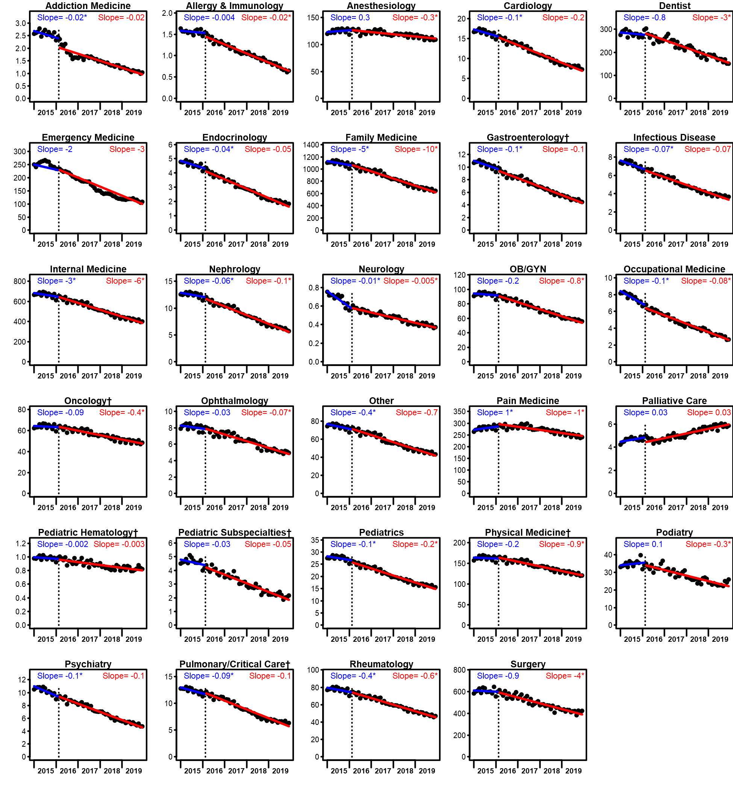
Monthly trends in numbers of dispensed opioid prescriptions are illustrated for 29 clinician specialties. Data are drawn from the IQVIA Longitudinal Prescription (LRx) database from 2015 through 2019. Each point represents prescriptions dispensed for one calendar month, standardized to a 30-day month length. All numbers of monthly prescriptions dispensed are presented per 100,000 population. Modeled monthly trendlines are depicted prior to the release (blue lines) and after release (red lines) of the CDC Guideline (denoted by the dotted line), accompanied by slopes estimated for each trendline. Asterisks (*) indicate statistically significant (p<0.05) coefficients for slope (prior to release, blue) or change in slope (after release, red) for each statistic reported. †For display purposes, some clinician specialty titles have been abbreviated here; see Supplementary Table SX for details of all specialty groups.

