Supplementary material

Development of Equilibrium Dialysis ID-UPLC/MS/MS Candidate Reference Measurement Procedure for Free Thyroxine in Human Serum

Ashley Ribera¹, Li Zhang¹, Amonae Dabbs-Brown¹, Otoe Sugahara¹, Krista Poynter¹, Katleen Van Uytfanghe², Eri Shimizu³, A E van Herwaarden⁴, Julianne C. Botelho¹, Uliana Danilenko¹, and Hubert W. Vesper¹

- Division of Laboratory Sciences, National Center for Environmental Health, Centers for Disease Control and Prevention, 4770 Buford Hwy NE, Atlanta, GA, 30341
- Laboratory for Analytical Chemistry, Faculty of Pharmaceutical Sciences, Ghent University, Ghent, Belgium
- Reference Material Institute for Clinical Chemistry Standards, Kawasaki, Kanagawa, Japan
- Department of Laboratory Medicine, Radboud University Medical Centre, Nijmegen, The Netherlands

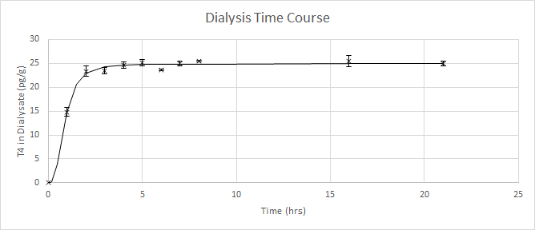

Supplementary Figure S1. FT4 concentrations obtained at different equilibrium durations (mean concentration +/-1SD) using method A.
The FT4 concentration at 1-hour intervals from 0–8 hours and at 16 and 21 hours was measured in duplicate. A plateau in concentration is observed at 4 hours, indicating that equilibrium is reached.

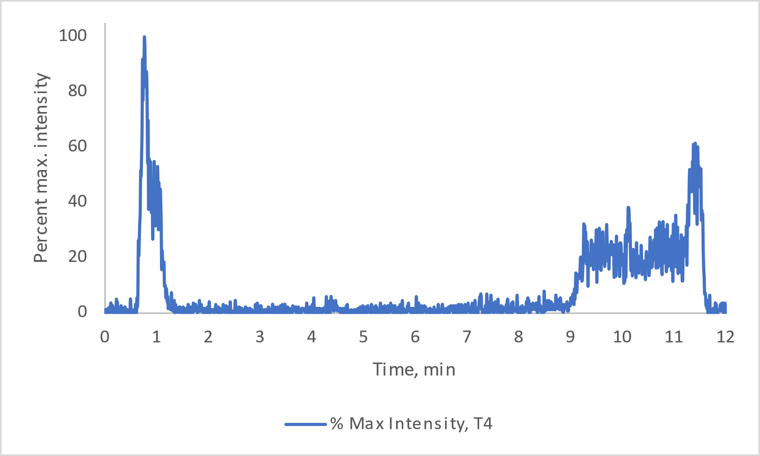
B
A

Supplementary Figure S2. Representative total ion chromatogram of (A) a blank sample HEPES dialysis buffer extracted by method A and (B) a neat blank containing 38.1 pmol/L ¹³C₆-T4. No interferences were detected around the retention time of T4 and ¹³C₆-T4 (7.0 minutes).

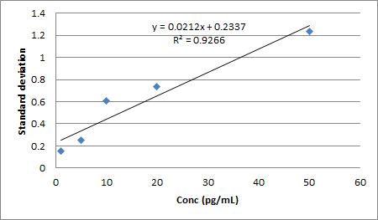
Supplementary Figure S3. Estimation of LOD
To determine the LOD, 5 levels of T4 spiked in HEPES dialysis buffer (1–50 pg/mL) were analyzed and plotted against the standard deviation of replicate measurements of each level measured in duplicate over 3 days. The LOD was estimated as 3 times the standard deviation at the extrapolated concentration of 0.

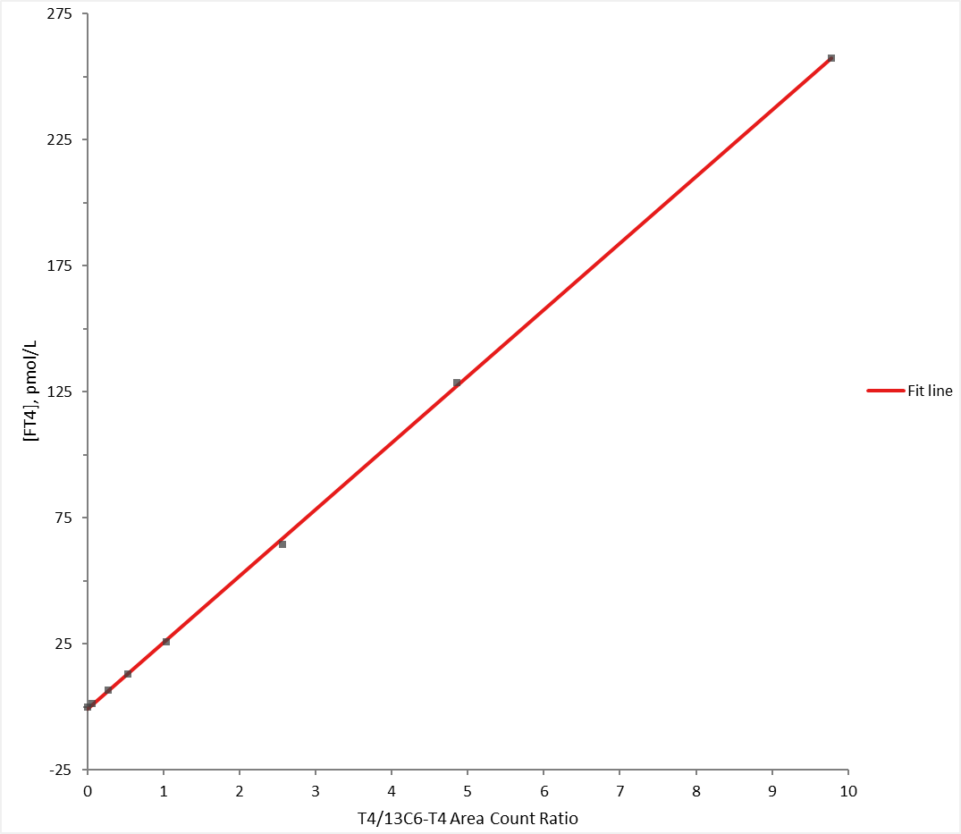
Analyte | Model | Linear Model Residuals | Quadratic Model Residuals | Probability
FT4 | Not Weighted | 0.015863 | 0.016038 | 0.57263
FT4 | 1/SQRT(x) | 0.000043 | 0.000040 | 0.03118
FT4 | 1/x | 0.000004 | 0.000003 | 0.00017
FT4 | 1/x² | 0.000000 | 0.000000 | 0.00006
FT4 | 1/y | 0.000007 | 0.000005 | 0.00002

Supplementary Figure S4. Linearity assessment
The linear model of a 7-point calibration curve (not weighted) with T4 concentrations at 1.29, 6.44, 12.9, 25.7, 64.4, 128, and 257 pmol/L was shown in the graph, and the R² value was 1.000 supporting excellent fit. The residuals of linear and nonlinear models (not weighted) were comparable. Considering best fitting and model simplicity, a linear model was chosen to construct calibration curves.

Sample ID | Sample Type
RB | Run blank
INST | System suitability sample
RB | Run blank
CC1_1 | Calibrator level 1 replicate 1
CC2_1 | Calibrator level 2 replicate 1
CC3_1 | Calibrator level 3 replicate 1
CC4_1 | Calibrator level 4 replicate 1
CC5_1 | Calibrator level 5 replicate 1
ISBlank_1 | Internal standard blank replicate 1
RB | Run blank
QC1_1 | QC sample 1 replicate 1
QC1_2 | QC sample 1 replicate 2
QC1_3 | QC sample 1 replicate 3
QC2_1 | QC sample 2 replicate 1
QC2_2 | QC sample 2 replicate 2
QC2_3 | QC sample 2 replicate 3
Sample1_1 | Patient sample 1 replicate 1
Sample1_2 | Patient sample 1 replicate 2
RB | Run blank
CC1_2 | Calibrator level 1 replicate 2
CC2_2 | Calibrator level 2 replicate 2
CC3_2 | Calibrator level 3 replicate 2
CC4_2 | Calibrator level 4 replicate 2
CC5_2 | Calibrator level 5 replicate 2
ISBlank_2 | Internal standard blank replicate 2
RB | Run blank
Sample2_1 | Patient sample 2 replicate 1
Sample2_2 | Patient sample 2 replicate 2
Sample3_1 | Patient sample 3 replicate 1
Sample3_2 | Patient sample 3 replicate 2
Sample4_1 | Patient sample 4 replicate 1
Sample4_2 | Patient sample 4 replicate 2
Sample5_1 | Patient sample 5 replicate 1
Sample5_2 | Patient sample 5 replicate 2
RB | Run blank
CC1_3 | Calibrator level 1 replicate 3
CC2_3 | Calibrator level 2 replicate 3
CC3_3 | Calibrator level 3 replicate 3
CC4_3 | Calibrator level 4 replicate 3
CC5_3 | Calibrator level 5 replicate 3
ISBlank_3 | Internal standard blank replicate 3
RB | Run blank
INST | System suitability sample
RB | Run blank

Supplementary Table S1. Structure of the Analytical Series
Calibrators and serum materials are alternated with run blanks during analysis by LC-MS/MS. All samples are typically prepared in duplicate, while the 2 levels of quality control (QC) materials and 5-point calibration curves are prepared in triplicate. Samples, QC, and calibrators are analyzed in triplicate in a 24-hour period by repeat injections to minimize variability related to injection and analysis. Repeat measurements were performed on different days during value assignment.

Analogs of Thyroxine | MW (g/mol) | Retention  Times (min) | Vendor
3,5,3'-triiodothyronine | 650.97 | 6.62 | Sigma-Aldrich, St. Louis, MO
3,3',5'-triiodothyronine | 650.97 | 6.16 | Sigma-Aldrich, St. Louis, MO
3,5-Diiodothyronine | 525.08 | 5.04 | Santa Cruz Biotechnology, Inc., Dallas, TX
3,3’-Diiodothyronine | 525.08 | 5.84 | Santa Cruz Biotechnology, Inc., Dallas, TX
3-Iodothyronine | 399 | 4.34 | Santa Cruz Biotechnology, Inc., Dallas, TX
Thyronine | 273 | 3.04 | Santa Cruz Biotechnology, Inc., Dallas, TX
3-Iodothyronamine | 355 | 4.40 | Sigma-Aldrich, St. Louis, MO
3,5-Diiodo-tyrosine | 433 | 0.69 | Sigma-Aldrich, St. Louis, MO
3-Iodo-tyrosine | 307 | 0.69 | Sigma-Aldrich, St. Louis, MO
Tyrosine | 181 | 0.69 | Sigma-Aldrich, St. Louis, MO
3,5,3'-Triiodothyroacetic acid | 621.93 | 7.79 | Sigma-Aldrich, St. Louis, MO
3,3′,5,5′-Tetraiodothyroacetic acid | 747.83 | 8.42 | Sigma-Aldrich, St. Louis, MO

Supplementary Table S2. List of Compounds Tested for Interference
Structural analogs of T4 were assessed for potential interference to T4 (retention time=6.95 min) by comparing their retention times. None of the 12 compounds tested interfered with T4.

Supplementary
Uncertainty Calculation
Type A budget derives from the imprecision of samples used for uncertainty calculation. The intra-assay, inter-assay, and total percent coefficients of variation (CVs) were determined, according to the principles described in CLSI EP 5-A3.

Type B budget
Type B budget | Contribution to the standard uncertainty budget
Purity of the IRMM-468 Thyroxine | 0.35%
Analytical balance | negligible
Uncertainty associated with the density meter | 0.1%
u_{typeB =(}u_{purity} ²₊u_{density measurements}²₎^{1/2}
u_{sample}= (u_{typeA} ²+u_{typeB}²)^{1/2}

Supplementary Table S3. Calculation of measurement uncertainty
Potential sources of uncertainty were evaluated and used to calculate the standard uncertainty and expanded uncertainty, according to ISO Guide to the Expression of Uncertainty in Measurement 2008. The estimated variance of Type A uncertainty was obtained from imprecision of the repeated measurements inclusive independent ED. Type B uncertainty was estimated from uncertainties in the purity of the primary reference material, inaccuracy in the weighing of each component, and the measurement of the serum dialysate density. Type A and B uncertainties were combined quadratically to determine the standard uncertainty. Expanded uncertainty, at the 95% confidence level, was determined by multiplying standard uncertainty by a coverage factor, k=2.

 |  | Calibrator T4 QI/CI |  |  |  |  | Sample T4 QI/CI
 |  | Replicate 1 | Replicate 2 | Replicate 3 |  |  | Day 1 | Day 2 | Day 3
Day 1 | CC Level 1 | 4.49 | 4.42 | 4.35 |  | Sample 1 | 4.43 | 4.61 | 4.48
 | CC Level 2 | 4.58 | 4.26 | 4.44 |  | Sample 2 | 4.37 | 4.63 | 4.65
 | CC Level 3 | 4.42 | 4.33 | 4.38 |  | Sample 3 | 4.38 | 4.64 | 4.40
 | CC Level 4 | 4.50 | 4.35 | 4.41 |  | Sample 4 | 4.57 | 4.53 | 4.40
 | CC Level 5 | 4.30 | 4.51 | 4.58 |  | Sample 5 | 4.42 | 4.48 | 4.62
Day 2 | CC Level 1 | 4.44 | 4.50 | 4.43 |  | Sample 6 | 4.39 | 4.46 | 4.37
 | CC Level 2 | 4.44 | 4.70 | 4.62 |  | Sample 7 | 4.64 | 4.45 | 4.51
 | CC Level 3 | 4.51 | 4.43 | 4.41 |  | Sample 8 | 4.65 | 4.42 | 4.32
 | CC Level 4 | 4.35 | 4.66 | 4.26 |  | Sample 9 | 4.49 | 4.24 | 4.66
 | CC Level 5 | 4.57 | 4.49 | 4.33 |  | Sample 10 | 4.46 | 4.65 | 4.60
Day 3 | CC Level 1 | 4.48 | 4.33 | 4.47 |  | Sample 11 | 4.47 | 4.55 | 4.32
 | CC Level 2 | 4.32 | 4.67 | 4.52 |  | Sample 12 | 4.60 | 4.66 | 4.68
 | CC Level 3 | 4.43 | 4.39 | 4.46 |  | Sample 13 | 4.37 | 4.71 | 4.62
 | CC Level 4 | 4.49 | 4.40 | 4.31 |  | Sample 14 | 4.42 | 4.48 | 4.43
 | CC Level 5 | 4.33 | 4.47 | 4.53 |  | Sample 15 | 4.58 | 4.59 | 4.52
Day 4 | CC Level 1 | 4.67 | 4.42 | 4.51 |  | Sample 16 |  | 4.90 | 4.62
 | CC Level 2 | 4.42 | 4.49 | 4.63 |  | Sample 17 |  | 4.77 | 4.60
 | CC Level 3 | 4.52 | 4.59 | 4.53 |  | Sample 18 |  | 4.34 | 4.42
 | CC Level 4 | 4.53 | 4.58 | 4.53 |  | Sample 19 |  | 4.54 | 4.37
 | CC Level 5 | 4.64 | 4.39 | 4.51 |  | Sample 20 |  | 4.66 | 4.64

Supplementary Table S4. Comparison of QI/CI Ratio between (A) calibrators and (B) single donor sera.
Sets of 5-level calibrators were prepared as described in the Methods section in triplicate over 4 days, and the ratio of the T4 quantitation ion to the T4 confirmation ion were compared to those of 20 single donor samples prepared in singlicate over 2-3 analytical runs. Mean QI/CI ratio ± 95% CI was 4.47 ± 0.03 for calibrators and 4.52 ± 0.04 for samples, with a mean percent difference of sample to calibrator QI/CI of 1.3%.

