Supplementary Figure 1
Inclusion Flow Diagram
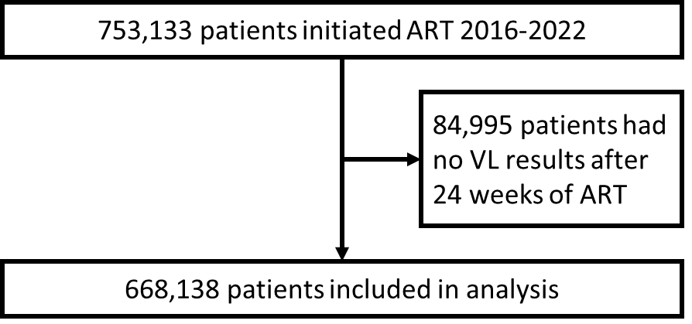

Supplementary Table 1. Patient characteristics
Characteristic | N (%)
Total patients | 668,138 (100.0)
Sex
Female | 413,895 (61.9)
Male | 254,243 (38.1)
Age, median (IQR): | 32 (26-40)
<15 | 25,100 (3.8)
≥15 | 643,038 (96.2)
15–24 | 97,994 (14.7)
25–34 | 264,345 (39.6)
35–44 | 175,511 (26.3)
45–54 | 74,668 (11.2)
≥55 | 30,520 (4.6)
Year of ART initiation
2016 | 67,696 (10.1)
2017 | 65,346 (9.8)
2018 | 60,526 (9.1)
2019 | 76,232 (11.4)
2020 | 204,110 (30.5)
2021 | 172,745 (25.9)
2022 | 21,483 (3.2)
Total number of VL results after ≥24 weeks of ART
1 | 187,321 (28.0)
2 | 248,483 (37.2)
3 | 119,187 (17.8)
4 | 67,412 (10.1)
≥5 | 45,735 (6.8)
Regimen exposureª
NRTI exposure
TDF plus emtricitabine or lamivudine | 649,865 (97.3)
Zidovudine plus lamivudine | 17,693 (2.6)
Abacavir plus lamivudine | 21,026 (3.1)
NNRTI exposure
Efavirenz | 116,522 (17.4)
Nevirapine | 19,683 (3.0)
INSTI exposure
TLD | 633,736 (94.8)
Other INSTI | 17,807 (2.7)
Protease inhibitor exposure
Ritonavir-boosted lopinavir | 10,985 (1.6)
Ritonavir-boosted atazanavir | 3,200 (0.5)
ªMeasured as cumulative exposure (i.e., all documented regimens received)

