Supplementary Tables and Figures
Table S1. WHO member states responding to the WHO-UNICEF Joint Reporting Form (JRF) and number reporting and not reporting school-based vaccination, by calendar year 2008 – 2017
Year | Number of WHO states responding to school-based vaccination section of the Joint Reporting Form (JRF) | Number of WHO member states reported using school-based vaccination | Among the WHO member states responding to school-based vaccination section of the JRF in 2008 (n=163), number reported to use school-based vaccination in current year | Among the WHO member states that did not respond to school-based vaccination section of the JRF on school-based vaccination in 2008 (n=31), number reported to use school-based vaccination in current year^{a,b}
2008 | 163 | 95 | 95
2009 | 168 | 98 | 93 | 5
2010 | 175 | 94 | 89 | 5
2011 | 168 | 93 | 89 | 4
2012 | 175 | 100 | 93 | 7
2013 | 170 | 98 | 89 | 9
2014 | 178 | 103 | 93 | 10
2015 | 179 | 102 | 92 | 10
2016 | 183 | 99 | 91 | 8
2017 | 181 | 108 | 95 | 13
a. The 13 WHO member states that did not respond in 2008 but in 2017 reported they are now using school-based vaccination are: Cambodia (HPV), Eswatini (DT, MR, OPV), Kuwait (TD, MMR), Marshall Islands (TDAP, HPV, Influenza, MCV), Micronesia (HPV), New Zealand (TDAP, HPV), Niue (TDAP), Qatar (TDAP), Macedonia (TD, OPV, MMR, HPV), Timor-Leste (DT), Uganda (HPV, TT), United Arab Emirates (TDAP, HPV, MMR, OPV, Varicella)

b. The 15 WHO member states that changed from reporting no school-based vaccination in 2008 to having school-based vaccination in 2017 are: Belize (TD, HPV), Bhutan (TD, HPV), Bolivia (DT, Penta, OPV), Bosnia and Herzegovina (DT, TD, TT, OPV), Cote d’Ivoire (HPV), Djibouti (MCV), Eritrea (TD), Guatemala (TD), Jamaica (HPV), Mongolia (TD), Philippines (TD, MR), Rwanda (HPV), Sao Tome and Principe (HPV), South Africa (HPV, TD), Spain (TD, DTAP, HPV, Men C, Varicella)

Figure S1. World Health Organization Joint Reporting Form, Section 3, School-Based Immunization
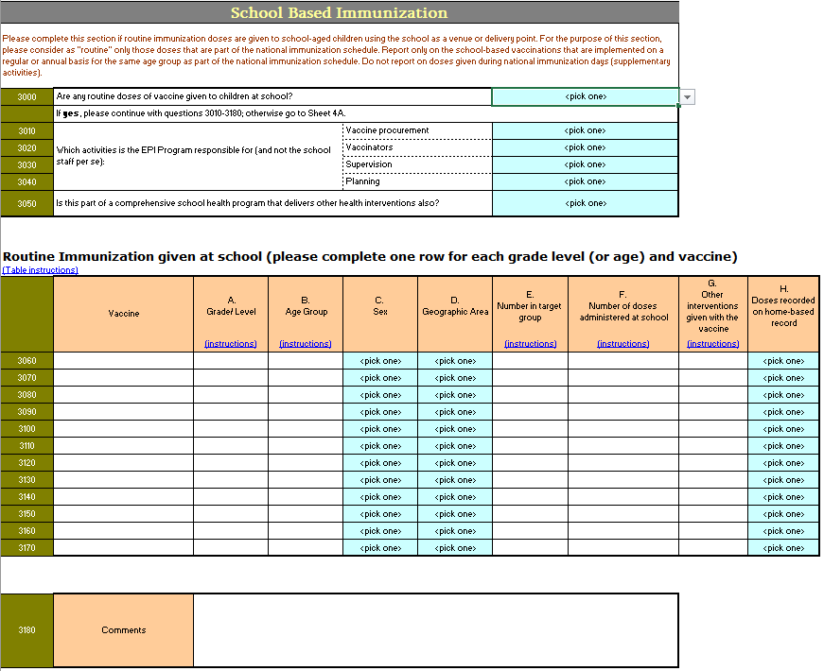

Figure S2. Map of countries delivering school-based vaccinationsª in 194 World Health Organization (WHO) member states, according to data from the WHO–United Nations Children’s Fund (UNICEF) Joint Reporting Form on activities that occurred in 2017
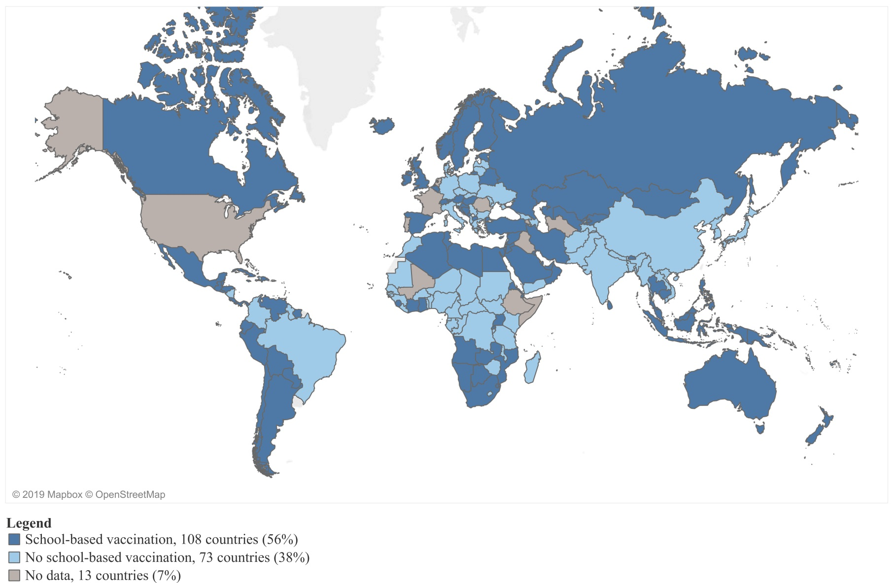
ª School-based vaccination is defined as the delivery of routinely recommended doses of vaccines to school-aged children using the school as a venue for delivery (excludes doses given during campaigns).
Figure S3. Number of different antigens delivered in schoolsª in 106 World Health Organization (WHO) member states reporting specific vaccines delivered in schools in 2017 on the WHO–United Nations Children’s Fund (UNICEF) Joint Reporting Form, by World Bank income level
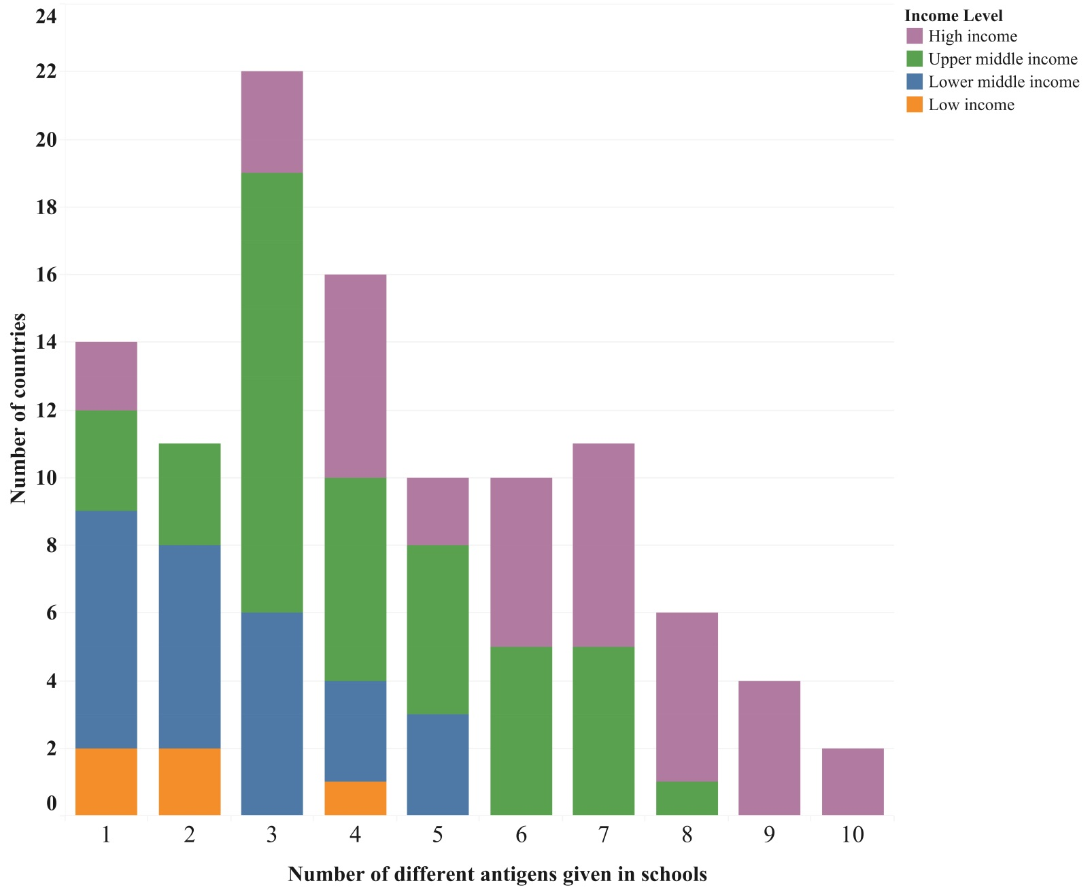
ª School-based vaccination is defined as the delivery of routinely recommended doses of vaccines to school-aged children using the school as a venue for delivery (excludes doses given during campaigns).

Figure S4. Antigens delivered in schoolsª in the 106 World Health Organization (WHO) member states reporting specific vaccines delivered in schools in 2017 on the WHO–United Nations Children’s Fund Joint Reporting Form

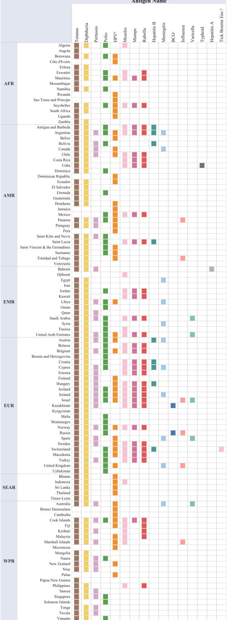
ª School-based vaccination is defined as the delivery of routinely recommended doses of vaccines to school-aged children using the school as a venue for delivery (excludes doses given during campaigns).

