Appendix 1.
Data Source
Data extraction was performed using the online analytic tool, Merative® MarketScan® Treatment Pathways. We used de-identified patient data from the Merative® MarketScan® Commercial Database for those with private insurance (n=46,774,103) and Merative® MarketScan® Multi-state Medicaid Database for those with Medicaid coverage (n=14,188,317), from October 1, 2015 to December 31, 2019. The Commercial Database contains enrollment, demographic, and service-level claims data from inpatient and outpatient medical services, and outpatient prescription drug claims data for individuals insured by private health insurance, primarily sponsored by employers, in the United States.¹ The Multi-State Medicaid Database also contains enrollment and demographic data, as well as medical and prescription drug claims data for individuals covered by the Children Health Insurance Program (CHIP) or Medicaid programs from between 9 and 12 geographically dispersed states depending on the year examined.¹
Study Population
The study sample consisted of individuals with a first diagnosis of malaria between October 1, 2015 and December 31, 2019, using the International Classification of Diseases, Tenth revision, Clinical Modification (ICD-10-CM) diagnosis codes. Malaria diagnosis codes of ICD-10-CM used are: B50.0, B50.8, and B50.9 for falciparum malaria; B51.0, B51.8, and B51.9 for vivax malaria; B52.0, B52.8, and B52.9 for malariae malaria; B53.0 for ovale malaria; B53.1 for knowlesi malaria; B53.8 for other malaria; and B54 for unspecified malaria.
The selection process was conducted separately for hospitalized and non-hospitalized patients. These sample selection procedures also were performed separately for each database (Commercial and Medicaid). The flow charts of sample selection are provided in eAppendix 2 for those with private insurance and eAppendix 3 for those with Medicaid.
For malaria patients who were hospitalized, we first identified individuals with malaria-related hospitalizations during October 2015−December 2019. We restricted our sample to those enrolled only in commercial plans or Medicaid (i.e., patients enrolled in Medicare were excluded since the MarketScan® database does not fully capture the payment information for individuals with Medicare). We also excluded patients with capitated insurance plans or who were not continuously enrolled between 30 days before and 90 days after the first hospitalization with a diagnosis of malaria. Individuals enrolled in capitated plans were not included because their insurance claims do not provide complete payment information rather often reflect only encounters instead of actual claims,² thus limiting our ability to estimate the total costs. The inclusion criteria of continuous enrollment 30 days before and 90 days after a malaria diagnosis is based on the assumption that this period is sufficient to include all patient visits associated with malaria. Finally, we categorized patients into two groups: inpatients with malaria as primary diagnoses and inpatients with malaria as non-primary diagnoses at the first hospitalization. We also created subgroups of patients with severe malaria who were defined as having one or more of the following criteria: 1) neurologic symptoms defined as having Clinical Classifications Software (CCS) grouping of diagnoses codes 82, 83, 85, or 95 (paralysis, epilepsy, convulsions, alteration of consciousness, coma, stupor, brain damage, other nervous system disorders), 2) renal failure defined as having CCS codes 157, 3) severe anemia defined as having CCS code 59 (deficiency anemia) with CCS grouping of procedures 222 (blood transfusion), 4) acute respiratory distress syndrome defined as having CCS code 131, 5) jaundice defined as having ICD-10-CM code R17, or 6) malaria-related hospitalizations with an in-hospital death.³ Our classification of severe malaria is modified from the definition of severe malaria used by the U.S. Centers for Disease Control and Prevention because the MarketScan database does not fully capture information about laboratory test results or prescription drug use during hospitalization. However, we note that our sample did not include any in-hospital deaths. Patients who were not defined as having severe malaria were considered as having uncomplicated malaria.
For malaria patients who were not hospitalized (those with only outpatient visits for malaria treatment), we first identified individuals who had outpatient claims with malaria diagnosis codes after excluding those with inpatient claims with malaria diagnosis codes. In the first stage, patients with a diagnosis labeled as “rule-out” (i.e., tested and confirmed not to have malaria) were excluded. In the second stage, we then applied the same exclusion criteria to the selected non-hospitalized patients as the hospitalized patients (i.e., we excluded patients 1) with Medicare coverage, 2) with capitated insurance plans, or 3) who did not have continuous enrollment in their insurance plans for the period between 30 days before and 90 days after the first diagnosis of malaria). In the third and final stage, we attempted to exclude individuals with malaria outpatient diagnosis codes who had prescription drug claims that were consistent with chemoprophylaxis regimens as opposed to infection treatment regimens. We used the use and days of supply of antimalarial drugs to determine the final cohort of outpatients with malaria infections. Individuals with malaria diagnosis codes were classified as having malaria infection if they filled prescriptions for 1) artemether-lumefantrine, 2) quinine sulfate, 3) atovaquone-proguanil with ≤8 days of supply, 4) chloroquine phosphate with ≤5 days of supply, 5) mefloquine with ≤5 days of supply, 6) hydroxychloroquine with ≤5 days of supply, or 7) primaquine phosphate with ≤15 days of supply, between 30 days before and 90 days after the first outpatient diagnosis of malaria. The thresholds of days of supply were determined based on the treatment regimen for each drug in order to exclude individuals who appeared to fill prescriptions that would be consistent with chemoprohylaxis.⁴ The sample selection was conducted sequentially from 1) to 7) and continued until no further patients with treatment consistent with recommended regimens for malaria infection were found. We further excluded individuals who were observed to have received prescription drugs consistent with both malaria treatment and prophylaxis purposes (i.e., they filled at least one prescription consistent with treatment for malaria infection and one prescription consistent with malaria chemoprophylaxis). We also excluded individuals who did not have outpatient visits with malaria diagnoses between 30 days before and 30 days after the prescription fill of antimalarial drugs.
Outcomes
We estimated the mean cost of malaria treatment per person associated with the first malaria diagnosis (i.e., if the same individual was diagnosed with malaria after at least a 90-day period, the second observation would not be included in our analysis). We included an observation period of up to 120 days to include additional treatment costs associated with the initial malaria diagnosis for each patient. We separately reported results for hospitalized and non-hospitalized patients. The costs were estimated using the reported payments in the MarketScan Research Databases.
For hospitalized patients, we examined the costs of inpatient services, outpatient services, and outpatient prescription drugs for malaria treatment that were incurred within a period before and after hospitalization. Information about prescription drugs administered while hospitalized are not available in the MarketScan Research Databases and associated payments are assumed to be included in the inpatient services payments. The costs of inpatient services were defined as costs for any inpatient services with malaria diagnosis codes incurred within 90 days after the first inpatient diagnosis of malaria. We assumed that the 90-day window would include all inpatient services associated with the first malaria hospitalization. For costs of outpatient services among hospitalized patients, we estimated the costs of outpatient services incurred between 30 days before and 90 days after the date of first inpatient diagnosis of malaria. For costs of outpatient prescription drugs among hospitalized patients, we estimated the costs of antimalarial drugs used for malaria treatment only, which was determined by the same algorithm used for selecting malaria non-hospitalized patients as described above (i.e., restricting antimalarial drug use to those with reasonable days of supply that were consistent with malaria infection treatment regimens), incurred between 30 days before and 90 days after the first inpatient malaria diagnosis. We assumed that the use of antimalarial drugs associated with the first inpatient malaria diagnosis would occur between 30 days before and 90 days after the first malaria hospitalization.
For non-hospitalized patients, we examined the costs of outpatient services and prescription drugs for malaria treatment. For costs of outpatient services, we first identified the date of the first use of antimalarial drugs between 30 days before and 90 days after their first outpatient diagnosis of malaria. Then, we estimated the costs of outpatient services incurred between 30 days before and 30 days after the date of first antimalarial drug use for treatment. For costs of prescription drugs, we used the same algorithm as that for hospitalized patient and estimated only the costs of antimalarial drugs used for malaria treatment incurred between 30 days before and 90 days after the first outpatient malaria diagnosis. The same algorithm was used to determine whether the drug was used for malaria infection treatment.
All costs were further examined by source of payment, insurance and out-of-pocket. Insurance cost was estimated based on the amount of payments made by the insurance provider, and the out-of-pocket cost was based on the amount of deductibles, copayments, and coinsurance paid by patients.
Statistical Analyses
Descriptive statistics were reported for demographic and selected clinical characteristics of the study population. For each patient, we extracted data on available patient characteristics, including age (0-17, 18-39, 40-64, 65-79, and 80+ years old), sex (female, and male), census region (South, Northeast, Midwest, and West), urbanicity of residence (urban and rural), one or more diagnosis codes for plasmodium species (P. falciparum, P. vivax, P. ovale, P. malariae, P. knowlesi, other malaria, and unspecified malaria). For hospitalized patients, length of hospital stay (days) and severity of malaria (uncomplicated and severe malaria) were also examined. Information on census region and urbanicity of residence was not available for patients in the MarketScan® Multi-state Medicaid Database.
To examine the significance of differences between privately insured hospitalized patients with primary malaria diagnoses and those with non-primary diagnoses, we used Welch’s t-test for the mean age and length of hospital stay and simple logistic regression for the proportion of uncomplicated and severe malaria. P-values <0.05 were deemed statistically significant. For the other characteristics (age group, sex, census region, rural, and plasmodium species), significant differences between the two groups (privately insured hospitalized patients with primary and non-primary malaria diagnoses) were determined based on whether 95% confidence intervals overlapped. Due to small sample sizes, we did not perform statistical testing for patients with Medicaid. All costs were adjusted to 2019 U.S. dollars using the Consumer Price Index for medical care.⁵ Analyses were conducted using Stata SE Statistical Software (version 16.1, StataCorp LLC, College Station, TX).
Additional details regarding the cost of treatment are provided as eAppendix 5.
Appendix 2. Selection of privately insured patients with malaria, Oct 2015−Dec 2019 Merative® MarketScan® Commercial Claims and Encounters Database

(a) Hospitalized patients

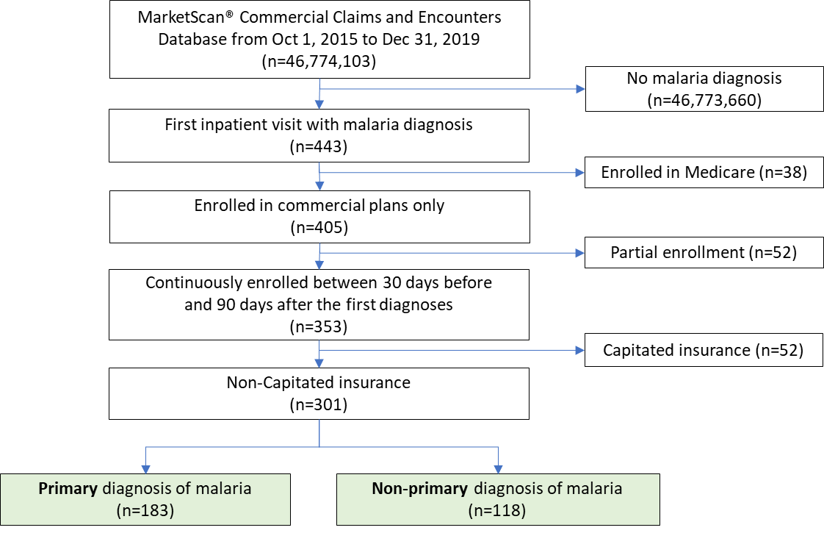

(b) Non-hospitalized patients
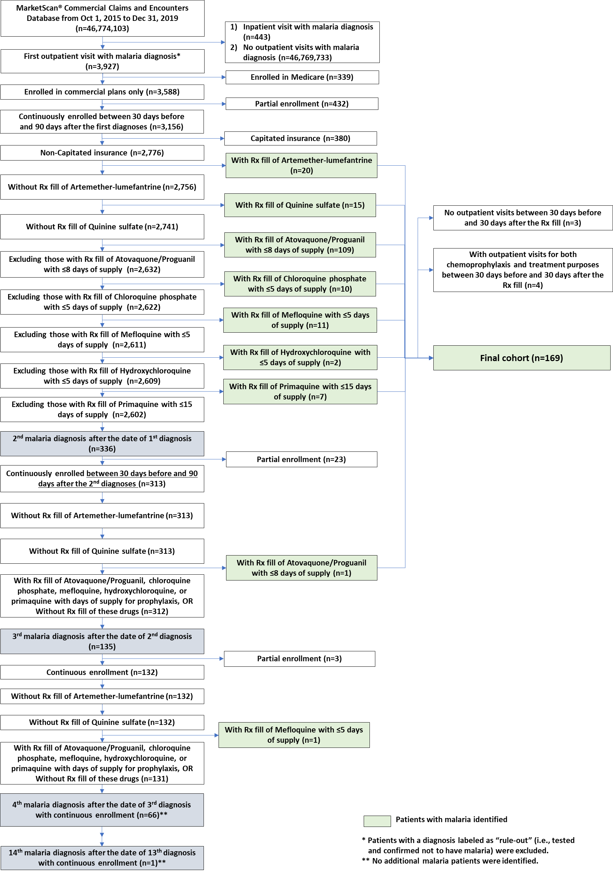
Appendix 3. Selection of Medicaid enrollees with malaria, Oct 2015−Dec 2019 Merative® MarketScan® Multi-state Medicaid Database

(a) Hospitalized patients

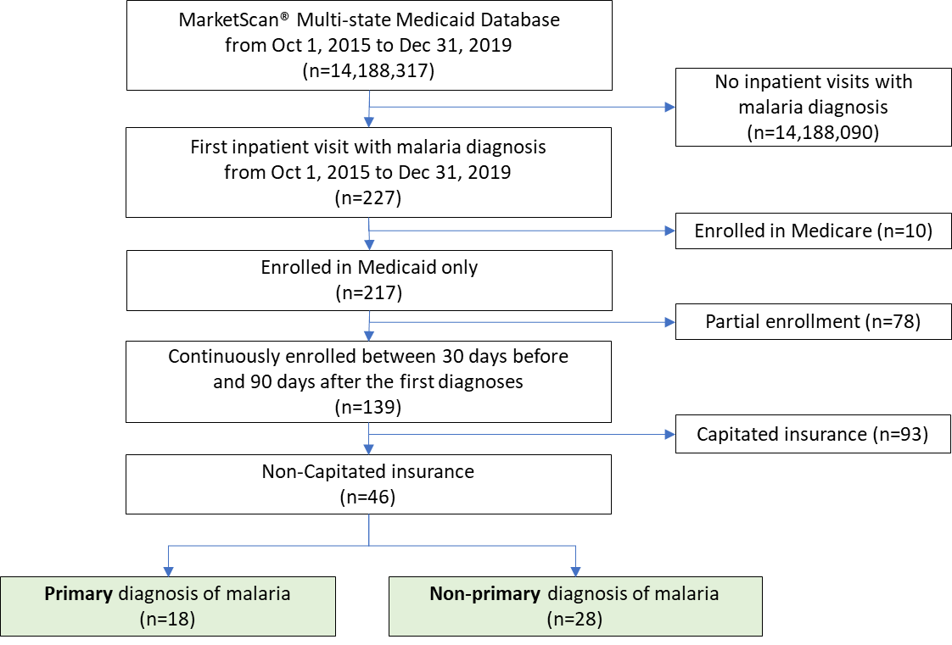

(b) Non-hospitalized patients
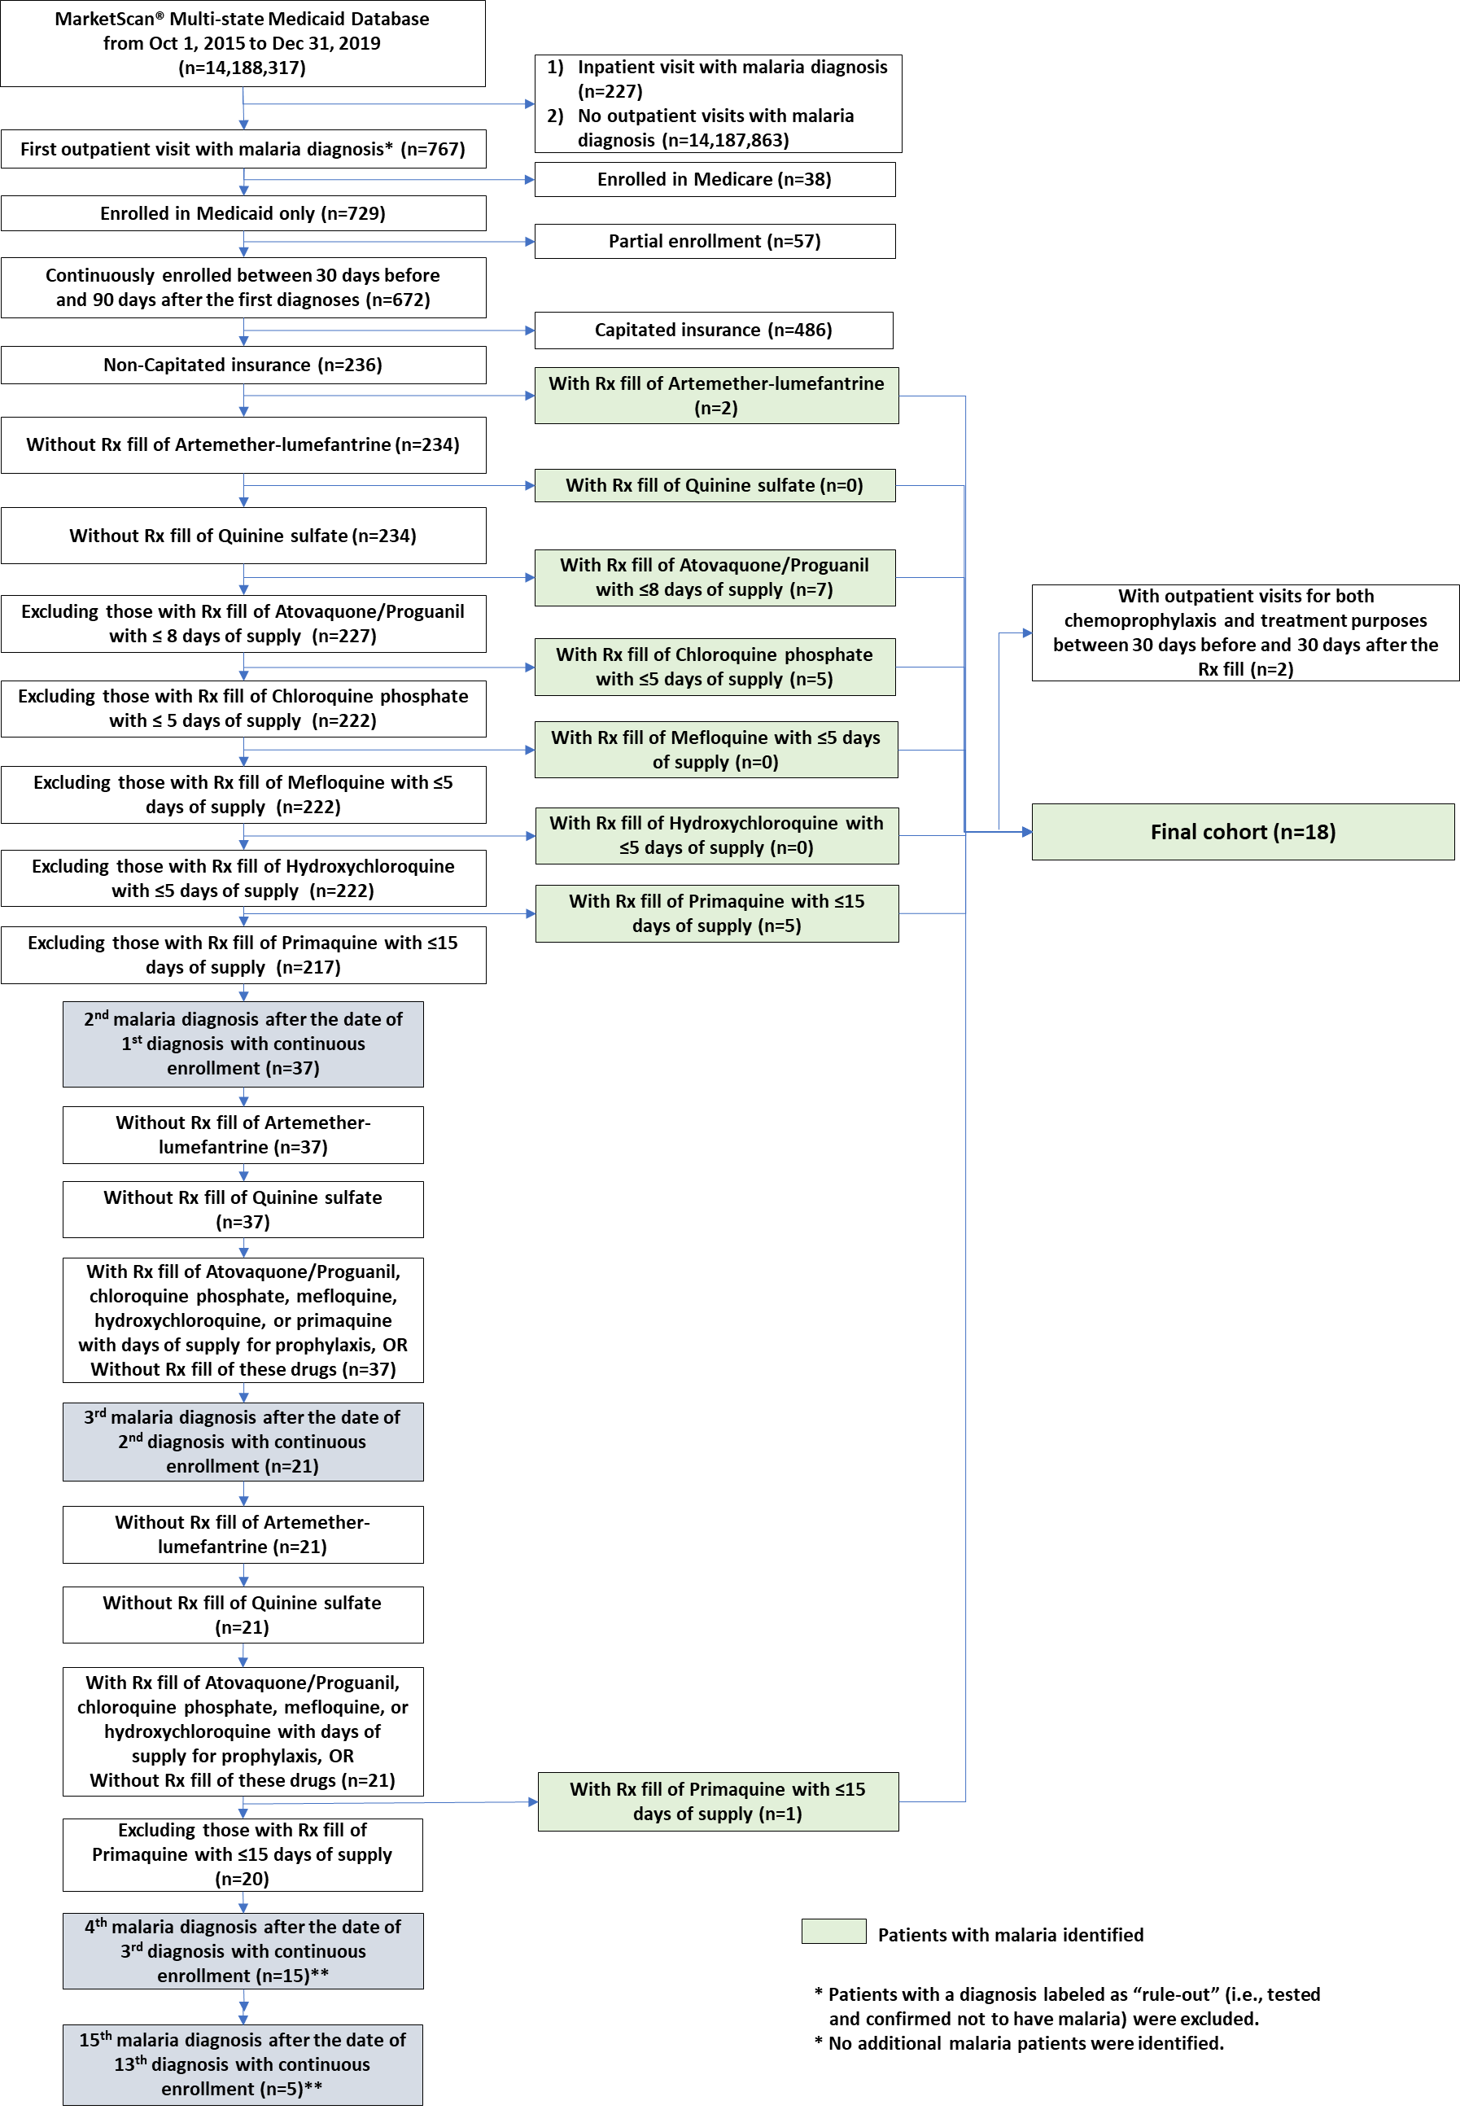
Appendix 4. Geographic information of patients’ residence for those with private insurance, Oct 2015−Dec 2019 Merative® MarketScan® Commercial Claims and Encounters Database
 | Patients with Private Insurance
 | Hospitalized |  |  | Non-hospitalized
 | Total | Primary Dxª | Non-primary Dx^{b}
Sample size (n) | 301 | 183 | 118 | 169
Census region, No. (%)^{c}
South | 150 (49.8) | 85 (46.4) | 65 (55.1) | 83 (49.1)
Northeast | 73 (24.3) | 49 (26.8) | 24 (20.3) | 34 (20.1)
Midwest | 38 (12.6) | 21 (11.5) | 17 (14.4) | 24 (14.2)
West | 23 (7.6) | 13 (7.1) | 10 (8.5) | 28 (16.6)
Unknown | 17 (5.6) | 15 (8.2) | 2 (1.7) | 0 (0.0)
Rurality, No. (%)
Rural | 17 (5.6) | 8 (4.4) | 9 (7.6) | 12 (7.1)
Non-rural | 267 (88.7) | 159 (86.9) | 108 (91.5) | 157 (92.9)
Unknown | 17 (5.6) | 16 (8.7) | 1 (0.8) | 0 (0.0)
ª Inpatients with malaria diagnosis codes as primary diagnosis
^{b} Inpatients with malaria diagnosis codes as non-primary diagnosis
^{c} Census region of patient’s residence was based on U.S. Census Bureau regions (https://www2.census.gov/geo/pdfs/maps-data/maps/reference/us_regdiv.pdf). Geographic information (census region and urbanicity of patient residence) is not available in the MarketScan Multi-state Medicaid database.

Appendix 5. Estimated mean costs of malaria treatment per person among those with private insurance and those with Medicaid, Oct 2015−Dec 2019 Merative® MarketScan® Commercial Claims and Encounters Database and Multi-state Medicaid Database (2019 USD)
 |  |  | Hospitalized Patients |  |  |  |  |  |  |  |  | Non-hospitalized Patients
 |  |  | All |  |  | Inpatient Primary Dx ª |  |  | Inpatient Non-primary Dx ^{b}
 |  |  | n | Mean | 95% CI | n | Mean | 95% CI | n | Mean | 95% CI | n | Mean | 95% CI
 |  |  | Private Insurance
Overall
Total |  |  | 301 | 27,642 | [21,163, 34,121] | 183 | 17,092 | [14,440, 19,744] | 118 | 44,004 | [28,313, 59,695] | 169 | 1,177 | [888, 1,465]
Insurance |  |  | 301 | 25,702 | [19,247, 32,157] | 183 | 15,235 | [12,610, 17,859] | 118 | 41,934 | [26,290, 57,579] | 169 | 796 | [562, 1,031]
Out-of-pocket |  |  | 301 | 1,941 | [1,736, 2,145] | 183 | 1,858 | [1,593, 2,122] | 118 | 2,070 | [1,744, 2,395] | 169 | 380 | [284, 477]
By Service Type
Inpatient services
Total |  |  | 301 | 27,099 | [20,648, 33,550] | 183 | 16,496 | [13,910, 19,083] | 118 | 43,541 | [27,904, 59,178] | - | - | -
Insurance |  |  | 301 | 25,221 | [18,795, 31,647] | 183 | 14,713 | [12,156, 17,271] | 118 | 41,518 | [25,929, 57,107] | - | - | -
Out-of-pocket |  |  | 301 | 1,877 | [1,674, 2,080] | 183 | 1,783 | [1,521, 2,046] | 118 | 2,023 | [1,701, 2,346] | - | - | -
Outpatient services
Total |  |  | 174 | 911 | [663, 1,159] | 127 | 830 | [552, 1,108] | 47 | 1,132 | [592, 1,673] | 169 | 1,088 | [803, 1,373]
Insurance |  |  | 174 | 813 | [569, 1,058] | 127 | 734 | [459, 1,009] | 47 | 1,027 | [497, 1,556] | 169 | 734 | [504, 964]
Out-of-pocket |  |  | 174 | 98 | [74, 123] | 127 | 96 | [68, 123] | 47 | 106 | [54, 157] | 169 | 354 | [259, 449]
Outpatient Rx drugs ^{c}
Total |  |  | 76 | 67 | [51, 83] | 57 | 64 | [47, 81] | 19 | 75 | [34, 115] | 169 | 89 | [41, 136]
Insurance |  |  | 76 | 41 | [27, 55] | 57 | 39 | [24, 54] | 19 | 47 | [12, 81] | 169 | 62 | [17, 108]
Out-of-pocket |  |  | 76 | 26 | [20, 32] | 57 | 25 | [18, 32] | 19 | 28 | [16, 39] | 169 | 26 | [21, 32]
By Disease Severity
Uncomplicated Malaria
Total |  |  | 188 | 14,535 | [12,669, 16,402] | 127 | 12,846 | [10,692, 15,000] | 61 | 18,051 | [14,522, 21,581] | - | - | -
Insurance |  |  | 188 | 12,917 | [11,105, 14,730] | 127 | 11,309 | [9,214, 13,403] | 61 | 16,267 | [12,842, 19,692] | - | - | -
Out-of-pocket |  |  | 188 | 1,618 | [1,391, 1,844] | 127 | 1,538 | [1,249, 1,826] | 61 | 1,784 | [1,421, 2,148] | - | - | -
Severe Malaria ^{d}
Total |  |  | 113 | 49,449 | [33,104, 65,794] | 56 | 26,721 | [20,089, 33,354] | 57 | 71,778 | [40,661, 102,895] | - | - | -
Insurance |  |  | 113 | 46,971 | [30,637, 63,305] | 56 | 24,139 | [17,420, 30,857] | 57 | 69,403 | [38,338, 100,468] | - | - | -
Out-of-pocket |  |  | 113 | 2,478 | [2,100, 2,856] | 56 | 2,583 | [2,051, 3,115] | 57 | 2,375 | [1,824, 2,926] | - | - | -
 |  |  | Medicaid ^{e}
Overall
Total |  |  | 46 | 19,361 | [8,263, 30,459] | 18 | 5,996 | [4,104, 7,888] | 28 | 27,952 | [10,085, 45,819] | 18 | 551 | [280, 823]
Insurance |  |  | 46 | 19,299 | [8,197, 30,402] | 18 | 5,966 | [4,074, 7,858] | 28 | 27,871 | [9,993, 45,748] | 18 | 546 | [275, 818]
Out-of-pocket |  |  | 46 | 62 | [-23, 146] | 18 | 30 | [-21, 81] | 28 | 82 | [-57, 220] | 18 | 5 | [2, 7]
ª Inpatients with malaria diagnosis codes as primary diagnosis.
^{b} Inpatients with malaria diagnosis codes as non-primary diagnosis; top 5 primary diagnoses were sepsis, unspecified organism (30%), other specified sepsis (11%), fever (6%), urinary tract infection (3%), and human immunodeficiency virus disease (3%).
^{c} Prescription drugs administered while hospitalized are not available in MarketScan database and the payments are assumed to be included in the inpatient services.
^{d} Those with severe malaria were defined as having one or more of the following diagnoses or procedures: neurologic symptoms, severe anemia with blood transfusion, renal failure, acute respiratory distress syndrome, jaundice, exchange transfusion, and in-hospital death.³
^{e} Due to the small sample size of the Medicaid sample, costs were not further examined by type of service and the status of severe malaria.

Appendix 6. Estimated median costs of malaria treatment per person and interquartile range (IQR) among those with private insurance and those with Medicaid, Oct 2015−Dec 2019 Merative® MarketScan® Commercial Claims and Encounters Database and Multi-state Medicaid Database (2019 USD)
 | Hospitalized Patients |  |  |  |  |  |  |  |  | Non-hospitalized Patients
 | Total |  |  | Primary Dx ª |  |  | Non-primary Dx ^{b}
 | n | Median | IQR | n | Median | IQR | n | Median | IQR | n | Median | IQR
Private Insurance
Overall
Total | 301 | 14,712 | [8,928, 25,378] | 183 | 12,652 | [6,276, 19,130] | 118 | 20,203 | [10,475, 32,140] | 169 | 311 | [177, 1,410]
Insurance | 301 | 12,103 | [5,892, 23,119] | 183 | 10,423 | [4,771, 17,781] | 118 | 17,837 | [8,380, 30,560] | 169 | 180 | [67, 610]
Out-of-pocket | 301 | 1,562 | [322, 3,049] | 183 | 1,505 | [202, 2,949] | 118 | 1,972 | [446, 3,084] | 169 | 103 | [44, 340]
By Disease Severity
Uncomplicated Malaria
Total | 188 | 11,570 | [5,578, 18,948] | 127 | 10,883 | [4,167, 16,817] | 61 | 15,199 | [9,170, 22,102] | - | - | -
Insurance | 188 | 9,687 | [4,005, 17,777] | 127 | 8,879 | [3,544, 14,722] | 61 | 14,159 | [6,787, 20,142] | - | - | -
Out-of-pocket | 188 | 1,273 | [147, 2,707] | 127 | 984 | [100, 2,706] | 61 | 1,468 | [446, 2,782] | - | - | -
Severe Malaria ^{c}
Total | 113 | 21,793 | [13,392, 44,205] | 56 | 18,008 | [13,169, 28,652] | 57 | 28,184 | [14,327, 66,319] | - | - | -
Insurance | 113 | 17,895 | [10,769, 42,628] | 56 | 15,932 | [9,811, 27,918] | 57 | 26,949 | [11,628, 60,913] | - | - | -
Out-of-pocket | 113 | 2,098 | [813, 3,704] | 56 | 2,180 | [1,235, 3,672] | 57 | 2,078 | [657, 3,704] | - | - | -
Medicaid ^{d}
Overall
Total | 46 | 6,778 | [3,932, 16,706] | 18 | 5,132 | [3,244, 6,615] | 28 | 11,890 | [5,546, 23,685] | 18 | 404 | [204, 613]
Insurance | 46 | 6,777 | [3,932, 16,705] | 18 | 5,132 | [3,244, 6,613] | 28 | 11,890 | [5,536, 23,663] | 18 | 393 | [198, 613]
Out-of-pocket | 46 | 0 | [0, 19] | 18 | 0 | [0, 16] | 28 | 0 | [0, 27] | 18 | 5 | [0, 8]
ª Inpatients with malaria diagnosis codes as primary diagnosis.
^{b} Inpatients with malaria diagnosis codes as non-primary diagnosis; top 5 primary diagnoses were sepsis, unspecified organism (30%), other specified sepsis (11%), fever (6%), urinary tract infection (3%), and human immunodeficiency virus disease (3%).
^{c} Those with severe malaria were defined as having one or more of the following diagnoses or procedures: neurologic symptoms, severe anemia with blood transfusion, renal failure, acute respiratory distress syndrome, jaundice, exchange transfusion, and in-hospital death.³
^{d} Due to the small sample size of the Medicaid sample, costs were not further examined by type of service and the status of severe malaria.

References
1. IBM MarketScan Research Databases for life sciences researchers IBM Watson Health Accessed November 22,, 2021. https://www.ibm.com/downloads/cas/OWZWJ0QO
2. IBM MarketScan Research Databases User Guide: Commercial Claims and Encounters Database and Medicare Supplemental and Coordination of Benefits Database. Data Year 2018 Edition. 2018.
3. Khuu D, Eberhard ML, Bristow BN, et al. Economic impact of malaria-related hospitalizations in the United States, 2000-2014. J Infect Public Health. May-Jun 2019;12(3):424-433. doi:10.1016/j.jiph.2018.11.010
4. CDC. Malaria: treatment of malaria: guidelines for clinicians (United States). Centers for Disease Control and Prevention. Updated September 30, 2022. Accessed January 4, 2022. https://www.cdc.gov/malaria/diagnosis_treatment/clinicians1.html
5. CPI for All Urban Consumers (CPI-U), U.S. city average, Medical care. U.S. Bureau of Labor Statistics. Accessed February 5, 2022. https://data.bls.gov/cgi-bin/surveymost?cu

