Supplementary Data

Supplemental Methods
Participant enrollment
All patients and accompanying persons were eligible, irrespective of their symptoms. For the schools and the churches, a sampling frame was created by combining data obtained from local associations, the Ministry of Education, the Archdiocese, and field visits. Children were chosen by systematic random sampling per grade, and any church attendees approached were asked to participate in the study. The targeted sample size per type of venue (health facilities, schools, and churches) was 2,100 participants, with a total targeted sample size of 6,300 participants.

Antigen conjugation to microbeads
To covalently bind antigens to microbeads, beads were washed with 0.1M sodium phosphate, pH 6.2 (NaP) and were activated by suspending in NaP with 50 mg/mL of EDC (1-ethyl-3-[3-dimethylaminutesopropyl] carbodiimide hydrochloride) and 50 mg/mL sulfo-NHS (sulfo N-hydroxylsulfosuccinimide) and incubating with rotation for 20 minutes at room temperature (RT) protected from light. After wash with 2-(N-morpholino)ethanesulfonic acid (MES, 50 mM MES, 0.85% NaCl, pH 5.0), beads were suspended in MES with appropriate concentration of SGE protein and rotated for two hours at room temperature (RT), protected from light. Beads were washed and suspended in PBS with 1% bovine serum albumin (BSA) and incubated for 30 minutes at RT by rotation. Beads were then washed with storage buffer (PBS, 1% BSA, 0.02% sodium azide and 0.05% Tween-20) and suspended in storage buffer containing protease inhibitors (200 µg/mL Pefabloc, 200 µg/ml EDTA, 1 µg/mL pepstatin A and 1 µg/mL leupeptin) and stored at 4°C until use.

Sample processing and multiplex IgG detection
Whole blood was eluted from DBS by incubation in Buffer B (PBS containing 0.5% BSA, 0.05% Tween 20, 0.02% sodium azide, 0.5% polyvinyl alcohol, 0.8% polyvinylpyrrolidone and 0.5% w/v E. coli extract) at 4°C degrees overnight. Washes between incubation steps used a handheld magnet (Luminex Corp), and after addition of 100µl wash buffer (PBS, 0.05% Tween-20, PBST) to each well. Conjugated beads (~800/well) were suspended in Buffer A (PBS, 0.5% BSA, 0.05% Tween-20, 0.02% NaN3) and 50 µL bead mix added to each well. Plates were washed two times with PBST and 50 µL of sample (at 1:50 whole blood) was added to each well along with 50 µL of reagent mix: biotinylated anti-human IgG (1:500, Southern Biotech, Birmingham, AL), biotinylated anti-human IgG4 (1:625, Southern Biotech), and streptavidin-phycoerythrin (PE) (1:200 Invitrogen, Waltham, MA). Plates were incubated overnight with gentle shaking at room temperature and protected from light. The next morning (after ~16h total incubation time), plates were washed 3x, and beads resuspended with 100µL PBS and read on the MAGPIX machine. Median fluorescence intensity (MFI) signal was generated for a target of 50 beads/region.

Supplementary Table 1. Remote sensing data: resolutions, units, and sources

Predictor | Unit | Spatial Resolution | Temporal Resolution | Source
Air temperature | °C | 0.05 decimal degrees | 1 month | Hooker, et al, Sci Data (2018)
Average rainfall | mm | 0.05 x 0.05 degree | 1 dekad | CHIRPS
Distance to nearest water body | m | N/A | N/A | Digital Chart of the World
Elevation | m | 90 m | N/A | CGIAR SRTM
Normalized difference vegetation index | ratio | 250 m | 1 dekad | USGS
Population density | population / km² | 1 km² | 1 year | WorldPop

Supplementary Table 2. Enrollment site (n=33) characteristics, remotely sensed data: Artibonite, Haiti, April-May 2017

Predictor | Median (Range)
Air temperature (°C) | 25.9 (24.5-26.2)
Average rainfall (mm) | 297 (265-332)
Distance to nearest water body (m) | 2311 (928-5096)
Elevation (m) | 110 (28-594)
Normalized difference vegetation index | 0.55 (0.40-0.86)
Population density (per sq km) | 424 (150-1237)

Supplementary Table 3. Parameter estimates of odds ratios for main effects of multilevel logistic regression with household-level covariates added without accounting for clustering within a householdª

Effect | Estimate | Standard error | Odds ratio | 95% CI |  | p-value
 |  |  |  | Lower | Upper
Age (ref. >15 years)
6 months to 5 years | 1.31 | 0.25 | 3.70 | 2.28 | 6.02 | <0.0001
5-15 years | 1.68 | 0.20 | 5.37 | 3.64 | 7.94 | <0.0001
Sex (ref. female) | 0.26 | 0.15 | 1.30 | 0.97 | 1.74 | 0.08
History of fever (ref. none) | 0.27 | 0.23 | 1.31 | 0.83 | 2.06 | 0.25
Current fever (ref. none) | 0.01 | 0.44 | 1.01 | 0.43 | 2.38 | 0.98
Individual bed net usage (ref. no) | 0.12 | 0.15 | 1.13 | 0.84 | 1.51 | 0.42
Positive hsRDT^{b} (ref. negative) | -1.52 | 1.19 | 0.22 | 0.02 | 2.25 | 0.20
P. falciparum seropositivity (ref. seronegative)
PfAMA1 | 0.12 | 0.20 | 1.13 | 0.76 | 1.68 | 0.55
MSP2 CH150/9 | 0.02 | 0.31 | 1.02 | 0.56 | 1.86 | 0.96
CSP | 0.55 | 0.27 | 1.74 | 1.02 | 2.94 | 0.04
MSP2 Dd2 | 0.28 | 0.34 | 1.33 | 0.68 | 2.60 | 0.41
E140 | -0.03 | 0.26 | 0.97 | 0.58 | 1.62 | 0.90
E175 | 0.19 | 0.41 | 1.21 | 0.54 | 2.68 | 0.64
E181 | -0.22 | 0.41 | 0.80 | 0.36 | 1.79 | 0.59
Etramp 4 Ag 2 | 0.33 | 0.30 | 1.39 | 0.77 | 2.50 | 0.27
Etramp 5 Ag 1 | 0.09 | 0.34 | 1.09 | 0.56 | 2.12 | 0.79
GEXP18 | 0.12 | 0.31 | 1.13 | 0.61 | 2.08 | 0.70
PfGLURP R0 | 0.82 | 0.42 | 2.25 | 0.98 | 5.17 | 0.06
PfGLURP R2 | 0.16 | 0.27 | 1.17 | 0.68 | 2.01 | 0.57
H103 | -0.20 | 0.56 | 0.82 | 0.27 | 2.47 | 0.72
HRP2 | 0.39 | 0.33 | 1.48 | 0.78 | 2.83 | 0.23
HSP40 Ag 1 | -0.08 | 0.42 | 0.92 | 0.40 | 2.10 | 0.84
Hyp 2 | -0.21 | 0.39 | 0.81 | 0.38 | 1.73 | 0.59
LSA-1 | -0.10 | 0.43 | 0.90 | 0.39 | 2.09 | 0.81
PfMSP-1₁₉ | 0.01 | 0.19 | 1.01 | 0.70 | 1.47 | 0.95
Rh5.1 | 0.20 | 0.34 | 1.22 | 0.63 | 2.38 | 0.55
Rh4.2 | -0.02 | 0.32 | 0.98 | 0.53 | 1.81 | 0.94
Rh2_2030 | -0.95 | 0.30 | 0.39 | 0.22 | 0.69 | 0.001
SBP1 | 0.15 | 0.17 | 1.16 | 0.84 | 1.62 | 0.37
SEA-1 | 0.449 | 0.22 | 1.57 | 1.03 | 2.39 | 0.04
Owns any livestock (ref. none) | -0.03 | 0.17 | 0.97 | 0.69 | 1.35 | 0.84
Household size >5 (ref. ≤5) | 0.06 | 0.15 | 1.06 | 0.80 | 1.41 | 0.69
Elevation (m) | -0.00 | 0.00 | 1.00 | 1.00 | 1.00 | 0.15
Air temperature (°C) >25.9 °C  (ref. ≤25.9 °C) | 0.28 | 0.15 | 1.32 | 0.99 | 1.75 | 0.06
Distance (m) to nearest water body >2311m (ref. ≤2311m) | 0.12 | 0.17 | 1.12 | 0.80 | 1.58 | 0.51
Population density (per sq. km.) | -0.00 | 0.00 | 1.00 | 1.00 | 1.00 | 0.85
Normalized difference vegetation index | -0.18 | 0.91 | 0.83 | 0.14 | 5.00 | 0.84
Average rainfall (mm) | 0.00 | 0.00 | 1.00 | 1.00 | 1.01 | 0.36
ªBold text indicates a statistically significant association with high anti-SGE IgG level
^{b}High sensitivity rapid diagnostic test

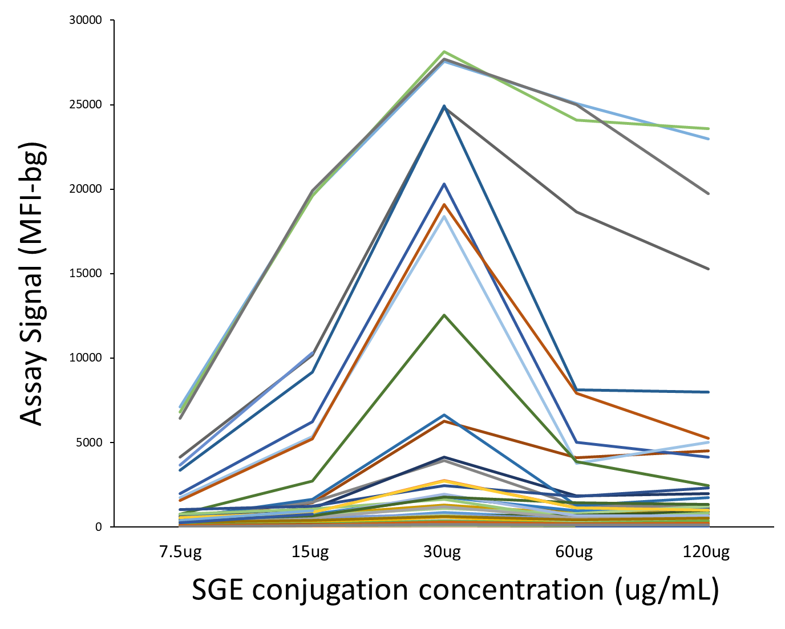
Supplementary Figure 1. Optimal SGE homogenate concentration for bead conjugation. Microbeads were conjugated with different concentrations of crude homogenate and tested against a random panel of blood samples from 78 Haitian participants to obtain assay signal (MFI-bg).

A  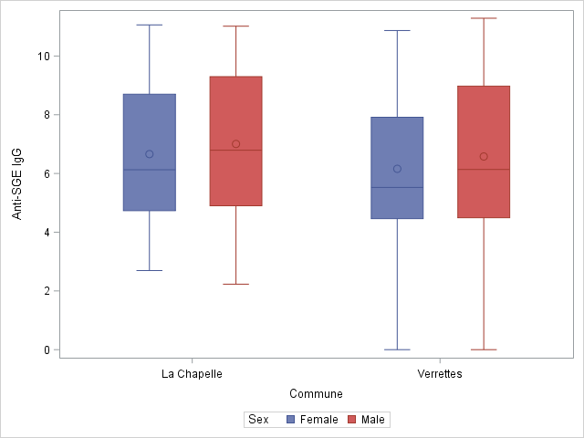 | B  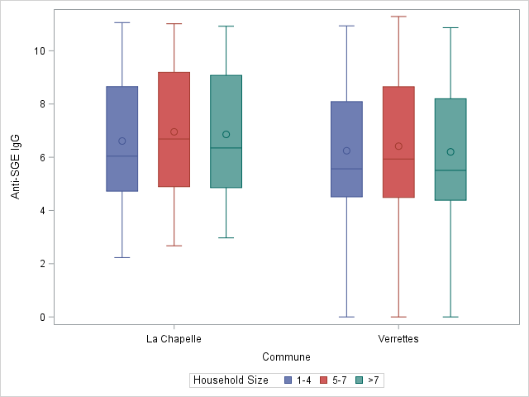
C  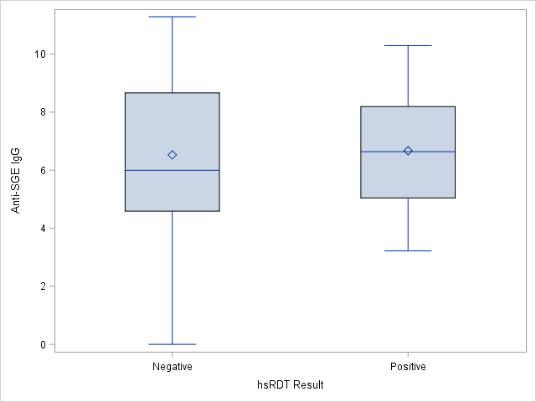 | D  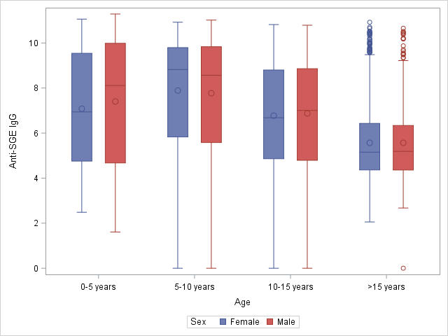
Supplementary Figure 2. Boxplots of the association between anti-SGE IgG and select covariates. (A) Anti-salivary gland extract (SGE) immunoglobulin G (IgG) level by commune and sex, (B) by commune and household size, (C) by hsRDT result, and (D) by age and sex. Boxes represent the interquartile range of values for each category shown in the plot, with the first quartile depicted at the bottom of the box and the third quartile at the top. The horizontal line in each box is the median value for each category, while the diamond represents the mean. Whiskers extend 1.5x IQR above and below boxes.

A  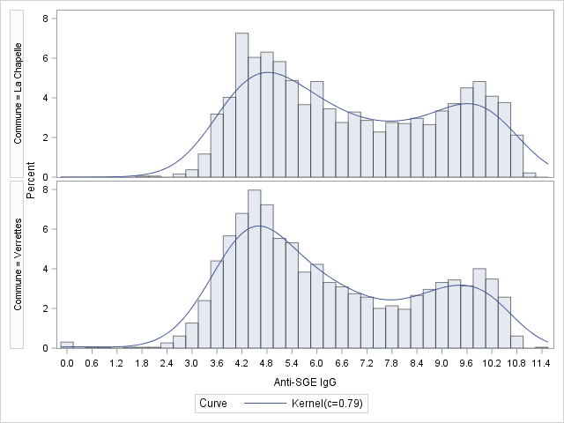 | B  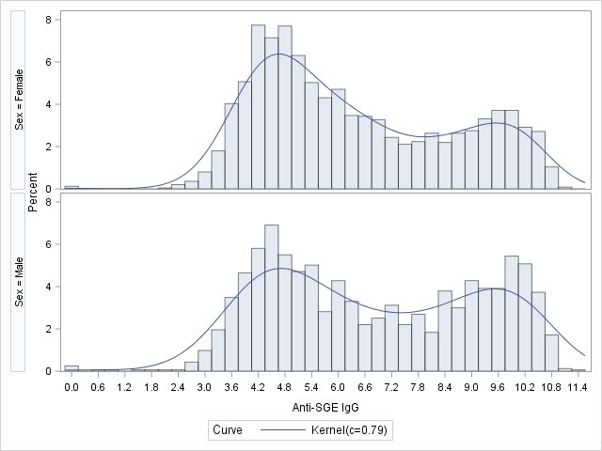
Supplementary Figure 3. Histograms of the association between anti-SGE IgG and select covariates. (A) Anti-salivary gland extract (SGE) immunoglobulin G (IgG) level by commune and (B) sex. Each bar represents the percent of the study population that has a given anti-SGE IgG value, categorized either by sex (male or female) or commune of residence (La Chapelle or Verrettes).

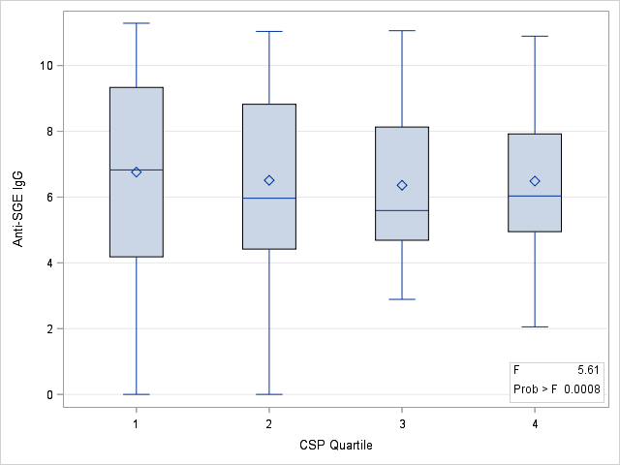 | 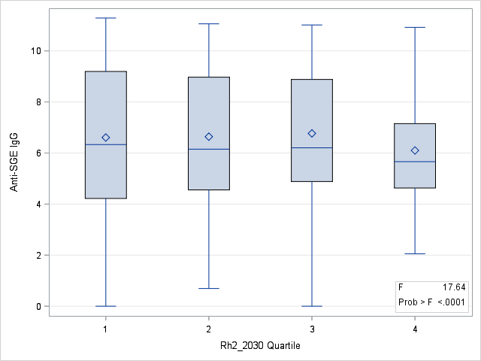
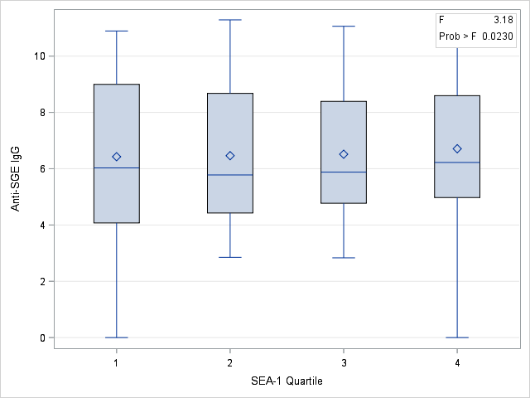
Supplementary Figure 4. Association between anti-SGE IgG and select P. falciparum antigens. Antigens depicted are those found to be significantly associated with an above-median anti-salivary gland extract (SGE) immunoglobulin G (IgG) response. Each antigen’s median fluorescence intensity (MFI) values were log-transformed, categorized into quartiles, and then plotted against anti-SGE IgG. Boxplots display the first-quartile (bottom of each box), third-quartile (top of each box), median (line within the box), mean (diamond within the box), minimum (bottom whisker), and maximum (top whisker) anti-SGE IgG values based on each antigen’s log-transformed quartile grouping. The F test statistic shown in each plot was obtained from ANOVA, with a p-value <0.05 indicating there are statistically significant differences in mean anti-SGE IgG values among the P. falciparum antigen quartiles.

