Table S1. Descriptive statistics in case and control groups for CP 2.
Variable | Sub-categories | Case N=13,152 |  | Control N=112,222 |  | P-value
 |  | N or mean | % or SD | N or mean | % or SD
Demographics
Age | at index date year | 78.1 | 10.2 | 64.5 | 10.0 | <0.001^{b}
Gender | Female | 8,171 | 62.1% | 66,392 | 59.2% | <0.001ª
 | Male | 4,981 | 37.9% | 45,830 | 40.8%
Race and Ethnicity | Hispanic | 2,699 | 20.5% | 14,721 | 13.1% | <0.001ª
 | Non-Hispanic White | 6,657 | 50.6% | 67,443 | 60.1%
 | Non-Hispanic Black | 2,635 | 20.0% | 19,238 | 17.1%
 | Non-Hispanic Other | 306 | 2.3% | 3,359 | 3.0%
 | Unknown | 855 | 6.5% | 7,461 | 6.6%
Length of medical history in OneFlorida+
Number of years range | [1, 2) | 3,162 | 24.0% | 30,218 | 26.9% | <0.001ª
 | [2, 4) | 4,402 | 33.5% | 37,910 | 33.8%
 | [4, 6) | 3,451 | 26.2% | 27,891 | 24.9%
 | [6, +) | 2,137 | 16.2% | 16,203 | 14.4%
Number of Encounters | All types of encounters | 305.5 | 528.6 | 104.5 | 230.1 | <0.001^{c}
 | Ambulatory encounter | 71.2 | 103.3 | 52.1 | 85.5 | <0.001^{c}
ª Pearson Chi-square test; ^{b} two-sample t-test; ^{c} Wilcoxon Rank Sum Test;

Table S2. Descriptive statistics in case and control groups for CP 3.
Variable | Sub-categories | Case N=5,721 |  | Control N=47,871 |  | P-value
 |  | N or mean | % or SD | N or mean | % or SD
Demographics
Age | at index date year | 78.0 | 10.0 | 64.4 | 10.0 | <0.001^{b}
Gender | Female | 3,727 | 65.1% | 28,208 | 58.9% | <0.001ª
 | Male | 1,994 | 34.9% | 19,663 | 41.1%
Race and Ethnicity | Hispanic | 1,203 | 21.0% | 6,227 | 13.0% | <0.001ª
 | Non-Hispanic White | 2,872 | 50.2% | 28,695 | 59.9%
 | Non-Hispanic Black | 1,199 | 21.0% | 8,263 | 17.3%
 | Non-Hispanic Other | 80 | 1.4% | 1,338 | 2.8%
 | Unknown | 367 | 6.4% | 3,348 | 7.0%
Length of medical history in OneFlorida+
Number of years range | [1, 2) | 1,446 | 25.3% | 13,419 | 28.0% | <0.001ª
 | [2, 4) | 1,941 | 33.9% | 16,669 | 34.8%
 | [4, 6) | 1,579 | 27.6% | 12,257 | 25.6%
 | [6, +) | 755 | 13.2% | 5,526 | 11.5%
Number of Encounters | All types of encounters | 373.5 | 574.8 | 110.7 | 235.8 | <0.001^{c}
 | Ambulatory encounter | 81.0 | 99.7 | 55.0 | 88.7 | <0.001^{c}
ª Pearson Chi-square test; ^{b} two-sample t-test; ^{c} Wilcoxon Rank Sum Test;

Table S3. Descriptive statistics in case and control groups for CP 4.
Variable | Sub-categories | Case N=5,184 |  | Control N=42,222 |  | P-value
 |  | N or mean | % or SD | N or mean | % or SD
Demographics
Age | at index date year | 76.7 | 9.5 | 63.8 | 9.7 | <0.001^{b}
Gender | Female | 3,186 | 61.5% | 24,718 | 58.5% | <0.001ª
 | Male | 1,998 | 38.5% | 17,504 | 41.5%
Race and Ethnicity | Hispanic | 1,095 | 21.1% | 4,290 | 10.2% | <0.001ª
 | Non-Hispanic White | 2,578 | 49.7% | 25,348 | 60.0%
 | Non-Hispanic Black | 973 | 18.8% | 8,118 | 19.2%
 | Non-Hispanic Other | 80 | 1.5% | 1,072 | 2.5%
 | Unknown | 458 | 8.8% | 3,394 | 8.0%
Length of medical history in OneFlorida+
Number of years range | [1, 2) | 1,474 | 28.4% | 13,232 | 31.3% | <0.001ª
 | [2, 4) | 1,978 | 38.2% | 15,975 | 37.8%
 | [4, 6) | 1,154 | 22.3% | 8,671 | 20.5%
 | [6, +) | 578 | 11.1% | 4,344 | 10.3%
Number of Encounters | All types of encounters | 339.9 | 564.8 | 140.2 | 265.2 | <0.001^{c}
 | Ambulatory encounter | 98.0 | 127.7 | 70.5 | 100.9 | <0.001^{c}
ª Pearson Chi-square test; ^{b} two-sample t-test; ^{c} Wilcoxon Rank Sum Test;

Table S4. Prediction performance for a prediction window size of 0-year.
Feature strategy | CP | Model | AUC  (95% CI) | Sensitivity  (95% CI) | Specificity  (95% CI) | PPV  (95% CI) | NPV  (95% CI)
Knowledge-driven | CP 1 | LR | 0.892  (0.892, 0.893) | 0.83  (0.827, 0.833) | 0.8  (0.797, 0.803) | 0.324  (0.322, 0.326) | 0.976  (0.976, 0.976)
 |  | GBT | 0.894  (0.894, 0.895) | 0.828  (0.825, 0.831) | 0.806  (0.804, 0.808) | 0.33  (0.328, 0.332) | 0.976  (0.976, 0.976)
 | CP 2 | LR | 0.898  (0.898, 0.899) | 0.839  (0.835, 0.842) | 0.801  (0.797, 0.804) | 0.331  (0.328, 0.334) | 0.977  (0.977, 0.977)
 |  | GBT | 0.899  (0.899, 0.9) | 0.835  (0.831, 0.838) | 0.808  (0.805, 0.811) | 0.338  (0.335, 0.341) | 0.977  (0.976, 0.977)
 | CP 3 | LR | 0.9  (0.899, 0.901) | 0.829  (0.825, 0.833) | 0.818  (0.815, 0.822) | 0.354  (0.35, 0.357) | 0.976  (0.975, 0.976)
 |  | GBT | 0.9  (0.899, 0.901) | 0.847  (0.844, 0.851) | 0.802  (0.798, 0.805) | 0.339  (0.336, 0.342) | 0.978  (0.977, 0.978)
 | CP 4 | LR | 0.877  (0.876, 0.878) | 0.817  (0.812, 0.822) | 0.781  (0.776, 0.786) | 0.316  (0.312, 0.32) | 0.972  (0.971, 0.973)
 |  | GBT | 0.877  (0.876, 0.878) | 0.814  (0.808, 0.819) | 0.783  (0.777, 0.789) | 0.317  (0.313, 0.322) | 0.972  (0.971, 0.972)
Data-driven | CP 1 | LR | 0.917  (0.918, 0.917) | 0.829  (0.832, 0.827) | 0.86  (0.862, 0.858) | 0.406  (0.41, 0.403) | 0.978  (0.978, 0.977)
 |  | GBT | 0.931  (0.932, 0.931) | 0.851  (0.853, 0.848) | 0.858  (0.86, 0.855) | 0.409  (0.413, 0.406) | 0.98  (0.981, 0.98)
 | CP 2 | LR | 0.922  (0.922, 0.921) | 0.833  (0.836, 0.83) | 0.864  (0.867, 0.862) | 0.42  (0.423, 0.416) | 0.978  (0.978, 0.978)
 |  | GBT | 0.936  (0.936, 0.935) | 0.855  (0.857, 0.852) | 0.865  (0.868, 0.863) | 0.428  (0.432, 0.424) | 0.981  (0.981, 0.98)
 | CP 3 | LR | 0.919  (0.92, 0.918) | 0.838  (0.841, 0.834) | 0.861  (0.864, 0.858) | 0.421  (0.426, 0.416) | 0.978  (0.978, 0.978)
 |  | GBT | 0.939  (0.94, 0.938) | 0.862  (0.866, 0.858) | 0.866  (0.871, 0.862) | 0.439  (0.446, 0.432) | 0.981  (0.982, 0.981)
 | CP 4 | LR | 0.891  (0.892, 0.89) | 0.803  (0.807, 0.798) | 0.829  (0.834, 0.825) | 0.368  (0.373, 0.363) | 0.972  (0.972, 0.971)
 |  | GBT | 0.911  (0.912, 0.91) | 0.833  (0.837, 0.828) | 0.831  (0.835, 0.827) | 0.379  (0.384, 0.374) | 0.976  (0.976, 0.975)

Table S5. Prediction performance for a prediction window size of 1-year.
Feature strategy | CP | Model | AUC  (95% CI) | Sensitivity  (95% CI) | Specificity  (95% CI) | PPV  (95% CI) | NPV  (95% CI)
Knowledge-driven | 1 | LR | 0.870  (0.87, 0.87) | 0.800  (0.796, 0.803) | 0.787  (0.784, 0.79) | 0.341  (0.338, 0.343) | 0.966  (0.966, 0.967)
 |  | GBT | 0.871  (0.871, 0.872) | 0.807  (0.804, 0.81) | 0.781  (0.778, 0.784) | 0.337  (0.334, 0.339) | 0.967  (0.967, 0.968)
 | 2 | LR | 0.878  (0.877, 0.878) | 0.809  (0.805, 0.813) | 0.792  (0.788, 0.796) | 0.354  (0.35, 0.357) | 0.967  (0.967, 0.968)
 |  | GBT | 0.878  (0.877, 0.879) | 0.819  (0.815, 0.824) | 0.783  (0.78, 0.787) | 0.347  (0.344, 0.351) | 0.969  (0.968, 0.969)
 | 3 | LR | 0.879  (0.878, 0.88) | 0.809  (0.804, 0.814) | 0.800  (0.796, 0.805) | 0.370  (0.365, 0.374) | 0.967  (0.966, 0.968)
 |  | GBT | 0.879  (0.878, 0.88) | 0.819  (0.815, 0.824) | 0.789  (0.784, 0.793) | 0.359  (0.355, 0.363) | 0.968  (0.968, 0.969)
 | 4 | LR | 0.856  (0.855, 0.858) | 0.794  (0.788, 0.799) | 0.774  (0.769, 0.779) | 0.345  (0.341, 0.349) | 0.962  (0.961, 0.963)
 |  | GBT | 0.854  (0.853, 0.855) | 0.785  (0.78, 0.79) | 0.782  (0.777, 0.787) | 0.351  (0.347, 0.355) | 0.961  (0.96, 0.961)
Data-driven | 1 | LR | 0.884  (0.885, 0.884) | 0.797  (0.8, 0.794) | 0.824  (0.827, 0.822) | 0.384  (0.387, 0.381) | 0.967  (0.968, 0.967)
 |  | GBT | 0.9  (0.9, 0.899) | 0.822  (0.824, 0.819) | 0.82  (0.823, 0.818) | 0.386  (0.389, 0.383) | 0.971  (0.971, 0.971)
 | 2 | LR | 0.887  (0.888, 0.886) | 0.811  (0.815, 0.807) | 0.816  (0.819, 0.812) | 0.383  (0.387, 0.379) | 0.969  (0.969, 0.968)
 |  | GBT | 0.904  (0.905, 0.903) | 0.824  (0.828, 0.821) | 0.827  (0.831, 0.824) | 0.402  (0.406, 0.398) | 0.971  (0.972, 0.971)
 | 3 | LR | 0.882  (0.883, 0.881) | 0.802  (0.806, 0.797) | 0.821  (0.826, 0.816) | 0.394  (0.399, 0.389) | 0.966  (0.967, 0.966)
 |  | GBT | 0.906  (0.908, 0.906) | 0.836  (0.84, 0.831) | 0.825  (0.83, 0.82) | 0.409  (0.415, 0.404) | 0.972  (0.973, 0.972)
 | 4 | LR | 0.851  (0.853, 0.85) | 0.79  (0.796, 0.784) | 0.77  (0.776, 0.764) | 0.34  (0.345, 0.336) | 0.961  (0.962, 0.96)
 |  | GBT | 0.876  (0.877, 0.875) | 0.815  (0.82, 0.81) | 0.784  (0.788, 0.779) | 0.361  (0.365, 0.357) | 0.966  (0.967, 0.966)

Table S6. Prediction performance for a prediction window size of 3-year
Feature strategy | CP | Model | AUC  (95% CI) | Sensitivity  (95% CI) | Specificity  (95% CI) | PPV  (95% CI) | NPV  (95% CI)
Knowledge-driven | 1 | LR | 0.855  (0.854, 0.856) | 0.798  (0.794, 0.801) | 0.764  (0.761, 0.767) | 0.372  (0.37, 0.375) | 0.956  (0.955, 0.956)
 |  | GBT | 0.856  (0.855, 0.857) | 0.791  (0.787, 0.795) | 0.770  (0.766, 0.773) | 0.376  (0.373, 0.379) | 0.955  (0.954, 0.955)
 | 2 | LR | 0.868  (0.867, 0.869) | 0.812  (0.808, 0.816) | 0.773  (0.769, 0.778) | 0.398  (0.394, 0.401) | 0.957  (0.957, 0.958)
 |  | GBT | 0.868  (0.867, 0.869) | 0.814  (0.81, 0.819) | 0.769  (0.764, 0.774) | 0.394  (0.39, 0.398) | 0.958  (0.957, 0.959)
 | 3 | LR | 0.872  (0.87, 0.873) | 0.812  (0.807, 0.818) | 0.787  (0.783, 0.792) | 0.425  (0.421, 0.429) | 0.956  (0.955, 0.957)
 |  | GBT | 0.867  (0.866, 0.869) | 0.821  (0.816, 0.827) | 0.775  (0.77, 0.78) | 0.414  (0.41, 0.419) | 0.958  (0.957, 0.959)
 | 4 | LR | 0.846  (0.844, 0.848) | 0.772  (0.766, 0.778) | 0.789  (0.784, 0.795) | 0.417  (0.412, 0.422) | 0.947  (0.946, 0.948)
 |  | GBT | 0.841  (0.839, 0.843) | 0.776  (0.769, 0.783) | 0.781  (0.774, 0.789) | 0.410  (0.404, 0.416) | 0.948  (0.947, 0.949)
Data-driven | 1 | LR | 0.856  (0.857, 0.855) | 0.772  (0.777, 0.768) | 0.795  (0.799, 0.791) | 0.398  (0.402, 0.395) | 0.952  (0.953, 0.952)
 |  | GBT | 0.876  (0.877, 0.876) | 0.8  (0.804, 0.796) | 0.798  (0.802, 0.795) | 0.41  (0.414, 0.407) | 0.958  (0.959, 0.958)
 | 2 | LR | 0.863  (0.864, 0.862) | 0.791  (0.797, 0.786) | 0.786  (0.792, 0.781) | 0.406  (0.411, 0.402) | 0.954  (0.955, 0.953)
 |  | GBT | 0.884  (0.885, 0.883) | 0.807  (0.812, 0.802) | 0.805  (0.81, 0.8) | 0.434  (0.439, 0.429) | 0.958  (0.959, 0.957)
 | 3 | LR | 0.856  (0.858, 0.855) | 0.779  (0.786, 0.772) | 0.798  (0.805, 0.792) | 0.43  (0.436, 0.424) | 0.95  (0.951, 0.948)
 |  | GBT | 0.884  (0.885, 0.882) | 0.815  (0.822, 0.808) | 0.8  (0.807, 0.793) | 0.444  (0.451, 0.437) | 0.958  (0.959, 0.956)
 | 4 | LR | 0.82  (0.822, 0.818) | 0.755  (0.764, 0.746) | 0.759  (0.768, 0.749) | 0.382  (0.39, 0.375) | 0.942  (0.943, 0.94)
 |  | GBT | 0.854  (0.856, 0.852) | 0.799  (0.807, 0.791) | 0.764  (0.772, 0.756) | 0.4  (0.407, 0.393) | 0.952  (0.953, 0.95)

Table S7. Prediction performance for a prediction window size of 5-year
Feature strategy | CP | Model | AUC  (95% CI) | Sensitivity (95% CI) | Specificity  (95% CI) | PPV  (95% CI) | NPV  (95% CI)
Knowledge-driven | CP 1 | LR | 0.841  (0.84, 0.842) | 0.759  (0.755, 0.763) | 0.781  (0.777, 0.785) | 0.441  (0.437, 0.444) | 0.935  (0.934, 0.936)
 |  | GBT | 0.839  (0.838, 0.84) | 0.766  (0.761, 0.772) | 0.769  (0.763, 0.774) | 0.431  (0.426, 0.435) | 0.936  (0.935, 0.937)
 | CP 2 | LR | 0.849  (0.847, 0.851) | 0.776  (0.77, 0.782) | 0.779  (0.773, 0.784) | 0.462  (0.458, 0.467) | 0.935  (0.933, 0.936)
 |  | GBT | 0.845  (0.843, 0.847) | 0.764  (0.759, 0.77) | 0.786  (0.781, 0.792) | 0.467  (0.463, 0.472) | 0.932  (0.931, 0.933)
 | CP 3 | LR | 0.851  (0.847, 0.854) | 0.793  (0.782, 0.805) | 0.773  (0.763, 0.783) | 0.481  (0.472, 0.49) | 0.936  (0.933, 0.939)
 |  | GBT | 0.849  (0.845, 0.852) | 0.795  (0.784, 0.805) | 0.773  (0.764, 0.783) | 0.481  (0.473, 0.49) | 0.936  (0.934, 0.939)
 | CP 4 | LR | 0.830  (0.826, 0.834) | 0.788  (0.773, 0.802) | 0.742  (0.727, 0.756) | 0.441  (0.43, 0.452) | 0.935  (0.932, 0.938)
 |  | GBT | 0.830  (0.826, 0.835) | 0.786  (0.773, 0.799) | 0.749  (0.736, 0.762) | 0.446  (0.435, 0.456) | 0.935  (0.932, 0.938)
Data-driven | CP 1 | LR | 0.827  (0.828, 0.826) | 0.75  (0.755, 0.745) | 0.773  (0.778, 0.768) | 0.429  (0.433, 0.425) | 0.932  (0.933, 0.931)
 |  | GBT | 0.854  (0.855, 0.853) | 0.789  (0.795, 0.784) | 0.775  (0.78, 0.77) | 0.444  (0.448, 0.44) | 0.942  (0.943, 0.941)
 | CP 2 | LR | 0.826  (0.828, 0.824) | 0.756  (0.762, 0.749) | 0.773  (0.779, 0.767) | 0.449  (0.454, 0.444) | 0.929  (0.93, 0.928)
 |  | GBT | 0.858  (0.86, 0.856) | 0.8  (0.806, 0.793) | 0.778  (0.784, 0.772) | 0.469  (0.475, 0.464) | 0.941  (0.943, 0.94)
 | CP 3 | LR | 0.817  (0.82, 0.813) | 0.768  (0.778, 0.758) | 0.757  (0.767, 0.748) | 0.455  (0.462, 0.447) | 0.927  (0.93, 0.925)
 |  | GBT | 0.853  (0.856, 0.85) | 0.797  (0.806, 0.787) | 0.782  (0.79, 0.774) | 0.491  (0.498, 0.483) | 0.937  (0.94, 0.935)
 | CP 4 | LR | 0.785  (0.79, 0.78) | 0.749  (0.763, 0.734) | 0.721  (0.734, 0.708) | 0.406  (0.414, 0.397) | 0.922  (0.925, 0.919)
 |  | GBT | 0.831  (0.835, 0.828) | 0.789  (0.801, 0.776) | 0.749  (0.762, 0.736) | 0.445  (0.455, 0.436) | 0.936  (0.938, 0.933)

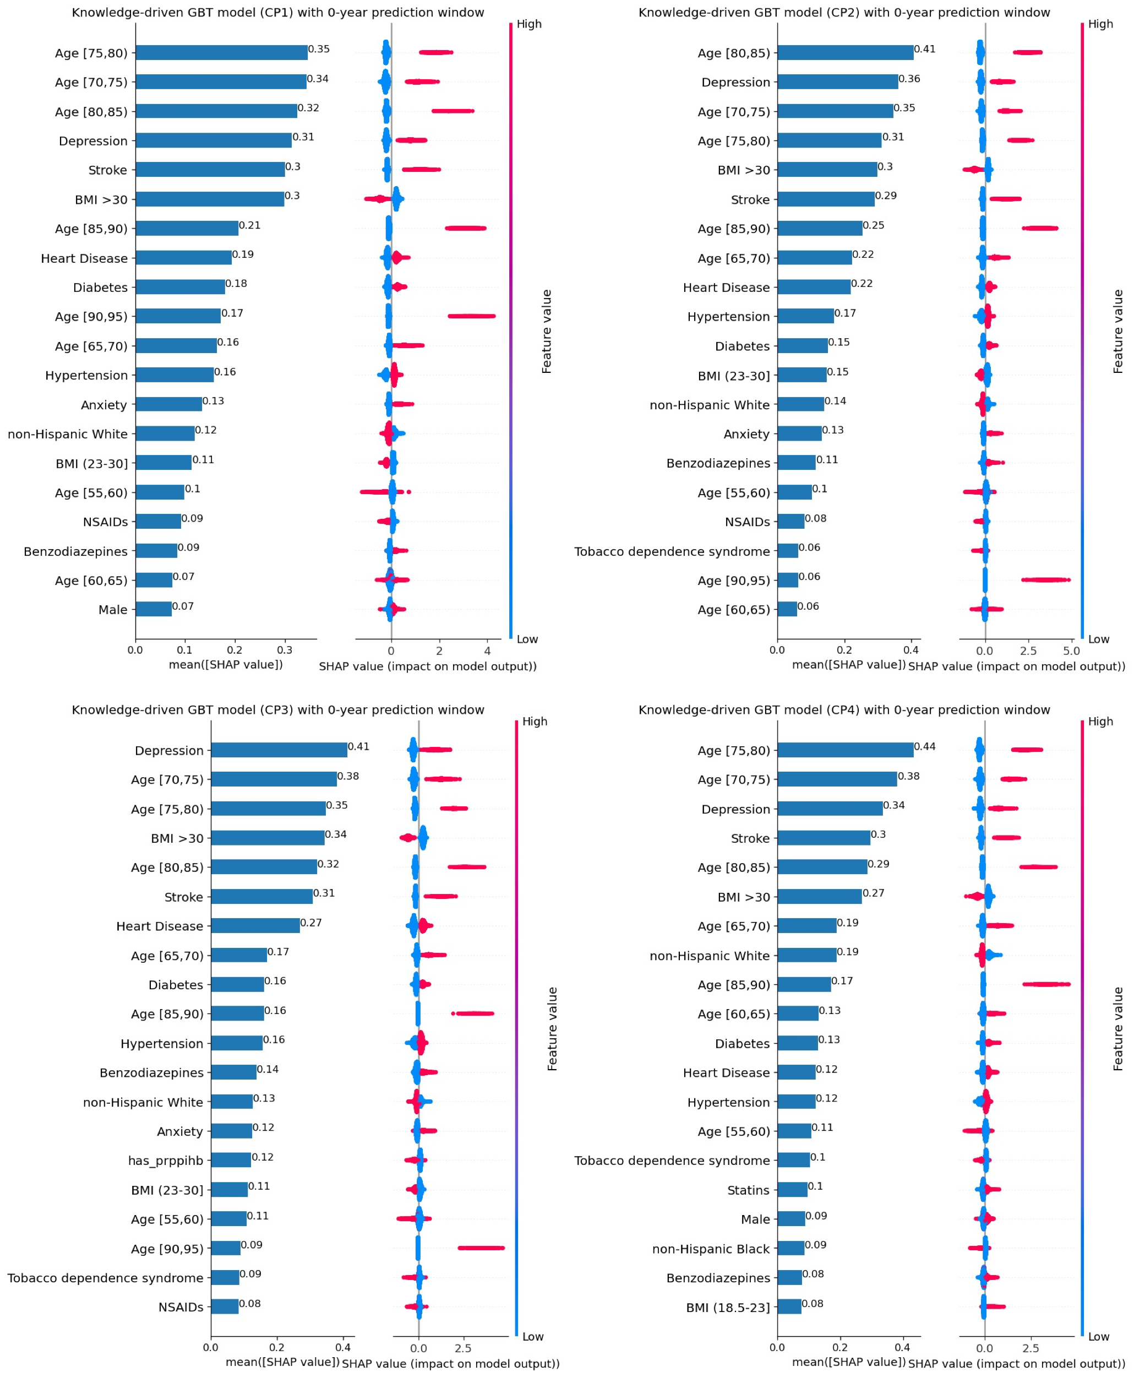
Figure S1. Under the knowledge-driven approach, SHAP plot of the top-20 features for GBT models based on different CP algorithms with 0-year prediction window.

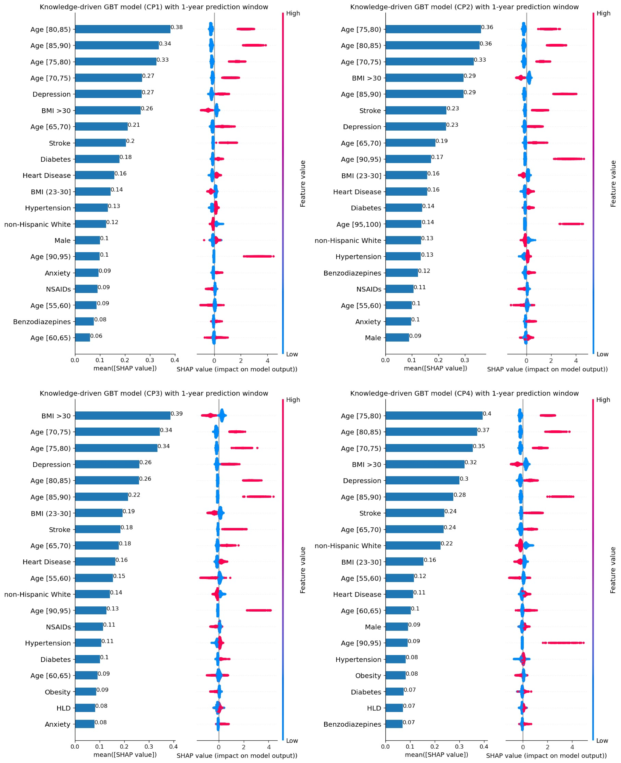
Figure S2. Under the knowledge-driven approach, SHAP plot of the top-20 features for GBT models based on different CP algorithms with 1-year prediction window.

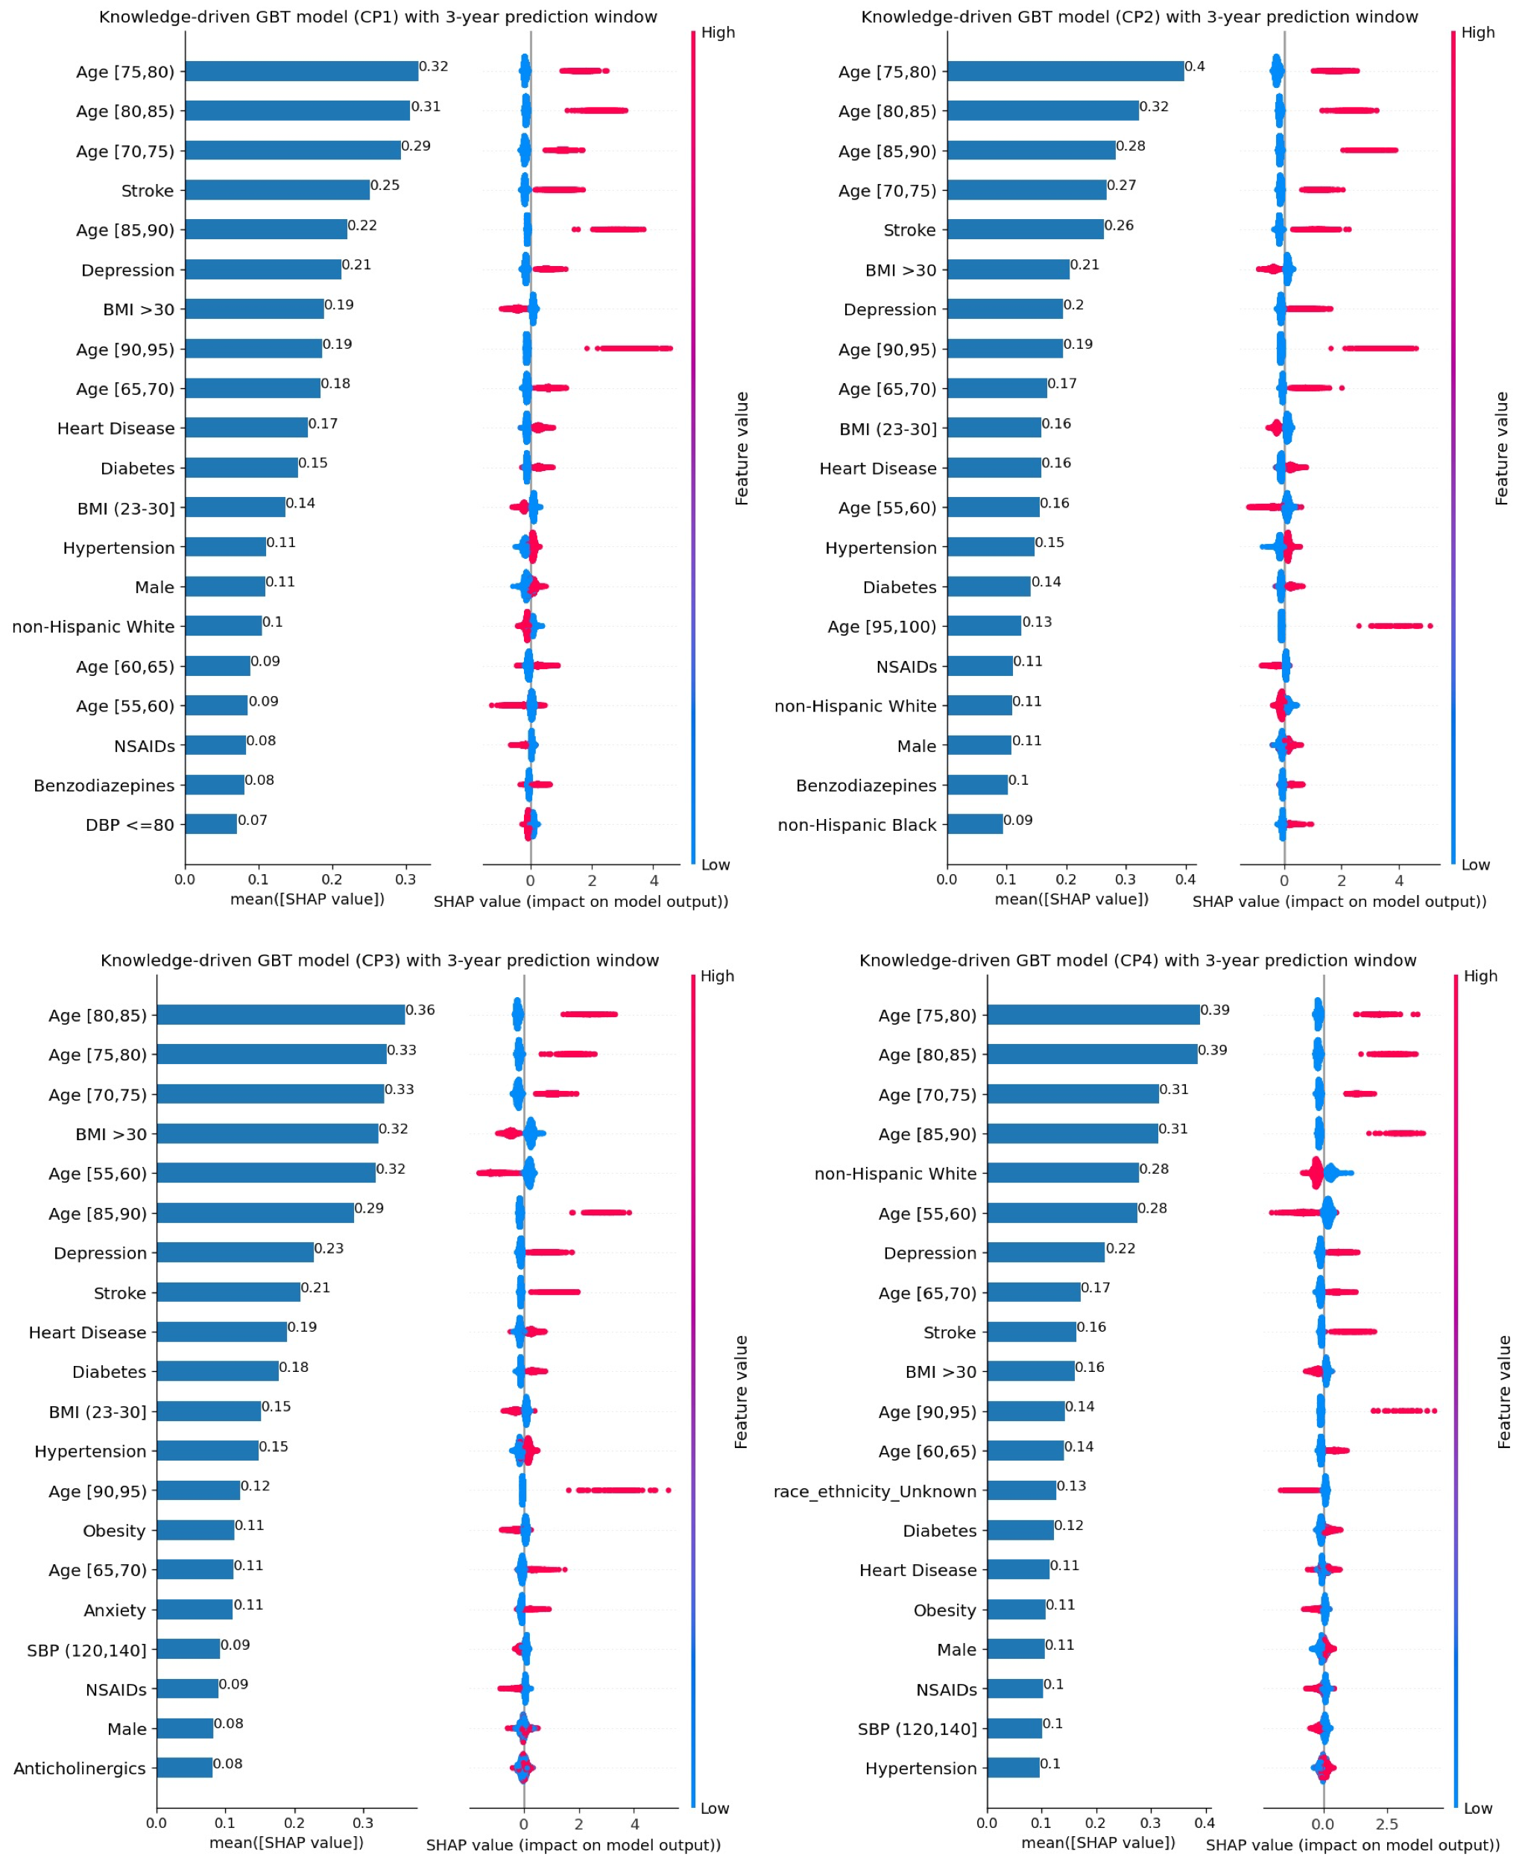

Figure S3. Under the knowledge-driven approach, SHAP plot of the top-20 features for GBT models based on different CP algorithms with 3-year prediction window.

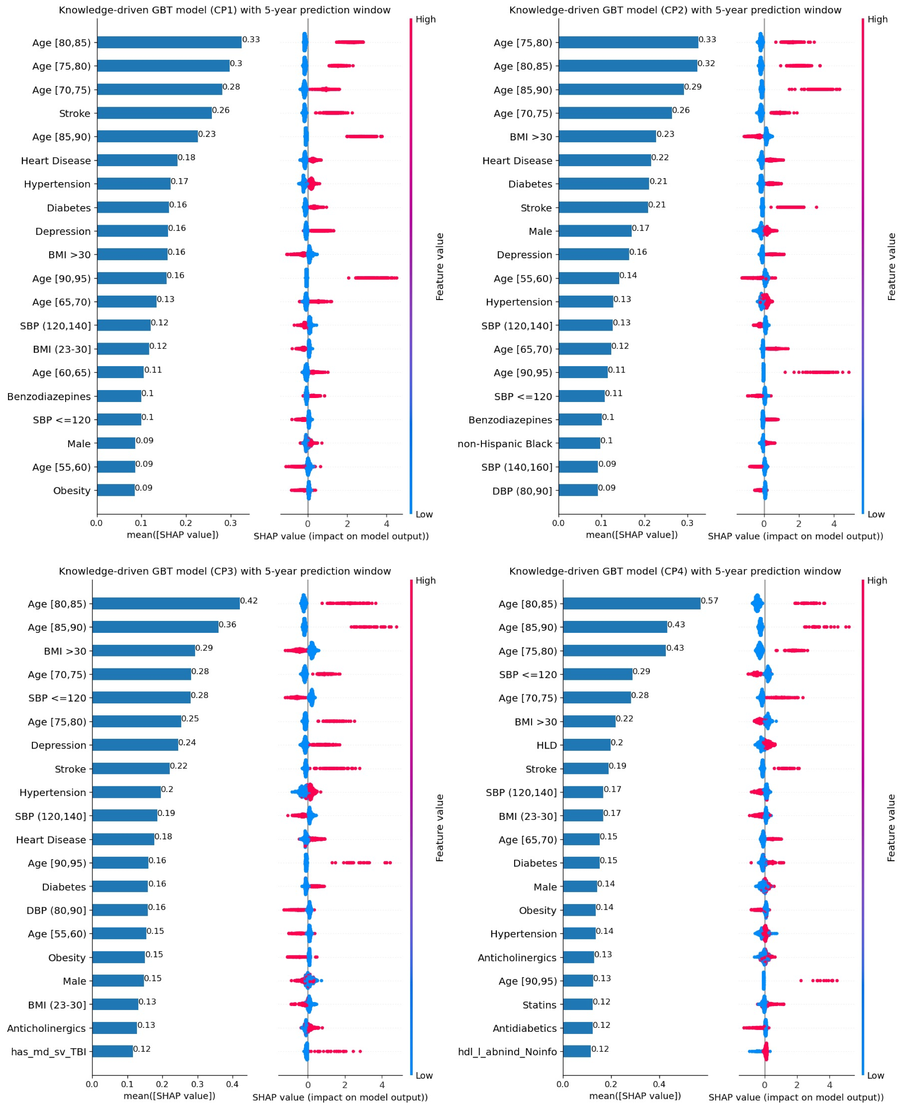

Figure S4. Under the knowledge-driven approach, SHAP plot of the top-20 features for GBT models based on different CP algorithms with 5-year prediction window.

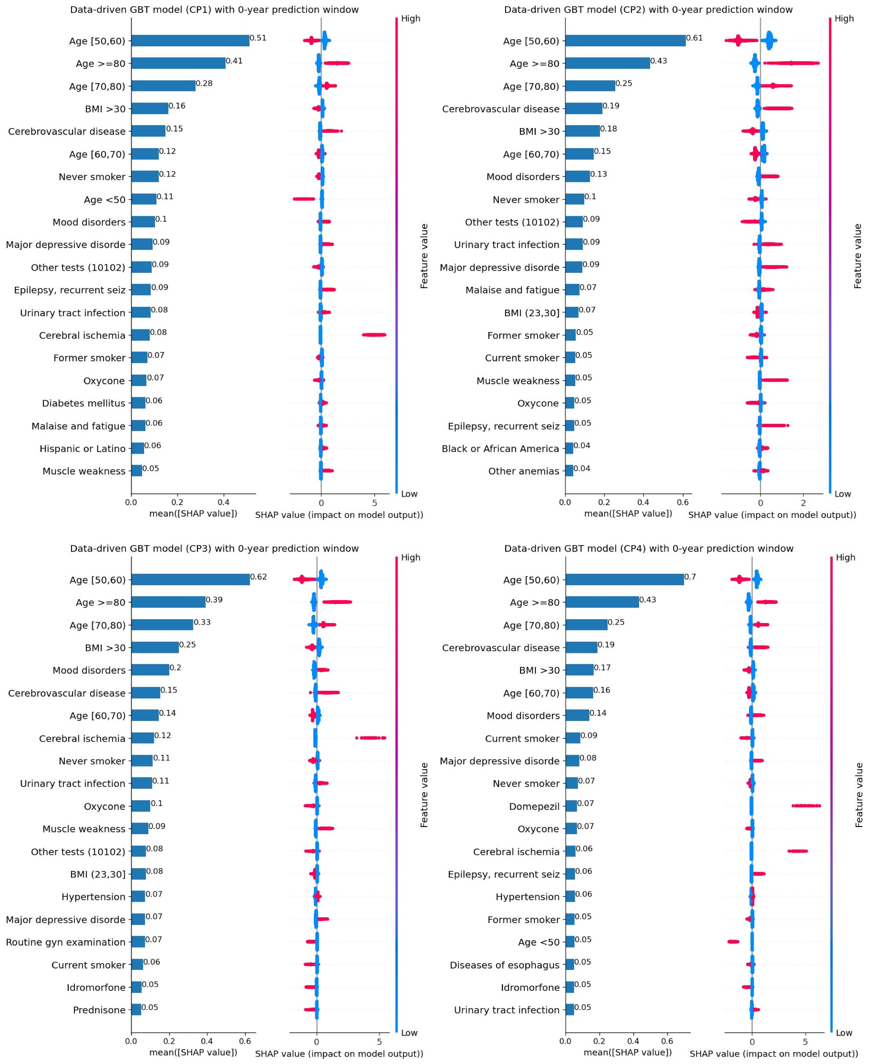

Figure S5. Under the data-driven approach, SHAP plot of the top-20 features for GBT models based on different CP algorithms with 0-year prediction window.

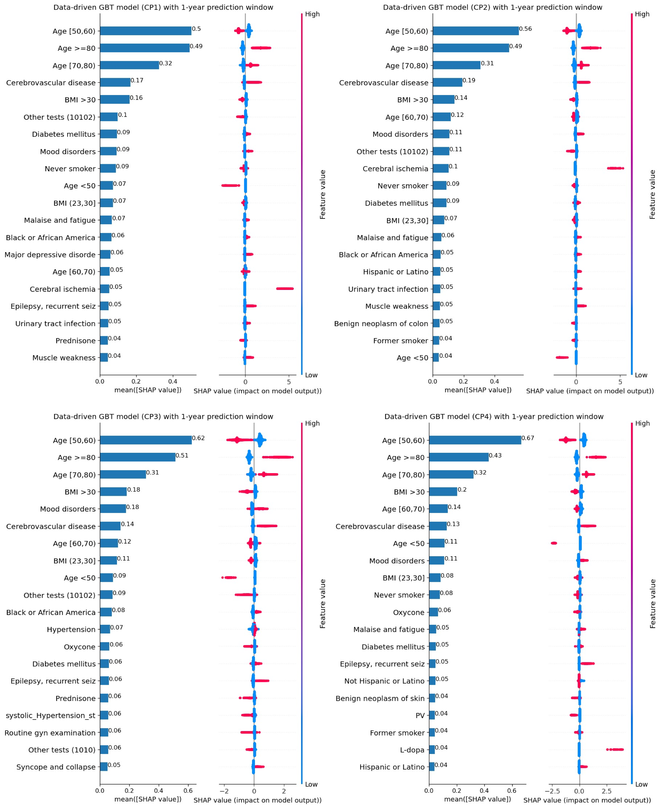

Figure S6. Under the data-driven approach, SHAP plot of the top-20 features for GBT models based on different CP algorithms with 1-year prediction window.

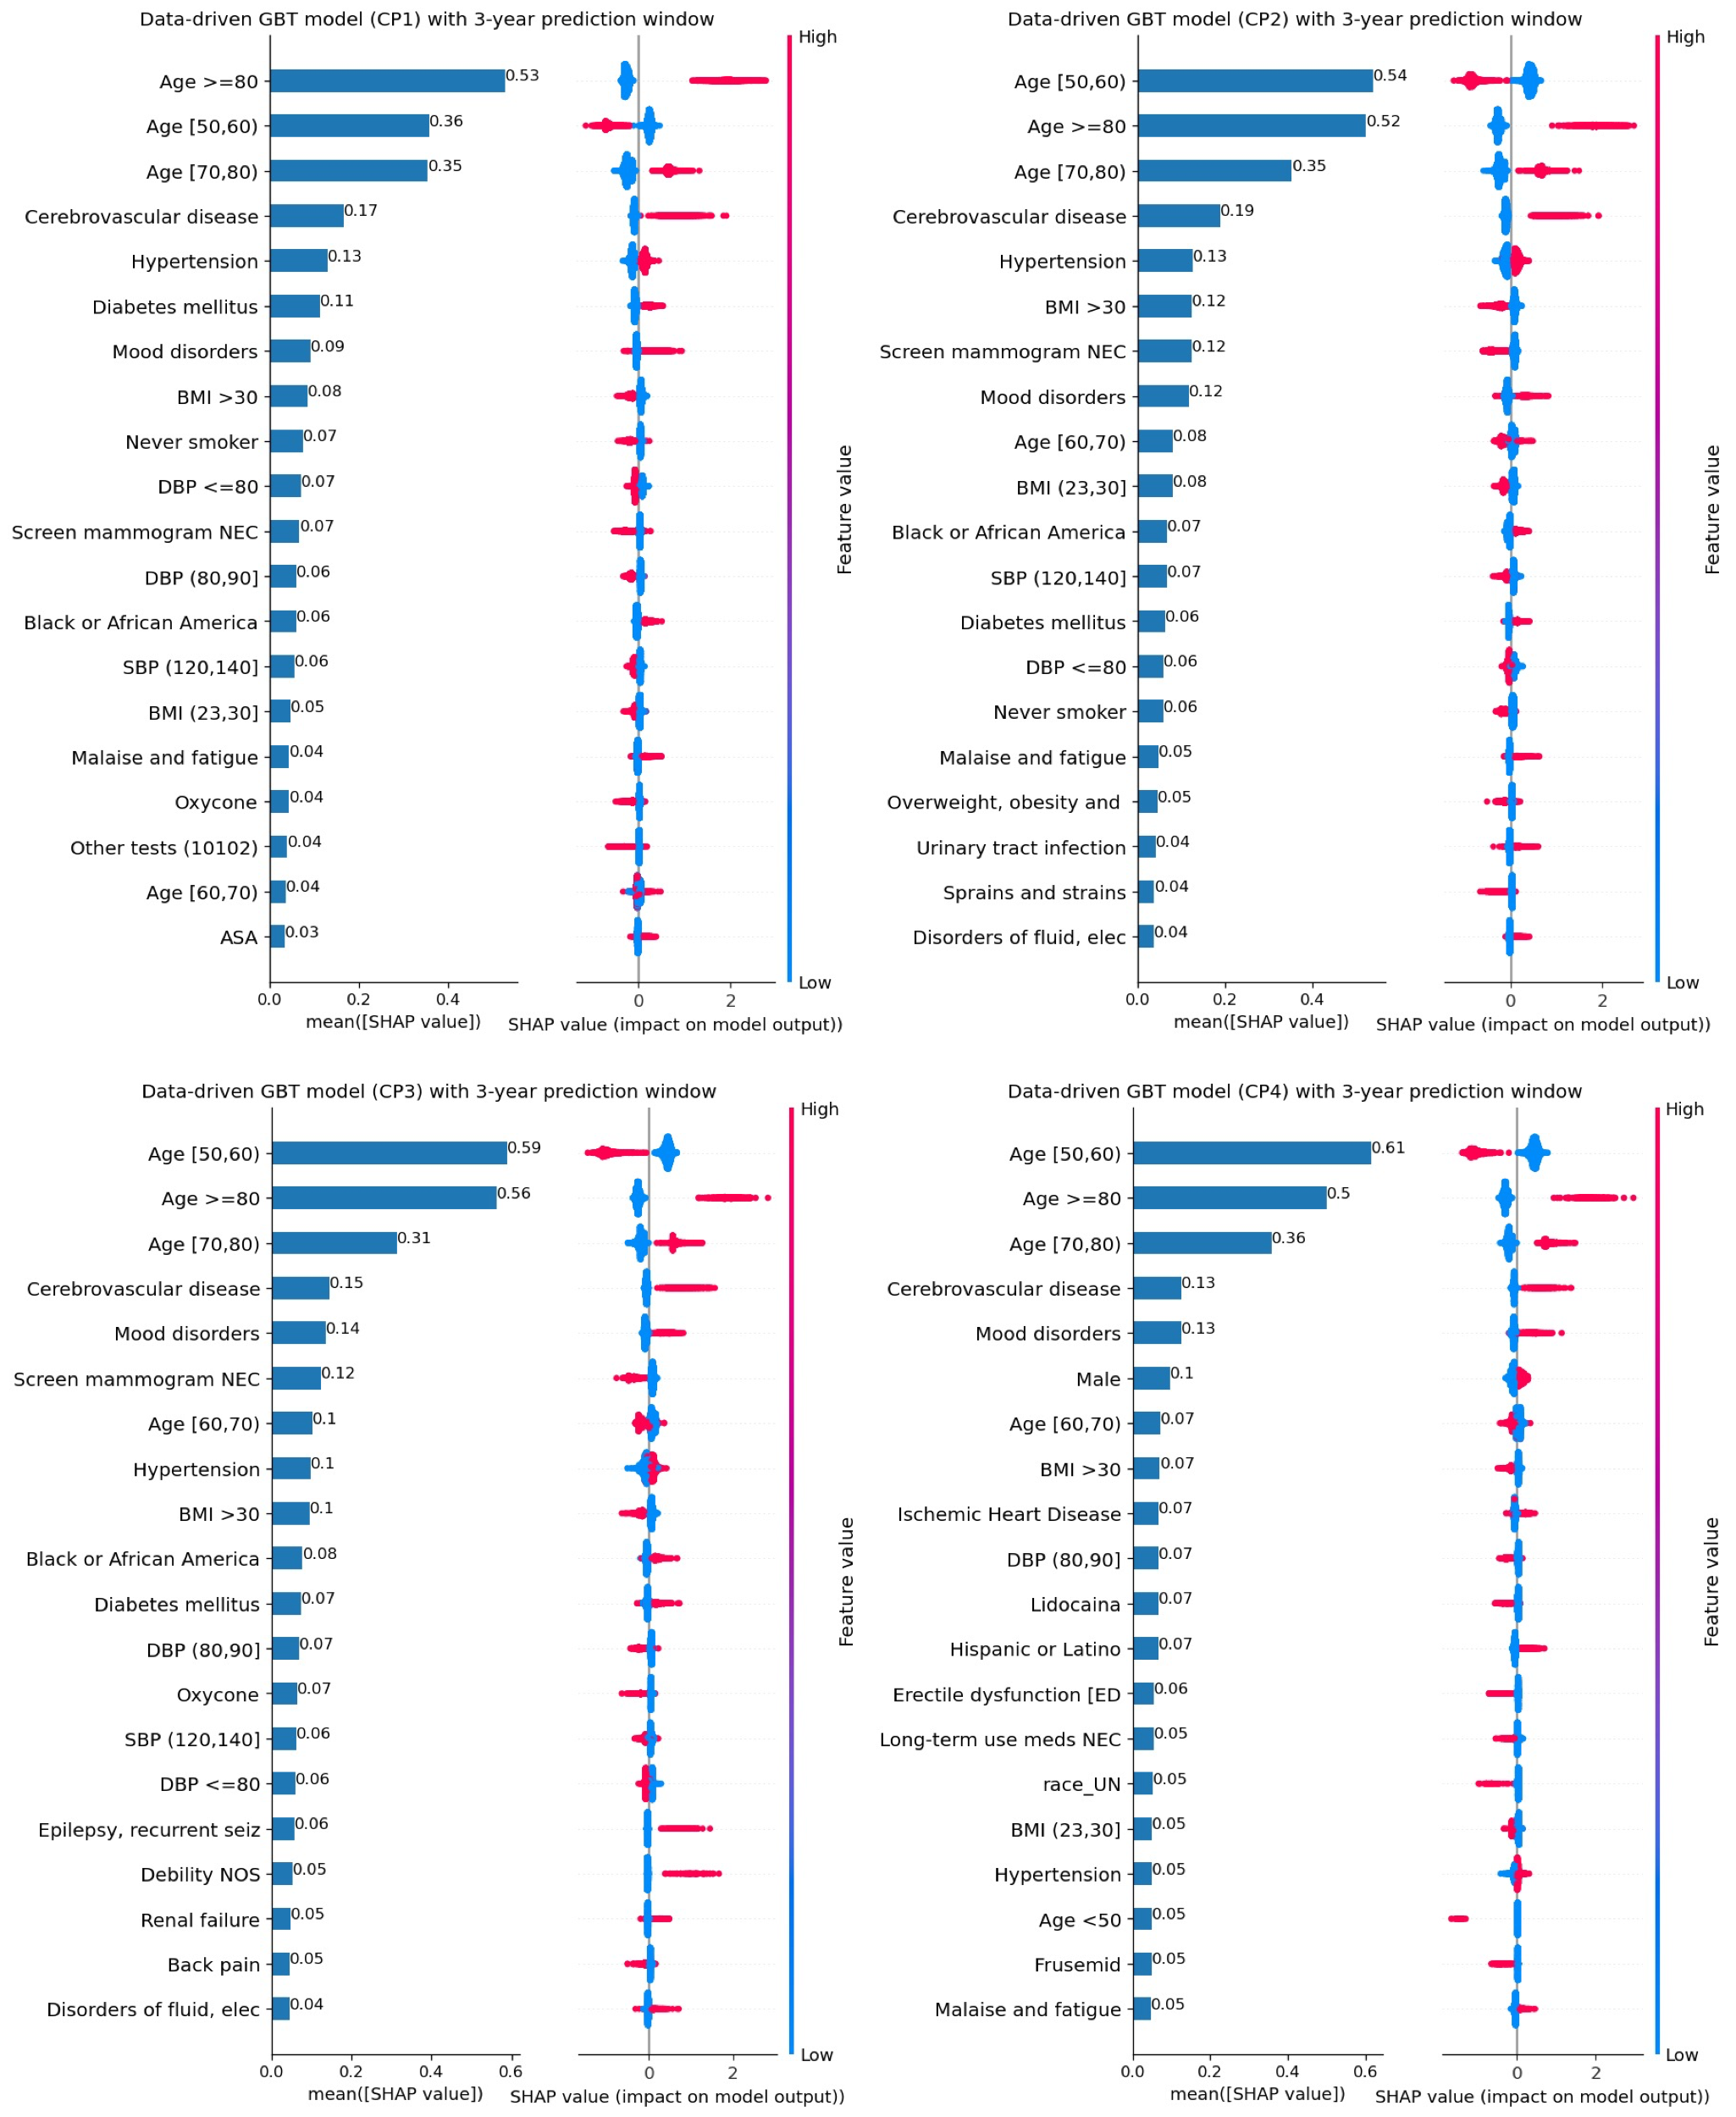

Figure S7. Under the data-driven approach, SHAP plot of the top-20 features for GBT models based on different CP algorithms with 3-year prediction window.

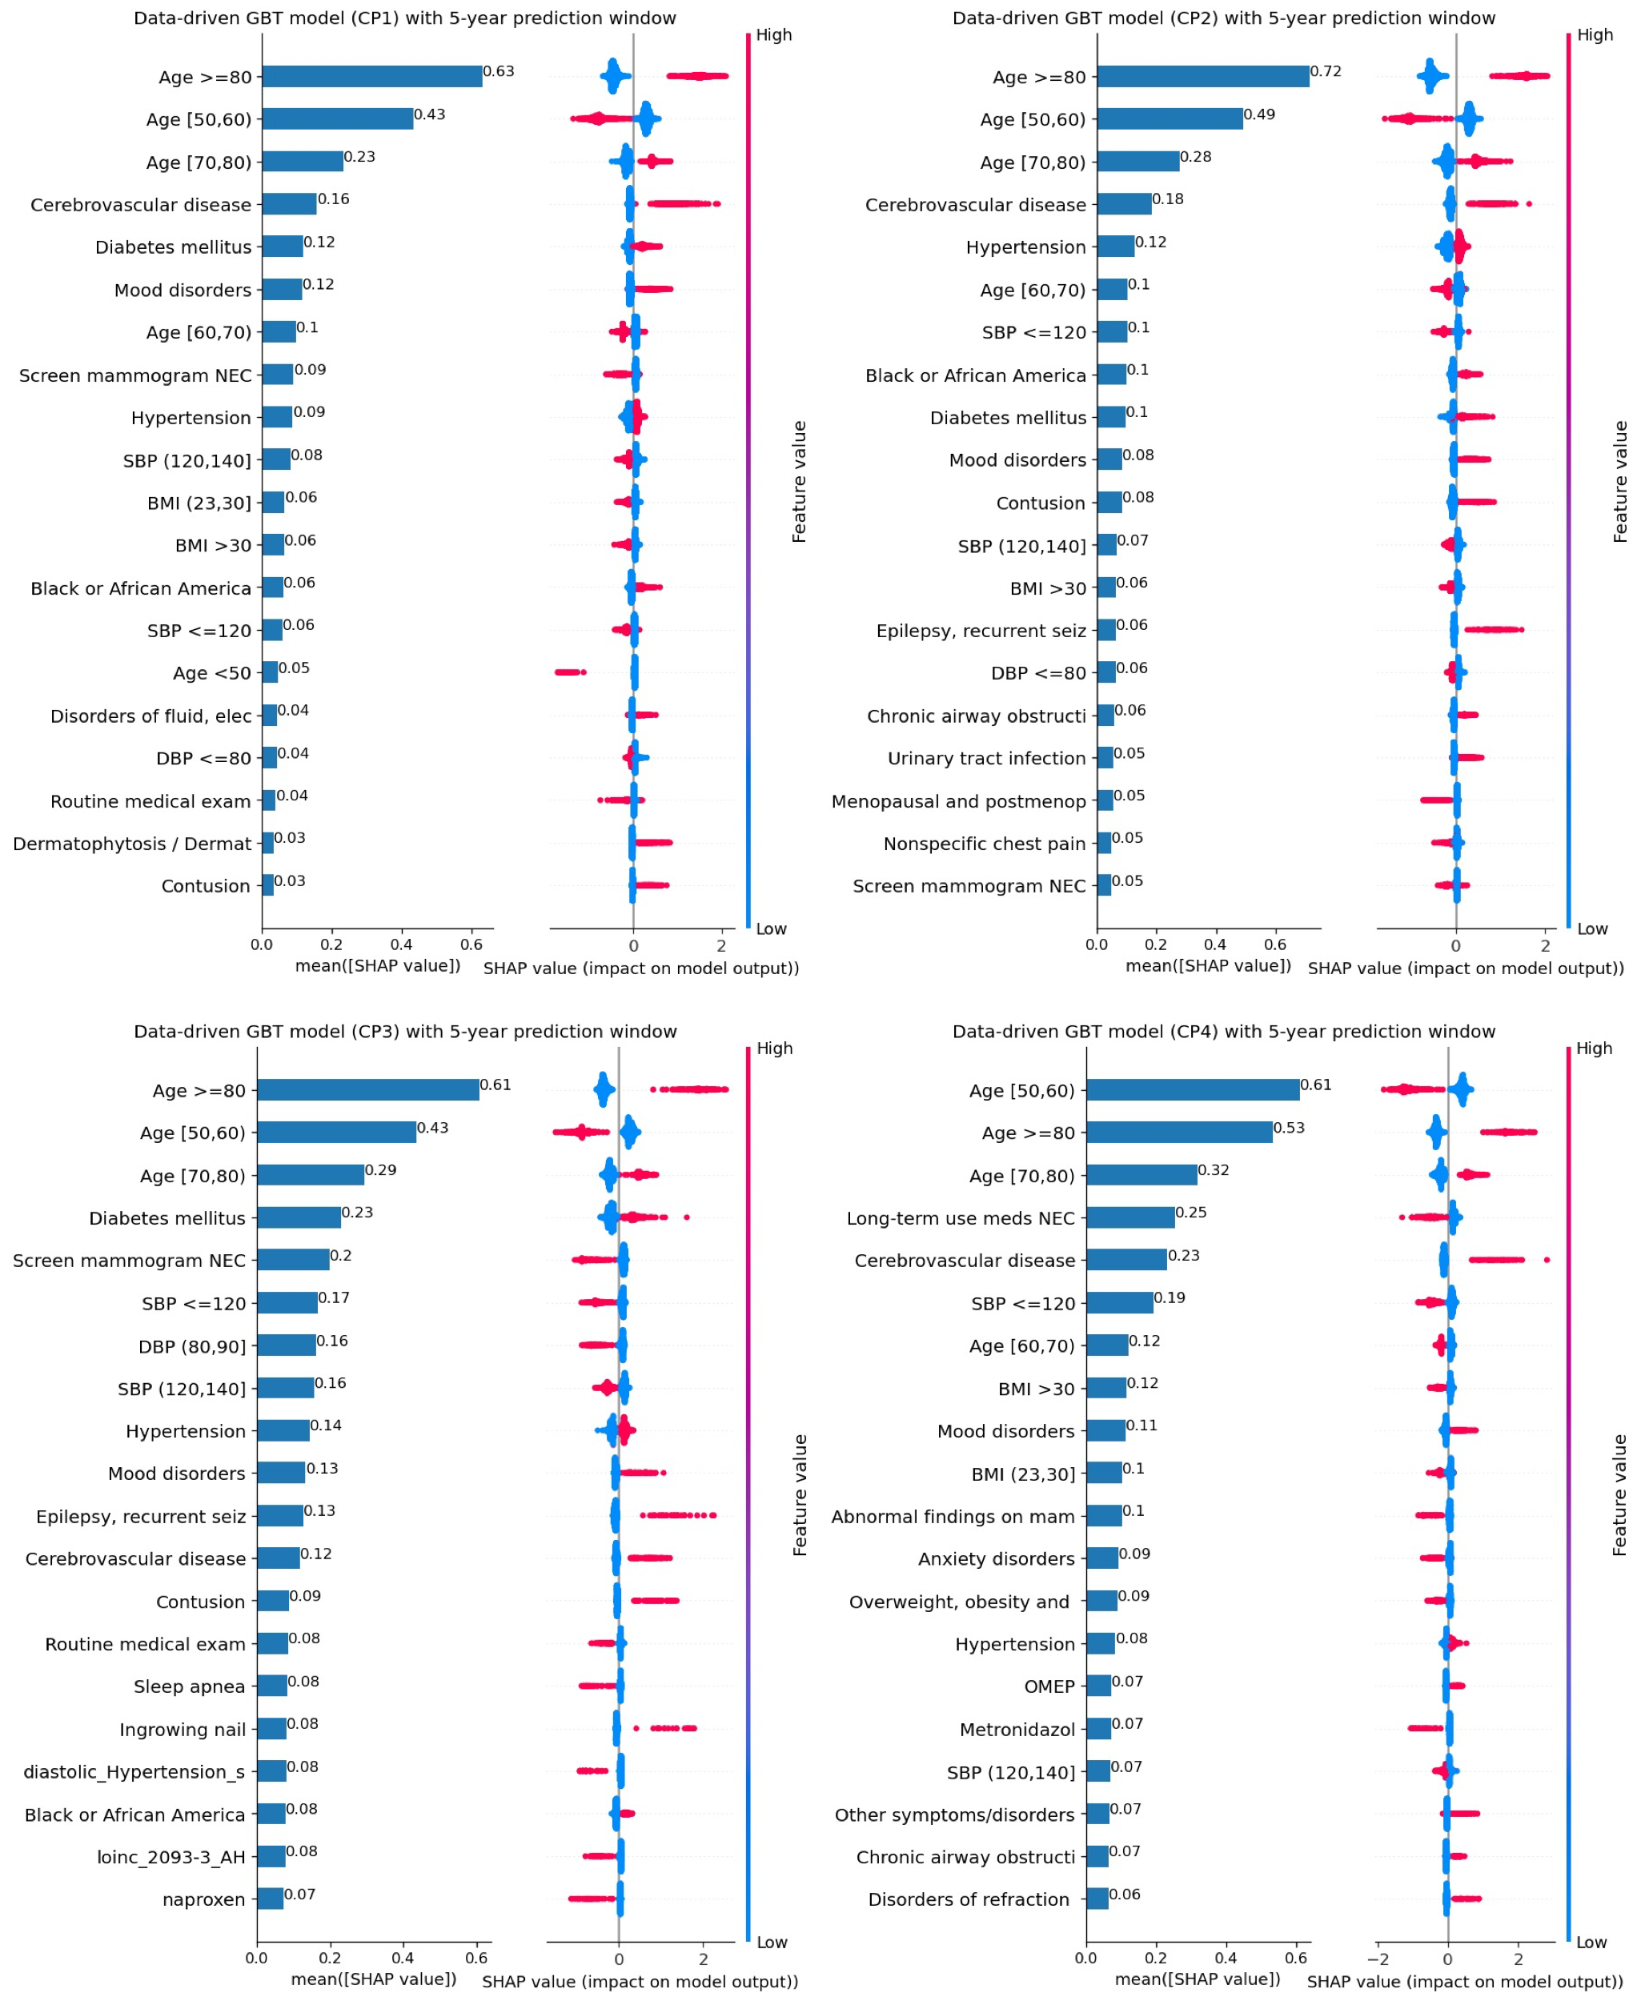
Figure S8. Under the data-driven approach, SHAP plot of the top-20 features for GBT models based on different CP algorithms with 5-year prediction window.

