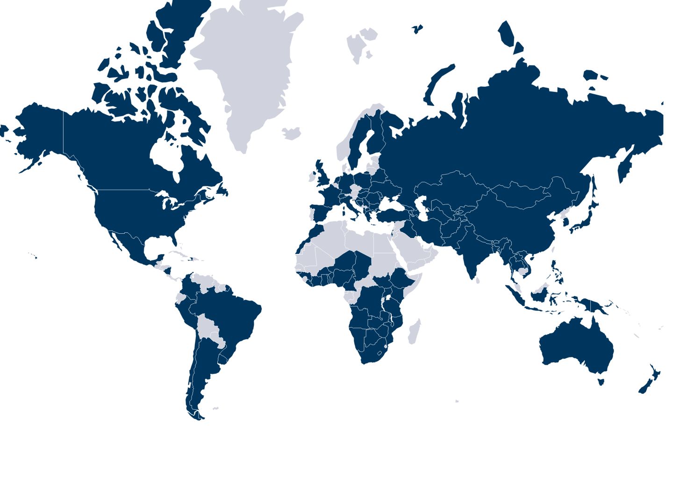
Appendix Figure 1. Global distribution of B. anthracis occurrence records (n = 874)

Appendix Figure 2. Global model - coefficient of variation (CV) (uncertainty)

Appendix Figure 3. Circumpolar model - coefficient of variation (CV) (uncertainty)

