Supporting Information
A highly sensitive and long-term stable wearable patch for continuous analysis of biomarkers in sweat
Farnaz Lorestani ^{a*}, Xianzhe Zhang ª, Abu Musa Abdullah ª, Xin Xin ª, Yushen Liu ª, MD Mashfiqur Rahman ª, Md Abu Sayeed Biswas ª, Bowen Li ª, Ankan Dutta ^{a,b}, Zhenyuan Niu ª, Shuvendu Das ª, Shishir Barai ª, Ke Wang ^{c}, Huanyu Cheng ^{a*}
- Department of Engineering Science and Mechanics, Pennsylvania State University, University Park, Pennsylvania16802, USA
- Center for Neural Engineering, The Pennsylvania State University, University Park, PA, 16802, USA
- Materials Research Institute, The Pennsylvania State University, University Park, PA 16802
Email: fkl5072@psu.edu (F.L.) and huanyu.cheng@psu.edu (H.C.)

Experimental Section/Methods
    - Fabrication of microfluidic channels and sensing devices
Figure S1. Geometric parameters and dimensions of the microfluidic patch and three-electrode sensor in the integrated system.

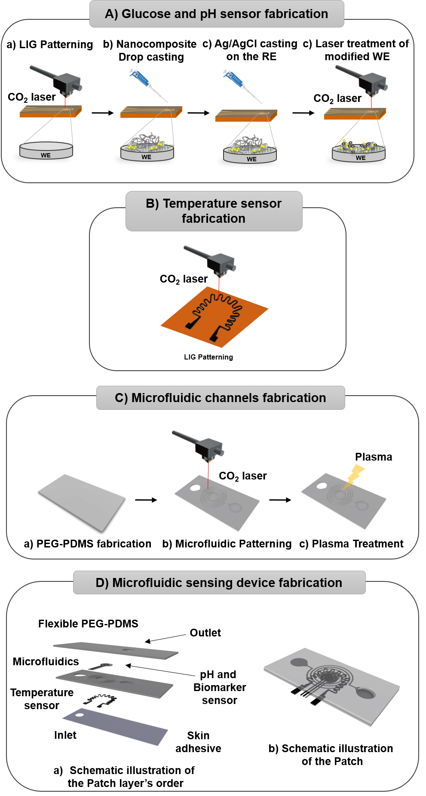
Figure S2. Fabrication procedure of the biosensing device. A) Glucose and pH sensor fabrication: a) patterning of three LIG electrodes. b) Ag/AuNPs-rGO-CNT alloy nanocomposite drop casting on the working electrode, c) Ag/AgCl casting on the reference electrode for glucose and pH sensor, d) laser treatment of the modified working electrode with Ag/AuNPs-rGO-CNT alloy nanocomposite. B) Temperature sensor fabrication: patterning of LIG temperature sensor. C) Microfluidic channels fabrication: a) preparation of the PEG-PDMS layer, b) patterning of microfluidic network, c) plasma treatment of the fabricated microfluidic layers. D) Assembly of microfluidic electrochemical sensing device: a) exploded view and b) bird’s eye view of the assembled microfluidic electrochemical sensing patch.
  - Material characterization
    - Characterization of laser-treated Ag/AuNPs-GO-CNT alloy-modified nanocomposite electrode
A stable film of well-dispersed quantum-sized gold/silver alloys (Au/AgNPs) on the rGO-CNT nanosheets was obtained by one-step facile laser treatment without using other chemical reagents. The laser treatment effect on the surface chemistry of the deposited nanocomposite film on the LIG WE was explored by characterizing the deposited film by the FESEM (Figure S3). The laser treatment created a 3D network structure of rGO-CNT flakes with a higher available specific surface area (Figure S3aii). As shown in Figure S3bi, the agglomeration of both AgNRs and AuNPs in the drop-casted Ag/AuNPs-GO-CNT film before laser treatment was observed. In comparison, the laser-treated Ag/AuNPs-rGO-CNT film showed a relatively uniform distribution of the alloy’s components in the deposited film (Figure S3bii). Further characterization of the laser-treated Ag/AuNPs-rGO-CNT nanocomposite film by EDS analysis showed existing elements based on their weight percentage and atom percentage (Figure S4). Also, the agglomeration of the metals in the nanocomposite film before laser treatment was confirmed by the TEM analysis (Figure S5).
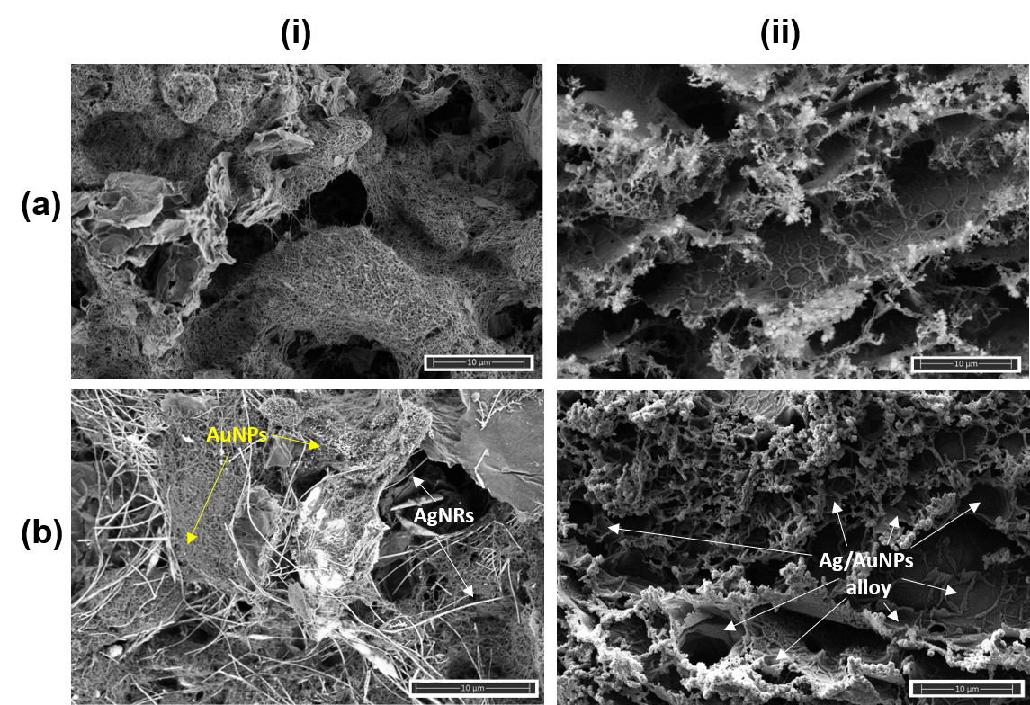
Figure S3. FESEM images of LIG nanocomposite electrodes before (left) and after (right) laser treatment: (a) GO-CNT-modified LIG and (b) AgNRs/AuNPs-GO-CNT alloys-modified LIG electrodes (i) before and (ii) after laser treatment.
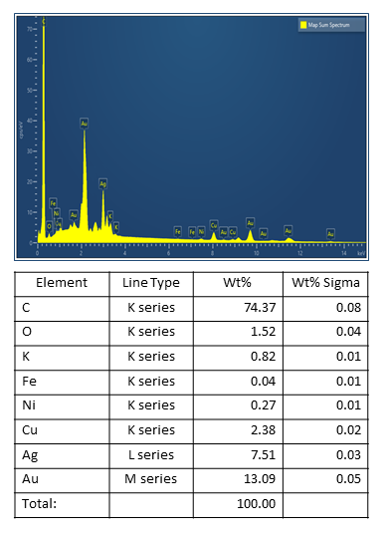
Figure S4. EDS analysis of the laser-treated Ag/AuNPs-rGO-CNT nanocomposite: EDS analysis of the laser-treated Ag/AuNPs-rGO-CNT nanocomposite showing existing elements based on their weight and atom percentage.
Figure S5. TEM image and elemental mapping analysis of the AgNRs/AuNPs-rGO-CNT nanocomposite before laser treatment.

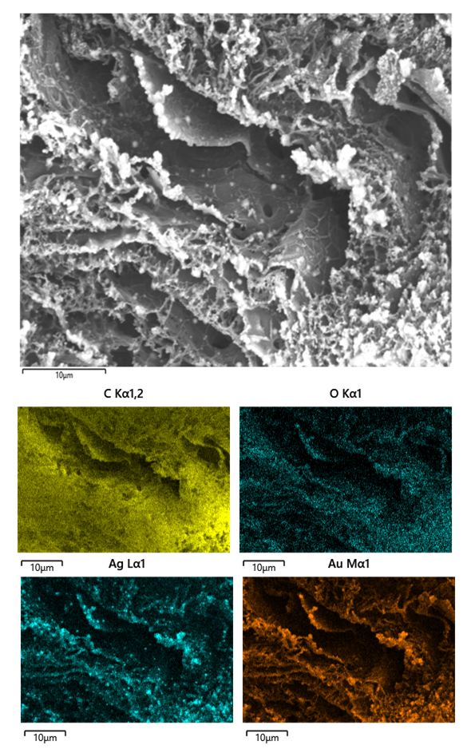
Figure S6. Elemental mapping analysis of the laser-treated Ag/AuNPs-GO-CNT nanocomposite showing the significant presence of Ag and Au along with C and O.
  - Electrochemical characterization
Although enzymatic electrochemical glucose sensors show high selectivity and sensitivity due to highly efficient enzyme catalysis, their application has been limited due to high cost and large performance variations by temperature, pH, humidity, and toxic chemicals.^{[3–5]} In contrast, nonenzymatic sensors based on direct electrocatalytic oxidation of glucose on electrodes have been pursued,^{[6–8]} with an emphasis on the development of functional nanomaterials for increased sensitivity. Carbon nanotubes (CNT) with high aspect ratios have extraordinary conductivity and chemical and mechanical stability,^{[9,10]} whereas graphene with many novel physiochemical properties as a catalyst provides unique support for nonenzymatic biosensors. In different kinds of graphene-based hybrids, the utmost carbon materials used for electrochemical purposes with some oxygen groups on the surface (e.g., carboxylic, phenolic, aldehyde, carboxyl, and others) have been fabricated to elevate the electroanalytical sensing performance.^{[11–13]} Oxygen functional groups can increase carbon surface hydrophilicity in the aqueous solutions. Meanwhile, the oxygen content increases (or decreases) the stability of the carbon anode (or cathode).^{[14]} Graphene oxide (GO) also contains hydrophilic oxygen groups and multiple aromatic parts that could assist in obtaining a GO-CNT complex with a strong π–π stacking interaction. In addition, there is a higher edge (or surface charge) density on the GO sheets (ρL) (not maximized in the 3D arrangement) than that of 3D networked CNT with a high specific surface area. The GO–CNT composite could effectually incorporate the high surface area of CNT with the high charge density of GO to result in a dramatically high edge density per unit nominal area, with superior performance over individual GO or CNT. Replacing GO with reduced GO (rGO) in the non-covalent rGO-CNT nanocomposite further increases the conductivity, while maintaining an excellent catalytic effect for electrochemical sensing.^{[15–17]} Considering the use of metal-based nanocomposite as highly efficient catalytic materials for non-enzymatic glucose sensors,^{[18–20]} we further introduced silver nanorods (AgNRs) into the nanocomposites and investigated their catalyst activity, reproducibility, selectivity, and stability.
The in vitro tests of glucose measurements with the AgNRs-rGO-CNT nanocomposite-modified electrode were performed in cyclic voltammetry (CV) between -0.3 and 0.8 V at a scan rate of 50 mVs⁻¹ in 0.1 M NaOH solution in the presence of 1 M glucose (Figure S7a). The amperometric sensor response at 0.55 V progressively increases with the increasing consecutive glucose concentration step (Figure S7b). The oxidation current changes rapidly with a fractional glucose addition, achieving a 95% steady-state current within 5s. The steady-state response increases with the glucose concentration within the range of 0.1 mM to 20 mM (Figure S7c), with a higher sensitivity in the range from 0.2 mM to 0.5 mM (linear calibration curve in the inset). The large error bars (n=3) indicate the reproducibility issues due to the agglomeration of AgNRs in the nanocomposite. The evaluation shows the fabricated modified sensor's ability to selectively detect glucose in the presence of other substances commonly found in sweat, such as urea, ascorbic acid, and uric acid. The selectivity of the sensor (at +0.55 V) to glucose over ascorbic acid, fructose, lactic acid, and uric acid is investigated (Figure S7d). The concentration of other substances in the sweat is not necessarily similar to the targeted analyte for example uric acid and ascorbic acid available range in the sweat is around 10 to 20 micromol/L, which is only 6.3% of that in serum.^{[21–23]} However, the response current lost 39.69% after seven days of sensor storage in ambient or 0.1 M NaOH between successive runs, indicating relatively poor stability (Figure S7ef).
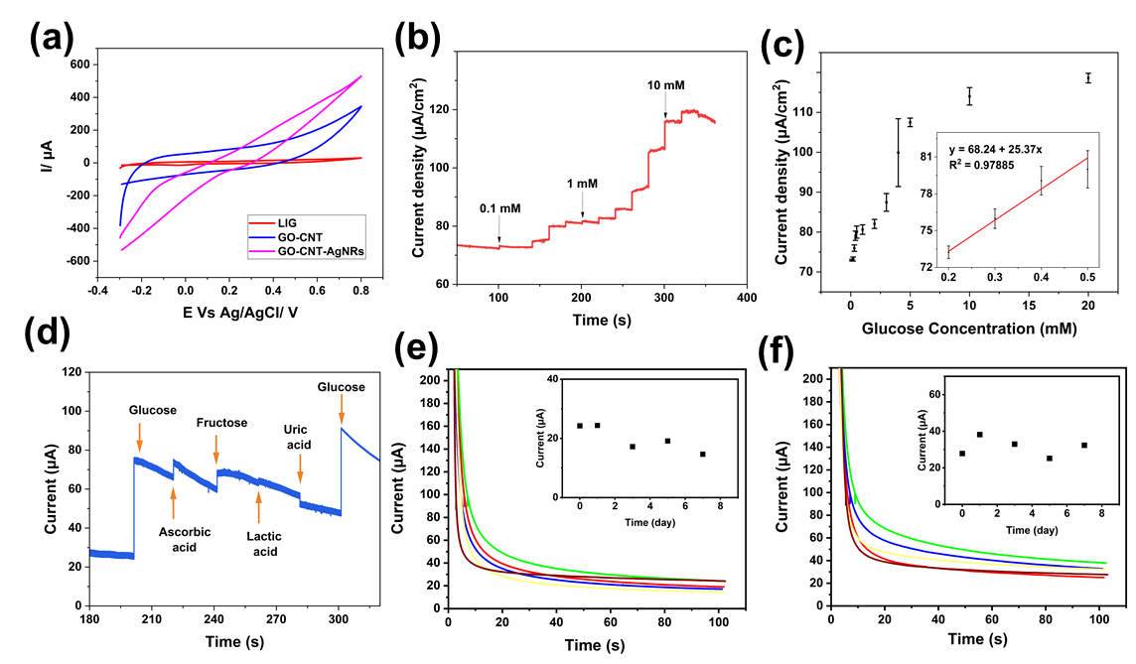
Figure S7. In-vitro glucose measurements with the AgNRs-rGO-CNT nanocomposite-modified LIG electrode: (a) Cyclic voltammetry of the LIG WE before and after modification with GO-CNT or AgNRs-rGO-CNT nanocomposites for oxidation of 1 mM glucose in 0.1 M NaOH with scan rate 50 mV/s. (b) Amperometry of the modified LIG WE with the optimized AgNRs-rGO-CNT nanocomposite to consecutive injection of glucose into the stirred 0.1 M NaOH with an applied potential of +0.55 V and (c) the corresponding calibration curves. (d) Selectivity study of the AgNRs-rGO-CNT nanocomposite biosensor (at +0.55 V vs. Ag/AgCl): 5 mM glucose, 25 µM ascorbic acid, 20 µM fructose, 5 mM lactic acid, 20 µM uric acid. Stability of the AgNRs-rGO-CNT nanocomposite biosensor kept in (e) ambient conditions and (f) 0.1 M NaOH between such successive runs to 1 mM glucose over one week, with the corresponding current-time plot of the chronoamperometric response shown in the insets.

Figure S8. The current response vs. the applied voltage on the laser-treated Ag/AuNPs-rGO-CNT nanocomposite-modified LIG WE in chronoamperometry for determining the optimized potential for glucose detection (1 mM glucose in 0.1 M NaOH).

Figure S9. Effect of the laser treatment on the stability of the Ag/AuNPs-rGO-CNT nanocomposite-modified LIG WE to detect glucose: Stability of the Ag/AuNPs-rGO-CNT nanocomposite-modified biosensor kept in (a) 0.1 M NaOH and (b) ambient conditions between such successive runs to 1 mM glucose over one week: (i) before and (ii) after laser treatment and (iii) comparison of the stability, with the corresponding current-time plot of the chronoamperometric response shown in the inset.
  - Characterization of pH sensor
The cyclic voltammetry was measured with the laser-treated Ag/AuNPs-rGO-CNT nanocomposite-modified LIG WE in different pH buffer solutions (Figure S10a). The response shows a linear plot of the anodic potential with respect to the pH from 4 to 8 that is clinically relevant to the sweat pH (Figure S10b).
Figure S10. (a) CV measurement of the laser-treated Ag/AuNPs-rGO-CNT nanocomposite-modified LIG WE immersed in different buffer solutions with a pH from 4 to 8 at a scan rate of 1 mV/s and (b) the corresponding calibration curve of the anodic peak potential of the electrode with respect to the pH, with the optical image of the pH electrodes shown in the inset.
  - Characterization of temperature sensor
The patterned LIG and heating circuit were placed on each side of a PI film. The heating circuit was connected to a variable DC power supply, while the LIG temperature sensor was connected to a testing circuit to measure the resistance change, with a commercial temperature sensor (Texas Instruments LMT70EVM) placed on top for calibration. With increased temperature generated from the heating circuit, the resistance change of the LIG temperature sensor was obtained as a function of the temperature measured by the commercial temperature sensor (Figure S11).
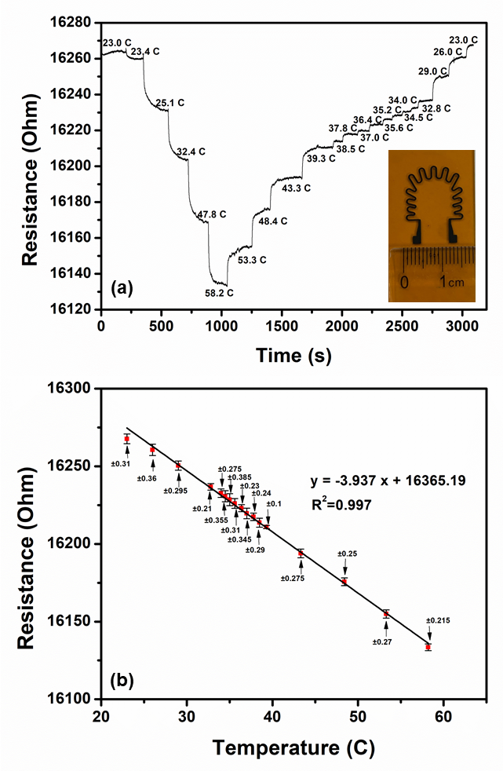
Figure S11. (a) Relative resistance changes from the LIG temperature sensor as a function of temperature and (b) the corresponding linear fitting calibration curve (n=3), with the optical image of the LIG temperature electrodes shown in the inset.
  - Non-invasive sweat-sensing characterization

Figure S12. Biosensor validation in artificial sweat. (a) The chronoamperometric responses of the glucose biosensor with the optimized laser-treated Ag/AuNPs-rGO-CNT alloy nanocomposite to consecutively injected glucose into the artificial sweat applied potential of 0.7 V and (b) the corresponding calibration curve.
Figure S13. Photographs of the flexible microfluidic wearable device upon (a) bending, (b) twisting, and on-body upon (c) compression and (d) bending.
Figure S14. Diagrams of the sweat glucose concentration measured by the laser-treated nanocomposite sweat sensors compared to the blood glucose concentrations measured by the commercial glucometer.
    - Calibration of glucose biosensors based on variations in temperature and pH
The accurate glucose measurement based on the obtained current was calibrated based on the measured changes in pH and temperature. First, the linear fitting curve of the glucose biosensor between current density I (in µA/cm²) and glucose concentration C (in mM) at pH 7 and temperature 20°C (Figure 5C) follows:
I = m _{ref} C + k_{ref}, (S1)
where the slope m_{ref}= 242.17 (m, µA/mM⁻¹) represents the sensitivity and k_{ref}=323.96 µA is the intercept.
The effects of temperature and pH on the current density response vs. glucose concentration through the variant slope and intercept (Figures 6A and C) can be accounted for by calculating the variation factors for them ($t_{slope}$ and $t_{intercept}$ for temperature, $p_{slope}$ and $p_{intercept}$for pH). With respect to the reference conditions, the variation factors under each condition are expressed as:
$t_{slope}=\frac{{Slope}_{T}}{{Slope}_{ref}}$ (S2)
$t_{intercept}=\frac{{Intercept}_{T}}{{Intercept}_{ref}}$ (S3)
$p_{slope}=\frac{{Slope}_{pH}}{{Slope}_{ref}}$ (S4)
$p_{intercept}=\frac{{Intercept}_{pH}}{{Intercept}_{ref}}$ (S5)
The variation factors in a given temperature range from t_{i} to t_{i+1} can also be obtained from the fitted piecewise linear curve as:
$k_{ref}=\frac{k_{i+1}-k_{i}}{t_{i+1}-t_{i}}×\left(t-t_{i}\right)+k_{i}$ (S6)
$m_{ref}=\frac{m_{i+1}-m_{i}}{t_{i+1}-t_{i}}×\left(t-t_{i}\right)+m_{i}$ (S7)
Similarly, the variation factors in a given pH range from p_{i} to p_{i+1} can also be obtained from the fitted piecewise linear curve as:
$k_{ref}=\frac{k_{i+1}-k_{i}}{p_{i+1}-p_{i}}×\left(p-p_{i}\right)+k_{i}$ (S8)
$m_{ref}=\frac{m_{i+1}-m_{i}}{p_{i+1}-p_{i}}×\left(p-p_{i}\right)+m_{i}$ (S9)
As a result, the corrected slope (m) and intercept (k) are written as:
m= m_{ref} × p_{slope} × t_{slope} (S10)
k= k_{ref} × p_{intercept} × t_{intercept} (S11)

Table S1. Correction factors calculated from Eqns. (S2 and S3) for the slope and intercept at various temperatures based on the data collected in Figure 6A.
Temperature, T (°C) | Slope | Slope factor | Intercept | Intercept factor
20 | 253.29 | 1.04 | 393.7 | 1.21
40 | 263.02 | 0.79 | 430.86 | 1.39
45 | 257.53 | 0.98 | 539.13 | 1.67
50 | 256.47 | 1.06 | 627.54 | 2.03

Table S2. Correction factors using Eqns. (S4 and S5) for the slope and intercept at various pH based on the data collected in Figure 6B.
pH | Slope | Slope factor | Intercept | Intercept factor
5 | 230.88 | 0.68 | 304.09 | 1.31
7 | 242.17 | 0.76 | 323.96 | 1.43
9 | 246.94 | 0.94 | 393.7 | 1.58

Therefore, the glucose concentration after temperature and pH calibration is:
I_{(t,p,C)} = m × C + k (S12)
The linear fitting equations for t_{slope} and t_{intercept} in the range from 20 to 40°C are expressed as:
$t_{slope}^{20-40}$ = -0.0125x + 1.2959 (S13)
$t_{intercept}^{20-40}$ = 0.0062x + 1.0903 (S14)
Similarly, the linear fitting equations for p_{slope} and p_{intercept} in the range from 5 to 9 are written as:
$p_{slope}^{5-9}$ = 0.0419x + 0.471 (S15)
$p_{intercept}^{5-9}$ = 0.0643x + 0.9894 (S16)
For the measured temperature of 29.9°C and pH of 7.5 before the meal as an example, the temperature variation factors were calculated from Eqns. (S11-S12) as below:
$t_{slope}^{29.9°C}=0.9221$ (S17)
$t_{intercept}^{29.9°C}=1.2757$ (S18)
Correspondingly, the factors at pH (7.5) based on equations (S13) and (S14), were calculated as follows:
$p_{slope}^{7.5}=0.7852$ (S19)
$p_{intercept}^{7.5}=1.4716$ (S20)
Subsequently, the corrected slope and intercept were obtained from Eqns. (S10-S11) as:
$m = m_{ref} × t_{slope}^{37.2°C}× p_{slope}^{7.5}= 242.17*0.9221 *0.7852 = 175.33$
$k = k_{ref} ×t_{intercept}^{37.2°C}× p_{intercept}^{7.5} = 323.96*1.2757*1.4716 = 608.17$
Therefore, the calibrated glucose concentration c_{corrected} was calculated using the corrected slope and intercept as $c_{corrected}={\left(I-k_{corrected}\right)}/{m_{corrected}}$, which gave $0.1202 mM$ for the current value of 629.28 µA before the meal. Similarly, the calibrated glucose concentration was calculated as 0.1542 mM (or 0.1608 mM) for the current value of $630.68$(or 632.05) µA at pH of 7.2 (or 7.3) and temperature of 31.4°C (or 30.4°C) after the meal (or one hour after the meal).
Table S3. Sweat glucose calculation before pH and temperature calibration.
Type | Before meal |  | After meal |  | 1 h after meal
Type | Current (µA) | Concentration  (mM) | Current (µA) | Concentration  (mM) | Current (µA/) | Concentration  (mM)
Sweat Glucose | 629.28 | 0.094 | 630.68 | 0.101 | 632.05 | 0.109

Table S.4. Comparison between this work and recently reported (non-)enzymatic glucose sensors.
Electrode | Analyte | Stability | Method | LOD(µM) | Range(µM) |  | Sensitivity (µAmM⁻¹cm⁻²) | Ref | Type
LIG-Au-Ni | Glucose | N/A | CV, CA | 1.5 µM | 0.3-30 mM | 3500 µAmM⁻¹cm⁻² |  | ^{[24]} | Non-enzymatic
NP-LIG (Nail-polish) | Nitrite, Glucose | 91.0% over 15 days | CV, DPV, CA | 0.9 µM | 2-1000µM | N/A |  | ^{[25]} | Non-enzymatic
Au@Ni/  graphene | Glucose | 90% over 7 days | CV, CA | 0.0157 mM | 0.5-10 mM | 23.17 µAmM⁻¹cm⁻² |  | ^{[26]} | Non-enzymatic
LIG-CuNCs | Glucose | N/A | CV, CA | 250 nM | 25µM-4mM | 4532.2 µAmM⁻¹cm⁻² |  | ^{[27]} | Non-enzymatic
LIG-CuNPs | Glucose | 94.04% over 21 days | CV, CA | 0.39 µM | 10µM-5mM | 495 µAmM⁻¹cm⁻² |  | ^{[28]} | Non-enzymatic
LIG-Carbon | Glucose | N/A | CV | 6.31 µM | 1-10µM | 252.3 µAmM⁻¹cm⁻² |  | ^{[29]} | Non-enzymatic
LSG-CuONPs | Glucose | 4000 s | CV, LSV, CA | 0.1 µM | 1µM-5mM | N/A |  | ^{[30]} | Non-enzymatic
LSG-Cu | Glucose, Dopamine | N/A | CV, CA, DPV | - | 0.001-0.5mM (Glucose) | 84.07 µAmM⁻¹cm⁻² (Glucose) |  | ^{[31]} | Non-enzymatic
Co/Zn-NPC/LIG | Glucose, Lactate | N/A | CV, CA | 0.025 µM | 0-1.5 mM | 82.7 µAmM⁻¹cm⁻² |  | ^{[32]} | Enzymatic
Ag/AuNPs-rGO-CNT-LIG | Glucose, | 91.6% over 21 days | CV, CA | 0.079 µM | 10µM-5mM | 1317.69 µAmM⁻¹cm⁻² |  | This Work | Non-enzymatic

References:
[1] N. M. Huang, H. N. Lim, C. H. Chia, M. A. Yarmo, M. R. Muhamad, Int. J. Nanomedicine 2011, 6, 3443.
[2] A. Gökaltun, Y. B. A. Kang, M. L. Yarmush, O. B. Usta, A. Asatekin, Sci. Rep. 2019, 9, 1.
[3] M. Nemiwal, T. C. Zhang, D. Kumar, Enzyme Microb. Technol. 2022, 110006.
[4] S. M. Khor, J. Choi, P. Won, S. H. Ko, Nanomaterials 2022, 12, 221.
[5] L. Johnston, G. Wang, K. Hu, C. Qian, G. Liu, Front. Bioeng. Biotechnol. 2021, 9.
[6] Z. Golsanamlou, M. Mahmoudpour, J. Soleymani, A. Jouyban, Crit. Rev. Anal. Chem. 2021, 1.
[7] Y. Luo, B. Zhu, S. Zhang, P. Zhang, X. Li, L. Wang, B. Lu, J. Travas‐Sejdic, Adv. Mater. Technol. 2022, 2101571.
[8] N. Liu, X. Xiang, M. Sun, P. Li, H. Qin, H. Liu, Y. Zhou, L. Wang, L. Wu, J. Zhu, Biosens. Bioelectron. X 2022, 10, 100110.
[9] B. Dai, R. Zhou, J. Ping, Y. Ying, L. Xie, TrAC Trends Anal. Chem. 2022, 116658.
[10] P. Valkova, M. Pohanka, Bratisl. Lek. Listy 2022, 123, 618.
[11] G. Balkourani, T. Damartzis, A. Brouzgou, P. Tsiakaras, Sensors 2022, 22, 355.
[12] E. Papanikolaou, Y. V Simos, K. Spyrou, E. I. Tzianni, P. Vezyraki, K. Tsamis, M. Patila, S. Tigas, M. I. Prodromidis, D. P. Gournis, Exp. Biol. Med. 2022, 15353702221134104.
[13] G. Amala, S. M. Gowtham, RSC Adv. 2017, 7, 36949.
[14] M. Nakamura, M. Nakanishi, K. Yamamoto, J. Power Sources 1996, 60, 225.
[15] K. L. Leong, M. Y. Ho, X. Y. Lee, M. S.-L. Yee, Nano 2020, 15, 2030004.
[16] N. Mohamad Nor, N. S. Ridhuan, K. Abdul Razak, Biosensors 2022, 12, 1136.
[17] P. Panda, K. Pal, S. Chakroborty, Mater. Lett. 2021, 303, 130508.
[18] S. Liu, W. Zeng, Q. Guo, Y. Li, J. Mater. Sci. Mater. Electron. 2020, 31, 16111.
[19] Q. Dong, H. Ryu, Y. Lei, Electrochim. Acta 2021, 370, 137744.
[20] X. Niu, X. Li, J. Pan, Y. He, F. Qiu, Y. Yan, Rsc Adv. 2016, 6, 84893.
[21] F. Gao, C. Liu, L. Zhang, T. Liu, Z. Wang, Z. Song, H. Cai, Z. Fang, J. Chen, J. Wang, Microsystems Nanoeng. 2023, 9, 1.
[22] C.-T. Huang, M.-L. Chen, L.-L. Huang, I.-F. Mao, Chin. J. Physiol. 2002, 45, 109.
[23] B. Ibarlucea, A. Pérez Roig, D. Belyaev, L. Baraban, G. Cuniberti, Microchim. Acta 2020, 187, 1.
[24] J. Zhu, S. Liu, Z. Hu, X. Zhang, N. Yi, K. Tang, M. G. Dexheimer, X. Lian, Q. Wang, J. Yang, J. Gray, H. Cheng, Biosens. Bioelectron. 2021, 193, 113606.
[25] N. Zhang, J. Yang, C. Hu, Sensors Actuators B Chem. 2022, 357, 131394.
[26] X. Gao, X. Du, D. Liu, H. Gao, P. Wang, J. Yang, Sci. Rep. 2020, 10, 1365.
[27] F. Tehrani, B. Bavarian, Sci. Rep. 2016, 6, 27975.
[28] Y. Zhang, N. Li, Y. Xiang, D. Wang, P. Zhang, Y. Wang, S. Lu, R. Xu, J. Zhao, Carbon N. Y. 2020, 156, 506.
[29] V. S. Andriianov, V. S. Mironov, A. V Smikhovskaia, E. M. Khairullina, I. I. Tumkin, Opt. Quantum Electron. 2020, 52, 1.
[30] A. Prabhakaran, P. Nayak, ACS Appl. Nano Mater. 2019, 3, 391.
[31] V. B. Juska, G. Juska, J. Chem. Technol. Biotechnol. 2021, 96, 1086.
[32] M. Asaduzzaman, M. A. Zahed, M. Sharifuzzaman, M. S. Reza, X. Hui, S. Sharma, Y. Do Shin, J. Y. Park, Biosens. Bioelectron. 2023, 219, 114846.

