Supplementary Appendix
Table of Contents
SECTION 1. SUPPLEMENTAL FIGURES………………………………...……………………………………………………..2
Supplemental Figure 1. Date first COVID-19 vaccination (Pfizer-BioNTech, Moderna, or Johnson & Johnson/Janssen [J&J]) received by Social Vulnerability Index (SVI) quartile among unique subjects, January 1, 2021 – July 8, 2022………………………………………………….3
Supplemental Figure 2. Date first COVID-19 vaccination (Pfizer-BioNTech, Moderna, or Johnson & Johnson/Janssen [J&J]) received by Social Vulnerability Index (SVI) quartile among unique subjects aged 18-49 years old, January 1, 2021 – July 8, 2022 …………………3
Supplemental Figure 3. Date first COVID-19 vaccination (Pfizer-BioNTech, Moderna, or Johnson & Johnson/Janssen [J&J]) received by Social Vulnerability Index (SVI) quartile among unique subjects aged 50-64 years old, January 1, 2021 – July 8, 2022…………………4
Supplemental Figure 4. Date first COVID-19 vaccination (Pfizer-BioNTech, Moderna, or Johnson & Johnson/Janssen [J&J]) received by Social Vulnerability Index (SVI) quartile among unique subjects aged 65+ years old, January 1, 2021 – July 8, 2022 ……………………4
Supplemental Figure 5. Date COVID-19 primary series vaccination (2 mRNA doses or 1 Johnson & Johnson/Janssen [J&J] dose) completed by Social Vulnerability Index (SVI) quartile among unique subjects aged 18-49 years old, January 1, 2021 – July 8, 2022 ……5
Supplemental Figure 6. Date COVID-19 primary series vaccination (2 mRNA doses or 1 Johnson & Johnson/Janssen [J&J] dose) completed by Social Vulnerability Index (SVI) quartile among unique subjects aged 50-64 years old, January 1, 2021 – July 8, 2022 ……5
Supplemental Figure 7. Date COVID-19 primary series vaccination (2 mRNA doses or 1 Johnson & Johnson/Janssen [J&J] dose) completed by Social Vulnerability Index (SVI) quartile among unique subjects aged 65+ years old, January 1, 2021 – July 8, 2022 ………6
Supplemental Figure 8. Date COVID-19 booster dose completed by Social Vulnerability Index (SVI) quartile among unique subjects aged 18-49 years old with a completed primary series (2 mRNA doses or 1 Johnson & Johnson/Janssen [J&J] dose), January 1, 2021 – July 8, 2022 …………………………………………………………………………………………………………6
Supplemental Figure 9. Date COVID-19 booster dose completed by Social Vulnerability Index (SVI) quartile among unique subjects aged 50-64 years old with a completed primary series (2 mRNA doses or 1 Johnson & Johnson/Janssen [J&J] dose), January 1, 2021 – July 8, 2022 .………………………………………………………………………………………………………..7
Supplemental Figure 10. Date COVID-19 booster dose completed by Social Vulnerability Index (SVI) quartile among unique subjects aged 65+ years old with a completed primary series (2 mRNA doses or 1 Johnson & Johnson/Janssen [J&J] dose), January 1, 2021 – July 8, 2022 …………………………………………………………………………………………………………………….7

SECTION S2. SUPPLEMENTAL TABLES
Supplemental Table 1. Geocoding tools used by VISION Network sites ………………………….8
Supplemental Table 2. mRNA COVID-19 vaccine effectiveness against laboratory-confirmed COVID-19 associated emergency department or urgent care event by Social Vulnerability Index (SVI) theme quartile, vaccine doses and timing, and SARS-CoV-2 subvariant era ………………………………………………………………………………………………………………..9
Supplemental Table 3. mRNA COVID-19 vaccine effectiveness against laboratory-confirmed COVID-19 associated emergency department or urgent care event by Social Vulnerability Index (SVI) quartile, age group, vaccine doses and timing, and SARS-CoV-2 subvariant era ………………………………………………………………………………………………………………15
Supplemental Table 4. mRNA COVID-19 vaccine effectiveness against laboratory-confirmed COVID-19 associated hospitalization by Social Vulnerability Index (SVI) theme quartile, vaccine doses and timing, and SARS-CoV-2 subvariant era …………………………….20
Supplemental Table 5. mRNA COVID-19 vaccine effectiveness against laboratory-confirmed COVID-19 associated hospitalization by Social Vulnerability Index (SVI) quartile, age group, vaccine doses and timing, and SARS-CoV-2 subvariant era ……………26

SECTION S3. SUPPLEMENTAL METHODS ………………………………………………………………………………….31
- Extracting Percent Positivity Data from HHS Protect …………………………………………………….31
- Statistical methods ……………………………………………………………………………………………………….32
2.1 Overview ….………………………………………………………………………………………………………32
2.2 Inverse propensity score weighting………………………………………………………………… ..33
2.3 Primary Outcome Model and Covariate Adjustment …………………………………………35
2.4 Subgroup analyses ……………………………………………………………………………………………36

SUPPLEMENTAL REFERENCES …………………………………………………………………………………………………..37

Section S1. Supplemental Figures
Supplemental Figure 1. Date first COVID-19 vaccination (Pfizer-BioNTech, Moderna, or Johnson & Johnson/Janssen [J&J]) received by Social Vulnerability Index (SVI) quartile among unique subjects, January 1, 2021 – July 8, 2022.
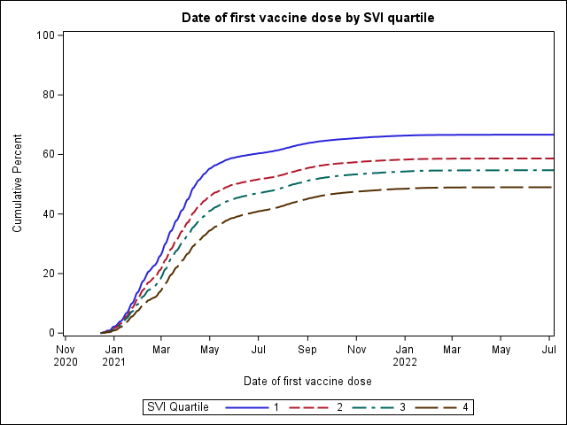

Supplemental Figure 2. Date first COVID-19 vaccination (Pfizer-BioNTech, Moderna, Johnson & Johnson/Janssen [J&J]) received by Social Vulnerability Index (SVI) quartile among unique subjects aged 18-49 years old, January 1, 2021 – July 8, 2022.
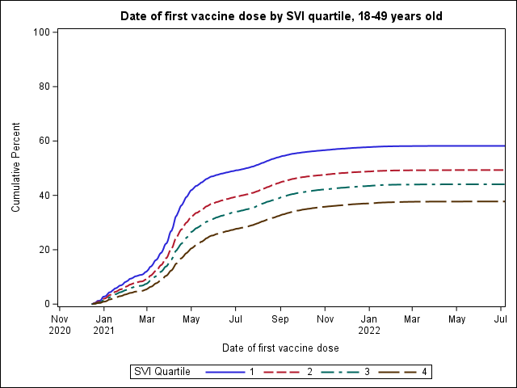
Supplemental Figure 3. Date first COVID-19 vaccination (Pfizer-BioNTech, Moderna, or Johnson & Johnson/Janssen [J&J]) received by Social Vulnerability Index (SVI) quartile among unique subjects aged 50-64 years old, January 1, 2021 – July 8, 2022.
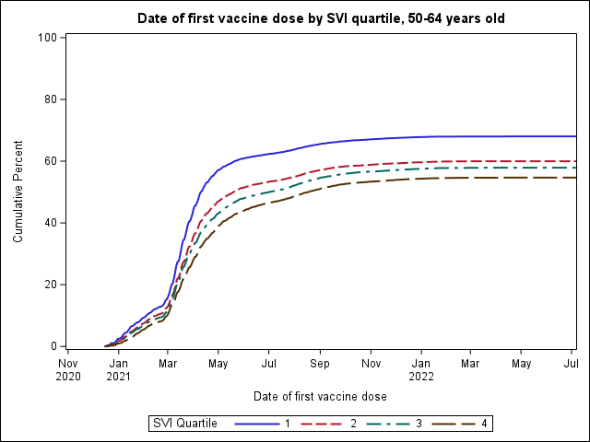

Supplemental Figure 4. Date first COVID-19 vaccination (Pfizer-BioNTech, Moderna, or Johnson & Johnson/Janssen [J&J]) received by Social Vulnerability Index (SVI) quartile among unique subjects aged 65+ years old, January 1, 2021 – July 8, 2022.
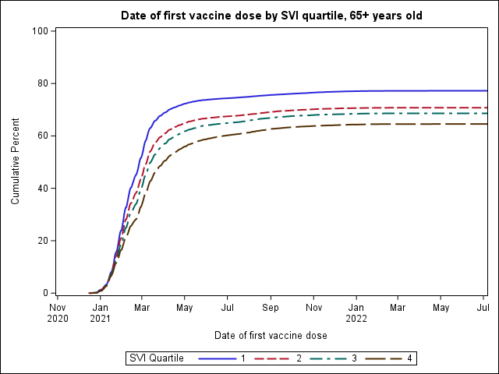
Supplemental Figure 5. Date COVID-19 primary series vaccination (2 mRNA doses or 1 Johnson & Johnson/Janssen [J&J] dose) completed by Social Vulnerability Index (SVI) quartile among unique subjects aged 18-49 years old, January 1, 2021 – July 8, 2022.
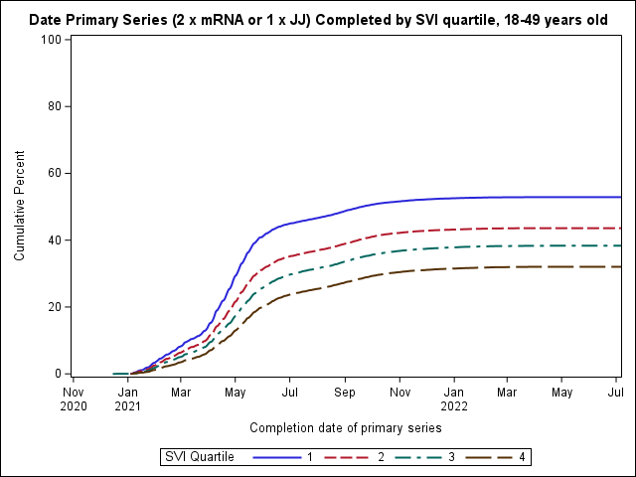

Supplemental Figure 6. Date COVID-19 primary series vaccination (2 mRNA doses or 1 Johnson & Johnson/Janssen [J&J] dose) completed by Social Vulnerability Index (SVI) quartile among unique subjects aged 50-64 years old, January 1, 2021 – July 8, 2022.
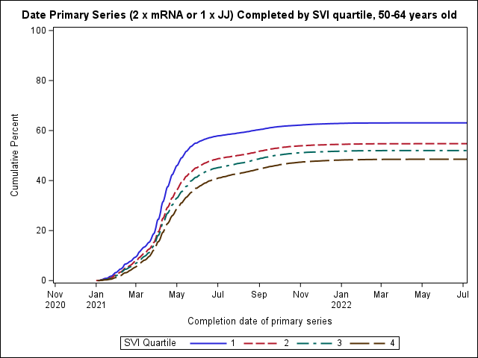
Supplemental Figure 7. Date COVID-19 primary series vaccination (2 mRNA doses or 1 Johnson & Johnson/Janssen [J&J] dose) completed by Social Vulnerability Index (SVI) quartile among unique subjects aged 65+ years old, January 1, 2021 – July 8, 2022.
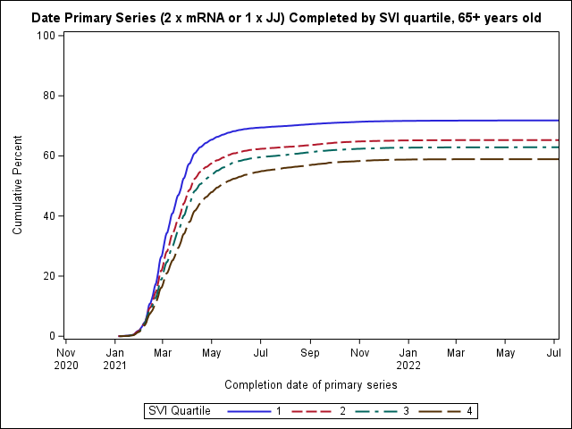

Supplemental Figure 8. Date COVID-19 booster dose completed by Social Vulnerability Index (SVI) quartile among unique subjects aged 18-49 years old with a completed primary series (2 mRNA doses or 1 Johnson & Johnson/Janssen [J&J] dose), January 1, 2021 – July 8, 2022.
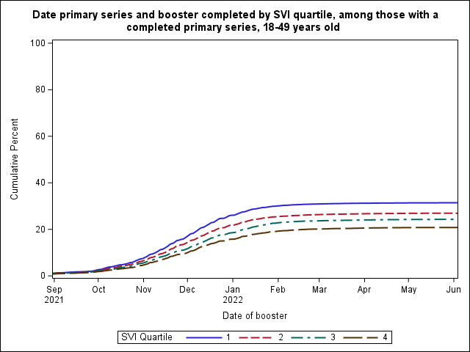
Supplemental Figure 9. Date COVID-19 booster dose completed by Social Vulnerability Index (SVI) quartile among unique subjects aged 50-64 years old with a completed primary series (2 mRNA doses or 1 Johnson & Johnson/Janssen [J&J] dose), January 1, 2021 – July 8, 2022.
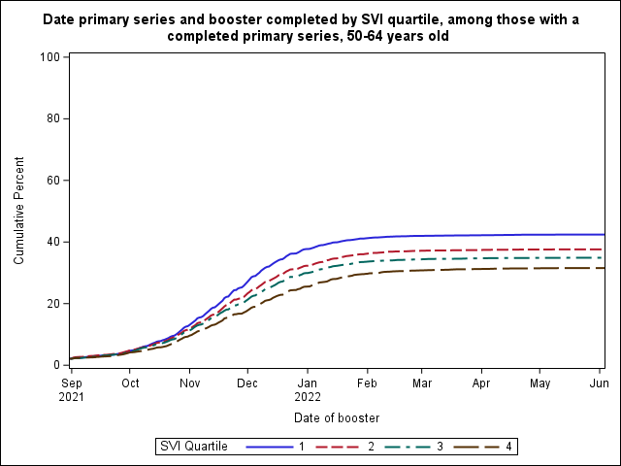

Supplemental Figure 10. Date COVID-19 booster dose completed by Social Vulnerability Index (SVI) quartile among unique subjects aged 65+ years old with a completed primary series (2 mRNA doses or 1 Johnson & Johnson/Janssen [J&J] dose), January 1, 2021 – July 8, 2022.
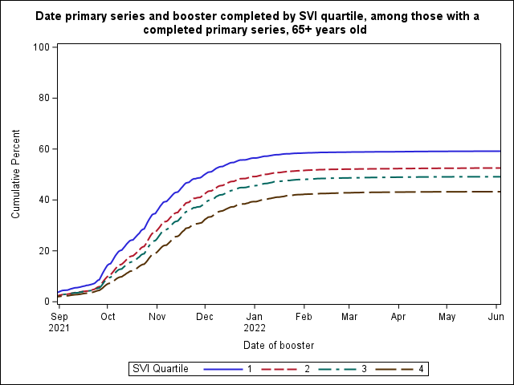
Section S2. Supplemental Tables
Supplemental Table 1. Geocoding tools used by VISION Network sites
Site | Approach
Baylor, Scott & White Health (BSWH) | ArcGIS Pro and StreetMap Premium
Children’s Hospital Minnesota (CHM) | ArcGIS
Regenstrief Institute (RGN) | ArcGIS
Kaiser Permanente Northwest Center for Health Research | ArcGIS
University of Colorado (UCO) | Melissa
HealthPartners Institute (HP) | Automated process maintained by HP IT department; uses Census Geocoding Services Web application to map addresses to geocodes.
Intermountain Healthcare (IM) | Informatica
Paso del Norto Health Information Exchange (PHIX) | Geocodio

Supplemental Table 2. mRNA COVID-19 vaccine effectiveness against laboratory-confirmed COVID-19 associated emergency department or urgent care event by Social Vulnerability Index (SVI) theme quartile, vaccine doses and timing, and SARS-CoV-2 subvariant era.
Subgroup | Days Since Vaccination  Median (IQR) | Total in Subgroup | SARS-CoV-2 Negative | SARS-CoV-2 Positive | SARS-CoV-2 Positive  Row % | Unadjusted VE | 95% CI | Adjusted VE | 95% CI | p-value
SVI Theme 1 (Socioeconomic Status)
Delta Era
Unvaccinated (Referent)
SVI Q1 |  | 12207 | 8643 | 3564 | 29.2
SVI Q2 |  | 11184 | 8089 | 3095 | 27.7
SVI Q3 |  | 9935 | 7578 | 2357 | 23.7
SVI Q4 |  | 7181 | 5471 | 1710 | 23.8
2 doses, 14-149 days prior |  |  |  |  |  |  |  |  |  | 0.78
SVI Q1 | 96 (59-130) | 3439 | 3295 | 144 | 4.2 | 89 | (87-91) | 87 | (84-89)
SVI Q2 | 95 (58-128) | 2429 | 2326 | 103 | 4.2 | 88 | (86-91) | 86 | (83-89)
SVI Q3 | 93 (59-127) | 2048 | 1962 | 86 | 4.2 | 86 | (82-89) | 85 | (80-88)
SVI Q4 | 92 (57-125.25) | 1236 | 1189 | 47 | 3.8 | 87 | (83-91) | 87 | (81-90)
2 doses, ≥150 days prior |  |  |  |  |  |  |  |  |  | <0.01
SVI Q1 | 215 (189-244) | 15276 | 13915 | 1361 | 8.9 | 76 | (75-78) | 81 | (79-82)
SVI Q2 | 215 (188-244) | 8852 | 8102 | 750 | 8.5 | 76 | (74-78) | 80 | (77-81)
SVI Q3 | 213 (187-244) | 6199 | 5677 | 522 | 8.4 | 70 | (67-73) | 74 | (71-77)
SVI Q4 | 211 (185-241) | 3157 | 2850 | 307 | 9.7 | 66 | (61-70) | 73 | (69-77)
3 doses, ≥7 days prior |  |  |  |  |  |  |  |  |  | 0.2
SVI Q1 | 35 (19-55) | 5637 | 5483 | 154 | 2.7 | 93 | (92-94) | 96 | (95-96)
SVI Q2 | 34 (20-53) | 2804 | 2736 | 68 | 2.4 | 94 | (92-95) | 95 | (93-96)
SVI Q3 | 33 (19-54) | 1718 | 1684 | 34 | 2 | 94 | (91-95) | 95 | (92-96)
SVI Q4 | 33 (19-52) | 660 | 639 | 21 | 3.2 | 89 | (84-93) | 92 | (87-95)
BA.1 Era
Unvaccinated (Referent)
SVI Q1 |  | 11228 | 6646 | 4582 | 40.8
SVI Q2 |  | 11018 | 6574 | 4444 | 40.3
SVI Q3 |  | 10981 | 6569 | 4412 | 40.2
SVI Q4 |  | 8406 | 4951 | 3455 | 41.1
2 doses, 14-149 days prior |  |  |  |  |  |  |  |  |  | 0.1
SVI Q1 | 105 (72.5-128) | 1831 | 1327 | 504 | 27.5 | 45 | (39-51) | 49 | (42-55)
SVI Q2 | 108 (76-129) | 1604 | 1133 | 471 | 29.4 | 39 | (31-45) | 42 | (33-49)
SVI Q3 | 104 (72-128) | 1420 | 1057 | 363 | 25.6 | 49 | (42-55) | 55 | (47-61)
SVI Q4 | 104 (71-127) | 889 | 633 | 256 | 28.8 | 42 | (33-50) | 49 | (39-57)
2 doses, ≥150 days prior |  |  |  |  |  |  |  |  |  | <0.01
SVI Q1 | 268 (232-310) | 9421 | 6459 | 2962 | 31.4 | 33 | (30-37) | 36 | (32-40)
SVI Q2 | 267 (231-308) | 6792 | 4714 | 2078 | 30.6 | 35 | (30-39) | 36 | (31-41)
SVI Q3 | 264 (224-306) | 5522 | 3797 | 1725 | 31.2 | 32 | (28-37) | 32 | (27-37)
SVI Q4 | 259 (218-300) | 3351 | 2207 | 1144 | 34.1 | 26 | (19-32) | 22 | (14-29)
3 doses, ≥7 days prior |  |  |  |  |  |  |  |  |  | 0.33
SVI Q1 | 79 (50-110) | 11923 | 10475 | 1448 | 12.1 | 80 | (79-81) | 80 | (78-81)
SVI Q2 | 76 (48-106) | 6514 | 5761 | 753 | 11.6 | 81 | (79-82) | 80 | (77-82)
SVI Q3 | 74 (46-104) | 4276 | 3750 | 526 | 12.3 | 79 | (77-81) | 78 | (75-81)
SVI Q4 | 71 (42-102) | 1947 | 1692 | 255 | 13.1 | 78 | (75-81) | 76 | (71-80)
SVI Theme 2 (Household Composition & Disability)
Delta Era
Unvaccinated (Referent)
SVI Q1 |  | 10759 | 8014 | 2745 | 25.5
SVI Q2 |  | 10284 | 7629 | 2655 | 25.8
SVI Q3 |  | 10762 | 7853 | 2909 | 27
SVI Q4 |  | 8702 | 6285 | 2417 | 27.8
2 doses, 14-149 days prior |  |  |  |  |  |  |  |  |  | 0.38
SVI Q1 | 96 (59-130) | 2920 | 2809 | 111 | 3.8 | 88 | (86-91) | 87 | (84-90)
SVI Q2 | 94 (58-128) | 2505 | 2407 | 98 | 3.9 | 88 | (86-90) | 86 | (82-88)
SVI Q3 | 96 (59-128) | 2302 | 2192 | 110 | 4.8 | 86 | (84-89) | 84 | (80-87)
SVI Q4 | 90 (57-125) | 1425 | 1364 | 61 | 4.3 | 88 | (85-91) | 88 | (84-91)
2 doses, ≥150 days prior |  |  |  |  |  |  |  |  |  | 0.17
SVI Q1 | 214 (188-243) | 12520 | 11499 | 1021 | 8.2 | 74 | (72-76) | 80 | (78-81)
SVI Q2 | 215 (188-244) | 9072 | 8306 | 766 | 8.4 | 74 | (71-76) | 78 | (76-80)
SVI Q3 | 215 (188-245) | 7352 | 6684 | 668 | 9.1 | 73 | (70-75) | 78 | (76-80)
SVI Q4 | 214 (188-244) | 4540 | 4055 | 485 | 10.7 | 69 | (65-72) | 76 | (73-79)
3 doses, ≥7 days prior |  |  |  |  |  |  |  |  |  | 0.58
SVI Q1 | 35 (20-55) | 4222 | 4106 | 116 | 2.8 | 92 | (90-93) | 95 | (94-96)
SVI Q2 | 34 (19-53) | 2987 | 2917 | 70 | 2.3 | 93 | (91-95) | 95 | (93-96)
SVI Q3 | 34 (19-53) | 2422 | 2365 | 57 | 2.4 | 93 | (92-95) | 95 | (93-97)
SVI Q4 | 34 (20-54) | 1188 | 1154 | 34 | 2.9 | 92 | (89-95) | 94 | (90-96)
BA.1 Era
Unvaccinated (Referent)
SVI Q1 |  | 10587 | 6353 | 4234 | 40
SVI Q2 |  | 10698 | 6269 | 4429 | 41.4
SVI Q3 |  | 11179 | 6731 | 4448 | 39.8
SVI Q4 |  | 9169 | 5387 | 3782 | 41.2
2 doses, 14-149 days prior |  |  |  |  |  |  |  |  |  | 0.15
SVI Q1 | 104 (73.5-127) | 1631 | 1174 | 457 | 28 | 42 | (34-48) | 43 | (35-50)
SVI Q2 | 106 (76-129) | 1567 | 1097 | 470 | 30 | 39 | (32-46) | 46 | (38-53)
SVI Q3 | 106 (73-128) | 1434 | 1064 | 370 | 25.8 | 47 | (40-54) | 52 | (44-58)
SVI Q4 | 104 (69-128) | 1112 | 815 | 297 | 26.7 | 48 | (40-55) | 54 | (46-61)
2 doses, ≥150 days prior |  |  |  |  |  |  |  |  |  | 0.53
SVI Q1 | 266 (231-307) | 8295 | 5691 | 2604 | 31.4 | 31 | (27-35) | 33 | (29-38)
SVI Q2 | 266 (230-308) | 6753 | 4592 | 2161 | 32 | 33 | (29-38) | 33 | (28-38)
SVI Q3 | 265 (226-306.75) | 6002 | 4129 | 1873 | 31.2 | 31 | (27-36) | 30 | (25-35)
SVI Q4 | 265 (223-306.25) | 4036 | 2765 | 1271 | 31.5 | 35 | (29-39) | 36 | (30-42)
3 doses, ≥7 days prior |  |  |  |  |  |  |  |  |  | 0.1
SVI Q1 | 77 (48-107) | 9297 | 8163 | 1134 | 12.2 | 79 | (78-81) | 78 | (76-80)
SVI Q2 | 77 (48-108) | 6733 | 5893 | 840 | 12.5 | 80 | (78-81) | 79 | (76-81)
SVI Q3 | 76 (48-106) | 5430 | 4782 | 648 | 11.9 | 79 | (78-81) | 77 | (74-80)
SVI Q4 | 76 (47-106) | 3200 | 2840 | 360 | 11.2 | 82 | (80-84) | 82 | (79-85)
SVI Theme 3 (Minority Status & Language)
Delta Era
Unvaccinated (Referent)
SVI Q1 |  | 11219 | 7683 | 3536 | 31.5
SVI Q2 |  | 10973 | 8067 | 2906 | 26.5
SVI Q3 |  | 10691 | 8194 | 2497 | 23.4
SVI Q4 |  | 7624 | 5837 | 1787 | 23.4
2 doses, 14-149 days prior |  |  |  |  |  |  |  |  |  | 0.13
SVI Q1 | 91 (57-129) | 2469 | 2343 | 126 | 5.1 | 88 | (86-90) | 84 | (81-87)
SVI Q2 | 96 (59-129) | 2643 | 2543 | 100 | 3.8 | 89 | (87-91) | 88 | (85-90)
SVI Q3 | 97 (60-129) | 2564 | 2471 | 93 | 3.6 | 88 | (85-90) | 88 | (85-90)
SVI Q4 | 93 (57-126) | 1476 | 1415 | 61 | 4.1 | 86 | (82-89) | 84 | (78-88)
2 doses, ≥150 days prior |  |  |  |  |  |  |  |  |  | <0.01
SVI Q1 | 216 (189-245) | 9856 | 8928 | 928 | 9.4 | 77 | (76-79) | 80 | (79-82)
SVI Q2 | 215 (189-244) | 10458 | 9538 | 920 | 8.8 | 73 | (71-75) | 79 | (77-81)
SVI Q3 | 213 (187-243) | 8806 | 8119 | 687 | 7.8 | 72 | (70-75) | 77 | (74-79)
SVI Q4 | 212 (186-242) | 4364 | 3959 | 405 | 9.3 | 67 | (63-70) | 73 | (69-76)
3 doses, ≥7 days prior |  |  |  |  |  |  |  |  |  | 0.31
SVI Q1 | 35 (20-54) | 3588 | 3482 | 106 | 3 | 93 | (92-95) | 95 | (94-96)
SVI Q2 | 35 (19-54) | 3605 | 3522 | 83 | 2.3 | 93 | (92-95) | 95 | (94-97)
SVI Q3 | 33 (19-53) | 2681 | 2620 | 61 | 2.3 | 92 | (90-94) | 94 | (92-96)
SVI Q4 | 34 (19-56) | 945 | 918 | 27 | 2.9 | 90 | (86-93) | 93 | (89-96)
BA.1 Era
Unvaccinated (Referent)
SVI Q1 |  | 8959 | 5689 | 3270 | 36.5
SVI Q2 |  | 10271 | 6330 | 3941 | 38.4
SVI Q3 |  | 12091 | 7057 | 5034 | 41.6
SVI Q4 |  | 10312 | 5664 | 4648 | 45.1
2 doses, 14-149 days prior |  |  |  |  |  |  |  |  |  | 0.02
SVI Q1 | 103 (69-127) | 1286 | 992 | 294 | 22.9 | 48 | (41-55) | 55 | (47-61)
SVI Q2 | 106 (73-130) | 1596 | 1192 | 404 | 25.3 | 46 | (39-52) | 51 | (43-57)
SVI Q3 | 108 (77-129) | 1671 | 1147 | 524 | 31.4 | 36 | (29-43) | 39 | (31-47)
SVI Q4 | 103 (72-126) | 1191 | 819 | 372 | 31.2 | 45 | (37-51) | 51 | (43-57)
2 doses, ≥150 days prior |  |  |  |  |  |  |  |  |  | <0.01
SVI Q1 | 268 (231-309) | 5674 | 4134 | 1540 | 27.1 | 35 | (30-40) | 39 | (34-44)
SVI Q2 | 268 (230-309) | 7128 | 5002 | 2126 | 29.8 | 32 | (27-36) | 37 | (32-41)
SVI Q3 | 265 (228-306) | 7693 | 5175 | 2518 | 32.7 | 32 | (28-36) | 33 | (28-37)
SVI Q4 | 263 (223-303) | 4591 | 2866 | 1725 | 37.6 | 27 | (21-32) | 22 | (16-28)
3 doses, ≥7 days prior |  |  |  |  |  |  |  |  |  | 0.05
SVI Q1 | 78 (49-107) | 7540 | 6755 | 785 | 10.4 | 80 | (78-81) | 81 | (79-83)
SVI Q2 | 78 (49-108) | 7675 | 6746 | 929 | 12.1 | 78 | (76-80) | 79 | (76-81)
SVI Q3 | 75 (47-107) | 6657 | 5776 | 881 | 13.2 | 79 | (77-80) | 78 | (75-80)
SVI Q4 | 72 (44-104) | 2788 | 2401 | 387 | 13.9 | 80 | (78-82) | 76 | (72-79)
SVI Theme 4 (Housing Type & Transportation)
Delta Era
Unvaccinated (Referent)
SVI Q1 |  | 11723 | 8622 | 3101 | 26.4
SVI Q2 |  | 9761 | 7105 | 2656 | 27.2
SVI Q3 |  | 9421 | 6874 | 2547 | 27
SVI Q4 |  | 9602 | 7180 | 2422 | 25.2
2 doses, 14-149 days prior |  |  |  |  |  |  |  |  |  | 0.22
SVI Q1 | 94 (59-129) | 3005 | 2889 | 116 | 3.9 | 89 | (86-91) | 86 | (83-89)
SVI Q2 | 91 (59-127) | 2143 | 2062 | 81 | 3.8 | 89 | (87-92) | 88 | (85-91)
SVI Q3 | 96 (58-128) | 2015 | 1933 | 82 | 4.1 | 89 | (86-91) | 86 | (82-89)
SVI Q4 | 97 (57-128) | 1989 | 1888 | 101 | 5.1 | 84 | (81-87) | 83 | (79-87)
2 doses, ≥150 days prior |  |  |  |  |  |  |  |  |  | 0.12
SVI Q1 | 216 (189-245) | 12202 | 11221 | 981 | 8 | 76 | (74-77) | 80 | (78-81)
SVI Q2 | 215 (189-242) | 7750 | 7008 | 742 | 9.6 | 72 | (69-74) | 77 | (75-79)
SVI Q3 | 214 (188-244) | 6984 | 6365 | 619 | 8.9 | 74 | (71-76) | 79 | (76-81)
SVI Q4 | 212 (186-242) | 6548 | 5950 | 598 | 9.1 | 70 | (67-73) | 76 | (74-79)
3 doses, ≥7 days prior |  |  |  |  |  |  |  |  |  | 0.69
SVI Q1 | 35 (20-55) | 4254 | 4146 | 108 | 2.5 | 93 | (91-94) | 95 | (94-96)
SVI Q2 | 35 (20-55) | 2571 | 2508 | 63 | 2.5 | 93 | (91-95) | 95 | (94-97)
SVI Q3 | 34 (19-53) | 2189 | 2134 | 55 | 2.5 | 93 | (91-95) | 95 | (93-96)
SVI Q4 | 32 (19-51) | 1805 | 1754 | 51 | 2.8 | 91 | (89-93) | 94 | (91-96)
BA.1 Era
Unvaccinated (Referent)
SVI Q1 |  | 11795 | 7099 | 4696 | 39.8
SVI Q2 |  | 10258 | 6068 | 4190 | 40.9
SVI Q3 |  | 9654 | 5757 | 3897 | 40.4
SVI Q4 |  | 9926 | 5816 | 4110 | 41.4
2 doses, 14-149 days prior |  |  |  |  |  |  |  |  |  | 0.3
SVI Q1 | 106 (76-129) | 1727 | 1240 | 487 | 28.2 | 41 | (34-47) | 45 | (37-52)
SVI Q2 | 105 (72-128) | 1383 | 1026 | 357 | 25.8 | 50 | (43-56) | 54 | (47-60)
SVI Q3 | 107 (74-129) | 1327 | 950 | 377 | 28.4 | 41 | (33-48) | 49 | (41-56)
SVI Q4 | 103 (71-127) | 1307 | 934 | 373 | 28.5 | 43 | (36-50) | 46 | (37-53)
2 doses, ≥150 days prior |  |  |  |  |  |  |  |  |  | 0.58
SVI Q1 | 270 (233-309) | 8589 | 5956 | 2633 | 30.7 | 33 | (29-37) | 34 | (30-39)
SVI Q2 | 265 (229-308) | 5905 | 4054 | 1851 | 31.4 | 34 | (29-38) | 33 | (27-38)
SVI Q3 | 263 (225.5-305) | 5399 | 3703 | 1696 | 31.4 | 32 | (27-37) | 35 | (29-40)
SVI Q4 | 261 (222-304) | 5193 | 3464 | 1729 | 33.3 | 29 | (24-34) | 30 | (24-35)
3 doses, ≥7 days prior |  |  |  |  |  |  |  |  |  | 0.52
SVI Q1 | 77 (49-107) | 9069 | 7936 | 1133 | 12.5 | 78 | (77-80) | 78 | (75-80)
SVI Q2 | 78 (49-109) | 5741 | 5055 | 686 | 11.9 | 80 | (79-82) | 78 | (76-81)
SVI Q3 | 77 (48-107) | 5314 | 4689 | 625 | 11.8 | 80 | (78-82) | 80 | (77-82)
SVI Q4 | 74 (45-105) | 4536 | 3998 | 538 | 11.9 | 81 | (79-83) | 80 | (77-82)

Supplemental Table 3. mRNA COVID-19 vaccine effectiveness against laboratory-confirmed COVID-19 associated emergency department or urgent care event by Social Vulnerability Index (SVI) quartile, age group, vaccine doses and timing, and SARS-CoV-2 subvariant era.
Subgroup | Days Since Vaccination  Median (IQR) | Total in Subgroup | SARS-CoV-2 Negative | SARS-CoV-2 Positive | SARS-CoV-2 Positive  Row % | Unadjusted VE | 95% CI | Adjusted VE | 95% CI | p-value
Delta Era
18-49 years old
Unvaccinated (Referent)
SVI Q1 |  | 8079 | 6182 | 1897 | 23.5
SVI Q2 |  | 6870 | 5332 | 1538 | 22.4
SVI Q3 |  | 5992 | 4665 | 1327 | 22.1
SVI Q4 |  | 6076 | 4791 | 1285 | 21.1
2 doses, 14-149 days prior |  |  |  |  |  |  |  |  |  | 0.04
SVI Q1 | 96 (60-130) | 2463 | 2368 | 95 | 3.9 | 87 | (84-89) | 85 | (80-88)
SVI Q2 | 91 (53-126) | 1621 | 1559 | 62 | 3.8 | 86 | (82-89) | 84 | (79-88)
SVI Q3 | 94 (57-128) | 1229 | 1194 | 35 | 2.9 | 90 | (85-93) | 91 | (86-94)
SVI Q4 | 94 (59-126) | 1029 | 983 | 46 | 4.5 | 83 | (76-87) | 81 | (73-86)
2 doses, ≥150 days prior |  |  |  |  |  |  |  |  |  | 0.03
SVI Q1 | 206 (182-235) | 7562 | 7062 | 500 | 6.6 | 77 | (74-79) | 80 | (77-82)
SVI Q2 | 205 (180-237) | 4062 | 3827 | 235 | 5.8 | 79 | (75-82) | 78 | (74-81)
SVI Q3 | 203 (180-234) | 2636 | 2458 | 178 | 6.8 | 75 | (70-78) | 74 | (68-78)
SVI Q4 | 202 (178-233) | 1801 | 1663 | 138 | 7.7 | 69 | (63-74) | 73 | (66-78)
3 doses, ≥7 days prior |  |  |  |  |  |  |  |  |  | 0.17
SVI Q1 | 29 (16-50) | 1319 | 1282 | 37 | 2.8 | 91 | (87-93) | 94 | (91-96)
SVI Q2 | 29 (16-48) | 717 | 701 | 16 | 2.2 | 92 | (87-95) | 92 | (85-96)
SVI Q3 | 31 (16-49) | 390 | 385 | 5 | 1.3 | 95 | (89-98) | 93 | (79-98)
SVI Q4 | 33 (17-50) | 251 | 240 | 11 | 4.4 | 83 | (69-91) | 83 | (65-92)
50-64 years old
Unvaccinated (Referent)
SVI Q1 |  | 2327 | 1398 | 929 | 39.9
SVI Q2 |  | 1946 | 1168 | 778 | 40
SVI Q3 |  | 1574 | 1087 | 487 | 30.9
SVI Q4 |  | 1559 | 1089 | 470 | 30.1
2 doses, 14-149 days prior |  |  |  |  |  |  |  |  |  | 0.47
SVI Q1 | 100.5 (62-133.75) | 578 | 553 | 25 | 4.3 | 93 | (90-95) | 93 | (88-95)
SVI Q2 | 97 (65-128) | 442 | 417 | 25 | 5.7 | 91 | (86-94) | 90 | (84-93)
SVI Q3 | 103 (70.5-132) | 391 | 373 | 18 | 4.6 | 89 | (83-93) | 87 | (78-92)
SVI Q4 | 99 (54-129) | 372 | 358 | 14 | 3.8 | 91 | (84-95) | 90 | (82-95)
2 doses, ≥150 days prior |  |  |  |  |  |  |  |  |  | <0.01
SVI Q1 | 213 (189-239) | 3351 | 3014 | 337 | 10.1 | 83 | (81-85) | 85 | (82-87)
SVI Q2 | 211 (187-237) | 1878 | 1689 | 189 | 10.1 | 83 | (80-86) | 85 | (82-88)
SVI Q3 | 211 (186-238) | 1367 | 1216 | 151 | 11.1 | 72 | (66-77) | 73 | (67-79)
SVI Q4 | 208 (185-237) | 1201 | 1098 | 103 | 8.6 | 78 | (73-83) | 81 | (76-85)
3 doses, ≥7 days prior |  |  |  |  |  |  |  |  |  | 0.08
SVI Q1 | 30 (17-50) | 947 | 922 | 25 | 2.6 | 96 | (94-97) | 97 | (95-98)
SVI Q2 | 32 (17-52) | 516 | 495 | 21 | 4.1 | 94 | (90-96) | 93 | (89-96)
SVI Q3 | 33 (19-56.25) | 360 | 350 | 10 | 2.8 | 94 | (88-97) | 91 | (82-96)
SVI Q4 | 32 (19-52) | 228 | 224 | 4 | 1.8 | 96 | (89-98) | 97 | (90-99)
65+ years old
Unvaccinated (Referent)
SVI Q1 |  | 1818 | 1167 | 651 | 35.8
SVI Q2 |  | 1780 | 1185 | 595 | 33.4
SVI Q3 |  | 1395 | 943 | 452 | 32.4
SVI Q4 |  | 1091 | 774 | 317 | 29.1
2 doses, 14-149 days prior |  |  |  |  |  |  |  |  |  | 0.59
SVI Q1 | 86 (53.5-125.5) | 339 | 321 | 18 | 5.3 | 90 | (84-94) | 87 | (78-92)
SVI Q2 | 83 (46.25-121.75) | 258 | 243 | 15 | 5.8 | 88 | (79-93) | 83 | (70-90)
SVI Q3 | 93 (59-127) | 205 | 192 | 13 | 6.3 | 86 | (75-92) | 84 | (69-91)
SVI Q4 | 96 (60-124) | 225 | 211 | 14 | 6.2 | 84 | (72-91) | 77 | (59-87)
2 doses, ≥150 days prior |  |  |  |  |  |  |  |  |  | 0.17
SVI Q1 | 232 (210-256) | 3750 | 3308 | 442 | 11.8 | 76 | (73-79) | 79 | (75-82)
SVI Q2 | 231 (205-254) | 2627 | 2341 | 286 | 10.9 | 76 | (72-79) | 78 | (74-82)
SVI Q3 | 228 (203-255) | 1875 | 1648 | 227 | 12.1 | 71 | (66-76) | 76 | (71-80)
SVI Q4 | 228 (201-254) | 1374 | 1220 | 154 | 11.2 | 69 | (62-75) | 71 | (64-77)
3 doses, ≥7 days prior |  |  |  |  |  |  |  |  |  | 0.18
SVI Q1 | 39 (23-58) | 3060 | 2979 | 81 | 2.6 | 95 | (94-96) | 96 | (95-97)
SVI Q2 | 36 (21-54) | 1544 | 1512 | 32 | 2.1 | 96 | (94-97) | 96 | (94-97)
SVI Q3 | 38 (22-58) | 967 | 949 | 18 | 1.9 | 96 | (94-98) | 96 | (94-98)
SVI Q4 | 31 (18-49.25) | 520 | 503 | 17 | 3.3 | 92 | (86-95) | 92 | (85-96)
BA.1 Era
18-49 years old
Unvaccinated (Referent)
SVI Q1 |  | 7280 | 4591 | 2689 | 36.9
SVI Q2 |  | 7001 | 4379 | 2622 | 37.5
SVI Q3 |  | 6448 | 3948 | 2500 | 38.8
SVI Q4 |  | 7183 | 4147 | 3036 | 42.3
2 doses, 14-149 days prior |  |  |  |  |  |  |  |  |  | 0.27
SVI Q1 | 105 (72-128) | 1224 | 884 | 340 | 27.8 | 34 | (25-43) | 36 | (25-45)
SVI Q2 | 106 (74-129) | 1111 | 811 | 300 | 27 | 38 | (29-47) | 39 | (28-48)
SVI Q3 | 106 (72-127) | 888 | 646 | 242 | 27.2 | 41 | (31-50) | 48 | (37-56)
SVI Q4 | 100 (70-127) | 794 | 566 | 228 | 28.7 | 45 | (35-53) | 47 | (36-56)
2 doses, ≥150 days prior |  |  |  |  |  |  |  |  |  | 0.59
SVI Q1 | 253 (223-293) | 4865 | 3364 | 1501 | 30.9 | 24 | (18-30) | 25 | (18-31)
SVI Q2 | 250 (218-292) | 3543 | 2460 | 1083 | 30.6 | 26 | (20-33) | 22 | (14-30)
SVI Q3 | 249 (216-287) | 2626 | 1757 | 869 | 33.1 | 22 | (14-29) | 18 | (8-27)
SVI Q4 | 245 (207.5-283) | 2131 | 1380 | 751 | 35.2 | 26 | (17-32) | 19 | (8-28)
3 doses, ≥7 days prior |  |  |  |  |  |  |  |  |  | 0.71
SVI Q1 | 63 (38-92) | 3604 | 3112 | 492 | 13.7 | 73 | (70-75) | 70 | (66-74)
SVI Q2 | 61 (37-92) | 1961 | 1717 | 244 | 12.4 | 76 | (72-79) | 74 | (68-78)
SVI Q3 | 61 (38-93) | 1342 | 1155 | 187 | 13.9 | 74 | (69-78) | 73 | (66-79)
SVI Q4 | 59 (36-90) | 807 | 694 | 113 | 14 | 78 | (72-81) | 74 | (66-80)
50-64 years old
Unvaccinated (Referent)
SVI Q1 |  | 1967 | 1086 | 881 | 44.8
SVI Q2 |  | 1900 | 1077 | 823 | 43.3
SVI Q3 |  | 1711 | 985 | 726 | 42.4
SVI Q4 |  | 1701 | 962 | 739 | 43.5
2 doses, 14-149 days prior |  |  |  |  |  |  |  |  |  | 0.1
SVI Q1 | 106 (71.5-127) | 334 | 244 | 90 | 26.9 | 55 | (41-65) | 61 | (48-71)
SVI Q2 | 104 (71.75-129.25) | 260 | 173 | 87 | 33.5 | 34 | (14-50) | 40 | (18-55)
SVI Q3 | 116 (88-134) | 213 | 160 | 53 | 24.9 | 55 | (38-68) | 63 | (47-75)
SVI Q4 | 106 (72.5-126) | 255 | 173 | 82 | 32.2 | 38 | (18-53) | 47 | (26-62)
2 doses, ≥150 days prior |  |  |  |  |  |  |  |  |  | 0.08
SVI Q1 | 270 (238-304) | 2074 | 1401 | 673 | 32.5 | 41 | (33-48) | 46 | (37-53)
SVI Q2 | 265 (232.25-297) | 1446 | 1007 | 439 | 30.4 | 43 | (35-51) | 53 | (45-60)
SVI Q3 | 264 (226-298) | 1205 | 823 | 382 | 31.7 | 37 | (26-46) | 41 | (30-50)
SVI Q4 | 261 (220-297) | 1097 | 723 | 374 | 34.1 | 33 | (20-42) | 37 | (25-47)
3 doses, ≥7 days prior |  |  |  |  |  |  |  |  |  | 0.44
SVI Q1 | 69.5 (43-100) | 2466 | 2156 | 310 | 12.6 | 82 | (79-85) | 82 | (78-85)
SVI Q2 | 67 (40.75-100) | 1320 | 1155 | 165 | 12.5 | 81 | (78-85) | 81 | (76-84)
SVI Q3 | 68 (41-98.25) | 956 | 838 | 118 | 12.3 | 81 | (76-84) | 79 | (73-84)
SVI Q4 | 66 (38-97) | 744 | 640 | 104 | 14 | 79 | (73-83) | 76 | (69-82)
65+ years old
Unvaccinated (Referent)
SVI Q1 |  | 1954 | 1091 | 863 | 44.2
SVI Q2 |  | 1754 | 959 | 795 | 45.3
SVI Q3 |  | 1386 | 743 | 643 | 46.4
SVI Q4 |  | 1348 | 772 | 576 | 42.7
2 doses, 14-149 days prior |  |  |  |  |  |  |  |  |  | 0.35
SVI Q1 | 102 (76.25-128) | 214 | 160 | 54 | 25.2 | 57 | (41-69) | 54 | (34-68)
SVI Q2 | 113 (84.5-128.75) | 190 | 133 | 57 | 30 | 48 | (29-63) | 38 | (9-57)
SVI Q3 | 113 (88-131.25) | 124 | 89 | 35 | 28.2 | 55 | (33-70) | 59 | (32-75)
SVI Q4 | 101 (69-125) | 137 | 111 | 26 | 19 | 69 | (51-80) | 63 | (41-76)
2 doses, ≥150 days prior |  |  |  |  |  |  |  |  |  | 0.1
SVI Q1 | 303 (272-331) | 2162 | 1538 | 624 | 28.9 | 49 | (42-55) | 52 | (44-58)
SVI Q2 | 302 (269-332) | 1511 | 1098 | 413 | 27.3 | 55 | (47-61) | 53 | (45-60)
SVI Q3 | 299 (265-328) | 1262 | 842 | 420 | 33.3 | 42 | (32-50) | 49 | (39-57)
SVI Q4 | 291.5 (252-324) | 1164 | 784 | 380 | 32.6 | 35 | (23-45) | 38 | (26-48)
3 doses, ≥7 days prior |  |  |  |  |  |  |  |  |  | 0.02
SVI Q1 | 94 (66-123) | 5156 | 4582 | 574 | 11.1 | 84 | (82-86) | 83 | (80-85)
SVI Q2 | 89 (63-117) | 2971 | 2668 | 303 | 10.2 | 86 | (84-88) | 85 | (82-88)
SVI Q3 | 87 (59-115) | 1999 | 1788 | 211 | 10.6 | 86 | (84-88) | 86 | (83-88)
SVI Q4 | 84 (54-113.75) | 1334 | 1173 | 161 | 12.1 | 82 | (78-85) | 78 | (72-82)

Supplemental Table 4. mRNA COVID-19 vaccine effectiveness against laboratory-confirmed COVID-19 associated hospitalization by Social Vulnerability Index (SVI) theme quartile, vaccine doses and timing, and SARS-CoV-2 subvariant era.
Subgroup | Days Since Vaccination  Median (IQR) | Total in Subgroup | SARS-CoV-2 Negative | SARS-CoV-2 Positive | SARS-CoV-2 Positive  Row % | Unadjusted VE | 95% CI | Adjusted VE | 95% CI | p-value
SVI Theme 1 (Socioeconomic Status)
Delta Era
Unvaccinated (Referent)
SVI Q1 |  | 2585 | 1388 | 1197 | 46.3
SVI Q2 |  | 2874 | 1601 | 1273 | 44.3
SVI Q3 |  | 2850 | 1713 | 1137 | 39.9
SVI Q4 |  | 2537 | 1620 | 917 | 36.1
2 doses, 14-149 days prior |  |  |  |  |  |  |  |  |  | 0.62
SVI Q1 | 89 (51-130) | 309 | 293 | 16 | 5.2 | 94 | (89-96) | 91 | (84-95)
SVI Q2 | 92 (55.5-125.5) | 323 | 308 | 15 | 4.6 | 94 | (90-96) | 94 | (89-96)
SVI Q3 | 99 (57-128) | 361 | 342 | 19 | 5.3 | 92 | (87-95) | 89 | (83-93)
SVI Q4 | 90 (55-122) | 310 | 296 | 14 | 4.5 | 92 | (86-95) | 91 | (84-95)
2 doses, ≥150 days prior |  |  |  |  |  |  |  |  |  | 0.12
SVI Q1 | 230 (202-256) | 2417 | 2147 | 270 | 11.2 | 85 | (83-87) | 86 | (83-88)
SVI Q2 | 228 (198-255) | 2000 | 1769 | 231 | 11.6 | 84 | (81-86) | 86 | (83-88)
SVI Q3 | 226 (195.25-252) | 1802 | 1584 | 218 | 12.1 | 79 | (76-82) | 81 | (78-84)
SVI Q4 | 221 (192.75-249) | 1248 | 1132 | 116 | 9.3 | 82 | (78-85) | 85 | (81-88)
3 doses, ≥7 days prior |  |  |  |  |  |  |  |  |  | 0.09
SVI Q1 | 37 (21-56) | 957 | 926 | 31 | 3.2 | 96 | (94-97) | 97 | (95-98)
SVI Q2 | 31 (18-51.75) | 646 | 633 | 13 | 2 | 97 | (96-99) | 98 | (96-99)
SVI Q3 | 33 (18.5-53.5) | 467 | 446 | 21 | 4.5 | 93 | (89-95) | 93 | (88-96)
SVI Q4 | 30.5 (17-50.75) | 262 | 254 | 8 | 3 | 94 | (89-97) | 97 | (91-99)
BA.1 Era
Unvaccinated (Referent)
SVI Q1 |  | 2242 | 1312 | 930 | 41.5
SVI Q2 |  | 2356 | 1418 | 938 | 39.8
SVI Q3 |  | 2484 | 1502 | 982 | 39.5
SVI Q4 |  | 2300 | 1454 | 846 | 36.8
2 doses, 14-149 days prior |  |  |  |  |  |  |  |  |  | 0.76
SVI Q1 | 106 (76.5-128.5) | 207 | 171 | 36 | 17.4 | 70 | (57-79) | 67 | (51-78)
SVI Q2 | 100 (65-126) | 217 | 172 | 45 | 20.7 | 60 | (45-72) | 57 | (38-71)
SVI Q3 | 107 (80-128) | 185 | 148 | 37 | 20 | 62 | (45-74) | 65 | (48-77)
SVI Q4 | 104 (60.25-126) | 174 | 139 | 35 | 20.1 | 57 | (37-70) | 59 | (39-72)
2 doses, ≥150 days prior |  |  |  |  |  |  |  |  |  | 0.02
SVI Q1 | 299 (258-333) | 1539 | 1169 | 370 | 24 | 55 | (48-61) | 58 | (51-65)
SVI Q2 | 294 (256-328) | 1425 | 1081 | 344 | 24.1 | 52 | (44-58) | 51 | (42-59)
SVI Q3 | 289 (249-326) | 1386 | 1066 | 320 | 23.1 | 54 | (47-60) | 60 | (53-66)
SVI Q4 | 281 (236-320) | 1028 | 765 | 263 | 25.6 | 41 | (30-50) | 42 | (31-52)
3 doses, ≥7 days prior |  |  |  |  |  |  |  |  |  | 0.03
SVI Q1 | 91 (62-121) | 2334 | 2182 | 152 | 6.5 | 90 | (88-92) | 90 | (87-92)
SVI Q2 | 86 (57-116) | 1711 | 1586 | 125 | 7.3 | 88 | (85-90) | 89 | (85-91)
SVI Q3 | 82 (52.25-112) | 1350 | 1235 | 115 | 8.5 | 86 | (82-88) | 85 | (81-89)
SVI Q4 | 78 (49.5-109) | 771 | 699 | 72 | 9.3 | 82 | (77-86) | 82 | (76-87)
SVI Theme 2 (Household Composition & Disability)
Delta Era
Unvaccinated (Referent)
SVI Q1 |  | 2144 | 1281 | 863 | 40.2
SVI Q2 |  | 2554 | 1451 | 1103 | 43.2
SVI Q3 |  | 3065 | 1776 | 1289 | 42.1
SVI Q4 |  | 3083 | 1814 | 1269 | 41.2
2 doses, 14-149 days prior |  |  |  |  |  |  |  |  |  | 0.58
SVI Q1 | 89 (53-123) | 270 | 259 | 11 | 4.1 | 94 | (88-97) | 90 | (82-95)
SVI Q2 | 91.5 (51-129.5) | 302 | 289 | 13 | 4.3 | 94 | (90-97) | 94 | (89-97)
SVI Q3 | 90.5 (56-130) | 380 | 356 | 24 | 6.3 | 91 | (86-94) | 90 | (84-93)
SVI Q4 | 97 (57-124.5) | 351 | 335 | 16 | 4.6 | 93 | (89-96) | 92 | (86-95)
2 doses, ≥150 days prior |  |  |  |  |  |  |  |  |  | 0.85
SVI Q1 | 228 (199-255) | 1881 | 1681 | 200 | 10.6 | 82 | (79-85) | 84 | (81-87)
SVI Q2 | 227 (196-252) | 1793 | 1601 | 192 | 10.7 | 84 | (81-87) | 85 | (82-88)
SVI Q3 | 228 (197-255) | 2040 | 1804 | 236 | 11.6 | 82 | (79-85) | 84 | (81-86)
SVI Q4 | 225 (196-252) | 1753 | 1546 | 207 | 11.8 | 81 | (77-84) | 84 | (81-87)
3 doses, ≥7 days prior |  |  |  |  |  |  |  |  |  | 0.15
SVI Q1 | 36 (21-55) | 682 | 665 | 17 | 2.5 | 96 | (94-98) | 97 | (94-98)
SVI Q2 | 35 (20-55) | 590 | 575 | 15 | 2.5 | 97 | (94-98) | 96 | (93-98)
SVI Q3 | 31 (18-51) | 681 | 660 | 21 | 3.1 | 96 | (93-97) | 97 | (95-98)
SVI Q4 | 35 (18-52) | 379 | 359 | 20 | 5.3 | 92 | (87-95) | 94 | (89-96)
BA.1 Era
Unvaccinated (Referent)
SVI Q1 |  | 1876 | 1143 | 733 | 39.1
SVI Q2 |  | 2176 | 1295 | 881 | 40.5
SVI Q3 |  | 2732 | 1666 | 1066 | 39
SVI Q4 |  | 2598 | 1582 | 1016 | 39.1
2 doses, 14-149 days prior |  |  |  |  |  |  |  |  |  | 0.05
SVI Q1 | 102 (68-124) | 157 | 123 | 34 | 21.7 | 57 | (36-71) | 49 | (23-66)
SVI Q2 | 107 (74.5-127.5) | 187 | 147 | 40 | 21.4 | 60 | (43-72) | 61 | (42-74)
SVI Q3 | 103 (72.25-127.75) | 206 | 177 | 29 | 14.1 | 74 | (62-83) | 77 | (64-85)
SVI Q4 | 104 (69-129) | 233 | 183 | 50 | 21.5 | 57 | (41-69) | 56 | (38-69)
2 doses, ≥150 days prior |  |  |  |  |  |  |  |  |  | 0.6
SVI Q1 | 293.5 (252-331) | 1292 | 999 | 293 | 22.7 | 54 | (46-61) | 56 | (47-63)
SVI Q2 | 293 (257-327) | 1278 | 956 | 322 | 25.2 | 50 | (42-57) | 56 | (47-63)
SVI Q3 | 291 (249-325) | 1509 | 1149 | 360 | 23.9 | 51 | (44-57) | 55 | (47-61)
SVI Q4 | 291 (243-328.5) | 1299 | 977 | 322 | 24.8 | 49 | (40-56) | 49 | (40-57)
3 doses, ≥7 days prior |  |  |  |  |  |  |  |  |  | 0.34
SVI Q1 | 88 (60-119) | 1722 | 1606 | 116 | 6.7 | 89 | (86-91) | 89 | (85-91)
SVI Q2 | 88 (58-119) | 1575 | 1465 | 110 | 7 | 89 | (86-91) | 89 | (86-91)
SVI Q3 | 86 (56-114) | 1639 | 1507 | 132 | 8.1 | 86 | (83-89) | 86 | (82-89)
SVI Q4 | 83 (53-112) | 1230 | 1124 | 106 | 8.6 | 85 | (82-88) | 86 | (81-89)
SVI Theme 3 (Minority Status & Language)
Delta Era
Unvaccinated (Referent)
SVI Q1 |  | 3173 | 1555 | 1618 | 51
SVI Q2 |  | 2832 | 1567 | 1265 | 44.7
SVI Q3 |  | 2781 | 1801 | 980 | 35.2
SVI Q4 |  | 2060 | 1399 | 661 | 32.1
2 doses, 14-149 days prior |  |  |  |  |  |  |  |  |  | 0.27
SVI Q1 | 94.5 (53.75-127.25) | 300 | 273 | 27 | 9 | 90 | (86-94) | 88 | (82-92)
SVI Q2 | 90 (56-126) | 345 | 331 | 14 | 4.1 | 95 | (91-97) | 93 | (88-96)
SVI Q3 | 89 (54-130) | 369 | 355 | 14 | 3.8 | 93 | (88-96) | 93 | (87-96)
SVI Q4 | 92 (55-125) | 289 | 280 | 9 | 3.1 | 93 | (87-97) | 93 | (85-96)
2 doses, ≥150 days prior |  |  |  |  |  |  |  |  |  | 0.47
SVI Q1 | 231 (200-258) | 2170 | 1852 | 318 | 14.7 | 83 | (81-86) | 85 | (82-87)
SVI Q2 | 228 (199-254) | 2082 | 1854 | 228 | 10.9 | 85 | (82-87) | 85 | (82-87)
SVI Q3 | 224 (197-252) | 2059 | 1864 | 195 | 9.5 | 81 | (77-84) | 82 | (78-85)
SVI Q4 | 220 (191-248) | 1156 | 1062 | 94 | 8.1 | 81 | (76-85) | 85 | (81-88)
3 doses, ≥7 days prior |  |  |  |  |  |  |  |  |  | 0.23
SVI Q1 | 36 (21-53) | 763 | 733 | 30 | 3.9 | 96 | (94-97) | 97 | (95-98)
SVI Q2 | 32 (19-54) | 749 | 735 | 14 | 1.9 | 98 | (96-99) | 97 | (95-99)
SVI Q3 | 32 (19-53) | 571 | 549 | 22 | 3.9 | 93 | (89-95) | 95 | (91-97)
SVI Q4 | 34 (17-54) | 249 | 242 | 7 | 2.8 | 94 | (87-97) | 94 | (85-98)
BA.1 Era
Unvaccinated (Referent)
SVI Q1 |  | 2347 | 1378 | 969 | 41.3
SVI Q2 |  | 2332 | 1417 | 915 | 39.2
SVI Q3 |  | 2657 | 1641 | 1016 | 38.2
SVI Q4 |  | 2046 | 1250 | 796 | 38.9
2 doses, 14-149 days prior |  |  |  |  |  |  |  |  |  | 0.69
SVI Q1 | 103 (74-128) | 189 | 154 | 35 | 18.5 | 68 | (53-78) | 65 | (47-77)
SVI Q2 | 99 (63-124) | 208 | 168 | 40 | 19.2 | 63 | (47-74) | 62 | (45-74)
SVI Q3 | 110 (75.5-129) | 235 | 187 | 48 | 20.4 | 59 | (43-70) | 56 | (36-69)
SVI Q4 | 104 (71.5-127) | 151 | 121 | 30 | 19.9 | 61 | (41-74) | 68 | (50-79)
2 doses, ≥150 days prior |  |  |  |  |  |  |  |  |  | 0.01
SVI Q1 | 298 (255-333) | 1340 | 1034 | 306 | 22.8 | 58 | (51-64) | 62 | (54-68)
SVI Q2 | 296 (257.5-331) | 1435 | 1105 | 330 | 23 | 54 | (46-60) | 58 | (50-65)
SVI Q3 | 290 (250-326) | 1585 | 1194 | 391 | 24.7 | 47 | (39-54) | 49 | (40-56)
SVI Q4 | 282 (239-316.75) | 1018 | 748 | 270 | 26.5 | 43 | (33-52) | 45 | (34-54)
3 doses, ≥7 days prior |  |  |  |  |  |  |  |  |  | 0.04
SVI Q1 | 89 (60-117) | 1918 | 1776 | 142 | 7.4 | 89 | (86-91) | 89 | (86-91)
SVI Q2 | 90 (59-120) | 1846 | 1721 | 125 | 6.8 | 89 | (86-91) | 89 | (86-91)
SVI Q3 | 83 (54-113) | 1715 | 1589 | 126 | 7.3 | 87 | (84-89) | 87 | (83-90)
SVI Q4 | 78 (50-110) | 687 | 616 | 71 | 10.3 | 82 | (76-86) | 81 | (74-86)
SVI Theme 4 (Housing Type & Transportation)
Delta Era
Unvaccinated (Referent)
SVI Q1 |  | 3299 | 1836 | 1463 | 44.4
SVI Q2 |  | 2665 | 1515 | 1150 | 43.1
SVI Q3 |  | 2561 | 1538 | 1023 | 40
SVI Q4 |  | 2321 | 1433 | 888 | 38.3
2 doses, 14-149 days prior |  |  |  |  |  |  |  |  |  | 0.88
SVI Q1 | 91 (53.75-130) | 372 | 351 | 21 | 5.7 | 92 | (88-95) | 90 | (84-94)
SVI Q2 | 91 (56-127.75) | 326 | 312 | 14 | 4.3 | 94 | (90-97) | 92 | (86-95)
SVI Q3 | 95.5 (58.75-126) | 324 | 308 | 16 | 4.9 | 92 | (87-95) | 92 | (87-96)
SVI Q4 | 89 (50-120) | 281 | 268 | 13 | 4.6 | 92 | (86-96) | 91 | (84-95)
2 doses, ≥150 days prior |  |  |  |  |  |  |  |  |  | 0.76
SVI Q1 | 228 (199-254) | 2500 | 2220 | 280 | 11.2 | 84 | (82-86) | 85 | (82-87)
SVI Q2 | 226 (196-253) | 1706 | 1514 | 192 | 11.2 | 83 | (80-86) | 85 | (82-88)
SVI Q3 | 227 (197-254) | 1695 | 1504 | 191 | 11.3 | 81 | (77-84) | 83 | (80-86)
SVI Q4 | 226 (196-253) | 1566 | 1394 | 172 | 11 | 80 | (76-83) | 83 | (80-86)
3 doses, ≥7 days prior |  |  |  |  |  |  |  |  |  | 0.38
SVI Q1 | 36 (21-56) | 856 | 834 | 22 | 2.6 | 97 | (95-98) | 97 | (96-99)
SVI Q2 | 34 (19-53.25) | 564 | 542 | 22 | 3.9 | 95 | (92-97) | 95 | (92-97)
SVI Q3 | 33 (19.75-51.25) | 524 | 506 | 18 | 3.4 | 95 | (91-97) | 95 | (92-97)
SVI Q4 | 30 (17-50) | 388 | 377 | 11 | 2.8 | 95 | (91-97) | 97 | (93-99)
BA.1 Era
Unvaccinated (Referent)
SVI Q1 |  | 2763 | 1665 | 1098 | 39.7
SVI Q2 |  | 2424 | 1441 | 983 | 40.5
SVI Q3 |  | 2136 | 1325 | 811 | 38
SVI Q4 |  | 2059 | 1255 | 804 | 39
2 doses, 14-149 days prior |  |  |  |  |  |  |  |  |  | 0.27
SVI Q1 | 99 (64-125) | 221 | 175 | 46 | 20.8 | 60 | (44-71) | 53 | (32-68)
SVI Q2 | 107 (77-128.5) | 215 | 173 | 42 | 19.5 | 64 | (50-75) | 65 | (50-76)
SVI Q3 | 107 (71.75-129) | 212 | 178 | 34 | 16 | 69 | (54-79) | 72 | (57-81)
SVI Q4 | 104 (73-126) | 135 | 104 | 31 | 23 | 53 | (30-69) | 56 | (31-71)
2 doses, ≥150 days prior |  |  |  |  |  |  |  |  |  | 0.91
SVI Q1 | 294 (255-330) | 1736 | 1309 | 427 | 24.6 | 51 | (43-57) | 54 | (46-60)
SVI Q2 | 293 (253-328) | 1352 | 1032 | 320 | 23.7 | 55 | (47-61) | 56 | (48-63)
SVI Q3 | 288 (245-325) | 1185 | 925 | 260 | 21.9 | 54 | (46-61) | 53 | (44-61)
SVI Q4 | 291 (244-328) | 1105 | 815 | 290 | 26.2 | 44 | (35-53) | 52 | (42-60)
3 doses, ≥7 days prior |  |  |  |  |  |  |  |  |  | 0.77
SVI Q1 | 89 (59-117) | 2156 | 2005 | 151 | 7 | 89 | (86-90) | 88 | (85-90)
SVI Q2 | 88 (57-119) | 1480 | 1365 | 115 | 7.8 | 88 | (85-90) | 87 | (83-90)
SVI Q3 | 84 (55-113) | 1413 | 1314 | 99 | 7 | 88 | (85-90) | 88 | (84-91)
SVI Q4 | 83 (54-113) | 1117 | 1018 | 99 | 8.9 | 85 | (81-88) | 86 | (82-89)

Supplemental Table 5. mRNA COVID-19 vaccine effectiveness against laboratory-confirmed COVID-19 associated hospitalization by Social Vulnerability Index (SVI) quartile, age group, vaccine doses and timing, and SARS-CoV-2 subvariant era.
Subgroup | Days Since Vaccination  Median (IQR) | Total in Subgroup | SARS-CoV-2 Negative | SARS-CoV-2 Positive | SARS-CoV-2 Positive  Row % | Unadjusted VE | 95% CI | Adjusted VE | 95% CI | p-value
Delta Era
18-49 years old
Unvaccinated (Referent)
SVI Q1 |  | 840 | 486 | 354 | 42.1
SVI Q2 |  | 818 | 480 | 338 | 41.3
SVI Q3 |  | 840 | 536 | 304 | 36.2
SVI Q4 |  | 1015 | 679 | 336 | 33.1
2 doses, 14-149 days prior |  |  |  |  |  |  |  |  |  | 0.68
SVI Q1 | 97.5 (48.75-134.25) | 116 | 114 | 2 | 1.7 | 98 | (90-99) | 96 | (84-99)
SVI Q2 | 84 (50.25-124) | 102 | 99 | 3 | 2.9 | 96 | (86-99) | 95 | (82-98)
SVI Q3 | 85.5 (54.75-124.5) | 96 | 94 | 2 | 2.1 | 96 | (85-99) | 97 | (84-99)
SVI Q4 | 86 (55-113) | 101 | 100 | 1 | 1 | 98 | (86-100) | 99 | (91-100)
2 doses, ≥150 days prior |  |  |  |  |  |  |  |  |  | 0.64
SVI Q1 | 206 (179-240) | 285 | 272 | 13 | 4.6 | 93 | (88-96) | 94 | (88-96)
SVI Q2 | 202 (178-242) | 245 | 233 | 12 | 4.9 | 93 | (87-96) | 92 | (85-96)
SVI Q3 | 201.5 (177.75-233.5) | 192 | 179 | 13 | 6.8 | 87 | (77-93) | 89 | (79-94)
SVI Q4 | 199.5 (174-225) | 180 | 171 | 9 | 5 | 89 | (79-95) | 89 | (76-95)
3 doses, ≥7 days prior
SVI Q1 | 39 (21-55) | 45 | 44 | 1 | 2.2 | NC |  | NC
SVI Q2 | 32 (17.75-58.5) | 36 | 36 | 0 | 0 | NC |  | NC
SVI Q3 | 39 (17-60.5) | 31 | 30 | 1 | 3.2 | NC |  | NC
SVI Q4 | 29 (16-46.5) | 19 | 19 | 0 |  | NC |  | NC
50-64 years old
Unvaccinated (Referent)
SVI Q1 |  | 773 | 326 | 447 | 57.8
SVI Q2 |  | 790 | 368 | 422 | 53.4
SVI Q3 |  | 709 | 405 | 304 | 42.9
SVI Q4 |  | 828 | 491 | 337 | 40.7
2 doses, 14-149 days prior |  |  |  |  |  |  |  |  |  | 0.67
SVI Q1 | 81 (58-120) | 83 | 77 | 6 | 7.2 | 94 | (87-98) | 90 | (77-96)
SVI Q2 | 105.5 (61.5-132) | 88 | 81 | 7 | 8 | 92 | (83-97) | 91 | (79-96)
SVI Q3 | 106 (69-133) | 119 | 115 | 4 | 3.4 | 95 | (87-98) | 94 | (82-98)
SVI Q4 | 82 (49.5-117) | 111 | 108 | 3 | 2.7 | 96 | (87-99) | 96 | (85-99)
2 doses, ≥150 days prior |  |  |  |  |  |  |  |  |  | 0.64
SVI Q1 | 211 (186-235) | 452 | 400 | 52 | 11.5 | 91 | (87-93) | 91 | (87-93)
SVI Q2 | 209 (184.25-236.75) | 390 | 351 | 39 | 10 | 90 | (86-93) | 90 | (85-93)
SVI Q3 | 210 (186-237) | 355 | 330 | 25 | 7 | 90 | (84-93) | 90 | (84-94)
SVI Q4 | 211.5 (188-237.75) | 410 | 373 | 37 | 9 | 86 | (79-90) | 87 | (81-91)
3 doses, ≥7 days prior |  |  |  |  |  |  |  |  |  | 0.02
SVI Q1 | 37.5 (21-54.25) | 92 | 91 | 1 | 1.1 | 99 | (94-100) | 99 | (92-100)
SVI Q2 | 31 (19-51) | 72 | 70 | 2 | 2.8 | 98 | (90-99) | 97 | (88-99)
SVI Q3 | 30.5 (18.25-45.75) | 66 | 64 | 2 | 3 | 96 | (83-99) | 97 | (87-99)
SVI Q4 | 26.5 (15.5-46.75) | 58 | 53 | 5 | 8.6 | 86 | (65-95) | 85 | (64-93)
65+ years old
Unvaccinated (Referent)
SVI Q1 |  | 1225 | 702 | 523 | 42.7
SVI Q2 |  | 1209 | 687 | 522 | 43.2
SVI Q3 |  | 967 | 612 | 355 | 36.7
SVI Q4 |  | 832 | 550 | 282 | 33.9
2 doses, 14-149 days prior |  |  |  |  |  |  |  |  |  | 0.44
SVI Q1 | 101 (60.25-130) | 130 | 120 | 10 | 7.7 | 89 | (78-94) | 84 | (68-92)
SVI Q2 | 69 (40-112) | 113 | 105 | 8 | 7.1 | 90 | (79-95) | 87 | (72-94)
SVI Q3 | 96 (62-126.5) | 119 | 113 | 6 | 5 | 91 | (79-96) | 90 | (75-96)
SVI Q4 | 106 (60-126) | 125 | 113 | 12 | 9.6 | 79 | (62-89) | 76 | (56-87)
2 doses, ≥150 days prior |  |  |  |  |  |  |  |  |  | 0.29
SVI Q1 | 237 (213-260) | 1670 | 1450 | 220 | 13.2 | 80 | (76-83) | 79 | (74-82)
SVI Q2 | 236 (209-261.5) | 1359 | 1183 | 176 | 12.9 | 80 | (76-84) | 81 | (77-85)
SVI Q3 | 234 (208.5-258) | 1087 | 936 | 151 | 13.9 | 72 | (65-78) | 74 | (67-79)
SVI Q4 | 231 (202-255.75) | 842 | 754 | 88 | 10.4 | 77 | (70-83) | 79 | (72-84)
3 doses, ≥7 days prior |  |  |  |  |  |  |  |  |  | 0.05
SVI Q1 | 36 (21-56) | 787 | 762 | 25 | 3.2 | 96 | (93-97) | 96 | (94-98)
SVI Q2 | 33 (19-52) | 541 | 528 | 13 | 2.4 | 97 | (94-98) | 98 | (96-99)
SVI Q3 | 34.5 (18-52.25) | 356 | 340 | 16 | 4.5 | 92 | (86-95) | 93 | (88-96)
SVI Q4 | 30 (17-50) | 229 | 222 | 7 | 3.1 | 94 | (87-97) | 97 | (93-99)
BA.1 Era
18-49 years old
Unvaccinated (Referent)
SVI Q1 |  | 614 | 386 | 228 | 37.1
SVI Q2 |  | 610 | 430 | 180 | 29.5
SVI Q3 |  | 676 | 446 | 230 | 34
SVI Q4 |  | 834 | 597 | 237 | 28.4
2 doses, 14-149 days prior
SVI Q1 | 93 (67-129) | 57 | 45 | 12 | 21.1 | 55 | (13-77) | NC
SVI Q2 | 106 (73-126) | 69 | 58 | 11 | 15.9 | 55 | (12-77) | NC
SVI Q3 | 95.5 (64-126.5) | 62 | 48 | 14 | 22.6 | 43 | (-5-69) | NC
SVI Q4 | 106.5 (71.25-125.75) | 62 | 54 | 8 | 12.9 | 63 | (20-83) | NC
2 doses, ≥150 days prior
SVI Q1 | 259.5 (223-302) | 236 | 183 | 53 | 22.5 | 51 | (31-65) | NC
SVI Q2 | 259 (225.75-297) | 208 | 168 | 40 | 19.2 | 43 | (16-61) | NC
SVI Q3 | 256 (213-302) | 177 | 146 | 31 | 17.5 | 59 | (37-73) | NC
SVI Q4 | 255.5 (207.5-294.25) | 184 | 146 | 38 | 20.6 | 34 | (3-56) | NC
3 doses, ≥7 days prior |  |  |  |  |  |  |  |  |  | 0.79
SVI Q1 | 64 (42-90.25) | 180 | 166 | 14 | 7.8 | 86 | (75-92) | 82 | (67-90)
SVI Q2 | 63 (38-100.5) | 114 | 109 | 5 | 4.4 | 89 | (73-96) | 89 | (69-96)
SVI Q3 | 60 (39-92.5) | 98 | 91 | 7 | 7.1 | 85 | (67-93) | 78 | (43-91)
SVI Q4 | 70.5 (44.75-104.25) | 82 | 78 | 4 | 4.9 | 87 | (64-95) | 86 | (52-96)
50-64 years old
Unvaccinated (Referent)
SVI Q1 |  | 556 | 308 | 248 | 44.6
SVI Q2 |  | 609 | 357 | 252 | 41.4
SVI Q3 |  | 628 | 370 | 258 | 41.1
SVI Q4 |  | 692 | 432 | 260 | 37.6
2 doses, 14-149 days prior
SVI Q1 | 100 (68.5-122.5) | 55 | 40 | 15 | 27.3 | NC |  | NC
SVI Q2 | 97 (71.5-128.5) | 47 | 38 | 9 | 19.1 | NC |  | NC
SVI Q3 | 117.5 (96.5-136.75) | 50 | 41 | 9 | 18 | NC |  | NC
SVI Q4 | 109.5 (68.25-129.25) | 60 | 50 | 10 | 16.7 | NC |  | NC
2 doses, ≥150 days prior |  |  |  |  |  |  |  |  |  | 0.27
SVI Q1 | 275 (243-309.25) | 284 | 219 | 65 | 22.9 | 63 | (49-73) | 63 | (47-75)
SVI Q2 | 272 (241.75-307.25) | 336 | 261 | 75 | 22.3 | 59 | (45-70) | 58 | (41-70)
SVI Q3 | 273 (228.75-305.25) | 324 | 248 | 76 | 23.5 | 56 | (41-68) | 54 | (35-67)
SVI Q4 | 268 (226-305) | 329 | 249 | 80 | 24.3 | 47 | (28-60) | 41 | (19-58)
3 doses, ≥7 days prior |  |  |  |  |  |  |  |  |  | 0.4
SVI Q1 | 70.5 (44.75-101.25) | 320 | 293 | 27 | 8.4 | 89 | (82-93) | 88 | (80-93)
SVI Q2 | 68 (43-99) | 265 | 243 | 22 | 8.3 | 87 | (80-92) | 88 | (79-93)
SVI Q3 | 72 (48-106.5) | 215 | 197 | 18 | 8.4 | 87 | (78-92) | 85 | (74-92)
SVI Q4 | 66 (43-101) | 201 | 181 | 20 | 9.9 | 82 | (70-89) | 78 | (61-88)
65+ years old
Unvaccinated (Referent)
SVI Q1 |  | 1193 | 693 | 500 | 41.9
SVI Q2 |  | 1121 | 636 | 485 | 43.3
SVI Q3 |  | 908 | 487 | 421 | 46.4
SVI Q4 |  | 941 | 544 | 397 | 42.2
2 doses, 14-149 days prior
SVI Q1 | 103 (73-126.5) | 83 | 72 | 11 | 13.2 | NC |  | NC
SVI Q2 | 107 (67-124) | 109 | 87 | 22 | 20.2 | NC |  | NC
SVI Q3 | 103.5 (70.25-126) | 66 | 49 | 17 | 25.8 | NC |  | NC
SVI Q4 | 99 (69.5-125) | 63 | 48 | 15 | 23.8 | NC |  | NC
2 doses, ≥150 days prior |  |  |  |  |  |  |  |  |  | 0.66
SVI Q1 | 312 (278-342) | 1031 | 785 | 246 | 23.9 | 57 | (48-64) | 59 | (50-66)
SVI Q2 | 307 (276-340) | 899 | 675 | 224 | 24.9 | 56 | (47-64) | 60 | (50-67)
SVI Q3 | 303 (266-336) | 726 | 526 | 200 | 27.6 | 56 | (46-64) | 56 | (45-65)
SVI Q4 | 298.5 (254-332) | 644 | 475 | 169 | 26.2 | 51 | (39-61) | 51 | (38-62)
3 doses, ≥7 days prior |  |  |  |  |  |  |  |  |  | 0.03
SVI Q1 | 97 (67-124) | 1778 | 1660 | 118 | 6.6 | 90 | (88-92) | 89 | (86-92)
SVI Q2 | 92 (63-119) | 1287 | 1200 | 87 | 6.8 | 90 | (88-93) | 90 | (87-93)
SVI Q3 | 85 (59-114) | 975 | 897 | 78 | 8 | 90 | (87-92) | 89 | (85-92)
SVI Q4 | 85 (53.5-115) | 651 | 587 | 64 | 9.8 | 85 | (80-89) | 82 | (75-87)

Section S3: Supplemental Methods
1. Extracting Percent Positivity Data from HHS Protect
National laboratory testing data, including data on the state and county level, are available on the password-protected HHS Protect Public Data Hub. The laboratory testing data include viral SARS-CoV-2 laboratory test results (reverse transcription polymerase chain reaction [RT-PCR]) from over 1,000 United States laboratories and testing locations including commercial and reference laboratories, public health laboratories, hospital laboratories, and other testing locations. Data presented in HHS Protect are representative of diagnostic specimens being tested and reflect the majority of, but not all, SARS-CoV-2 laboratory-based testing conducted in the United States. Data from HHS Protect are electronic health records and do not contain personally identifiable information (see https://www.hhs.gov/sites/default/files/hhs-protect-faqs.pdf for more information).
For this analysis, daily laboratory testing data were downloaded from HHS Protect and aggregated at the county-level by date of report. Using the county-level average of the daily percentage of tests that were positive during each day and the prior six days, we further aggregated and computed each date’s daily seven-day average separately for each site geographic sub-region (aggregates of counties) by taking into account county population sizes. This population-weighted daily value for each site sub-region was then assigned to each medical encounter as a measure of local SARS-CoV-2 circulation based on the medical encounter index date and site sub-region of the medical facility within which the respective encounter occurred.

2. Statistical Methods
2.1 Overview
This section further expands on the statistical methodology that was used to estimate the association of symptomatic laboratory-confirmed SARS-CoV-2 infection in an emergency department (ED) or urgent care (UC) clinic setting or hospital setting with vaccination status. In the context of a test-negative study conducted during a period of ≥50% Delta and Omicron BA.1 sublineage predominance among medical encounters for patients with COVID-19–like illness, the odds of having each specific vaccination status (each defined based on the number of doses received and number of days since the most recent dose) versus unvaccinated status was compared between SARS-CoV-2–positive cases and SARS-CoV-2–negative controls. The test-negative design can minimize biases associated with access to vaccines and healthcare seeking behaviors and has been used extensively to estimate vaccine effectiveness (VE) against medically attended influenza virus illness (1,2). Methods for the current analysis were based on those of prior VISION Network analyses, which have been detailed elsewhere (3). Analyses were conducted separately among ED or UC encounters, and hospitalizations. Analyses were also conducted separately for each pairwise vaccination status comparison (e.g., 2 doses with 2nd dose 14-149 days earlier versus unvaccinated). Both inverse propensity score weighting and covariate adjustment procedures were used to control for confounding, that is, to control for differences in characteristics between vaccinated and unvaccinated patients when estimating odds ratios for each pairwise comparison, which were then used to estimate VE in each setting using the formula VE = [1−adjusted OR] x 100%.

2.2 Inverse Propensity Score Weighting
Using established methods for estimating propensity scores within case-control studies (4), we first estimated propensity-for-vaccination scores among SARS-CoV–negative controls, with potential confounding variables used as independent variables and vaccination status as the dependent variable. Next, the fitted model was used to calculate propensity-for-vaccination scores for SARS-CoV-2–positive cases. Because each vaccinated category was compared with unvaccinated status in separate analyses, the propensity score represented the estimated probability of being in the specific vaccination category of interest versus being unvaccinated, conditional on measured covariates representing potential confounding variables. Finally, in primary multivariable regression models to estimate the association between symptomatic medically attended laboratory-confirmed SARS-CoV-2 infection and vaccination status, vaccinated patients were weighted by the inverse of their propensity to be vaccinated and unvaccinated patients were weighted by the inverse of their propensity to not be vaccinated. Inverse propensity score weighting was designed to estimate an overall average treatment effect.
Propensity to be vaccinated was estimated using boosted regression trees (BRT), a nonparametric sequential regression technique (4). Regularization settings to prevent overfitting by BRT methods were determined based on overall sample size; however, the following guidelines were followed: shallow tree depth (2-3 interaction levels), large number of trees (7,000), low learning rate (0.01), and 75% bagging.
Among a set of measured covariates that were identified as potential confounders, those included in the propensity score model were covariates empirically determined to be associated with both the outcome (case-control status) and exposure (vaccination status), with significant differences between groups defined as those with an absolute standardized mean or proportion difference >0.10. The following socio-demographic, facility, and medical factors were considered for inclusion: age, sex, race, ethnicity, calendar date (number of days since January 1, 2021 based on medical encounter index date), geographic region (based on sub-regions defined for each site), local SARS-CoV-2 circulation on the day of each medical encounter index date, urban-rural classification of facility, hospital type (hospital setting only), number of hospital beds (hospital setting only), chronic respiratory condition, chronic non-respiratory condition, asthma, chronic obstructive pulmonary disease, other chronic lung disease, heart failure, ischemic heart disease, hypertension, other heart disease, stroke, other cerebrovascular disease, diabetes type 1, diabetes type 2, diabetes due to underlying conditions or other specified diabetes, other metabolic disease (excluding diabetes), clinical obesity, clinical underweight, renal disease, liver disease, blood disorder, dementia, other neurological/musculoskeletal disorder, Down syndrome, and the presence of at least one prior molecular or rapid antigen SARS-CoV-2 test record documented in the electronic medical record ≥15 days before the medical encounter index date (pre-vaccination, if vaccinated). Four covariates were included in the propensity score model regardless of their association with the outcome and exposure: age, calendar date, geographic region, and local SARS-CoV-2 circulation on the day of each medical encounter index date.
Applying best practices for inverse probability of treatment weights described by Austin and Stuart (5), the distributions of weights were examined for each vaccination status comparison in each medical setting. In each subgroup, outlying weights were identified at the extreme upper end of the distribution. Therefore, we truncated weights at the 99th percentile for each subgroup. Propensity scores and weights were calculated using the ‘twang’ R package (6). All propensity score analyses were conducted using R version 4.1.2.

2.3 Primary Outcome Model and Covariate Adjustment
The primary outcome model to estimate the association between symptomatic medically attended laboratory-confirmed SARS-CoV-2 infection and vaccination status was a multivariable logistic regression model, with SARS-CoV-2 test result (i.e., case-control status) as the dependent variable and vaccination status by SVI quartile as an independent variable with 8 categories. To calculate VE, the OR was calculated comparing the vaccinated to the unvaccinated within the same level of SVI. For example, 2 doses 14-49 days prior in the 3rd SVI quartile was compared to the unvaccinated in the 3rd SVI quartile. Medical encounter observations were weighted by their inverse propensity to be vaccinated (if vaccinated) or unvaccinated (if not vaccinated). Four covariates were also directly included as additional independent variables in the regression model to account for possible residual confounding that remained after inverse propensity score weighting based on BRT modeling. The four variables were age (as a spline), calendar date (as spline), geographic region, and local SARS-CoV-2 circulation on the day of each medical encounter index date (as a spline). Spline functions for calendar date, local SARS-CoV-2 circulation, and age were defined as natural cubic splines with knots at quartiles. In addition, any other covariates with distributions that remained imbalanced between vaccinated and unvaccinated patients after inverse propensity score weighting, based on an absolute standardized mean or proportion difference >0.2, were also included directly in the respective regression model. To determine the significance of the effect of SVI, the model described above was compared to the same model without SVI with a likelihood ratio test.

2.4 Subgroup Analyses
The analyses described were conducted in each setting (ED or UC encounters, and hospitalizations) and in different subgroups within each setting. Analyses were conducted by sublineage predominance era using the overall SVI score. They were also conducted separately for each of the four SVI themes by sublineage predominance era. Additionally, subgroup analyses stratified by age group (18-49, 50-64, and 65+) were also conducted. Propensity score weights and OR estimates for each vaccination status comparison were only calculated using patient encounters qualifying for inclusion in the respective subgroup.

Supplemental References
- Foppa IM, Haber M, Ferdinands JM, Shay DK. The case test-negative design for studies of the effectiveness of influenza vaccine. Vaccine. 2013; 31:3104–9.
- Jackson ML, Nelson JC. The test-negative design for estimating influenza vaccine effectiveness. Vaccine.2013; 31:2165–8.
- Thompson MG, Stenehjem E, Grannis S, Ball S, et al. Effectiveness of COVID-19 vaccines in ambulatory and inpatient care settings. 2011; 385(15): 1355-71.
- McCaffrey DF, Ridgeway G, Morral AR. Propensity score estimation with boosted regression for evaluating causal effects in observational studies. Psychological methods. 2004; 9(4): 403.
- Austin PC, Stuart, EA. Moving towards best practices when using inverse probability of treatment weights (IPTW) using the propensity score to estimate causal treatment effects in observational studies. Statistics and Medicine, 2015; 34: 3661-3679.
- Ridgeway G, McCaffrey D, Morral AR, Burgette L, Grriffin BA. Toolkit for Weighting and Analysis of Nonequivalent Groups: A tutorial for the twang package. Santa Monica, CA: RAND Corporation; 2017.

