SUPPLEMENTAL

Supplemental Table 1. Electronic health record predictor variables used for the development of sexually transmitted infections (STIs)* with ≥1 repeat STIs or ≥2 repeat STIs prediction algorithm.
Predictor Variables | ICD-9-CM† | ICD-10-CM†
Demographics
Sex
Age in 2018
Age at incident STI
Race-ethnicity
Home language
Years of electronic health records data recorded prior to incident year
Diagnoses prior to incident year and incident diagnosis
Incident STI: Chlamydia
Incident STI: Syphilis
Incident STI: genital Gonorrhea
Incident STI: oropharynx Gonorrhea
Incident STI: rectal Gonorrhea
Incident STI: unknown anatomic site Gonorrhea
Abnormal anal cytology | 796.7x | R85.619
Anal dysplasia | 569.44 | K62.82
Anal carcinoma in situ | 230.5, 230.6 | D01.3
Alcohol dependence | 305.00, 305.01, 305.02, 303.90, 303.91, 303.92 | F10.2
Amphetamine dependence | 304.4x | F15.x
Anal syphilis | 091.1 | A51.1
Anogenital warts | 078.11 | A63.0
Anorectal ulcer | 569.41 | K62.6
Anorexia nervosa | 307.1 | F50.0
Bulimia nervosa | 307.51 | F50.2
Chancroid | 099.0 | A57
Chlamydial infection of anus and rectum | 099.52 | A56.3
Chlamydial infection of pharynx | 099.51 | A56.4
Cocaine dependence | 304.2x | F14.x
Counseling child sexual abuse | V61.21 | Z61.4, Z61.5
Contact with or exposure to venereal disease | V01.6 | Z20.2, Z20.6
Depression | 296.2, 296.3, 296.82, 300.4, 301.12, 308.0, 309.0-309.1, 309.28, 311 | F32.x, F33.x, F34.1, F43.21, F43.23, F06.31-F06.32
Eating disorder NOS | 307.50 | F50.9
Foreign body in anus | 937 | T18.5
Gender identity disorders | 302.0 | F64.8, F64.9, F66.0
Genital herpes | 054.1x | A60.0
Gonococcal infection of anus and rectum | 098.7 | A54.6
Gonococcal pharyngitis | 098.6 | A54.5
Granuloma inguinale | 099.2 | A58
Herpes simplex with complications | 054.8, 054.9, 054.79 | A60.1, A60.9
High risk sexual behavior | V69.2 | Z72.5
HIV | 042.x, V08 | B20.x to B24.x, B97.35, Z21
HIV counseling | V65.44 | Z71.7
Lymphoma granuloma venereum | 099.1 | A55
Nongonococcal urethritis | 099.4x | N34.1
Opioid dependence | 304.0x | F11.x
Pelvic inflammatory disease | 614, 614.1-614.3, 614.5, 614.9 | N72, N73.0, N73.2, N73.5, N73.9
Sedative, hypnotic, or anxiolytic dependence | 304.1x | F13.x
Syphilis of any site or stage except late latent | 091.x, 092.x, 093.x, 094.x, 095.x, 097.9 | A51.x, A52.0, A52.7
Trans-sexualism | 302.5, 302.50, 302.51, 302.52, 302.53 | F64.0, F64.1
Trans-sexualism or gender identity disorders | 302.0, 302.5, 302.50, 302.51, 302.52, 302.53 | F64.8, F64.9, F66.0, F64.0, F64.1
Unspecified drug dependence | 304.9x | F19.x
Unspecified sexually transmitted disease | 099.9 | A63.x, A64
Laboratory tests and results
Anal cytology test ever
Ser testing for lymphoma granuloma venereum ever
Prior to incident year
Number of HIV tests
Number of HIV ELISA tests
Number of HIV Western Blot tests
Number of HIV RNA tests
Number of HIV antigen and antibody tests
Testing for acute HIV, defined as HIV RNA testing and not meeting case-detection criteria for HIV infection
Number of total Chlamydia tests and number of positive tests
Number of total rectal site Chlamydia tests and number of positive tests
Number of total oropharyngeal site Chlamydia tests and number of positive tests
Number of total urogenital site Chlamydia tests and number of positive tests
Number of total Gonorrhea tests and number of positive tests
Number of total rectal site Gonorrhea tests and number of positive tests
Number of total oropharyngeal site Gonorrhea tests and number of positive tests
Number of total urogenital site Gonorrhea tests and number of positive tests
Number of hepatitis C virus antibody tests
Number of hepatitis C virus RNA tests
Number of hepatitis B virus DNA tests
Number of hepatitis B virus surface antigen tests
Number of syphilis tests
Number of positive hepatitis C virus antibody or RNA tests
In the prior year
Number of HIV tests
Number of HIV ELISA tests
Number of HIV Western Blot tests
Number of HIV RNA tests
Number of HIV antigen and antibody tests
Number of total Chlamydia tests and number of positive tests
Number of total rectal site Chlamydia tests and number of positive tests
Number of total oropharyngeal site Chlamydia tests and number of positive tests
Number of total urogenital site Chlamydia tests and number of positive tests
Number of total Gonorrhea tests and number of positive tests
Number of total rectal site Gonorrhea tests and number of positive tests
Number of total oropharyngeal site Gonorrhea tests and number of positive tests
Number of total urogenital site Gonorrhea tests and number of positive tests
Number of hepatitis C virus antibody tests
Number of hepatitis C virus RNA tests
Number of hepatitis B virus DNA tests
Number of hepatitis B virus surface antigen tests
Number of syphilis tests
In the prior 2 years
Number of HIV tests
Number of HIV ELISA tests
Number of HIV Western Blot tests
Number of HIV RNA tests
Number of HIV antigen and antibody tests
Testing for acute HIV, defined as HIV RNA testing and not meeting case-detection criteria for HIV infection
Number of total Chlamydia tests and number of positive tests
Number of total rectal site Chlamydia tests and number of positive tests
Number of total oropharyngeal site Chlamydia tests and number of positive tests
Number of total urogenital site Chlamydia tests and number of positive tests
Number of total Gonorrhea tests and number of positive tests
Number of total rectal site Gonorrhea tests and number of positive tests
Number of total oropharyngeal site Gonorrhea tests and number of positive tests
Number of total urogenital site Gonorrhea tests and number of positive tests
Number of hepatitis C virus antibody tests
Number of hepatitis C virus RNA tests
Number of hepatitis B virus DNA tests
Number of hepatitis B virus surface antigen tests
Number of syphilis tests
Prescriptions for prior to incident year, prior year, and in the prior 2 years‡
PrEP: Tenofovir disoproxil fumarate/emtricitabine
Azithromycin
Bicillin
Ceftriaxone
Methadone
Suboxone
Viagra cilais or levitra
Clinical events and combinations of variables
Years since first hepatitis B per ESP
Years since first HCV antibody positive test
Years since first HCV RNA positive test
Years since first hepatitis C per ESP
Years since first HIV per ESP
Years since first HbSAg reactive or HBV DNA positive
Prior to incident year
Number of HIV encounters
Syphilis case created in ESP
Number of clinical encounters
Positive case-detection for acute hepatitis B infection prior to incident year
Positive case-detection criteria for HIV infection prior to Incident year
Hepatitis B positive, defined as HbSAg reactive or HBV DNA+ ever
Positive case-detection criteria for acute hepatitis C infection
Female sex or sex with any variables indicating testing, diagnosis, or treatment for gonorrhea, chlamydia or syphilis, or with diagnosis of unspecified sexually transmitted disease or pelvic inflammatory disease
Opioid dependence or Buprenorphine plus naloxone prescription or methadone prescription or amphetamine dependence or cocaine dependence
In the prior year
Number of HIV encounters
Syphilis case created in ESP
Number of clinical encounters
In the prior 2 years
Number of HIV encounters
Syphilis case created in ESP
Number of clinical encounters
ESP: Electronic medical record Support for Public Health
*Sexually transmitted infection, defined as positive laboratory result for chlamydia, gonorrhea, or a syphilis diagnosis.
†ICD-9-CM: International Classification of Diseases, Ninth Revision, Clinical Modification; ICD-10-CM: International Classification of Diseases, Tenth Revision, Clinical Modification
‡ Doxycycline is not included because its commonly used for other non-STI conditions such as acne and Lyme disease.

Supplemental Table 2. Characteristics of machine learning algorithms included in the Super Learner library.
Algorithm* | Produces an Interpretable  Parametric Model | Performs  Covariate Selection Internally | Can Discover  Interactions &  Non-Linearities
Logistic Regression | X
LASSO | X | X
RIDGE | X
BART |  | X | X
Gradient Boosting |  | X | X
Neural Network |  |  | X
SVM |  |  | X
*LASSO: least absolute shrinkage and selection operator using AUC loss, RIDGE: ridge regression using AUC loss, BART: Bayesian Additive Regression Trees, SVM: support vector machine.

Supplemental Table 3. Performance of LASSO* algorithm for detecting ≥2 repeat diagnoses of sexually transmitted infections (STIs)† in 730 days, 2008-2015.
Fraction of the Study Population | Sensitivity | Specificity | Positive Predictive Value | Negative Predictive Value
10% | 97.3% | 10.3% | 2.8% | 99.3%
20% | 94.6% | 20.7% | 3.0% | 99.3%
30% | 91.5% | 31.8% | 3.4% | 99.3%
40% | 89.2% | 41.3% | 3.8% | 99.3%
50% | 83.9% | 50.9% | 4.3% | 99.2%
60% | 75.8% | 61.2% | 4.9% | 99.0%
70% | 66.4% | 71.0% | 5.7% | 98.8%
80% | 53.4% | 81.1% | 6.9% | 98.5%
90% | 36.3% | 91.0% | 9.6% | 98.2%
99% | 7.6% | 99.2% | 19.3% | 97.6%
* LASSO: least absolute shrinkage and selection operator using AUC loss
† Sexually transmitted infection, defined as positive laboratory result for chlamydia, gonorrhea, or a syphilis diagnosis.

A) 2 Repeat STIs B) 3 Repeat STIs
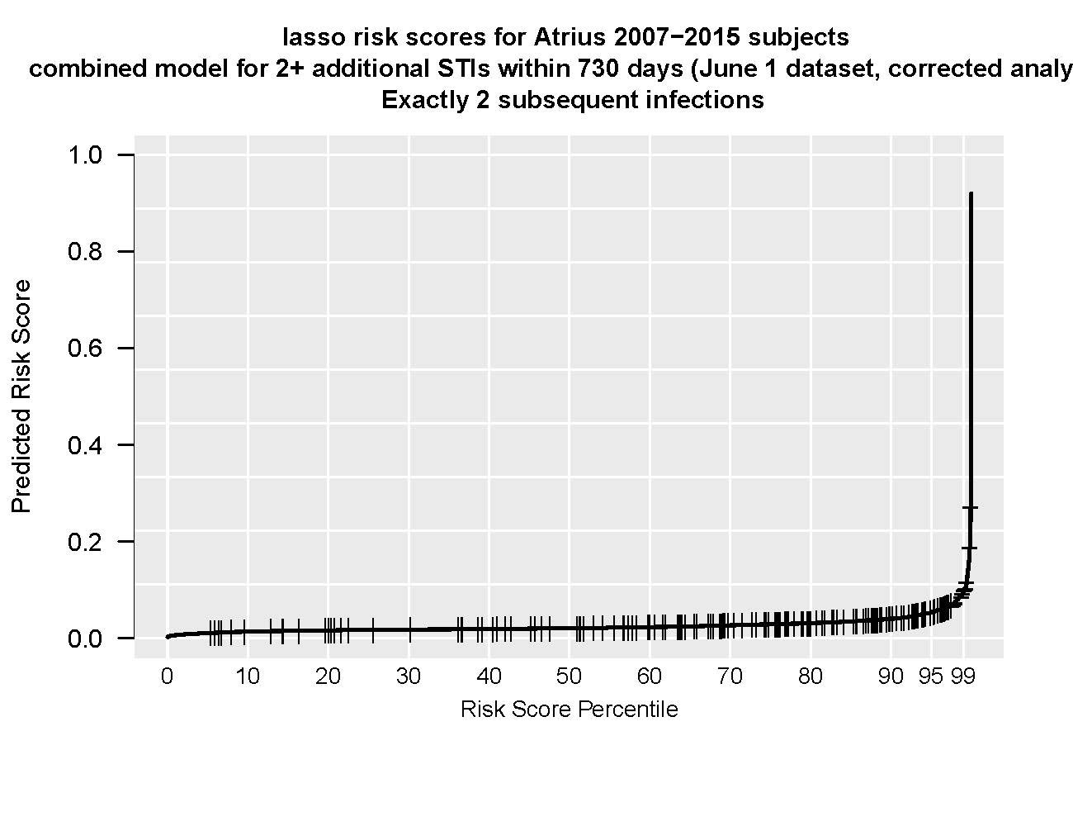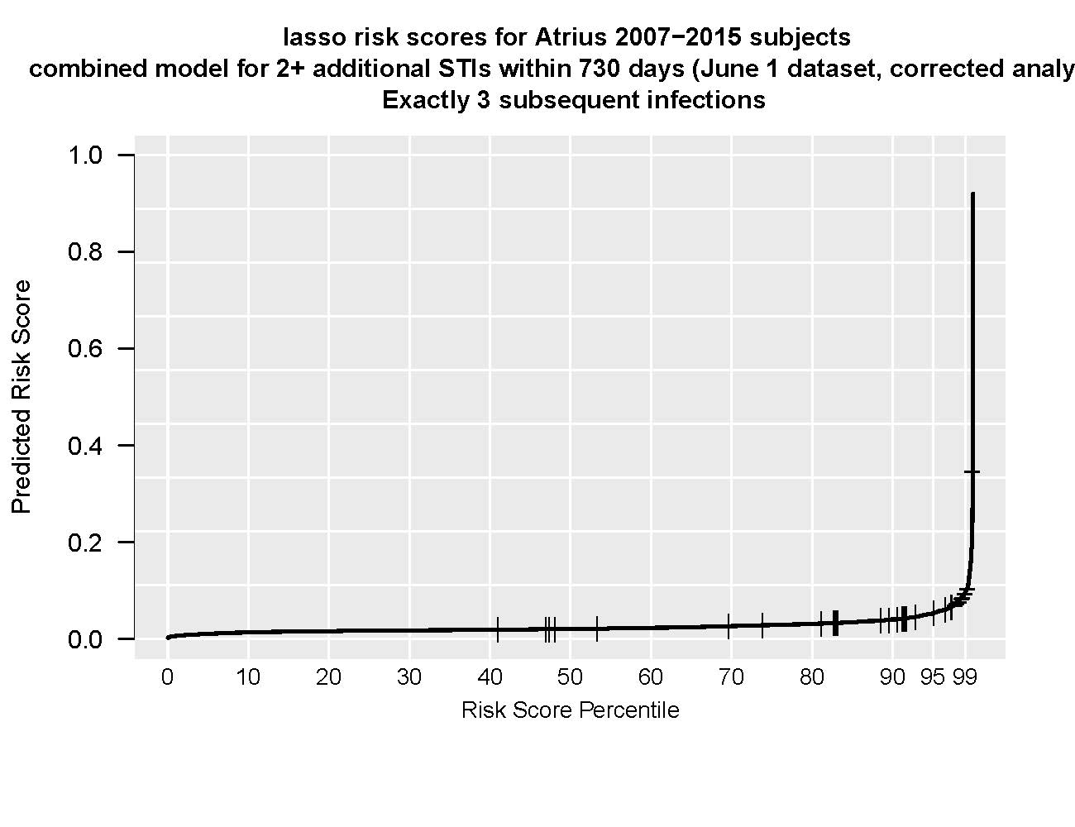
C) 4 Repeat STIs D) ≥5 Repeat STIs
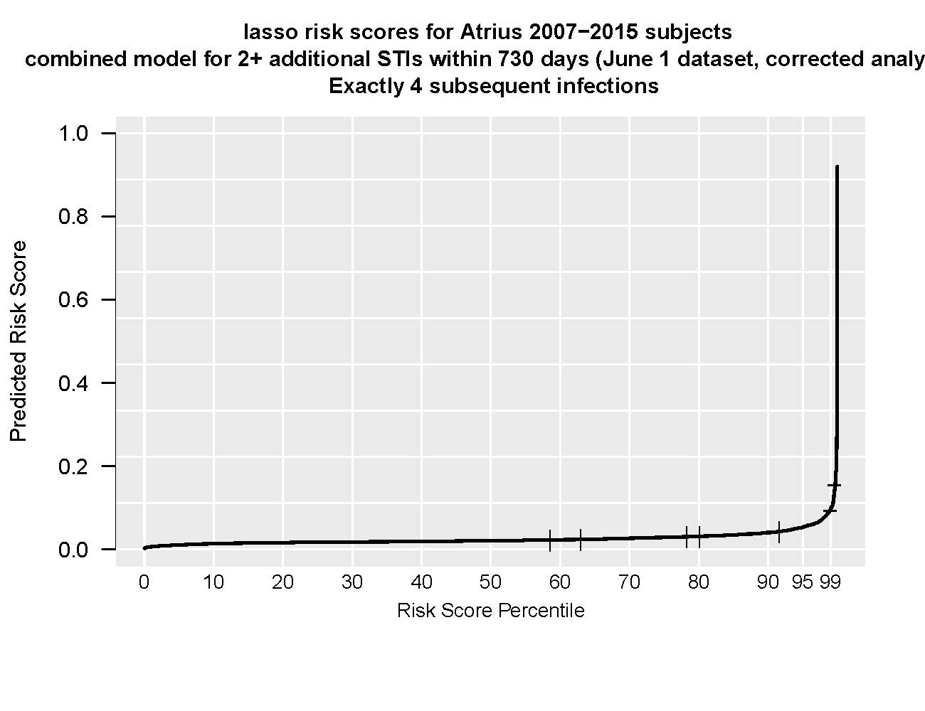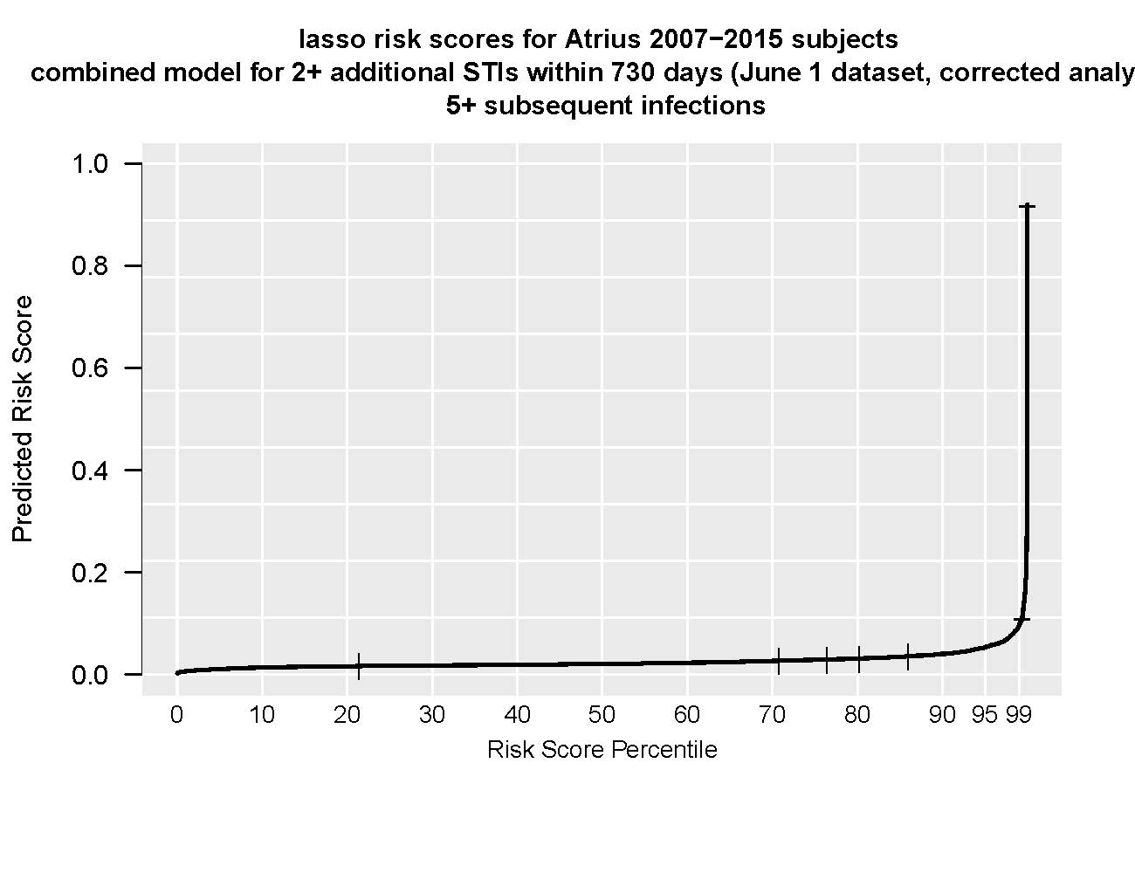
Supplemental Figure 1. LASSO* regression model distribution of predicted risk scores, ≥2 repeat diagnoses of sexually transmitted infections (STIs)† within 730 days. A) Risk score distribution for patients with exactly 2 repeat STIs. B) Risk score distribution for patients with exactly 3 repeats. C) Risk score distribution for patients with exactly 4 repeat STIs. D) Risk score distribution for patients with ≥5 repeat STIs.
* LASSO: least absolute shrinkage and selection operator using AUC loss
† Sexually transmitted infection, defined as positive laboratory result for chlamydia, gonorrhea, or a syphilis diagnosis.

Supplemental Table 4. Differences in the distribution of repeat diagnoses of sexually transmitted infections (STIs)* between the primary algorithm development with only Atrius Health data and the Atrius Health dataset augmented with MDPH† surveillance data stratified by duration of follow-up time, 2008-2015.
 | 730 day follow-up |  |  |  | 365 day follow-up
Number of repeat STIs | Atrius  Health Data  (n=8,723)‡ |  | MDPH Augmented Data  (n=8,745) |  | Atrius  Health Data  (n=8,723) |  | MDPH Augmented Data  (n=8,745)
 | n | % | n | % | n | % | n | %
0 | 7517 | 86.2 | 7465 | 85.4 | 7935 | 91.1 | 7887 | 90.2
1 | 982 | 11.3 | 1021 | 11.7 | 685 | 7.8 | 741 | 8.5
2 | 173 | 2.0 | 197 | 2.3 | 88 | 1.0 | 97 | 1.1
3 | 35 | 0.4 | 41 | 0.5 | 10 | 0.1 | 12 | 0.1
4+ | 15 | 0.2 | 21 | 0.2 | 5 | 0.1 | 8 | 0.1
* Sexually transmitted infection, defined as positive laboratory result for chlamydia, gonorrhea, or a syphilis diagnosis.
† MDPH: Massachusetts Department of Public Health
‡ One incident STI had -1 repeat STI within 730 days. This incident STI was retained in categorized as having 0 repeat STI within 730 days.

