Supplementary Material
Cross-sectional and prospective associations of early childhood circulating metals with early and mid-childhood cognition in the Project Viva cohort.
Ruwan Thilakaratne¹; Pi-I D. Lin²; Sheryl L. Rifas-Shiman²; Julio Landero³; Robert O. Wright³; David Bellinger⁴; Emily Oken²; and Andres Cardenas^{5*}

¹Division of Epidemiology, School of Public Health, University of California, Berkeley, Berkeley, CA, USA
²Division of Chronic Disease Research Across the Lifecourse, Department of Population Medicine, Harvard Medical School and Harvard Pilgrim Health Care Institute, Boston, MA, USA
³Department of Environmental Medicine and Institute for Exposomic Research, Icahn School of Medicine at Mount Sinai, New York City, NY, USA
⁴Departments of Neurology and Psychiatry, Harvard Medical School, Boston, MA, USA
⁵Department of Epidemiology and Population Health, Stanford University, Stanford, CA, USA

*Corresponding author:
Andres Cardenas, PhD
Department of Epidemiology and Population Health
Stanford University
Stanford, CA 94305
andresca@stanford.edu

Table of Contents
Table S1. Comparison of covariate distributions between early and mid-childhood analytic samples in a study of associations of early childhood (~3 years) erythrocyte metal concentrations with early and mid-childhood (~8 years) cognitive test scores, in the Project Viva pre-birth cohort, Boston, Massachusetts, USA. 6
Table S2. Detection rates and distributions of early childhood (~3 years) erythrocyte metal concentrations in the Project Viva cohort, Boston, Massachusetts, USA (N=349). 8
Table S3. Measurement reliability statistics for well-detected (>60%) early childhood (~3 years) erythrocyte metals, and comparisons to laboratory reference ranges and maternal first-trimester (~10 weeks) erythrocyte concentrations, in the Project Viva cohort, Boston, Massachusetts, USA. 11
Table S4. Tabular presentation of results from main text Figure 1: multivariable linear regression estimates and 95% confidence intervals of adjusted mean difference in early childhood (~3 years) cognitive test scores assessing visual-motor ability (WRAVMA) or receptive vocabulary (PPVT-III), associated with a doubling in early childhood erythrocyte concentration of a non-essential or essential metal. 13
Table S5. Tabular presentation of results from main text Figure 2: multivariable linear regression estimates and 95% confidence intervals of adjusted mean difference in mid-childhood (~8 years) cognitive test scores assessing visual memory (WRAML2), visual-motor ability (WRAVMA), crystallized intelligence (KBIT-II verbal), or fluid intelligence (KBIT-II non-verbal), associated with a doubling in early childhood (~3 years) erythrocyte concentration of a non-essential or essential metal. 15
Table S6. Estimates and 95% confidence intervals of adjusted mean difference in early childhood (~3 years) cognitive test scores assessing visual-motor ability (WRAVMA) or receptive vocabulary (PPVT-III), associated with a doubling in early childhood erythrocyte concentration of a non-essential or essential metal. Estimates are from multivariable linear regression models with adjustment for covariates, including first-trimester erythrocyte concentration, but no adjustment for other concurrently measured early childhood erythrocyte metals. 18
Table S7. Estimates and 95% confidence intervals of adjusted mean difference in mid-childhood (~8 years)cognitive test scores assessing visual memory (WRAML2), visual-motor ability (WRAVMA), crystallized intelligence (KBIT-II verbal), or fluid intelligence (KBIT-II non-verbal), associated with a doubling in early childhood (~3 years) erythrocyte concentration of a non-essential or essential metal. Estimates are from multivariable linear regression models with adjustment for covariates, including first-trimester erythrocyte concentration, but no adjustment for other concurrently measured early childhood erythrocyte metals. 20
Figure S1. Causal diagram for a study of the associations of early childhood (~3 years) erythrocyte concentrations of metals with child cognition in early and mid- (~8 years) childhood, in the Project Viva pre-birth cohort, Boston, Massachusetts, USA. PPVT-III: Peabody Picture Vocabulary Test, 3rd edition; WRAVMA: Wide Range Assessment of Visual Motor Abilities; WRAML2: Wide Range Assessment of Memory and Learning, 2nd edition; KBIT-II: Kaufman Brief Intelligence Test, 2nd edition. 22
Figure S2. Flow diagram of participant selection from the Project Viva pre-birth cohort (Boston, Massachusetts, USA) for a study of associations of early childhood (~3 years) erythrocyte metal concentrations with child cognitive test scores at early and mid-childhood (~8 years). 23
Figure S3. Spearman correlation coefficients among early childhood (~3 years) erythrocyte concentrations of well-detected (>60%) non-essential (arsenic (As), barium (Ba), cadmium (Cd), cesium (Cs), mercury (Hg), lead (Pb), tin (Sn), and strontium (Sr)) and essential (cobalt (Co), copper (Cu), magnesium (Mg), manganese (Mn), molybdenum (Mo), selenium (Se), and zinc (Zn)) metals, in the Project Viva pre-birth cohort, Boston, Massachusetts, USA (N=349). 24
Figure S4. Pearson correlation coefficients between child cognitive test scores in early (~3 years) and mid- (~8 years) childhood in the Project Viva pre-birth cohort, Boston, Massachusetts, USA (N=349 children). In early childhood, receptive vocabulary (Peabody Picture Vocabulary Test, 3rd edition (PPTV-III)) and visual-motor ability (Wide Range Assessment of Visual Motor Abilities (WRAVMA)) were assessed, and in mid-childhood, visual memory (Wide Range Assessment of Memory and Learning, 2nd edition (WRAML2)), visual-motor ability (WRAVMA visual-motor subtest), fluid intelligence (Kaufman Brief Intelligence Test, 2nd edition (KBIT-II) non-verbal component), and crystallized intelligence (KBIT-II verbal component) were assessed. ECH: early childhood visit (~3 years); MCH: mid-childhood visit (~8 years). 25
Figure S5. Quantile g-computation estimates and 95% confidence intervals of adjusted mean difference in early childhood cognitive test scores for each quartile increase in early childhood erythrocyte concentration of a mixture of non-essential (As, Ba, Cd, Cs, Hg, Pb, Sn, and Sr) (A) or essential (Co, Cu, Mg, Mn, Mo, Se, and Zn) (B) metals. Cognitive tests assessed visual-motor function (WRAVMA) or receptive vocabulary (PPVT-III). WRAVMA is composed of three subtests assessing visual-motor, fine motor, and visual spatial abilities, which are combined to create a summary score. Mixture component point estimates are provided to the right of the point estimates and intervals. Models adjusted for child race and ethnicity, fish consumption, daycare attendance, breastfeeding duration, household income, maternal KBIT-II composite score at mid-childhood visit, education, marital status, age at enrollment, maternal first-trimester erythrocyte concentrations of metals in the mixture, and early childhood erythrocyte concentrations of metals in the other mixture (e.g. non-essential metal mixture estimate is adjusted for essential metal mixture). WRAVMA: Wide Range Assessment of Visual Motor Abilities; PPVT-III: Peabody Picture Vocabulary Test, 3rd edition. 27
Figure S6. Concentration-response functions for the associations of early childhood (~3 years) erythrocyte concentrations of each of nine non-essential (As, Ba, Cd, Cs, Hg, Pb, Sn, Sr) and six essential metals (Co, Cu, Mg, Mn, Mo, Se, Zn) (top horizontal axis) with early childhood (~3 years) visual-motor function (WRAVMA summary) cognitive test scores, stratified by the 10th, 50th, or 90th percentile of each other metal (right vertical axis), from Bayesian kernel machine regression models. All other components were fixed at their medians. Variation in the shape of the functions across quantiles of other metals indicates interaction. WRAVMA: Wide Range Assessment of Visual Motor Abilities. 28
Figure S7. Concentration-response functions for the associations of early childhood (~3 years) erythrocyte concentrations of each of nine non-essential (As, Ba, Cd, Cs, Hg, Pb, Sn, Sr) and six essential metals (Co, Cu, Mg, Mn, Mo, Se, Zn) (top horizontal axis) with early childhood (~3 years) receptive vocabulary (PPVT-III) cognitive test scores, stratified by the 10th, 50th, or 90th percentile of each other metal (right vertical axis), from Bayesian kernel machine regression models. All other components were fixed at their medians. Variation in the shape of the functions across quantiles of other metals indicates interaction. PPVT-III: Peabody Picture Vocabulary Test, 3rd edition. 29
Figure S8. Concentration-response functions for the associations of early childhood (~3 years) erythrocyte concentrations of each of nine non-essential (As, Ba, Cd, Cs, Hg, Pb, Sn, Sr) and six essential metals (Co, Cu, Mg, Mn, Mo, Se, Zn) (top horizontal axis) with mid-childhood (~8 years) visual memory (WRAML2) cognitive test scores, stratified by the 10th, 50th, or 90th percentile of each other metal (right vertical axis), from Bayesian kernel machine regression models. All other components were fixed at their medians. Variation in the shape of the functions across quantiles of other metals indicates interaction. WRAML2: Wide Range Assessment of Memory and Learning, 2nd edition. 30
Figure S9. Concentration-response functions for the associations of early childhood (~3 years) erythrocyte concentrations of each of nine non-essential (As, Ba, Cd, Cs, Hg, Pb, Sn, Sr) and six essential metals (Co, Cu, Mg, Mn, Mo, Se, Zn) (top horizontal axis) with mid-childhood (~8 years) visual-motor (WRAVMA visual-motor subtest) cognitive test scores, stratified by the 10th, 50th, or 90th percentile of each other metal (right vertical axis), from Bayesian kernel machine regression models. All other components were fixed at their medians. Variation in the shape of the functions across quantiles of other metals indicates interaction. WRAVMA: Wide Range Assessment of Visual-Motor Function. 31
Figure S10. Concentration-response functions for the associations of early childhood (~3 years) erythrocyte concentrations of each of nine non-essential (As, Ba, Cd, Cs, Hg, Pb, Sn, Sr) and six essential metals (Co, Cu, Mg, Mn, Mo, Se, Zn) (top horizontal axis) with mid-childhood (~8 years) crystallized intelligence (KBIT-II verbal) cognitive test scores, stratified by the 10th, 50th, or 90th percentile of each other metal (right vertical axis), from Bayesian kernel machine regression models. All other components were fixed at their medians. Variation in the shape of the functions across quantiles of other metals indicates interaction. KBIT-II: Kaufman Brief Intelligence Test, 2nd edition. 32
Figure S11. Concentration-response functions for the associations of early childhood (~3 years) erythrocyte concentrations of each of nine non-essential (As, Ba, Cd, Cs, Hg, Pb, Sn, Sr) and six essential metals (Co, Cu, Mg, Mn, Mo, Se, Zn) (top horizontal axis) with mid-childhood (~8 years) fluid intelligence (KBIT-II non-verbal) cognitive test scores, stratified by the 10th, 50th, or 90th percentile of each other metal (right vertical axis), from Bayesian kernel machine regression models. All other components were fixed at their medians. Variation in the shape of the functions across quantiles of other metals indicates interaction. KBIT-II: Kaufman Brief Intelligence Test, 2nd edition. 33
Figure S12. Sensitivity analyses of adjusted mean difference in early childhood (~3 years) (A) and mid-childhood (~8 years) (B) cognitive test scores and 95% confidence intervals per doubling of early childhood erythrocyte concentration of non-essential metals. Reference model (“Ref.”) is a multivariable linear regression model adjusting for child race and ethnicity, fish consumption, daycare attendance, breastfeeding duration, household income, maternal intelligence (PPVT-III for early childhood visit; KBIT-II composite for mid-childhood visit), education, marital status, age at enrollment, early childhood erythrocyte concentrations of all other metals, and maternal first-trimester erythrocyte concentration of the metal. Estimates and intervals for each metal present, from left to right: Ref.; Ref. with additional adjustment for Youth Healthy Eating Index; Ref. with additional adjustment for presence of household smoking; and Ref. with removal of other early childhood metals from the model. KBIT-II: Kaufman Brief Intelligence Test, 2nd edition; PPVT-III: Peabody Picture Vocabulary Test, 3rd edition; WRAVMA: Wide Range Assessment of Visual Motor Abilities; WRAML2: Wide Range Assessment of Memory and Learning, 2nd edition; YHEI: Youth Healthy Eating Index. 34
Figure S13. Sensitivity analyses of adjusted mean difference in early childhood (~3 years) (A) and mid-childhood (~8 years) (B) cognitive test scores and 95% confidence intervals per doubling of early childhood erythrocyte concentration of essential metals. Reference model (“Ref.”) is a multivariable linear regression model adjusting for child race and ethnicity, fish consumption, daycare attendance, breastfeeding duration, household income, maternal intelligence (PPVT-III for early childhood visit; KBIT-II composite for mid-childhood visit), education, marital status, age at enrollment, early childhood erythrocyte concentrations of all other metals, and maternal first-trimester erythrocyte concentration of the metal. Estimates and intervals for each metal present, from left to right: Ref.; Ref. with additional adjustment for Youth Healthy Eating Index; Ref. with additional adjustment for presence of household smoking; and Ref. with removal of other early childhood metals from the model. KBIT-II: Kaufman Brief Intelligence Test, 2nd edition; PPVT-III: Peabody Picture Vocabulary Test, 3rd edition; WRAVMA: Wide Range Assessment of Visual Motor Abilities; WRAML2: Wide Range Assessment of Memory and Learning, 2nd edition; YHEI: Youth Healthy Eating Index. 35
Figure S14. Sensitivity analyses of adjusted mean difference in early childhood (~3 years) (A) and mid-childhood (~8 years) (B) cognitive test scores and 95% confidence intervals per quartile increase in early childhood erythrocyte concentration of a mixture of non-essential (As, Ba, Cd, Cs, Hg, Pb, Sn, and Sr) or essential (Co, Cu, Mg, Mn, Mo, Se, and Zn) metals. Reference model is a quantile g-computation model adjusting for child race and ethnicity, fish consumption, daycare attendance, breastfeeding duration, household income, maternal intelligence (PPVT-III for early childhood visit; KBIT-II composite for mid-childhood visit), education, marital status, age at enrollment, early childhood erythrocyte concentrations of metals in the other mixture, and maternal first-trimester erythrocyte concentration of all metals in the mixture. Estimates and intervals for each mixture present, from left to right: Ref.; Ref. with additional adjustment for Youth Healthy Eating Index; Ref. with additional adjustment for presence of household smoking; and Ref. with removal of early childhood erythrocyte metals in the other mixture from the model. KBIT-II: Kaufman Brief Intelligence Test, 2nd edition; PPVT-III: Peabody Picture Vocabulary Test, 3rd edition; WRAVMA: Wide Range Assessment of Visual Motor Abilities; WRAML2: Wide Range Assessment of Memory and Learning, 2nd edition; YHEI: Youth Healthy Eating Index. 36

Table S1. Comparison of covariate distributions between early and mid-childhood analytic samples in a study of associations of early childhood (~3 years) erythrocyte metal concentrations with early and mid-childhood (~8 years) cognitive test scores, in the Project Viva pre-birth cohort, Boston, Massachusetts, USA.
Covariate | Included in early childhood cognition analyses (N=336)  N (%) or mean ± SD | Included in mid-childhood cognition analyses (N=296)  N (%) or mean ± SD
Child sex
Male | 178 (53.0%) | 154 (52.0%)
Female | 158 (47.0%) | 142 (48.0%)
Child race and ethnicity
NH White | 242 (72.0%) | 212 (71.6%)
NH Black | 40 (11.9%) | 37 (12.5%)
Hispanic | 8 (2.4%) | 7 (2.4%)
NH Asian | 5 (1.5%) | 4 (1.4%)
More than one race | 41 (12.2%) | 36 (12.2%)
Maternal education
Graduate school | 104 (31.0%) | 93 (31.4%)
Four-year college graduate | 150 (44.6%) | 128 (43.2%)
Some college/Associate’s, or less | 82 (24.4%) | 75 (25.3%)
Annual household income
$70,000 or less | 103 (30.7%) | 90 (30.4%)
$70,001-$100,000 | 83 (24.7%) | 72 (24.3%)
Greater than $100,000 | 150 (44.6%) | 134 (45.3%)
Child attendance to daycare
Did not attend a daycare | 86 (25.6%) | 72 (24.3%)
Attended a daycare | 250 (74.4%) | 224 (75.7%)
Maternal marital status
Not married | 37 (11.0%) | 32 (10.8%)
Married | 299 (89.0%) | 264 (89.2%)
Child fish consumption
Never | 160 (47.6%) | 136 (45.9%)
Less than once per week | 82 (24.4%) | 73 (24.7%)
Once per week or more | 94 (28.0%) | 87 (29.4%)
Breastfeeding duration, months | 6.85 ± 4.43 | 6.96 ± 4.39
Maternal age at enrollment, years | 33.1 ± 4.58 | 32.9 ± 4.69
Maternal receptive vocabulary (PPVT-III) score | 108 ± 13.5 | 108 ± 13.7
NH: Non-Hispanic; PPVT-III: Peabody Picture Vocabulary Test, 3rd edition; SD: standard deviation

Table S2. Detection rates and distributions of early childhood (~3 years) erythrocyte metal concentrations in the Project Viva cohort, Boston, Massachusetts, USA (N=349).
Metal | Mean LOD (ng/g)ª | Percent detected^{b} | Mean (SD) (ng/g) | Minimum (ng/g) | 5% (ng/g) | 25% (ng/g) | Median (ng/g) | 75% (ng/g) | 95% (ng/g) | Maximum (ng/g)
Essential
Cobalt (Co) | 0.02 | 68% | 0.045 (0.0538) | 0.0141 | 0.0141 | 0.0141 | 0.0342 | 0.0531 | 0.113 | 0.667
Chromium (Cr) | 0.51 | 15% | 0.826 (4.98) | 0.361 | 0.361 | 0.361 | 0.361 | 0.361 | 1.32 | 91.5
Copper (Cu) | 0.51 | 100% | 575 (94.6) | 73.1 | 437 | 524 | 564 | 632 | 738 | 878
Magnesium (Mg) | 1.64 | 100% | 44,731 (6,686.1) | 6,340 | 34,640 | 41,100 | 44,700 | 48,600 | 54,860 | 68,900
Manganese (Mn) | 0.15 | 100% | 18.9 (6.05) | 2.33 | 10.1 | 14.6 | 18.1 | 21.9 | 30.6 | 48.5
Molybdenum (Mo) | 0.06 | 100% | 0.374 (0.265) | 0.0922 | 0.16 | 0.25 | 0.32 | 0.411 | 0.7 | 2.89
Nickel (Ni) | 0.17 | 16% | 0.202 (0.856) | 0.12 | 0.12 | 0.12 | 0.12 | 0.12 | 0.37 | 16
Selenium (Se) | 0.17 | 100% | 215 (41.2) | 22.9 | 163 | 190 | 212 | 239 | 287 | 452
Zinc (Zn) | 4.29 | 100% | 6,730 (1,320) | 787 | 4,690 | 5,900 | 6,690 | 7,570 | 8,860 | 11,000
Non-essential
Aluminum (Al) | 4.39 | 36% | 7.15 (13.3) | 3.1 | 3.1 | 3.1 | 3.1 | 6.17 | 21.1 | 158
Antimony (Sb) | 0.03 | 54% | 0.546 (0.707) | 0.0144 | 0.0212 | 0.0212 | 0.0268 | 1.08 | 1.88 | 3.06
Arsenic (As) | 0.05 | 100% | 0.591 (1.4) | 0.0354 | 0.116 | 0.199 | 0.334 | 0.596 | 1.67 | 24.4
Barium (Ba) | 0.17 | 68% | 1.36 (3.09) | 0.108 | 0.12 | 0.12 | 0.826 | 1.81 | 3.6 | 52.1
Beryllium (Be) | 0.03 | 12% | 0.0228 (0.00842) | 0.0101 | 0.0212 | 0.0212 | 0.0212 | 0.0212 | 0.0338 | 0.112
Bismuth (Bi) | 0.01 | 21% | 0.0235 (0.101) | 0.00707 | 0.00707 | 0.00707 | 0.00707 | 0.00707 | 0.047 | 1.36
Cadmium (Cd) | 0.02 | 100% | 0.228 (0.3) | 0.017 | 0.0721 | 0.122 | 0.166 | 0.232 | 0.416 | 3.32
Cesium (Cs) | 0.01 | 100% | 2.58 (0.795) | 0.36 | 1.42 | 2.01 | 2.5 | 3.05 | 4 | 5.5
Mercury (Hg) | 0.06 | 99% | 1.21 (1.84) | 0.0424 | 0.137 | 0.232 | 0.454 | 1.21 | 4.66 | 13.2
Lead (Pb) | 0.17 | 100% | 33.7 (21.9) | 4.13 | 11.5 | 19.3 | 27.3 | 43.3 | 76.6 | 193
Tin (Sn) | 0.1 | 91% | 0.314 (0.275) | 0.0635 | 0.0707 | 0.17 | 0.237 | 0.36 | 0.806 | 2.36
Titanium (Ti) | 3.3 | 46% | 2.99 (5.56) | 1.52 | 1.78 | 2.33 | 2.33 | 2.35 | 4.72 | 97.1
Strontium (Sr) | 0.22 | 100% | 2.23 (1.21) | 0.195 | 1.3 | 1.67 | 2.04 | 2.46 | 3.69 | 20.1
Uranium (U) | 0.004 | 5% | 0.00293 (0.000685) | 0.00253 | 0.00283 | 0.00283 | 0.00283 | 0.00283 | 0.00283 | 0.0117
Vanadium (V) | 0.06 | 24% | 0.0848 (0.26) | 0.0283 | 0.0424 | 0.0424 | 0.0424 | 0.0424 | 0.185 | 4.4
Tungsten (W) | 0.02 | 9% | 0.0168 (0.0179) | 0.0114 | 0.0141 | 0.0141 | 0.0141 | 0.0141 | 0.0216 | 0.269
LOD: limit of detection; SD: standard deviation.
ªLODs are metal- and batch-specific. Eight batches were run on eight separate days and concentration estimates on a given day were compared to the LOD for that day. LOD on a given day was calculated as follows: LOD = SD of method blank (n=10) × 3. For simplicity, the mean across daily LODs is reported ('Mean LOD' column). Values below the LOD were imputed as LOD/sqrt(2).
^{b}Metals with detection rates of at least 60% were considered 'well-detected' and were analyzed in multivariate models for associations with cognition.

Table S3. Measurement reliability statistics for well-detected (>60%) early childhood (~3 years) erythrocyte metals, and comparisons to laboratory reference ranges and maternal first-trimester (~10 weeks) erythrocyte concentrations, in the Project Viva cohort, Boston, Massachusetts, USA.
Metal | ICCª | Percent of duplicates with %RPD < 20%^{b} | Early childhood erythrocyte concentration, median (IQR) (ng/g) | Laboratory reference range (ng/g)^{c} | Maternal first-trimester erythrocyte concentration, median (IQR) (ng/g)^{d}
Essential
Cobalt (Co) | 0.32 | 63% | 0.0342 (0.0141-0.0531) | – | 0.0458 (0.0458-0.0458)
Copper (Cu) | 0.94 | 100% | 564 (524-632) | 520-900 | 564 (516-618)
Magnesium (Mg) | 0.9 | 94% | 44,700 (41,100-48,600) | 39,000-59,000 | 41,100 (37,000-46,100)
Manganese (Mn) | 0.98 | 100% | 18.1 (14.6-21.9) | 9-30 | 16.2 (13.1-20.4)
Molybdenum (Mo) | 0.97 | 100% | 0.32 (0.25-0.411) | 0.2-1 | 0.242 (0.142-0.412)
Selenium (Se) | 0.95 | 100% | 212 (190-239) | 160-490 | 248 (219-282)
Zinc (Zn) | 0.96 | 100% | 6,690 (5,900-7,570) | 7,200-13,000 | 10,400 (9,270-11,600)
Non-Essential
Arsenic (As) | 1 | 94% | 0.334 (0.199-0.596) | <8 | 0.836 (0.41-1.54)
Barium (Ba) | 1 | 69% | 0.826 (0.12-1.81) | – | 3.18 (2-5.96)
Cadmium (Cd) | 0.9 | 81% | 0.166 (0.122-0.232) | <2 | 0.388 (0.269-0.563)
Cesium (Cs) | 0.97 | 100% | 2.5 (2.01-3.05) | <15 | 2.53 (2.01-3.18)
Mercury (Hg) | 1 | 94% | 0.454 (0.232-1.21) | <10 | 3.28 (1.64-6.5)
Lead (Pb) | 1 | 100% | 27.3 (19.3-43.3) | <50 | 17.7 (13.5-23.8)
Tin (Sn) | 0.82 | 38% | 0.237 (0.17-0.36) | – | 0.997 (0.997-1.58)
Strontium (Sr) | 0.97 | 94% | 2.04 (1.67-2.46) | – | –
ICC: intraclass correlation coefficient; RPD: relative percent difference; SD: standard deviation.
ªICC for within-person instrument replicate error (N=5 replicates per person), indicating the proportion of variability in measurements attributable to between-person variation rather than within-person variation. Higher ICC (range: 0-1) corresponds to lower instrument measurement error.
^{b}A randomly selected 4% of samples (N=16) were analyzed in duplicate to assess replicability, estimated using relative percent difference, the absolute difference between the two measurements divided by their average and converted to a percentage. For each analyte, the percent of the N=16 duplicates with %RPD < 20% is provided.
^{c}Reference ranges for young children are derived from a laboratory website: Doctor’s Data Inc. Red Blood Cell (RBC) Elements. Accessed August 12, 2022. https://newsite.doctorsdata.com/Red-Blood-Cell-Elements
^{d}First-trimester (~10 weeks) maternal erythrocyte concentrations are reported. Strontium was not measured in maternal samples.

Table S4. Tabular presentation of results from main text Figure 1: multivariable linear regression estimates and 95% confidence intervals of adjusted mean difference in early childhood (~3 years) cognitive test scores assessing visual-motor ability (WRAVMA) or receptive vocabulary (PPVT-III), associated with a doubling in early childhood erythrocyte concentration of a non-essential or essential metal.
 | Adjustedª mean difference (95% CI) in early childhood cognitive test score per doubling of early childhood erythrocyte metal concentration
Metal | WRAVMA summary | WRAVMA visual-motor | WRAVMA fine-motor | WRAVMA visual-spatial | PPVT-III perceptive vocabulary
Non-essential
As | -0.08 ( -1.31, 1.15) | 0.17 ( -1.13, 1.46) | 0.39 ( -0.84, 1.62) | -0.61 ( -2.22, 1.00) | 0.63 ( -0.78, 2.05)
Ba | -0.34 ( -0.95, 0.27) | -0.87 ( -1.52, -0.22) | -0.20 ( -0.81, 0.42) | 0.58 ( -0.22, 1.37) | 0.77 ( 0.05, 1.49)
Cd | 0.45 ( -0.90, 1.79) | -0.06 ( -1.53, 1.41) | -0.74 ( -2.11, 0.63) | 2.05 ( 0.28, 3.82) | 0.55 ( -1.04, 2.14)
Cs | 0.68 ( -2.25, 3.62) | 1.23 ( -1.94, 4.40) | 0.68 ( -2.30, 3.67) | -0.47 ( -4.32, 3.39) | -0.50 ( -3.97, 2.96)
Hg | 0.28 ( -0.61, 1.18) | 0.34 ( -0.62, 1.29) | 0.12 ( -0.79, 1.03) | 0.08 ( -1.09, 1.26) | 0.40 ( -0.65, 1.45)
Pb | -2.43 ( -4.01, -0.86) | -1.76 ( -3.44, -0.08) | -2.10 ( -3.69, -0.51) | -2.07 ( -4.08, -0.06) | -1.45 ( -3.26, 0.36)
Sn | -0.11 ( -1.26, 1.04) | -0.13 ( -1.37, 1.12) | 1.15 ( -0.02, 2.32) | -0.87 ( -2.37, 0.62) | -0.15 ( -1.50, 1.21)
Sr | 0.26 ( -2.02, 2.54) | -0.22 ( -2.65, 2.22) | -0.88 ( -3.20, 1.44) | 2.18 ( -0.80, 5.16) | 0.76 ( -1.92, 3.45)
Essential
Co | -0.38 ( -1.15, 0.38) | -0.35 ( -1.17, 0.47) | -0.53 ( -1.30, 0.24) | 0.13 ( -0.86, 1.12) | -0.10 ( -0.99, 0.79)
Cu | -2.09 ( -7.99, 3.80) | -0.89 ( -7.32, 5.53) | 0.53 ( -5.47, 6.54) | -4.76 (-12.42, 2.91) | -2.79 ( -9.75, 4.18)
Mg | 8.11 ( 1.53, 14.68) | 6.40 ( -0.77, 13.56) | 2.69 ( -3.98, 9.35) | 10.28 ( 1.80, 18.77) | 6.69 ( -1.05, 14.43)
Mn | 0.40 ( -2.49, 3.30) | 2.81 ( -0.30, 5.92) | -0.15 ( -3.09, 2.79) | -2.06 ( -5.81, 1.68) | -0.78 ( -4.14, 2.59)
Mo | 0.33 ( -1.42, 2.07) | -1.12 ( -2.99, 0.76) | 0.37 ( -1.41, 2.15) | 0.49 ( -1.75, 2.74) | 0.08 ( -1.95, 2.11)
Se | -3.81 ( -9.51, 1.89) | -7.14 (-13.35, -0.94) | -2.23 ( -8.06, 3.61) | 1.61 ( -5.87, 9.10) | -4.97 (-11.75, 1.81)
Zn | -4.58 ( -9.55, 0.39) | -2.46 ( -7.79, 2.87) | -1.62 ( -6.68, 3.44) | -7.25 (-13.66, -0.84) | -0.99 ( -6.81, 4.84)
CI: confidence interval; PPVT-III: Peabody Picture Vocabulary Test, 3rd edition; WRAVMA: Wide Range Assessment of Visual Motor Abilities
N=336 children were included in these analyses, on whom there was data on at least one exposure, one early childhood outcome, and all covariates.
ªModels adjusted for child race and ethnicity, fish consumption, daycare attendance, breastfeeding duration, household income, maternal PPVT-III score at early childhood visit, education, marital status, and age at enrollment. For each metal, we also adjusted for the maternal first-trimester erythrocyte concentration of the metal, and early childhood erythrocyte concentrations of the 14 other concurrently measured metals.

Table S5. Tabular presentation of results from main text Figure 2: multivariable linear regression estimates and 95% confidence intervals of adjusted mean difference in mid-childhood (~8 years) cognitive test scores assessing visual memory (WRAML2), visual-motor ability (WRAVMA), crystallized intelligence (KBIT-II verbal), or fluid intelligence (KBIT-II non-verbal), associated with a doubling in early childhood (~3 years) erythrocyte concentration of a non-essential or essential metal.
 | Adjustedª mean difference (95% CI) in early childhood cognitive test score per doubling of early childhood erythrocyte metal concentration
Metal | WRAVMA visual-motor | WRAML2 total | WRAML2 picture memory | WRAML2 design memory | KBIT-II non-verbal | KBIT-II verbal
Non-essential
As | -0.49 ( -2.53, 1.55) | -0.40 ( -0.94, 0.14) | -0.25 ( -0.63, 0.14) | -0.14 ( -0.49, 0.20) | 0.14 ( -1.96, 2.25) | -0.26 ( -1.75, 1.24)
Ba | -0.12 ( -1.15, 0.90) | 0.23 ( -0.04, 0.51) | 0.21 ( 0.01, 0.40) | 0.02 ( -0.15, 0.19) | 0.41 ( -0.65, 1.47) | 0.08 ( -0.68, 0.83)
Cd | 1.55 ( -0.69, 3.78) | 0.00 ( -0.59, 0.60) | -0.05 ( -0.47, 0.38) | 0.04 ( -0.33, 0.42) | 0.51 ( -1.79, 2.81) | 0.37 ( -1.26, 2.01)
Cs | -1.87 ( -6.96, 3.22) | -0.84 ( -2.20, 0.52) | -0.66 ( -1.62, 0.31) | -0.16 ( -1.02, 0.70) | -2.08 ( -7.35, 3.19) | -1.84 ( -5.58, 1.91)
Hg | 0.09 ( -1.43, 1.62) | 0.16 ( -0.24, 0.56) | 0.22 ( -0.06, 0.50) | -0.06 ( -0.31, 0.20) | 1.63 ( 0.08, 3.17) | 0.80 ( -0.31, 1.91)
Pb | -1.60 ( -4.29, 1.09) | -0.04 ( -0.76, 0.67) | 0.25 ( -0.25, 0.76) | -0.33 ( -0.78, 0.13) | -0.76 ( -3.53, 2.00) | -1.46 ( -3.43, 0.51)
Sn | -0.85 ( -2.79, 1.09) | 0.20 ( -0.32, 0.72) | -0.14 ( -0.51, 0.23) | 0.34 ( 0.01, 0.68) | 0.37 ( -1.65, 2.39) | -0.18 ( -1.61, 1.26)
Sr | -0.58 ( -4.99, 3.84) | 0.56 ( -0.61, 1.73) | 0.21 ( -0.62, 1.04) | 0.36 ( -0.39, 1.10) | -4.69 ( -9.25, -0.14) | -0.72 ( -3.96, 2.52)
Essential
Co | -0.72 ( -1.99, 0.55) | 0.01 ( -0.32, 0.35) | -0.01 ( -0.24, 0.23) | 0.02 ( -0.19, 0.24) | -0.10 ( -1.40, 1.20) | -0.47 ( -1.39, 0.45)
Cu | 2.16 ( -8.23, 12.55) | 0.38 ( -2.38, 3.15) | -0.87 ( -2.83, 1.10) | 1.19 ( -0.57, 2.95) | 0.61 (-10.13, 11.34) | 2.04 ( -5.60, 9.68)
Mg | 6.40 ( -5.28, 18.07) | -1.27 ( -4.36, 1.83) | 0.26 ( -1.94, 2.46) | -1.41 ( -3.37, 0.55) | -2.68 (-14.68, 9.33) | -0.62 ( -9.15, 7.92)
Mn | -4.39 ( -9.29, 0.52) | 0.76 ( -0.54, 2.06) | 0.32 ( -0.60, 1.24) | 0.39 ( -0.43, 1.21) | 2.74 ( -2.28, 7.76) | 1.07 ( -2.49, 4.64)
Mo | 0.62 ( -2.35, 3.59) | 0.31 ( -0.48, 1.10) | 0.15 ( -0.41, 0.71) | 0.19 ( -0.31, 0.69) | 0.96 ( -2.10, 4.01) | 1.82 ( -0.35, 3.98)
Se | 3.50 ( -5.87, 12.87) | 0.00 ( -2.47, 2.47) | -0.43 ( -2.18, 1.33) | 0.39 ( -1.18, 1.97) | -3.84 (-13.44, 5.77) | -0.20 ( -7.03, 6.62)
Zn | -0.88 ( -9.48, 7.72) | 0.87 ( -1.40, 3.14) | 1.00 ( -0.62, 2.62) | -0.17 ( -1.61, 1.28) | -10.01 (-18.83, -1.18) | -1.21 ( -7.50, 5.08)
CI: confidence interval; KBIT-II: Kaufman Brief Intelligence Test, 2nd edition; WRAML2: Wide Range Assessment of Memory and Learning, 2nd edition; WRAVMA: Wide Range Assessment of Visual Motor Abilities
N=296 children were included in these analyses, on whom there was data on at least one exposure, one mid-childhood outcome, and all covariates.
ªModels adjusted for child race and ethnicity, fish consumption, daycare attendance, breastfeeding duration, household income, maternal KBIT-II composite score at mid-childhood visit, education, marital status, and age at enrollment. For each metal, we also adjusted for the maternal first-trimester erythrocyte concentration of the metal, and early childhood erythrocyte concentrations of the 14 other concurrently measured metals.

Table S6. Estimates and 95% confidence intervals of adjusted mean difference in early childhood (~3 years) cognitive test scores assessing visual-motor ability (WRAVMA) or receptive vocabulary (PPVT-III), associated with a doubling in early childhood erythrocyte concentration of a non-essential or essential metal. Estimates are from multivariable linear regression models with adjustment for covariates, including first-trimester erythrocyte concentration, but no adjustment for other concurrently measured early childhood erythrocyte metals.
 | Adjustedª mean difference (95% CI) in early childhood cognitive test score per doubling of early childhood erythrocyte metal concentration
Metal | WRAVMA summary | WRAVMA visual-motor | WRAVMA fine-motor | WRAVMA visual-spatial | PPVT-III perceptive vocabulary
Non-essential
As | -0.05 (-1.04, 0.95) | -0.10 (-1.18, 0.98) | 0.17 (-0.83, 1.17) | -0.18 (-1.49, 1.13) | 0.52 (-0.63, 1.68)
Ba | -0.37 (-0.93, 0.20) | -0.90 (-1.50, -0.30) | -0.11 (-0.68, 0.45) | 0.32 (-0.42, 1.06) | 0.71 ( 0.06, 1.37)
Cd | 0.37 (-0.88, 1.62) | -0.14 (-1.51, 1.22) | -0.46 (-1.72, 0.81) | 1.49 (-0.15, 3.13) | 0.50 (-0.96, 1.95)
Cs | -0.56 (-2.98, 1.85) | -0.61 (-3.25, 2.03) | -0.23 (-2.69, 2.22) | -0.76 (-3.94, 2.42) | 0.13 (-2.70, 2.95)
Hg | 0.04 (-0.70, 0.77) | 0.05 (-0.74, 0.85) | 0.05 (-0.69, 0.80) | -0.06 (-1.02, 0.90) | 0.29 (-0.56, 1.15)
Pb | -1.73 (-3.09, -0.37) | -1.56 (-3.02, -0.10) | -1.51 (-2.88, -0.14) | -1.26 (-3.04, 0.53) | -0.60 (-2.18, 0.98)
Sn | -0.21 (-1.34, 0.92) | -0.41 (-1.64, 0.83) | 1.08 (-0.05, 2.22) | -0.82 (-2.30, 0.65) | -0.24 (-1.56, 1.09)
Sr | 0.10 (-2.09, 2.30) | -0.35 (-2.72, 2.03) | -0.88 (-3.10, 1.35) | 1.61 (-1.26, 4.47) | -0.22 (-2.78, 2.35)
Essential
Co | -0.16 (-0.90, 0.58) | -0.05 (-0.85, 0.75) | -0.46 (-1.20, 0.28) | 0.24 (-0.72, 1.19) | -0.20 (-1.05, 0.65)
Cu | -0.37 (-4.26, 3.53) | -1.74 (-6.01, 2.53) | 0.72 (-3.25, 4.69) | -0.58 (-5.71, 4.55) | 0.68 (-3.88, 5.25)
Mg | 2.46 (-1.68, 6.60) | 0.84 (-3.72, 5.39) | 1.45 (-2.78, 5.68) | 3.27 (-2.18, 8.71) | 3.55 (-1.33, 8.43)
Mn | 0.86 (-1.46, 3.17) | 1.31 (-1.21, 3.84) | 0.28 (-2.09, 2.64) | 0.01 (-3.02, 3.05) | 0.59 (-2.11, 3.29)
Mo | 0.49 (-1.18, 2.15) | -1.21 (-3.01, 0.60) | 0.61 (-1.09, 2.32) | 0.90 (-1.27, 3.06) | 0.67 (-1.26, 2.59)
Se | -0.74 (-4.35, 2.88) | -2.63 (-6.57, 1.31) | 0.13 (-3.54, 3.80) | 0.87 (-3.89, 5.63) | 0.29 (-3.94, 4.51)
Zn | -1.40 (-4.82, 2.01) | -1.67 (-5.37, 2.03) | 0.01 (-3.45, 3.46) | -2.30 (-6.77, 2.16) | 1.21 (-2.79, 5.20)
CI: confidence interval; PPVT-III: Peabody Picture Vocabulary Test, 3rd edition; WRAVMA: Wide Range Assessment of Visual Motor Abilities
N=336 children were included in these analyses, on whom there was data on at least one exposure, one early childhood outcome, and all covariates.
ªModels adjusted for child race and ethnicity, fish consumption, daycare attendance, breastfeeding duration, household income, maternal PPVT-III score at early childhood visit, education, marital status, and age at enrollment. For each metal, we also adjusted for the maternal first-trimester erythrocyte concentration of the metal.

Table S7. Estimates and 95% confidence intervals of adjusted mean difference in mid-childhood (~8 years)cognitive test scores assessing visual memory (WRAML2), visual-motor ability (WRAVMA), crystallized intelligence (KBIT-II verbal), or fluid intelligence (KBIT-II non-verbal), associated with a doubling in early childhood (~3 years) erythrocyte concentration of a non-essential or essential metal. Estimates are from multivariable linear regression models with adjustment for covariates, including first-trimester erythrocyte concentration, but no adjustment for other concurrently measured early childhood erythrocyte metals.
 | Adjustedª mean difference (95% CI) in early childhood cognitive test score per doubling of early childhood erythrocyte metal concentration
Metal | WRAVMA visual-motor | WRAML2 total | WRAML2 picture memory | WRAML2 design memory | KBIT-II non-verbal | KBIT-II verbal
Non-essential
As | -0.38 ( -2.07, 1.32) | -0.27 ( -0.72, 0.18) | -0.07 ( -0.39, 0.25) | -0.20 ( -0.48, 0.09) | 0.90 ( -0.87, 2.66) | 0.18 ( -1.06, 1.43)
Ba | -0.07 ( -1.02, 0.89) | 0.17 ( -0.08, 0.42) | 0.19 ( 0.01, 0.37) | -0.02 ( -0.18, 0.14) | 0.60 ( -0.39, 1.60) | 0.17 ( -0.53, 0.86)
Cd | 1.74 ( -0.33, 3.81) | 0.01 ( -0.54, 0.56) | -0.06 ( -0.45, 0.33) | 0.06 ( -0.29, 0.41) | 0.54 ( -1.63, 2.72) | 0.38 ( -1.15, 1.91)
Cs | -0.94 ( -5.25, 3.37) | -0.65 ( -1.79, 0.50) | -0.33 ( -1.15, 0.48) | -0.32 ( -1.05, 0.41) | -1.34 ( -5.84, 3.17) | -1.95 ( -5.12, 1.21)
Hg | -0.21 ( -1.45, 1.03) | 0.02 ( -0.31, 0.35) | 0.16 ( -0.07, 0.40) | -0.14 ( -0.35, 0.07) | 1.46 ( 0.18, 2.74) | 0.56 ( -0.34, 1.47)
Pb | -1.34 ( -3.67, 0.98) | -0.12 ( -0.74, 0.50) | 0.11 ( -0.33, 0.55) | -0.26 ( -0.65, 0.14) | -0.42 ( -2.85, 2.01) | -1.50 ( -3.20, 0.21)
Sn | -0.74 ( -2.63, 1.16) | 0.20 ( -0.30, 0.70) | -0.18 ( -0.53, 0.18) | 0.37 ( 0.05, 0.69) | 0.10 ( -1.89, 2.08) | -0.06 ( -1.46, 1.34)
Sr | -1.28 ( -5.17, 2.61) | 0.25 ( -0.78, 1.29) | -0.15 ( -0.88, 0.59) | 0.41 ( -0.25, 1.07) | -3.75 ( -7.79, 0.30) | -1.13 ( -3.99, 1.73)
Essential
Co | -0.75 ( -1.96, 0.45) | 0.01 ( -0.31, 0.33) | 0.01 ( -0.22, 0.24) | 0.01 ( -0.20, 0.21) | 0.15 ( -1.10, 1.41) | -0.32 ( -1.20, 0.56)
Cu | 4.35 ( -3.74, 12.45) | 0.70 ( -1.45, 2.85) | -0.11 ( -1.64, 1.43) | 0.75 ( -0.62, 2.12) | -1.79 (-10.25, 6.68) | 1.74 ( -4.22, 7.69)
Mg | 5.80 ( -2.74, 14.34) | -0.05 ( -2.30, 2.20) | 0.52 ( -1.09, 2.12) | -0.54 ( -1.98, 0.90) | -1.28 (-10.16, 7.61) | 2.02 ( -4.23, 8.27)
Mn | -1.41 ( -5.56, 2.74) | 0.70 ( -0.39, 1.79) | 0.38 ( -0.40, 1.16) | 0.29 ( -0.41, 0.99) | 2.89 ( -1.40, 7.17) | 2.16 ( -0.85, 5.18)
Mo | 0.89 ( -1.94, 3.71) | 0.46 ( -0.29, 1.21) | 0.20 ( -0.33, 0.74) | 0.28 ( -0.20, 0.76) | 1.76 ( -1.18, 4.71) | 2.41 ( 0.35, 4.47)
Se | 3.37 ( -3.75, 10.49) | 0.21 ( -1.67, 2.09) | 0.12 ( -1.22, 1.46) | 0.08 ( -1.12, 1.28) | -1.65 ( -9.06, 5.75) | 1.83 ( -3.38, 7.03)
Zn | 3.65 ( -3.22, 10.51) | 0.74 ( -1.08, 2.56) | 0.78 ( -0.52, 2.07) | -0.05 ( -1.22, 1.11) | -6.36 (-13.50, 0.77) | 0.43 ( -4.62, 5.48)
CI: confidence interval; KBIT-II: Kaufman Brief Intelligence Test, 2nd edition; WRAML2: Wide Range Assessment of Memory and Learning, 2nd edition; WRAVMA: Wide Range Assessment of Visual Motor Abilities
N=296 children were included in these analyses, on whom there was data on at least one exposure, one mid-childhood outcome, and all covariates.
ªModels adjusted for child race and ethnicity, fish consumption, daycare attendance, breastfeeding duration, household income, maternal KBIT-II composite score at mid-childhood visit, education, marital status, and age at enrollment. For each early childhood metal, we also adjusted for the maternal first-trimester erythrocyte concentration of the same metal.

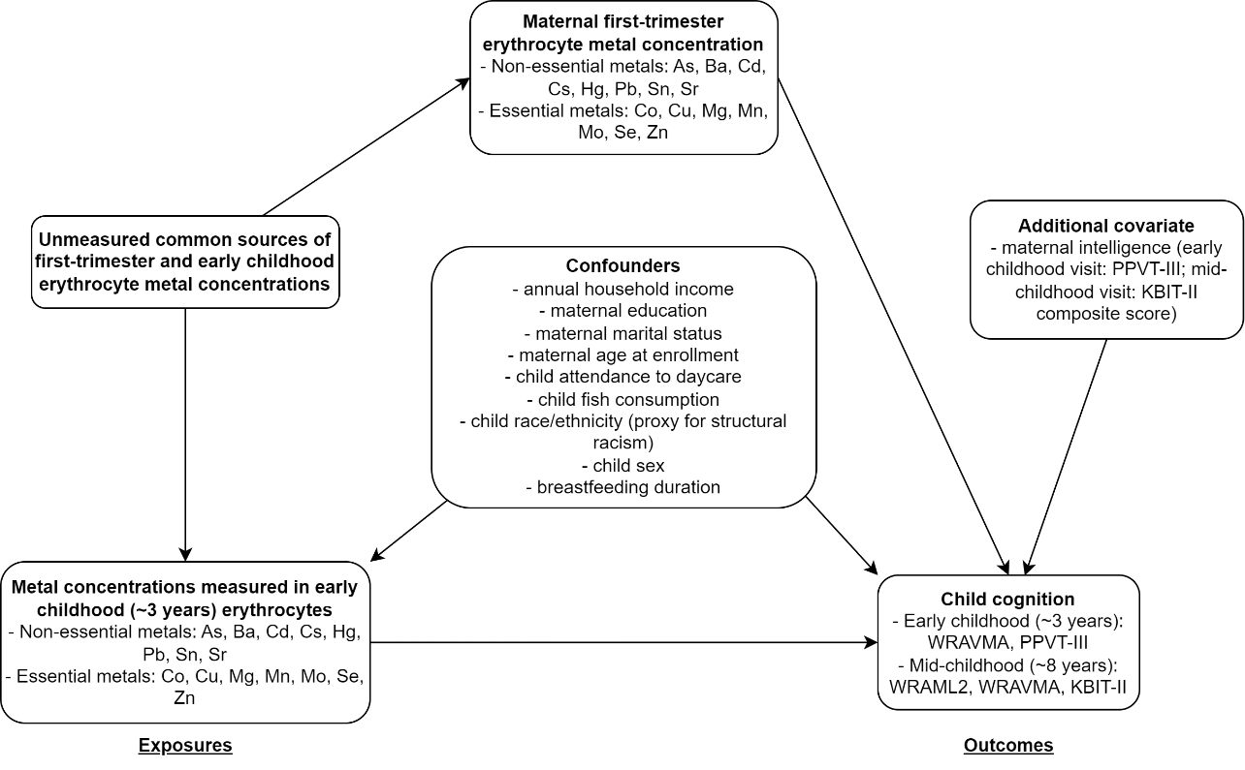

Figure S1. Causal diagram for a study of the associations of early childhood (~3 years) erythrocyte concentrations of metals with child cognition in early and mid- (~8 years) childhood, in the Project Viva pre-birth cohort, Boston, Massachusetts, USA. PPVT-III: Peabody Picture Vocabulary Test, 3rd edition; WRAVMA: Wide Range Assessment of Visual Motor Abilities; WRAML2: Wide Range Assessment of Memory and Learning, 2nd edition; KBIT-II: Kaufman Brief Intelligence Test, 2nd edition.

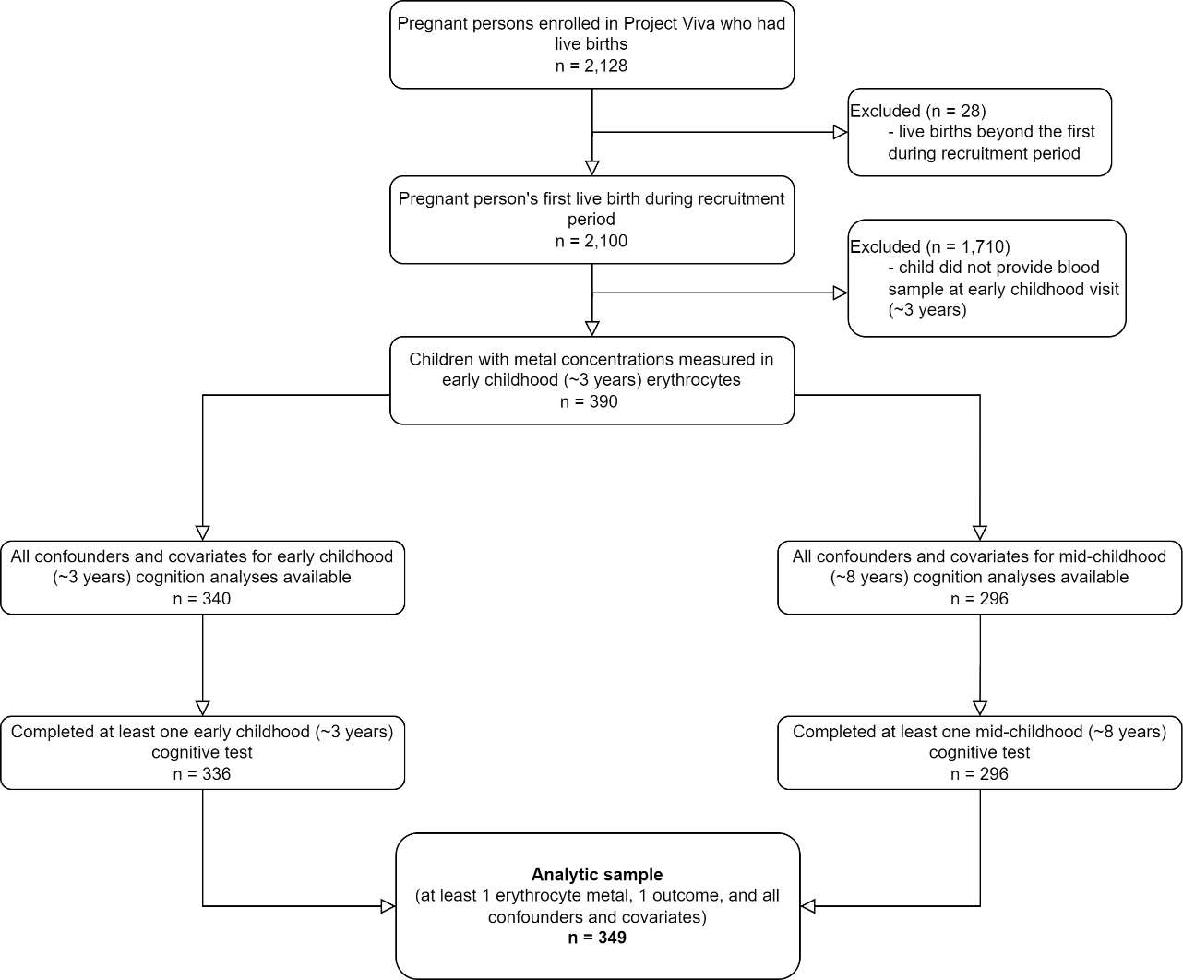

Figure S2. Flow diagram of participant selection from the Project Viva pre-birth cohort (Boston, Massachusetts, USA) for a study of associations of early childhood (~3 years) erythrocyte metal concentrations with child cognitive test scores at early and mid-childhood (~8 years).

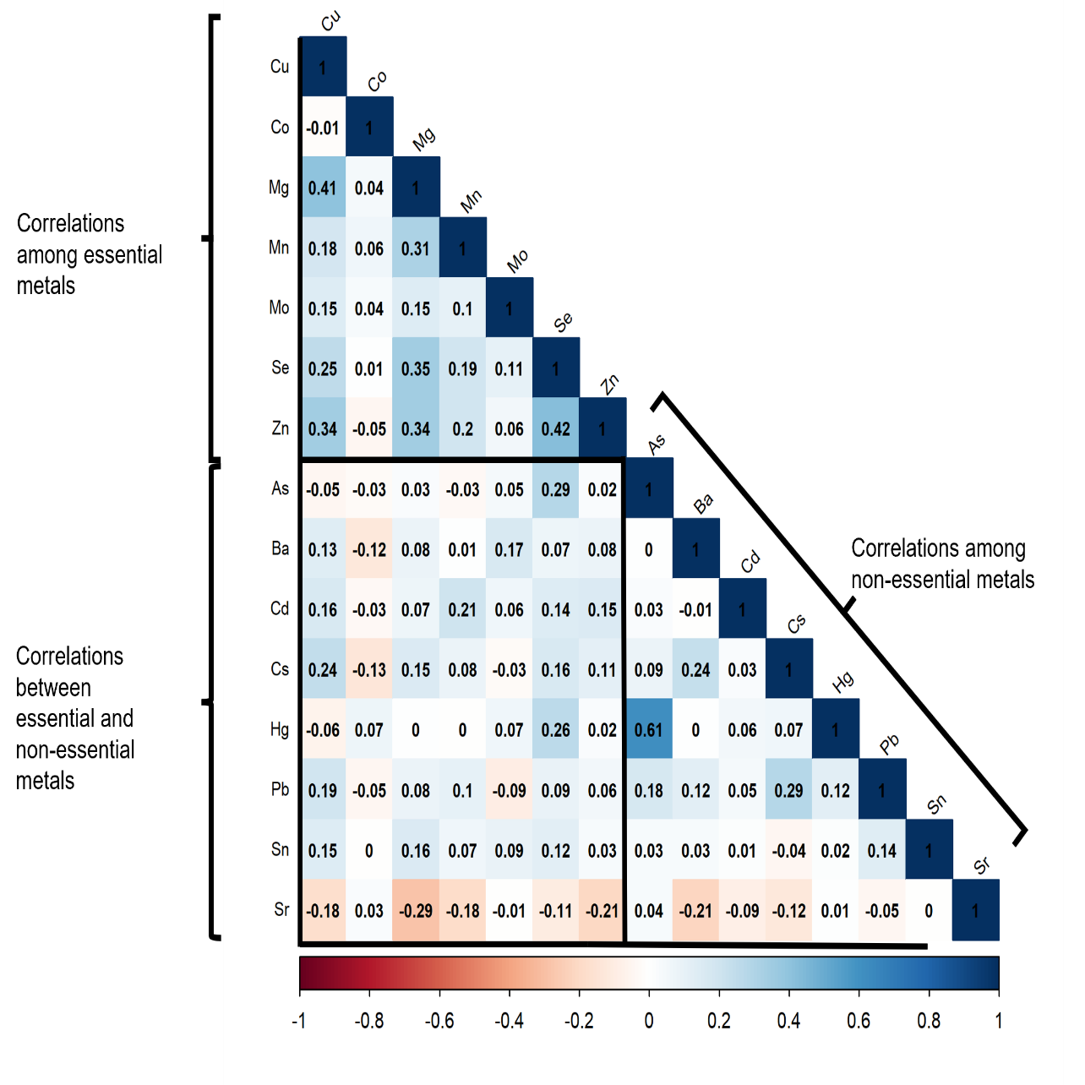

Figure S3. Spearman correlation coefficients among early childhood (~3 years) erythrocyte concentrations of well-detected (>60%) non-essential (arsenic (As), barium (Ba), cadmium (Cd), cesium (Cs), mercury (Hg), lead (Pb), tin (Sn), and strontium (Sr)) and essential (cobalt (Co), copper (Cu), magnesium (Mg), manganese (Mn), molybdenum (Mo), selenium (Se), and zinc (Zn)) metals, in the Project Viva pre-birth cohort, Boston, Massachusetts, USA (N=349).

Figure S4. Pearson correlation coefficients between child cognitive test scores in early (~3 years) and mid- (~8 years) childhood in the Project Viva pre-birth cohort, Boston, Massachusetts, USA (N=349 children). In early childhood, receptive vocabulary (Peabody Picture Vocabulary Test, 3rd edition (PPTV-III)) and visual-motor ability (Wide Range Assessment of Visual Motor Abilities (WRAVMA)) were assessed, and in mid-childhood, visual memory (Wide Range Assessment of Memory and Learning, 2nd edition (WRAML2)), visual-motor ability (WRAVMA visual-motor subtest), fluid intelligence (Kaufman Brief Intelligence Test, 2nd edition (KBIT-II) non-verbal component), and crystallized intelligence (KBIT-II verbal component) were assessed. ECH: early childhood visit (~3 years); MCH: mid-childhood visit (~8 years).

Figure S5. Quantile g-computation estimates and 95% confidence intervals of adjusted mean difference in early childhood cognitive test scores for each quartile increase in early childhood erythrocyte concentration of a mixture of non-essential (As, Ba, Cd, Cs, Hg, Pb, Sn, and Sr) (A) or essential (Co, Cu, Mg, Mn, Mo, Se, and Zn) (B) metals. Cognitive tests assessed visual-motor function (WRAVMA) or receptive vocabulary (PPVT-III). WRAVMA is composed of three subtests assessing visual-motor, fine motor, and visual spatial abilities, which are combined to create a summary score. Mixture component point estimates are provided to the right of the point estimates and intervals. Models adjusted for child race and ethnicity, fish consumption, daycare attendance, breastfeeding duration, household income, maternal KBIT-II composite score at mid-childhood visit, education, marital status, age at enrollment, maternal first-trimester erythrocyte concentrations of metals in the mixture, and early childhood erythrocyte concentrations of metals in the other mixture (e.g. non-essential metal mixture estimate is adjusted for essential metal mixture). WRAVMA: Wide Range Assessment of Visual Motor Abilities; PPVT-III: Peabody Picture Vocabulary Test, 3rd edition.

Figure S6. Concentration-response functions for the associations of early childhood (~3 years) erythrocyte concentrations of each of nine non-essential (As, Ba, Cd, Cs, Hg, Pb, Sn, Sr) and six essential metals (Co, Cu, Mg, Mn, Mo, Se, Zn) (top horizontal axis) with early childhood (~3 years) visual-motor function (WRAVMA summary) cognitive test scores, stratified by the 10th, 50th, or 90th percentile of each other metal (right vertical axis), from Bayesian kernel machine regression models. All other components were fixed at their medians. Variation in the shape of the functions across quantiles of other metals indicates interaction. WRAVMA: Wide Range Assessment of Visual Motor Abilities.

Figure S7. Concentration-response functions for the associations of early childhood (~3 years) erythrocyte concentrations of each of nine non-essential (As, Ba, Cd, Cs, Hg, Pb, Sn, Sr) and six essential metals (Co, Cu, Mg, Mn, Mo, Se, Zn) (top horizontal axis) with early childhood (~3 years) receptive vocabulary (PPVT-III) cognitive test scores, stratified by the 10th, 50th, or 90th percentile of each other metal (right vertical axis), from Bayesian kernel machine regression models. All other components were fixed at their medians. Variation in the shape of the functions across quantiles of other metals indicates interaction. PPVT-III: Peabody Picture Vocabulary Test, 3rd edition.

Figure S8. Concentration-response functions for the associations of early childhood (~3 years) erythrocyte concentrations of each of nine non-essential (As, Ba, Cd, Cs, Hg, Pb, Sn, Sr) and six essential metals (Co, Cu, Mg, Mn, Mo, Se, Zn) (top horizontal axis) with mid-childhood (~8 years) visual memory (WRAML2) cognitive test scores, stratified by the 10th, 50th, or 90th percentile of each other metal (right vertical axis), from Bayesian kernel machine regression models. All other components were fixed at their medians. Variation in the shape of the functions across quantiles of other metals indicates interaction. WRAML2: Wide Range Assessment of Memory and Learning, 2nd edition.

Figure S9. Concentration-response functions for the associations of early childhood (~3 years) erythrocyte concentrations of each of nine non-essential (As, Ba, Cd, Cs, Hg, Pb, Sn, Sr) and six essential metals (Co, Cu, Mg, Mn, Mo, Se, Zn) (top horizontal axis) with mid-childhood (~8 years) visual-motor (WRAVMA visual-motor subtest) cognitive test scores, stratified by the 10th, 50th, or 90th percentile of each other metal (right vertical axis), from Bayesian kernel machine regression models. All other components were fixed at their medians. Variation in the shape of the functions across quantiles of other metals indicates interaction. WRAVMA: Wide Range Assessment of Visual-Motor Function.

Figure S10. Concentration-response functions for the associations of early childhood (~3 years) erythrocyte concentrations of each of nine non-essential (As, Ba, Cd, Cs, Hg, Pb, Sn, Sr) and six essential metals (Co, Cu, Mg, Mn, Mo, Se, Zn) (top horizontal axis) with mid-childhood (~8 years) crystallized intelligence (KBIT-II verbal) cognitive test scores, stratified by the 10th, 50th, or 90th percentile of each other metal (right vertical axis), from Bayesian kernel machine regression models. All other components were fixed at their medians. Variation in the shape of the functions across quantiles of other metals indicates interaction. KBIT-II: Kaufman Brief Intelligence Test, 2nd edition.

Figure S11. Concentration-response functions for the associations of early childhood (~3 years) erythrocyte concentrations of each of nine non-essential (As, Ba, Cd, Cs, Hg, Pb, Sn, Sr) and six essential metals (Co, Cu, Mg, Mn, Mo, Se, Zn) (top horizontal axis) with mid-childhood (~8 years) fluid intelligence (KBIT-II non-verbal) cognitive test scores, stratified by the 10th, 50th, or 90th percentile of each other metal (right vertical axis), from Bayesian kernel machine regression models. All other components were fixed at their medians. Variation in the shape of the functions across quantiles of other metals indicates interaction. KBIT-II: Kaufman Brief Intelligence Test, 2nd edition.

Figure S12. Sensitivity analyses of adjusted mean difference in early childhood (~3 years) (A) and mid-childhood (~8 years) (B) cognitive test scores and 95% confidence intervals per doubling of early childhood erythrocyte concentration of non-essential metals. Reference model (“Ref.”) is a multivariable linear regression model adjusting for child race and ethnicity, fish consumption, daycare attendance, breastfeeding duration, household income, maternal intelligence (PPVT-III for early childhood visit; KBIT-II composite for mid-childhood visit), education, marital status, age at enrollment, early childhood erythrocyte concentrations of all other metals, and maternal first-trimester erythrocyte concentration of the metal. Estimates and intervals for each metal present, from left to right: Ref.; Ref. with additional adjustment for Youth Healthy Eating Index; Ref. with additional adjustment for presence of household smoking; and Ref. with removal of other early childhood metals from the model. KBIT-II: Kaufman Brief Intelligence Test, 2nd edition; PPVT-III: Peabody Picture Vocabulary Test, 3rd edition; WRAVMA: Wide Range Assessment of Visual Motor Abilities; WRAML2: Wide Range Assessment of Memory and Learning, 2nd edition; YHEI: Youth Healthy Eating Index.

Figure S13. Sensitivity analyses of adjusted mean difference in early childhood (~3 years) (A) and mid-childhood (~8 years) (B) cognitive test scores and 95% confidence intervals per doubling of early childhood erythrocyte concentration of essential metals. Reference model (“Ref.”) is a multivariable linear regression model adjusting for child race and ethnicity, fish consumption, daycare attendance, breastfeeding duration, household income, maternal intelligence (PPVT-III for early childhood visit; KBIT-II composite for mid-childhood visit), education, marital status, age at enrollment, early childhood erythrocyte concentrations of all other metals, and maternal first-trimester erythrocyte concentration of the metal. Estimates and intervals for each metal present, from left to right: Ref.; Ref. with additional adjustment for Youth Healthy Eating Index; Ref. with additional adjustment for presence of household smoking; and Ref. with removal of other early childhood metals from the model. KBIT-II: Kaufman Brief Intelligence Test, 2nd edition; PPVT-III: Peabody Picture Vocabulary Test, 3rd edition; WRAVMA: Wide Range Assessment of Visual Motor Abilities; WRAML2: Wide Range Assessment of Memory and Learning, 2nd edition; YHEI: Youth Healthy Eating Index.

Figure S14. Sensitivity analyses of adjusted mean difference in early childhood (~3 years) (A) and mid-childhood (~8 years) (B) cognitive test scores and 95% confidence intervals per quartile increase in early childhood erythrocyte concentration of a mixture of non-essential (As, Ba, Cd, Cs, Hg, Pb, Sn, and Sr) or essential (Co, Cu, Mg, Mn, Mo, Se, and Zn) metals. Reference model is a quantile g-computation model adjusting for child race and ethnicity, fish consumption, daycare attendance, breastfeeding duration, household income, maternal intelligence (PPVT-III for early childhood visit; KBIT-II composite for mid-childhood visit), education, marital status, age at enrollment, early childhood erythrocyte concentrations of metals in the other mixture, and maternal first-trimester erythrocyte concentration of all metals in the mixture. Estimates and intervals for each mixture present, from left to right: Ref.; Ref. with additional adjustment for Youth Healthy Eating Index; Ref. with additional adjustment for presence of household smoking; and Ref. with removal of early childhood erythrocyte metals in the other mixture from the model. KBIT-II: Kaufman Brief Intelligence Test, 2nd edition; PPVT-III: Peabody Picture Vocabulary Test, 3rd edition; WRAVMA: Wide Range Assessment of Visual Motor Abilities; WRAML2: Wide Range Assessment of Memory and Learning, 2nd edition; YHEI: Youth Healthy Eating Index.

