Appendix A. Map of 2019 survey response rates by county in Michigan, Minnesota, and Wisconsin, United States. Not shown in this figure are a small number of participants (n=9 from Michigan and n=7 from Wisconsin) who completed the survey from non-recruited counties.
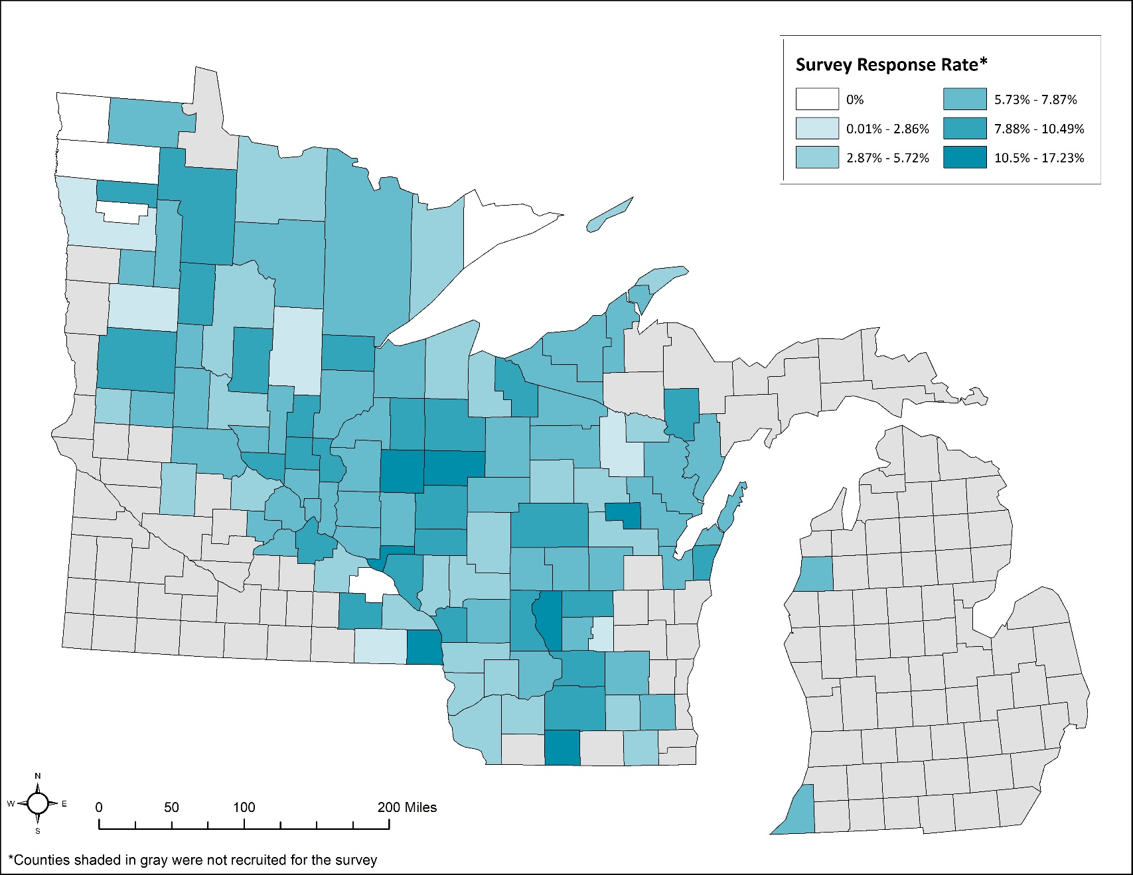

Appendix B. Survey questions provided in the 2019 Upper Midwest Tick-borne Disease Prevention Survey. Slight language modifications were applied as needed for state-specific questions (e.g., county of residence).
Section 1 of 5
The first questions ask about your experiences with ticks and diseases spread by ticks.
On average, between the months of April through Every day October, how often do you spend time in places where Every week ticks could get on you, like wooded or brushy areas? Every month
Less than once a month Once or twice a season Never

How likely are you to get ticks on you...

Not at all Slightly Somewhat Very Extremely Not applicable
...around your home?
...around your cabin or vacation home?
...while at work?
...around recreational areas in your community?
...at other locations or doing other activities?

You answered that you may get ticks on you while at work. What is your occupation?

You answered that you are likely to get ticks on you at other locations or doing other activities not

listed above. Please describe these activities.

Have you ever removed a tick from your skin or Yes
clothing? No

In the last year, have you removed a tick from your Yes
skin or clothing? No

Which of the following illnesses have you heard of?
Yes No
Lyme disease
Anaplasmosis Babesiosis Ehrlichiosis Powassan virus disease Rocky Mountain spotted fever

How serious do you feel each of the following illnesses are?

Not at all Slightly Somewhat Very Extremely Don't know
Lyme disease Anaplasmosis Babesiosis Ehrlichiosis Powassan virus disease Rocky Mountain spotted fever

In the community where you live, how common do you Not at all think diseases spread by ticks are? Slightly
Somewhat Very Extremely

In the coming year, how likely do you think it is Not at all
that you or another person in your household will Slightly
get a disease spread by ticks? Somewhat
Very Extremely

Has any person in your household, including yourself, ever been diagnosed by a health care provider as having a disease spread by ticks?

Yes No
In the past year 1 to 5 years ago More than 5 years ago

Section 2 of 5
The following questions ask about what precautions you take to protect yourself and others in your household from ticks.
After being outdoors in places where you could get Never
ticks, how often do you check yourself thoroughly Rarely
for ticks? Sometimes
Most of the time Always

Which of the following are reasons why you do not always check yourself thoroughly for ticks? (Check all that apply)
You forget
You think it is too much trouble
You do not think you could find a tick on yourself
You check for ticks but not thoroughly
You are not worried about ticks None of the above

Are there other reasons why you do not always check yourself thoroughly for ticks?

When you are outdoors in places where you could get Never ticks on you, how often do you use bug repellent on Rarely
your skin or clothing? Sometimes
Most of the time
Always

Which of the following are reasons why you do not always use bug spray on your skin or clothing? (Check all that apply)
You forget to use or bring bug spray
You are concerned about the cost of bug spray
You are concerned about the safety of bug spray for yourself or your family
You did not know this might prevent tick bites and diseases spread by ticks
You do not like bug spray
You are not worried about ticks None of the above

Are there other reasons why you do not always use bug repellent on your skin or clothing?

Have you ever treated your property, either at your Yes
home, cabin, or vacation home, with a pesticide to No
kill ticks? Don't know

Did you treat your property with pesticide yourself or did you hire a professional to do it? (Check all that apply)

Treated it myself Hired a professional Do not remember

Which of the following are reasons why you have not treated your property with a pesticide to kill
ticks? (Check all that apply)
You did not know lawn-based pesticides to kill ticks were available
It seemed like too much work
You are concerned about the cost
You are concerned about the health or safety of yourself, your family, or the environment
You are not worried about ticks on your property You do not own your property
None of the above

Are there other reasons why you have not treated your property with a pesticide to kill ticks?

Have you ever treated your property, either at your Yes
home, cabin, or vacation home, with devices that No
apply pesticide to rodents to kill ticks? Don't know

Examples of devices like this are the Damminix or Thermacell tick tube.

Did you treat your property with these rodent devices yourself or did you hire a professional to do it? (Check all that apply)

Treated it myself Hired a professional Do not remember

Which of the following are reasons why you have not treated your property with devices that apply pesticide to rodents to kill ticks? (Check all that apply)
You did not know such rodent devices with pesticide were available
It seemed like too much work
You are concerned about the cost
You are concerned about the health or safety of yourself, your family, or the environment
You are not worried about ticks on your property You do not own your property
None of the above

Are there other reasons why you have not treated your property with devices that apply pesticide to
rodents to kill ticks?

Section 3 of 5
The following questions ask about prevention methods you may be willing to do to protect yourself and others in your household from ticks. The methods listed may be available now or may become available in the future. Assume that all of the methods listed are safe and effective.

Before or after spending time in places where ticks could get on you, which of the following would you be willing to do to protect yourself and others in your household from ticks? (Check all that apply)
Check for ticks at least once a day
Shower or bathe within two hours of being outdoors Tumble-dry clothing or gear on high heat for at least ten minutes
Treat pet(s) with a product to prevent tick bites
Use a natural bug repellent, like oil of lemon eucalyptus, on your skin or clothing
Use a synthetic bug repellent, like DEET, on your skin or clothing
Wear clothing that has been pretreated with a long-lasting bug repellent, like permethrin

Section 4 of 5
The following questions will help us understand how you prefer to learn about tick bite prevention.
Prior to taking part in this study, have you seen any Yes
information about ticks or the prevention of No
diseases spread by ticks from the Minnesota Don't know Department of Health, such as its website,
brochures, posters, or speakers?

How helpful would you or others in your household find each of the following resources for preventing diseases spread by ticks?

Not at all Slightly Somewhat Very Extremely
Online resources such as a website, archived webinars,
podcasts, or YouTube videos

Printable resources such as fact sheets, tick identification cards,
or brochures

Community resources such as billboards, posters, or signs
In-person presentations or discussions
Regular email or text updates A smartphone app

Are there any particular topics you would like to know more about in order to help you or others in
your household protect yourselves from ticks?

Section 5 of 5
The final section of this survey asks a few demographic questions about you and your household.

Currently, in which county do you live?

Which one of the following best describes the type of Urban
area in which you currently live? Suburban Town
Rural

What is your age (in years)?

What is your gender? Female
Male Other
Prefer not to answer

You said that you identify as a gender other than female or male. Please tell us:

How do you describe your ethnicity? Hispanic or Latino
Not Hispanic or Latino Prefer not to answer

How do you describe your race? (Check all that apply)
American Indian or Alaska Native Asian
Black or African American
Native Hawaiian or Other Pacific Islander
White
Prefer not to answer

What is the highest level of education you have Never attended school
completed? Some high school or less
Completed high school or obtained GED or alternative credential
Trade school such as cosmetology school or
electrical school
Some college
Associate's degree or a 2-year college degree Bachelor's degree or a 4-year college degree Master's degree
Advanced degree such as a Ph.D, a law degree, or a medical degree
Prefer not to answer

Including all sources, what is your current total Less than $25,000
annual household income before taxes? $25,001 to $40,000
$40,001 to $55,000
$55,001 to $65,000
$65,001 to $75,000
$75,001 to $100,000
More than $100,000
Prefer not to answer

