Supplemental Table 1 – Demographic and Clinical Characteristics of Persons Diagnosed with Mpox in Georgia, May–October, 2022
Characteristic | Hospitalized*  N=123 | Not Hospitalized  N=1798 | Total (n)  N=1921
 | (n, column%) | (n, column%) | (n, column %)
Age (median, interquartile range) | 35 (29-41) | 34 (29–40) | 34 (29–40)
Sex at birth
Male | 117 (95.1%) | 1757 (97.7%) | 1874 (97.6%)
Female | 6 (4.9%) | 41 (2.2%) | 47 (2.4%)
Current Gender
Cisgender man | 113 (91.9%) | 1738 (96.7%) | 1851 (96.4%)
Cisgender woman | 5 (4.0%) | 37 (2.1%) | 42 (2.2%)
Transgender woman | Data suppressed | Data suppressed | 23 (1.2%)
Transgender man or another gender identity | Data suppressed | Data suppressed | 5 (0.3%)
Race/Ethnicity
Hispanic | Data suppressed | Data suppressed | 145 (7.5%)
Non-Hispanic
Black or African American | 104 (84.6%) | 1362 (75.8%) | 1466 (76.3%)
White | 14 (11.3%) | 210 (11.7%) | 224 (11.7%)
Other | Data suppressed | Data suppressed | 20 (1.0%)
American Indian/Alaska Native | Data suppressed | Data suppressed | —
Hawaiian/Pacific Islander | Data suppressed | Data suppressed | —
Multiracial | Data suppressed | Data suppressed | 13 (0.7%)
Unknown | Data suppressed | Data suppressed | 28 (1.5%)
Asian | Data suppressed | Data suppressed | 20 (1.0%)
Received at least one dose of JYNNEOS vaccine ≥14 days prior to mpox date§ | Data suppressed | Data suppressed | 38 (2.0%)
Person without HIV | 37 (30.1%) | 760 (42.3%) | 797 (41.5%)
Person with HIV | 86 (69.9%) | 1038 (67.7%) | 1124 (58.5%)
CD4 <350 cells/mm³ | 34 (39.5%) | 181 (17.4%) | 215 (19.1%)
Viral load unsuppressed¶ | 26 (30.2%) | 161 (15.5%) | 187 (16.6%)
Not engaged in care in year prior to mpox† | 15 (17.4%) | 122 (11.8%) | 137 (12.2%)
New HIV diagnosis ** | Data suppressed | Data suppressed | 5 (0.3%)
*Strata with at least one cell <5 are reported as data suppressed
§ Mpox date defined as the earliest known of symptom onset, diagnosis, or report date
¶Viral suppression defined as HIV viral load <200 copies/mL
†Not engaged in care defined as having no documented CD4 or VL in year prior to mpox symptom onset date, or if unavailable, mpox diagnosis date
**HIV diagnosis date within 14 days of mpox date

Supplemental Table 2 – Relative Risk of Hospitalization Among Persons Diagnosed with Mpox in Georgia (N=1780)*
Characteristics | Multivariable  Relative Risk (95% Confidence Interval)
HIV Status
No HIV | (Ref)
HIV
CD4 <350 cells/mm3
Viral load unsuppressed§ | 3.6 (2.0–6.4)
Viral load suppressed§ | 2.3 (1.2–4.4)
CD4 ≥350 cells/mm3
Viral load unsuppressed§ | 1.5 (0.6–3.5)
Viral load suppressed§ | 0.9 (0.5–1.5)
Not engaged in care | 2.2 (1.2–4.2)
Age Quartile (years)
<29 | 0.9 (0.6–1.3)
29–33 | (Ref)
34–39 | 1.0 (0.7–1.3)
40+ | 1.2 (0.9–1.6)
Race/Ethnicity
Black Or African American | 1.4 (0.9–2.2)
Hispanic | 0.5 (0.2–1.1)
White | (Ref)
Current Gender
Cisgender Man | (Ref)
Cisgender Woman | 1.7 (1.1–2.6)
*People with HIV who were in care but were missing either a CD4 or VL and demographic subgroups with <4 reported hospitalizations were excluded from multivariable analysis. A total of 141 persons were excluded from model due to demographic categories with less than four hospitalizations (n=110) or missing CD4 or VL for PWH (n=31).
§Viral suppression defined as HIV viral load <200 copies/mL

Supplemental Figure 1 – Length of Hospital Stay for Persons Hospitalized with Mpox in Georgia (n=79)
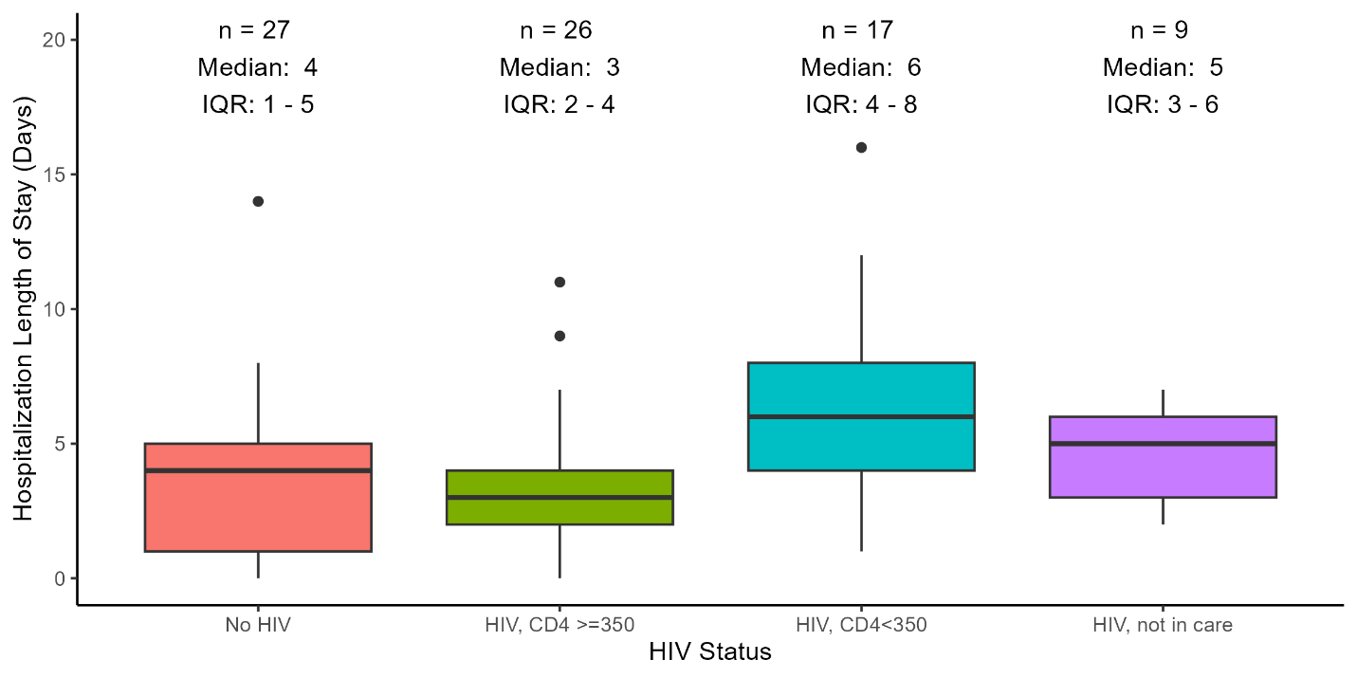

Supplemental Symptom Analysis

Methods
After fitting our primary multivariable model, we undertook an exploratory analysis to examine whether any symptoms were significantly associated with increased risk of hospitalization. Symptoms were not included in our primary analysis due to increased missingness of data and because symptoms were obtained at variable times during the course of illness, including after hospitalization. We fit models including HIV status, race/ethnicity, age quartile, current gender, and each symptom separately to assess the association with hospitalization.

Results
Symptoms associated with risk of hospitalization (Supplemental Table 3) included lymphadenopathy (RR 2.4, 95% CI: 1.5–3.7), vomiting (RR 2.3, 1.5–3.5), and abdominal pain (RR 2.1, 95% CI: 1.6–2.7). Rectal symptoms were also associated with hospitalization including rectal pain (RR 1.6, 95% CI: 1.1–2.1), rectal bleeding (RR 1.5, 95% CI 1.1–2.0), pus or blood in stools (RR 1.5, 1.2–2.1), and proctitis (RR 1.6, 1.2–2.0).

Supplemental Table 3 – Relative Risk of Hospitalization
Symptom | Number of Persons with Available Data | Relative Risk (95% Confidence Interval)
Lymphadenopathy | 1284 | 2.4 (1.5–3.7)
Vomiting | 1296 | 2.3 (1.5–3.5)
Abdominal Pain | 1329 | 2.1 (1.6–2.7)
Fever | 1305 | 1.6 (1.0–2.5)
Proctitis | 1318 | 1.6 (1.2–2.0)
Conjunctivitis | 1282 | 1.6 (0.8–3.2)
Rectal Pain | 1333 | 1.6 (1.1–2.1)
Pus or Blood in Stools | 1332 | 1.5 (1.2–2.1)
Rectal Bleeding | 1333 | 1.5 (1.1–2.0)
Headache | 1294 | 1.4 (1.0–2.2)
Chills | 1306 | 1.4 (0.9–2.2)
Tenesmus | 1327 | 1.4 (1.0–1.9)
Myalgias | 1296 | 1.3 (0.9–2.0)
Malaise | 1188 | 0.9 (0.6–1.5)
Pruritis | 1292 | 0.9 (0.6–1.3)

