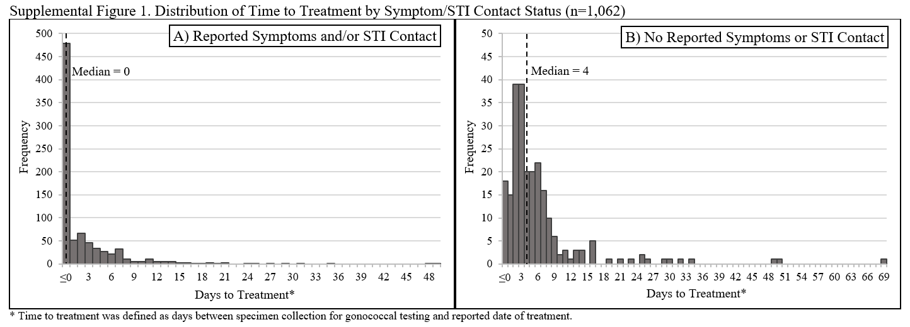

SUPPLEMENTAL REFERENCES

31s. Gaydos CA, Ako MC, Lewis M, et al. Use of a Rapid Diagnostic for Chlamydia trachomatis and Neisseria gonorrhoeae for Women in the Emergency Department Can Improve Clinical Management: Report of a Randomized Clinical Trial. Annals of Emergency Medicine. 2019; 74(1):36–44.
32s. Bilello LA, Livingood WC, Lukens-Bull K, et al. Texting Test Results Reduces the Time to Treatment for Sexually Transmitted Infections. Journal of Public Health Management and Practice. 2019; 25(2):165.
33s. Kahn M, Pol BVD. Advances in Diagnostics of Sexually Transmitted Infections. Infectious Disease Clinics. 2023; 37(2):381–403.

