Hypertension Prevalence and Control among U.S. Women of Reproductive Age

Xingran Weng, DrPH, Rebecca C. Woodruff, PhD, MPH, Soyoun Park, PhD, MS,
Angela M. Thompson-Paul, PhD, MSPH, Siran He, PhD, MSPH, Donald Hayes, MD, MPH, Elena V. Kuklina, MD, PhD, Nicole L. Therrien, PharmD, MPH, Sandra L. Jackson, PhD, MPH

Appendix
Appendix Table 1. Standard Codes for Identifying Pregnancy Related Events from IQVIA AEMR – U.S. 2019 Data
Data Table | Standard Code
Condition | 442440, 442053, 4214343, 40480278, 439321, 434705, 45765500, 442914, 443874, 141639, 196751, 443016, 4028644, 432585, 4242401, 4064978, 440794, 195878, 201637, 43530912, 440476, 45757125, 4209094, 196754, 195328, 443868, 443328, 438205, 194710, 198216, 442072, 4034097, 442777, 4129032, 45757148, 443773, 436176, 436747, 4062569, 435026, 4058243, 197333, 4061350, 442049, 81357, 4063692, 78224, 4063037, 439316, 436173, 436183, 4217975, 4061852, 440460, 136743, 195877, 444461, 45757144, 435017, 4062686, 4242238, 136755, 443293, 432396, 198488, 194106, 198495, 4062811, 443873, 4015162, 438820, 76756, 439688, 36715374, 80782, 193532, 438490, 197339, 433270, 435616, 4065753, 4062264, 4037495, 78217, 45757129, 4065749, 4311246, 444077, 72377, 72374, 73824, 73537, 73538, 73546, 74433, 77624, 74104, 76750, 77621, 81086, 80159, 78210, 81358, 81636, 81923, 141084, 192978, 192679, 192979, 193273, 138484, 138811, 197048, 193831, 197042, 194100, 193525, 195025, 197346, 195595, 196178, 198496, 197049, 196757, 200160, 198816, 199089, 199097, 199891, 199076, 201366, 314423, 314103, 314432, 321074, 315881, 313833, 314099, 197047, 433832, 432375, 433260, 433276, 433548, 433826, 433837, 433823, 434435, 434111, 435324, 435887, 434712, 435655, 435610, 435330, 436166, 435880, 437334, 436740, 437920, 437933, 437936, 438226, 437341, 437934, 439095, 438481, 438805, 439322, 439323, 439324, 439329, 438823, 439330, 440166, 440457, 441364, 435886, 440785, 440787, 440477, 440793, 441632, 441910, 442171, 437045, 437062, 437948, 442088, 441644, 442054, 442271, 442294, 439325, 442441, 442781, 443020, 440464, 440788, 443246, 441365, 444048, 443929, 442442, 442596, 4049621, 4058113, 4174506, 4175637, 4058403, 4060038, 4060295, 4061341, 4143214, 4143296, 4061157, 4028339, 4061971, 4061850, 4062567, 4063038, 4146460, 4147414, 4064169, 4064437, 4211831, 4064821, 4185383, 4031414, 4065745, 4065761, 4066234, 4065626, 4300078, 4069761, 4037762, 4193062, 4129689, 4041280, 4197245, 4200256, 4163851, 4167493, 4230221, 4171113, 4281684, 36712703, 4289303, 4297611, 40539858, 43021951, 43530960, 43530910, 43530911, 45757093, 45757113, 45757171, 45757173, 45757136, 45757149, 45757208, 45757214, 45757212, 45757079, 45757094, 45770893, 46269811, 72700, 72390, 72692, 73526, 75605, 77619, 76482, 77059, 73282, 74434, 74415, 74422, 74706, 78494, 80778, 75015, 76761, 78218, 76769, 76770, 77338, 79890, 80479, 79896, 80463, 72696, 75882, 135601, 137613, 137940, 192678, 193271, 139888, 192699, 193259, 193277, 192972, 192974, 192980, 193544, 194098, 193827, 194694, 196488, 196762, 194699, 194700, 193269, 192379, 193539, 195019, 197050, 194711, 196181, 196746, 200784, 200792, 196484, 196758, 196182, 198212, 198221, 200149, 197043, 200455, 196170, 196177, 197938, 197608, 201350, 200153, 200472, 200791, 198486, 201091, 315884, 313272, 313543, 316494, 312383, 321367, 315327, 317941, 196486, 375016, 199087, 200789, 201642, 432371, 432968, 432976, 432695, 432430, 432689, 432441, 432690, 432386, 433812, 434095, 433540, 434427, 434708, 434094, 434097, 435028, 434714, 435020, 435024, 434715, 435323, 435357, 435000, 435031, 435008, 435331, 435318, 435883, 4014295, 4014296, 4014456, 435871, 436767, 437055, 437342, 436489, 437620, 438206, 436768, 438196, 437061, 437622, 437929, 437946, 437688, 438480, 438487, 438543, 437942, 438220, 439077, 438815, 439083, 439094, 439317, 439310, 439318, 434089, 434431, 439380, 439894, 439331, 439656, 439893, 439390, 440481, 440453, 440795, 441369, 441085, 440475, 435607, 435874, 441363, 441348, 441631, 441640, 441926, 442080, 442082, 437931, 437947, 441645, 442071, 438542, 439092, 439093, 442051, 441915, 442090, 442421, 442058, 442085, 442353, 442346, 442419, 442422, 442355, 442772, 442594, 443133, 443012, 443019, 443054, 443242, 443243, 443249, 443324, 443245, 443435, 443291, 443326, 441349, 441911, 443705, 443871, 444067, 444098, 444417, 442420, 444251, 444293, 442919, 4051642, 4079857, 4024659, 4053583, 4058375, 4174577, 4025198, 4173169, 4113508, 4113055, 4113510, 4085900, 4060429, 4060556, 4060034, 4060157, 4060037, 4060296, 4060312, 4060036, 4060424, 4060039, 4027371, 4143074, 4113187, 4061351, 4028479, 4061848, 4116344, 4181751, 4145335, 4062552, 4062269, 4062557, 4062685, 4062558, 4118910, 4063306, 4145940, 4145939, 4062791, 4063175, 4063307, 4064723, 4064424, 4064724, 4064423, 4091321, 4214186, 4064819, 4064722, 4065093, 4065094, 4064296, 4033096, 4065747, 4065635, 4064579, 4066005, 4065618, 4065627, 4065737, 4187090, 4188598, 4094046, 4067106, 4034096, 4244438, 4127201, 4097608, 4129710, 4038495, 4129834, 4132434, 4161205, 4307820, 4099889, 4309364, 4135209, 4164218, 4199437, 4311256, 4102318, 4103298, 4316372, 4228043, 4266517, 4171359, 4323285, 37016152, 4277749, 4239938, 36712695, 4283690, 4336226, 4242241, 4285746, 36715476, 36715504, 37110280, 37110290, 35625971, 42538946, 40482406, 40483581, 45757789, 45757775, 43021054, 45757588, 43021952, 43531010, 43530951, 43530908, 43530907, 43531007, 43531711, 42536563, 44784482, 44784550, 44784536, 44783183, 45765501, 45757118, 45757153, 45757176, 45757155, 45757122, 45757132, 45757117, 45757124, 45757142, 45757092, 45757166, 45757198, 45757123, 45757175, 45757356, 45757143, 45757151, 45757170, 45772082, 45772076, 46274066, 46269813, 46269812, 37206229, 37206228, 73268, 72378, 72973, 72970, 72693, 72697, 74440, 74698, 73267, 74716, 76772, 77347, 77615, 76491, 76771, 77056, 73534, 74717, 79091, 78818, 79889, 80156, 80474, 75608, 76763, 77340, 80478, 81360, 133816, 79897, 80165, 77052, 134414, 192376, 192385, 132685, 138207, 139895, 192971, 192384, 193275, 80467, 193825, 194109, 194702, 192372, 193535, 195600, 192694, 193821, 194707, 193820, 192380, 192387, 194704, 196759, 193264, 194101, 194429, 194439, 196172, 195870, 197337, 197051, 197344, 196475, 196765, 197930, 195317, 197031, 197616, 198499, 201083, 199088, 198819, 200468, 313829, 316478, 321080, 314107, 315013, 320456, 321638, 195014, 374430, 432373, 201359, 432682, 432389, 433274, 433545, 432969, 314426, 4011615, 432975, 432967, 433536, 433542, 433864, 434110, 432977, 434436, 434484, 435021, 433828, 434096, 434416, 434701, 435018, 435604, 435868, 435606, 435325, 435022, 435640, 4014454, 4014455, 436474, 436742, 435869, 435875, 436180, 436766, 436007, 436477, 436485, 437060, 437611, 436483, 437623, 438489, 437937, 439327, 439319, 439320, 434413, 434713, 439658, 439379, 439393, 439883, 440158, 440167, 440161, 440466, 440462, 441073, 441361, 441362, 435609, 436169, 441641, 442079, 4073090, 438491, 442050, 442055, 442070, 442081, 441678, 441649, 441919, 441924, 442059, 441922, 441929, 442096, 442083, 442549, 442558, 442333, 442573, 442769, 442915, 443263, 443329, 443330, 443404, 441081, 443445, 443521, 443247, 441643, 443700, 443903, 444244, 444269, 444094, 444267, 4075295, 442418, 444386, 442920, 443214, 444023, 444114, 4021397, 4057979, 4057976, 4084768, 4142037, 4112809, 4113509, 4086393, 4060558, 4060559, 4143293, 4143292, 4061463, 4143187, 4061847, 4062133, 4062790, 4062566, 4118054, 4063155, 4063158, 4063159, 4145952, 4146775, 4146482, 4062131, 4088588, 4030872, 4064171, 4064172, 4064560, 4064725, 4064965, 4064559, 4121646, 4185780, 4065624, 4065625, 4065866, 4218813, 4034100, 4034088, 4126571, 4126257, 4129027, 4248725, 4198040, 4162865, 4169954, 4319561, 4234604, 4322726, 4274955, 4273560, 37018878, 4328870, 36712702, 40318617, 36713583, 36713582, 36715505, 37396169, 37116834, 42872398, 45757688, 43020670, 43530945, 43530950, 43530939, 43531008, 43531710, 44783943, 43531419, 44784551, 45765502, 45757112, 45757160, 45757137, 45757152, 45757050, 45757141, 45757107, 45757167, 45757172, 45757134, 45757139, 45757191, 45757199, 45757156, 45757101, 45757126, 45757135, 45772074, 46269805
Measurement | 36713464, 4087235
Observation | 45757177, 4060101, 37017056, 4060188, 4060239, 4173786, 434697, 43530893, 36713460, 45765734, 4079835, 37017058, 4061433, 45765733, 45765728, 43530884, 4246974, 4047392, 4059484, 4145318, 43530891, 45765732, 46272991, 40481872, 43530881, 43530886, 36675595, 4088025, 4060243, 4060687, 36713471, 4047564, 4253306, 42534813, 45763657, 36717636, 43530888, 46270016
Procedure | 4297232
AEMR, Ambulatory Electronic Medical Records.

Appendix Table 2. Standard Codes for Identifying Hypertension from IQVIA AEMR – U.S. 2019 Data
Data Table | Standard Code
Condition | 193493, 195556, 201313, 316866, 318437, 313502, 314958, 316994, 319034, 312648, 320128, 317898, 319826, 376965, 314369, 314378, 317895, 439698, 439696, 442604, 442603, 442766, 442626, 443771, 444101, 4048212, 762001, 762000, 762034, 762033, 4108213, 764011, 4110947, 4173820, 765535, 4058987, 4110948, 765536, 4178312, 4028741, 4061667, 4180283, 4209293, 4212496, 4183981, 4242878, 4298200, 4032952, 4033353, 4302748, 4249016, 4305599, 4253928, 4167358, 4262182, 4263067, 4263504, 4322735, 4322893, 36712757, 4342636, 4289933, 36715087, 37110302, 35624277, 42538697, 42709887, 43020457, 43020456, 43021852, 43021854, 43021836, 43021835, 43021853, 43022028, 43021748, 44782692, 44782429, 44782703, 44782728, 44782691, 44809027, 44809026, 44782689, 44809569, 44784640, 44784621, 44784639, 44809548, 44811933, 44811932, 45766198, 45757445, 45757446, 45757447, 45771064, 45771067, 46273514, 46273636, 46270355, 46270353, 46270354, 37208172, 37311148, 37311147, 3656115
Procedure | 40481459, 43021505
Observation | 4015733, 4017170, 4016922, 4201850, 44803796
AEMR, Ambulatory Electronic Medical Records.
Appendix Table 3. Standard Codes for Antihypertensive Medications from IQVIA AEMR – U.S. 2019 Data
Data Table | Standard Code
Drug | 1328652, 1332442, 1341927, 1328743, 1328585, 1328659, 1331266, 1332528, 1342441, 1342507, 1328589, 1341305, 1346862, 1328583, 1328653, 1332495, 1332496, 1342476, 1346990, 1328657, 1332450, 1342439, 1340161, 1345886, 1351586, 1350552, 1347387, 1340160, 1341268, 1346686, 1350554, 1331235, 1331265, 1332419, 1332527, 1351559, 1342472, 1342473, 1345858, 1363082, 1353815, 1350513, 1363058, 1373225, 1395081, 1395094, 1395099, 1395073, 1510708, 1510725, 1510706, 1510724, 1510707, 1510726, 1510809, 1510810, 792891, 792878, 1328714, 1328715, 1332532, 1340128, 1560058, 1346713, 1351587, 1353818, 1353884, 793584, 904549, 904598, 907021, 904597, 907042, 904542, 904545, 907043, 907020, 904591, 1719007, 1719009, 932750, 1719008, 942425, 19021906, 942423, 948855, 957209, 956942, 956950, 957141, 957207, 942426, 948817, 19022617, 19022750, 948818, 956877, 957138, 957206, 963910, 957204, 19022949, 19023829, 19023903, 19021909, 974428, 974860, 974883, 19003678, 19003734, 19003572, 19003607, 19003671, 19003922, 19003925, 19003781, 974647, 974732, 974884, 974170, 974429, 974739, 974740, 974741, 19003541, 974852, 19003609, 19003677, 974200, 19003543, 19003854, 19023997, 19024089, 19003638, 19003740, 19023797, 19023906, 19023907, 19023932, 19023798, 19023825, 19023901, 19023905, 19024112, 19003738, 19024936, 19024814, 19024932, 19024975, 19025033, 19025064, 19025097, 19025142, 19025172, 19025175, 19025501, 19005702, 19024939, 19025096, 19025171, 19025062, 19025502, 19024933, 19024973, 19025231, 19005704, 974828, 974885, 19025150, 19025174, 19027222, 19026192, 19061252, 991382, 19009160, 992614, 19023800, 19023908, 19023998, 992620, 19010432, 19010577, 19010268, 974166, 974642, 19010269, 19010378, 19010145, 19010377, 19003545, 19025144, 19025177, 19029027, 19029374, 19011442, 19027600, 19061700, 19092316, 19012824, 19061826, 19060952, 19029062, 19013174, 19062267, 19013173, 19013393, 19063005, 19063374, 19115265, 19062645, 19062259, 19115843, 19115841, 19115830, 19115845, 19115795, 19115856, 19030040, 19063475, 19029632, 19016169, 19016221, 19031850, 19096677, 19064962, 19016222, 19016342, 19016869, 19065130, 19017409, 19017500, 19017025, 19017059, 19017083, 19017193, 19015994, 19115847, 19116551, 19116595, 19116550, 19116959, 19019236, 19019662, 19018811, 19017982, 19019937, 19019157, 19019663, 19019200, 19019232, 19019234, 19117253, 19019333, 19117237, 19117280, 19116692, 19116960, 19117234, 19117249, 19117250, 19117252, 19117299, 19117483, 19116991, 19019231, 19019332, 19116901, 19117102, 19117057, 19117500, 19117561, 19117490, 19117548, 19096097, 19117556, 19118121, 19118539, 19117554, 19118350, 19067557, 19069037, 19020269, 19020295, 19021264, 19021168, 19021262, 19017406, 19116428, 19100332, 19099951, 19099954, 19033403, 19099955, 19117282, 19120005, 19120314, 19120321, 1308849, 1314580, 1308306, 19100829, 19121068, 1314009, 19120510, 1308850, 1314577, 19100830, 19100565, 19069128, 19033982, 19033959, 19100828, 19101748, 19102169, 19021329, 19021526, 19070523, 1309832, 1309833, 1312743, 1312749, 1312776, 19021201, 1317677, 1318953, 19021528, 19101835, 1308307, 1313295, 1313296, 1314612, 1319943, 1317678, 1319904, 1319951, 1319998, 1328170, 1314005, 1314581, 1326085, 1318859, 1318957, 1318984, 1318985, 1319909, 40019430, 1319979, 1320036, 1318167, 1319972, 19102492, 19102567, 1319903, 1319944, 19100566, 1319973, 1326015, 1326084, 1328167, 1328217, 1326020, 40020436, 40020854, 40020345, 19036750, 19036927, 19035050, 40020858, 19036749, 19036471, 19103826, 19103650, 40020852, 1308034, 1312778, 1312779, 19132612, 19121746, 19132832, 19121931, 19132616, 19132619, 19132999, 19133211, 19133580, 19133612, 19133567, 19071629, 19071553, 19071685, 19133213, 19133563, 19133569, 19103799, 19103895, 19131969, 1318853, 1328169, 19103794, 19103788, 19037083, 19036703, 19104066, 19037456, 19036923, 19036924, 19037452, 19037460, 19037455, 19037521, 19040227, 40026186, 19038603, 19133645, 19133558, 19133593, 19133657, 19133682, 19133629, 19133570, 19036450, 19036917, 19036926, 19133557, 19133588, 19133847, 19133842, 19132831, 19133628, 19133646, 19133683, 19133661, 19134249, 19134281, 19134240, 19134245, 19133582, 19133642, 19134264, 19123947, 19073165, 40076816, 40077353, 19038722, 40077344, 40077369, 19074671, 40078733, 19125472, 19134552, 19134250, 19134541, 19134990, 19134991, 19134904, 19134994, 19135002, 19134812, 19134657, 19134983, 19134998, 19042717, 19134982, 19134986, 19042651, 19106274, 19106340, 19106269, 19106536, 19106242, 19106430, 19075942, 40030848, 40030845, 40030847, 40031155, 40032253, 40030840, 19106768, 40077345, 19106898, 19044937, 19107373, 19044761, 19044936, 19107302, 19107317, 19107489, 19107515, 19125668, 19127561, 19127661, 19127398, 19127434, 40034892, 19134902, 19134905, 19135231, 19134740, 19134909, 19135233, 40034888, 40035696, 40035969, 40035699, 19134979, 19135003, 19135029, 19134999, 40034890, 40035266, 40035691, 40035697, 19135746, 19128155, 19106534, 19128169, 40037280, 19128164, 40031154, 40084971, 40085584, 19076924, 19107943, 19107969, 19107937, 19108129, 40084981, 40088090, 40088077, 40088073, 40088087, 19108072, 19128393, 19045568, 19128390, 19108605, 19108802, 19108804, 19045583, 19045770, 19046430, 19046451, 19047127, 19108803, 19109178, 19109561, 19109413, 19047474, 19109702, 19047679, 19110024, 19135745, 19110028, 19110021, 19128168, 40087704, 40039682, 40087702, 40039676, 40039229, 40040339, 40040327, 40040334, 40040340, 40040347, 40088089, 19129156, 19110873, 40042337, 40042338, 40042339, 40092812, 40042334, 40096153, 40040335, 40040338, 40088085, 19129584, 19129686, 19129737, 19048172, 19048661, 19048608, 19048138, 19111602, 19048640, 19111679, 19111430, 19077546, 19078104, 19078351, 40044455, 40044462, 19078138, 19110972, 19079658, 40098151, 40099406, 40127589, 19129688, 40127543, 19130274, 19080313, 19054309, 19054306, 19054304, 19055363, 19054217, 19054486, 40045119, 40044456, 19112606, 40000501, 40044821, 40045122, 40045754, 19112054, 19112253, 40044843, 40100657, 40044841, 40044778, 40044836, 40044848, 40045009, 40045764, 40044832, 40103118, 40044853, 40102453, 40102545, 40102548, 19112979, 19081429, 19081452, 19081453, 40100659, 19081294, 40045755, 40045765, 19054091, 19113474, 19081869, 40049782, 19081891, 19081867, 36250181, 40000896, 40044825, 40045115, 19082790, 19082787, 19113476, 19081522, 19114044, 19057857, 19113825, 19113737, 19114630, 40049781, 40049783, 40049968, 40136656, 19113736, 40165448, 40165451, 40138364, 40165458, 40165769, 40165776, 40165782, 40165445, 40165447, 40165455, 40165790, 40165748, 40050442, 40165760, 40052887, 40165777, 40165754, 40165762, 40165781, 40136657, 19059398, 40054917, 40054950, 40165452, 40054948, 19084946, 40226383, 40226400, 40226377, 40226399, 40226394, 40166557, 40166821, 40166829, 40058203, 40167213, 40167271, 40142669, 40167095, 40167121, 40167206, 40167279, 40167207, 40166820, 40167091, 40167201, 40167287, 40167288, 40167616, 40167289, 40142761, 40226395, 19084947, 40226368, 40226373, 40226366, 40226406, 40167282, 40226371, 40226381, 40226396, 40226404, 40144930, 40167293, 40167294, 40167845, 40226375, 40226376, 40226393, 40226402, 40054918, 40167847, 40167846, 40227654, 40167801, 40167852, 19086513, 40168400, 40168498, 40168497, 40168655, 40168671, 40168694, 19086974, 40227651, 40226378, 40057033, 40059153, 40007381, 40166818, 40115015, 40007378, 19088287, 40147135, 19087486, 40147525, 40167286, 40061778, 40061775, 40007385, 40061776, 40168692, 40167802, 40168695, 40168706, 40168701, 40066143, 40065457, 40065458, 40066137, 40066139, 40227650, 40168697, 19086973, 40007429, 40169602, 40169651, 40169703, 40169603, 40169687, 40169694, 40169691, 40169702, 40169598, 40169704, 40119906, 40147529, 40231837, 40010566, 40231752, 40231756, 40169688, 40169712, 40171505, 40171512, 40171415, 40171550, 40171551, 40171557, 40171412, 40171413, 40171498, 40171507, 40171504, 40171679, 40171506, 40171842, 40171517, 40171560, 40171674, 40171668, 40171677, 40171918, 40065740, 40171556, 40171663, 40065687, 40171851, 40171885, 40171893, 40171899, 40171553, 40171672, 40171673, 40171871, 40171848, 40171854, 40171888, 40171913, 40171914, 40068427, 40068359, 40068436, 40171880, 40171904, 40068437, 40068447, 40171667, 40171865, 40171879, 40171915, 42705363, 40171864, 40171900, 40171897, 40171844, 40171894, 40068439, 40069151, 40069552, 40068428, 40068435, 40068775, 40069553, 40069686, 46221723, 46221724, 40010561, 40155320, 40231839, 42706471, 40172815, 40172824, 40172813, 40172817, 40172819, 40069551, 42707380, 40160343, 42707381, 42707384, 40171669, 40171678, 40171846, 42707641, 40015092, 40014787, 40162439, 42705339, 40162436, 40015380, 40015379, 40162412, 40162417, 40162435, 40162415, 40155317, 40162769, 40162874, 40162864, 40162863, 40163106, 40163315, 40163316, 40163116, 40163270, 40163317, 40163318, 40163319, 40163342, 40163345, 40163351, 40163309, 40163312, 40162870, 40163121, 40163274, 40163323, 40172816, 40172825, 40163348
AEMR, Ambulatory Electronic Medical Records.

Appendix Table 4. Hypertension Prevalence and Control among WRA from IQVIA AEMR – U.S. 2019 Data
Characteristics | Crude Hypertension Prevalence,  % | Age-standardized Hypertension Prevalence,  % | Crude Hypertension Control,  % | Age-standardized Hypertension Control,  %
All WRA | 22.4 | 21.8 | 32.5 | 33.8
Age group, years
18-34 | 16.6 | 10.5% | 36.3 | 22.9%
35-44 | 30.7 | 11.3% | 29.5 | 10.9%
Race or Hispanic ethnicity ª
White | 22.5 | 22.0 | 34.0 | 35.3 ^{e, f}
Black | 31.7 | 30.2 | 23.3 | 24.3^{d}
Asian | 13.8 | 12.9 | 34.2 | 36.7 ^{e, g}
Hispanic | 15.0 | 15.0 | 25.9 | 27.0 ^{d}
Other | 26.9 | 26.0 | 34.8 | 36.1 ^{f, g}
Unknown | 18.1 | 17.8 | 32.5 | 34.0
Census region ^{b}
Northeast | 18.1 | 17.7 | 35.5 | 37.0 ^{h}
Midwest | 20.1 | 19.8 | 35.3 | 36.9 ^{h}
South | 25.9 | 25.1 | 30.2 | 31.4
West | 19.5 | 19.1 | 34.4 | 35.8
BMI, kg/m²
Underweight | 12.0 | 12.9 ^{c} | 56.7 | 56.6
Healthy Weight | 13.0 | 13.2 ^{c} | 49.4 | 50.0
Overweight | 20.8 | 20.1 | 37.1 | 38.3
Obese | 39.3 | 37.2 | 26.6 | 27.1
Missing | 7.4 | 7.2 | 16.4 | 18.3
Currently used tobacco
Yes | 35.7 | 33.5 | 33.7 | 35.2
No | 21.2 | 20.7 | 32.3 | 33.6
Diabetes
Yes | 60.5 | 54.6 | 31.0 | 31.6
No | 20.9 | 20.5 | 32.6 | 33.9
Note:
BP cutoff for hypertension was ≥130/80 mmHg and hypertension control was <130/80 mmHg.
Pairwise Tukey test was performed among all age standardized estimates. Pairs with nonsignificant comparisons (p-value ≥ 0.05) were annotated using the same superscript ("^{c}”, “^{d}”, “^{e}”, “^{f}”, “^{g}”, “^{h}”) in the table.
a: IQVIA combines race or Hispanic ethnicity in 1 field
b: Northeast (Connecticut, Maine, Massachusetts, New Hampshire, Rhode Island, Vermont, New Jersey, New York, Pennsylvania), Midwest (Illinois, Indiana, Michigan, Ohio, Wisconsin, Iowa, Kansas, Minnesota, Missouri, Nebraska, North Dakota, South Dakota), South (Delaware, District of Columbia, Florida, Georgia, Maryland, North Carolina South Carolina, Virginia, West Virginia, Alabama, Kentucky, Mississippi, Tennessee, Arkansas, Los Angeles, Oklahoma, Texas), West (Arizona, Colorado, Idaho, Montana, Nevada, New Mexico, Utah, Wyoming, Alaska, Carolina, Hawaii, Oregon, Washington).
AEMR, Ambulatory Electronic Medical Records; BP, blood pressure; BMI, body mass index; WRA, women of reproductive age.

Appendix Figure 1. Age standardized hypertension prevalence (by different criterion and any criteria) from IQVIA AEMR – U.S. 2019 data and NHANES 2011-2018 data. The top panel shows the age standardized hypertension prevalence of each criterion and any criteria using IQVIA AEMR – U.S. 2019 data. The bottom panel presents the weighted age standardized hypertension prevalence by each criterion and any criteria using NHANES 2011-2018 data. Prevalence from IQVIA and NHANES data was aligned across the panel based on similar criterion used in those 2 data sources. Since NHANES data did not contain participants’ diagnosis information, no prevalence was estimated based on the diagnosis criterion in bottom panel.
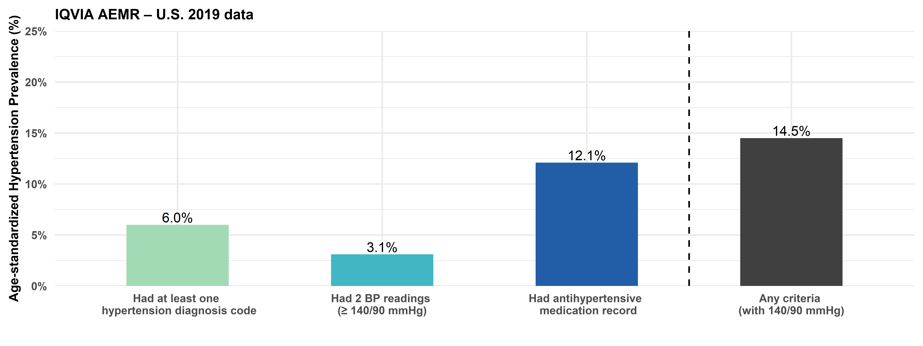
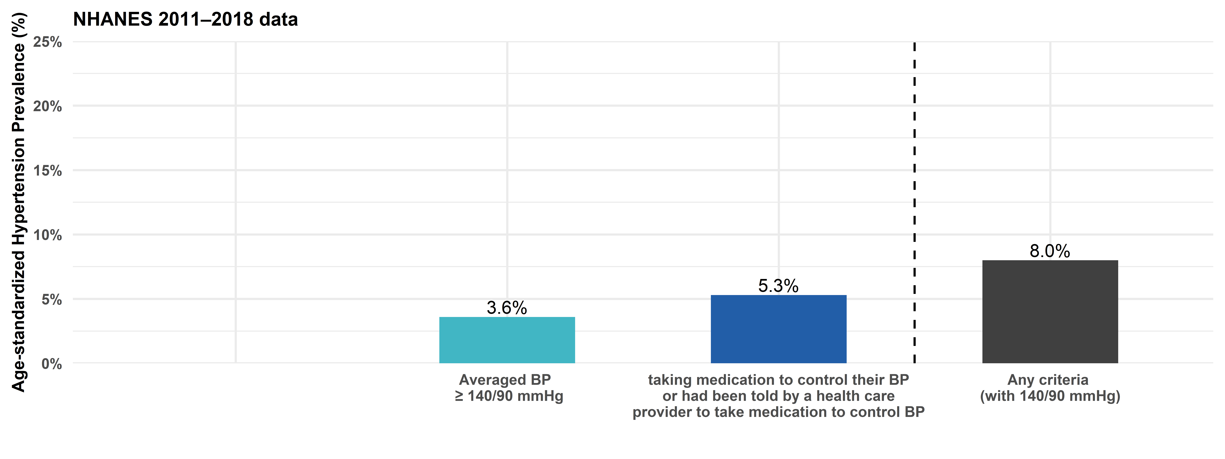
AEMR, Ambulatory Electronic Medical Records; BP, blood pressure; NHANES, National Health and Nutrition Examination Survey.
Appendix Figure 2. Age standardized hypertension control among women of reproductive age from IQVIA AEMR – U.S. 2019 data and National Health and Nutrition Examination Survey 2011–2018 data. For IQVIA AEMR – U.S. 2019 data, hypertension control means patients’ latest paired blood pressure reading should be less than 140/90 mmHg. For National Health and Nutrition Examination Survey (NHANES) 2011–2018 data, hypertension control means participants’ averaged paired blood pressure reading should be less than 140/90 mmHg among those taking antihypertensive medication.
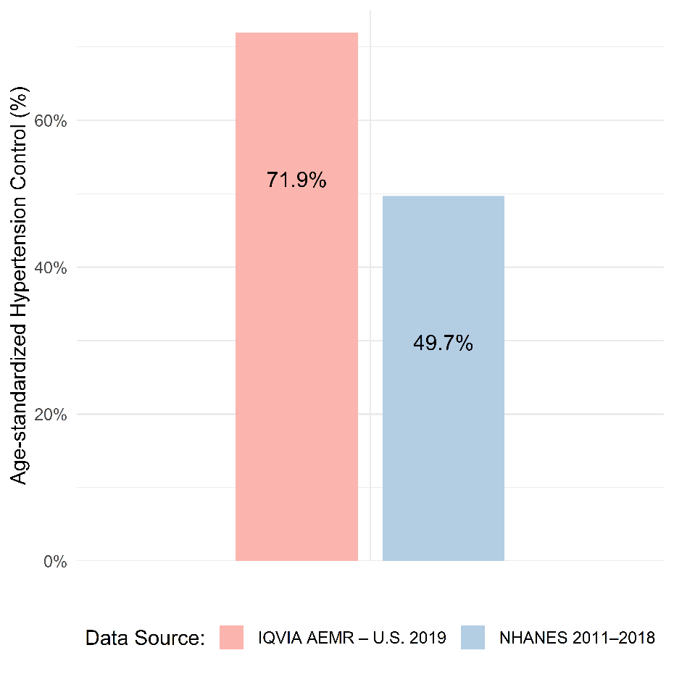
AEMR, Ambulatory Electronic Medical Records.

