Supplementary materials: Simulation of full HIV cluster networks in a nationally representative model indicates intervention opportunities

Detailed methods

We used the Progression and Transmission of HIV (PATH 4.0), a stochastic dynamic network simulation model of sexual transmission of HIV in the United States¹. This model utilizes an agent-based evolving network modeling (ABENM) simulation technique², which includes both individual-level network and compartmental modeling structures. People with HIV (PWH) and their immediate contacts are simulated at the individual level in the network, and all other susceptible persons using a compartmental modeling structure. Specifically, for persons in the network, features such as age, transmission risk-group (heterosexual female, heterosexual male, men who have sex with men (with men only and with men and women)), degree (degree is the number of lifetime contacts per person), and pseudo-geographic jurisdiction are tracked at the individual-level. Whereas, in the compartmental model, the population is compartmentalized by combinations of age-group, transmission risk-group, degree-bin (degrees are grouped into bins analogous to age grouped into age-groups), and pseudo-geographic jurisdictions.

PATH 4.0 uses four modules to simulate HIV epidemic projections over time: a compartmental module for simulating susceptible persons, an evolving contact network algorithm (ECNA) for generating sexual partnership networks, a Bernoulli transmission module for simulating new infections, and a disease progression module for simulating HIV-related events for persons with HIV infection. Details of the ABENM and PATH 4.0 have been previously described¹, and summarized below.

Compartmental module
Every time-step (monthly) of the simulation, this module updates the demographic features of susceptible persons in the compartmental model. Specifically, it simulates births, aging, and deaths.

Evolving contact network algorithm (ECNA) module
As new persons in the individual-level model become infected (according to the Bernoulli transmission module, described below), network connections are created with their immediate contacts. Immediate contacts are defined as all sexual partners a person will have over their lifetime. In the model, immediate contacts can either be existing susceptible persons in the network or persons in the compartmental portion of the model. If a person in the compartmental portion of the model is assigned as an immediate contact, then that person is transitioned from the compartmental portion of the model to the network portion of the model (by adding a new person with features representative of the person in the compartmental model and accordingly decrementing the number of persons with that feature by 1 in the corresponding compartment), thus evolving the contact network. The functioning of these evolving network dynamics is modeled by an evolving contact network algorithm (ECNA).

The ECNA is an integration of machine learning, Markov processes, simulation, and assignment optimization modeling techniques. The ECNA ensures that the dynamics of the evolving network fit to behavioral data including partnership mixing, number of partners by age, and partnership concurrency, obtained from the literature on large behavioral surveys, such as the National HIV Behavioral Surveys (NHBS) (https://www.cdc.gov/hiv/statistics/systems/nhbs/index.html), National Survey for Family Growth (NSFG) https://www.cdc.gov/nchs/nsfg/index.htm, and the National Survey for Sexual Health and Behavior (NSSHB) https://nationalsexstudy.indiana.edu/index.html.

The functioning of the ECNA includes determining who to add as immediate contacts of newly infected persons, such that the features of the persons in a partnership fit to the data on partnership mixing. Partnership mixing was maintained for each of the following: across age groups, across transmission risk-groups, across geography (mixing within and across jurisdictions), and across sexual behavior (specifically, degree; e.g., persons with a higher degree are more likely to form partnerships with other persons with a higher degree). Degree distributions (the distribution of the number of lifetime partners) varied by transmission group, and accordingly, mixing between age-group and degree-bins also varied by transmission-group as they are built into the network algorithm. We assumed that the degree distribution follows a power-law distribution, and the corresponding contact network is a scale-free network. With this distribution, most persons have few lifetime partners, while a small number of persons have a large number of partners.

For every newly infected person, after determining and making network connections with each of their immediate contacts, the ECNA algorithm also determines when these sexual partnerships are initiated and terminated, by matching to the distribution for the number of partners by age, the age-mixing between partnerships, proportion of persons having concurrent partners, and duration of concurrency. Thus, the duration of partnerships is inherently generated as an outcome of the algorithm (with shorter duration observed among younger populations and persons with larger number of lifetime partners).

We modeled ‘pseudo’-geographic jurisdictions (i.e., we assigned persons to one of 25 randomly chosen pseudo-jurisdictions) for purposes of introducing heterogeneity in contact selection and geographic mixing, to represent network structure formations more realistically. Geographical mixing (mixing within and across jurisdictions) varied by transmission group, based on data on the geographic distribution of HIV transmission networks in the United States ³.

Bernoulli transmission module

Every time-step (monthly) of the simulation, the Bernoulli transmission module determines if a susceptible person in the network becomes infected using a Bernoulli transmission equation. Note that, as susceptible persons in the compartmental model are not connected to an infected person in the network, their chance of infection is zero. Further note that, susceptible persons can move from compartmental model to the network upon becoming partners of the infected person, modeled using the ECNA algorithm discussed above, which would then expose them to the infection. For susceptible persons in the network, transmission is determined based on the number of active partnerships, number of sex acts (varying by age, transmission risk-group, and number of active partners), type of sex act (varying by transmission risk-group), condom use (varying by status of HIV-awareness of active infected partner, age-group, and transmission risk-group), infection status (acute v. non-acute) of each active infected partner, and viral suppression status of each active partner with HIV infection.

Disease progression module
At every time-step of the simulation, the disease progression module updates the individual-level demographic and disease dynamics for every person with HIV infection, including aging, HIV-related and natural mortality, HIV disease progression, and changes in diagnosis, care, and treatment status. The module updates natural HIV progression parameters such as CD4 cell count, viral load, opportunistic infection (OI) incidence, and onset of acquired immune deficiency syndrome (AIDS). These HIV-specific parameters are updated as a function of care and treatment status and ART regimen. For persons on ART treatment, the module also simulates changes in ART regimen over time by simulating viral load rebound. It updates changes in diagnosis, care, and treatment status by generating events of testing, initiation of treatment, and dropping-out or re-entry into treatment by calibrating to match annual surveillance estimates for the distribution of PWH by care continuum stages (unaware, aware not in care, and on ART treatment with viral load suppression, and on ART treatment with viral load suppression), using transmission-risk group specific data as per year being simulated. This method validated well to surveillance data on diagnoses by age-group, and CD4 count at diagnosis (which is typically a proxy for time from infection to diagnoses).
As diagnosis and viral suppression vary across jurisdictions, we indirectly modeled this through assignment of weights for each jurisdiction as follows. We randomly selected 25 values (for each of the 25 pseudo-jurisdictions) between the maximum and minimum range in proportion aware across counties in the U.S. The weight for each jurisdiction was set as the proportion aware in jurisdiction divided by the national proportion aware. All persons in a jurisdiction were assigned the jurisdiction weight. Thus, persons in a jurisdiction whose proportion aware was higher (or lower) than national average have a weight greater (or lower) than 1. At every-time step, the number of persons to newly diagnose was estimated by calibrating to the national value for the proportion aware for that year, and weighted (as per above weights) random sampling was used to select the persons to diagnose. As all persons in a jurisdiction have the same weight, this weighted random selection generates some dependency in diagnoses. A similar method was used for determining proportion of persons with viral suppression.
Model implementation
We initialized the PATH 4.0 model with a population that is representative of PWH, infected through sexual transmission, in the United States in 2006. Specifically, the epidemic and demographic features, such as disease stage, care continuum stage, age, and risk group, were representative of the distributions of these features in PWH in the United States in 2006, as estimated through surveillance and survey systems including the National HIV Surveillance System (NHSS) (https://www.cdc.gov/hiv/statistics/index.html) , the Medical Monitoring Project (MMP) (https://www.cdc.gov/hiv/statistics/systems/mmp/index.html), the HIV Outpatient Study (HOPS)⁴, the American Community Survey (ACS) (https://www.census.gov/programs-surveys/acs). After initialization of the model to 2006, we ran the simulation, from 2006 to 2017 in monthly-time steps, accounting for the changes in testing and care behaviors by calibrating to the care continuum distribution of PWH in each year being simulated, taking estimates from NHSS.
To replicate molecular cluster detection in the simulation, we applied a cluster generation algorithm at the end of each simulation run, corresponding to the end of the year 2017, for identification of clusters among persons with HIV diagnosed between 2015 and 2017. The algorithm identifies clusters using time as a proxy for genetic distance⁵. Specifically, we defined genetic distance (GD) between any two HIV infections as the sum of the difference between each infection’s time of diagnosis and time of the transmission event that commonly connects them in a transmission network (Supplementary Figure 1a). Then, for each GD threshold, we generated clusters by grouping infections such that each infection in a cluster is within the specified GD threshold of at least one other infection in the cluster (Supplementary Figure 1b). We set GD thresholds by assuming that the viral sequence will change approximately 1%, on average, over a 10-year interval⁶, e.g., a GD threshold of 5 years in the simulation model would represent a molecular genetic distance of 0.5%.
Though the model was initiated in 2006, as it was calibrated to that year using data from the surveillance systems, simulating the model to 2017 and conducting validation on clusters generated for 2015 to 2017 would keep it distinct from the calibration year and thus provide confidence in the model's ability to replicate the network dynamics.
Expanded validation of transmission network, cluster distribution, and transmission rate
To expand the prior model validation, we compared selected model clustering outcomes to cluster outcomes for persons with HIV diagnosed during January 2015–December 2017 for whom a nucleotide sequence data was reported to NHSS by December 2017; we excluded persons for whom injection drug use was identified as the transmission category. We compared the proportion of diagnosed infections that were clustered, and the distribution of cluster sizes across genetic distance thresholds of 0.5%, 0.75%, 1.0%, 1.5%, and 2.0% (equivalent to 5, 7.5, 10, 15, and 20 years of distance in the model, respectively). Alignment of the model clustering outcomes across these thresholds with outcomes observed in NHSS requires not only that the dynamics of care, behavior, and network metrics be modeled accurately, but also that temporal changes in these aspects are successfully replicated through the network dynamics.
Additionally, transmission rates in detected clusters were compared between model simulations and as observed in NHSS data.
Transmission rates
We calculate transmission rate of a cluster as the number of new infections in the cluster divided by the cumulative person-time in which persons in the cluster were infected with HIV, defined as follows:
incidence by person-time =${(I_{2015}+I_{2016}+I_{2017})}/{({\hat{P}}_{2015}+{\hat{P}}_{2016}+{\hat{P}}_{2017})}$
where,
$I_{year}$= number of new infections in year,
${\hat{P}}_{year}=$ sum of HIV-infected person-time of each PWH = $\left\{\begin{aligned}1: if the PWH was infected prior to year and alive for full year; \\ \frac{months of infection and alive}{12}: if infected during year or alive for any fraction of the year\end{aligned}\right.$

The incidence by person-time approach parallels the approach by which transmission rate calculations are generated through molecular phylogenetic analyses of NHSS data, in which the time to the most recent common ancestor is used to infer the cumulative person-time of HIV infection over a cluster ⁷. This approach differs, however, from approaches that have previously been used to generate overall population estimates ^{8,9}, which are typically calculated by dividing the estimated incidence by the estimated prevalence. Because of this, we conducted a sensitivity analysis in which we also calculated overall and cluster-specific transmission rates using a more standard approach of new infections divided by the prevalence, defined as follows:
incidence by prevalence =${(I_{2015}+I_{2016}+I_{2017})}/{(P_{2015}+P_{2016}+P_{2017})}$
where,
$I_{year}$= number of new infections in year,
$P_{year}=$ number of alive PWH at the end of the previous year
Analysis of NHSS sequence data to identify clusters and calculation of cluster-specific transmission rates based on molecular phylogenetic analysis was conducted using methods as previously described ⁷. To increase the likelihood of phylogenetic model convergence for smaller clusters, we implemented a constant population size for clusters <10 persons. Data were analyzed across the entire national dataset, such that identified clusters can span jurisdictions.
A sensitivity analysis in which transmission rates were calculated in the model using the incidence by person-time method yielded similar transmission rates to those calculated by the incidence by prevalence method.
Cluster composition metrics
To assess the full extent and composition of clusters, we focused on clusters defined at the 0.5% genetic distance thresholds. This is the genetic distance threshold currently used for routine HIV cluster detection in the United States⁷.
First, we identified ‘detected clusters’ in the model, which reflect the portion of a full cluster that can be identified through analysis of NHSS data, based on diagnosed infections for which a sequence is reported.
Detected clusters
As of December 2017, HIV sequences had been reported to NHSS for 48.5% of HIV infections that were diagnosed during 2015–2017 in 27 participating jurisdictions representing 70% of HIV diagnoses in 2015 ¹⁰. To replicate this sequence completeness in the model, we randomly selected 48% of simulated infections diagnosed between 2015 and 2017 and set their status as a ‘sequenced’ infection. To identify detected clusters, the cluster generation algorithm is applied only to these sequenced infections. If a diagnosed and sequenced infection was within the given genetic distance threshold from at least one other infection that was diagnosed and sequenced during this 3-year period, it was considered clustered. If not, it was considered not clustered. We refer to the resulting clusters as detected clusters. Detected clusters may include persons with HIV who are not alive as of the last time-step of the model.
Priority clusters: To focus on clusters with active growth, we further identified ‘priority clusters’, defined as detected clusters defined at the 0.5% genetic distance threshold with at least 3 infections diagnosed and sequenced in the most recent year of analysis. ⁷. Non-priority clusters were those clusters that did not meet this criterion.
Because routine analyses of NHSS data to identify priority clusters are conducted prospectively by health departments and CDC, priority clusters are identified when they first meet the priority cluster definition. To approximate this in the model and in our NHSS analysis used for comparison, we distinguished new and ongoing priority clusters, as of the time of the last model timestep or as of December 31st, 2017 (in analysis of NHSS data).
Ongoing priority clusters were defined as clusters with at least 3 diagnosed and sequenced infections in 2017 in which at least 3 additional infections in the cluster were diagnosed and sequenced in a single calendar year during 2012–2016 (indicating that the cluster first met priority criteria prior to 2017)
New priority clusters were defined as those with at least 3 diagnosed and sequenced infections in 2017 in which fewer than 3 infections in the cluster were diagnosed and sequenced in each calendar year during 2012–2016 (indicating that the cluster met priority criteria for the first time in 2017).
Non-priority clusters were defined as detected clusters at the 0.5% genetic distance threshold that did not meet either ongoing priority or new priority clusters criteria (i.e., did not have at least 3 infections diagnosed in any single year during 2012–2017).
Full clusters
To understand the full extent and composition of clusters in the model, for each detected cluster, we identified the full cluster that would have been observed if all HIV infections in the cluster were diagnosed and sequenced (Supplemental figure 1a and 1b). To generate full clusters in the model, we applied the cluster generation algorithm to all infections diagnosed during 2015–2017 as well as all infections that were undiagnosed as of the last model time step, assuming that sequences were available for all infections. Infections diagnosed prior to 2015 that are linked to the cluster at the 0.5% threshold are also included. Detected clusters were mapped to the corresponding full clusters to allow for comparisons of detected to full clusters. Therefore, every full cluster has at least one detected cluster as a subset. Because the cluster generation algorithm utilizes the date of diagnosis to calculate the genetic distance between two infections, the date of the last model time step was used in place of diagnosis date to calculate clustering for undiagnosed infections.
Attributes of infections within a cluster and overall, such as recency of infection and diagnosis status, were determined as of the last model time step.
Model replications
We ran the simulation 30 times. Additionally, within each model run, we conducted 11 replications in which the subset of 48% of ‘sequenced’ infections were randomly selected from the simulated infections in that run that were diagnosed during 2015-2017. Detected clusters were generated based on these sequenced infections, resulting in a total of 330 separate model outcomes. Each run generates multiple clusters of varying types and sizes. We extracted cluster outcomes for each run and calculated the median and range for each.

Supplemental Results
Expanded validation of transmission network, cluster distributions, and transmission rate
Cluster distributions generated by the simulation model aligned with distributions observed through analysis of NHSS data across a range of genetic distance thresholds (Supplemental Figure 2a and 2b). Model outcomes were aligned with observed data for the proportion of diagnosed HIV infections that were identified as part of any cluster and part of a priority cluster (Figure 2a). In NHSS data, the proportion of infections diagnosed during 2015–2017 for which a sequence was available that were part of any cluster ranged from 22.2% at the 0.5% threshold to 55.4% at the 2.0% threshold; the proportion in priority clusters ranged from 0.9% at the 0.5% threshold to 1.9% at the 2.0% threshold. Model simulations included the observed NHSS data point for all thresholds except the proportion in any cluster at the 1.0% threshold.
Similarly, at the cluster level, model outcomes aligned with observed data for the distribution of clusters by cluster size (Figure 2b). In NHSS data, the majority of clusters at all genetic distance thresholds were size 2, ranging from 62.5% of clusters at the 0.5% threshold to 50.0% of clusters at the 2.0% threshold. Clusters of larger size were less common, and among those of size 26 or greater, just 0.3% of clusters in NHSS data were at the 0.5% level, and 1.6% of clusters at the 2.0% threshold. The model output followed this pattern, with the range of proportions in model simulations including the observed NHSS data point for all thresholds and size categories.
Transmission rates in clusters simulated in the model were consistent with those observed in clusters identified through analysis of NHSS data (Supplemental Table 1). In analysis of NHSS data reported through December 2017, 14 new priority sexual transmission clusters were identified; the median transmission rate for these new priority clusters was 34 transmissions per 100 persons/year, with a range of 23-82. In the simulation, the median transmission rate in detected new priority clusters in December 2017 was 27, with a range in individual clusters from 0 to 120.

Supplementary Discussion
For all but one data point, the proportion of diagnosed and sequenced infections that were in a cluster as observed through NHSS were within the bounds of model simulations, across multiple genetic distance thresholds. Additionally, the model replicated not only the high median transmission rates observed in detected clusters in previous analyses, but also the very high rates observed for certain individual clusters, suggesting that the model is successfully replicating the dynamics, including network structure, sexual behaviors, and care behaviors, that give rise to rapidly growing clusters that have resulted in large scale public health response activities ¹¹.

Supplementary References
1. Singh S, France AM, Chen YH, Farnham PG, Oster AM, Gopalappa C. Progression and transmission of HIV (PATH 4.0)-A new agent-based evolving network simulation for modeling HIV transmission clusters. Math Biosci Eng. Mar 3 2021;18(3):2150-2181. doi:10.3934/mbe.2021109
2. Eden M, Castonguay R, Munkhbat B, Balasubramanian H, Gopalappa C. Agent-based evolving network modeling: a new simulation method for modeling low prevalence infectious diseases. Health Care Manag Sci. Sep 2021;24(3):623-639. doi:10.1007/s10729-021-09558-0
3. Board AR, Oster AM, Song R, et al. Geographic Distribution of HIV Transmission Networks in the United States. J Acquir Immune Defic Syndr. Nov 1 2020;85(3):e32-e40. doi:10.1097/QAI.0000000000002448
4. Buchacz K, Armon C, Palella FJ, Jr., et al. The HIV Outpatient Study-25 Years of HIV Patient Care and Epidemiologic Research. Open Forum Infect Dis. May 2020;7(5):ofaa123. doi:10.1093/ofid/ofaa123
5. Chen YH FA, Farnham PG, Sansom SL, Gopalappa C, Oster AM. . Replicating HIV transmission clusters in a US HIV agent-based Model. . presented at: Society for Medical Decision Making; October 16, 2018. 2018; Montreal, Canada. Session Poster number PS3-55.
6. Hightower GK, May SJ, Perez-Santiago J, et al. HIV-1 clade B pol evolution following primary infection. PLoS One. 2013;8(6):e68188. doi:10.1371/journal.pone.0068188
7. Oster AM, France AM, Panneer N, et al. Identifying clusters of recent and rapid HIV Transmission through analysis of molecular surveillance data. J Acquir Immune Defic Syndr. Dec 15 2018;79(5):543-550. doi:10.1097/QAI.0000000000001856
8. Holtgrave DR, Hall HI, Prejean J. HIV transmission rates in the United States, 2006-2008. Open AIDS J. 2012;6:26-8. doi:10.2174/1874613601206010026
9. Li Z, Purcell DW, Sansom SL, Hayes D, Hall HI. Vital Signs: HIV transmission along the continuum of care - United States, 2016. MMWR Morb Mortal Wkly Rep. Mar 22 2019;68(11):267-272. doi:10.15585/mmwr.mm6811e1
10. Oster AM, Wertheim JO, Hernandez AL, Ocfemia MC, Saduvala N, Hall HI. Using molecular HIV surveillance data to understand transmission between subpopulations in the United States. J Acquir Immune Defic Syndr. Dec 1 2015;70(4):444-51. doi:10.1097/QAI.0000000000000809
11. Oster AM, Lyss SB, McClung RP, et al. HIV cluster and outbreak detection and response: the science and experience. Am J Prev Med. Nov 2021;61(5 Suppl 1):S130-S142. doi:10.1016/j.amepre.2021.05.029

Supplementary Tables and Figures
Supplementary Table 1. Transmission rates for detected new priority clusters as of December 2017 in the model and newly identified priority clusters as of December 31, 2017 in the National HIV Surveillance System (NHSS).
 | Incidence by person-time (per 100 persons)
model | 27 (0 - 120)
NHSS | 34 (23-82)

Supplementary Figure 1. Simulation cluster algorithm approach to infer genetic distance relationships and clusters including for detected and full clusters.
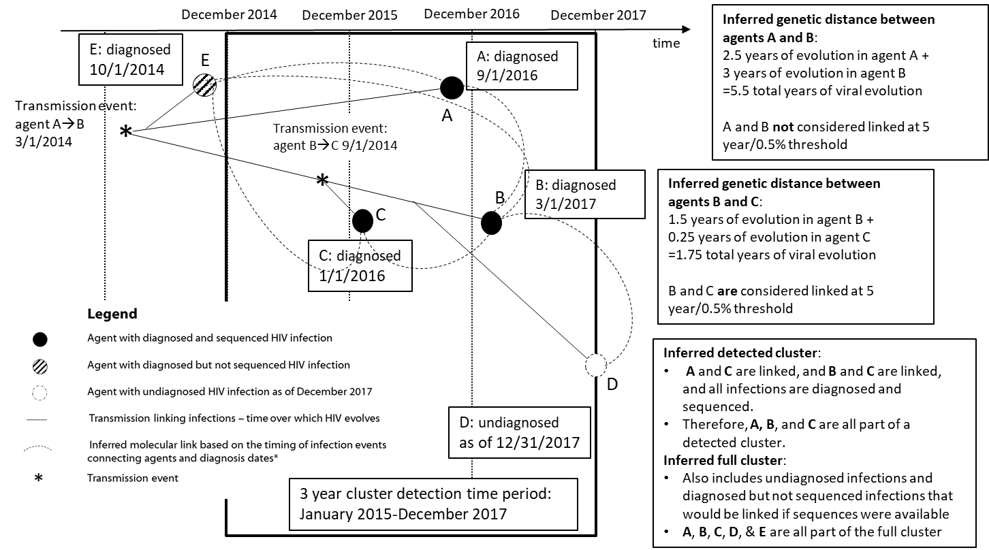

*Inference of molecular links for undiagnosed infections is based on the date of the last time step of the model (12/31/2017)

Supplementary figure 2a: Proportion of HIV infections diagnosed during 2015-2017 with a sequence that are clustered and in a priority cluster, by genetic distance threshold, as generated in the simulation model (box whisker plots with median, inter-quartile range, and range), and as observed through analysis of National HIV Surveillance System (NHSS) for HIV infections diagnosed during 2015-2017 and reported through December 2017.

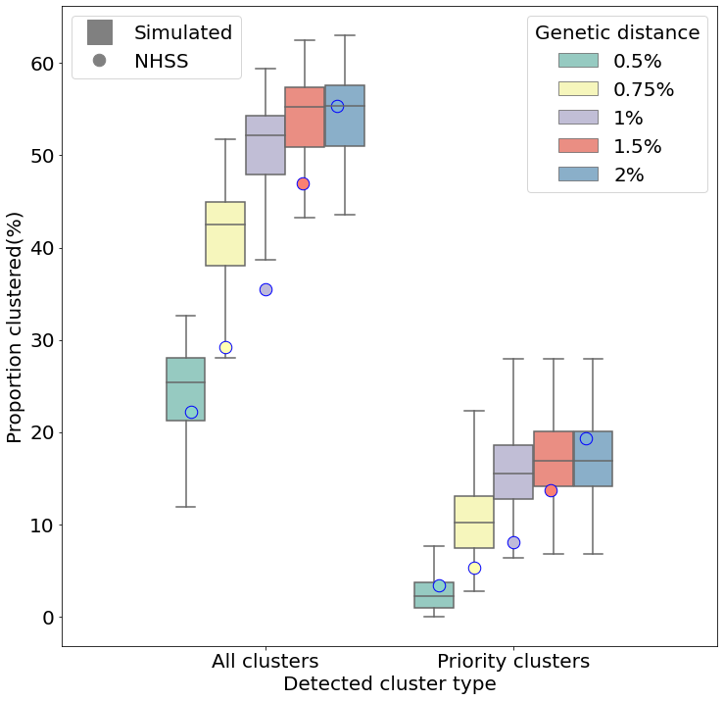

Supplementary figure 2b: Proportion of molecular detected HIV clusters by size and genetic distance threshold, as generated in the simulation model (box whisper plots with median, inter-quartile range, and range), and as observed through analysis of National HIV Surveillance System (NHSS) for HIV infections diagnosed during 2015-2017 and reported through December 2017.
