**Supplementary Tables and Information**

**Table S1. Patient acceptability at three-month side-by-side preference comparison**

|  |  |  |  |  |
| --- | --- | --- | --- | --- |
|  | Recent use of traditional latrine  (n=46)  n (%) | Recent use of SaTo Pan Latrine  (n=28)  n (%) | P value | Test |
| On a scale of 1 (very poor) to 5 (very good), what do you think about the toilets at this HCF? | 3.0 [3.0-4.0] | 4.0 [3.0-4.0] | **0.02** | Wilcoxon |
| Was there visible feces around the toilet or floor when you used it? (Yes) | 2 (4.3) | 2 (7.1) | 0.37 | Fisher exact |
| Was there a bad smell in the toilet when you used it? (Yes) | 23 (50) | 5 (18) | **0.02** | Chi-square |
| Were there flies in the toilet when you used it? (Yes) | 12 (26) | 0 (0.0) | **<0.01** | Fisher exact |
| What was the main reason for your choice of latrine? |  |  |  |  |
| Convenience | 34 (76) | 15 (54) | **<0.01** | Fisher exact |
| Preference | 7 (16) | 13 (46) |  |  |
| Unknown | 4 (8.9) | 0 (0) |  |  |

**Table S2: In-charge and cleaner preferences at endline in healthcare facilities in intervention arm**

|  |  |
| --- | --- |
|  | Intervention HCFs  (n=18)  n (%) |
| **In-charge Report** |  |
| Number surveyed | *n=18* |
| Would you like to keep all of the SaTo pans installed? | 14 (78) |
| **Cleaner Report** |  |
| Number surveyed | *n=20* |
| Difficulty cleaning SaTo floor versus previous/other latrines |  |
| More difficult | 0 (0) |
| Same difficulty | 2 (10) |
| Less difficult | 18 (90) |
| Difficulty cleaning SaTo drophole versus previous/other latrines |  |
| More difficult | 2 (10) |
| Same difficulty | 1 (5) |
| Less difficult | 17 (85) |
| Have you experienced any challenges with the SaTo pan? (Yes) | 6 (30) |
| Too little space | 2 (1) |
| Bucket stolen | 1 (0.5) |
| Bucket broken | 1 (0.5 |
| Bucket used for other purpose | 2 (1) |

**Figure S1: Instructional poster demonstrating flushing of SaTo pan, annotated to show functional components**

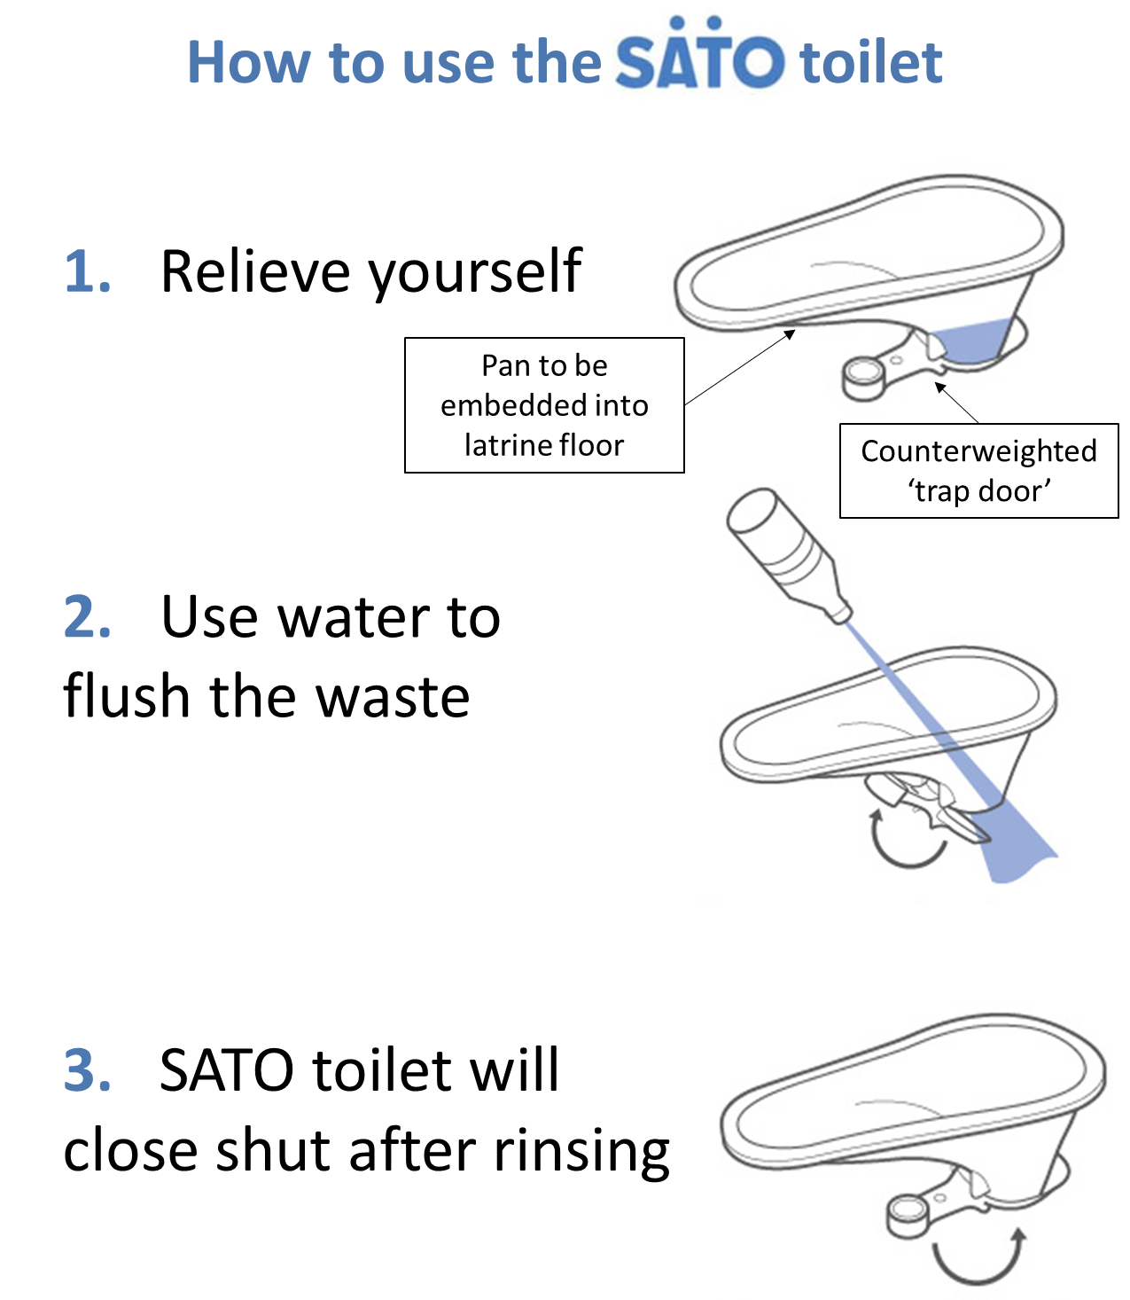

**Figure S2: Photograph of SaTo pan installed within cement platform of pit latrine in healthcare facility**

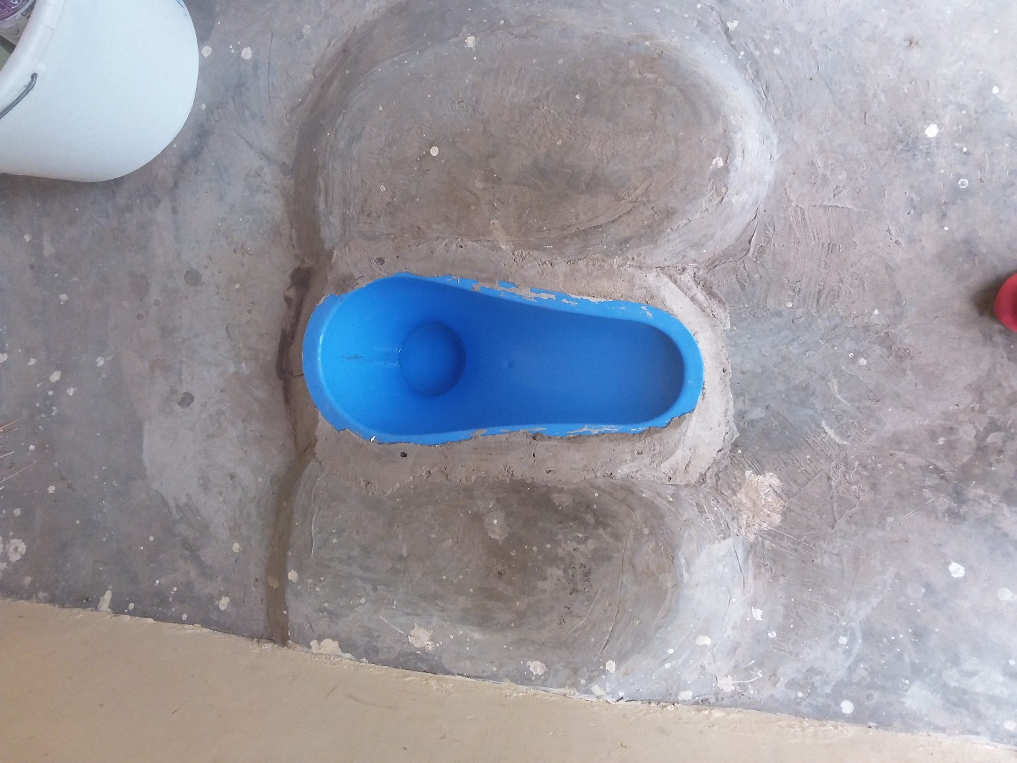

**Questionnaire S1: Patient Questionnaire**

|  |  |
| --- | --- |
| **Question** | **Response** |
| 2. Name of Sub-county: | 1 Nyando 2 Nyakach |
| 4. [READ CONSENT] Are you willing to participate? | 1 Yes 0 No |
| 5. How old are you? |  |
| 6. [DO NOT READ OUT LOUD] Respondent sex | 1 Male 2 Female |
| 7. Are you here with anyone else? | 1 Yes 0 No |
| 8. Number of Children (under 5 years) |  |
| 9. Number of other adults (anyone over 5 years old) |  |
| 10. Have you EVER used the toilets at this health facility? | 1 Yes 0 No 99 Don't know |
| 11. In the PAST WEEK, have you used the toilets at this health facility? | 1 Yes 0 No 99 Don't know |
| 12. On a scale of one to five, where 5 is very good and 1 is very poor, what do you think about the toilets at this health center/dispensary/hospital? | 5 Very good 4 Good 3 OK 2 Poor 1 Very poor 99 Don't know |
| 13. Was there visible feces around the toilet or floor when you used it? | 1 Yes 0 No 99 Don't know |
| 14. Was there a bad smell in the toilet when you used it? | 1 Yes 0 No 99 Don't know |
| 15. Were there flies in the toilet when you used it? | 1 Yes 0 No 99 Don't know |
| 16. Was there a cover over the hole in the toilet? | 1 Yes 0 No 99 Don't know |
| 17. Were you able to close the door when you used the toilet? | 1 Yes 0 No 99 Don't know |
| 18. Were you able to lock the door when you used the toilet? | 1 Yes 0 No 99 Don't know |
| 19. Did you feel secure when you used the toilet? | 1 Yes 0 No 99 Don't know |
| 20. Do you consider the toilet at this health center (dispensary, hospital) acceptable to use? | 1 Yes 0 No 99 Don't know |
| 21. Why? (select all that apply) | 1 Clean 2 No smell 3 Not broken 4 No flies 5 Private 6 Menstrual hygiene facilities 7 Handwashing station 8 Drophole cover 99 Don't know |
| 22. Why not? (select all that apply) | 1 Toilet too full 2 Visible feces on floor, drophole, or walls 3 Bad smell 4 Broken slab/floor 5 Flies 6 No privacy 7 Lack of menstrual hygiene facilities 8 Lack of a handwashing station 9 No drophole cover 10 Door locked (can’t open) 11 Too crowded/not enough toilets 99 Don't know |
| 23. Do you prefer to use the toilet at this health facility or the one at your home? | 1 This facility 2 Own home |
| 24. (If at this facility) What are all the reasons? (select all that apply) | 1 No facility at home 2 Cleaner 3 Less smell 4 Easier to access 5 More comfortable 6 My children can use it 7 More private 8 Less flies 9 Disposal for menstrual hygiene material present 10 Handwashing station present 11 Drophole cover present |
| 25. (If at own home) What are all the reasons? (select all that apply) | 1 No facility at home 2 Cleaner 3 Less smell 4 Easier to access 5 More comfortable 6 My children can use it 7 More private 8 Less flies 9 Disposal for menstrual hygiene material present 10 Handwashing station present 11 Drophole cover present |
| 26. Please choose the 3 most important things that prevent you from visiting a toilet [READ choices out loud or show tablet] | 1 Toilet too full 2 Visible feces on floor, drophole, or walls 3 Bad smell 4 Broken slab/floor 5 Flies 6 No privacy 7 Lack of menstrual hygiene facilities 8 Lack of a handwashing station 9 No drophole cover 10 Door locked (can’t open) 11 Too crowded/not enough toilets 99 Don't know |
| Enumerator Comments |  |

**Questionnaire S2: Latrine Observation**

|  |  |
| --- | --- |
| **Question** | **Response** |
| Name of Sub-County: | 1 Nyando 2 Nyakach |
| 1. How many toilets/latrines (holes) TOTAL are in the block? |  |
| 2. Is this latrine functional TODAY (Note: Functional means the latrine is able to be used by patients or staff)? | 1 Yes 0 No |
| 3. Why is the latrine not functioning? |  |
| 4. Take a picture of the latrine, including the drophole and doorway in the picture |  |
| 5. What type of latrine is this? | 0 Flush/pour-flush (not-Satopan)  1 Pit latrine, WITH Satopan  2 Pit latrine, no satopan  3 Don’t know and latrine locked |
| 6. What type of Satopan is it? | 0 Flex 1 Pan 2 Don't know and latrine locked |
| 7. Are there any visible problems with the Satopan? | 0 No problems  1 Pan or flex is broken or cracked  2 Drophole doesn’t close shut  3 Satopan is not level (gap between pan and concrete) |
| 8. Is this latrine for patients, staff, or both? | 1 Staff only 2 Patients only 3 Not separated/Both staff and patients 4 Don't know and latrine locked |
| 9. Is this latrine for women, men, or not separated? | 1 Women only 2 Men only 3 Not separated 4 Don't know and latrine locked |
| [DO NOT READ OUT LOUD] | |
| 10. Is there a slab (concrete with iron bars) present? | 1 Yes 0 No 99 I don't know |
| 11. Is the pit lined? | 1 Yes 0 No 99 I don't know |
| 12. Does this latrine hole have a pipe or vent that reaches through the roof? | 1 Yes 0 No 99 I don't know |
| 13. Is there intact feces (more than just traces) on the floors or drophole? | 1 Yes 0 No 99 I don't know |
| 14. Is there a strong or unbearable odor inside or outside the latrine compartment? | 1 Yes 0 No 99 I don't know |
| 15. Is there a puddle of urine or stagnant water inside the compartment? | 1 Yes 0 No 99 I don't know |
| 16. Is there rubbish, trash, used cleansing materials, or other items on the FLOOR of the latrine? | 1 Yes 0 No 99 I don't know |
| 17. Is the toilet private? (there are closable doors that lock from the inside and no large gaps in the structure) | 1 Yes 0 No 99 I don't know |
| 18. Is there a poster with instructions for how to use the Satopan in the latrine or on the door? | 1 Yes 0 No 99 I don't know |
| 19. How many flies are there? | 0 No flies 1 A few flies 2 Swarms of flies |
| 20. Is there a bin (to throw away menstrual hygiene products or trash) inside the cubicle? | 1 Yes 0 No |
| 21. Does the bin have a lid on it? | 1 Yes 0 No |
| 22. Open the bin (if necessary) and observe if the bin is: | 0 Empty, no signs of use 1 Empty, signs of use 2 Filled, but not overflowing, with waste in it 3 Is overflowing with waste |
| 23. Is there a sign or other directions in the compartment indicating to throw menstrual waste in trash? | 1 Yes 0 No |
| 24. Is there water in the cabin for FLUSHING? | 1 Yes 0 No 99 I don't know |
| Take a picture of the bucket for flushing, including any scoop |  |
| 26. Is there water for HANDWASHING inside the cubicle? | 1 Yes 0 No 99 I don't know |
| 27. Is there soap inside the cubicle? | 1 Yes 0 No 99 I don't know |
| 28. Is this toilet accessible from the patient area without stairs or steps? | 1 Yes 0 No 99 I don't know |
| 29. Are there handrails for support on the wall or floor? | 1 Yes 0 No 99 I don't know |
| 30. Is the entry at least 80 cm wide? | 1 Yes 0 No 99 I don't know |
| 31. Is the seat raised? | 1 Yes 0 No 99 I don't know |
| 32. Is the door handle within reach for someone using a wheelchair or crutches / sticks? | 1 Yes 0 No 99 I don't know |
| 33. Is there a functional handwashing station with soap and water within 5 meters of the toilets in this block? | 0 No handwashing station 1 Handwashing station, no water 2 Handwashing station with water, no soap 3 Yes, handwashing station with soap and water |
| 34. Is there alcohol-based hand sanitizer available within 5 meters of the toilets in this block? | 1 Yes 0 No |
| 35. Is there water for flushing within 5 meters of the SaTo Pan latrines? | 1 Yes 0 No |
| Take a picture of the bucket for flushing, including any scoop |  |

**Questionnaire S3: Cleaner Survey**

|  |  |
| --- | --- |
| **Question** | **Response** |
| D2. Name of Sub-county: | 1 Nyando 2 Nyakach |
| D4. [READ CONSENT] Are you willing to participate? | 1 Yes 0 No |
| D5. What is your role at this health facility? | 1 Cleaner |
| D6. Are you responsible for cleaning all or parts of the healthcare facility? | 1 Yes 0 No |
| D7. (Respondent sex) | 1 Male 2 Female |
| D8. What is the HIGHEST level of education or training you have COMPLETED? | 5 Vocational school 4 Finished university 3 Finished secondary school 2 Finished primary school 1 Finished prepatory school 0 No formal schooling |
| D9. How long have you been working at this health center? (in YEARS) |  |
| D10. How long have you been working at this health center? (in MONTHS) |  |
| D11. Do you ever have to pick up human feces outside of the toilets (e.g., from pans in wards)? | 1 Yes 0 No |
| D12. Do you ever have to pick up children’s feces outside of the toilets (e.g., from pans in wards)? | 1 Yes 0 No |
| D13. What is the most common way you dispose of child feces? | 1 Pan 2 Ground 3 Latrine 4 Shower 5 Diaper (cloth) 6 No particular method 7 Trash/solid waste (non-infectious) 8 Infectious waste |
| D14. Where is the diaper then disposed of? (select all that apply) | 2 Ground 3 Latrine 4 Shower 6 No particular method 7 Trash/solid waste (non-infectious) 8 Infectious waste |
| D15. Where is the pan then emptied? (select all that apply) | 2 Ground 3 Latrine 4 Shower 6 No particular method 7 Trash/solid waste (non-infectious) 8 Infectious waste |
| D16. Do you dispose of menstrual hygiene products in the latrine or toilet along with normal fecal waste? | 1 Yes 0 No 2 Not applicable |
| D17. Yes or no: Is it easy for you to complete all of the cleaning tasks that are expected of you for your job? | 1 Yes 0 No |
| D18. What supplies do you normally use to clean the facility? | 0 Bucket  1 Bleach/Jik  2 Soap  3 Water  4 Mop/rag  5 Broom |
| D19. Do you feel you have access to adequate cleaning supplies to perform the tasks required for your job? | 1 Yes 0 No |
| D20. How often are the toilets at the facility cleaned? | 1 Once a day 2 More than once a day 3 More than once a week 4 Once a week (=4 times a month) 5 Once a month 6 Once a year 0 Never 99 Don't know |
| D21. How often do YOU clean the toilet? | 1 Once a day 2 More than once a day 3 More than once a week 4 Once a week (=4 times a month) 5 Once a month 6 Once a year 0 Never 99 Don't know |
| D22. What do you normally use to clean the toilets? (select all that apply) | 0 Bucket 1 Bleach/Jik 2 Soap (liquid or powder) 3 Water 4 Mop/rag 5 Broom |
| D23. Do you feel that you have access to adequate cleaning supplies to clean the toilets? | 1 Yes 0 No |
| D24. What are you missing? (select all that apply) | 0 Bucket 1 Bleach/Jik 2 Soap (liquid or powder) 3 Water 4 Mop/rag 5 Broom |
| D25. What do you normally wear while cleaning the toilets? (select all that apply) | 1 Gloves 2 Boots 3 Apron, gown or other body-covering PPE 4 Goggles 0 None of the above |
| D26. Do you feel that what you wear adequately protects you while you clean the toilets? | 1 Yes 0 No 99 Don't know |
| D27. What are you missing? (select all that apply) | 1 Gloves 2 Boots 3 Apron, gown or other body-covering PPE 4 Goggles 0 None of the above |
| D28. Have you ever received training on how to clean the toilets? | 1 Yes 0 No 99 Don't know |
| D29. Do you feel the training you have received on how to clean the toilet was adequate | 1 Yes 0 No 99 Don't know |
| D30. Which of the parts of the toilet/latrine do you usually clean? (select all that apply) | 0 Floor 1 Drophole 2 Door 3 Walls 4 Menstrual hygiene material bin 5 Commode |
| D31. Are there times when you cannot or do not clean the toilets? | 1 Yes 0 No 99 Don't know |
| D32. What are all the reasons you cannot or do not clean them? (Select all that apply) | 1 Not enough time to clean them 2 Not enough cleaning supplies 3 Not enough personal protective equipment 4 Too difficult to clean them 5 Forget to clean them 6 Avoid cleaning them because of disease |
| D33. Are there times when you clean the toilets, but do not clean the toilet floor? | 1 Yes 0 No 99 Don't know |
| D34. Is the toilet floor sometimes difficult to clean? | 1 Yes 0 No 99 Don't know |
| D35. Are there times when you do not clean the drophole? | 1 Yes 0 No 99 Don't know |
| D36. Is drophole sometimes difficult to clean? | 1 Yes 0 No 99 Don't know |
| D37. Since you’ve worked here, how many times have the toilets been emptied? | 0 0 times 1 1 time 2 2 times 3 3 times 4 4 times 5 5 times 6 >5 times 99 Don’t know |
| D38. The last time the toilet was full, and needed to be emptied, who emptied it? | 0 I did 1 Another cleaner 2 In-charge 3 Healthcare staff 4 Outside service: emptier 5 Outside service: mason 6 Not applicable 99 Don't know |
| D39. Does anyone else ever empty the toilet? | 1 Yes 0 No 99 Don't know |
| D40. Who else empties it? (select all that apply) | 0 I did 1 Another cleaner 2 In-charge 3 Healthcare staff 4 Outside service: emptier 5 Outside service: mason 6 Not applicable 99 Don't know |
| D41. In the past 3 months, how often have you had to clean feces from the floor of the toilet? | 0 Never 1 1 time 2 2 times 3 Once a month 4 Twice a month 5 About once per week 6 About twice per week 7 About everyday 8 Multiple times per day |
| D42. In the past 3 months, how often have you had to clean feces off of the floors of wards? | 0 Never 1 1 time 2 2 times 3 Once a month 4 Twice a month 5 About once per week 6 About twice per week 7 About everyday 8 Multiple times per day |
| D43. In the past month, how often do you clean toilets with water and detergent? | 1 More than once a day 2 Once a day 3 2-4 times per week 4 Once per week 5 Less than once per week |
| Enumerator comments |  |