Supplementary Figure 1: Association plots of 500kb regions centered on lead SNPs (A) rs7591996 and (B) rs1906953 from a previous GWAS of osteosarcoma risk.

(A)

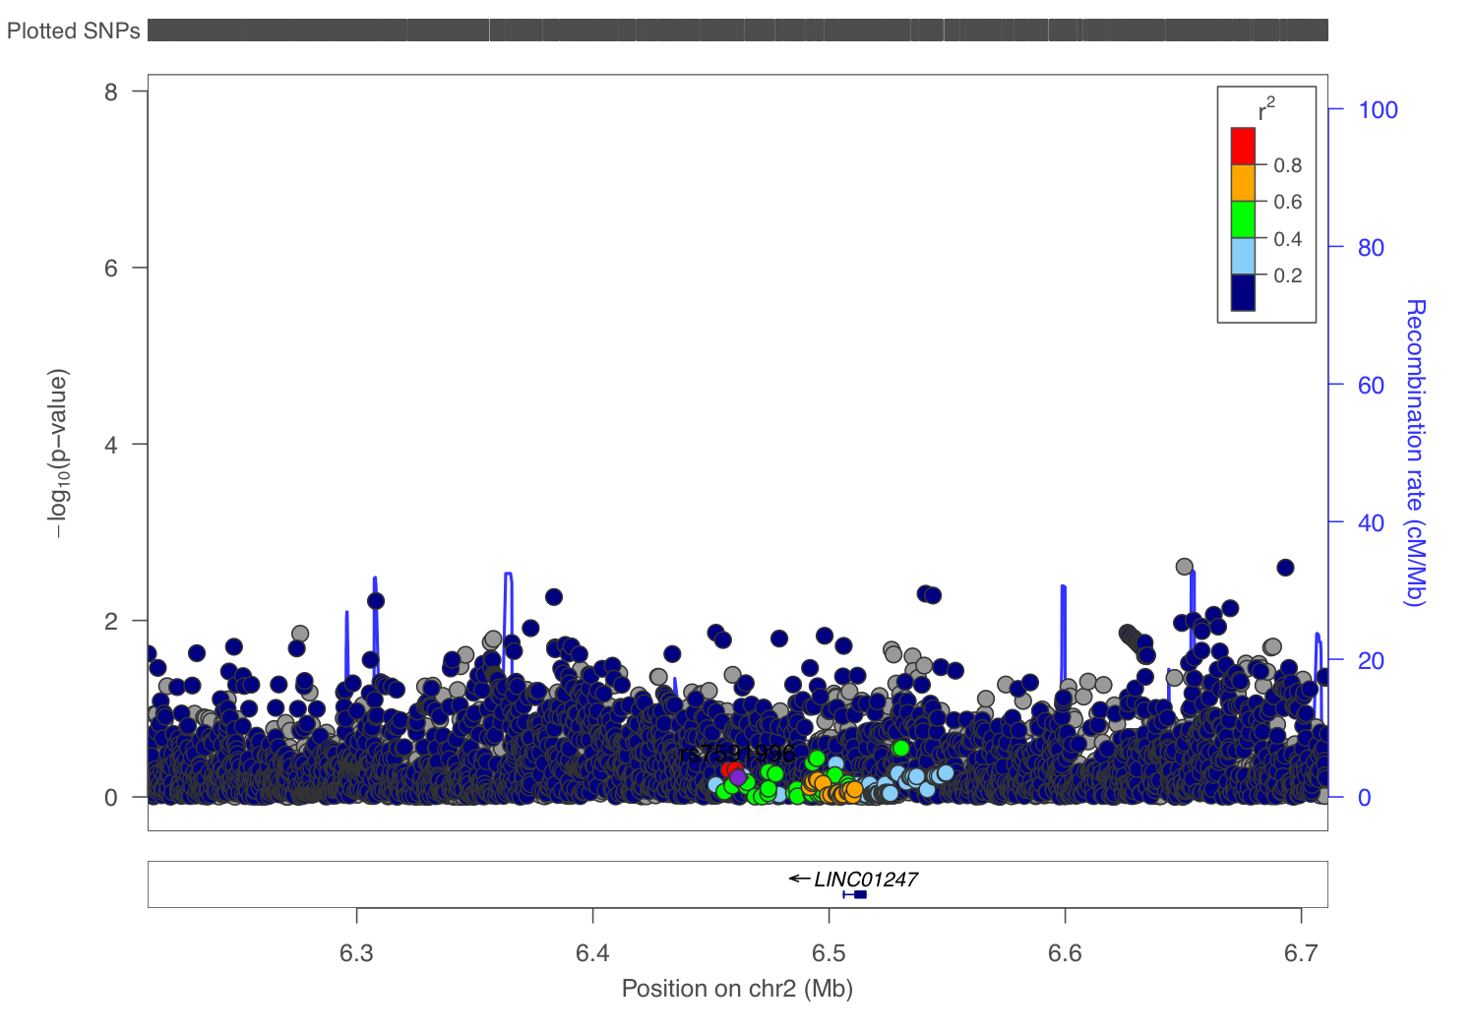

(B)



Supplementary Figure 2: Boxplots of leukocyte telomere length polygenic score across race/ethnic group control subjects.



Supplementary Figure 3: Forest plot of Mendelian randomization inverse-variance weighted estimates of per-standard deviation leukocyte telomere length effect on osteosarcoma risk.

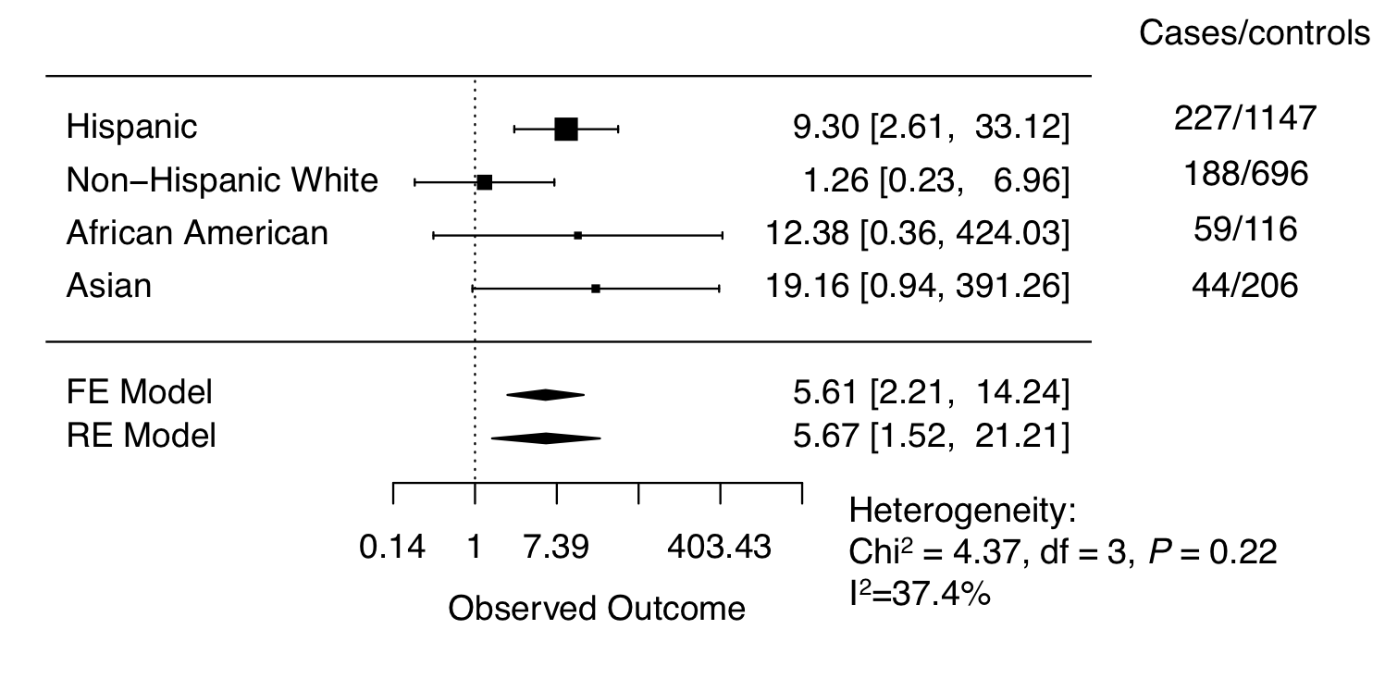

Supplementary Figure 4: Boxplots of polygenic scores for leukocyte telomere length in controls compared to osteosarcoma patients with different tumor sites. “Other sites” includes tumors of the pelvis, sacrum, coccyx, rib, sternum clavicle, and vertebral column.



Supplementary Table 1. Demographics and clinical features of 537 multiethnic pediatric osteosarcoma cases from the California Department of Public Health.

|  |  |  |
| --- | --- | --- |
| Variable | Mean (SD) or n (%) | Range |
| Age at diagnosis | 12.3 (3.6) | 1.0-19.0 |
| Sex, male | 292 (54.4%) | - |
| Race |  |  |
| Hispanic | 227 (42.3%) |  |
| Non-Hispanic White | 207 (38.5%) |  |
| African American | 59 (11.0%) |  |
| Asian | 44 (8.2%) |  |
| Metastasis present | 64 (11.9%) | - |
| Hispanic | 30 (13.2%) |  |
| Non-Hispanic White | 21 (10.1%) |  |
| African American | 6 (10.1%) |  |
| Asian | 7 (15.9%) |  |
| Tumor site in long bone | 488 (90.9%) | - |
| Undifferentiated tumor | 306 (57.0%) | - |
| Tumor size (mm) | 104 (82) | 3-95 |
|  |  |  |
|  |  |  |
|  |  |  |
|  |  |  |

Supplementary Table 2: Allele frequencies for osteosarcoma risk and metastasis variants across race/ethnic group controls subjects compared to populations from the 1000 Genomes reference groups for Admixed American (AMR), European (EUR), African (AFR), and East Asian (EAS).

|  |  |  |  |  |  |
| --- | --- | --- | --- | --- | --- |
| SNP | Effect allele | Race/ethnicity | California controls EAF | California cases EAF | 1000 Genomes* EAF |
| rs7591996 | C | Hispanic | 0.59 | 0.61 | 0.54 |
|  |  | Non-Hispanic white | 0.49 | 0.48 | 0.46 |
|  |  | Asian/Pacific islander | 0.62 | 0.65 | 0.65 |
|  |  | African American | 0.77 | 0.77 | 0.84 |
| rs1906953 | T | Hispanic | 0.26 | 0.23 | 0.24 |
|  |  | Non-Hispanic white | 0.14 | 0.16 | 0.14 |
|  |  | Asian/Pacific islander | 0.43 | 0.44 | 0.48 |
|  |  | African American | 0.44 | 0.52 | 0.51 |
| rs7034162 | A | Hispanic | 0.17 | 0.17 | 0.17 |
|  |  | Non-Hispanic white | 0.15 | 0.13 | 0.14 |
|  |  | Asian/Pacific islander | 0.35 | 0.34 | 0.39 |
|  |  | African American | 0.25 | 0.32 | 0.33 |

Supplementary Table 3: Allele frequencies for “long” alleles of leukocyte telomere length variants across race/ethnic group controls subjects compared to populations from the 1000 Genomes reference groups for Admixed American (AMR), European (EUR), East Asian (EAS), and African (AFR).

|  |  |  |  |  |
| --- | --- | --- | --- | --- |
| SNP | Gene | Race/ethnicity | California dataset MAF | 1000 Genomes MAF |
| rs11125529 | ACYP2 | Hispanic | 0.09 | 0.10 |
|  |  | Non-Hispanic white | 0.13 | 0.11 |
|  |  | Asian/Pacific islander | 0.12 | 0.16 |
|  |  | African American | 0.22 | 0.18 |
| rs10936599 | TERC | Hispanic | 0.57 | 0.65 |
|  |  | Non-Hispanic white | 0.76 | 0.76 |
|  |  | Asian/Pacific islander | 0.49 | 0.42 |
|  |  | African American | 0.93 | 0.96 |
| rs7675998 | NAF1 | Hispanic | 0.79 | 0.79 |
|  |  | Non-Hispanic white | 0.79 | 0.76 |
|  |  | Asian/Pacific islander | 0.76 | 0.83 |
|  |  | African American | 0.79 | 0.81 |
| rs2736100 | TERT | Hispanic | 0.38 | 0.43 |
|  |  | Non-Hispanic white | 0.51 | 0.50 |
|  |  | Asian/Pacific islander | 0.46 | 0.41 |
|  |  | African American | 0.40 | 0.47 |
| rs9420907 | OBFC1 | Hispanic | 0.11 | 0.13 |
|  |  | Non-Hispanic white | 0.15 | 0.13 |
|  |  | Asian/Pacific islander | 0.04 | 0.02 |
|  |  | African American | 0.51 | 0.60 |
| rs3027234 | CTC1 | Hispanic | 0.89 | 0.88 |
|  |  | Non-Hispanic white | 0.79 | 0.78 |
|  |  | Asian/Pacific islander | 0.93 | 0.96 |
|  |  | African American | 0.91 | 0.96 |
| rs8105767 | ZNF208 | Hispanic | 0.35 | 0.34 |
|  |  | Non-Hispanic white | 0.28 | 0.28 |
|  |  | Asian/Pacific islander | 0.30 | 0.31 |
|  |  | African American | 0.47 | 0.54 |
| rs755017 | RTEL1 | Hispanic | 0.18 | 0.20 |
|  |  | Non-Hispanic white | 0.11 | 0.12 |
|  |  | Asian/Pacific islander | 0.40 | 0.46 |
|  |  | African American | 0.28 | 0.31 |

Supplementary Table 4. Association analyses between leukocyte telomere length polygenic score and clinical features of 537 multi-ethnic pediatric osteosarcoma patients from California.

|  |  |  |
| --- | --- | --- |
| Clinical variable | Effect estimate (95%CI) per 1 SD increase in LTL score | P-value |
| Age at diagnosis | -0.14 years (-0.48, 0.20) | 0.41 |
| Tumor stage | -0.00 category (-0.07, 0.06) | 0.97 |
| Tumor differentiation | 0.01 grade (-0.06, 0.09) | 0.76 |
| Tumor size | -4.0 mm (-13, 5.0) | 0.38 |
| Tumor extension | 0.05 category (-0.06, -0.16) | 0.42 |
| Metastasis (Yes vs. no) | OR = 0.87 (0.63, 1.18) | 0.37 |
| Tumor site  (Any other site vs. long bone) | OR = 1.36 (0.96, 1.95) | 0.088 |

Supplementary Table 5. Cross tabulation analysis of tumor location by racial/ethnic groups among 537 multi-ethnic pediatric osteosarcoma cases from the California Department of Public Health.

|  |  |  |
| --- | --- | --- |
| Race | Long bone | Non-long bone |
| Hispanic | 212 (93.8%) | 14 (6.19%) |
| Non-Hispanic white | 183 (88.8%) | 23 (11.2%) |
| African American | 54 (91.5%) | 5 (8.47%) |
| Asian/Pacific Islander | 39 (88.6%) | 5 (11.4%) |

Fisher’s exact test assessing the association between tumor location and racial/ethnic groups: P=0.251

Supplementary Table 6. Power analyses for replication of previous European ancestry GWAS results in 537 multi-ethnic pediatric osteosarcoma cases from the California Department of Public Health.

|  |  |  |  |  |  |  |  |
| --- | --- | --- | --- | --- | --- | --- | --- |
| Study | SNP | Effect in previous study | | |  | Power in replication study | |
| EAF | OR (95% CI) | P |  | Cases/controls | Power |
| Osteosarcoma risk | rs7591996 | 0.45 | 1.39 (1.23-1.54) | 1.0×10-8 | Meta-analysis: | 537/2165 | 98.0% |
|  |  |  |  |  | Hispanic: | 227/1147 | 89.7% |
|  |  |  |  |  | Non-Hispanic white: | 188/696 | 81.3% |
|  |  |  |  |  | African American: | 59/116 | 9.1% |
|  |  |  |  |  | Asian/Pacific Islander: | 44/206 | 8.7% |
| Osteosarcoma risk | rs1906953 | 0.15 | 1.57 (1.35-1.83) | 8.0×10-9 | Meta-analysis: | 537/2165 | 97.1% |
|  |  |  |  |  | Hispanic: | 227/1147 | 90.1% |
|  |  |  |  |  | Non-Hispanic white: | 188/696 | 82.3% |
|  |  |  |  |  | African American: | 59/116 | 9.7% |
|  |  |  |  |  | Asian/Pacific Islander: | 44/206 | 9.3% |
| Osteosarcoma metastasis | rs7034162 | 0.11 | 2.43 (1.83-3.24) | 1.2×10−9 | Meta-analysis: | 64/473 | 78.5% |
|  |  |  |  |  | Hispanic: | 30/130 | 43.5% |
|  |  |  |  |  | Non-Hispanic white: | 21/114 | 33.2% |
|  |  |  |  |  | African American: | 6/39 | 12.5% |
|  |  |  |  |  | Asian/Pacific Islander: | 7/27 | 13.1% |

Supplementary Table 7. Linkage proportions among multiethnic pediatric osteosarcoma cases from the California Department of Public Health.

|  |  |  |
| --- | --- | --- |
| Age category | Linked n(%) | Unlinked n(%) |
| 0-<5 | 7 (100) | 0 (0) |
| 5-<10 | 115 (94.3) | 7 (5.7) |
| 10-<15 | 251 (96.2) | 10 (3.8) |
| 15-<19 | 164 (94.3) | 10 (5.7) |
| Total | 537 (95.2) | 27 (4.8) |

Fisher’s exact test P=0.66

Supplementary Table 8. Replication of previous European-ancestry candidate SNP analyses in meta-analyses and race/ethnicity-stratified analyses among 537 multi-ethnic pediatric osteosarcoma cases from the California Department of Public Health. P-values <0.05 and with effect sizes in the same direction as previous report are indicated in bold font.

|  |  |  |  |  |  |  |  |  |  |  |  |  |  |  |  |  |
| --- | --- | --- | --- | --- | --- | --- | --- | --- | --- | --- | --- | --- | --- | --- | --- | --- |
|  |  | **Previously-identified associations** | | | | **CA Meta-analysis** | | | **Whites** | | **Hispanics** | | **African-Americans** | | **Asians** | |
| **Chr:BP** | **rsID** | **PMID** | **Effect allele** | **OR** | **P** | **OR** | **P** | **I** | **OR** | **P** | **OR** | **P** | **OR** | **P** | **OR** | **P** |
| chr4:1785025 | rs6599400 | 216197041 | A | 1.51 | 0.0069 | 1.20 | **0.022** | 17.9 | 1.15 | 0.26 | 1.16 | 0.21 | 1.22 | 0.39 | 2.48 | **0.02** |
| chr4:123826780 | rs11737764 | 21619704 | T | 2.12 | 0.0016 | 0.93 | 0.46 | 32.9 | 1.06 | 0.79 | 1.02 | 0.89 | 0.59 | 0.031 | 0.76 | 0.59 |
| chr6:160430656 | rs1003737 | 23205180 | A | NA2 | 0.0001 | 1.03 | 0.72 | 0 | 1.03 | 0.82 | 1.10 | 0.36 | 0.78 | 0.25 | 0.98 | 0.93 |
| chr6:160468278 | rs998075 | 17684144 | A | 1.183 | 0.002 | 1.13 | 0.097 | 50.5 | 1.41 | **0.005** | 1.02 | 0.87 | 1.11 | 0.65 | 0.78 | 0.38 |
| chr6:160468383 | rs998074 | 17684144 | T | 1.183 | 0.002 | 1.12 | 0.10 | 50.6 | 1.41 | **0.005** | 1.02 | 0.87 | 1.09 | 0.70 | 0.78 | 0.38 |
| chr12:69235406 | rs1690916 | 216197041 | A | 0.62 | 0.0029 | 0.98 | 0.81 | 0 | 0.98 | 0.86 | 1.04 | 0.73 | 0.68 | 0.14 | 1.08 | 0.76 |
| chr12:102858816 | rs7956547 | 21619704 | C | 0.53 | 0.0019 | 1.14 | 0.15 | 60.9 | 1.46 | 0.006 | 1.05 | 0.72 | 0.70 | 0.20 | 0.82 | 0.53 |
| chr14:45651965 | rs11845507 | 21619704 | A | 1.96 | 0.0033 | 0.80 | 0.03 | 0 | 0.62 | 0.016 | 0.87 | 0.34 | 0.91 | 0.68 | 0.84 | 0.64 |
| chr14:45644589 | rs1367580 | 21619704 | T | 1.97 | 0.0031 | 0.85 | 0.10 | 37.3 | 0.60 | 0.012 | 0.88 | 0.37 | 1.14 | 0.57 | 0.94 | 0.87 |
| chr14:45662514 | rs4900664 | 21619704 | T | 2 | 0.0035 | 0.78 | 0.055 | 23.2 | 0.54 | 0.008 | 0.94 | 0.74 | 0.64 | 0.59 | 0.89 | 0.77 |
| chr14:45663828 | rs7141145 | 21619704 | A | 1.95 | 0.0039 | 0.81 | 0.034 | 0 | 0.62 | 0.018 | 0.85 | 0.26 | 0.99 | 0.95 | 0.84 | 0.64 |
| chr16:120334 | rs216614 | 21619704 | A | 4.8 | 0.0036 | 0.94 | 0.64 | 0 | 0.54 | 0.25 | 0.92 | 0.61 | 1.15 | 0.65 | 1.03 | 0.94 |
| chr16:1835393 | rs2575352 | 23205180 | T | NA2 | 0.0001 | 1.05 | 0.59 | 0 | 0.95 | 0.77 | 1.14 | 0.30 | 0.88 | 0.78 | 1.01 | 0.98 |
| chr17:7579472 | rs1042522 | 17096406 | G | 7.5 | 0.028 | 0.96 | 0.61 | 26.7 | 0.98 | 0.89 | 0.94 | 0.57 | 1.40 | 0.18 | 0.69 | 0.14 |
| chr17:7579801 | rs1642785 | 17096406 | G | 6.7 | 0.041 | 0.92 | 0.34 | 0 | 0.97 | 0.82 | 0.93 | 0.53 | 1.03 | 0.89 | 0.69 | 0.15 |
| chr17:62005645 | rs11079515 | 21619704 | G | 1.61 | 0.0016 | 1.05 | 0.52 | 0 | 1.07 | 0.59 | 1.12 | 0.29 | 0.71 | 0.30 | 0.83 | 0.47 |
| chr17:62006259 | rs7921 | 21619704 | A | 0.52 | 0.0009 | 0.96 | 0.69 | 27.9 | 0.80 | 0.14 | 1.11 | 0.44 | 0.86 | 0.56 | 1.81 | 0.27 |
| chr20:3023022 | rs3761243 | 21619704 | C | 1.6 | 0.002 | 1.11 | 0.14 | 0 | 1.12 | 0.39 | 1.09 | 0.40 | 1.04 | 0.88 | 1.31 | 0.26 |

1These variants were also identified as significantly associated with primary bone neoplasm risk in Naumov, et al. 2012 (PMID: 23113306).

2Odds ratios were from a family-based design with dyads/triads and reported genotypic associations rather than allelic associations. The “risk allele” from that study is identified as the effect allele in Table S8.

3Allelie additive odds ratios and p-values are presented, equivalent to the Cochran-Armitage test for trend, using the genotypic counts presented in Table 2 of Savage, et al. *CEBP* 2007.