Supplemental materials

Supplemental Table 1. Baseline characteristics of the per-protocol population page 2
Supplemental Table 2. Summary of poliovirus type 1 vaccine response and reciprocal antibody titers by page 3
study arms, per-protocol population
Supplemental Table 3. Summary of poliovirus type 1 vaccine virus particles detected among infants by select page 4
study arms, per-protocol population
Supplemental Figure 1. Poliovirus type 1 vaccine virus shedding and humoral immunity status by study page 5
arms, modified intention-to-treat population

Baseline Characteristics | Arm A |  | Arm B |  | Arm C |  | Arm D
 | mOPV1+fIPV6 |  | mOPV1+fIPV10 |  | mOPV1 |  | bOPV
 | (n=266) |  | (n=273) |  | (n=267) |  | (n=272)
Age (days) | 39 (37-40) |  | 39 (37-40) |  | 39 (37-41) |  | 39 (37-40)
Male | 129 | 49% | 148 | 54% | 129 | 49% | 148 | 54%
Mother's education
No formal school | 30 | 11% | 29 | 11% | 27 | 10% | 31 | 11%
Primary | 111 | 42% | 114 | 42% | 112 | 42% | 121 | 45%
Middle | 58 | 22% | 73 | 27% | 76 | 29% | 62 | 23%
High | 58 | 22% | 50 | 18% | 44 | 17% | 51 | 19%
Graduate | 9 | 3% | 7 | 3% | 8 | 3% | 7 | 3%
Exclusive breastfeeding | 51 | 19% | 63 | 23% | 49 | 18% | 61 | 22%
Wasting present | 13 | 5% | 18 | 7% | 14 | 5% | 8 | 3%
Stunting present | 29 | 11% | 29 | 11% | 31 | 12% | 39 | 14%
Type 1 poliovirus
Seropositive | 121 | 46% | 115 | 42% | 110 | 41% | 121 | 45%
Reciprocal antibody titers | 28.4 | (11.3-90.5) | 28.4 | (11.3-144.0) | 28.4 | (11.3-215.9) | 36.0 | (14.2-113.8)
Virus shedding | 0 | 0% | 3 | 1% | 6 | 2% | 6 | 2%
Type 2 poliovirus
Seropositive | 139 | 53% | 149 | 55% | 144 | 54% | 150 | 55%
Reciprocal antibody titers | 18.0 | (11.3-36.0) | 18.0 | (11.3-45.3) | 18.0 | (11.3-36.0) | 22.6 | (11.3-56.9)
Virus shedding | 0 | 0% | 0 | 0% | 0 | 0% | 0 | 0%
Type 3 poliovirus
Seropositive | 71 | 27% | 72 | 26% | 64 | 24% | 79 | 29%
Reciprocal antibody titers | 22.6 | (14.2-128.9) | 18.0 | (11.3-76.6) | 16.1 | (11.3-56.9) | 18.0 | (11.3-36.0)
Virus shedding | 0 | 0% | 7 | 3% | 6 | 2% | 9 | 3%
Data are n (%) and median (interquartile range) for age in days and reciprocal antibody titers among seropositive participants. Baseline measurements for participants were obtained at 6 weeks of age. mOPV1=monovalent oral poliovirus vaccine type 1, fIPV=fractional inactivated poliovirus vaccine, bOPV=bivalent oral poliovirus vaccine.

Supplemental Table 1. Baseline characteristics of the per-protocol population

 | Arm A |  | Arm B |  | Arm C |  | Arm D |  | Fisher's Exact Test or Kruskal-Wallis Test
 | mOPV1+fIPV6 |  | mOPV1+fIPV10 |  | mOPV1 |  | bOPV
 | (n=266) |  | (n=273) |  | (n=267) |  | (n=272)
One dose, 10 weeks
Immune response | 223 | 84% (79-88%) | 228 | 84% (79-88%) | 198 | 74% (68-79%) | 186 | 68% (62-4%) | A vs B/C: p = 0.11  B/C vs D: p = 0.0014
Reciprocal antibody titers | >1448 | (>1448->1448) | >1448 | (>1448->1448) | >1448 | (>1448->1448) | >1448 | (910.2->1448) | A vs B/C: p = 0.16  B/C vs D: p < 0.0001
Two doses, 14 weeks
Cumulative immune response | 255 | 96% (93-98%) | 264 | 97% (94-98%) | 251 | 94% (90-96%) | 244 | 90% (85-93%) | A vs C: p = 0.43  B vs C: p = 0.16  A vs B: p = 0.65  C vs D: p = 0.083
Reciprocal antibody titers | >1448 | (>1448->1448) | >1448 | (>1448->1448) | >1448 | (>1448->1448) | >1448 | (1152->1448) | A vs C: p = 0.36  B vs C: p = 0.011  A vs B: p = 0.11  C vs D: p = 0.14
Three doses, 18 weeks
Cumulative immune response | 261 | 98% (95-99%) | 268 | 98% (96-99%) | 264 | 99% (96-100%) | 262 | 96% (93-98%) | A vs C: p = 0.50  B vs C: p = 0.73  C vs D: p = 0.089
Reciprocal antibody titers | >1448 | (>1448->1448) | >1448 | (>1448->1448) | >1448 | (>1448->1448) | >1448 | (>1448->1448) | A vs C: p = 0.25  B vs C: p = 0.42  C vs D: p = 0.43
Data are the percentage of participants with immune response expressed as n/N and percentage including 95% confidence interval (CI). Immune response defined as seroconversion from seronegative (<1:8) to seropositive (>1:8), or a four-fold rise in antibody titers among seropositives adjusted for maternal antibody decay, and seropositivity maintained through 18 weeks of age. Cumulative immune response was defined as immune response at any point up to and including at the time of assessment. Reciprocal antibody titers are presented as the median (interquartile range) among responders. mOPV1=monovalent oral poliovirus vaccine type 1, fIPV=fractional inactivated poliovirus vaccine, bOPV=bivalent oral poliovirus vaccine. Fisher’s Exact test was used to test for inequality of proportions between study arms. Kruskal-Wallis Test was used to test for inequality of antibody titer distributions between study arms.

Supplemental Table 2. Summary of poliovirus type 1 vaccine response and reciprocal antibody titers by study arms, per-protocol population

Vaccine virus shedding | Arm A |  | Arm B |  | Arm C |  | Arm D |  | Fisher's Exact Test
 | mOPV1+fIPV6 |  | mOPV1+fIPV10 |  | mOPV1 |  | bOPV
 | (n=266) |  | (n=273) |  | (n=267) |  | (n=272)
Baseline*, 6 weeks | - | - | 3/263 | 1% (0-4%) | 6/256 | 2% (1-5%) | 6/264 | 2% (1-5%)
One week, 7 weeks | - | - | 226/260 | 87% (82-91%) | 206/250 | 82% (77-87%) | 206/258 | 80% (74-85%) | B/C v D: p=0.10
Two weeks, 8 weeks | - | - | 211/260 | 81% (76-86%) | 180/250 | 72% (66-77%) | 147/258 | 57% (51-63%) | B/C v D: p<0.0001
Baseline*, 14 weeks | 36/248 | 15% (11-20%) | 36/259 | 14% (10-19%) | 43/245 | 18% (13-23%) | - | -
One week, 15 weeks | 46/212 | 22% (17-28%) | 22/223 | 10% (6-15%) | 41/202 | 20% (15-27%) |  |  | A vs C: p=0.81  B vs C: p=0.0027
Two weeks, 16 weeks | 23/212 | 11% (7-16%) | 13/223 | 6 % (3-10%) | 30/202 | 15% (10-21%) |  |  | A v C: p=0.24  B vs C: p=0.0022
Data are the percentage of participants with vaccine virus detected in stool specimens expressed as n/N and percentage including 95% confidence interval (CI).
*Restricted to participants who were not shedding at baseline (either 6 weeks or 14 weeks depending on objective) and had stool specimen results available one week and two weeks post-vaccination. mOPV1=monovalent oral poliovirus vaccine type 1, fIPV=fractional inactivated poliovirus vaccine, bOPV=bivalent oral poliovirus vaccine. Fisher’s Exact test was used to test for inequality of proportions between study arms.

Supplemental Table 3. Summary of poliovirus type 1 vaccine virus particles detected among infants by select study arms, per-protocol population

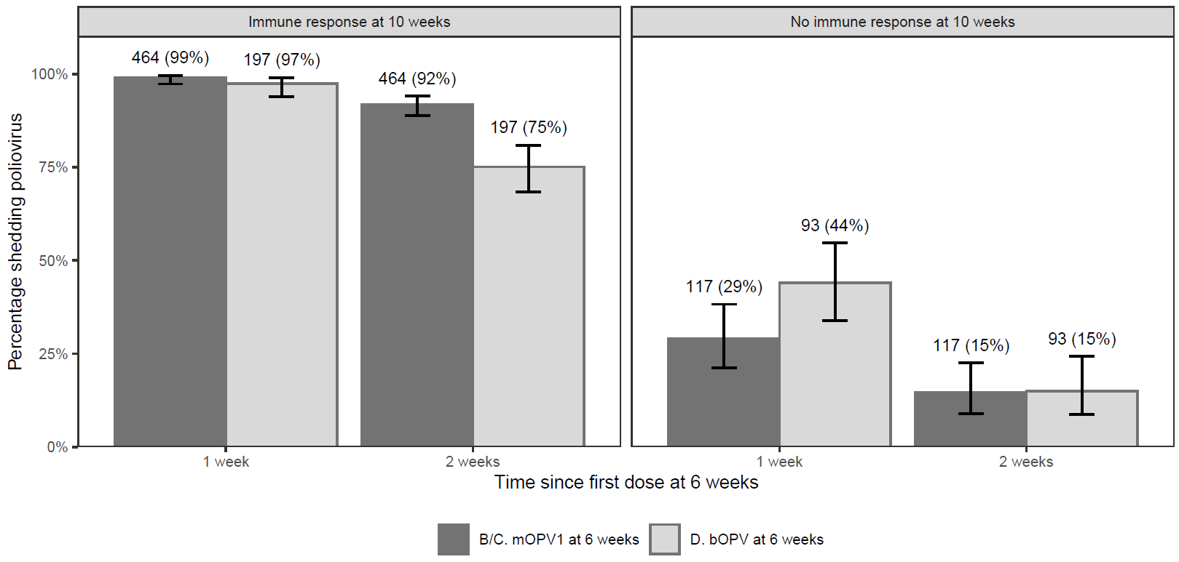
Supplemental Figure 1. Poliovirus type 1 vaccine virus shedding and humoral immunity status by study arms, modified intention-to-treat population
Data are the number of participants by study arms B/C versus arm D with immune response (n, denominator) and percent (%) of participants shedding poliovirus after the first dose at 6 weeks of age. mOPV1=monovalent oral poliovirus vaccine type 1, bOPV=bivalent oral poliovirus vaccine.

