**Supplemental Figure S1a:** Unadjusted Kaplan-Meier survival curve for non-external caused mortality risks by surgery and non-surgery subjects.

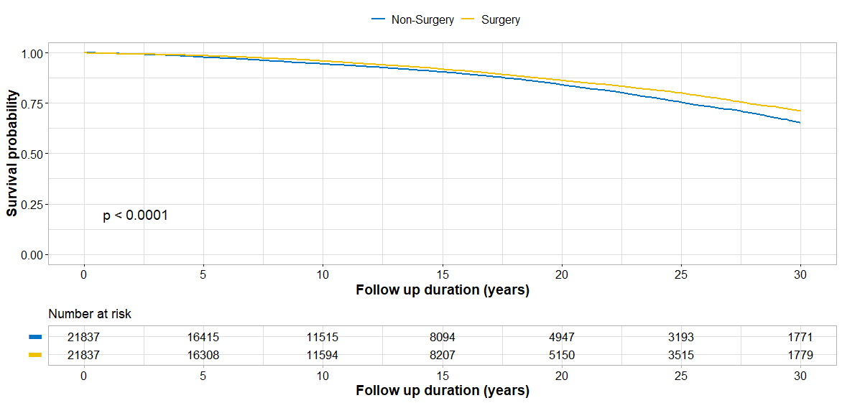

The difference in restricted mean survival time (RMST) between groups was 1.66 (95% CI 1.29-2.03; p<0.001).

**Figure S1b:** Unadjusted Kaplan-Meier survival curve for external caused mortality risks by surgery and non-surgery subjects.

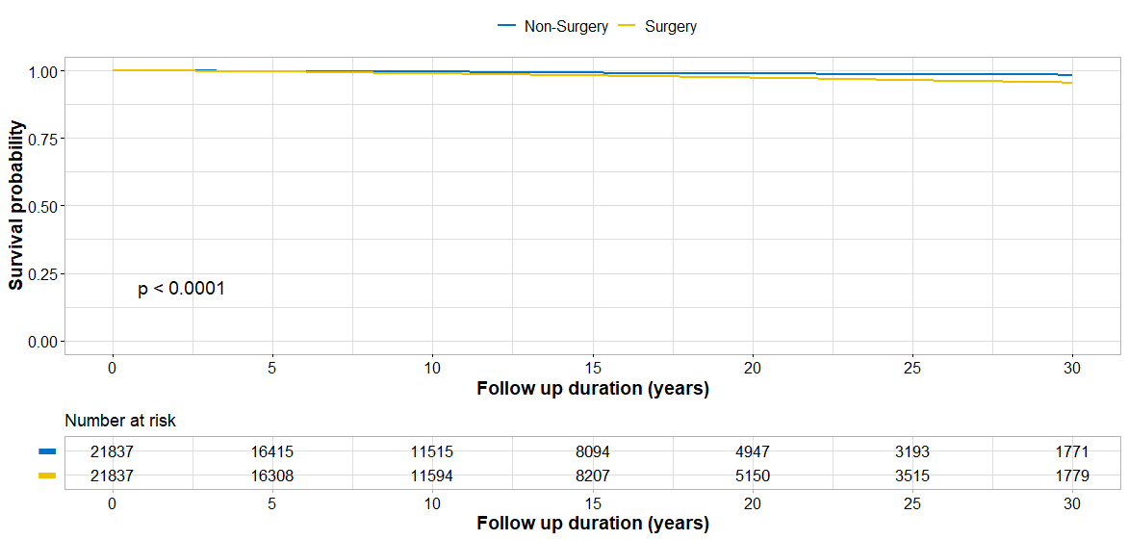

The difference in restricted mean survival time (RMST) was -0.65 (95% CI -0.78 to -0.52); p < 0.001).

**Figure S1c:** Unadjusted Kaplan-Meier survival curve for all-cause mortality risks by surgery and non-surgery subjects.

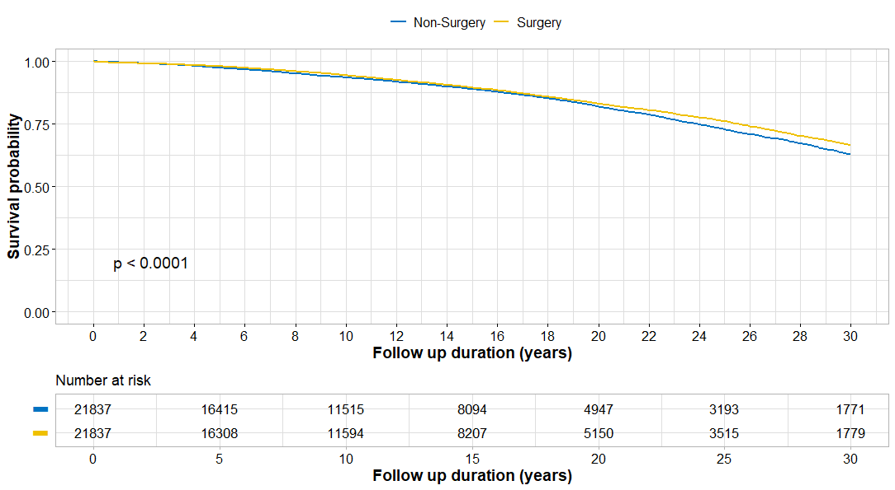

The difference in restricted mean survival time (RMST) was 1.23 (95% CI 0.87-1.60; p<0.001).