SUPPLEMENTAL MATERIALS

A platelet RNA biomarker of ticagrelor responsive genes is associated with platelet function and cardiovascular events

Rachel A Myers¹, Thomas L Ortel², Alexander Waldrop^{2,3}, MacIntosh Cornwell⁴, Jonathan D. Newman⁴, Natalie K Levy⁴, Tessa J. Barrett⁴, Kelly Ruggles⁴, Marcin A Sowa ⁴, Sandeep Dave^{2,3}, Geoffrey S Ginsburg ⁶, Jeffrey S. Berger^{4*}, and Deepak Voora^{2*}

1. Duke Clinical Research Unit, Duke University School of Medicine, Durham NC;
2. Departments of Medicine, Duke University Medical Center, Durham NC;
3. Center for Genomics and Computational Biology, Duke University, Durham, NC
4. NYU Grossman School of Medicine, Leon H. Charney Division of Cardiology, New York, NY
6. All of Us Research Program, National Institutes of Health, Bethesda, MD
*Corresponding Authors

Supplemental Methods:
To prioritize the list of differentially expressed genes to a manageable number amenable for validation we used three criteria described below. Genes that met all three of the following criteria were selected for validation:
- Genes that had average expression (log2 CMP) > 2 in at least one of the treatment groups (untreated or post treated).
- Differential expression analysis using three alternative quantification and/or normalization starting points (gene level RPKM, transcript-level counts, and transcript-level RPKM) was used to identify robust gene associations. Transcript-level counts were analyzed in the same way as the gene-level counts, described above. RPKM for gene- and transcript- level quantification was log2 transformed and used as input to the linear model, fit using the empirical bayes method, and using generalized linear hypothesis testing to test differences between specific treatment drugs or combinations of drugs. Differentially expressed genes with additional evidence of treatment response in any of these three analyses were prioritized for replication.
- To fulfill the third criterion, one of the following had to be met:
  - Regularized logistic regression (lasso) was used to construct a cross-validated, multi-gene model of drug exposure and the differentially expressed genes in this model were prioritized for replication. Briefly, participants were split 80%/20% for training and testing datasets. Within the training data set, participants were partitioned into 10-folds for cross validation, ensuring all samples from a participant fall within a single fold. Within each cross validation, genes were filtered by differential expression re-analysis, with genes having an adjusted p-value < 0.05 as input to the lasso model. The resulting models were preserved from each cross validation and genes were summarized by the number of cross validation models in which they appeared with non-0 weights. Differentially expressed genes appearing in any of the models were prioritized for replication.
  - Weighted gene co-expression network analysis (WGCNA) -- We applied WGCNA to the entire platelet mRNA sequencing data (i.e. 14333 genes in 312 samples). Using the default WGCNA parameters, we identified 111 networks (or “modules”). To further reduce the number of modules, we used hierarchical clustering of the aggregate expression of each module to merge modules with similar aggregate gene expression (Supplemental Figure 2). The result of this process was the identification of 30 unique modules that each represent the aggregate expression of the genes within each module. The attributes of these modules is listed in Supplemental Table 6. The aggregate expression of all genes assigned to a module can be summarized using principal components analysis (PCA) where the 1st principal component (named eigengene) is used as a summary measure of module gene expression. Because each module eigengene can be thought of as the aggregate expression of all of the genes in that module, we can use the eigengene value to test for association with ticagrelor exposure to assess the behavior of the entire module. Each module eigengene was tested for association with ticagrelor using an FDR < 5% cutoff. To select genes within each module, we selected the top 10 genes within each differentially expressed module that were themselves differentially expressed by ticagrelor at FDR < 5% (i.e. part of the original 3402) and 1) their connectivity to the module or 2) their correlation with each module eigengene.

Supplemental Table 1. Numbers of participants in each cohort
 | Discovery Cohort | Validation Cohort
Consented | 84 | 61
Withdrawn | 21 | 11
Lost to follow up | 5 | 1
Completed ticagrelor exposure | 58 | 49

Supplemental Table 2. Baseline characteristics participants
 | HV Discovery Cohort | HV Validation Cohort
Age mean (sd) | 42.9 (10.06) | 44.17 (10.76)
Sex
Male count (%) | 28 (33%) | 25 (41.67%)
Female count (%) | 56 (67%) | 35 (58.%)
BMI | 29.85 (7.44) | NA
Race
White | 37 (44.03%) | 33 (55%)
Black | 36 (42.9%) | 21 (33%)
Asian | 1 (1.2%) | 3 (5.0%)
American Indian | 1 (1.2%) | 0 (0%)
Other | 2 (2.4%) | 2 (3.33%)
Unknown/no response | 7 (8.3%) | 1 (1.67%)
Abbreviations as in Table 1. Sd = standard deviation. BMI = body mass index. NA = not available

Supplemental Table 3. Platelet function test results in discovery cohort
Assay | Baseline | 3 hour post 180 mg loading dose | 4 weeks post 90 mg BID
PFA100 (seconds) | 124.07 (29.68) | 172.48 (69.25)* | 182.78 (70.07)*
EPI 0.05 uM | 325.08 (281.46) | 120.53 (75.02)* | 145.94 (124.64)*
EPI 1 uM | 414.6 (302.43) | 190.21 (171.72)* | 204.43 (172.47)*
EPI 10 uM | 648.82 (227.31) | 417.21 (282.83)* | 509.52 (317.21)*
Collagen 2 mg/ml | 323.42 (62.33) | 232.37 (108.44)* | 259.41 (107.53), p=0.02
Collagen 5 mg/ml | 359.98 (50.32) | 323.35 (85.23)* | 341.82 (78.45)*
ADP 1 uM | 68.73 (85.81) | 2.16 (10.34)* | 0.81 (2.12)*
ADP 5 uM | 328.71 (83.26) | 14.71 (51.51)* | 20.6 (39.03)*
ADP 10 uM | 366.33 (62.68) | 31.72 (70.91)* | 46.23 (66.21)*
PFS | 0.05 (2.09) | -5.52 (2.11)* | -5.02 (2.03)*
Platelet count (10⁹/L) | 204.3 (66.12) | 237.69 (59.65)* | 243.88 (61.06)*
Mean platelet volume (fl) | 8.42 (0.8) | 8.39 (0.84) | 8.36 (0.86)
Abbreviations as per Table 1. Mean (sd) are reported for each platelet function assay. PFA100 = platelet function analyzer 100 assay closure time using collagen/epinephrine cartridge; EPI = epinephrine; ADP = adenosine diphosphate; PFS = platelet function score; fl = femtoliter. All p-values are for comparisons vs. baseline. * = p<0.001.

Supplemental Table 4. Platelet function in Validation cohort
Assay | Baseline | 3 hour post 180 mg loading dose | 4 weeks post 90 mg BID
PFA100 (seconds) | 120.46 (26.52) | 189.1 (80.07)* | 172.96 (75.61)*
EPI 0.05 uM | 307.79 (253.62) | 148.34 (116.54)* | 174.08 (144.94)*
EPI 1 uM | 411.2 (282.71) | 208.73 (192.46)* | 224.08 (195.47)*
EPI 10 uM | 647.4 (232.08) | 405 (258.69)* | 449.47 (261.5)*
Collagen 2 mg/ml | 331.05 (65.56) | 238.41 (91.84)* | 260.76 (75.17)*
Collagen 5 mg/ml | 392.89 (51.82) | 344.48 (81.84)* | 362.57 (67.17), p = 0.004
ADP 1 uM | 86.12 (89.21) | 0.54 (2.42)* | 2.15 (6.39)*
ADP 5 uM | 365.82 (74.24) | 11.82 (20.36)* | 19.87 (27.98)*
ADP 10 uM | 379.95 (40.63) | 36.18 (41.51)* | 57.59 (53.17)*
PFS | 0.59 (1.91) | -5.43 (1.83)* | -4.82 (1.75)*
Platelet count (10⁹/L) | 238.31 (71.29) | 244.14 (73.89), p=0.01 | 254.41 (72.85)*
Mean platelet volume (fl) | 8.34 (0.73) | 8.29 (0.74), p = 0.005 | 8.35 (0.79)
Abbreviations per Supplemental Table 3.

Supplemental Table 5. Ticagrelor Exposure Gene Set Genes (n=111)
Ensembl Gene ID | Gene Symbol | Chromosomal locus
ENSG00000170345 | FOS | chr14:75745476-75748933
ENSG00000171223 | JUNB | chr19:12873816-12985765
ENSG00000215791 | AL645728.2 | chr1:1477052-1510249
ENSG00000163131 | CTSS | chr1:150702671-150738433
ENSG00000128016 | ZFP36 | chr19:39897452-39900052
ENSG00000204287 | HLA-DRA | chr6:32407618-32412823
ENSG00000209082 | MT-TL1 | chrM:3229-3304
ENSG00000271043 | MTRNR2L2 | chr5:79922046-80172279
ENSG00000090382 | LYZ | chr12:69742120-69748014
ENSG00000269028 | MTRNR2L12 | chr3:96335980-96337000
ENSG00000084070 | SMAP2 | chr1:40810521-40888998
ENSG00000256222 | MTRNR2L3 | chr20:55926065-55954267
ENSG00000165507 | C10orf10 | chr10:45306471-45491339
ENSG00000109180 | OCIAD1 | chr4:48807228-48863834
ENSG00000146072 | TNFRSF21 | chr6:47199267-47277641
ENSG00000171222 | SCAND1 | chr20:34541538-34547394
ENSG00000100297 | MCM5 | chr22:35796055-35821423
ENSG00000234645 | AC097523.2 | chr2:139045598-139046363
ENSG00000108384 | RAD51C | chr17:56769933-56811703
ENSG00000215472 | RPL17-C18orf32 | chr18:47008027-47018906
ENSG00000132478 | UNK | chr17:73772514-73821886
ENSG00000183726 | TMEM50A | chr1:25568727-25756683
ENSG00000173085 | COQ2 | chr4:84182688-84206067
ENSG00000140740 | UQCRC2 | chr16:21963980-21994981
ENSG00000255990 | AC034102.1 | chr12:56367696-56388490
ENSG00000150455 | TIRAP | chr11:126152959-126215644
ENSG00000132357 | CARD6 | chr5:40841285-40860275
ENSG00000196352 | CD55 | chr1:207494852-207534311
ENSG00000130414 | NDUFA10 | chr2:240831866-240964819
ENSG00000026025 | VIM | chr10:17256237-17279592
ENSG00000099341 | PSMD8 | chr19:38865175-38874464
ENSG00000065054 | SLC9A3R2 | chr16:2075356-2089027
ENSG00000167244 | IGF2 | chr11:2150341-2182571
ENSG00000160255 | ITGB2 | chr21:46305867-46351904
ENSG00000184922 | FMNL1 | chr17:43268297-43394414
ENSG00000168010 | ATG16L2 | chr11:72525352-72853306
ENSG00000076928 | ARHGEF1 | chr19:42387227-42434302
ENSG00000130600 | H19 | chr11:2016405-2022700
ENSG00000177469 | PTRF | chr17:40554469-40575535
ENSG00000171608 | PIK3CD | chr1:9711789-9884584
ENSG00000134758 | RNF138 | chr18:29598334-30050447
ENSG00000106948 | AKNA | chr9:117096435-117156685
ENSG00000108669 | CYTH1 | chr17:76670129-76778379
ENSG00000137575 | SDCBP | chr8:59465482-59495419
ENSG00000000938 | FGR | chr1:27938574-27961788
ENSG00000210191 | MT-TL2 | chrM:12265-12336
ENSG00000244921 | CTB-36O1.7 | chr5:134240595-134347392
ENSG00000254132 | MTND6P3 | chr5:93488670-94620279
ENSG00000198840 | MT-ND3 | chrM:10058-10404
ENSG00000210127 | MT-TA | chrM:5586-5655
ENSG00000180581 | SRP9P1 | chr10:93558068-93625033
ENSG00000206573 | SETD5-AS1 | chr3:9022274-9520924
ENSG00000144744 | UBA3 | chr3:69024364-69129559
ENSG00000210194 | MT-TE | chrM:14673-14742
ENSG00000143742 | SRP9 | chr1:225965530-225978168
ENSG00000270230 | RP11-475J5.11 | chr5:99382153-99382674
ENSG00000163320 | CGGBP1 | chr3:88101093-88217879
ENSG00000229124 | VIM-AS1 | chr10:17256237-17279592
ENSG00000198695 | MT-ND6 | chrM:14148-14673
ENSG00000248923 | MTND5P11 | chr5:134240595-134347392
ENSG00000249119 | MTND6P4 | chr5:134240595-134347392
ENSG00000169218 | RSPO1 | chr1:38076950-38100595
ENSG00000105640 | RPL18A | chr19:17970684-17974962
ENSG00000196236 | XPNPEP3 | chr22:41253080-41369313
ENSG00000167283 | ATP5L | chr11:118230299-118302211
ENSG00000175602 | CCDC85B | chr11:65657874-65659105
ENSG00000248309 | MEF2C-AS1 | chr5:87803362-88762215
ENSG00000116266 | STXBP3 | chr1:109289295-109352148
ENSG00000100387 | RBX1 | chr22:41253080-41369313
ENSG00000119414 | PPP6C | chr9:127908851-127952218
ENSG00000115091 | ACTR3 | chr2:114647536-114720173
ENSG00000189045 | ANKDD1B | chr5:74907283-74967671
ENSG00000063177 | RPL18 | chr19:49118584-49140695
ENSG00000245910 | SNHG6 | chr8:67782983-67838633
ENSG00000181029 | TRAPPC5 | chr19:7741513-7747744
ENSG00000167978 | SRRM2 | chr16:2787076-2827298
ENSG00000172531 | PPP1CA | chr11:67159175-67193078
ENSG00000125691 | RPL23 | chr17:37004117-37010096
ENSG00000105193 | RPS16 | chr19:39923846-39926588
ENSG00000121749 | TBC1D15 | chr12:72233486-72320629
ENSG00000196642 | RABL6 | chr9:139685806-139735639
ENSG00000131469 | RPL27 | chr17:41150289-41154976
ENSG00000254934 | LINC00678 | chr11:27528384-27899195
ENSG00000136754 | ABI1 | chr10:26986587-27150016
ENSG00000137154 | RPS6 | chr9:19375448-19380252
ENSG00000108298 | RPL19 | chr17:37356535-37360980
ENSG00000178458 | H3F3AP6 | chr4:140586921-141075338
ENSG00000105669 | COPE | chr19:19010322-19057640
ENSG00000010244 | ZNF207 | chr17:30593194-30708905
ENSG00000148303 | RPL7A | chr9:136215068-136218281
ENSG00000229809 | ZNF688 | chr16:30580666-30597092
ENSG00000125356 | NDUFA1 | chrX:119004496-119010625
ENSG00000220875 | HIST1H3PS1 | chr6:26322103-26322520
ENSG00000063245 | EPN1 | chr19:56186591-56249768
ENSG00000078668 | VDAC3 | chr8:42249141-42263415
ENSG00000100316 | RPL3 | chr22:39708886-39716394
ENSG00000140299 | BNIP2 | chr15:59887073-59981733
ENSG00000102804 | TSC22D1 | chr13:45007654-45151283
ENSG00000189043 | NDUFA4 | chr7:10971577-10979883
ENSG00000125503 | PPP1R12C | chr19:55602280-55628927
ENSG00000076944 | STXBP2 | chr19:7694622-7712759
ENSG00000108424 | KPNB1 | chr17:45726841-45762871
ENSG00000141522 | ARHGDIA | chr17:79825596-79829282
ENSG00000089351 | GRAMD1A | chr19:35485687-35517375
ENSG00000068120 | COASY | chr17:40688189-40718295
ENSG00000089009 | RPL6 | chr12:112842993-112947717
ENSG00000089009 | RPL6 | chr12:112842993-112947717
ENSG00000125970 | RALY | chr20:32570857-32700138
ENSG00000116604 | MEF2D | chr1:156433518-156470620
ENSG00000111913 | FAM65B | chr6:24797548-25057301
ENSG00000101940 | WDR13 | chrX:48448429-48463581
ENSG00000156858 | PRR14 | chr16:30662037-30667761

Supplemental Table 6. Attributes of WGCNA modules and their association with ticagrelor exposure
Module Name | Number of genes within module | Percent variation explained by module eigengene | Number of ticagrelor differentially expressed genes (FDR < 5%) | Adjusted P-Value (FDR)
coral | 1182 | 0.3615667 | 412 | 2.49E-11
antiquewhite2 | 37 | 0.3738499 | 21 | 9.74E-10
sienna4 | 29 | 0.6495133 | 24 | 4.07E-07
coral2 | 63 | 0.5493519 | 16 | 1.75E-06
mediumpurple3 | 97 | 0.5161945 | 56 | 3.25E-06
lavenderblush2 | 41 | 0.5349828 | 7 | 4.40E-06
blue2 | 71 | 0.4417992 | 14 | 5.80E-06
darkolivegreen2 | 116 | 0.2067153 | 14 | 5.80E-06
plum4 | 22 | 0.4808508 | 3 | 1.15E-05
thistle | 44 | 0.4608872 | 24 | 2.26E-05
grey60 | 1710 | 0.3661776 | 550 | 0.00034554
indianred3 | 302 | 0.3675995 | 35 | 0.00034554
orange | 1945 | 0.4502556 | 249 | 0.00044763
navajowhite1 | 182 | 0.3758395 | 38 | 0.0017585
cyan | 207 | 0.441813 | 147 | 0.00193069
plum | 855 | 0.4621138 | 254 | 0.00684944
magenta4 | 41 | 0.6220161 | 2 | 0.01530331
navajowhite2 | 437 | 0.4509907 | 62 | 0.01530331
salmon1 | 20 | 0.5053557 | 0 | 0.01530331
coral1 | 66 | 0.1675752 | 14 | 0.02084977
darkgreen | 165 | 0.1921023 | 25 | 0.02260501
mediumpurple2 | 870 | 0.4285663 | 108 | 0.10728478
darkolivegreen4 | 118 | 0.3260233 | 18 | 0.13955516
darkmagenta | 112 | 0.1343584 | 31 | 0.22116482
lightgreen | 283 | 0.2922061 | 114 | 0.40936403
mediumpurple1 | 27 | 0.377489 | 3 | 0.40936403
blueviolet | 24 | 0.5229048 | 13 | 0.51707371
darkseagreen3 | 3051 | 0.3788617 | 834 | 0.68547154
firebrick3 | 25 | 0.4891038 | 13 | 0.75400033

Supplemental Table 7. Baseline characteristics of patients with peripheral arterial disease (PAD) and those with cardiovascular risk factors but no PAD (Control)
Characteristic | Measure | Control (N = 30) | PAD (N = 139) | p-value | Chi square p-value
Age | Years, mean (sd) | 59.87 (7.48) | 70.38 (10.89) | <0.001 | n/a
Sex | Female, N (%) | 17 (56.7) | 46 (33.1) | 0.024 | n/a
Race | Asian, N (%) | 1 (3.3) | 3 (2.2) | 0.743 | 0.182
Race | Black, N (%) | 3 (10) | 28 (20.1) | 0.126 | 0.182
Race | Other, N (%) | 9 (30) | 21 (15.1) | 0.108 | 0.182
Race | White, N (%) | 17 (56.7) | 87 (62.6) | 0.56 | 0.182
Ethnicity | Hispanic/Latino, N (%) | 9 (30) | 29 (21) | 0.334 | n/a
Smoking status | Never, N (%) | 22 (73.3) | 35 (25.2) | <0.001 | < 0.001
Smoking status | Former (quit >2 weeks ago), N (%) | 8 (26.7) | 83 (59.7) | 0.001 | < 0.001
Smoking status | Current (smoked within 2 weeks), N (%) | 0 (0) | 21 (15.1) | <0.001 | < 0.001
Diabetes | Yes, N (%) | 15 (50) | 76 (54.7) | 0.649 | n/a
Hypertension | Yes, N (%) | 19 (63.3) | 118 (84.9) | 0.029 | n/a
Hyperlipidemia | Yes, N (%) | 22 (73.3) | 96 (69.1) | 0.642 | n/a
Aspirin | Yes, N (%) | 30 (100) | 120 (86.3) | <0.001 | n/a
Clopidogrel | Yes, N (%) | 0 (0) | 52 (37.4) | <0.001 | n/a
Statin | Yes, N (%) | 18 (60) | 114 (82) | 0.029 | n/a
Any antiplatelet therapy | Yes, N (%) | 30 (100) | 127 (91.4) | <0.001 | n/a
History of coronary artery disease | Yes, N (%) | 0 (0) | 73 (52.5) | <0.001 | n/a
History of cerebrovascular disease | Yes, N (%) | 1 (3.3) | 22 (15.8) | 0.007 | n/a

Supplemental Figure 1. Application of prioritization criteria to filter list of 3409 differentially expressed genes to 111 transcripts used to define the TES.

Supplemental Figure 2 Correlation of Ticagrelor Exposure Signature (TES) Scores constructed all 3409 differentially expressed genes (y-axis) vs. the subset of 111 prioritized as being robustly and reproducibly differently expressed (x-axis).
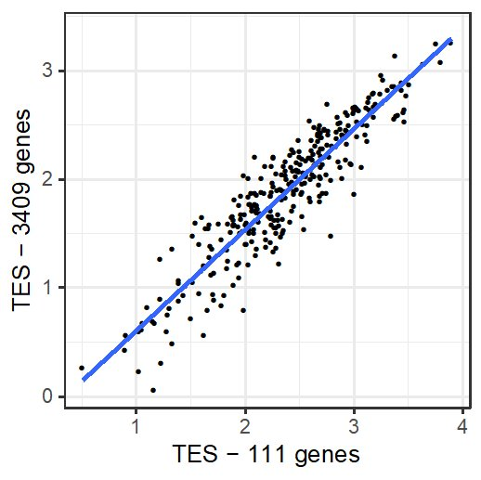

Supplemental Figure 3. Dendrogram of WGCNA modules. Hierarchical clustering of the aggregate expression of the 111 individual modules was performed. Modules with similar expression are closer to each other along the x-axis and similarities (or dissimilarities) between modules is indicated by the vertical distance between modules. The red-horizontal line depicts the cut-point for merging modules. Genes within modules that are part of a tree that forms below the red line are merged into a single module. For example the genes belonging to the darkolivegreen4 and honeydew1 modules are merged into a new module named darkolivegreen4 (not shown). In contrast, the genes in the darkmagenta and firebrick3 modules remain separate modules with the same names.
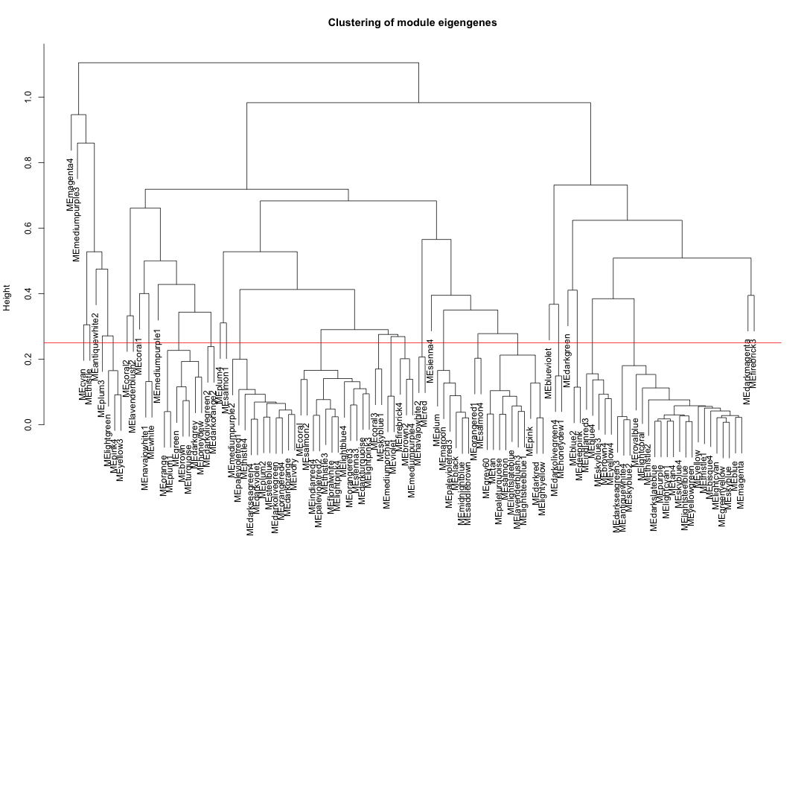

Major Resources Table
Animals (in vivo studies): NA
Genetically Modified Animals: NA
Antibodies
Target antigen | Vendor or Source | Catalog # | Working concentration | Lot # (preferred but not required) | Persistent ID / URL
Human CD42a | BD Biosciences | #558819 |  |  | https://www.bdbiosciences.com/en-us/products/reagents/flow-cytometry-reagents/research-reagents/single-color-antibodies-ruo/pe-mouse-anti-human-cd42a.561853
DNA/cDNA Clones: NA
Cultured Cells:
Name | Vendor or Source | Sex (F, M, or unknown) | Persistent ID / URL
Cluster of differentiation (CD) 34⁺ | Fred Hutchinson Cancer Research Center (Seattle, WA) | Unknown | https://www.fredhutch.org/en/research/divisions/clinical-research-division/research/co-operative-center-for-excellence-in-hematology/hematopoietic-cell-procurement-and-resource-development.html#order

Data & Code Availability:
Description | Source / Repository | Persistent ID / URL
RNA sequencing data | Gene Expression Omnibus | https://www.ncbi.nlm.nih.gov/geo/query/acc.cgi?acc=GSE158765

