Supplemental Table 1: International Classification of Diseases-6-10 codes for outcomes of interest with at least 10 cases used in all dose-response analyses
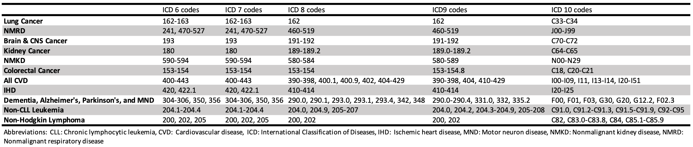

Supplemental Table 2: Radiation monitoring status for 2514 Mallinckrodt employees employed for at least 30 days, 1942-1966 and followed through 2019.
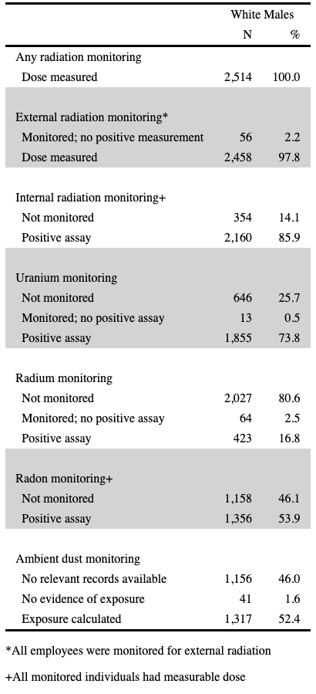

Supplemental Table 3: Dust exposures and external, internal, and total radiation doses (weighted-mGy) to specified organs and tissues received by 2514 monitored Mallinckrodt workers employed for at least 30 days 1942-1966 and followed through 2019 with differing weighting factors for internal uranium, radium, and radon doses for total doses.
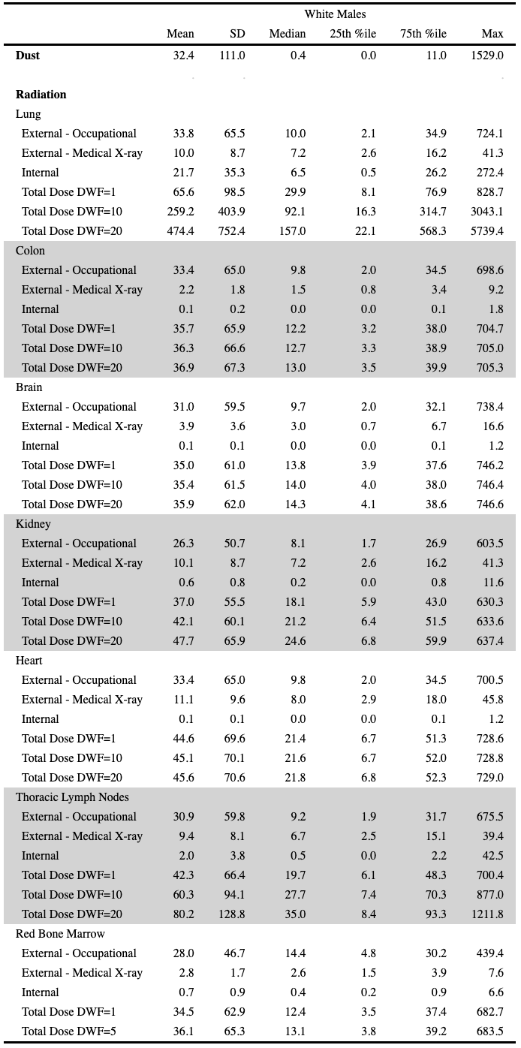
Abbreviations: DWF: dose weighting factor
Supplemental Table 4: Standardized mortality ratios (SMRs) and 95% confidence intervals (CI) for selected causes of death among 2514 Mallinckrodt Chemical Works employees with follow-up 1942-2019
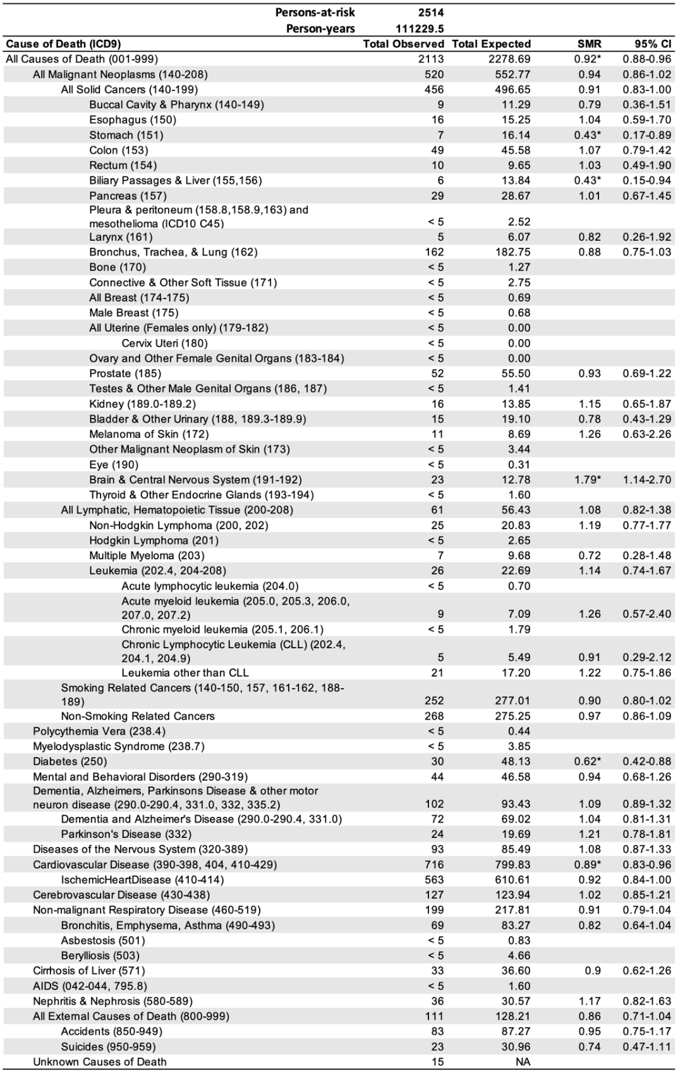
Abbreviations: CI: confidence interval, ICD: International Classification of Diseases, SMR: standardized mortality ratio
Supplemental Table 5: Standardized mortality ratios (SMRs) and 95% confidence intervals (CI) for selected causes of death among 438 salaried Mallinckrodt Chemical Works employees with follow-up 1942-2019.
Abbreviations: CI: confidence interval, ICD: International Classification of Diseases, SMR: standardized mortality ratio
Supplemental Table 6: Standardized mortality ratios (SMRs) and 95% confidence intervals (CI) for selected causes of death among 2076 hourly Mallinckrodt Chemical Works employees with follow-up 1942-2019.
Abbreviations: CI: confidence interval, ICD: International Classification of Diseases, SMR: standardized mortality ratio

Supplemental Table 7: Hazard ratios for selected causes of death for continuous organ-specific doses with internal dose weighting factor of 10 (5 for red bone marrow) for 2514 Mallinckrodt employees employed for at least 30 days, 1942-1966 and followed through 2019.
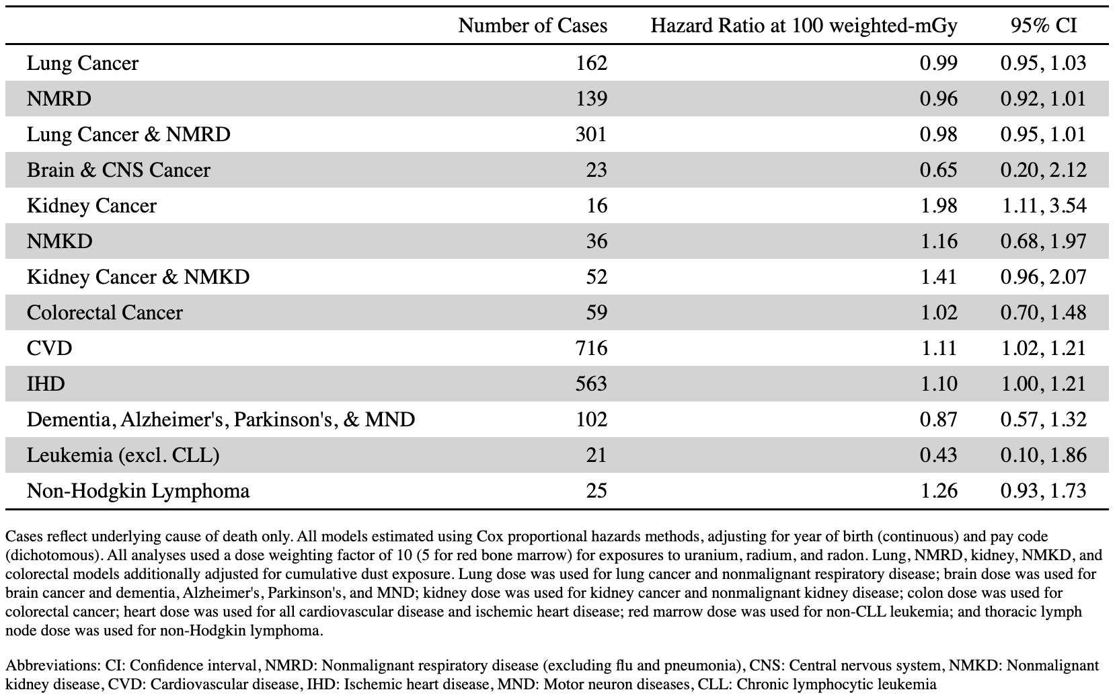

Supplemental Table 8: Hazard ratios for selected causes of death for continuous organ-specific doses with internal dose weighting factor of 20 for 2514 Mallinckrodt employees employed for at least 30 days, 1942-1966 and followed through 2019.
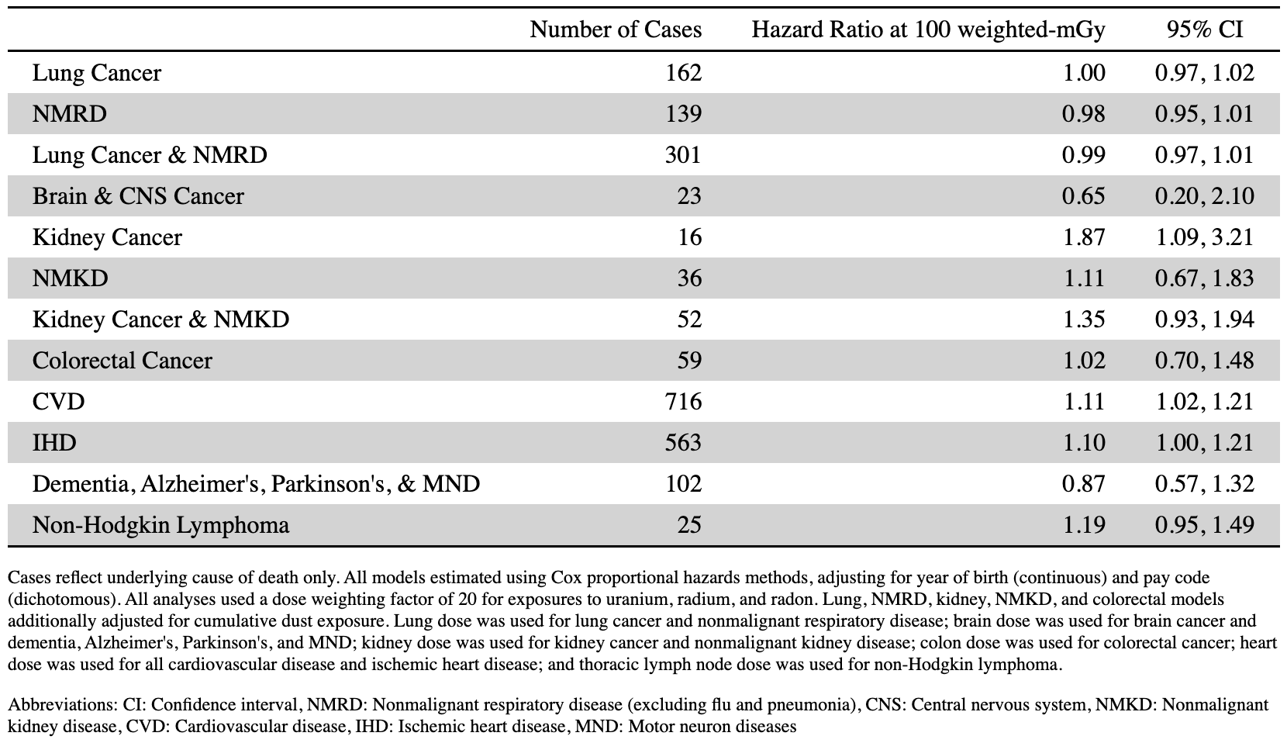

Supplemental Table 9: Hazard ratios for selected causes of death for categorical and continuous dust levels for 2514 Mallinckrodt employees employed for at least 30 days, 1942-1966 and followed through 2019, censoring at age 85 instead of 95.
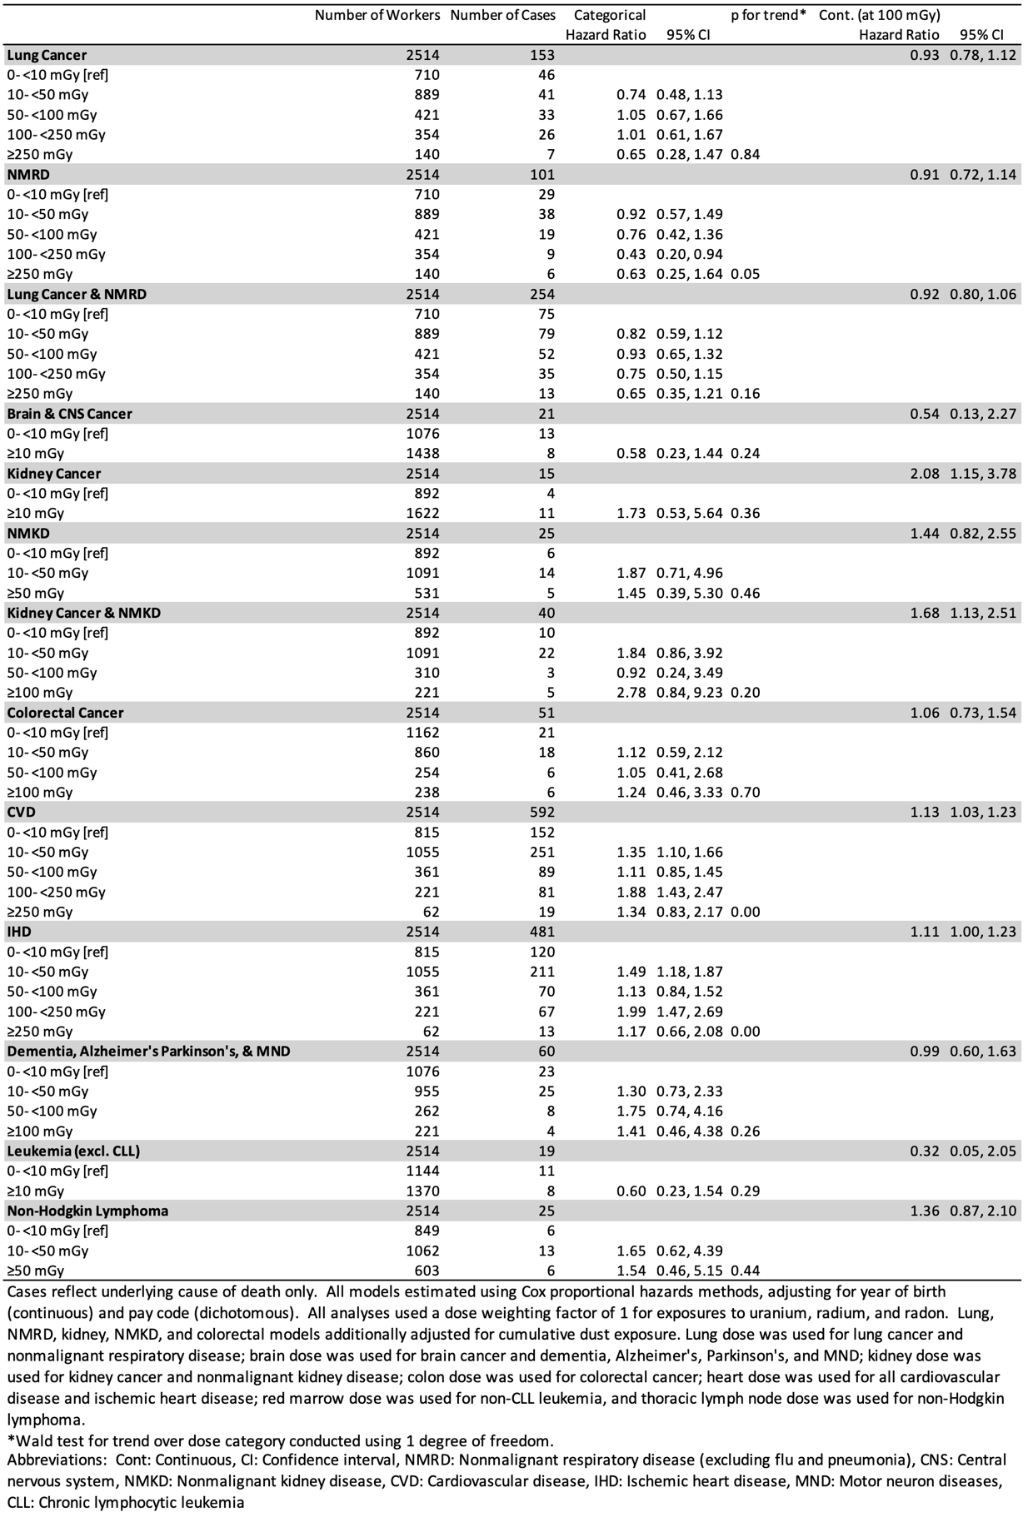
Supplemental Table 10: Hazard ratios for selected causes of death including contributing causes of death for continuous organ-specific doses for 2514 Mallinckrodt employees employed for at least 30 days, 1942-1966 and followed through 2019.
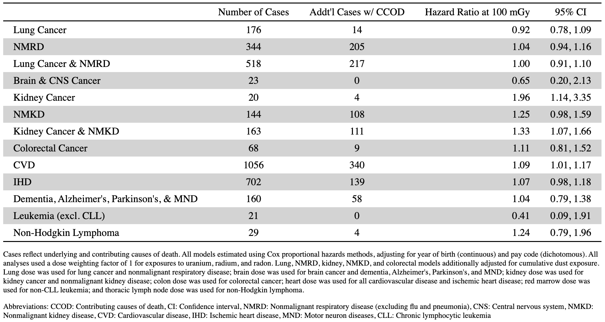

Supplemental Table 11: Hazard ratios for selected causes of death including contributing causes of death over continuous dust levels for 2514 Mallinckrodt employees employed for at least 30 days, 1942-1966 and followed through 2019.
