**Supplemental Figure S2.** **Confirmatory factor analysis of patient willingness to participate in PharmFITTM**

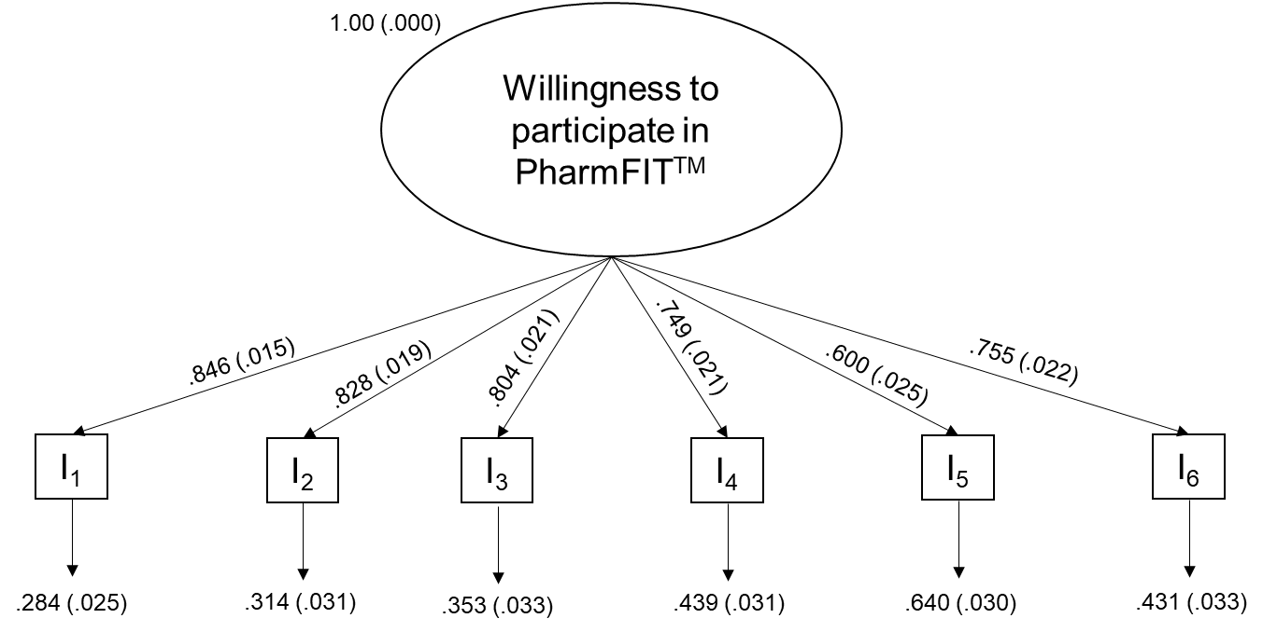

**Description.** Measurement model for the latent variable willingness to participate in PharmFIT™. “I” stands for indicator variable used in the model, found in Supplemental Table S2. Factor loadings are standardized.