**Supplemental Figure S1. Confirmatory factor analysis of Innovative traits of PharmFITTM**

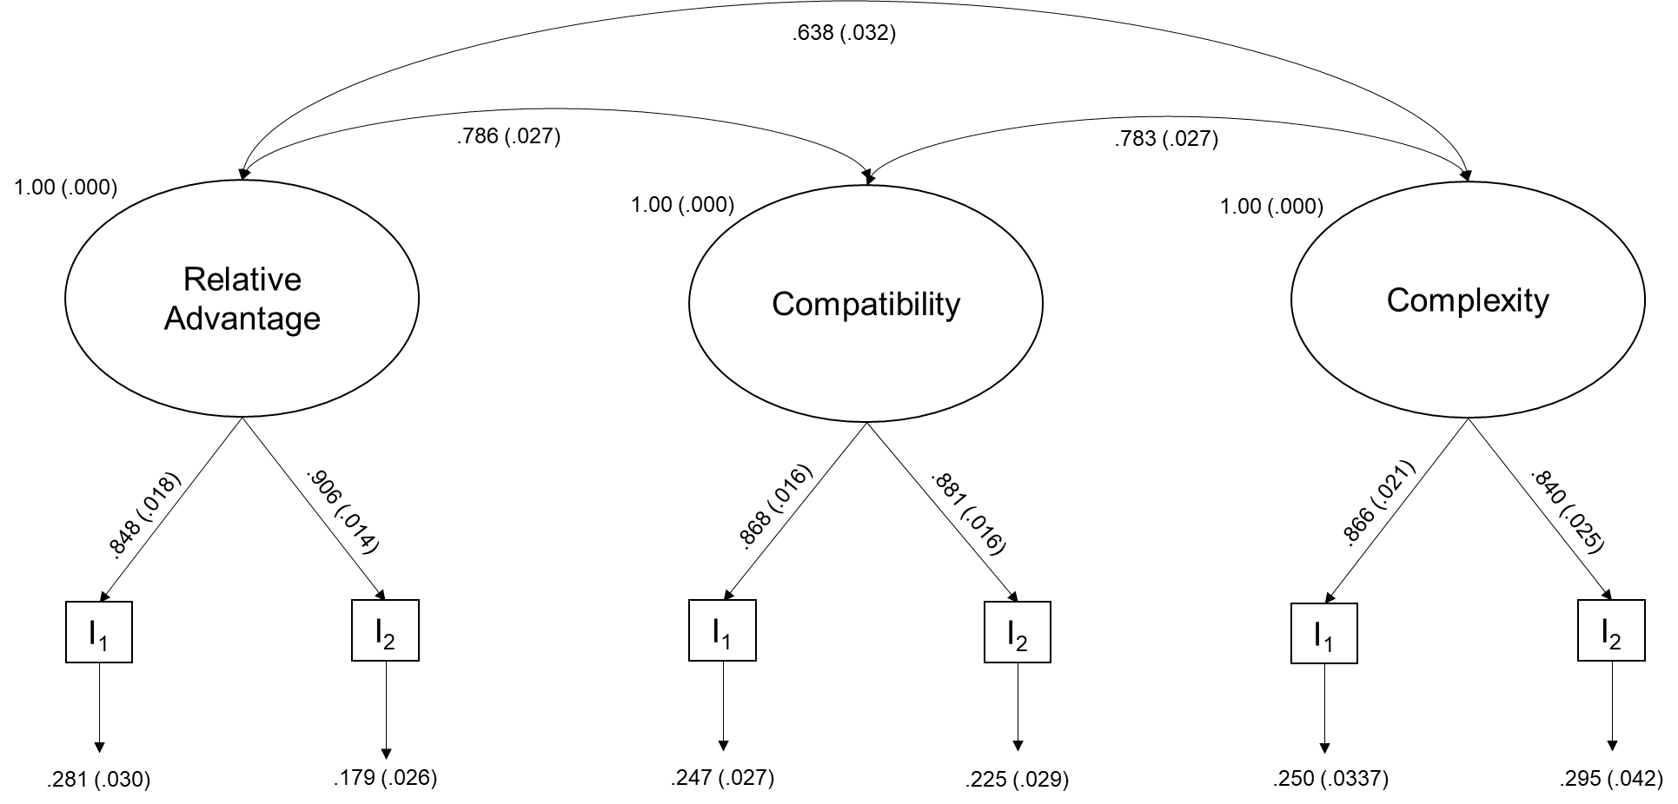

**Description.** Diffusion of Innovation measurement model for the latent variables relative advantage, compatibility, and complexity. “I” stands for indicator variable used in the model, found in Supplemental Table S2. Factor loadings are standardized.