Supplemental Figure S3. Confirmatory factor analysis of perceived service quality at the pharmacy

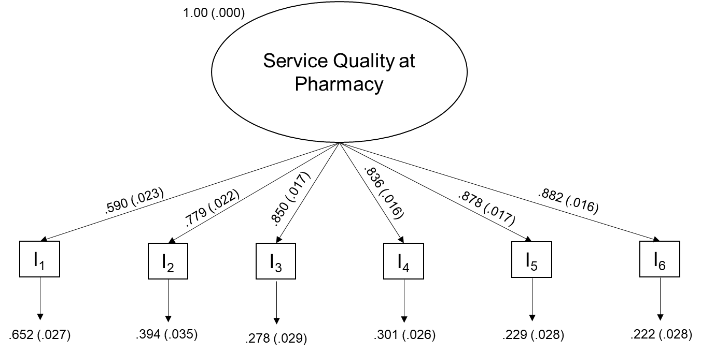

Description. Measurement model for the latent variable service quality at pharmacy. “I” stands for indicator variable used in the model, found in Supplemental Table S2. Factor loadings are standardized.

