Supplemental Material

Table S1. Percentage of samples above the limit of detection (LOD) for each PFAS analyte (ng/mL) in the analytic sets from the AZ-HEROES/RECOVER cohort.

Analyte | LOD, NJDOH | Post-Infection Cohort, n (%) | LOD, Eurofins | Post-Vaccination Cohort, n (%)
PFBS | 0.009 | 90 (58.8) | 0.1 | 210 (24.2)
PFDA | 0.019 | 140 (91.5) | 0.2 | 211 (24.3)
PFDoA | 0.013 | 22 (14.4) | 0.1 | 6 (0.7)
PFHpA | 0.011 | 64 (41.8) | 0.1 | 48 (5.5)
PFHxS | 0.019 | 153 (100.0) | 0.1 | 865 (99.7)
PFNA | 0.008 | 153 (100.0) | 0.2 | 765 (88.1)
Total PFOA | 0.014 | 153 (100.0) | 0.3 | 845 (97.4)
L-PFOA | NA | NA | 0.3 | 845 (97.4)
Br-PFOA | NA | NA | 0.3 | 0 (0.0)
Total PFOS | 0.014 | 153 (100.0) | 0.2 | 865 (99.7)
L-PFOS | NA | NA | 0.2 | 865 (99.7)
Br-PFOS | NA | NA | 0.2 | 825 (95.0)
PFOSA | 0.004 | 75 (49.0) | 0.1 | 0 (0.0)
PFUnDA | 0.006 | 135 (88.2) | 0.1 | 342 (39.4)
Abbreviations: NJDOH, New Jersey Department of Health; PFOA, perfluorooctanoic acid;
PFOS, perfluorooctane sulfonic acid; PFUnDA, perfluoroundecanoate;
PFBS, perfluorobutane sulfonate; PFDA, perfluorodecanoate; PFHxS, perfluorohexane sulfonic acid;
PFNA, perfluorononanoic acid.

Table S2. Unadjusted parameter estimates from regression models assessing the relationship between baseline PFAS levels and peak antibody response (Peak) and antibody decline over time (Slope) for RBD and S2 immune markers for post-infection cohort.

 | RBD AUC |  | S2 AUC
PFAS Analyte | Peak (95% CI)ª | Slope (95% CI)^{b} | Peak (95% CI)ª | Slope (95% CI)^{b}
PFOA | -0.13 (-0.29, 0.03) | 0.0007 (0.0001, 0.001) | -0.07 (-0.20, 0.07) | 0.0006 (-0.00001, 0.001)
PFOS | -0.13 (-0.27, 0.02) | 0.0007 (0.0001, 0.001) | -0.13 (-0.25, -0.005) | 0.0007 (0.0002, 0.001)
PFHxS | -0.11 (-0.23, 0.01) | 0.0005 (-0.00003, 0.001) | -0.09 (-0.20, 0.02) | 0.005 (0.00002, 0.001)
PFNA | -0.11 (-0.29, 0.06) | 0.0007 (-0.00007, 0.001) | -0.11 (-0.26, 0.04) | 0.0007 (0.00007, 0.001)

One model per each ELISA outcome/PFAS analyte combination, with an estimated peak and slope difference in each model.
ª Mean difference in antibody levels at week 0.
^{b} Change in the antibody trajectory over time for each unit increase in associated PFAS. Estimated from the interaction coefficient of time and PFAS analyte.
Bold signifies statistically significant at alpha = 0.05. P-values estimated using Satterthwaite's degrees of freedom method.
Abbreviations: CI, confidence interval; RBD, receptor-binding domain; AUC, area under the curve; PFOA, perfluorooctanoic acid; PFOS, perfluorooctane sulfonic acid; PFHxS, perfluorohexane sulfonic acid; PFNA, perfluorononanoic acid.

Table S3. Unadjusted parameter estimates from regression models assessing the relationship between baseline PFAS levels and peak antibody response (Peak) and antibody decline over time (Slope) for RBD and S2 immune markers for post-vaccination cohort

 | RBD AUC |  | S2 AUC
PFAS Analyte | Peak (95% CI)ª | Slope (95% CI)^{b} | Peak (95% CI)ª | Slope (95% CI)^{b}
Total PFOA | 0.04 (0.0008, 0.08) | -0.0001 (-0.0003, 0.0001) | 0.04 (-0.0002, 0.08) | -0.0001 (-0.0003, 0.0001)
Total PFOS | 0.02 (-0.01, 0.05) | 0.0001 (-0.00005, 0.0003) | 0.03 (-0.004, 0.06) | -0.00005 (-0.0002, 0.0001)
Br-PFOS | 0.04 (0.003, 0.07) | 0.0001 (-0.0001, 0.0002) | 0.05 (0.01, 0.08) | -0.0002 (-0.0003, -0.00001)
L-PFOS | 0.02 (-0.02, 0.05) | 0.0001 (-0.00002, 0.0003) | 0.02 (-0.01, 0.05) | -0.00001 (-0.0002, 0.0002)
L-PFOA | 0.04 (0.0008, 0.08) | -0.0001 (-0.0003, 0.0001) | 0.04 (-0.0004, 0.08) | -0.0001 (-0.0003, 0.0001)
PFHxS | 0.04 (0.01, 0.07) | 0.0001 (-0.0001, 0.0002) | 0.04 (0.01, 0.07) | -0.0002 (-0.0003, -0.00003)
PFNA | 0.004 (-0.04, 0.05) | -0.0001 (-0.0003, 0.0001) | 0.02 (-0.02, 0.06) | -0.0001 (-0.0003, 0.0001)

One model per each ELISA outcome/PFAS analyte combination, with an estimated peak and slope difference in each model.
ª Mean difference in antibody levels at week 0.
^{b} Change in the antibody trajectory over time for each unit increase in associated PFAS. Estimated from the interaction coefficient of time and PFAS analyte.
Bold signifies statistically significant at alpha = 0.05. P-values estimated using Satterthwaite's degrees of freedom method.
Abbreviations: CI, confidence interval; RBD, receptor-binding domain; AUC, area under the curve; PFOA, perfluorooctanoic acid; PFOS, perfluorooctane sulfonic acid; PFHxS, perfluorohexane sulfonic acid; PFNA, perfluorononanoic acid.

Figure S1. Distribution of PFAS analytes in post-infection sample, with concentrations normalized to mean zero and one standard deviation: (concentration – sample mean concentration)/(sample standard deviation concentration)

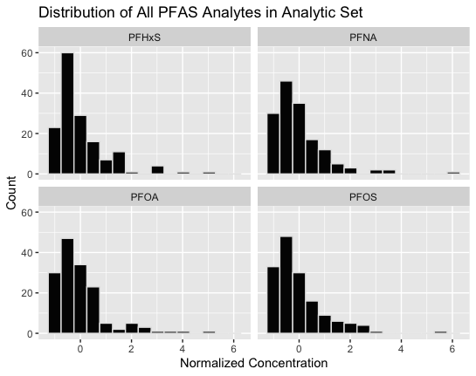

Figure S2. Distribution of PFAS analytes in post-vaccination sample, with concentrations normalized to mean zero and one standard deviation: (concentration – sample mean concentration)/(sample standard deviation concentration)

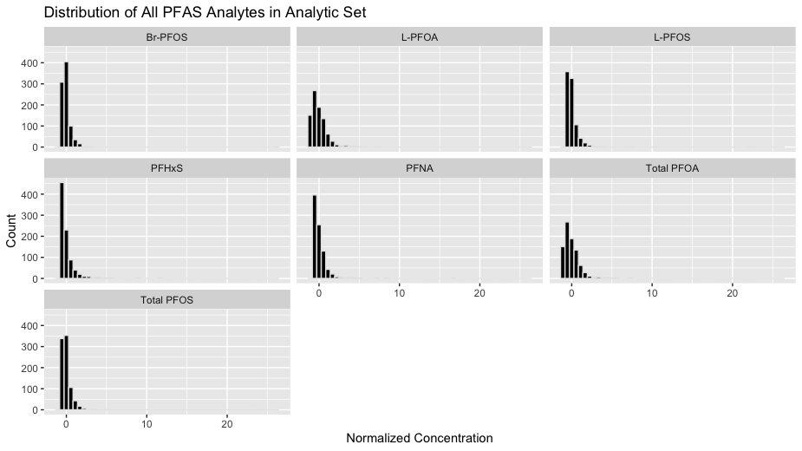

Figure S3: Fitted estimates for PFOA models for post-infection cohort, fitted at 20th, 40th, 60th, and 80th PFOA percentiles.

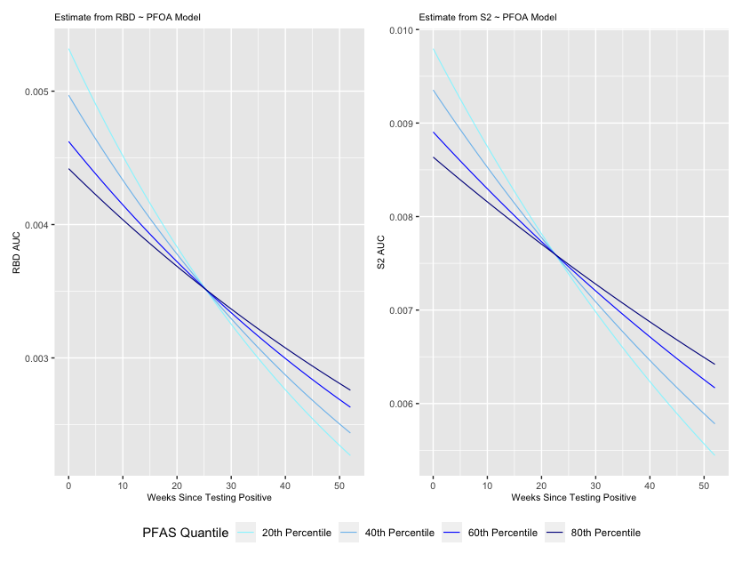

Figure S4: Fitted estimates for PFOS models for post-infection cohort, fitted at 20th, 40th, 60th, and 80th PFOS percentiles.

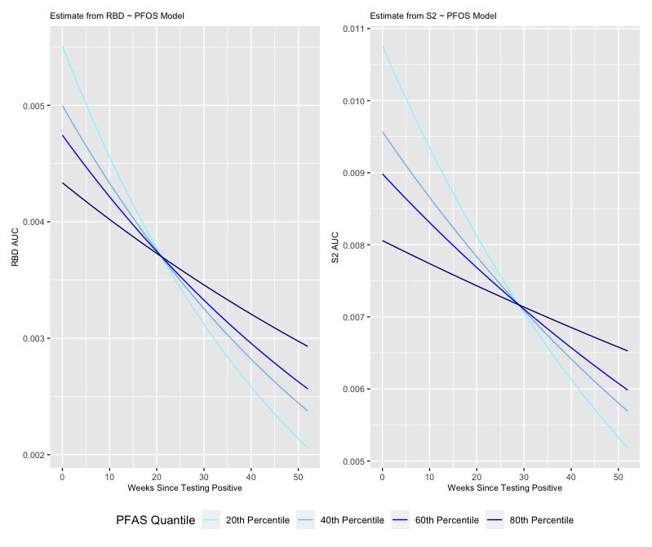

Figure S5: Fitted estimates for PFHxS models for post-infection cohort, fitted at 20th, 40th, 60th, and 80th PFHxS percentiles.

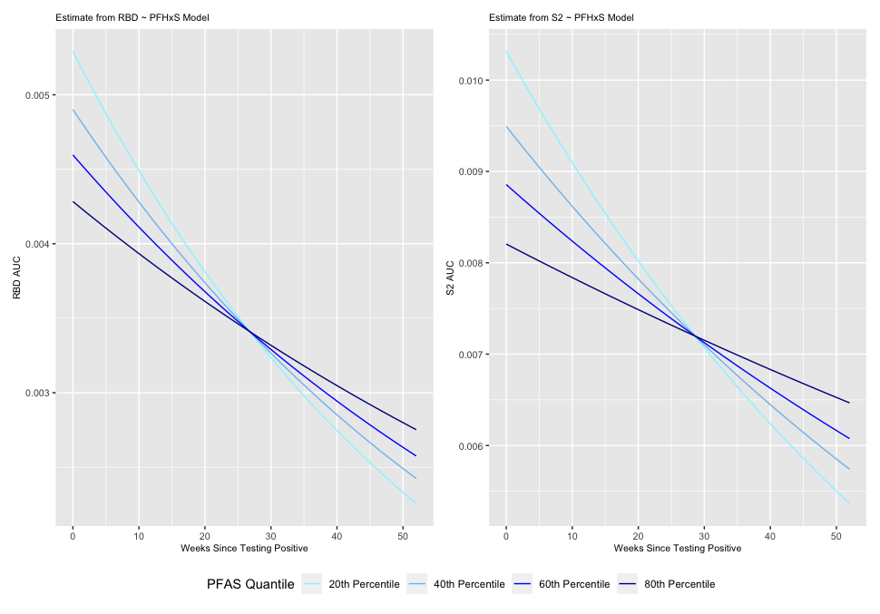
Figure S6: Fitted estimates for PFNA models for post-infection cohort, fitted at 20th, 40th, 60th, and 80th PFNA percentiles.

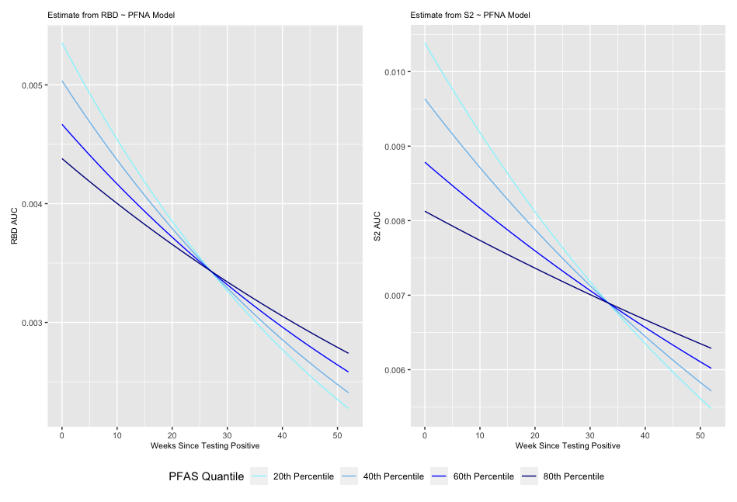
Figure S7: Fitted estimates for total PFOA models for post-vaccination cohort, fitted at 20th, 40th, 60th, and 80th total PFOA percentiles.

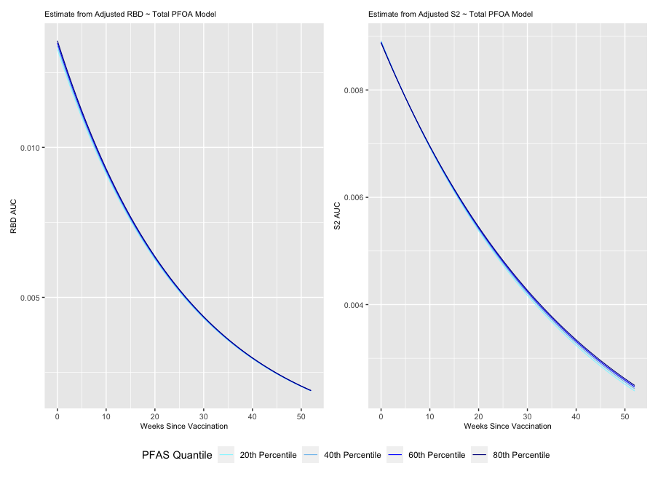

Figure S8: Fitted estimates for total PFOS models for post-vaccination cohort, fitted at 20th, 40th, 60th, and 80th total PFOS percentiles.

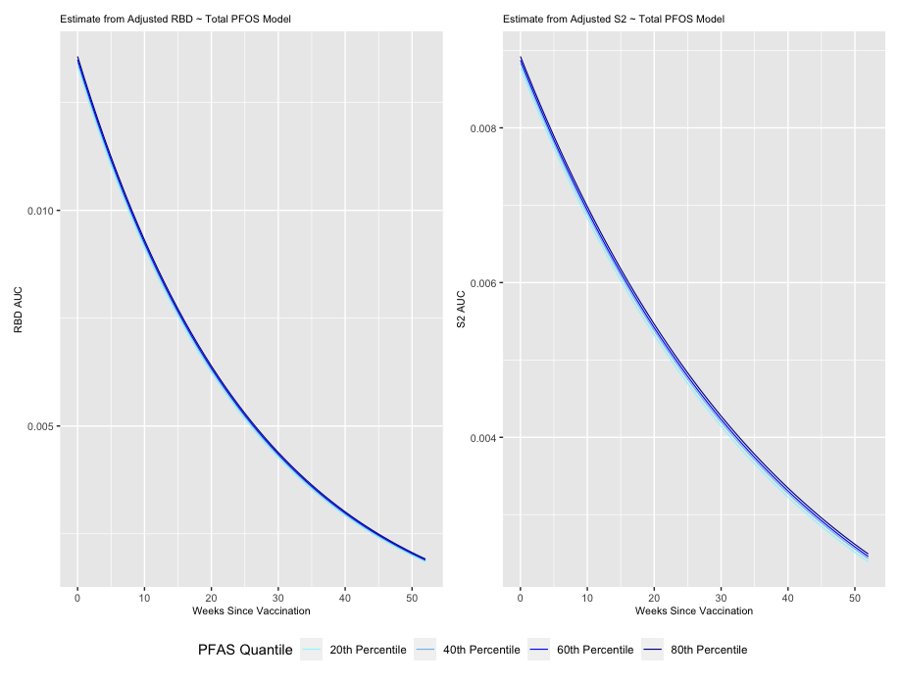

Figure S9: Fitted estimates for branched PFOS models for post-vaccination cohort, fitted at 20th, 40th, 60th, and 80th branched PFOS percentiles.

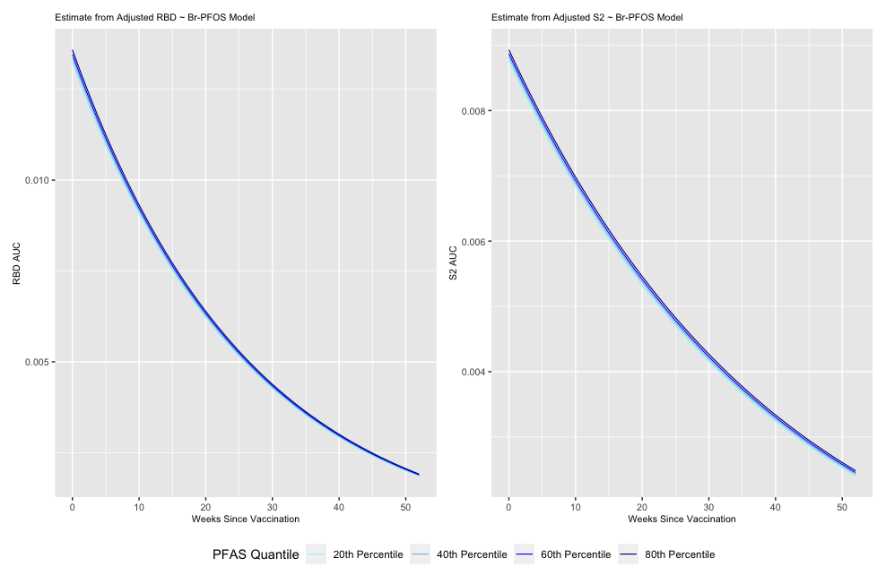
Figure S10: Fitted estimates for linear PFOS models for post-vaccination cohort, fitted at 20th, 40th, 60th, and 80th linear PFOS percentiles.

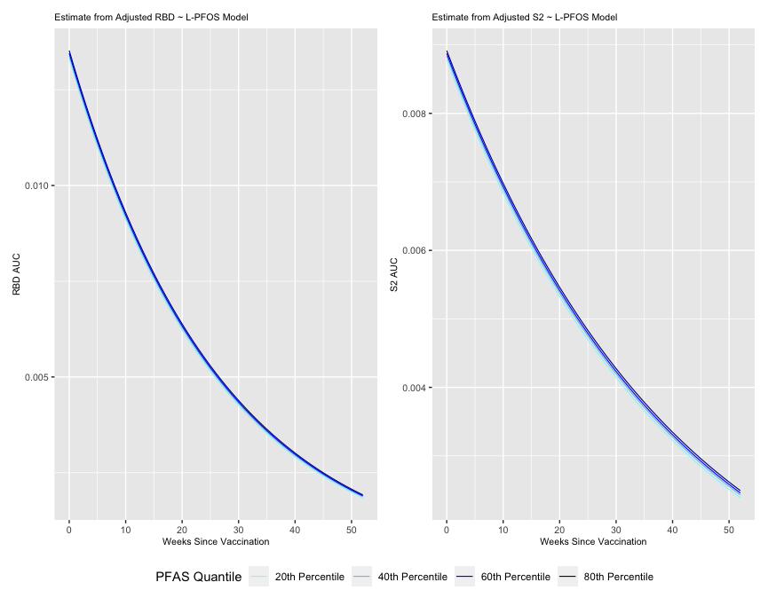

Figure S11: Fitted estimates for linear PFOA models for post-vaccination cohort, fitted at 20th, 40th, 60th, and 80th linear PFOA percentiles.

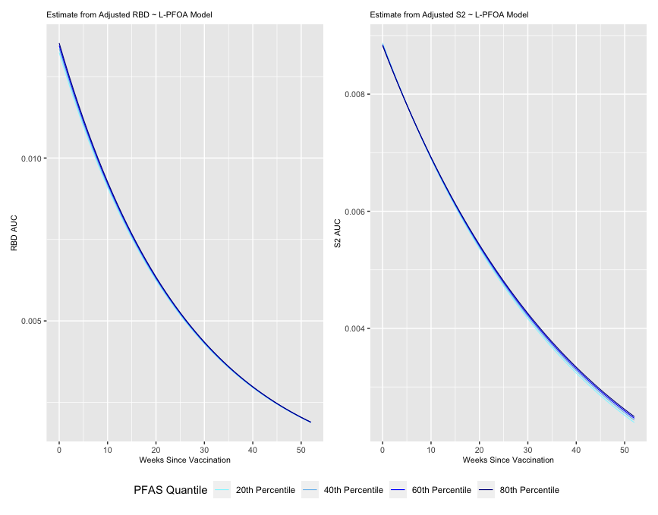

Figure S12: Fitted estimates for PFHxS models for post-vaccination cohort, fitted at 20th, 40th, 60th, and 80th PFHxS percentiles.

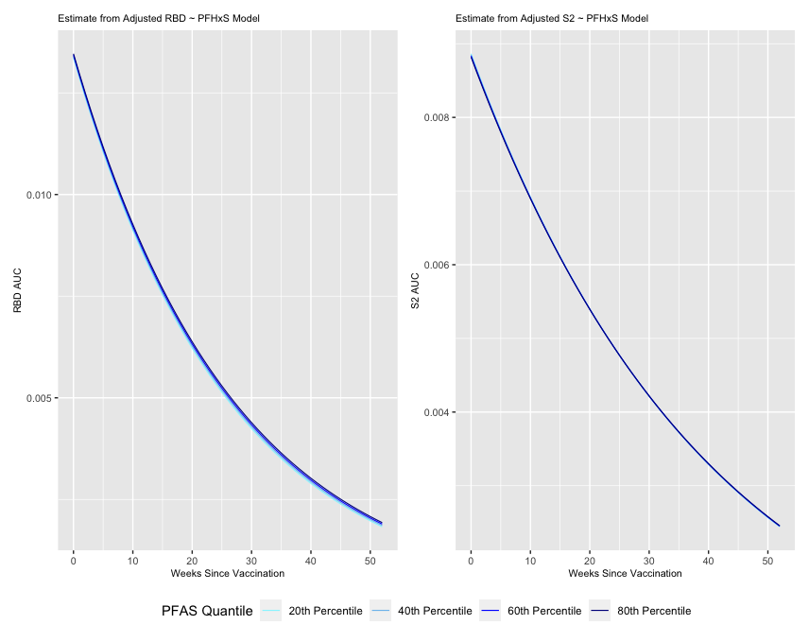
Figure S13: Fitted estimates for PFNA models for post-vaccination cohort, fitted at 20th, 40th, 60th, and 80th PFNA percentiles.

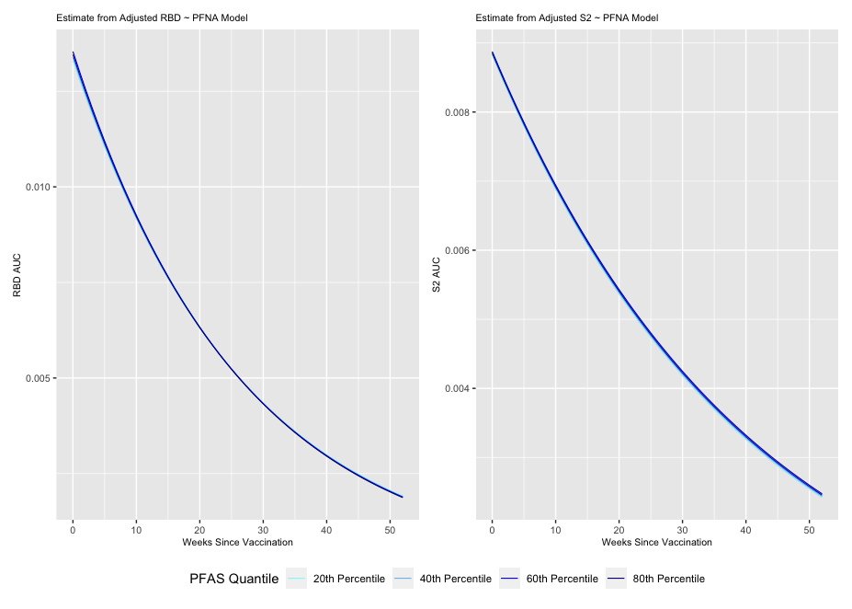

Figure S14. Log-transformed RBD and S2 AUC values over time for the post-infection cohort

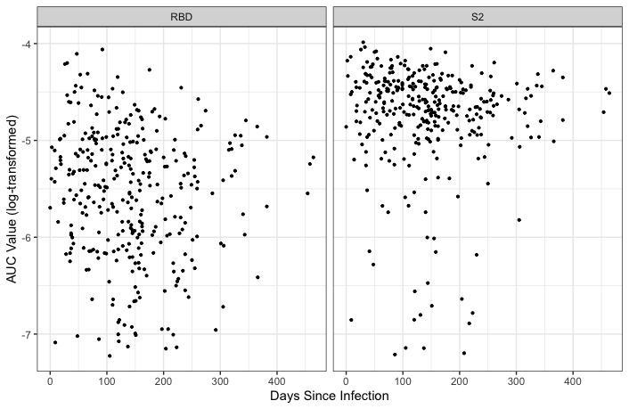

Figure S15. Log-transformed RBD and S2 AUC values over time for the post-vaccination cohort

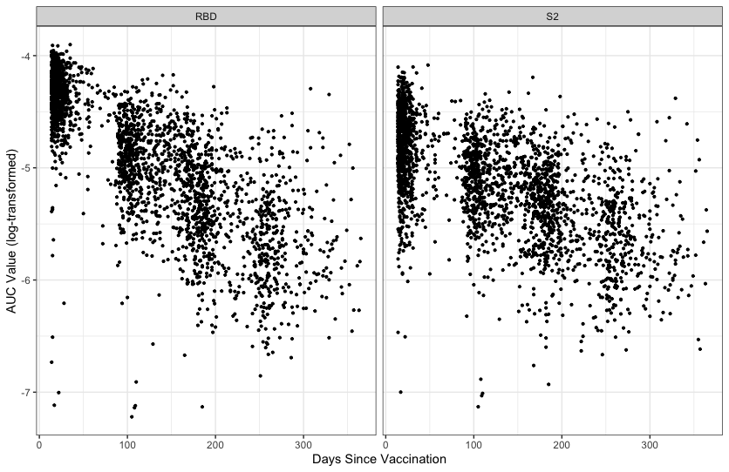

Figure S16. Pearson correlation of PFAS analytes for the post-infection cohort.

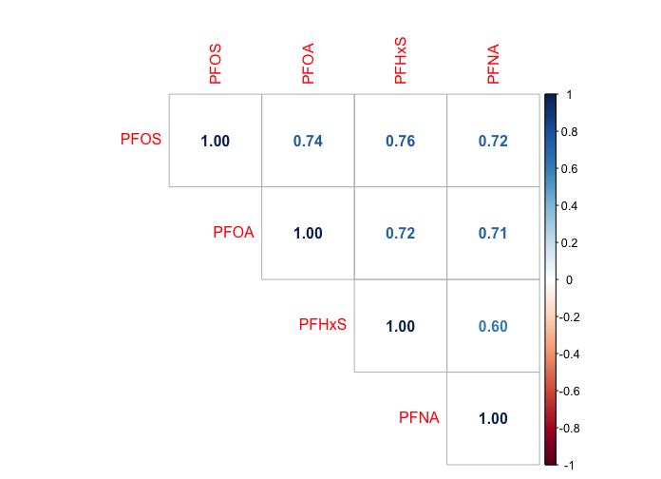
Figure S17. Pearson correlation of PFAS analytes for the post-vaccination cohort.

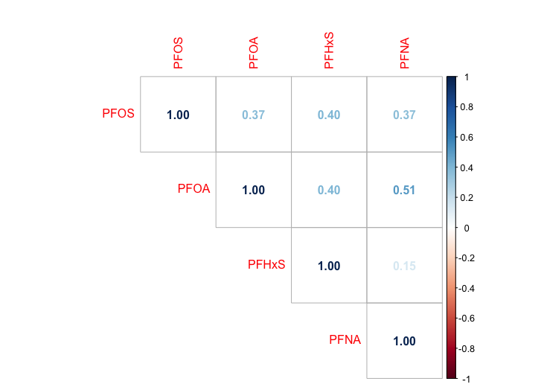

Figure S18. Causal diagram for the relationship between serum PFAS concentration and antibody response after SARS-CoV-2 infection or COVID-19 vaccination.

