Supplemental Digital Content 1
Contents
Supplemental Table S1. Fixed-Effect Standardized Estimates for HR and HRV (RMSSD) Predicting PTSD, and PTSD Predicting HR and HRV (RMSSD; Concurrent and Lagged Effects) 2
Supplemental Figure S1. Histogram of PTSD symptoms across timepoints 3
Supplemental Figure S2. Spaghetti plot of PTSD symptoms by timepoint for a subset of participants 3
Supplemental Figure S3. Histogram of HRV (MAVSD) values across timepoints 4
Supplemental Figure S4. Spaghetti plot of HRV (MAVSD) values by timepoint for a subset of participants 4
Supplemental Figure S5. Histogram of HRV (RMSSD) values across timepoints 5
Supplemental Figure S6. Spaghetti plot of HRV (RMSSD) values by timepoint for a subset of participants 5
R code for primary analyses 6

Supplemental Table S1. Fixed-Effect Standardized Estimates for HR and HRV (RMSSD) Predicting PTSD, and PTSD Predicting HR and HRV (RMSSD; Concurrent and Lagged Effects)
Outcome: PTSD
 | β | 95% CI | p | N_{ID} | Obs. | R² (cond.) | R² (marg.)
Concurrent effects
HRV (RMSSD) | -0.01 | [-0.05, 0.02] | .46 | 166 | 1524 | 0.81 | <0.01
Lagged effects
HRV (RMSSD) | -0.02 | [-0.06, 0.02] | .30 | 166 | 1469 | 0.83 | <0.01
Outcome: HRV (RMSSD)
 | β | 95% CI | p | N_{ID} | Obs. | R² (cond.) | R² (marg.)
Concurrent effects
PTSD | -0.11 | [-1.86, 1.64] | .90 | 166 | 1524 | N/A* | <0.01
Lagged effects
PTSD | -0.11 | [-0.19, -0.04] | .003 | 166 | 1442 | 0.54 | 0.01

Note. Bold values represent statistically significant effects (p < .01). Each model was estimated separately (i.e., concurrent vs. lagged effects), but is presented together for brevity. For lagged effects, the independent variable was one-time lagged to reflect the previous recording period, which was used to predict the dependent variable at the next recording period. PTSD = posttraumatic stress disorder, HRV = heart rate variability (i.e., root mean square of successive differences [RMSSD]), β = standardized regression estimate, 95% CI = 95% confidence interval, p = p-value, N_{ID} = number of persons included in the analysis; Obs. = total number of repeated measures observations at Level 1, R² (cond.) = conditional R-squared (i.e., percentage of within-person variance accounted for by both fixed and random effects), R² (marg.) = marginal R-squared (i.e., percentage of within-person variance accounted for by the fixed effects only). All results indicate unadjusted associations (i.e., non-transformed dependent variables and models without covariates). *For the concurrent effect of PTSD on HRV (RMSSD), the model would not converge with a random slope; therefore, the model was run with a fixed slope, which is why there is no R² (cond.) value for that model.

Supplemental Figure S1. Histogram of PTSD symptoms across timepoints
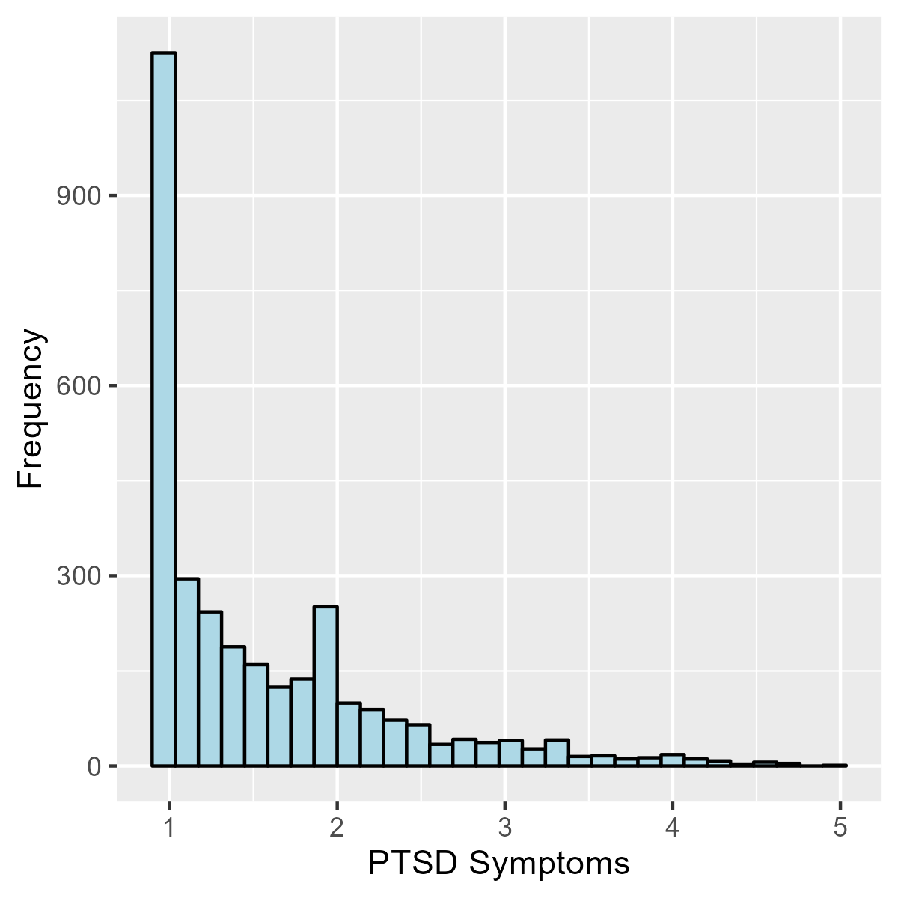

Supplemental Figure S2. Spaghetti plot of PTSD symptoms by timepoint for a subset of participants
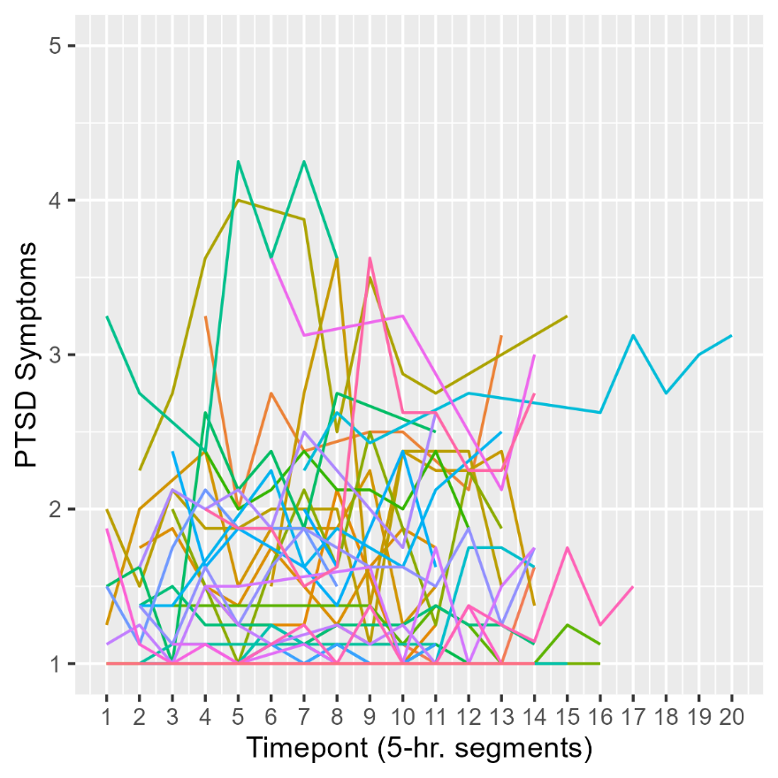

Supplemental Figure S3. Histogram of HRV (MAVSD) values across timepoints
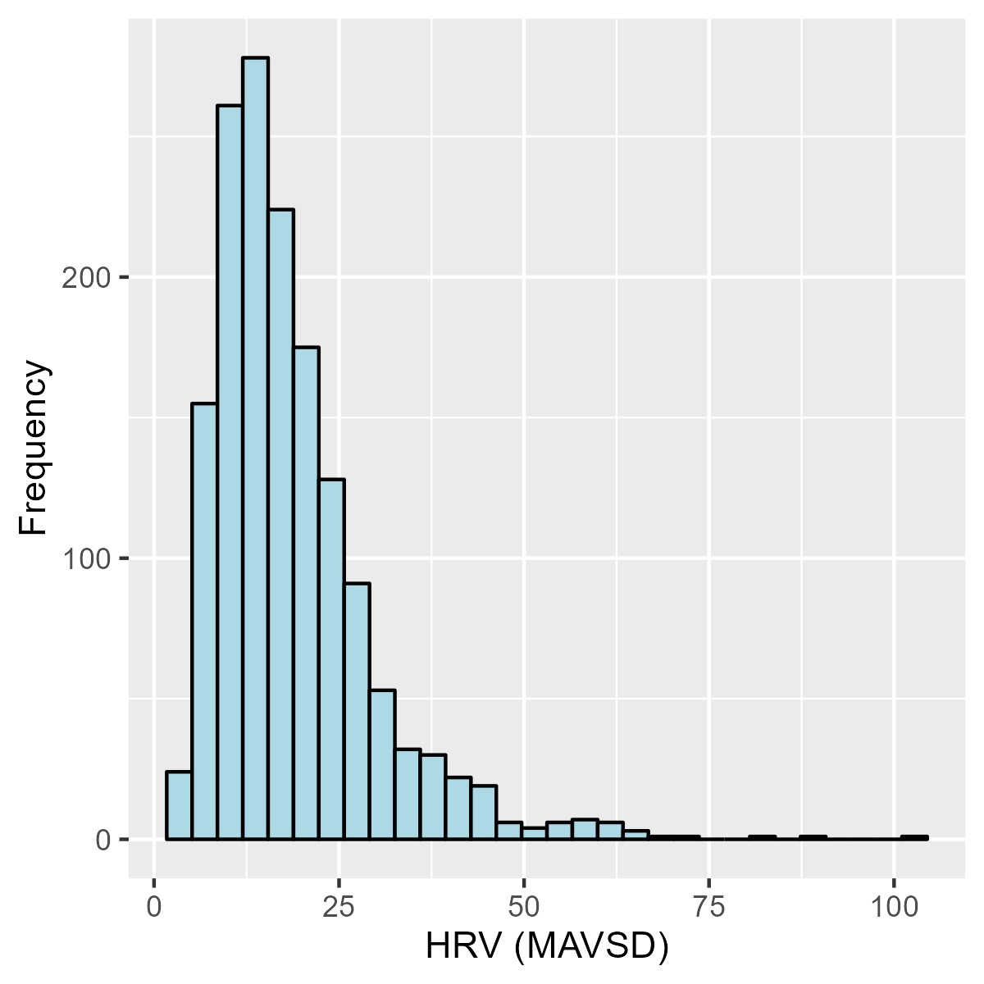

Supplemental Figure S4. Spaghetti plot of HRV (MAVSD) values by timepoint for a subset of participants
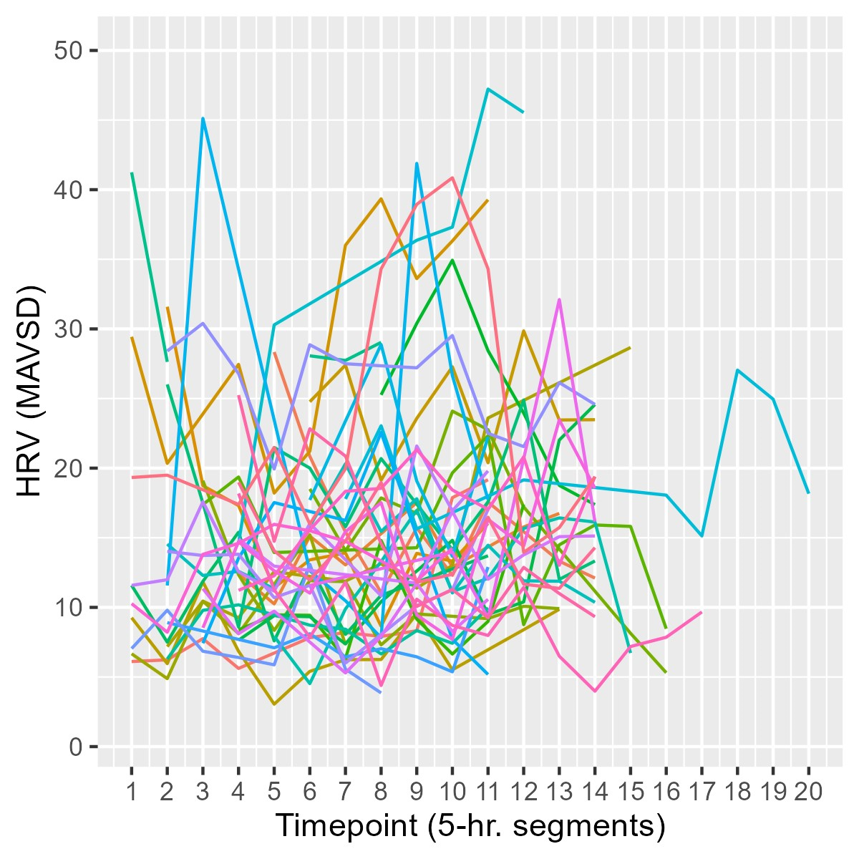

Supplemental Figure S5. Histogram of HRV (RMSSD) values across timepoints
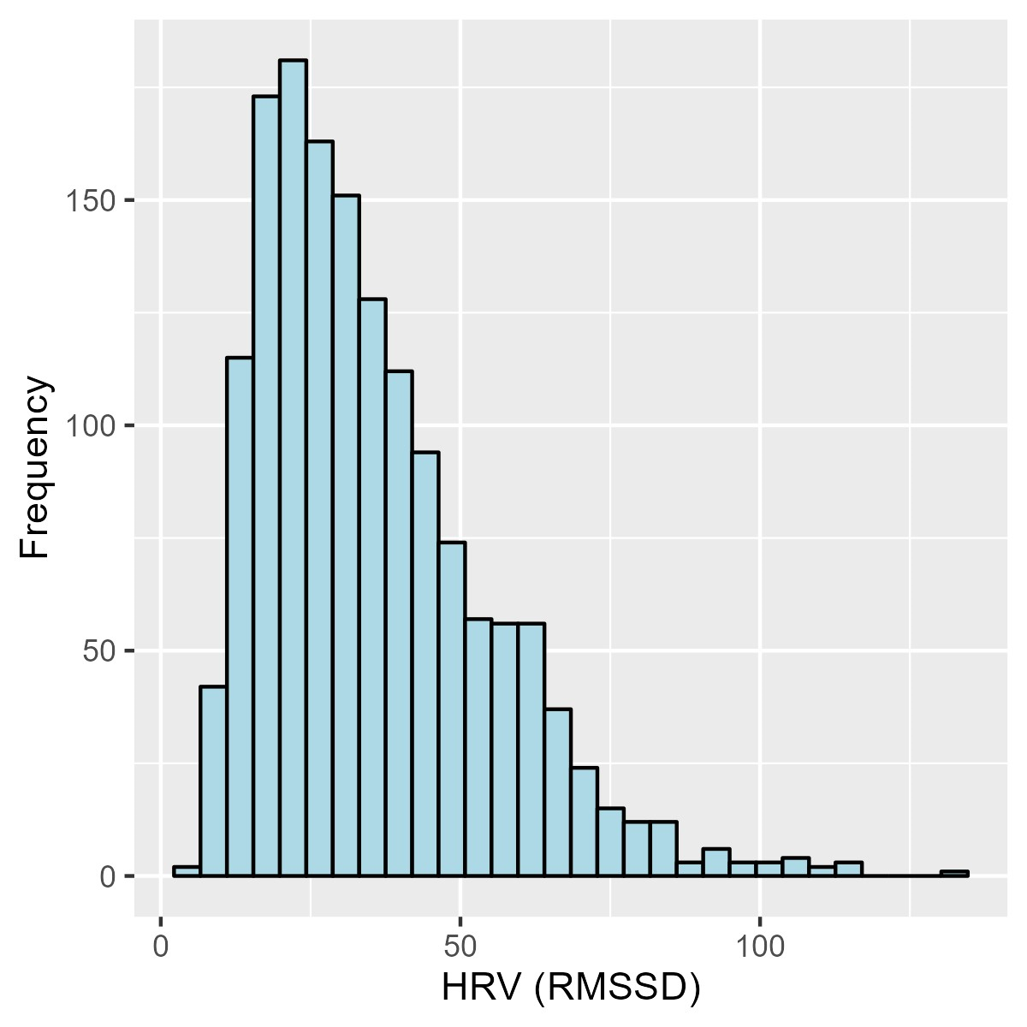

Supplemental Figure S6. Spaghetti plot of HRV (RMSSD) values by timepoint for a subset of participants
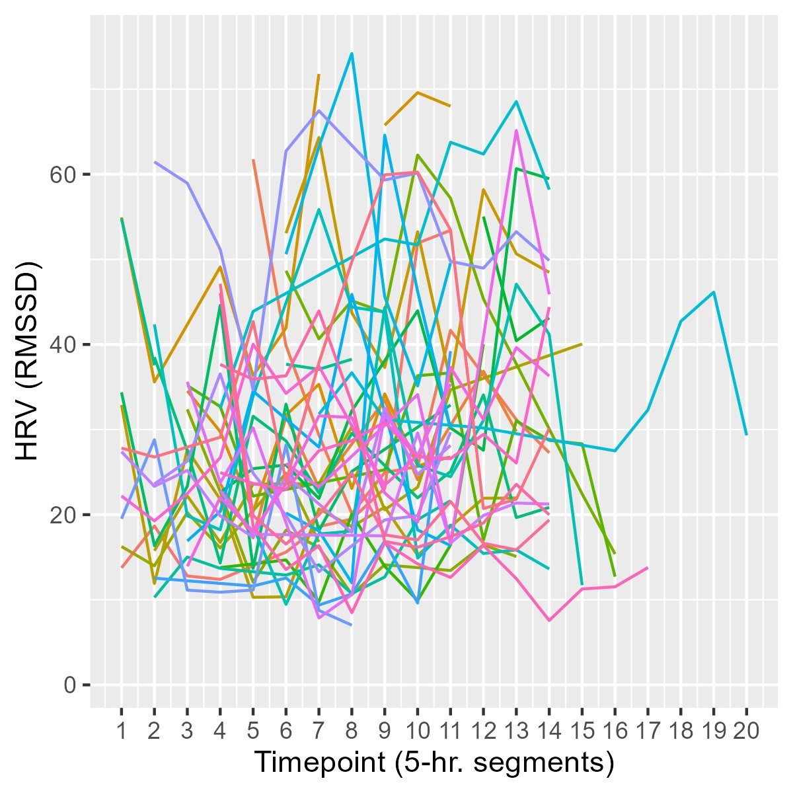

R code for primary analyses

library(lattice)
library(haven)
library(lme4)
library(nlme)
library(sjPlot)
library(reghelper)
library(dplyr)
library(ggplot2)
library(performance)
library(effectsize)
library(report)
library(psych)
library(see)

#load long data file with demographic variables
#N = 3440
hrv_cov <- read_sav("C:\\Downloads\\19.MASTER FILE EMA HRV ANALYSIS SAS INPUT 8.21.2018.sav")
names(hrv_cov)

a <- unique(hrv_cov$W_ID) #N = 172

hrv_cov1 <- hrv_cov[, c("W_ID",
"TIME",
"AGE_BL",
"SMOKER",
"HEART_PROB",
"CURR_PTSD",
"Lifetime_PTSD",
"PTSD_TOT_BL",
"SEX",
"Race",
"Ethnicity",
"Education")]

hrv_cov1$ID_N169 <- 1 #in analysis
hrv_cov1$ID_N169[hrv_cov1$W_ID=="03328" | hrv_cov1$W_ID =="14244"| hrv_cov1$W_ID =="44652" ] <- 0 #not in analysis; missing PTSD or HRV/HR all obs.
hrv_cov1$ID_N169[is.na(hrv_cov1$ID_N169)] <- 1
hrv_cov1$ID_N169 #60 missing observations, from 3 people

#subset to N = 169
hrv_cov1_N169 <- subset(hrv_cov1, ID_N169 == 1)
sample <- unique(hrv_cov1_N169$W_ID) #N169

#load long data file with other variables needed (HRV, HR, PTSD)

#N = 3440
hrv1 <- read_sav("C:\\Downloads\\All_stat_A_EMA_50MR.sav")
names(hrv1)
b <- unique(hrv1$ID) #N = 172
b

#################################################################
#remove folks not used in analyses for descriptive calculations
#################################################################

hrv1$ID_N169 <- 1 #in analysis
hrv1$ID_N169[hrv1$ID=="W03328" | hrv1$ID=="W14244"| hrv1$ID=="W44652" ] <- 0 #not in analysis; missing PTSD or HRV/HR all obs.
hrv1$ID_N169[is.na(hrv1$ID_N169)] <- 1
hrv1$ID_N169 #60 missing observations, from 3 people

#subset to N = 169
hrv1_N169 <- subset(hrv1, ID_N169 == 1)
sample <- unique(hrv1_N169$ID) #N169

#PTSD variables
hrv1_N169$EPTSD_avg
hrv1_N169$EPTSD_avg_lag

#HRV variables
hrv1_N169$MeanDeltaAbs.A
hrv1_N169$MeanDeltaAbs.A_lag

#HR variables
hrv1_N169$MeanRRI.A
hrv1_N169$MeanRRI.A_lag

#lag variables are moved up one time point (from previous time point)
cbind(hrv1_N169$EPTSD_avg,
hrv1_N169$EPTSD_avg_lag)

cbind(hrv1_N169$MeanDeltaAbs.A,
hrv1_N169$MeanDeltaAbs.A_lag)

cbind(hrv1_N169$MeanRRI.A,
hrv1_N169$MeanRRI.A_lag)

#subset data to just key Level 1 vars for generating descriptives for EMA data
level1 <- hrv1_N169[, c("EPTSD_avg",
"MeanDeltaAbs.A",
"MeanRRI.A",
"EPTSD_avg_lag",
"MeanDeltaAbs.A_lag",
"MeanRRI.A_lag")]

report(level1)

#sort by ID, TIME
attach(hrv_cov1_N169)
hrv_cov1_N169 <- hrv_cov1_N169[order(W_ID, TIME),]

#sort by ID, day, survey
attach(hrv1_N169)
hrv1_N169 <- hrv1_N169[order(ID, Day, Survey),]

#merge back with other file
hrv2 <- cbind(hrv_cov1_N169, hrv1_N169)
names(hrv2)

#subset to N169
hrv2 <- subset(hrv2, ID_N169 == 1) #Should have 3380 observations
sample <- unique(hrv2$ID) #Should have 169 IDs

#get first observation by ID
hrv_cov2 <- hrv2[!duplicated(hrv2$ID), ]
names(hrv_cov2)

hrv_cov2$W_ID <- as.numeric(as.character(hrv_cov2$W_ID))
hrv_cov2$TIME <- as.numeric(as.character(hrv_cov2$TIME))
hrv_cov2$AGE_BL <- as.numeric(as.character(hrv_cov2$AGE_BL))
hrv_cov2$SMOKER <- as.numeric(as.character(hrv_cov2$SMOKER))
hrv_cov2$HEART_PROB <- as.numeric(as.character(hrv_cov2$HEART_PROB))
hrv_cov2$CURR_PTSD <- as.numeric(as.character(hrv_cov2$CURR_PTSD))
hrv_cov2$Lifetime_PTSD <- as.numeric(as.character(hrv_cov2$Lifetime_PTSD))
hrv_cov2$PTSD_TOT_BL <- as.numeric(as.character(hrv_cov2$PTSD_TOT_BL))

table(hrv_cov2$SMOKER)
152/169

table(hrv_cov2$HEART_PROB)
144/169

table(hrv_cov2$CURR_PTSD)
30/169

table(hrv_cov2$Lifetime_PTSD)
63/169

table(hrv_cov2$SEX)
140/169

table(hrv_cov2$Race)
150/169

table(hrv_cov2$Ethnicity)
139/169

describe(hrv_cov2$AGE_BL)
describe(hrv_cov2$Education)
describe(hrv_cov2$PTSD_TOT_BL)

##################################################
#ICCs
##################################################

#PTSD
m <- lme(EPTSD_avg ~ 1,
random = ~1 | ID,
data = hrv2,
na.action = na.exclude)
summary(m)
#Extract the random effects
VarCorr(m)
#compute ICC
ICC_btwn <- 0.4356098 / (0.4356098 + 0.1082888 )
ICC_btwn # 0.8009026 80% of the variance in PTSD is due to person-to-person differences
ICC_wthn <- 1 - ICC_btwn
ICC_wthn # 0.1990974 #20% of the variance in PTSD is due to day-to-day within person differences

#HR
m <- lme(MeanRRI.A ~ 1,
random = ~1 | ID,
data = hrv2,
na.action = na.exclude)
summary(m)
#Extract the random effects
VarCorr(m)
#compute ICC
ICC_btwn <- 5673.778 / (5673.778 + 4624.137 )
ICC_btwn # 0.5509638 55% of the variance in PTSD is due to person-to-person differences
ICC_wthn <- 1 - ICC_btwn
ICC_wthn # 0.4490362 #45% of the variance in PTSD is due to day-to-day within person differences

#HRV
m <- lme(MeanDeltaAbs.A ~ 1,
random = ~1 | ID,
data = hrv2,
na.action = na.exclude)
summary(m)
#Extract the random effects
VarCorr(m)
#compute ICC
ICC_btwn <- 81.61223 / (81.61223 + 45.58940 )
ICC_btwn # 0.6415974 64% of the variance in PTSD is due to person-to-person differences
ICC_wthn <- 1 - ICC_btwn
ICC_wthn # 0.3584026 #36% of the variance in PTSD is due to day-to-day within person differences

##################################################
#HRV ANALYSES
##################################################

#PTSD to HRV (concurrent)
test1a <- lme(MeanDeltaAbs.A ~ 1 + EPTSD_avg,
random = ~1 + EPTSD_avg|ID,
correlation=corAR1(form=~1|ID),
data=hrv2,
na.action = na.exclude)
summary(test1a)
tab_model(test1a)
performance(test1a)
effectsize::effectsize(test1a)

#checking model assumptions
check_model(test1a)
#residuals(test1a)
describe(residuals(test1a), na.rm=T)
plot(test1a)
qqnorm(test1a, id = 0.05)

#log transformation
test1alog <- lme(log(MeanDeltaAbs.A) ~ 1 + EPTSD_avg,
random = ~1 + EPTSD_avg|ID,
correlation=corAR1(form=~1|ID),
data=hrv2,
na.action = na.exclude)
tab_model(test1a,test1alog)
effectsize::effectsize(test1alog)
performance(test1alog)

#covariate adjusted
test1b <- lme(MeanDeltaAbs.A ~ 1 + EPTSD_avg + AGE_BL + HEART_PROB + CURR_PTSD,
random = ~1 + EPTSD_avg|ID,
correlation=corAR1(form=~1|ID),
data=hrv2,
na.action = na.exclude)
summary(test1b)
tab_model(test1b)
performance(test1b)
effectsize::effectsize(test1b)

#checking model assumptions
check_model(test1b)
#residuals(test1b)
describe(residuals(test1b), na.rm=T)
plot(test1b)
qqnorm(test1b, id = 0.05)

##################################################
#PTSD to future HRV (lagged) *SIGNIFICANT

#null model
test2 <- lme(MeanDeltaAbs.A ~ 1 ,
random = ~1 |ID,
correlation=corAR1(form=~1|ID),
data=hrv2,
na.action = na.exclude)
summary(test2)
tab_model(test2)
performance(test2)
check_model(test2)
effectsize::effectsize(test2)

test2a <- lme(MeanDeltaAbs.A ~ 1 + EPTSD_avg_lag,
random = ~1 + EPTSD_avg_lag|ID,
correlation=corAR1(form=~1|ID),
data=hrv2,
na.action = na.exclude)
summary(test2a)
tab_model(test2a)
performance(test2a)
check_model(test2a)
effectsize::effectsize(test2a)

test2alog <- lme(log(MeanDeltaAbs.A) ~ 1 + EPTSD_avg_lag,
random = ~1 + EPTSD_avg_lag|ID,
correlation=corAR1(form=~1|ID),
data=hrv2,
na.action = na.exclude)
summary(test2alog)
tab_model(test2a,test2alog)
performance(test2alog)
effectsize::effectsize(test2alog)

# FIGURE 1
a <- ggplot(data=hrv2, aes(x=EPTSD_avg_lag, y=MeanDeltaAbs.A, group=factor(ID), colour="gray"), legend=FALSE) +
geom_smooth(method=lm, se=F, fullrange=F, lty=1, size=.5, color="light gray") +
geom_smooth(aes(group=1), method=lm, se=F, fullrange=F, lty=1, size=2, color="black") +
xlab("Lagged PTSD (from previous 5-hr interval)") + ylab("Heart Rate Variability (from next 5-hr interval)") +
ylim(5, 25)
b<- a + theme_classic(base_size = 11)
b
ggsave("C:\\Users\\danic\\Dropbox\\3. Working papers\\World Trade Center projects\\World Trade Center projects\\papers\\HRV and daily PTSD\\Figure1.png", width = 4, height = 4)

#comparing null model and model with predictor to calculate PRV
tab_model(test2a,test2)

#sigma-squared PRV reduction: (52.26-46.31)/52.26 = 11.3%

test2b <- lme(MeanDeltaAbs.A ~ 1 + EPTSD_avg_lag + AGE_BL + HEART_PROB + CURR_PTSD,
random = ~1 + EPTSD_avg_lag|ID,
correlation=corAR1(form=~1|ID),
data=hrv2,
na.action = na.exclude)
summary(test2b)
tab_model(test2b)
performance(test2b)
check_model(test2b)
effectsize::effectsize(test2b)

tab_model(test2b,test2)

#sigma-sqaured PRV reduction: (52.26-45.67)/52.26 = 12.6%

##################################################
#HRV to PTSD (concurrent)
test3a <- lme(EPTSD_avg ~ 1 + MeanDeltaAbs.A,
random = ~1 + MeanDeltaAbs.A|ID,
correlation=corAR1(form=~1|ID),
data=hrv2,
na.action = na.exclude)
summary(test3a)
tab_model(test3a)
performance(test3a)
check_model(test3a)
effectsize::effectsize(test3a)

test3alog <- lme(log(EPTSD_avg) ~ 1 + MeanDeltaAbs.A,
random = ~1 + MeanDeltaAbs.A|ID,
correlation=corAR1(form=~1|ID),
data=hrv2,
na.action = na.exclude)
summary(test3alog)
tab_model(test3a,test3alog)
performance(test3alog)

test3b <- lme(EPTSD_avg ~ 1 + MeanDeltaAbs.A + AGE_BL + HEART_PROB + CURR_PTSD,
random = ~1 + MeanDeltaAbs.A|ID,
correlation=corAR1(form=~1|ID),
data=hrv2,
na.action = na.exclude)
summary(test3b)
tab_model(test3b)
performance(test3b)
check_model(test3b)
effectsize::effectsize(test3b)

##################################################
#HRV to future PTSD (lagged)
test4a <- lme(EPTSD_avg ~ 1 + MeanDeltaAbs.A_lag,
random = ~1 + MeanDeltaAbs.A_lag|ID,
correlation=corAR1(form=~1|ID),
data=hrv2,
na.action = na.exclude)
summary(test4a)
tab_model(test4a)
performance(test4a)
check_model(test4a)
effectsize::effectsize(test4a)

test4alog <- lme(log(EPTSD_avg) ~ 1 + MeanDeltaAbs.A_lag,
random = ~1 + MeanDeltaAbs.A_lag|ID,
correlation=corAR1(form=~1|ID),
data=hrv2,
na.action = na.exclude)
tab_model(test4a,test4alog)
performance(test4alog)

test4b <- lme(EPTSD_avg ~ 1 + MeanDeltaAbs.A_lag + AGE_BL + HEART_PROB + CURR_PTSD,
random = ~1 + MeanDeltaAbs.A_lag|ID,
correlation=corAR1(form=~1|ID),
data=hrv2,
na.action = na.exclude)
summary(test4b)
tab_model(test4b)
performance(test4b)
check_model(test4b)
effectsize::effectsize(test4b)

##################################################

##################################################
#HR ANALYSES
##################################################
#PTSD to HR (concurrent)
test5a <- lme(MeanRRI.A ~ 1 + EPTSD_avg,
random = ~1 + EPTSD_avg|ID,
correlation=corAR1(form=~1|ID),
data=hrv1,
na.action = na.exclude)
summary(test5a)
tab_model(test5a)
performance(test5a)
check_model(test5a)
effectsize::effectsize(test5a)

test5alog <- lme(log(MeanRRI.A) ~ 1 + EPTSD_avg,
random = ~1 + EPTSD_avg|ID,
correlation=corAR1(form=~1|ID),
data=hrv1,
na.action = na.exclude)
summary(test5alog)
tab_model(test5a,test5alog)
performance(test5alog)

test5b <- lme(MeanRRI.A ~ 1 + EPTSD_avg + AGE_BL + HEART_PROB + CURR_PTSD,
random = ~1 + EPTSD_avg|ID,
correlation=corAR1(form=~1|ID),
data=hrv2,
na.action = na.exclude)
summary(test5b)
tab_model(test5b)
performance(test5b)
check_model(test5b)
effectsize::effectsize(test5b)

##################################################
#PTSD to future HR (lagged)
test6a <- lme(MeanRRI.A ~ 1 + EPTSD_avg_lag,
random = ~1 + EPTSD_avg_lag|ID,
correlation=corAR1(form=~1|ID),
data=hrv2,
na.action = na.exclude)
summary(test6a)
tab_model(test6a)
performance(test6a)
check_model(test6a)
effectsize::effectsize(test6a)

test6alog <- lme(log(MeanRRI.A) ~ 1 + EPTSD_avg_lag,
random = ~1 + EPTSD_avg_lag|ID,
correlation=corAR1(form=~1|ID),
data=hrv2,
na.action = na.exclude)
summary(test6alog)
tab_model(test6a,test6alog)
performance(test6alog)

test6b <- lme(MeanRRI.A ~ 1 + EPTSD_avg_lag + AGE_BL + HEART_PROB + CURR_PTSD,
random = ~1 + EPTSD_avg_lag|ID,
correlation=corAR1(form=~1|ID),
data=hrv2,
na.action = na.exclude)
summary(test6b)
tab_model(test6b)
performance(test6b)
check_model(test6b)
effectsize::effectsize(test6b)

##################################################
#HR to PTSD (concurrent)
test7a <- lme(EPTSD_avg ~ 1 + MeanRRI.A,
random = ~1 + MeanRRI.A|ID,
correlation=corAR1(form=~1|ID),
data=hrv2,
na.action = na.exclude)
summary(test7a)
tab_model(test7a)
performance(test7a)
check_model(test7a)
effectsize::effectsize(test7a)

test7alog <- lme(log(EPTSD_avg) ~ 1 + MeanRRI.A,
random = ~1 + MeanRRI.A|ID,
correlation=corAR1(form=~1|ID),
data=hrv2,
na.action = na.exclude)
summary(test7alog)
tab_model(test7a,test7alog)
performance(test7alog)

test7b <- lme(EPTSD_avg ~ 1 + MeanRRI.A + AGE_BL + HEART_PROB + CURR_PTSD,
random = ~1 + MeanRRI.A|ID,
correlation=corAR1(form=~1|ID),
data=hrv2,
na.action = na.exclude)
summary(test7b)
tab_model(test7b)
performance(test7b)
check_model(test7b)
effectsize::effectsize(test7b)

##################################################
#HR to future PTSD (lagged)

#increasing number of iterations to generate standardized effects
control.list <-
lmeControl(maxIter = 500, msMaxIter = 500, msMaxEval=500,
tolerance = 0.1, msTol = 0.1, sing.tol=1e-20)

test8a <- lme(EPTSD_avg ~ 1 + MeanRRI.A_lag,
random = ~1 + MeanRRI.A_lag|ID,
correlation=corAR1(form=~1|ID),
control=control.list,
data=hrv2,
na.action = na.exclude)
summary(test8a)
tab_model(test8a)
performance(test8a)
check_model(test8a)
effectsize::effectsize(test8a)

test8alog <- lme(log(EPTSD_avg) ~ 1 + MeanRRI.A_lag,
random = ~1 + MeanRRI.A_lag|ID,
correlation=corAR1(form=~1|ID),
control=control.list,
data=hrv2,
na.action = na.exclude)
summary(test8alog)
tab_model(test8a,test8alog)
performance(test8alog)

test8b <- lme(EPTSD_avg ~ 1 + MeanRRI.A_lag + AGE_BL + HEART_PROB + CURR_PTSD,
random = ~1 + MeanRRI.A_lag|ID,
correlation=corAR1(form=~1|ID),
control=control.list,
data=hrv2,
na.action = na.exclude)
summary(test8b)
tab_model(test8b)
performance(test8b)
check_model(test8b)
effectsize::effectsize(test8b)

