Supplementary Materials
Figure S1: Geographic Variation in Rate of OxyContin Misuse, 2004-2009
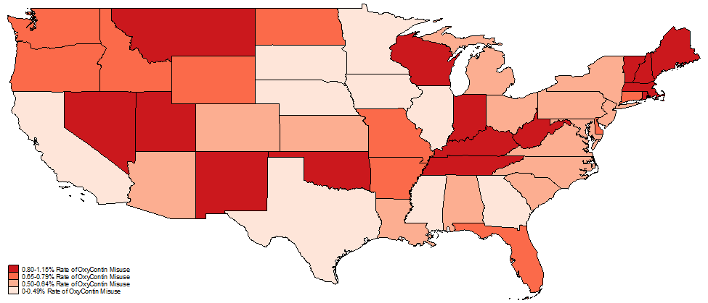
Source: 2004-2009 National Survey of Drug Use and Health

Figure S2: Exposure to reformulation and overdose deaths involving heroin and either gabapentinoids/Z-drugs or benzodiazepines
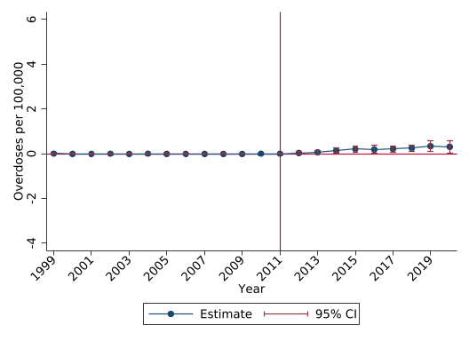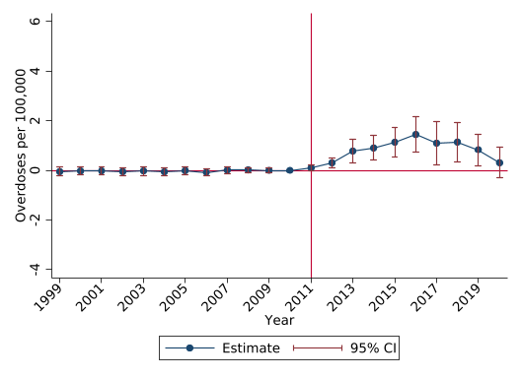
A. Gabapentinoids/Z-Drugs B. Benzodiazepines

Notes: Event study estimates presented with 95% confidence intervals. We regress overdose deaths per 100,000 involving the listed substance on state fixed effects, time fixed effects, the 2004-2009 pain reliever misuse rate interacted with year indicators, and the 2004-2009 OxyContin misuse rate interacted with year indicators. The coefficients on the OxyContin misuse rates are plotted. The 2010 estimate is normalized to 0. The regression is population-weighted and confidence intervals are adjusted for state-level clustering.

Figure S3: Exposure to reformulation and overdose deaths involving synthetic opioids and either gabapentinoids/Z-drugs or benzodiazepines
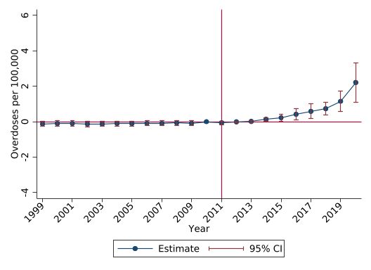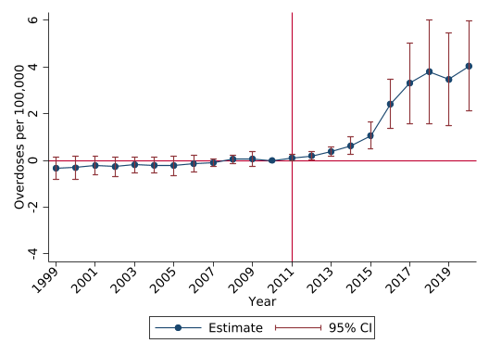
A. Gabapentinoids/Z-Drugs B. Benzodiazepines

Notes: Event study estimates presented with 95% confidence intervals. We regress overdose deaths per 100,000 involving the listed substance on state fixed effects, time fixed effects, the 2004-2009 pain reliever misuse rate interacted with year indicators, and the 2004-2009 OxyContin misuse rate interacted with year indicators. The coefficients on the OxyContin misuse rates are plotted. The 2010 estimate is normalized to 0. The regression is population-weighted and confidence intervals are adjusted for state-level clustering.

