Feasibility and Validity of the Coma Recovery Scale-Revised For Accelerated Standardized Testing: A practical assessment tool for detecting consciousness in the intensive care unit

Yelena G. Bodien PhD^{1,2,3}, Isha Vora PhD⁴, Alice Barra PhD^{1,5}, Kevin Chiang MD⁶, Camille Chatelle PhD^{1,5}, Kelsey Goostrey MPH¹, Geraldine Martens PhD^{1,5}, Christopher Malone PhD¹, Jennifer Mello MS, CCC-SLP⁸, Kristin Parlman DPT, PT^{9,10}, Jessica Ranford MS, OT¹⁰, Ally Sterling ScM, MBE¹, Abigail B. Waters PhD^{1,11}, Ronald Hirschberg MD^{1,3,12}, Douglas I. Katz MD¹³, Nicole Mazwi MD,¹⁴ Pengsheng Ni PhD,¹⁵ George Velmahos MD, PhD,⁶ Karen Waak DPT, PT^{9,10}, Brian L. Edlow MD^{2,3,16}, Joseph T. Giacino PhD^{1,3,17}

- Department of Physical Medicine and Rehabilitation, Spaulding Rehabilitation Hospital, Charlestown, MA
- Center for Neurotechnology and Neurorecovery, Department of Neurology, Massachusetts General Hospital and Harvard Medical School, Boston, MA
- Department of Physical Medicine and Rehabilitation, Harvard Medical School, Boston MA
- Department of Rehabilitation Sciences, MGH Institute of Health Professions, Boston, MA
- Coma GIGA Science Group, University of Liege, Liege, Belgium
- Department of Surgery, Massachusetts General Hospital, Boston, Massachusetts
- Department of Surgery, University of Montréal, Montréal, QC, Canada
- Department of Speech-language and Swallowing, Massachusetts General Hospital, Boston, MA
- Department of Physical Therapy, Massachusetts General Hospital, Boston, MA
- Department of Occupational Therapy, Massachusetts General Hospital Boston, MA
- Department of Clinical and Health Psychology, University of Florida, Gainesville, FL
- Department of Physical Medicine and Rehabilitation, Massachusetts General Hospital
- Department of Neurology, Boston University Chobanian & Avedisian School of Medicine, Boston, MA; Encompass Health Braintree Rehabilitation, Braintree, MA
- Department of Rehabilitation Medicine, University of Washington, Seattle, WA
- Biostatistics & Epidemiology Data Analytic Center, Department of Health Law, Policy and Management, Boston University School of Public Health, Boston, MA, USA
- Athinoula A. Martinos Center for Biomedical Imaging, Massachusetts General Hospital, Charlestown, MA
- Department of Psychiatry, Massachusetts General Hospital, Boston, MA

Table of Contents

Content | Page
Methods
CRSR-FAST Measure Development | 3
Supplementary Table 1: Approach to assessment of CRSR-FAST reliability and validity | 3
Supplementary Table 2,3: Approach for scoring CRSR-FAST and full-length CRS-R for assessment of validity and reliability | 4
Power Calculation | 4
Supplementary Table 4: Full Inclusion and Exclusion Criteria | 5
Supplementary Table 5: Test Completion Codes | 5
Supplementary Figure 1: Screening and Enrollment Flowchart | 6
Results
Supplementary Table 6: Individual Participant Clinical Characteristics, CRS-R, and CRSR-FAST Assessments | 7
Supplementary Figure 2: Distribution of CRS-R and CRSR-FAST Scores | 9
Supplementary Figure 3: Duration of CRS-R and CRSR-FAST Assessments | 10
Test Validity | 11
Supplementary Table 7: Concurrent Validity Values and Formula Variables | 11
Supplementary Table 8: Comparison of Alternate Concurrent Validity Metrics | 11
Supplementary Table 9: Descriptive analysis of discrepancies between the full-length CRS-R and the CRSR-FAST | 12
Supplementary Table 10: Test-retest Reliability Values and Formula Variables | 13
Supplementary Table 11: Test-retest Reliability Tests of Fixed Effect | 13
Supplementary Table 12: Inter-rater Reliability Values and Formula Variables | 13
References | 14

METHODS

CRSR-FAST Measure Development

Step 1: We identified the MCS items assessed on the CRS-R that are most likely to emerge first¹ and prioritized these items for inclusion in the CRSR-FAST.

Step 2: We invited physicians and allied clinical staff who are actively involved in the care of patients with severe TBI in the surgical intensive care unit (SICU), neurosciences intensive care unit (NeuroICU), and multidisciplinary ICU (MD-ICU) at Massachusetts General Hospital (MGH) to participate in a Clinical-User Panel to finalize the CRSR-FAST item content. At least one representative from each clinical specialty (i.e., neurology critical care medicine/surgery, physiatry, nursing SLP PT OT) participated on the Panel. We presented the Clinical-User Panel with the MCS items assessed on the CRS-R that are most likely to emerge first and conducted focus groups as well as online surveys via REDCap to determine the final item set. An 80% consensus among panel members was required to add or delete behaviors from the CRSR-FAST.

Step 3: We conducted a pilot study of CRSR-FAST administration in 3 ICUs at MGH (SICU, NeuroICU, MD-ICU), which did not result in any changes to the administration or scoring.

Supplementary Table 1: Approach to assessment of CRSR-FAST reliability and validity
Psychometric property | Comparison
Concurrent Validity | Rater Aª CRS-R versus Rater B CRSR-FAST^{b}
Test-retest reliability | Rater B CRSR-FAST versus Rater B CRSR-FAST
Inter-rater reliability^{c} | Rater B CRSR-FAST versus Rater C CRSR-FAST
ª Eight different examiners participated in CRS-R and CRSR-FAST assessments
^{b} Raters and the exam order was pseudorandomized to avoid order effects therefore the raters contributing to each comparison varied.
^{c} For interrater reliability analyses we selected the two CRSR-FAST assessments completed by different raters across the shortest time window.
All assessments were completed within 48 hours of the first assessment

Supplementary Table 2. Approach to scoring CRSR-FAST for assessment of validity and reliability
Binary Score | Highest Behavior Scored
Conscious  (any one of these behaviors indicates patient is conscious) | Reproducible Movement to Command OR  Visual Fixation/Pursuit OR  Automatic Motor Response OR  Localization to Noxious Stimulation OR  Intelligible Verbalization
Not Conscious | None of the above behaviors are observed

Supplementary Table 3. Approach to scoring full-length CRS-R to scoring for assessment of validity and reliability
Conscious (any one of these behaviors present on any subscale indicates patient is conscious) | Subscale | Behavior
 | Auditory Function | 4 – Consistent Movement to Command OR  3 – Reproducible Movement to Command
 | Visual Function | 5 – Object Recognition OR  4 – Object localization: Reaching OR  3 – Visual Pursuit OR  2 – Fixation OR
 | Motor Function | 6 – Functional Object Use OR  5 – Automatic Motor Response OR  4 – Object Manipulation OR  3 – Localization to Noxious Stimulation OR
 | Oromotor/  Verbal Function | 3 – Intelligible Verbalization
 | Communication | 2 – Functional: Accurate†  1 – Non-functional: Intentional
Not Conscious |  | None of the above behaviors are observed

Power Calculation
We based our sample size on requiring a concurrent validity kappa ≥ 0.6, which, with approximately 60% (range from 50-70%) of patients achieving a “conscious” rating on the CRS-R full, would require at least 42 participants, so the lower bound of 95% confidence interval of estimated kappa 0.6 is over 0.35.²

Supplementary Table 4: Full List of Inclusion and Exclusion Criteria
Inclusion Criteria
1 | Age 18 or older
2 | Fluent in English
3 | Surrogate available to provide informed consent
4 | Sustained a traumatic brain injury (defined by damage to brain tissue caused by an external mechanical force)
5 | Receiving care in the intensive care unit within 3 weeks of injury
6 | At least one Glasgow Outcome Scale (GCS) total score <9 within the first 48 hours of injury
7 | Unable to follow simple commands consistently at the time of enrollment
Exclusion Criteria
1 | History of developmental neurologic or major psychiatric disorder resulting in ongoing functional disability up to the time of the current injury
2 | Physician orders for comfort measures only

Supplementary Table 5: Test Completion Codes
1 | test completed in full, in person- results valid
Test attempted, not completed due to: |  | Test not attempted due to:
2.1 | impaired sensory function (cortical or peripheral) | 3.1 | impaired sensory function (cortical or peripheral)
2.2 | aphasia | 3.2 | aphasia
2.3 | physical injury (e.g., fracture, brachial plexus, hemiparesis) | 3.3 | physical injury (e.g., fracture, brachial plexus, hemiparesis)
2.4 | primary language barrier | 3.4 | primary language barrier
2.5 | illness/medical instability | 3.5 | illness/medical instability
2.6 | examiner error | 3.6 | examiner error
2.7 | logistical reasons | 3.7 | logistical reasons
2.8 | other (specify): | 3.8 | other (specify):

Supplementary Figure 1: Screening and Enrollment Flowchart

COVID COronaVIrus Disease of 2019; GCS Glasgow Coma Scale; ICU intensive care unit; WLST withdrawal of life-sustaining therapy

Acute Adult TBI ICU Admissions
09/01/2018 – 12/01/2022
n=776
Excluded (n= 649)
- No GCS < 9 in first 48 hrs (n=440)
- Prior history of brain injury (n=19)
- Not English speaking (n=20)
- Admitted during COVID Pandemic research restrictions (n=38)
- Consistently following commands prior to approach (n=93)
- Died WLST (n=32)
- Died Non-WLST (n=7)
Enrolled n=56
Did not complete at least 2 assessments (n=11)
- WLST prior to completion of at least 2 assessments (n=6)
- Consistently following commands prior to start of research activities (n=4)
- Medically unstable for exams
(i.e., cervico-spinal dissociation n=1)
Eligible n=127
Not Enrolled (n=71)
- Refused (n=21)
- Became ineligible (n=35)
  - Primary injury determined to be non-TBI (n=11)
  - Died WLST: 10
  - Died Not-WLST: 4
  - Regained consistent command-following (n=6)
  - Discharged out of ICU (n=4)
- COVID+ (n=6)
- Did not have or could not reach surrogate (n=9)
Completed at least 2 assessments n=45
RESULTS

Supplementary Table 6: Individual Participant Clinical Characteristics and CRS-R and CRSR-FAST Assessments
ID | Age | Sex | Cause of TBI | Best ED GCS Total | Worst ED GCS Total | CRS-R Subscale Rating | CRS-R Total | CRSR-FAST #1 highest  behavior | CRSR-FAST #2  highest  behavior | CRSR-FAST #3 highest  behavior | Day post-injury of 1st exam
1 | 19 | m | Gunshot | 7T | 7T | A0V4M5O0C0Ar2 | 11 | Fix/Pur | Auto | Auto | 7
2 | 19 | f | MVC | NA | 3 | A0V0M1O0C0Ar1 | 2 | None | None | None | 24
3 | 37 | m | MVC | 8T | 6T | A0V0M0O0C0Ar1 | 1 | Auto | Auto | Auto | 4
4 | 62 | m | MVC | 13 | 7T | A0V0M0O1C0Ar1 | 2 | None | None | None | 6
5 | 30 | m | MVC | 5 |  | A0V0M5O1C0Ar1 | 7 | None | Auto | Auto | 8
6 | 21 | m | Fall from >3ft | 13 | 10 | A1V3M1O1C0Ar1 | 7 | Fix/Pur | Fix/Pur | Fix/Pur | 18
7 | 48 | m | Fall from >3ft | 3 | 3 | A0V0M5O1C0Ar1 | 7 | None | None | Loc | 3
8 | 19 | m | MVC | 8 | 3T | A0V0M0O0C0Ar2 | 2 | None | None | None | 16
9 | 18 | m | MVC | 3T | 3T | A3V2M5O2C1Ar1 | 14 | Fix/Pur | Fix/Pur | CF | 3
10 | 50 | m | Fall from >3ft | 8 | 3TP | A0V0M0O0C0Ar0 | 0 | None | None | None | 4
11 | 56 | f | MVC | 7T | 7T | A0V0M5O0C0Ar0 | 5 | None | None | Loc | 2
12 | 77 | m | Ground level fall | 14 | 3T | A0V0M0O0C0Ar1 | 1 | None | None | None | 5
13 | 68 | m | Gunshot | 8CT | 8CT | A0V-M5O2C0Ar- | NAª | Auto | Auto | Auto | 17
14 | 35 | m | MVC |  | 7T | A0V1M2O0C0Ar1 | 4 | CF | CF | Auto | 15
15 | 74 | f | MVC | 5T | 3T | A0V0M0O0C0Ar1 | 1 | None | None | None | 11
16 | 72 | m | MVC | 3T | 7T | A0V0M2O0C0Ar1 | 3 | None | None | None | 5
17 | 21 | m | MVC | 6T | 5 | A0V1M5O0C0Ar1 | 7 | CF | CF | Fix/Pur | 14
18 | 34 | m | MVC | 7T | 6 | A0V0M3O0C0Ar1 | 4 | Auto | Loc | Auto | 5
19 | 66 | f | Ground level fall | 10 | 5T | A0V3M2O2C0Ar1 | 8 | Fix/Pur | Fix/Pur | Fix/Pur | 7
20 | 25 | m | MVC | NA | 3 | A0V0M0O2C0Ar1 | 3 | Fix/Pur | Fix/Pur | None | 14
21 | 37 | m | MVC | 3T | 3T | A3V4M4O0C0Ar1 | 12 | CF | None | None | 19
22 | 68 | f | Fall from >3ft | 14 | 8 | A0V3M2O1C0Ar1 | 7 | CF | CF | CF | 7
23 | 24 | f | MVC | 6T | 3PT | A0V0M2O0C0Ar1 | 3 | None | None | --^{b} | 3
24 | 20 | f | MVC | 7 | 3 | A1V1M1O1C0Ar0 | 4 | None | None | None | 12
25 | 52 | m | Ground level fall | 5T | 7T | A0V0M5O3C1Ar1 | 10 | CF | CF | CF | 6
26 | 31 | f | MVC | 3T | 6T | A2V2M5O1C0Ar1 | 11 | None | None | Fix/Pur | 9
27 | 73 | m | Fall from >3ft | 7T | 6T | A0V0M2O1C0Ar0 | 3 | None | None | None | 2
28 | 35 | m | Fall from >3ft | 8T | 6T | A1V0M5O1C0Ar1 | 8 | Auto | Auto | Auto | 8
29 | 28 | m | Fall from >3ft | 8T | 3t | A3V5M5O2C1Ar1 | 17 | Exp | CF | CF | 5
30 | 38 | f | MVC | 5T | 3T | A2V3M2O0C0Ar0 | 7 | None | Auto | None | 4
31 | 57 | m | MVC | NA | 3T | A0V2M2O0C0Ar1 | 5 | None | None | None | 7
32 | 26 | m | MVC | 6 | 3 | A2V3M5O1C0Ar1 | 12 | Auto | Auto | Auto | 12
33 | 58 | m | Gunshot | 6CT | 3CT | A0V0M2O0C0Ar0 | 2 | None | None | None | 2
34 | 30 | f | MVC | 3T | 3T | A0V4M5O2C0Ar1 | 12 | Auto | Auto | Auto | 9
35 | 35 | f | MVC | 7T | 7T | A0V0M5O2C0Ar1 | 8 | CF | CF | CF | 14
36 | 64 | m | Ground level fall | 10 | 7 | A4V5M5O3C1Ar2 | 21 | Auto | Auto | CF | 5
37 | 77 | f | Fall from >3ft | 12 | 3T | A3V5M0O0CAr2 | NA^{c} | Fix/Pur | CF | Fix/Pur | 8
38 | 22 | m | MVC | 7 | 3 | A0V1M5O3C1Ar1 | 11 | Auto | Auto | CF | 10
39 | 45 | f | Fall from >3ft | 14 | 10 | A4V5M5O3C2Ar3 | 22 | Exp | CF | Auto | 6
40 | 19 | m | MVC | 3 | 6T | A3V-M5O0C1Ar- | NA^{d} | Auto | CF | CF | 8
41 | 39 | f | MVC | 3T | 3T | A0V0M2O1C0Ar0 | 3 | None | None | None | 4
42 | 28 | m | MVC | 8 | 7T | A4V5M-O3C1Ar3 | NA^{e} | CF | CF | Exp | 7
43 | 75 | f | Ground level fall | 13 | 8 | A0V0M0O1C0Ar0 | 1 | None | None | None | 11
44 | 71 | m | Fall from >3ft | 8 | 3 | A0V0M2O1C0Ar0 | 3 | None | None | None | 3
45 | 63 | m | Fall from >3ft | 5T | 3T | A0V0M2O0C0Ar2 | 4 | None | None | None | 6
ª eyes sutured shut- visual subscale could not be administered and arousal subscale could not be scored; ^{b} withdrew prior to last assessment; ^{c} exam discontinued prior to communication subscale administration due to medical instability; ^{d} eyes swollen shut- visual subscale could not be administered and arousal subscale could not be scored; ^{e} 4-point restraints could not be removed due to safety concerns; - subscale not tested. CRS-R Subscale score Rating A auditory, V verbal, M motor, O oromotor, C communication, Ar arousal; CRSR-FAST (CRSR For Accelerated Standardized Testing) behaviors: Auto automatic motor responses; CF command-following; Fix/Pur visual fixation or pursuit; Exp intelligible expression; Loc localization to noxious stimulation.
ED Emergency Department; GCS Glasgow Coma Scale; f female; m male; T intubated; P paralyzed; C sedated; MVC motor vehicle collision; NA Not Available. Shading indicates an assessment resulted in a rating of “conscious”.

Supplementary Figure 2: Distribution of CRS-R and CRSR-FAST Scores

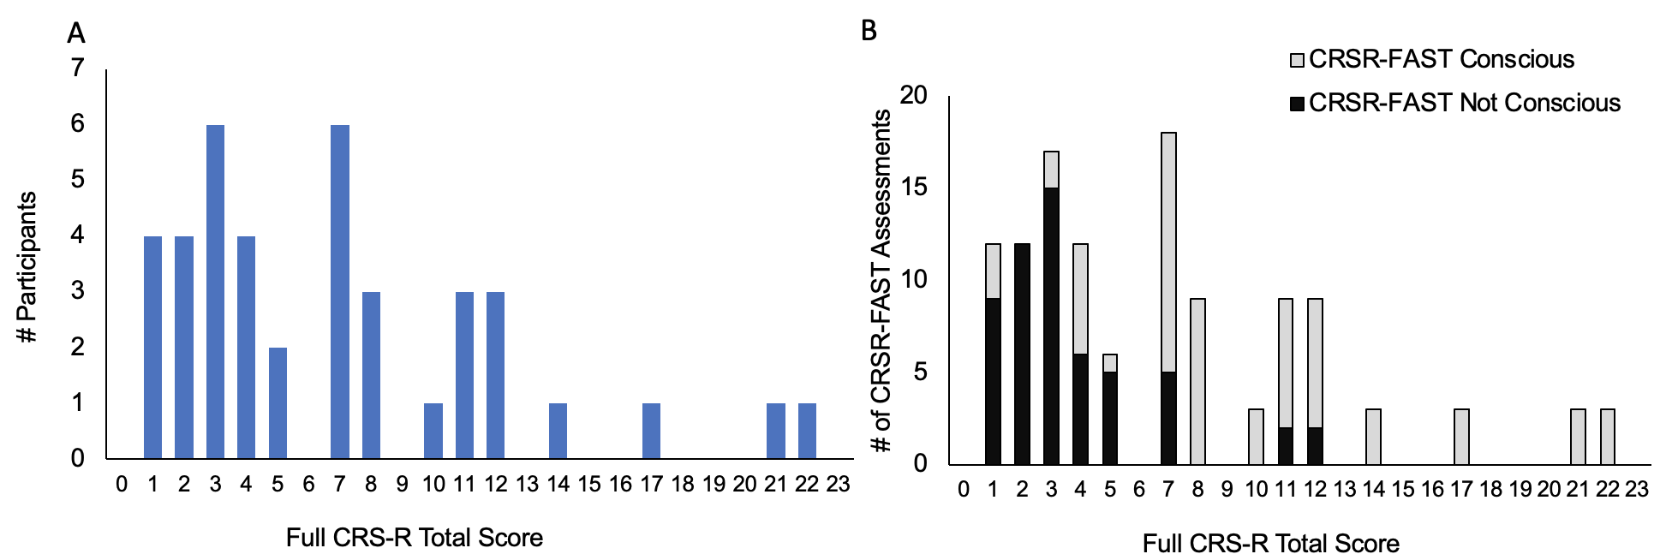

A: Full CRS-R total scores ranged from 1-22 (total range = 0-23). As expected, the total scores are skewed to the lower (i.e., more impaired) end of the CRS-R because the protocol excluded patients who were consistently following commands at the time of screening. Patients who are consistency following commands are unlikely to benefit from a scale that differentiates between patients who are and are not conscious in the intensive care unit (ICU). B: The number of CRSR-FAST assessments with a rating of conscious (grey bars) and not conscious (black bars) are presented for each CRS-R total score. The majority of CRSR-FAST assessments with a rating of not conscious occur in patients with CRS-R Total scores that are the lower end of the scale.

Supplementary Figure 3: Duration of CRS-R and CRSR-FAST Assessments

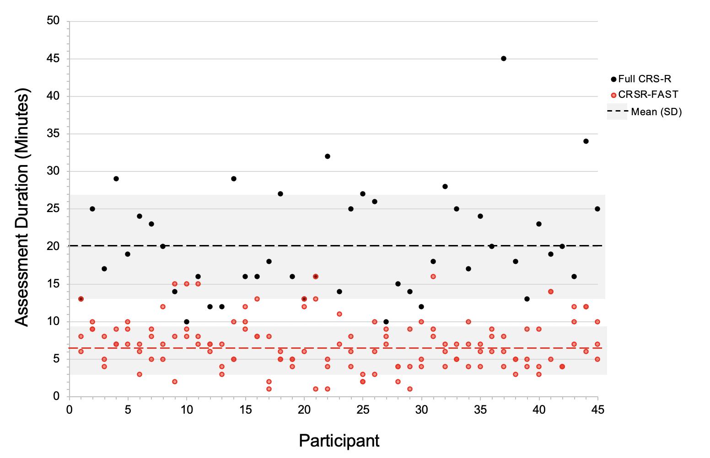
The CRSR-FAST mean [SD] administration time was 6.5 [3.3] min (red dotted line), which is approximately one third of the administration time for the full-length CRS-R (black dotted line; 20.1 [7.2] minutes, p<0.0001). Of 134 CRSR-FAST administrations (red dots), 81% required less than 10 minutes. All full-length CRS-R administrations (black dots) required 10 minutes or more.

Test Validity

Five patients had at least one confounded CRS-R subscale. However, the confounding factor was consistent across all examinations and did not affect calculation of validity or reliability for the CRS-FAST. We therefore included all 5 patients in the analyses.

Concurrent Validity

In addition to the Simple Kappa Coefficient we calculated the Matthews correlation coefficient (MCC^{3, 4} Pearson correlation applied to a binary outcome), F1 measures of agreement⁵ and the B-coefficient.⁶ Each approach for evaluating agreement supports our primary finding of a >0.60 (i.e. substantial) concurrent validity.

Supplementary Table 7: Concurrent Validity Values and Formula Variables
 |  | CRS-R
 |  | Conscious | Not-conscious | Sample size
CRSR-FAST | Conscious | 22$\left(n_{1}TPp_{11}\right)$ | 2$\left(n_{2}FPp_{21}\right)$ | 24$\left(p_{+1}\right)$
CRSR-FAST | Not-conscious | 5$\left(n_{3}FNp_{12}\right)$ | 16$\left(n_{4}TNp_{22}\right)$ | 21$\left(p_{+2}\right)$
 | Sample Size | 27$\left(p_{1+}\right)$ | 18$\left(p_{2+}\right)$ | 45

Supplementary Table 8: Comparison of Alternate Concurrent Validity Metrics
Validity Metric | Formula | Value | SE
Simple Kappa Coefficient | $$A=\frac{p_{0}-p_{e}}{1-p_{e}}$$  $$p_{o}=p_{11}+p_{22}$$  $$p_{e}=p_{1+}p_{+1}+p_{2+}p_{+2}$$ | 0.6847 | 0.1084
Matthews correlation coefficient (MCC) | $$\frac{p_{11}p_{22}-p_{12}p_{21}}{\sqrt{p_{1+}p_{+1}p_{2+}p_{+2}}}$$ | 0.6910 | 0.1070*
F1 measure | $$\frac{2n_{1}}{2n_{1}+n_{2}+n_{3}}$$ | 0.8627 | 0.0524*
B-coefficient | $$\frac{p_{11}^{2}+p_{22}^{2}}{p_{1+}p_{+1}+p_{2+}p_{+2}}$$ | 0.7212 | 0.0865*
*Bootstrap method 1000 samples (with a size of 45) with replacement was used to calculated MCC F1 and B-coefficient indices from each bootstrap sample and generate the standard deviation of each agreement index as the standard error estimate

Descriptive analysis of discrepancies between the full-length CRS-R and the CRSR-FAST

In 7 participants, the CRSR-FAST rating did not match the rating of the full-length CRS-R. These discrepancies are detailed in Supplementary Table 9. Behavioral fluctuation is common in both acute and chronic stages of recovery from TBI, therefore it is unknown whether these discrepancies represent a feature of the measures themselves or are the expected result of waxing and waning consciousness.

Supplementary Table 9: Descriptive analysis of discrepancies between the full-length CRS-R and the CRSR-FAST
Participant | Full-length CRS-R Rating | CRSR-FAST Rating #1 | Comments (include other CRSR-FAST ratings timing etc)
03 | Not conscious | Conscious | Automatic motor behavior was observed on all 3 CRSR-FAST exams. No conscious behaviors were observed on the CRS-R full exam which was administered after 2 CRSR-FAST exams.
05 | Conscious | Not conscious | Automatic motor behavior was observed on CRS-R full exam. Automatic motor behavior was not observed on the next CRSR-FAST exam but was observed on the following 2 CRSR-FAST exams.
11 | Conscious | Not conscious | Automatic motor behavior was observed on CRS-R full exam but not on any of the CRSR-FAST exams. Localization to noxious stimulation was observed on the third CRSR-FAST exam.
14 | Not conscious | Conscious | Reproducible command-following was observed on two CRSR-FAST exams and automatic motor behavior was observed on a third CRSR-FAST exam. No conscious behaviors were observed on the CRS-R full exam which was administered after 3 CRSR-FAST exams (over 2 days).
21 | Conscious | Not conscious | Reproducible command-following was observed on CRS-R full exam. Reproducible command-following was not observed on the CRSR-FAST exam administered immediately preceding or following the CRS-R full exam but was observed on the CRSR-FAST exam administered earlier on the same day.
30 | Conscious | Not conscious | Visual pursuit was observed on CRS-R full exam but not on any of the CRSR-FAST exams. Automatic motor response was observed on the second CRSR-FAST exam.
31 | Conscious | Not conscious | Visual fixation was observed on CRS-R full exam but not on any of the CRSR-FAST exams.
Test-retest Reliability

Supplementary Table 10: Test-retest Reliability Values and Formula Variables
CRSR-FAST Rating |  | N (variable)
Conscious | Conscious | 21 $\left(n_{1}\right)$
Conscious | Not conscious | 5 $\left(n_{2}+n_{3}\right)$
Not conscious | Not conscious | 16 $\left(n_{4}\right)$

We used the following formula to calculate test-retest reliability:
Mak’s $\tilde{ρ}$ | $$A=\frac{p_{0}-p_{e}}{1-p_{e}}$$  $$p_{o}=\frac{n_{1}+n_{4}}{n_{1}{+n}_{2}+n_{3}{+n}_{4}}$$  $$p_{e}=1-\frac{1}{2n\left(n-1\right)}\left[\left(2n_{1}+n_{2}+n_{3}\right)\left(2n_{4}+n_{2}+n_{3}\right)-\left(n_{2}+n_{3}\right)\right]$$

When fitting a mixed model with the 7 raters who contributed to test-retest data as a fixed effect, the interclass coefficient (ICC) 0.77 SE=0.07 which is similar to the Mak’s $ρ$=0.7636 (SE=0.0996). There was no effect of rater bias (i.e, more lenient or stringent ratings for any one of the 7 raters).

Supplementary Table 11: Test-retest Reliability Tests of Fixed Effects
Effect | Num DF | Den DF | F Value | Pr > F
CRSR-FAST | 6 | 42 | 0.73 | 0.6266

Inter-rater reliability

Supplementary Table 12: Inter-rater Reliability Values and Formula Variables
CRSR-FAST
Conscious | Conscious | 23 $\left(n_{1}\right)$
Conscious | Not-conscious | 2 $\left(n_{2}+n_{3}\right)$
Not-conscious | Not-conscious | 20 $\left(n_{4}\right)$

We used the following formula to calculate inter-rater reliability:

Mak’s $\tilde{ρ}$ | $$A=\frac{p_{0}-p_{e}}{1-p_{e}}$$  $$p_{o}=\frac{n_{1}+n_{4}}{n_{1}{+n}_{2}+n_{3}{+n}_{4}}$$  $$p_{e}=1-\frac{1}{2n\left(n-1\right)}\left[\left(2n_{1}+n_{2}+n_{3}\right)\left(2n_{4}+n_{2}+n_{3}\right)-\left(n_{2}+n_{3}\right)\right]$$

REFERENCES

1. Martens G, Bodien Y, Sheau K, Christoforou A, Giacino JT. Which behaviours are first to emerge during recovery of consciousness after severe brain injury? Ann Phys Rehabil Med 2020;63:263-269.
2. Shieh G. Sample size requirements for the design of reliability studies: precision consideration. Behav Res Methods 2014;46:808-822.
3. Chicco D, Jurman G. The advantages of the Matthews correlation coefficient (MCC) over F1 score and accuracy in binary classification evaluation. BMC Genomics 2020;21:6.
4. Chicco D, Tötsch N, Jurman G. The Matthews correlation coefficient (MCC) is more reliable than balanced accuracy, bookmaker informedness, and markedness in two-class confusion matrix evaluation. BioData Mining 2021;14:13.
5. Hripcsak G, Rothschild AS. Agreement, the f-measure, and reliability in information retrieval. J Am Med Inform Assoc 2005;12:296-298.
6. Shankar V, Bangdiwala SI. Observer agreement paradoxes in 2x2 tables: comparison of agreement measures. BMC Medical Research Methodology 2014;14:100.

