Supplemental Information

**Influence of puff topographies on e-liquid heating temperature, emission characteristics and modeled lung deposition of Puff Bar™**

Anand Ranparaa, Aleksandr B. Stefaniak*, Elizabeth Fernandez, Lauren N. Bowers, Elizabeth D. Arnold, Ryan F. LeBouf

a Department of Physiology and Pharmacology, School of Medicine, West Virginia University, Health Science Center, Morgantown, WV, United States

Respiratory Health Division, National Institute for Occupational Safety and Health,   
1095 Willowdale Road, Morgantown, WV, United States

* **Contact of corresponding author:** Aleksandr B Stefaniak, [boq9@cdc.gov](mailto:boq9@cdc.gov)

Respiratory Health Division, National Institute for Occupational Safety and Health, 1095 Willowdale Road, Morgantown, WV, United States

**Keywords:** Electronic cigarette, Puff Bar™, Particle size distributions, Respiratory deposition, Secondhand exposure estimates, Chemical characterization

# **Graphical abstract**

# **List of supplemental figures**

1. Supplemental Figure S1. Sensitivity analysis for chemical characterization of Puff Bar™ emissions at A) different number (i.e., 2, 3, 4, and 5) of puffs within 3 minutes and B) different puffing duration (minutes: 5, 6, 7, and 8)
2. Supplemental Figure S2. Total mass (average (µg/ml/puff)) of VCCs emitted by different flavor types of Puff Bar™ on aerosolizing at puff volumes (mL: 55, 65, and 75) for n = 3 per puff volume. *Puff Bar™ flavor types significantly influence (at p<0.05) total mass of VCCs.

# **List of supplemental tables**

1. Supplemental Table S1-3. Total mass, particle size distribution (PSD), lung deposition of all trials with Puff Bar™ for puff volume 55, 65, and 75 mL
2. Supplemental Table S4-6. Volatile carbonyl compounds (VCCs) emission of all trials with Puff Bar™ for puff volume 55, 65, and 75 mL

# **Graphical abstract**

This study assessed the effect of puff volumes (mL: 55, 65, and 75) on heating temperature from seven different Puff Bar™ e-liquids on the corresponding aerosol emissions. Increasing puff volumes from 55-mL to 75-mL increased e-liquid heating temperature by approximately 50 °C, which in turn, increased masses of emitted particles and VCCs. Dose modeling indicated that an abundance of small particles (~1 µm) emitted by Puff Bar™ presents an exposure risk for users and bystanders, which could pose respiratory health concerns to both (and especially for vulnerable bystanders who cannot easily remove themselves from the exposure). 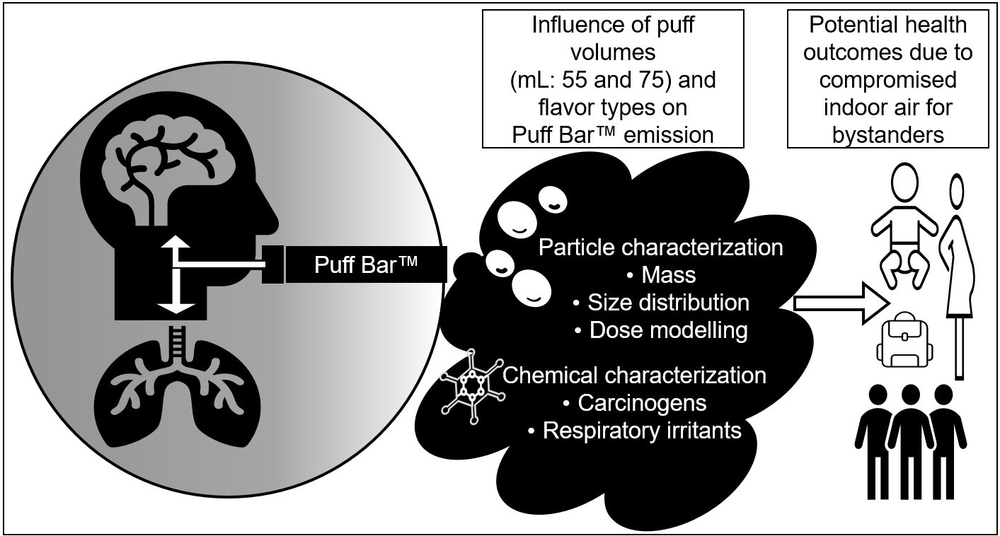

Supplemental Figure S1A). Sensitivity analysis for chemical characterization of Puff Bar™ emissions at different number (i.e., 2, 3, 4, and 5) of puffs within 3 minutes

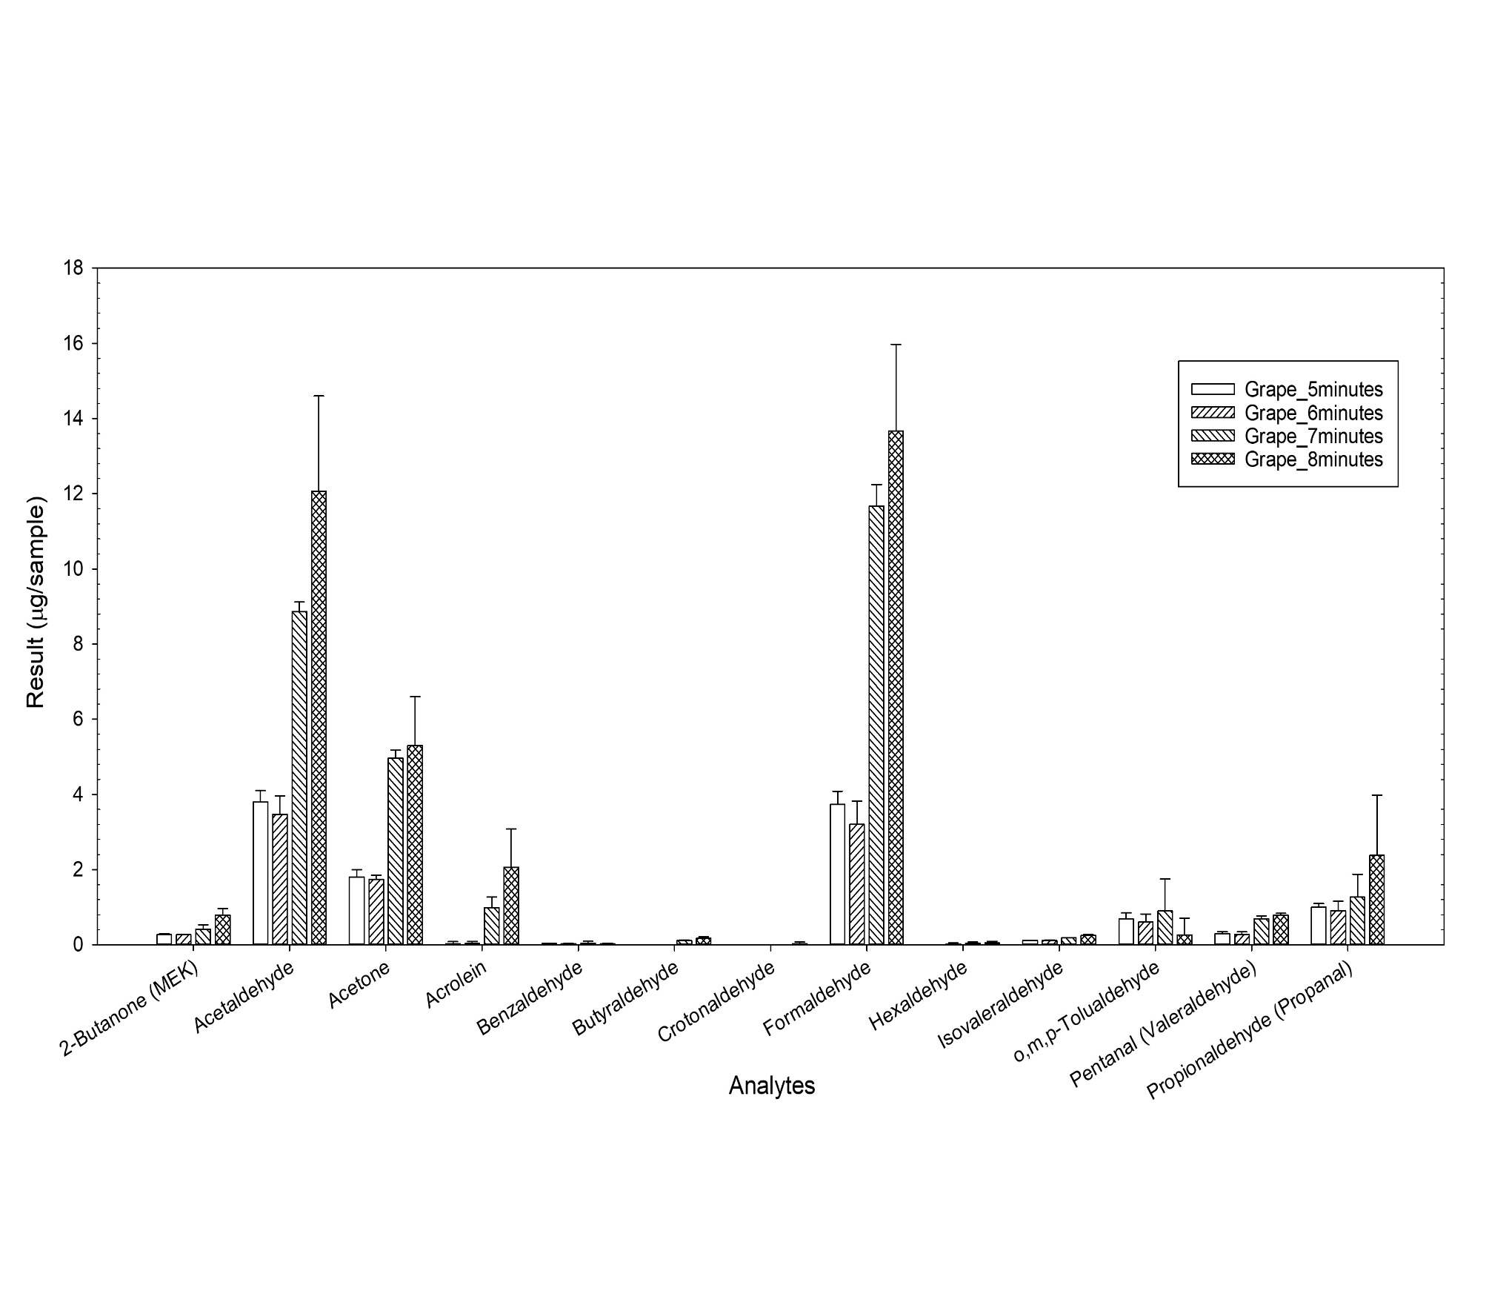

Supplemental Figure S1B). Sensitivity analysis for chemical characterization of Puff Bar™ emissions at different puffing duration (minutes: 5, 6, 7, and 8)

Figure S2. Total mass (average (µg/ml/puff)) of VCCs emitted by different flavor types of Puff Bar™ on aerosolizing at puff volumes (mL: 55, 65, and 75) for n = 3 per puff volume. *Puff Bar™ flavor types significantly influence (at p<0.05) total mass of VCCs.

|  |  |  |  |  |  |  |  |  |  |
| --- | --- | --- | --- | --- | --- | --- | --- | --- | --- |
| Puff Bar™ Flavors | Trial # | Total mass of aerosol | Mass based PSD | | Inhaled deposition fraction | | | | Exhaled fraction (%) |
| Average  (mg/puff) | MMAD (μm) | GSD | Head  (%) | TB  (%) | Pulmonary (%) | Total (%) |
| Cucumber | 1 | 5.7 | 1.06 | 1.56 | 37 | 20 | 42 | 30 | 70 |
| 2 | 5.2 | 0.99 | 1.47 | 37 | 20 | 42 | 30 | 70 |
| 3 | 5.2 | 0.99 | 1.45 | 36 | 21 | 43 | 27 | 73 |
| Grape | 1 | 5.1 | 1.12 | 1.71 | 39 | 20 | 41 | 33 | 67 |
| 2 | 5.1 | 1.14 | 1.71 | 40 | 20 | 41 | 33 | 67 |
| 3 | 4.5 | 1.10 | 1.66 | 39 | 20 | 41 | 32 | 68 |
| Melon Ice | 1 | 4.5 | 1.01 | 1.53 | 36 | 21 | 43 | 28 | 72 |
| 2 | 4.4 | 0.97 | 1.49 | 35 | 22 | 43 | 27 | 73 |
| 3 | 4.4 | 0.97 | 1.51 | 36 | 22 | 43 | 27 | 73 |
| OMG | 1 | 4.3 | 1.01 | 1.49 | 36 | 21 | 43 | 28 | 72 |
| 2 | 4.3 | 1.06 | 1.56 | 38 | 20 | 42 | 31 | 69 |
| 3 | 3.9 | 1.06 | 1.58 | 38 | 20 | 42 | 31 | 69 |
| Pomegranate | 1 | 5.1 | 1.01 | 1.47 | 36 | 21 | 43 | 28 | 72 |
| 2 | 5.1 | 1.06 | 1.49 | 37 | 21 | 43 | 29 | 71 |
| 3 | 5.0 | 1.01 | 1.49 | 36 | 21 | 43 | 28 | 72 |
| Sour Apple | 1 | 6.0 | 0.99 | 1.43 | 35 | 22 | 43 | 27 | 73 |
| 2 | 6.2 | 0.95 | 1.32 | 34 | 22 | 44 | 25 | 75 |
| 3 | 6.0 | 0.97 | 1.40 | 35 | 22 | 43 | 26 | 74 |
| Strawberry | 1 | 2.2 | 0.99 | 1.45 | 35 | 22 | 43 | 27 | 73 |
| 2 | 1.8 | 0.97 | 1.40 | 34 | 22 | 44 | 27 | 73 |
| 3 | 2.0 | 0.99 | 1.40 | 35 | 22 | 43 | 27 | 73 |

Table S1. Total mass, PSD, and lung deposition of all trials with Puff Bar™ for puff volume 55 mL

OMG – orange, mango, guava; PSD – particle size distribution; MMAD – mass median aerodynamic diameter; GSD – geometric standard deviation; TB – tracheobronchial

Table S2. Total mass, PSD, and lung deposition of all trials with Puff Bar™ for puff volume 65 mL

|  |  |  |  |  |  |  |  |  |  |
| --- | --- | --- | --- | --- | --- | --- | --- | --- | --- |
| Puff Bar™ Flavors | Trial # | Total mass of aerosol | Mass based PSD | | Inhaled deposition fraction | | | | Exhaled fraction (%) |
| Average  (mg/puff) | MMAD (μm) | GSD | Head  (%) | TB  (%) | Pulmonary (%) | Total (%) |
| Cucumber | 1 | 6.5 | 1.01 | 1.47 | 36 | 21 | 43 | 28 | 72 |
| 2 | 6.6 | 1.03 | 1.49 | 36 | 21 | 43 | 28 | 72 |
| 3 | 6.7 | 1.03 | 1.53 | 37 | 21 | 42 | 29 | 71 |
| Grape | 1 | 5.7 | 1.10 | 1.62 | 38 | 20 | 42 | 31 | 69 |
| 2 | 5.9 | 0.97 | 1.49 | 35 | 22 | 43 | 27 | 73 |
| 3 | 5.9 | 0.95 | 1.40 | 35 | 22 | 43 | 26 | 74 |
| Melon Ice | 1 | 4.9 | 0.97 | 1.38 | 35 | 22 | 43 | 26 | 74 |
| 2 | 5.0 | 0.99 | 1.45 | 35 | 21 | 43 | 27 | 73 |
| 3 | 5.4 | 0.95 | 1.38 | 34 | 22 | 43 | 25 | 75 |
| OMG | 1 | 4.3 | 1.01 | 1.45 | 36 | 21 | 43 | 28 | 72 |
| 2 | 4.8 | 1.03 | 1.45 | 36 | 21 | 43 | 28 | 72 |
| 3 | 4.9 | 1.01 | 1.56 | 37 | 21 | 42 | 29 | 71 |
| Pomegranate | 1 | 6.0 | 0.99 | 1.43 | 35 | 22 | 43 | 27 | 73 |
| 2 | 6.1 | 1.01 | 1.43 | 36 | 21 | 43 | 27 | 73 |
| 3 | 6.1 | 1.01 | 1.43 | 36 | 21 | 43 | 27 | 73 |
| Sour Apple | 1 | 6.4 | 0.97 | 1.40 | 35 | 22 | 43 | 26 | 74 |
| 2 | 7.3 | 0.95 | 1.34 | 34 | 22 | 44 | 25 | 75 |
| 3 | 8.6 | 0.86 | 1.12 | 31 | 24 | 44 | 22 | 78 |
| Strawberry | 1 | 3.5 | 0.93 | 1.32 | 33 | 23 | 44 | 25 | 75 |
| 2 | 3.7 | 0.95 | 1.36 | 34 | 22 | 44 | 26 | 74 |
| 3 | 3.7 | 0.99 | 1.40 | 35 | 22 | 43 | 27 | 73 |

OMG – orange, mango, guava; PSD – particle size distribution; MMAD – mass median aerodynamic diameter; GSD – geometric standard deviation; TB – tracheobronchial

Table S3. Total mass, PSD, and lung deposition of all trials with Puff Bar™ for puff volume 75 mL

|  |  |  |  |  |  |  |  |  |  |
| --- | --- | --- | --- | --- | --- | --- | --- | --- | --- |
| Puff Bar™ Flavors | Trial # | Total mass of aerosol | Mass based PSD | | Inhaled deposition fraction | | | | Exhaled fraction (%) |
| Average  (mg/puff) | MMAD (μm) | GSD | Head  (%) | TB  (%) | Pulmonary (%) | Total (%) |
| Cucumber | 1 | 6.7 | 0.99 | 1.40 | 35 | 22 | 43 | 27 | 73 |
| 2 | 6.7 | 0.99 | 1.38 | 35 | 22 | 43 | 26 | 74 |
| 3 | 6.8 | 0.99 | 1.43 | 35 | 21 | 43 | 27 | 73 |
| Grape | 1 | 6.1 | 1.08 | 1.60 | 38 | 20 | 42 | 31 | 69 |
| 2 | 6.4 | 1.10 | 1.51 | 38 | 20 | 42 | 30 | 70 |
| 3 | 6.7 | 1.06 | 1.53 | 37 | 21 | 42 | 30 | 70 |
| Melon Ice | 1 | 7.1 | 0.86 | 1.19 | 32 | 24 | 44 | 22 | 78 |
| 2 | 7.9 | 0.90 | 1.27 | 33 | 23 | 44 | 23 | 77 |
| 3 | 8.2 | 0.86 | 1.23 | 32 | 24 | 44 | 22 | 78 |
| OMG | 1 | 3.9 | 1.01 | 1.43 | 35 | 22 | 43 | 27 | 73 |
| 2 | 3.9 | 1.03 | 1.53 | 36 | 21 | 43 | 28 | 72 |
| 3 | 5.2 | 1.06 | 1.49 | 37 | 20 | 42 | 30 | 70 |
| Pomegranate | 1 | 6.1 | 0.97 | 1.40 | 35 | 22 | 43 | 26 | 74 |
| 2 | 6.1 | 1.01 | 1.47 | 36 | 21 | 43 | 28 | 72 |
| 3 | 6.4 | 0.97 | 1.40 | 35 | 22 | 43 | 26 | 74 |
| Sour Apple | 1 | 7.8 | 0.95 | 1.32 | 34 | 22 | 44 | 25 | 75 |
| 2 | 7.8 | 0.95 | 1.36 | 34 | 22 | 44 | 25 | 75 |
| 3 | 8.2 | 0.95 | 1.36 | 34 | 22 | 44 | 25 | 75 |
| Strawberry | 1 | 4.0 | 0.93 | 1.25 | 33 | 23 | 44 | 24 | 76 |
| 2 | 4.1 | 0.93 | 1.32 | 33 | 23 | 44 | 25 | 75 |
| 3 | 4.2 | 0.93 | 1.32 | 33 | 23 | 44 | 25 | 75 |

OMG – orange, mango, guava; PSD – particle size distribution; MMAD – mass median aerodynamic diameter;

GSD – geometric standard deviation; TB – tracheobronchial

Table S4. Volatile carbonyl compounds (VCCs) emission of all trials with Puff Bar™ for puff volume 55 mL

|  |  |  |  |  |  |  |  |
| --- | --- | --- | --- | --- | --- | --- | --- |
| Puff Bar™ Flavors | Trial # | Total mass of VCCs (μg/puff) | Mass (μg/puff) | | | | |
| Acetaldehyde | Acetone | Acrolein | Formaldehyde | Isovaleraldehyde |
| Cucumber | 1 | 1.31 | 0.10 (7.7%) | 0.33 (25.5%) | 0.01 (1.1%) | 0.60 (45.9%) | 0.21 (16.3%) |
| 2 | 1.25 | 0.08 (6.4%) | 0.33 (26.6%) | 0.01 (1.1%) | 0.57 (45.3%) | 0.23 (18.6%) |
| 3 | 1.24 | 0.07 (5.4%) | 0.33 (26.9%) | 0.01 (1.0%) | 0.57 (45.8%) | 0.24 (19.1%) |
| Grape | 1 | 2.14 | 0.77 (35.9%) | 0.53 (24.9%) | 0.11 (5.0%) | 0.57 (26.5%) | 0.00 (0.0%) |
| 2 | 1.90 | 0.67 (35.1%) | 0.47 (24.6%) | 0.00 (0.0%) | 0.53 (28.1%) | 0.02 (1.2%) |
| 3 | 1.85 | 0.67 (36.1%) | 0.50 (27.0%) | 0.00 (0.0%) | 0.53 (28.8%) | 0.03 (1.4%) |
| Melon Ice | 1 | 2.22 | 0.63 (28.5%) | 0.60 (27.0%) | 0.04 (1.6%) | 0.33 (15.0%) | 0.23 (10.3%) |
| 2 | 2.05 | 0.60 (29.2%) | 0.60 (29.2%) | 0.03 (1.6%) | 0.33 (16.2%) | 0.26 (12.8%) |
| 3 | 1.79 | 0.53 (29.9%) | 0.53 (29.9%) | 0.03 (1.8%) | 0.33 (18.7%) | 0.22 (12.5%) |
| OMG | 1 | 0.66 | 0.07 (11.1%) | 0.26 (39.5%) | 0.01 (0.9%) | 0.11 (17.2%) | 0.21 (31.4%) |
| 2 | 0.82 | 0.06 (7.8%) | 0.30 (36.7%) | 0.01 (0.8%) | 0.09 (11.4%) | 0.22 (27.3%) |
| 3 | 0.80 | 0.08 (10.0%) | 0.30 (37.2%) | 0.01 (0.8%) | 0.12 (15.1%) | 0.22 (28.0%) |
| Pomegranate | 1 | 5.01 | 1.40 (27.9%) | 0.63 (12.6%) | 0.70 (14.0%) | 1.07 (21.3%) | 0.27 (5.4%) |
| 2 | 4.38 | 1.20 (27.4%) | 0.57 (12.9%) | 0.60 (13.7%) | 0.90 (20.5%) | 0.26 (6.0%) |
| 3 | 3.99 | 1.10 (27.6%) | 0.53 (13.4%) | 0.53 (13.4%) | 0.83 (20.9%) | 0.24 (6.1%) |
| Sour Apple | 1 | 1.17 | 0.12 (10.3%) | 0.37 (31.4%) | 0.02 (1.6%) | 0.37 (31.4%) | 0.25 (21.1%) |
| 2 | 1.27 | 0.11 (8.6%) | 0.33 (26.2%) | 0.02 (1.5%) | 0.37 (28.8%) | 0.21 (16.8%) |
| 3 | 1.20 | 0.11 (9.4%) | 0.33 (27.2%) | 0.02 (1.6%) | 0.33 (27.8%) | 0.21 (17.8%) |
| Strawberry | 1 | 3.79 | 0.93 (24.7%) | 0.57 (15.0%) | 0.47 (12.3%) | 0.77 (20.2%) | 0.26 (7.0%) |
| 2 | 3.25 | 0.80 (24.6%) | 0.50 (15.4%) | 0.40 (12.3%) | 0.67 (20.5%) | 0.24 (7.3%) |
| 3 | 3.10 | 0.77 (24.7%) | 0.50 (16.1%) | 0.37 (11.8%) | 0.60 (19.3%) | 0.22 (7.0%) |

OMG – orange, mango, guava.

(%) – Mass proportion of VCCs

Table S5. Volatile carbonyl compounds (VCCs) emission of all trials with Puff Bar™ for puff volume 65 mL

|  |  |  |  |  |  |  |  |
| --- | --- | --- | --- | --- | --- | --- | --- |
| Puff Bar™ Flavors | Trial# | Total mass of VCCs (μg/puff) | Mass (μg/puff) | | | | |
| Acetaldehyde | Acetone | Acrolein | Formaldehyde | Isovaleraldehyde |
| Cucumber | 1 | 1.63 | 0.09 (5.7%) | 0.26 (15.9%) | 0.04 (2.5%) | 0.90 (55.2%) | 0.21 (12.7%) |
| 2 | 1.45 | 0.09 (6.2%) | 0.29 (19.7%) | 0.04 (2.5%) | 0.80 (55.1%) | 0.21 (14.2%) |
| 3 | 1.56 | 0.10 (6.2%) | 0.30 (19.4%) | 0.04 (2.6%) | 0.83 (53.3%) | 0.22 (13.9%) |
| Grape | 1 | 1.52 | 0.15 (10.1%) | 0.28 (18.3%) | 0.09 (5.7%) | 0.73 (48.4%) | 0.20 (13.2%) |
| 2 | 1.89 | 0.20 (10.7%) | 0.30 (15.7%) | 0.15 (8.1%) | 0.83 (44.0%) | 0.21 (10.9%) |
| 3 | 1.66 | 0.19 (11.3%) | 0.31 (18.7%) | 0.15 (8.9%) | 0.73 (44.3%) | 0.19 (11.5%) |
| Melon Ice | 1 | 1.06 | 0.11 (10.7%) | 0.37 (34.5%) | 0.01 (1.2%) | 0.27 (25.1%) | 0.21 (19.4%) |
| 2 | 1.06 | 0.12 (11.0%) | 0.37 (34.5%) | 0.02 (1.6%) | 0.27 (25.4%) | 0.21 (19.7%) |
| 3 | 1.07 | 0.11 (10.6%) | 0.40 (37.4%) | 0.02 (1.6%) | 0.25 (23.7%) | 0.20 (18.7%) |
| OMG | 1 | 0.90 | 0.12 (13.7%) | 0.40 (44.6%) | 0.01 (0.7%) | 0.11 (12.3%) | 0.24 (26.8%) |
| 2 | 0.99 | 0.16 (15.9%) | 0.43 (44.0%) | 0.01 (0.8%) | 0.14 (14.2%) | 0.22 (22.7%) |
| 3 | 0.72 | 0.07 (9.2%) | 0.32 (44.7%) | 0.01 (1.0%) | 0.11 (14.7%) | 0.22 (30.4%) |
| Pomegranate | 1 | 4.89 | 1.30 (26.6%) | 0.70 (14.3%) | 0.60 (12.3%) | 1.03 (21.1%) | 0.27 (5.5%) |
| 2 | 4.50 | 1.20 (26.6%) | 0.70 (15.5%) | 0.50 (11.1%) | 0.90 (20.0%) | 0.27 (6.0%) |
| 3 | 4.51 | 1.23 (27.4%) | 0.67 (14.8%) | 0.53 (11.8%) | 0.90 (20.0%) | 0.25 (5.6%) |
| Sour Apple | 1 | 1.13 | 0.08 (7.4%) | 0.28 (24.9%) | 0.02 (1.5%) | 0.37 (32.6%) | 0.25 (21.9%) |
| 2 | 0.97 | 0.08 (8.2%) | 0.30 (31.2%) | 0.02 (1.6%) | 0.33 (34.3%) | 0.21 (21.9%) |
| 3 | 1.14 | 0.09 (8.2%) | 0.28 (24.5%) | 0.02 (1.4%) | 0.43 (37.9%) | 0.18 (16.0%) |
| Strawberry | 1 | 5.38 | 1.37 (25.4%) | 0.70 (13.0%) | 0.67 (12.4%) | 1.30 (24.1%) | 0.20 (3.7%) |
| 2 | 4.47 | 1.10 (24.6%) | 0.60 (13.4%) | 0.50 (11.2%) | 1.03 (23.1%) | 0.24 (5.3%) |
| 3 | 4.66 | 1.17 (25.1%) | 0.60 (12.9%) | 0.53 (11.5%) | 1.13 (24.3%) | 0.20 (4.2%) |

OMG – orange, mango, guava

(%) – Mass proportion of VCCs

Table S6. Volatile carbonyl compounds (VCCs) emission of all trials with Puff Bar™ for puff volume 75 mL

|  |  |  |  |  |  |  |  |
| --- | --- | --- | --- | --- | --- | --- | --- |
| Puff Bar™ Flavors | Trial# | Total mass of VCCs (μg/puff) | Mass (μg/puff) | | | | |
| Acetaldehyde | Acetone | Acrolein | Formaldehyde | Isovaleraldehyde |
| Cucumber | 1 | 1.83 | 0.17 (9.3%) | 0.37 (20.1%) | 0.03 (1.5%) | 0.83 (45.6%) | 0.25 (13.7%) |
| 2 | 1.63 | 0.14 (8.8%) | 0.30 (18.2%) | 0.03 (2.0%) | 0.87 (53.3%) | 0.25 (15.6%) |
| 3 | 1.71 | 0.15 (8.8%) | 0.33 (19.1%) | 0.03 (2.0%) | 0.90 (52.7%) | 0.25 (14.8%) |
| Grape | 1 | 1.75 | 0.16 (9.2%) | 0.37 (21.0%) | 0.04 (2.3%) | 0.80 (45.8%) | 0.24 (13.9%) |
| 2 | 1.75 | 0.18 (10.1%) | 0.32 (18.3%) | 0.04 (2.5%) | 0.83 (47.6%) | 0.24 (13.5%) |
| 3 | 1.65 | 0.18 (10.7%) | 0.32 (19.6%) | 0.05 (3.0%) | 0.83 (50.6%) | 0.20 (12.3%) |
| Melon Ice | 1 | 1.00 | 0.11 (11.4%) | 0.25 (25.1%) | 0.01 (1.4%) | 0.33 (33.4%) | 0.23 (22.7%) |
| 2 | 1.27 | 0.13 (10.0%) | 0.33 (26.3%) | 0.02 (1.7%) | 0.37 (28.9%) | 0.24 (18.9%) |
| 3 | 1.08 | 0.13 (11.7%) | 0.30 (27.5%) | 0.02 (1.8%) | 0.37 (33.9%) | 0.23 (21.3%) |
| OMG | 1 | 0.81 | 0.10 (12.4%) | 0.28 (34.6%) | 0.01 (0.6%) | 0.17 (21.4%) | 0.25 (30.9%) |
| 2 | 0.83 | 0.11 (12.9%) | 0.31 (37.3%) | 0.01 (0.8%) | 0.17 (20.1%) | 0.24 (28.9%) |
| 3 | 0.89 | 0.13 (15.0%) | 0.33 (37.1%) | 0.01 (0.7%) | 0.16 (18.4%) | 0.26 (28.8%) |
| Pomegranate | 1 | 3.82 | 0.80 (20.9%) | 0.50 (13.1%) | 0.47 (12.2%) | 0.93 (24.4%) | 0.32 (8.4%) |
| 2 | 4.03 | 0.90 (22.4%) | 0.53 (13.2%) | 0.50 (12.4%) | 0.87 (21.5%) | 0.30 (7.4%) |
| 3 | 4.61 | 1.03 (22.4%) | 0.63 (13.7%) | 0.57 (12.3%) | 0.97 (21.0%) | 0.30 (6.5%) |
| Sour Apple | 1 | 1.09 | 0.14 (12.5%) | 0.33 (30.5%) | 0.01 (1.2%) | 0.33 (30.5%) | 0.25 (22.6%) |
| 2 | 1.19 | 0.14 (12.1%) | 0.37 (30.8%) | 0.01 (1.0%) | 0.37 (30.8%) | 0.26 (21.9%) |
| 3 | 0.97 | 0.10 (10.6%) | 0.28 (29.2%) | 0.01 (1.1%) | 0.32 (33.3%) | 0.23 (24.0%) |
| Strawberry | 1 | 6.02 | 1.53 (25.5%) | 0.67 (11.1%) | 0.80 (13.3%) | 1.43 (23.8%) | 0.24 (4.0%) |
| 2 | 5.26 | 1.27 (24.1%) | 0.57 (10.8%) | 0.70 (13.3%) | 1.30 (24.7%) | 0.23 (4.4%) |
| 3 | 5.15 | 1.30 (25.3%) | 0.57 (11.0%) | 0.70 (13.6%) | 1.33 (25.9%) | 0.20 (4.0%) |

OMG – orange, mango, guava

(%) – Mass proportion of VCCs