Supplementary Information
Author Information
Nan Zheng¹, Ying Jiang², Shan Jiang³, Jongwoon Kim³, Guo Chen⁴, Yueming Li⁵, Ji-Xin Cheng^{2, 4}, Xiaoting Jia³ * and Chen Yang^{4, 6} *
Affiliations
¹ Division of Materials Science and Engineering, Boston University, Boston, MA, USA
² Department of Biomedical Engineering, Boston University, Boston, MA, USA
³ Bradley Department of Electrical and Computer Engineering, Virginia Tech, Blacksburg, VA, USA
⁴ Department of Electrical and Computer Engineering, Boston University, Boston, MA, USA
⁵ Department of Mechanical Engineering, Boston University, Boston, MA, USA
⁶ Department of Chemistry, Boston University, Boston, MA, USA

Mechanical Index Calculation
The mechanical index (MI) is a unitless metric commonly used in the field of ultrasound imaging.¹ It provides an indication of the potential bioeffects when the tissue is exposure to a certain ultrasound field. Both the intensity and frequency of the ultrasound waves are taken into account. It’s defined as the peak negative pressure divided by the square root of the center frequency of the ultrasound wave. It is represented by the equation:
$$MI= \frac{P_{-}}{\sqrt{f_{c}}}$$
Where $P_{-}$ is the peak negative pressure of the ultrasound wave (MPa) and $f_{c}$ is the center frequency of the ultrasound pulse (MHz).
For the ultrasound with pressure of 2.3 MPa generated by mFOE, the peak negative pressure is -0.72 MPa and the central frequency is 12.5 MHz. Therefore, the MI is calculated as $0.72 MPa/\sqrt{12.5 MHz}=0.2$.
Supplementary Figure S1. Optical properties of the waveguide and optoacoustic emitter of mFOE. a. The optical loss of waveguide measured at 1030 nm with the cut-back method. b. Vis-NIR absorption spectrum of CB/PDMS mixture.
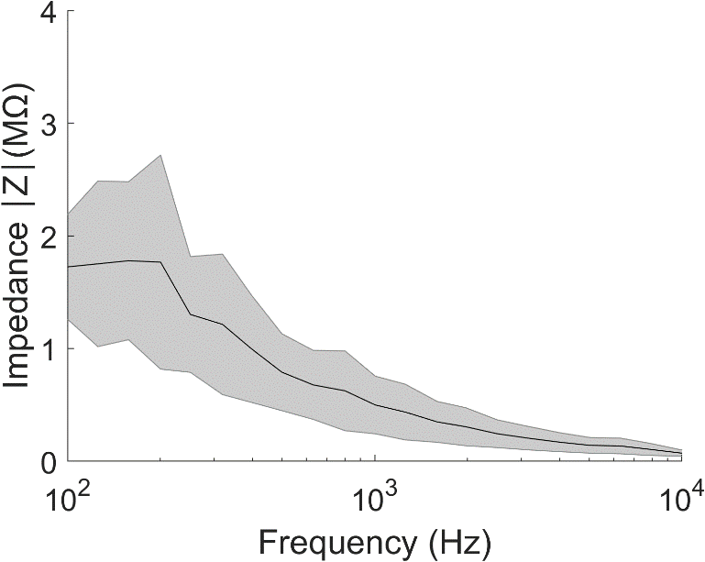
Supplementary Figure S2. Impedance measurements of the BiSn electrodes in multifunctional fiber. Shaded areas and solid curve in the figure represent the standard deviation and mean value respectively.

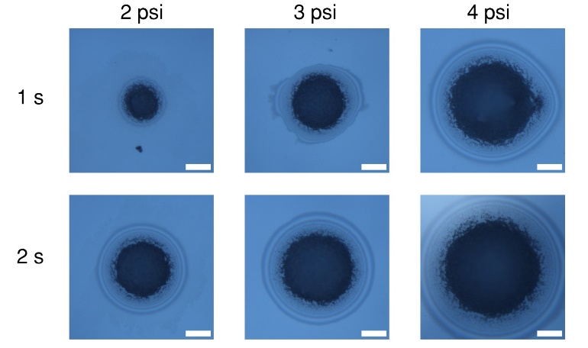
Supplementary Figure S3. Microscope images of deposited carbon black and PDMS composite.
The coverage area was controlled through tuning the injection pressure and time. Injection time was varied between 1 second and 2 seconds, and the pressure was varied from 2 psi, 3 psi and 4 psi. Scale bar: 50 µm.
Supplementary Figure S4. Attenuation curve of optoacoustic wave generated by mFOE along the axial direction. Relative pressure plotted as a function of the distance. Laser pulse energy was fixed at 41.8 µJ.

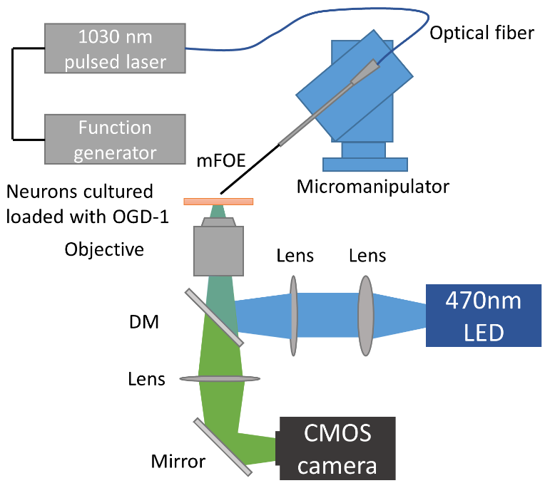
Supplementary Figure S5. Schematic of in vitro mFOE stimulation and calcium imaging set up.
Stimulation: 1030 nm pulsed laser is triggered by a function generator and delivered to the mFOE through an optical fiber. Calcium imaging: Oregon green is excited by 470 nm LED and the fluorescence signal is detected through a CMOS camera.
Supplementary Figure S6. Illustration of the laser pulse train for 5 bursts with 100 ms duration at 1Hz.

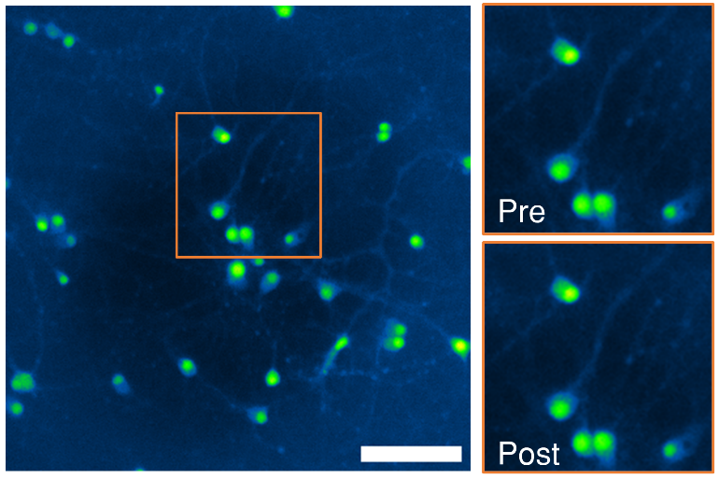
Supplementary Figure S7. Calcium imaging of neurons before and after mFOE stimulation with duration of 200 ms. Neurons were subjected to repeated stimulation using mFOE with a duration of 200 ms, repeated five times. The morphology and calcium signal of the same field of view were subsequently imaged and compared. No obvious differences were observed. Scale bar: 100 µm.
Supplementary Figure S8. Average calcium traces of laser only control groups. The laser duration was same with three conditions tested in mFOE stimulation (200 ms, 100 ms and 50 ms). Laser light with pulse energy of 41.8 µJ was triggered at the time point labelled by the red bar. Shaded areas: standard deviation. (N=3)

Supplementary Figure S9. Temperature change of the optoacoustic emitter integrated on mFOE. The pulse energy was maintained at 41.8 µJ and the burst duration was varied from 50 ms (blue), 100 ms (yellow) to 200 ms (orange). Laser was trigger at 2.5 second as labelled by the red bar.

Supplementary Figure S10. LFP recording of sham control stimulation experiments. a. Electrophysiological recording under light only stimulations delivered through a bare multifunctional fiber without optoacoustic emitter. b. Simultaneous optoacoustic stimulation and electrophysiological recording of an euthanized mouse. Same laser condition was used: pulse energy of 41.8 µJ, 50 ms burst of pulses, 1 Hz, blue dots indicate the laser onset.

Supplementary Figure S11. Confocal imaging of NeuN labelled neurons. At certain depth, NeuN labelled neurons are distributed unevenly because of the intrinsic structure of mice brain. For fair comparison, those samples were excluded from the later quantitative analysis. Scale bar: 100 µm.

Supplementary Table 1. The Young’s modulus of polymer materials used in mFOE and the commercial silica optical fiber.
Materials | PVDF² | PC³ | Silica⁴
Young’s Modulus (GPa) | 2.5-2.7 | 2.3-2.6 | 70

References

1. Sen, T., Tufekcioglu, O. & Koza, Y. Mechanical index. Anatol J Cardiol 15, 334-336 (2015).
2. Vinogradov, A. & Holloway, F. Electro-mechanical properties of the piezoelectric polymer PVDF. Ferroelectrics 226, 169-181 (1999).
3. Khun, N.W. & Liu, E. Thermal, mechanical and tribological properties of polycarbonate/acrylonitrile-butadiene-styrene blends. Journal of Polymer Engineering 33, 535-543 (2013).
4. Holmes, C., Godfrey, M., Mennea, P.L., Zahertar, S. & Dulieu-Barton, J.M. Flexible photonics in low stiffness doped silica for use in fibre reinforced polymer composite materials. Optical Materials 134 (2022).

