Supplemental Materials
Table S1: The 24 climate and landscape predictors included in the initial parameter selection for models based upon both field datasets. The ‘mean min max’ column shows whether predictor maximums, minimums, or means were averaged at the county level.
Variable Name | Min Mean Max | Brief Description | Data Source
Bio1 (°C) | Mean | Annual mean temperature | Daymet
Bio2 (°C) | Mean | Mean diurnal range | Daymet
Bio3 (%) | Max | Isothermality (BIO2/BIO7) (x100) | Daymet
Bio4 (°C) | Max | Temperature seasonality (Std Dev x 100) | Daymet
Bio5 (°C) | Max | Maximum temperature of the warmest month | Daymet
Bio6 (°C) | Min | Minimum temperature of coldest month | Daymet
Bio7 (°C) | Max | Annual range of temperature | Daymet
Bio8 (°C) | Mean | Mean temperature of wettest quarter | Daymet
Bio9 (°C) | Mean | Mean temperature of driest quarter | Daymet
Bio10 (°C) | Max | Maximum temperature of warmest quarter | Daymet
Bio11 (°C) | Min | Minimum temperature of coldest quarter | Daymet
Bio12 (°C) | Mean | Annual precipitation | Daymet
Bio13 (mm) | Max | Precipitation of wettest month | Daymet
Bio14 (mm) | Min | Precipitation of driest month | Daymet
Bio15 (mm) | Max | Precipitation seasonality (coefficient of variation) | Daymet
Bio16 (mm) | Max | Precipitation during wettest quarter | Daymet
Bio17 (mm) | Min | Precipitation during driest quarter | Daymet
Bio18 (mm) | Mean | Precipitation during warmest quarter | Daymet
Bio19 (mm) | Mean | Precipitation during coldest quarter | Daymet
GDD10  DEC-FEB (days) | Mean | Average growing degree days at 10 °C from DEC - FEB | Daymet
Monthly SWE  NOV-APR (mm) | Max | Snow water equivalent between NOV - APR | Daymet
Monthly VP  MAR-JUN (kPa) | Min | Vapor pressure between MAR - JUN | Daymet
Percent forest (%) | NA | Percent area covered by forest | USGS
DEM (m) | Mean | Average elevation | USGS
* The spatial resolution of all data layers was 1 km x 1 km.
** All Daymet climate variables were derived based on data from 1980-2015, forest cover was based on 2011 data and elevation was based on data collected in 2006.

Table S2: Model selection criteria and performance metrics for the testing and training runs of each modeling algorithm, based on predictors selected using percent deviance explained, used to construct the consensus models based upon the three pathogen datasets; A. phagocytophilum, Ba. microti, and Bo. miyamotoi.
A. phagocytophilum models
Performance metric | GLM |  | MARS |  | Maxent
 | Test | Train | Test | Train | Test | Train
AUC | 0.94 | 0.95 | 0.94 | 0.94 | 0.94 | 0.96
Percent correctly classified | 85.4 | 85.5 | 83.4 | 83.5 | 86.0 | 86.9
Mean threshold | 0.11 | 0.10 | 0.08 | 0.07 | 0.26 | 0.26
Sensitivity | 0.89 | 0.93 | 0.89 | 0.93 | 0.90 | 0.94
Specificity | 0.85 | 0.85 | 0.83 | 0.82 | 0.86 | 0.86
PPV | 0.41 | 0.42 | 0.38 | 0.38 | 0.42 | 0.44
NPV | 0.99 | 0.99 | 0.98 | 0.99 | 0.99 | 0.99
Correlation coefficient | 0.65 | 0.67 | 0.65 | 0.66 | 0.63 | 0.67
Ba. microti models
Performance metric | GLM |  | MARS |  | Maxent
 | Test | Train | Test | Train | Test | Train
AUC | 0.96 | 0.97 | 0.95 | 0.95 | 0.97 | 0.98
Percent correctly classified | 90.1 | 91.5 | 88.1 | 89.6 | 90.3 | 90.6
Mean threshold | 0.07 | 0.08 | 0.06 | 0.07 | 0.15 | 0.14
Sensitivity | 0.90 | 0.94 | 0.89 | 0.90 | 0.90 | 0.98
Specificity | 0.90 | 0.91 | 0.88 | 0.90 | 0.90 | 0.90
PPV | 0.35 | 0.40 | 0.31 | 0.34 | 0.36 | 0.38
NPV | 0.99 | 0.99 | 0.99 | 0.99 | 0.99 | 0.99
Correlation coefficient | 0.64 | 0.66 | 0.61 | 0.63 | 0.64 | 0.71
Bo. miyamotoi models
Performance metric | GLM |  | MARS |  | Maxent
 | Test | Train | Test | Train | Test | Train
AUC | 0.92 | 0.94 | 0.92 | 0.93 | 0.92 | 0.95
Percent correctly classified | 82.7 | 79.9 | 83.4 | 85.4 | 84.0 | 83.1
Mean threshold | 0.09 | 0.06 | 0.10 | 0.11 | 0.28 | 0.25
Sensitivity | 0.85 | 0.95 | 0.85 | 0.86 | 0.85 | 0.95
Specificity | 0.82 | 0.78 | 0.83 | 0.85 | 0.84 | 0.82
PPV | 0.31 | 0.29 | 0.32 | 0.35 | 0.33 | 0.33
NPV | 0.98 | 0.99 | 0.98 | 0.98 | 0.98 | 0.99
Correlation coefficient | 0.58 | 0.60 | 0.56 | 0.59 | 0.54 | 0.60
AUC: The AUC is a measure of model accuracy. A value of 1 indicates a ‘perfect’ model and values ≤ 0.5 indicate a poor distinction between counties classified as high- or low-suitability.
Percent Correctly Classified: (True Positive + True Negative) / (True Positive + True Negative + False Positive + False Negative)
Mean threshold: Probability threshold at which presence is with the sum of sensitivity and specificity maximized.
Sensitivity: True Positive / (True Positive + False Negative)
Specificity: True Negative / (True Negative + False Positive)
Positive Predictive Value (PPV) = True Positive / (True Positive / False Positive)
Negative Predictive Value (NPV) = True Negative / (False Negative + True Negative)
Correlation Coefficient: Linear relationship between the field data and model output.

Table S3: Relative contributions of the climate predictors selected using percent deviance explained used by the modeling algorithms for the three pathogen datasets; A. phagocytophilum, Ba. microti, and Bo. miyamotoi.
A. phagocytophilum models
Predictors | Percent Deviance Explained | Normalized contribution values (%)
 |  | GLM | MARS | Maxent
Max temp. warmest month (BIO5) | 35.1 | 5.6 | 0.6 | 1.7
Mean Vapor Pressure Mar - Jun | 23.7 | 29.9 | 52.3 | 43.4
Mean diurnal temp. range (BIO2) | 22.0 | 22.9 | 24.4 | 16.4
Precip. of coldest quarter (BIO19) | 15.7 | 15.7 | -- | 7.5
Isothermality (BIO3) | 13.9 | 8.4 | 3.8 | 3.3
Percent forest cover | 11.6 | 3.7 | 11.0 | 22.2
Precip. of warmest quarter (BIO18) | 9.1 | 12.6 | 6.6 | 3.5
Mean temp. of wettest quarter (BIO8) | 7.9 | 1.2 | 1.3 | 2.1
Ba. microti models
Predictors | Percent Deviance Explained | Normalized contribution values (%)
 |  | GLM | MARS | Maxent
Max temp. warmest month (BIO5) | 39.6 | 8.1 | 51.7 | 2.8
Mean Vapor Pressure Mar – Jun | 32.5 | 56.8 | 28.0 | 57.1
Isothermality (BIO3) | 28.5 | -- | 1.4 | 5.9
Mean diurnal temp. range (BIO2) | 24.3 | 8.5 | 7.0 | 3.3
Percent forest cover | 14.2 | 8.6 | -- | 21.7
Precip. of warmest quarter (BIO18) | 13.8 | 12.8 | 4.0 | 4.4
Precip. of coldest quarter (BIO19) | 13.4 | -- | 1.0 | 2.0
Mean temp. of wettest quarter (BIO8) | 8.6 | -- | -- | 0.2
Elevation | 5.7 | 5.2 | 2.5 | 2.0
Precip. wettest month (BIO13) | 5.2 | -- | 4.5 | 0.7
Bo. miyamotoi models
Predictors | Percent Deviance Explained | Normalized contribution values (%)
 |  | GLM | MARS | Maxent
Max temp. warmest month (BIO5) | 33.4 | 13.8 | 49.6 | 10.9
Mean diurnal temp. range (BIO2) | 23.9 | 17.3 | 9.4 | 19.7
Mean Vapor Pressure Mar - Jun | 18.9 | 30.3 | 16.7 | 28.5
Isothermality (BIO3) | 18.9 | -- | 2.2 | 2.1
Precip. of coldest quarter (BIO19) | 13.1 | 17.0 | 9.4 | 10.0
Precip. of warmest quarter (BIO18) | 11.1 | 13.5 | 6.6 | 9.4
Percent forest cover | 7.0 | 7.4 | 6.1 | 18.5
Mean temp. of wettest quarter (BIO8) | 5.7 | 0.7 | -- | 0.9
Percent Deviance Explained: Goodness of fit statistic, similar to an R² value.
Normalized Contribution Values: Describes the contribution of each predictor to the predictive power of each of the three models (GLM, MARS, Maxent).
Table S4: Sensitivity, specificity, positive predictive value (PPV), negative predictive value (NPV), and percent correctly classified (PCC) for the three consensus maps against the A. phagocytophilum, Ba. microti, and Bo. miyamotoi binary (reported / not reported) datasets, with the sensitivities of their three component models set at two different levels (90%, 95%). The model settings refer to the sensitivities set for the GLM, MARS, and Maxent models. Predictors were selected using percent deviance explained.
Consensus Layers | Model Settings | Sensitivity | Specificity | PPV | NPV | PCC
A. phagocytophilum consensus map | Sens: 90% | 90.1% | 86.7% | 44.2% | 98.7% | 87.0%
 | Sens: 95% | 95.4% | 81.8% | 38.0% | 99.3% | 83.2%
Ba. microti consensus map | Sens: 90% | 89.6% | 93.9% | 47.3% | 99.3% | 93.7%
 | Sens: 95% | 96.1% | 89.1% | 34.8% | 99.7% | 89.5%
Bo. miyamotoi consensus map | Sens: 90% | 91.4% | 83.0% | 33.7% | 99.0% | 83.7%
 | Sens: 95% | 96.1% | 77.9% | 29.1% | 99.5% | 79.5%

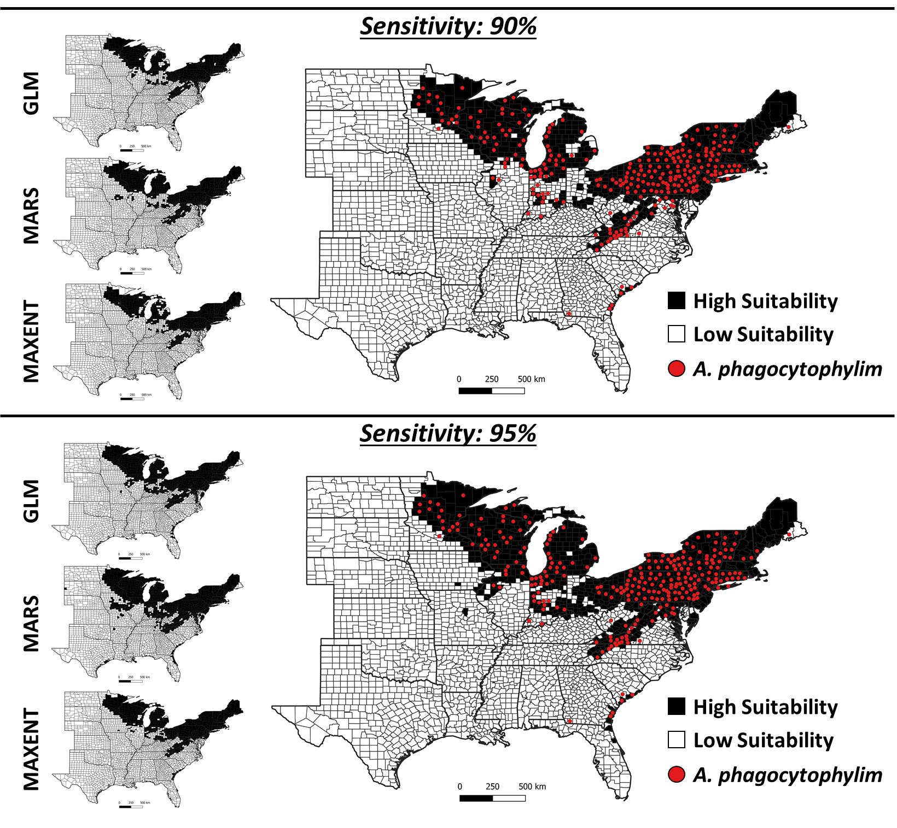
Figure 1S: Counties predicted to be highly suitable for detecting A. phagocytophilum-infected I. scapularis based on three individual models (GLM, MARS, Maxent) based on predictors selected using percent deviance explained, shown in maps on the left. The large consensus maps to the right show counties predicted to be highly suitable when ≥ 2 of the individual models predict high-suitability. Colored points on the large maps represent counties where A. phagocytophilum was detected in field collected host-seeking I. scapularis. The maps are shown at two levels of sensitivity (90%, 95%).
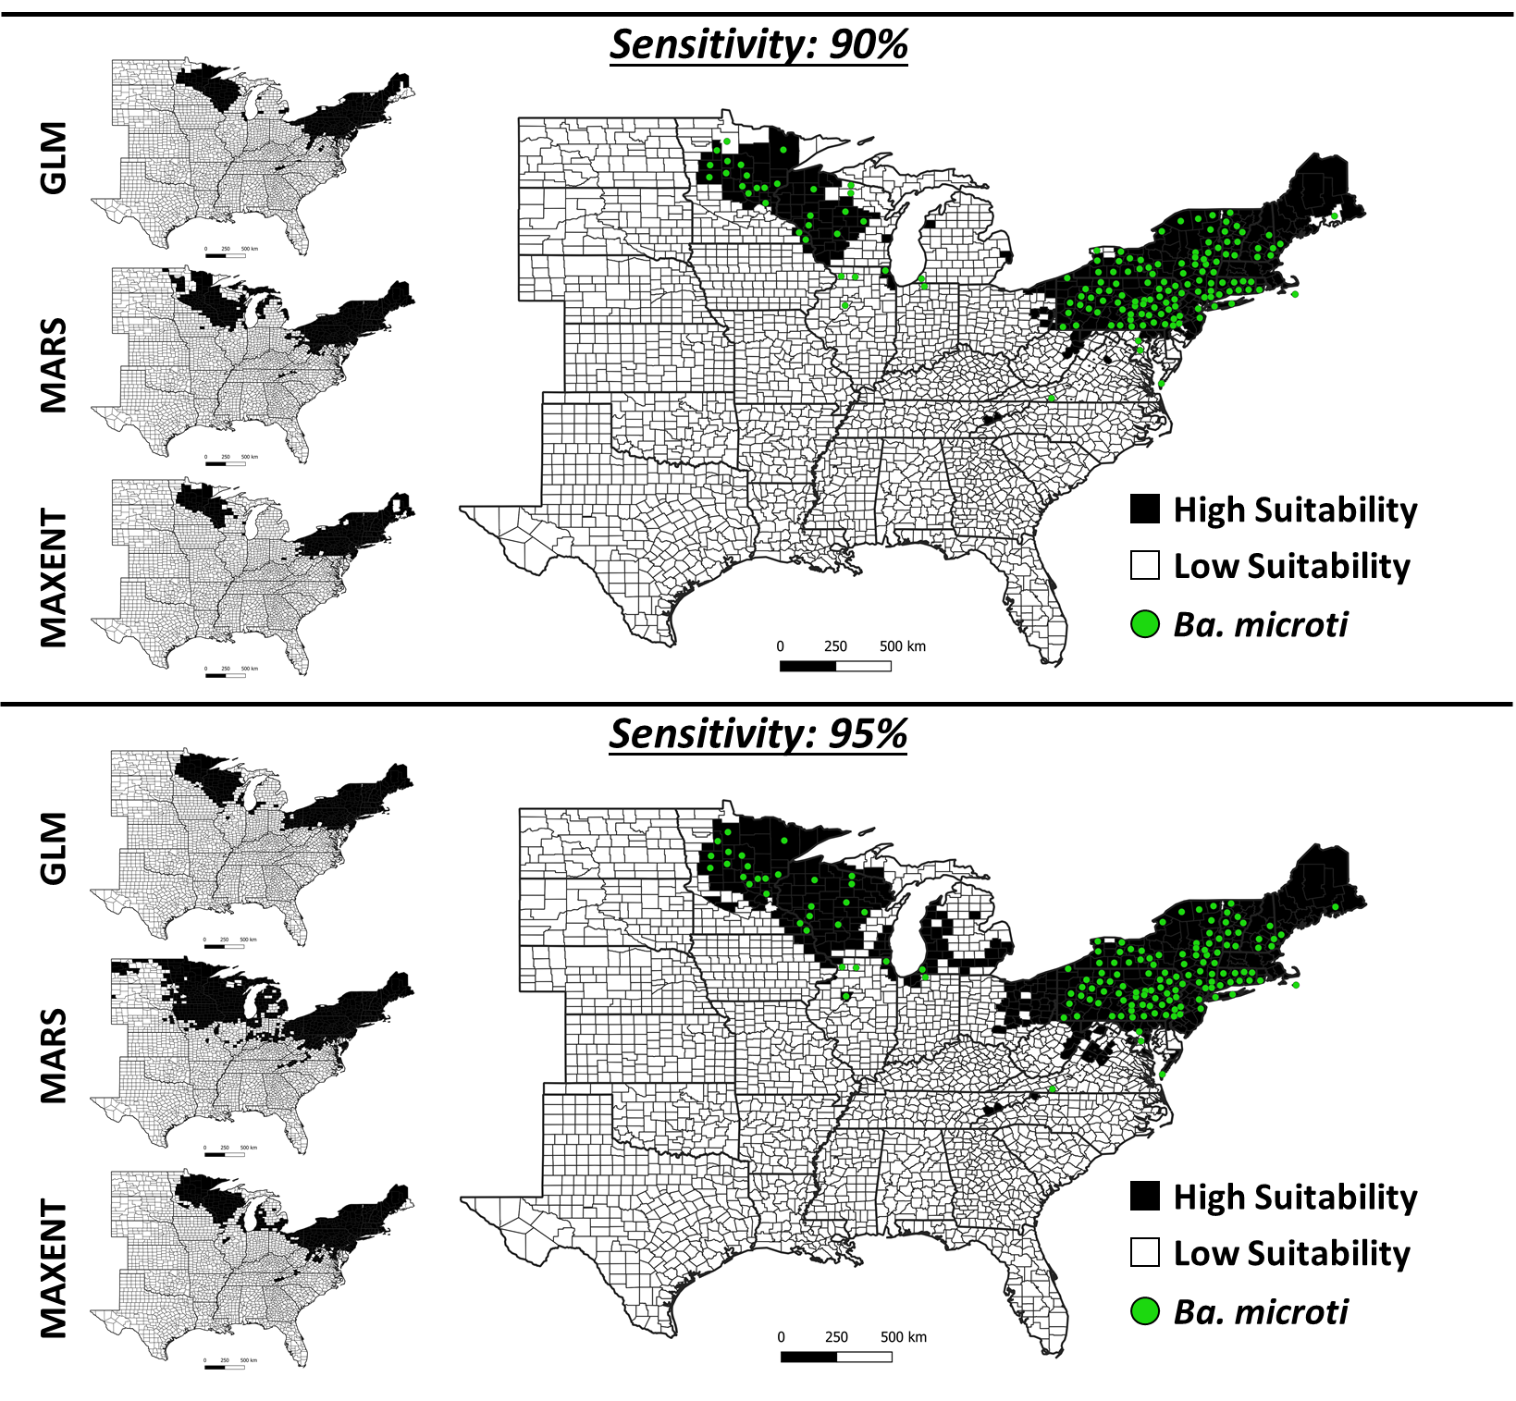
Figure 2S: Counties predicted to be highly suitable for detecting Ba. microti-infected I. scapularis based on three individual models (GLM, MARS, Maxent) based on predictors selected using percent deviance explained, shown in maps on the left. The large consensus maps to the right show counties predicted to be highly suitable when ≥ 2 of the individual models predict high-suitability. Colored points on the large maps represent counties where Ba. microti was detected in field collected host-seeking I. scapularis. The maps are shown at two levels of sensitivity (90%, 95%).
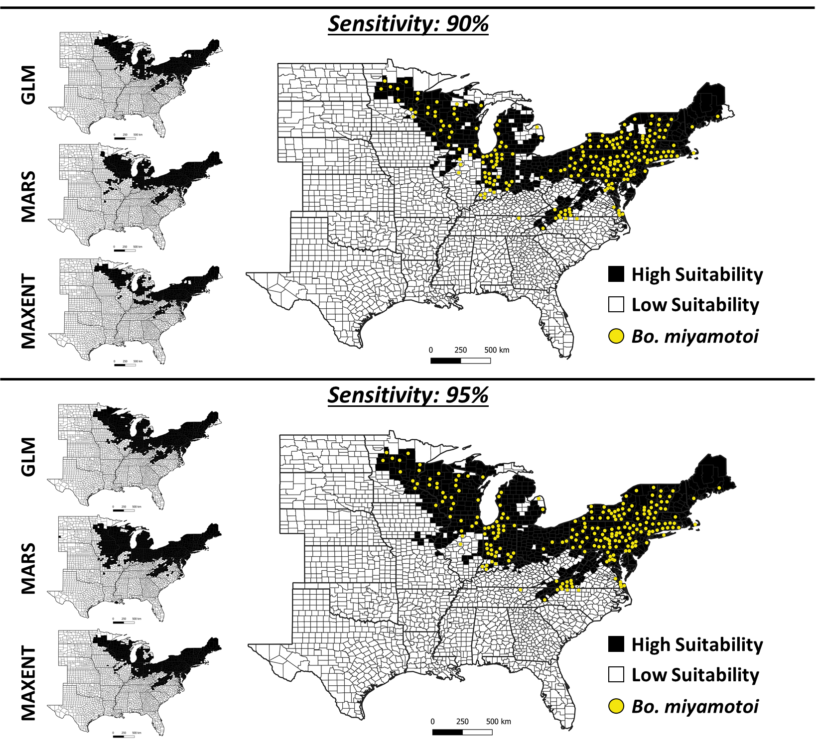
Figure 3S: Counties predicted to be highly suitable for detecting Bo. miyamotoi-infected I. scapularis based on three individual models (GLM, MARS, Maxent) based on predictors selected using percent deviance explained, shown in maps on the left. The large consensus maps to the right show counties predicted to be highly suitable when ≥ 2 of the individual models predict high-suitability. Colored points on the large maps represent counties where Bo. miyamotoi was detected in field collected host-seeking I. scapularis. The maps are shown at two levels of sensitivity (90%, 95%).
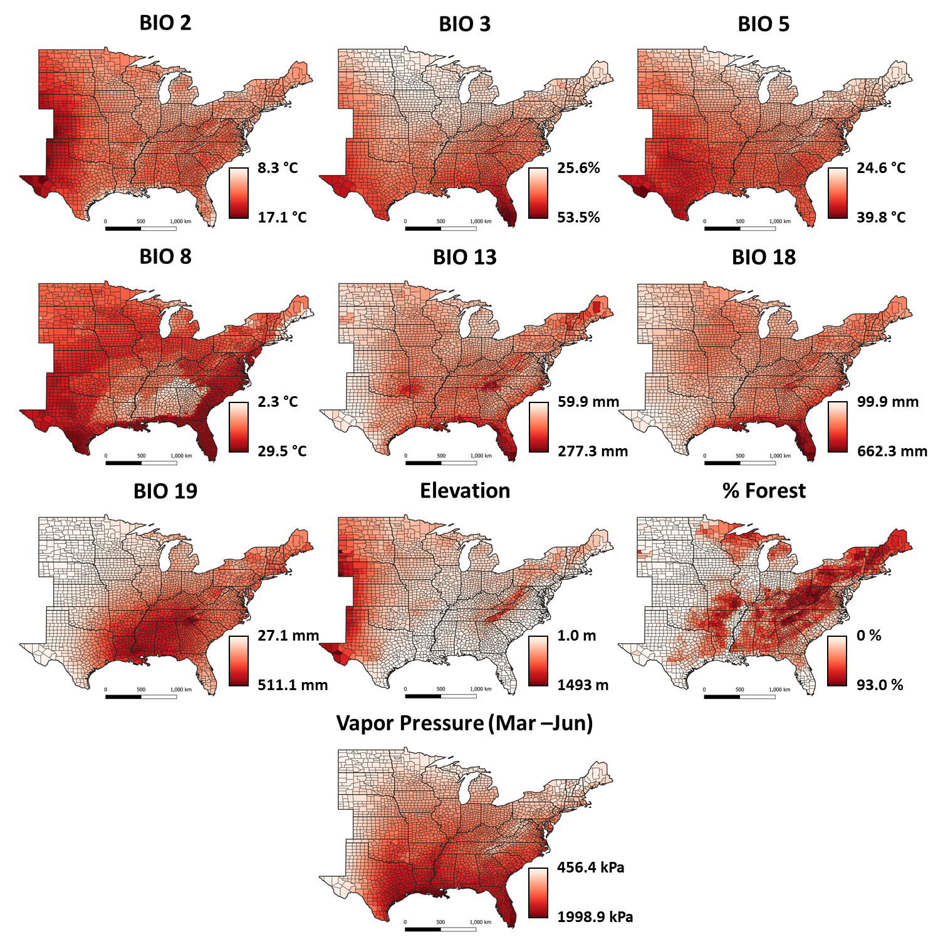
Figure 4S: Maps showing the geographic distribution of the ten predictors used by the three algorithms (GLM, MARS, Maxent) based on predictors selected using percent deviance explained to model suitable habitat for the three pathogens (A. phagocytophilum, Ba. microti, Bo. miyamotoi).

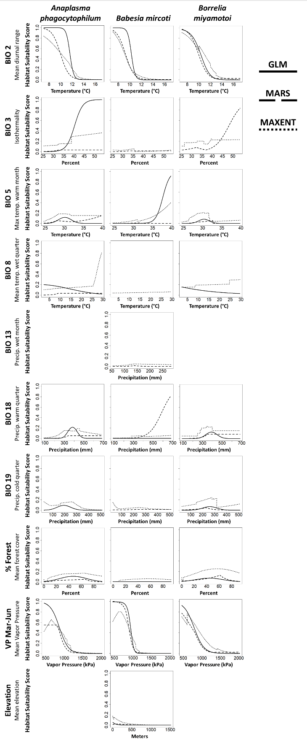
Figure 5S: Response curves for the predictive variables selected using percent deviance explained included in the climate suitability models using the three pathogen datasets; A. phagocytophilum, Ba. microti, and Bo. miyamotoi. The different line types represent the modeling algorithms, solid lines are GLM, dashed lines are MARS, and dotted lines are Maxent. Not all parameters were used in all models.

