SUPPLEMENTAL MATERIALS

Table S1. Demographics and clinical characteristics of 101 participants of the CLUES cohort with longitudinal DNA methylation analysis.
Patients Characteristics
Female Sex N |  |  | 90
Age mean years (SD) |  |  | 43 (13.3)
Disease Duration, mean years (SD) |  |  | 17.9 (10.4)
Self-reported race
 | White |  | 29
 | Black |  | 13
 | Asian |  | 34
 | Other |  | 3
Ethnicity
 | Hispanic |  | 22
 |  |  | Time 1 | Time 2
ACR Criteria*
 | Malar Rash |  | 51 | 51
 | Discoid Rash |  | 13 | 13
 | Oral Ulcers |  | 44 | 45
 | Photosensitivity |  | 41 | 41
 | Arthritis |  | 80 | 81
 | Serositis |  | 42 | 43
 | Hematologic manifestations |  | 54 | 55
 | Renal Criteria |  | 43 | 47
 | Neurologic Criteria |  | 15 | 16
 | Immunologic Criteria |  | 87 | 87
Clinical Subtype at cohort enrollment (n)
 | Mild (M1) |  | 27
 | Severe 1 (S1) |  | 46
 | Severe 2 (S2) |  | 28
SLEDAI at blood draw mean(SD)* |  |  | 2.68 (±2.71) | 3.34 (±4.12)
*p-value > 0.05

Table S2: Datasheet of SLE subtype associated CpGs (n=185) that showed stability over a two year period.

Table S3: Datasheet with 309 CpG sites with a methylation beta value difference > 0.03 and FDR < 0.5 over a 2 year period.

Table S4. Significant associations between DNA methylation and medications in a repeated measures model, adjusted for age, sex, and genetic PCs.

 | CpG | Gene Name | P-value
Azathioprine
 | cg25569341 | HDAC4 | 6.57E-05
 | cg15209676 | ZNF83 | 1.04E-04
Mycophenolate mofetil
 | cg26505274 | OASL | 1.31E-08
 | cg24603130 | ZCCHC2 | 4.30E-06
 | cg04253214 |  | 5.24E-05
 | cg04253214 | IFIT1 | 6.14E-05
 | cg03811829 | ISG15 | 1.13E-04
Prednisone
 | cg15821589 | FUBP1 | 2.66E-08
 | cg17749261 | TIPARP | 4.00E-07
 | cg01877318 | CDC27 | 5.78E-07
 | cg01534423 |  | 6.61E-06
 | cg22151281 | CEP78 | 1.90E-05
 | cg00955808 | FLJ22536 | 2.20E-05
 | cg18493069 | SNX3 | 2.41E-05
 | cg13390975 | BRIX1 | 3.55E-05
 | cg16222083 | DTL | 1.03E-04

Table S5. Significant associations between DNA methylation and disease activity in a repeated measures model, adjusted for age, sex, and genetic PCs.

 |  |  | Sledai Score
CpG | Chr | Gene | beta | p
cg09128104 | 17 | RARA | 0.698 | 0.000357
cg21524061 | 4 | TLR6 | 0.451 | 0.000488
cg09858955 | 2 | VRK2 | -1.208 | 0.0011
cg02173328 | 14 | SYNDIG1L | -0.318 | 0.00172
cg10552523 | 11 | IFITM1 | -1.213 | 0.00278
 |  |  | DsDNA antibody presence
 |  |  | beta | p
cg05070493 | 14 | TRAF3 | -0.0555 | 0.000255
cg01971407 | 11 | IFITM1 | -0.303 | 0.000257
cg05245822 | 18 |  | -0.2 | 0.000315
cg00959259 | 3 | PARP9 | -0.0929 | 0.000325
cg08122652 | 3 | PARP9 | -0.114 | 0.000398
 |  |  | Lupus Nephritis
 |  |  | beta | p
cg02968327 | 15 | IL16 | -0.0694 | 0.000155
cg17369694 | 6 | HLA-DRB5 | 0.061 | 0.000437
cg15273811 | 2 |  | 0.0741 | 0.000701
cg10025778 | 7 | CCDC146 | 0.0967 | 0.00073
cg09139047 | 6 | HLA-DRB1 | -0.0792 | 0.00105

Table S6 Datasheet of significant associations of self-reported ethnicity/race and genetic ancestry on methylation changes over time.

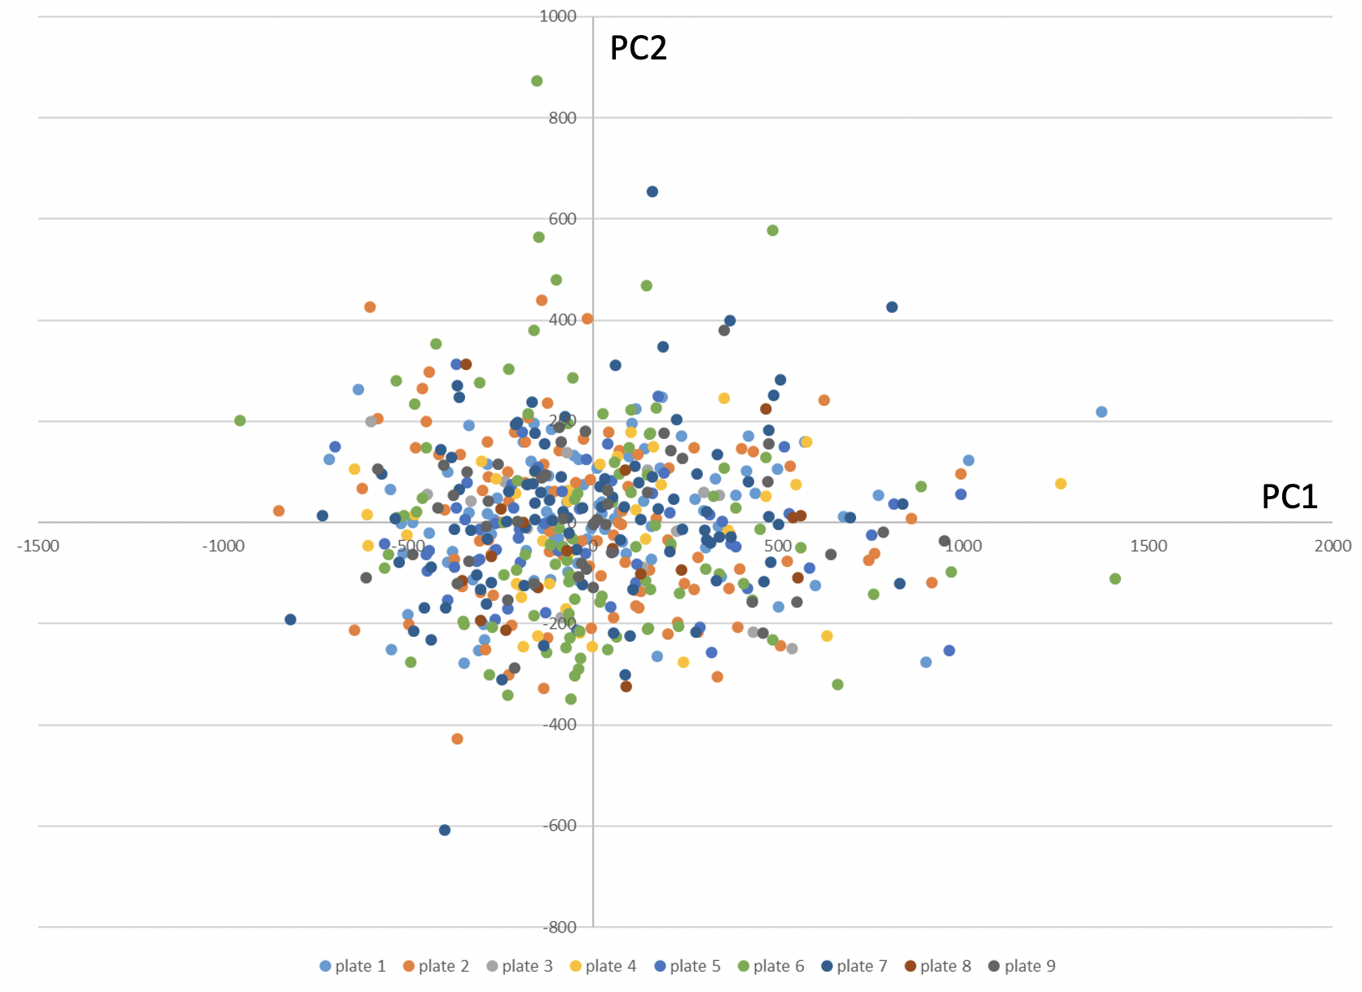

Fig S1. PCA plot after quality control, by assay plate.

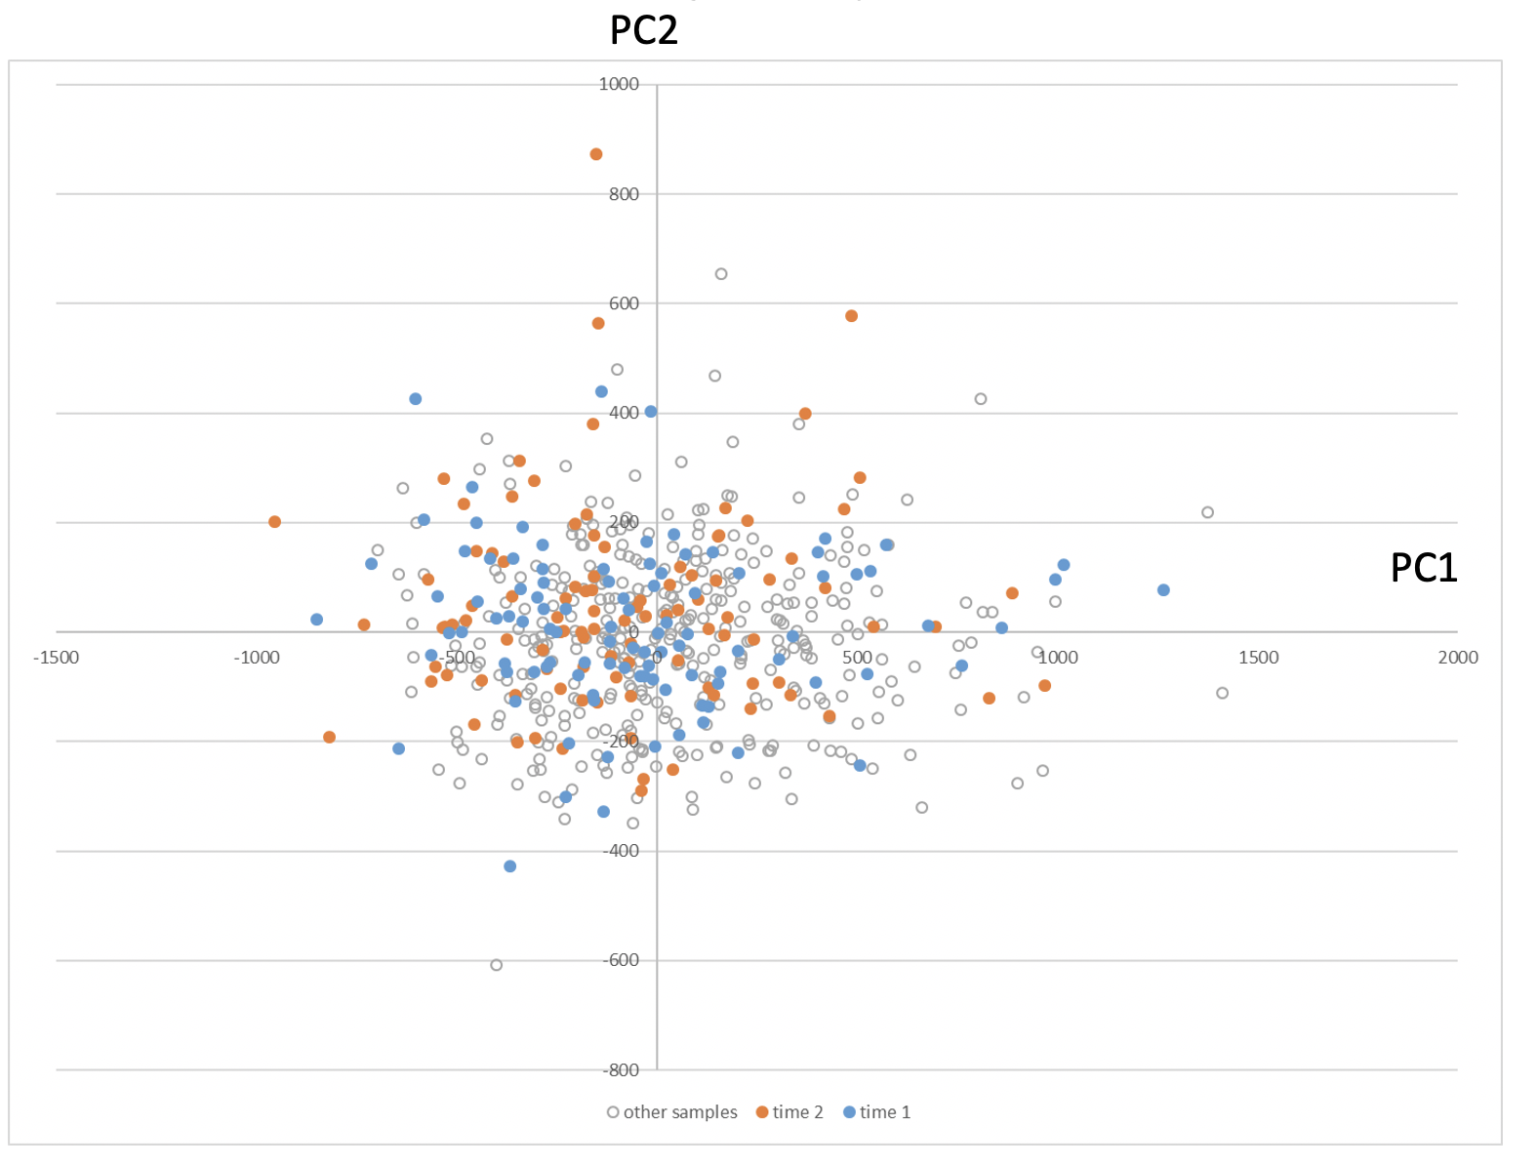

Fig S2. PCA plot after quality control, by timepoint

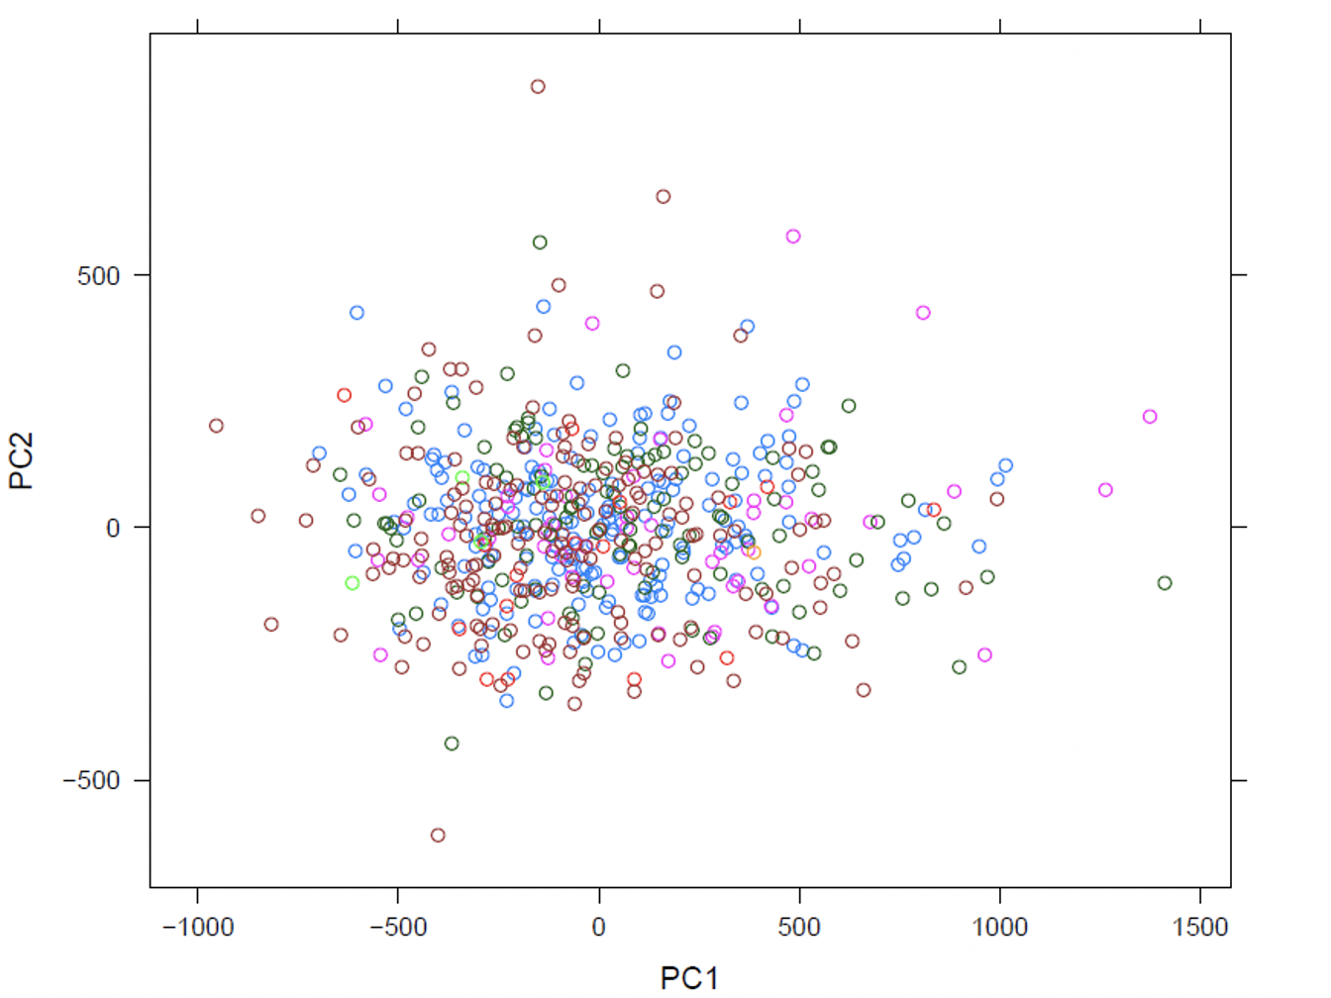

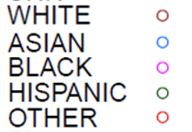

Fig S3. PCA plot after quality control, by race/ethnicity

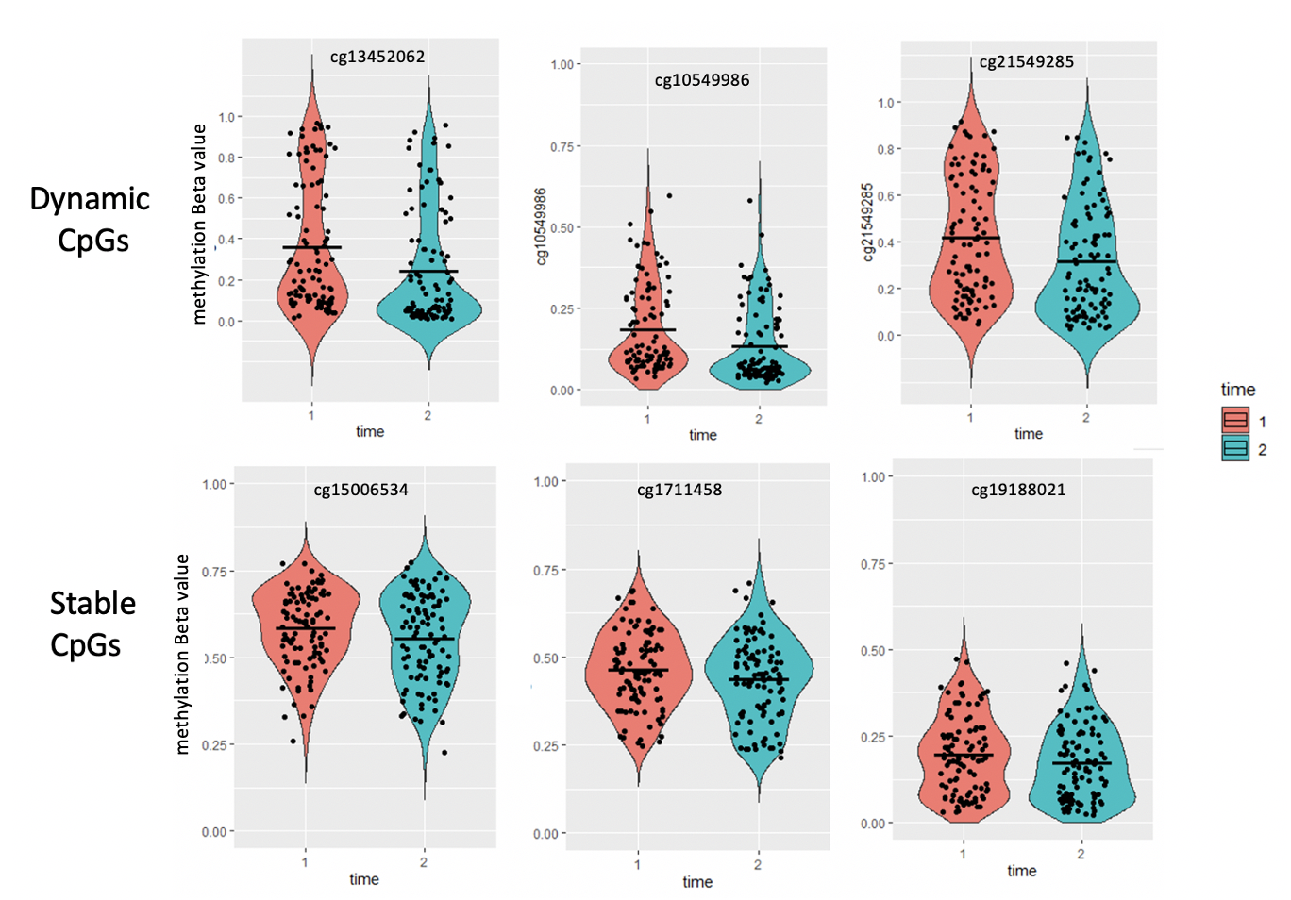

Fig S4. Violin plots of representative CpGs that had a significant change over time (dynamic CpGs) vs CpGs that did not change (stable Cpgs).

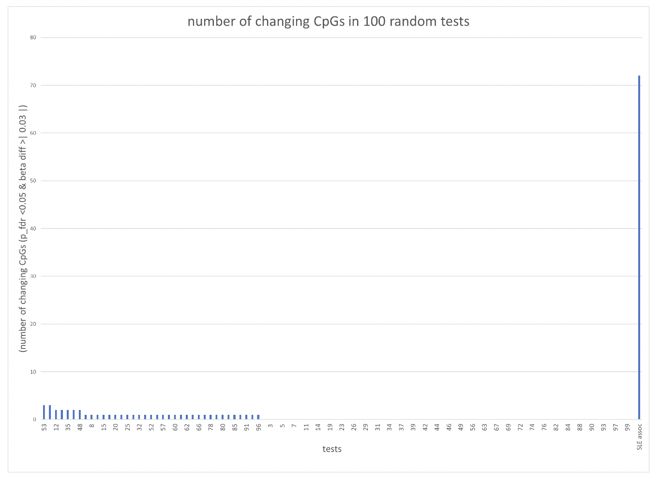

Figure S5. Enrichment of SLE-associated CpGs in CpGs with a significant change over two years. Histogram of CpGs with a significant change (paired t-test FDR <0.05, methylation difference > 3%) generated by randomly selecting 256 CpGs genome-wide with similar methylation variance as SLE-associated CpGs in one hundred tests.

Fig S6. Heat map of effect size of CpG sites with a significant cell population covariate. The 67 cpg sites in this heat map shows the M-value of the coefficient for the cell population for the sites that had at least one was statistically significant (at the Bonferroni level) cell population term in the model where methylation level was associated with timepoint. These 67 are a subset of the 309 cpg sites that changed over time.

