Supplemental Figure:
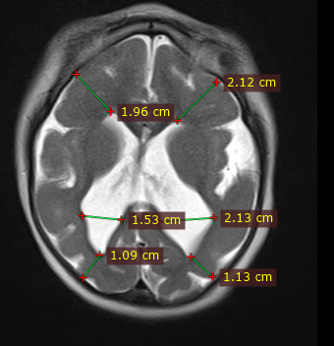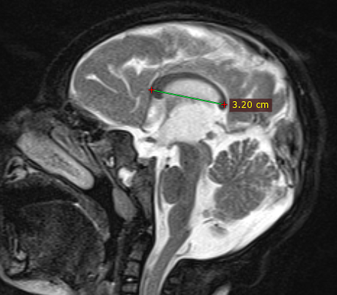
The images show examples of the measurements taken for a child with pattern 2. The upper image is an axial brain MRI. The lower image is a mid-sagittal brain MRI. Using RadiANT Digital Imaging Communications in Medicine (DICOM) Viewer (Medixant, Poznand, Poland), brain MRI and head CT’s were opened for measurement analysis. The distance between the outer portion of the cortical mantle to the ventricular lining in the right and left frontal lobes (at the level of the frontal horn) and the distance between the cortical mantle to the ventricular lining on the right and left occipital lobe was measured as the cortical thickness (upper image). The width of the right and left lateral ventricles were measured at the level of the atrium the axial image (upper image). The linear length of the corpus callosum was measured from the genu to the splenium on a mid-sagittal image (lower image).

