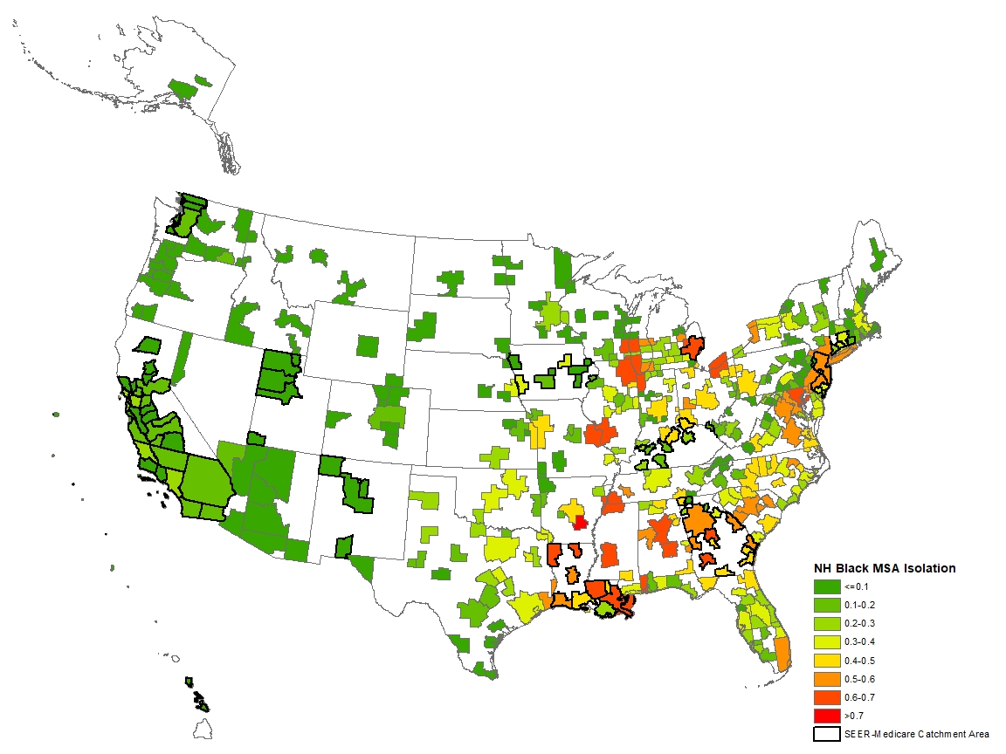
Figure S1. NH Black MSA Isolation among Metropolitan Statistical Areas in the United States, calculated using 2010 U.S. Census Population data

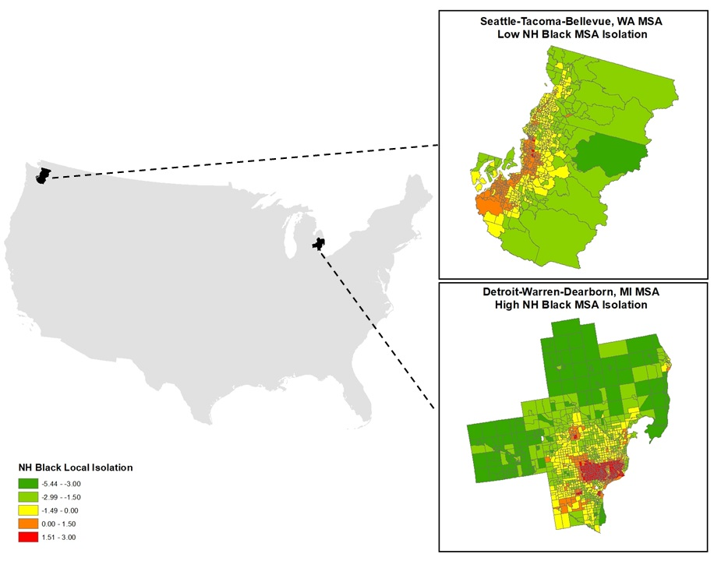
Figure S2. NH Black Local Isolation among two Metropolitan Statistical Areas within the SEER-Medicare Catchment Area, calculated using 2010 U.S. Census Population data

Table S1. Estimated Hazard Ratios at Different Levels of MSA Isolation

Reference | Comparison | HR | 95% CI | p | Interpretation
All-Cause Mortality
Low Local Isolation + Low MSA Isolation | Low Local Isolation + High MSA Isolation | 1.40 | 1.17-1.67 | <0.001 | High MSA Isolation in less isolated neighborhoods is significantly associated with worse survival for Black women with breast cancer.
High Local Isolation + Low MSA Isolation | High Local Isolation + High MSA Isolation | 1.09 | 0.99-1.21 | 0.089 | High MSA Isolation in more segregated neighborhoods is not significantly associated with worse survival for Black women with breast cancer.
BC-Specific Mortality
Low Local Isolation + Low MSA Isolation | Low Local Isolation + High MSA Isolation | 1.36 | 1.06-1.76 | 0.016 | High MSA Isolation in less isolated neighborhoods is significantly associated with worse breast cancer survival for Black women with breast cancer.
High Local Isolation + Low MSA Isolation | High Local Isolation + High MSA Isolation | 1.18 | 0.93-1.50 | 0.2 | High MSA Isolation in more segregated neighborhoods is not significantly associated with worse breast cancer survival among Black women with breast cancer.

