Supplemental File
A. Details about the implementation for each schema in ReDWINE and the extract, transform, load (ETL) process.
RAW Schema:
In the ReDWINE implementation, the RAW schema contains the following tables:
- Demographics: contains information such as patient identifier, birth date, death date, gender, race, and ethnicity.
- Diagnoses: contains information such as patient identifier, diagnosis type, diagnosis code (i.e., ICD code), diagnosis name, and diagnosis date;
- Encounters: contains patient medical encounter data, such as encounter identifier, encounter type, and encounter date;
- Encounter Notes: contains encounter notes scrubbed via NLMscrubber to best-effort de-identification (still containing some PHI) and related encounter metadata (patient identifier, encounter identifier, encounter date, etc.);
- Procedures: contains data related to medical procedures, such as procedure identifier, procedure type, procedure code;
- Procedure notes: contains procedure notes scrubbed via NLMscrubber to best-effort de-identification (still containing some PHI) and related procedure metadata (patient identifier, procedure identfier, procedure date).
We created these tables in the RAW schema and then loaded the EHR data we received from R3 into the tables using SQL programming language. For structured EHR data, we used the original data without processing. For unstructured EHR data (encounter notes and procedure notes), an encounter or a procedure could have multiple entries of text data in the original format. Therefore, we ran a SQL preprocessing script to merge free text entries for each encounter and procedure. This turned out to be very helpful for the clinical NLP tool that we used for automatically extracting concepts from the notes and mapping them to standardized concept identifiers . We will describe this tool in detail in the next section.
CDM Schema:
The CDM schema contains data from several sources, including the EHR data obtained from the RAW Schema, OMOP’s standardized vocabularies, and related metadata. This schema is generated using the CDM R package provided by the OHDSI community OHDSI/CommonDataModel. The process, as shown in Figure A1, includes three steps: 1) generate the Data Definition Language (DDL) SQL programs using the tool; 2) make further changes to the DDL programs in an automated manner; and 3) run these programs inside ReDWINE.
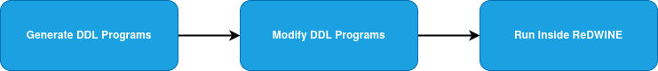
Figure A1. The DDL Generation and Running Process

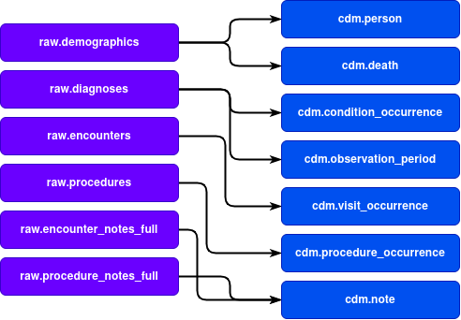
This CDM R package allows for generating OMOP CDM DDLs of various versions. The one we used is CDM version 5.3. The reason is that all of the primary OHDSI tools support this CDM version. Depending on data, the DDL script might need further changes. In our case, we had to increase the maximum allowed length for text documents and change the integer types. The text document size change was needed since some of our documents were larger than the default maximum. As for integer type changes, we had to alter the DDL programs as the default integer type could not hold large numbers we used for representing person identifiers and note identifiers. We automated these DLL program transformations by defining all of these replacements in advance and incorporating them into an R program. Once the steps successfully finish, the DDL programs are run inside ReDWINE to create the cdm schema and all of the cdm schema tables as defined by the OMOP CDM.
Figure A2.Table Mapping from the raw Schema to the cdm Schema

The ETL process is the most important process in the datamart and it should be performed with great care. Figure A3 depicts the piple for the ETL process. The CDM schema contains tables that are populated during the ETL process. During the ETL process, we ingest the data from the RAW schema, transform it, and load it into the CDM schema. For our pilot dataset, we leveraged a direct mapping from the RAW schema to the CDM schema, as shown in Figure A2. This mapping is not necessarily one-to-one mappings, meaning some tables (e.g., demographics) can be used to populate two different CDM tables. The mapping or data loading process virtually always involves some manual work in order to translate the data-specific concept language into the OMOP CDM compliant one. But once this work is done, the rest can be automated.
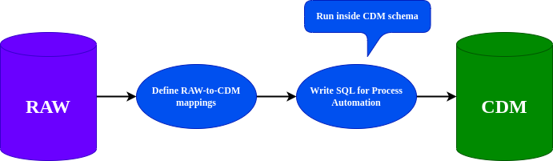
The loading process first involves mapping the data in the RAW schema to the OMOP CDM supported standardized vocabulary. Automated mapping and manual mapping are two approaches that are usually adopted in this step. Automated mapping can be used for the code that follows widely used standards in healthcare domains, such as ICD-9/10, CPT-4, etc. In the automated mapping step, we leveraged the OMOP standardized vocabularies requested and obtained from OHDSI Athena (note that the vocabularies need to be approved before downloading). We first loaded the OMOP vocabularies into the CDM schema and then applied the SQL function that we have developed to perform automated code-to-code mapping. The function utilizes the dictionaries that are loaded into the database and maps a code from the source data to the target CDM concept identifier. In our case, the source codes were ICD-9-CM, ICD-10, ICD-10-CM for the diagnosis, and CPT-4 for the procedure. An example of such a function call would look as follows: to_cdm(cpt_code, 'CPT4'), where the source code is from the CPT vocabulary and the target would be OMOP CDM concept ID. The SQL function we developed also allows for multiple-vocabulary lookups in which case it attempts to find if the source concept ID is present in one of the provided vocabularies. One example would be to_cdm(cpt_code, 'CPT4,ICD10'), when we are not sure whether the source code is in the CPT-4 vocabulary or ICD-10 vocabulary. In this case the function would first check if the code comes from the CPT-4 vocabulary and in case of a failed lookup, it would then move onto ICD-10 vocabulary and return the corresponding OMOP CDM concept identifier.
Figure A3.The ETL Pipeline.
The manual mapping was performed with assistance from domain experts in rehabilitation when there is no mapping from the source concept to the OMOP CDM standardized vocabulary. This can be the case if the healthcare system has its own naming conventions. In practice, manual mapping in SQL is done using SQL’s CASE statement or similar to consider different cases and for every case, map it to the OMOP CDM standardized concept identifier. For example, in the ReDWINE implementation, we had to create mappings between the ethnicity concept (e.g., “HISPANIC OR LATINO” and “NOT HISPANIC OR LATINO”) and the corresponding OMOP CDM concept identifiers (38003563 and 38003564, respectively). An example of the SQL code responsible for handling this mapping can be found in Table A1. A more complex case is mapping encounter visit types to the standardized vocabulary since all encounter visits are specific to the local health care system and clinical setting, sometimes with location names. Domain experts assisted in this process to look up the semantically closest concept in the OMOP CDM standardized vocabulary. If no similar concepts could be identified, we assigned a concept identifier of 0 per OHDSI’s suggestion. Table A2 lists an example of SQL code for mapping enc_type column from RAW schema to OMOP CDM concept IDs in the CDM schema.
Table A1. An example of SQL code for handling ethnicity mapping.
1 CASE
2 WHEN ethnicity = 'HISPANIC OR LATINO' THEN 38003563
3 WHEN ethnicity = 'NOT HISPANIC OR LATINO' THEN 38003564
4 ELSE 0
5 END AS ethnicity_concept_id
Once the standardized data were loaded, we performed a set of analyses using OHDSI’s ACHILLES tool to ensure data quality. ACHILLES can be run on the CDM schema in order to generate descriptive statistics on the OMOP CDM database. These statistics can then be used by data analytics tools such as ATLAS. The statistics themselves are loaded into the RESULTS schema.
Table A2. An example of SQL code for mapping enc_type column from RAW schema to OMOP CDM concept IDs in the CDM schema.
1 CASE
2 WHEN enc_type = 'ABSTRACT' THEN 45877039
3 WHEN enc_type = 'ALLERGY MIXING' THEN 44791052
4 WHEN enc_type = 'ALLERGY SHOT' THEN 46272888
5 WHEN enc_type = 'AMBULATORY VISIT SUMMARY' THEN 46237886
6 WHEN enc_type = 'ANTICOAGULATION' THEN 35803400
7 WHEN enc_type = 'ANTICOAGULATION SCHEDULED' THEN 35803400
8 WHEN enc_type = 'APPOINTMENT' THEN 4089197
9 --over 100 WHEN statements omitted
10 ELSE 0
11 END AS visit_concept_id

Text Analytical Capabilities
After performing ETL process followed by running the ACHILLES tool on the data, we used the clinical NLP tool to automatically extract medical concepts from encounter notes and procedure notes, and mapped them to the appropriate OMOP CDM standardized concept identifiers. We used the OHNLP Toolkit, which was developed by the OHNLP consortium, to automate concept extraction from the clinical notes. The OHNLP Toolkit uses is a ontology-derived dictionary-based approach and uses MedTagger [1] as the backbone for information extraction. Specifically, medical concepts were extracted from notes, normalized to Unified Medical Language System (UMLS) concept unique identifiers (CUIs), then mapped to associated OHDSI standardized Concept IDs, and finally stored in the Note_NLP table. An exact string matching algorithm was used to automate the mapping process and manual linking was created if an exact text match could not be found. The OHNLP Toolkit leveraged the ConText algorithm [3] to identify negation (is the condition negated or not), assertion (asserted vs. possible vs. hypothetical), temporality (historical or current), and experiencer (whether or not it relates to the patient, as opposed to, for example, a family member). The OHNLP Toolkit has been validated in previous studies. In [1], it is also reported that 89% of heart failure patients can be identified by using the OHNLP algorithm and that 99% can be identified by combining the OHNLP NLP algorithm with ICD-9 codes. In a large multi-site study known as the national COVID cohort collaborative (N3C), the overall accuracy of the OHNLP NLP toolkit is 71% [4]. Another benefit of using the OHNLP Toolkit is that one can define customized rules for extracting specific concepts and phenotypes from notes. The process will populate the Note_NLP table in the CDM schema.
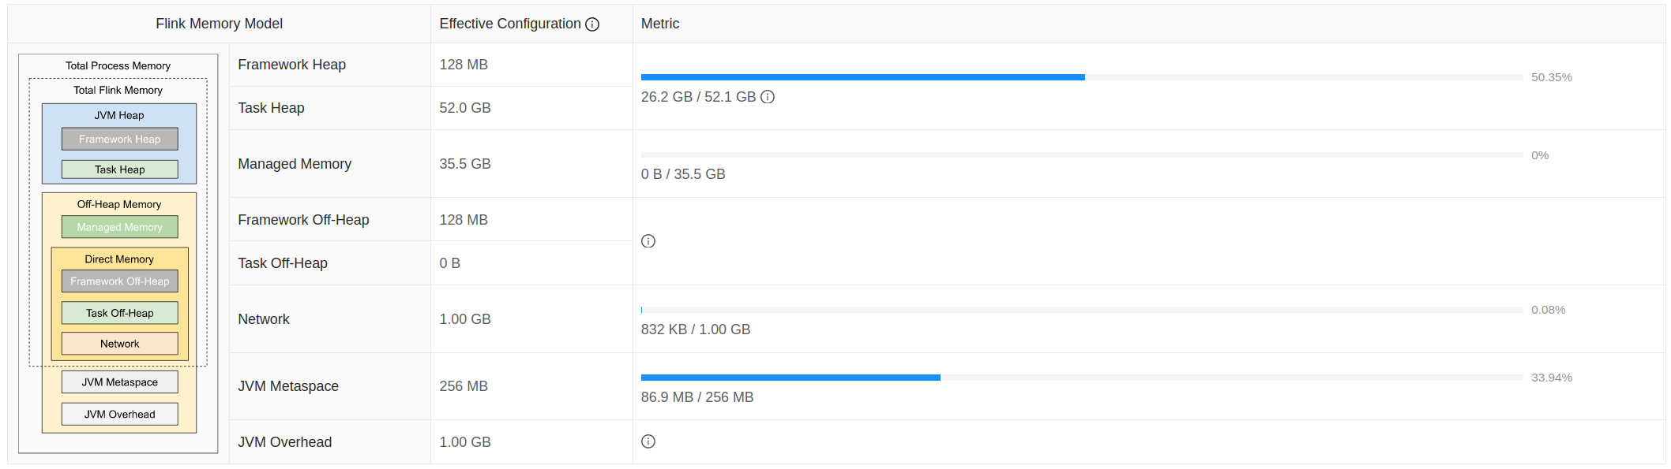
The OHNLP Toolkit uses Apache Flink, an open-source, unified stream-processing and batch-processing framework, to observe the batch text data processing process and corresponding statistics, as shown in Figure A4. We found this feature to be extremely helpful for debugging. Specifically, for ReDWINE, the initial “Task Heap” memory was not large enough, which would result in unsuccessful exits. The tool helped us debug the issue and we then increased the memory to 52.0 GB. The OHNLP Toolkit took around 8 hours to complete the text analysis for over 2 million notes and concept extraction and populated these concepts in the Note_NLP table of the CDM schema. More details about the OHNLP Toolkit can be found in the previous study [2].
Figure A4.Apache Flink Running on the Server via OHNLP Toolkit.
Data Analytic Tools
Broadsea is a tool that allows for running the core OHDSI data analytics stack inside a Docker container. This includes the ATLAS web application and the HADES R packages within a RStudio Server. The containerization of the core stack allows for the cross-platform implementation. This means that ReDWINE can be deployed on most major platforms including Linux, macOS, and Windows. In our case, we used Linux for both hosting our database as well as deploying Docker containers. It should be noted that we migrated to Broadsea 2.0 a few weeks after the release since the broad support from the OHDSI community. For the most part, it was a painless process, but it does involve configuration of the database connections for Broadsea 2.0 to access the CDM data as well as the ACHILLES-populated results table. After deploying the Docker containers, we have both ATLAS as well as HADES running inside our containers and researchers can access both through the Broadsea 2.0 portal running on ReDWINE.
Reference
1. Liu H, Bielinski SJ, Sohn S, Murphy S, Wagholikar KB, Jonnalagadda SR, Ravikumar K, Wu ST, Kullo IJ, Chute CG: An information extraction framework for cohort identification using electronic health records. AMIA Summits on Translational Science Proceedings 2013, 2013:149.
2. Wen A, Fu S, Moon S, El Wazir M, Rosenbaum A, Kaggal VC, Liu S, Sohn S, Liu H, Fan J: Desiderata for delivering NLP to accelerate healthcare AI advancement and a Mayo Clinic NLP-as-a-service implementation. NPJ digital medicine 2019, 2:130.
3. Harkema, H., Dowling, J. N., Thornblade, T. & Chapman, W. W. ConText: an algorithm for determining negation, experiencer, and temporal status from clinical reports. J. Biomed. Inf. 42, 839–851 (2009).
4. Liu, S., Wen, A., Wang, L., He, H., Fu, S., Miller, R., Williams, A., Harris, D., Kavuluru, R., Liu, M. and Abu-El-Rub, N., 2021. An open natural language processing development framework for EHR-based clinical research: a case demonstration using the national COVID cohort collaborative (N3C). arXiv preprint arXiv:2110.10780.

https://www.postgresql.org/docs/current/sql.html
https://github.com/OHDSI/CommonDataModel
https://athena.ohdsi.org/
https://www.postgresql.org/docs/current/functions-conditional.html
https://github.com/OHDSI/Atlas
https://www.docker.com/resources/what-container/

